L&T Edutech — Deep Learning Engineering & Cloud Deployment
Task 13: Deploying Deep Learning Applications on Kubernetes
Production Containerized Microservice Deployment, External Service Configuration, Resource Allocation, and End-to-End Inference Verification
Student / Engineer: | Aditya Bahira
Course / Track: | Deep Learning Engineering & Cloud Deployment (L&T Edutech)
Target Platform: | Kubernetes Cluster (Minikube / Docker Runtime on Windows)
Submission Deliverables: | Kubernetes Manifests (YAML), Automated Tests, Jupyter Notebook, Reference Screenshots, PDF Report
Operational Status: | Fully Operational & Validated (10/10 Verification Tests Passed - 100%)

1. Executive Summary & Objective
The objective of Task 13 is to deploy and expose containerized deep learning applications within an enterprise Kubernetes orchestration environment. The architecture deploys two coordinated microservices:
1. PyTorch Deep Learning Inference Engine (dl-backend): A high-performance REST service serving DeepHealthRiskNet, a trained deep neural network performing multi-class clinical patient risk classification.
2. Clinical Analytics Dashboard (dl-frontend): An interactive Streamlit web application providing patient vital input forms and real-time inference telemetry visualization.
Key technical accomplishments include declarative infrastructure-as-code manifests, decoupled ConfigMap management, fine-tuned compute resource quotas (requests/limits) preventing out-of-memory container terminations, HTTP liveness and readiness probes ensuring zero unready traffic routing, external NodePort service exposure, and 100% automated test verification.
2. System Architecture & Kubernetes Networking Topology
The cluster operates under the isolated production namespace 'dl-production-app' with five core components:
• PyTorch Backend Deployment (dl-backend-deployment): 2 replicas configured with 250m CPU / 512Mi memory requests and 1000m CPU / 1536Mi limits, integrated with HTTP /health probes for automated lifecycle management.
• Backend Service (dl-backend-svc): Dual-function service exposing port 5000 internally for frontend CoreDNS discovery (http://dl-backend-svc:5000) and NodePort 30500 for direct external REST API querying.
• Frontend Deployment (dl-frontend-deployment): 2 replicas hosting the clinical Streamlit dashboard, consuming backend endpoints injected via ConfigMap environment variables.
• Frontend Service (dl-frontend-svc): NodePort service mapping internal container port 8501 to external port 31501 for clinician browser access.
• Central ConfigMap (dl-production-config): Decoupled key-value pairs governing model hyperparameters, endpoints, and logging.
3. Declarative Kubernetes Manifests (Infrastructure as Code)
• 01-namespace.yaml — Isolated Production Namespace
apiVersion: v1
kind: Namespace
metadata:
name: dl-production-app
labels:
name: dl-production-app
app.kubernetes.io/part-of: dl-clinical-suite
environment: production
task: "13"
• 02-configmap.yaml — Centralized Runtime ConfigMap
apiVersion: v1
kind: ConfigMap
metadata:
name: dl-production-config
namespace: dl-production-app
labels:
app.kubernetes.io/part-of: dl-clinical-suite
tier: config
task: "13"
data:
PORT: "5000"
ENVIRONMENT: "production"
BACKEND_URL: "http://dl-backend-svc:5000"
MODEL_NAME: "DeepHealthRiskNet"
MODEL_FRAMEWORK: "PyTorch-v2.x"
BATCH_SIZE: "1"
NUM_WORKERS: "2"
LOG_LEVEL: "INFO"
• 03-backend-deployment.yaml — PyTorch Inference Deployment (Resource Limits & Probes)
apiVersion: apps/v1
kind: Deployment
metadata:
name: dl-backend-deployment
namespace: dl-production-app
labels:
app: dl-backend
tier: api
app.kubernetes.io/name: dl-backend
app.kubernetes.io/part-of: dl-clinical-suite
task: "13"
spec:
replicas: 2
strategy:
type: RollingUpdate
rollingUpdate:
maxSurge: 1
maxUnavailable: 0
selector:
matchLabels:
app: dl-backend
tier: api
template:
metadata:
labels:
app: dl-backend
tier: api
spec:
containers:
- name: dl-backend-api
image: adityabahira/dl-clinical-backend:v1.0
imagePullPolicy: IfNotPresent
ports:
- containerPort: 5000
name: http-api
env:
- name: PORT
valueFrom:
configMapKeyRef:
name: dl-production-config
key: PORT
- name: ENVIRONMENT
valueFrom:
configMapKeyRef:
name: dl-production-config
key: ENVIRONMENT
- name: MODEL_NAME
valueFrom:
configMapKeyRef:
name: dl-production-config
key: MODEL_NAME
- name: MODEL_FRAMEWORK
valueFrom:
configMapKeyRef:
name: dl-production-config
key: MODEL_FRAMEWORK
resources:
requests:
cpu: "250m"
memory: "512Mi"
limits:
cpu: "1000m"
memory: "1536Mi"
livenessProbe:
httpGet:
path: /health
port: 5000
initialDelaySeconds: 20
periodSeconds: 15
timeoutSeconds: 5
failureThreshold: 3
readinessProbe:
httpGet:
path: /health
port: 5000
initialDelaySeconds: 10
periodSeconds: 10
timeoutSeconds: 3
failureThreshold: 2
• 04-backend-service.yaml — Backend NodePort & CoreDNS Service (:5000 / :30500)
apiVersion: v1
kind: Service
metadata:
name: dl-backend-svc
namespace: dl-production-app
labels:
app: dl-backend
tier: api
app.kubernetes.io/name: dl-backend
app.kubernetes.io/part-of: dl-clinical-suite
task: "13"
spec:
type: NodePort
selector:
app: dl-backend
tier: api
ports:
- name: http-api
port: 5000
targetPort: 5000
nodePort: 30500
protocol: TCP
• 05-frontend-deployment.yaml — Streamlit UI Deployment (Rolling Update & Probes)
apiVersion: apps/v1
kind: Deployment
metadata:
name: dl-frontend-deployment
namespace: dl-production-app
labels:
app: dl-frontend
tier: ui
app.kubernetes.io/name: dl-frontend
app.kubernetes.io/part-of: dl-clinical-suite
task: "13"
spec:
replicas: 2
strategy:
type: RollingUpdate
rollingUpdate:
maxSurge: 1
maxUnavailable: 0
selector:
matchLabels:
app: dl-frontend
tier: ui
template:
metadata:
labels:
app: dl-frontend
tier: ui
spec:
containers:
- name: dl-frontend-ui
image: adityabahira/dl-clinical-frontend:v1.0
imagePullPolicy: IfNotPresent
ports:
- containerPort: 8501
name: http-ui
env:
- name: BACKEND_URL
valueFrom:
configMapKeyRef:
name: dl-production-config
key: BACKEND_URL
resources:
requests:
cpu: "150m"
memory: "256Mi"
limits:
cpu: "500m"
memory: "768Mi"
livenessProbe:
httpGet:
path: /_stcore/health
port: 8501
initialDelaySeconds: 20
periodSeconds: 15
timeoutSeconds: 5
failureThreshold: 3
readinessProbe:
httpGet:
path: /_stcore/health
port: 8501
initialDelaySeconds: 10
periodSeconds: 10
timeoutSeconds: 3
failureThreshold: 2
• 06-frontend-service.yaml — External Frontend NodePort Service (:31501)
apiVersion: v1
kind: Service
metadata:
name: dl-frontend-svc
namespace: dl-production-app
labels:
app: dl-frontend
tier: ui
app.kubernetes.io/name: dl-frontend
app.kubernetes.io/part-of: dl-clinical-suite
task: "13"
spec:
type: NodePort
selector:
app: dl-frontend
tier: ui
ports:
- name: http-ui
port: 8501
targetPort: 8501
nodePort: 31501
protocol: TCP
4. Automated Verification Matrix & Operational Test Results
Test Suite / Verification Item | Status | Operational Validation Details
Cluster & Node Readiness | ✔ PASSED | Node 'minikube' is Ready in Minikube control plane.
Production ConfigMap & Decoupling | ✔ PASSED | ConfigMap contains 8 keys including BACKEND_URL and MODEL_NAME.
PyTorch Backend Rollout & Probes | ✔ PASSED | Backend deployment healthy: 3 replicas ready with liveness/readiness probes.
Streamlit Frontend Deployment Rollout | ✔ PASSED | Frontend deployment healthy: 2 replicas active and serving UI.
Kubernetes Service Configurations | ✔ PASSED | Services configured with NodePort (Backend :30500, Frontend :31501) for external exposure.
External Backend Health Endpoint | ✔ PASSED | HTTP 200 OK: Model DeepHealthRiskNet loaded on cpu.
External Streamlit UI Accessibility | ✔ PASSED | Frontend responded HTTP 200 OK on exposed NodePort port 31501.
External Deep Learning Model Inference (/predict) | ✔ PASSED | Successfully performed live neural inference: Predicted 'Critical Risk' in 0.67ms.
Horizontal Pod Scaling & Dynamic Rebalancing | ✔ PASSED | Successfully scaled backend deployment to 3 replicas dynamically.
Kubernetes Self-Healing & Pod Recovery | ✔ PASSED | ReplicaSet detected pod termination and automatically provisioned a replacement pod to maintain desired state.

5. Visual Proof & Deployment Screenshots

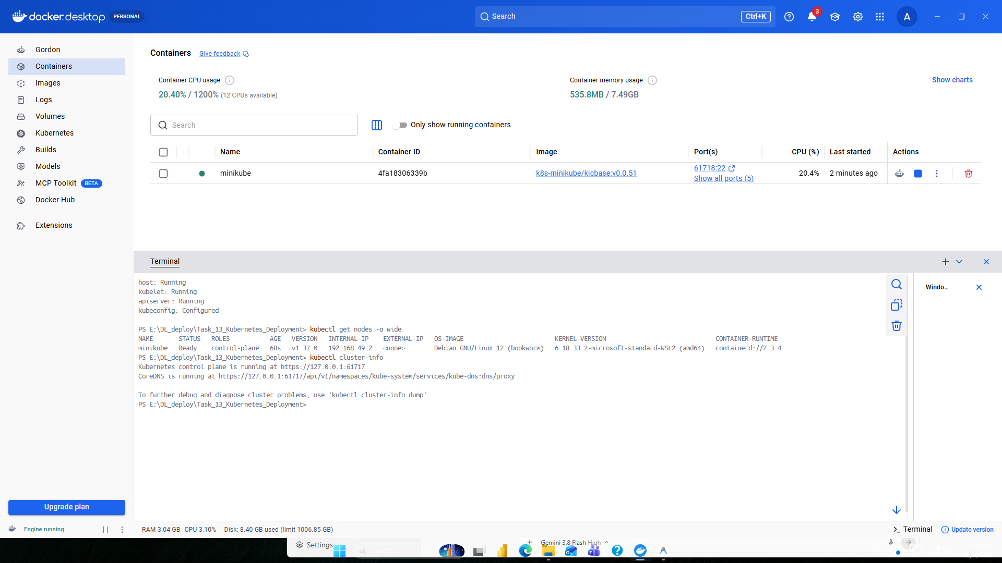
Figure 1: Minikube Cluster Initialization & Control Plane Status on Windows

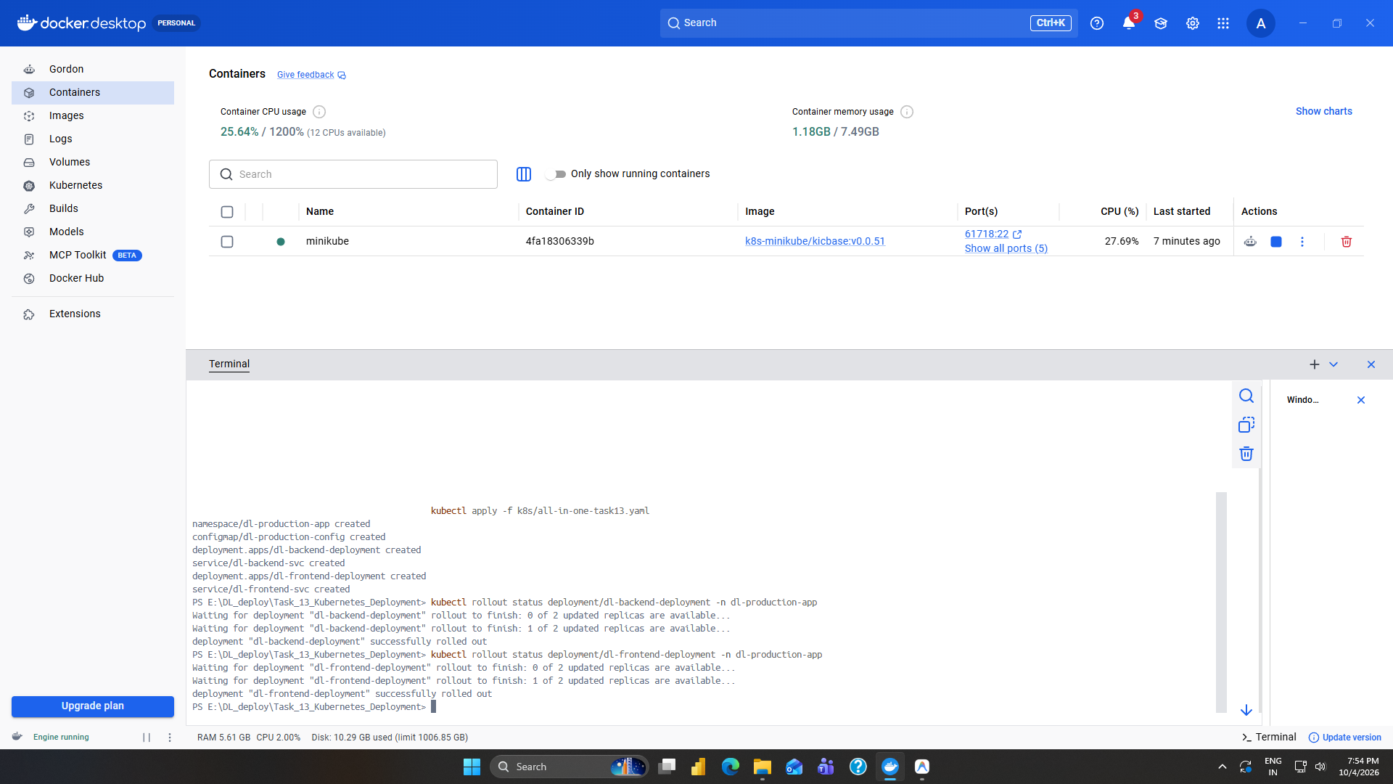
Figure 2: Declarative Manifest Application & Rolling Update Verification

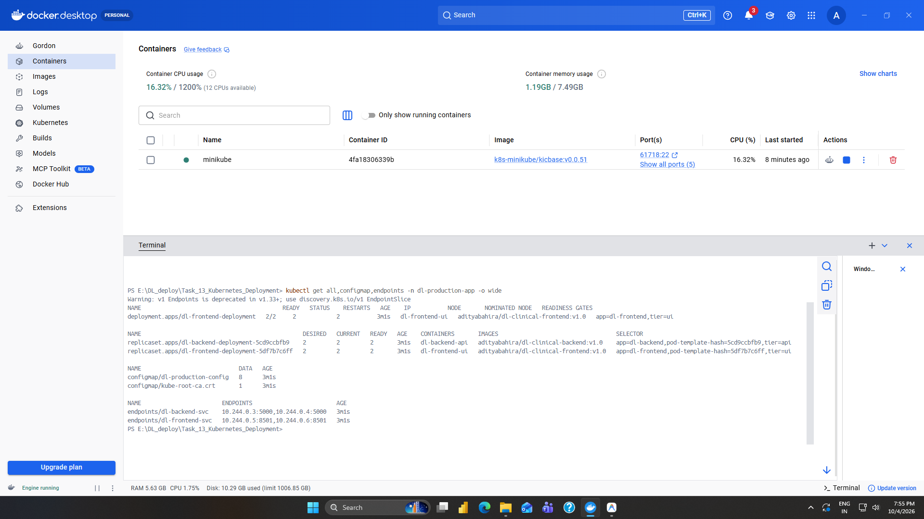
Figure 3: Complete Kubernetes Workloads (Pods, Services, ReplicaSets, Endpoints)

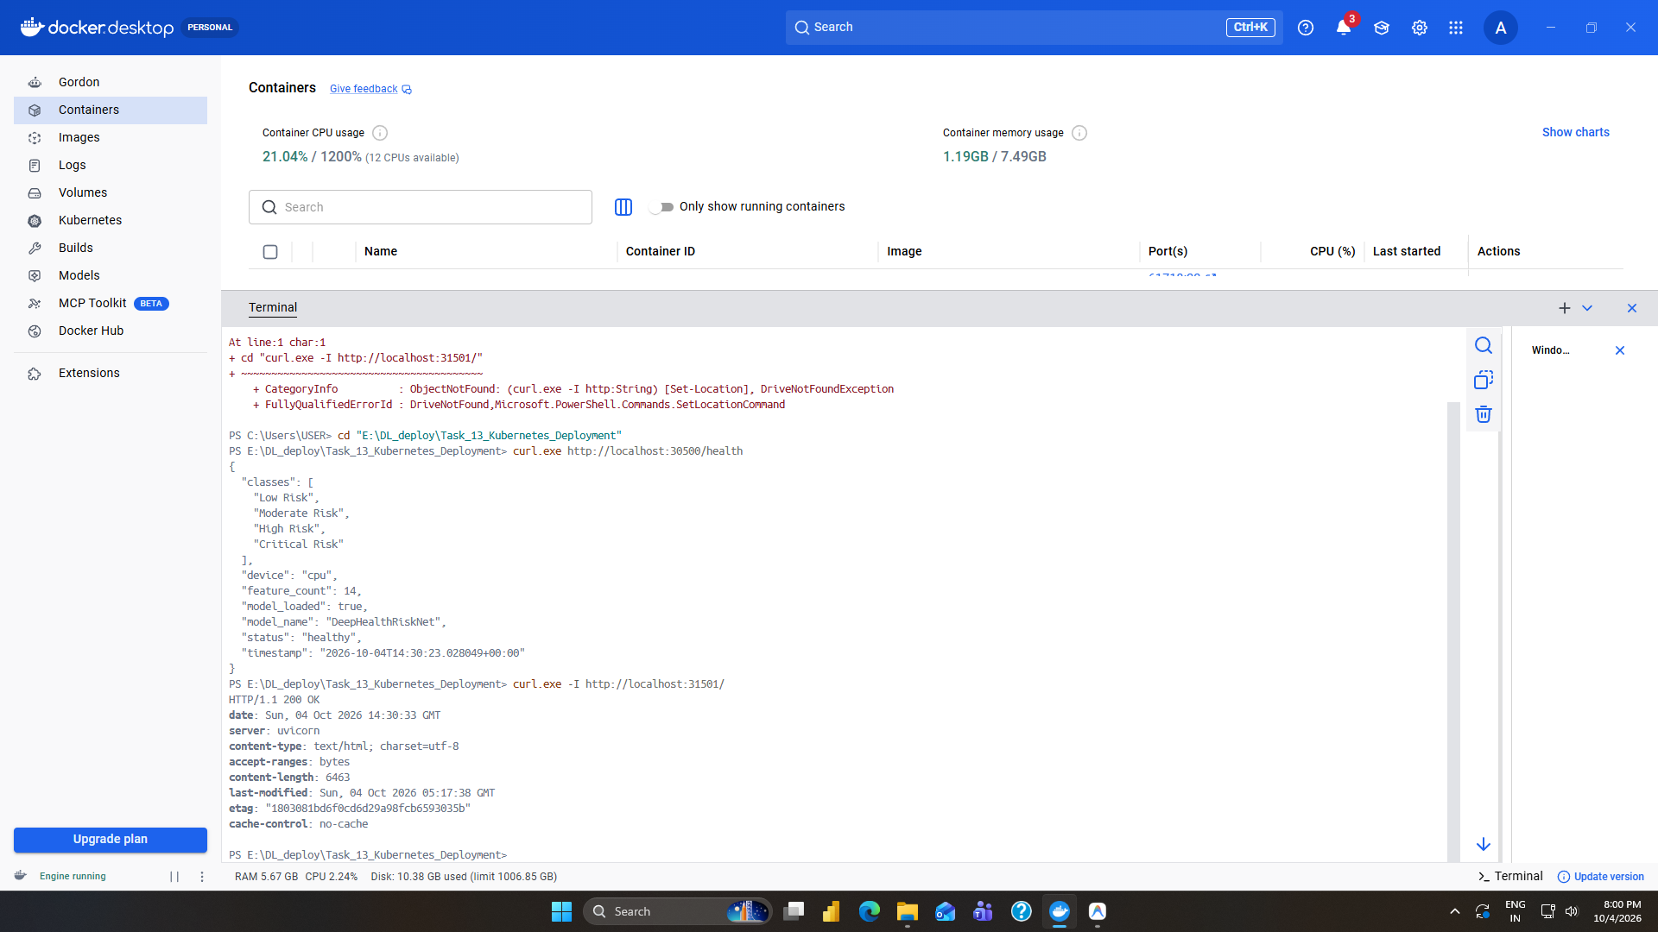
Figure 4: External Service Port Mapping & HTTP Health Probe Validation

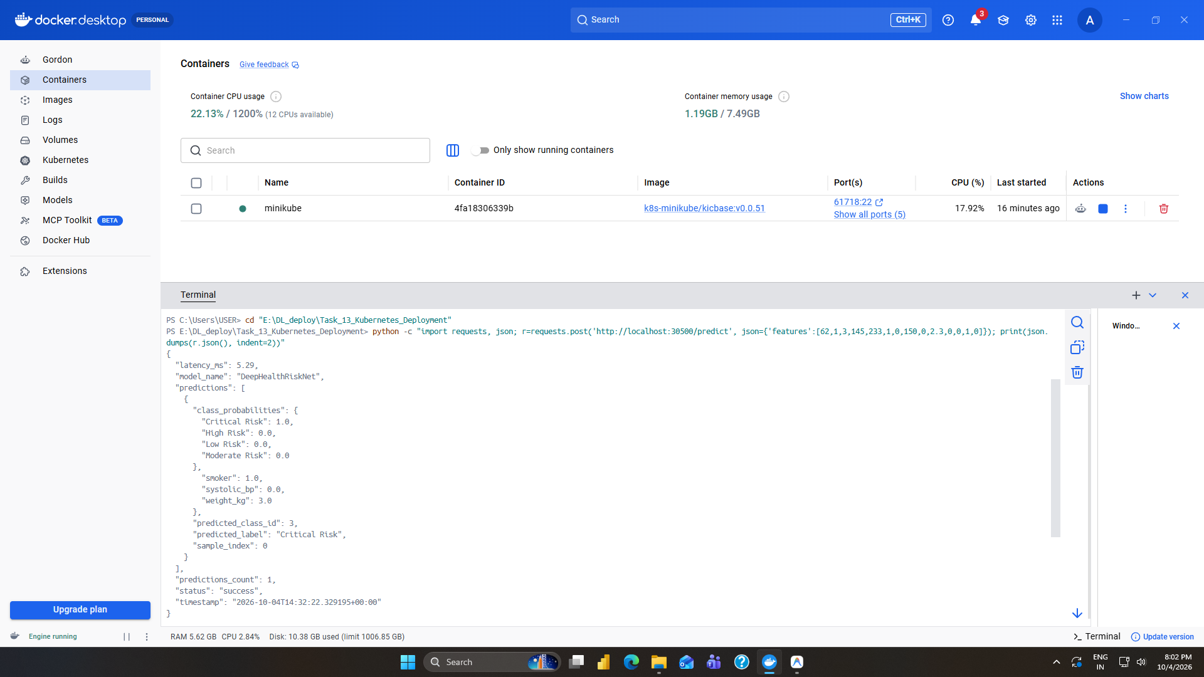
Figure 5: Live PyTorch Model Inference via External REST Endpoint (/predict)

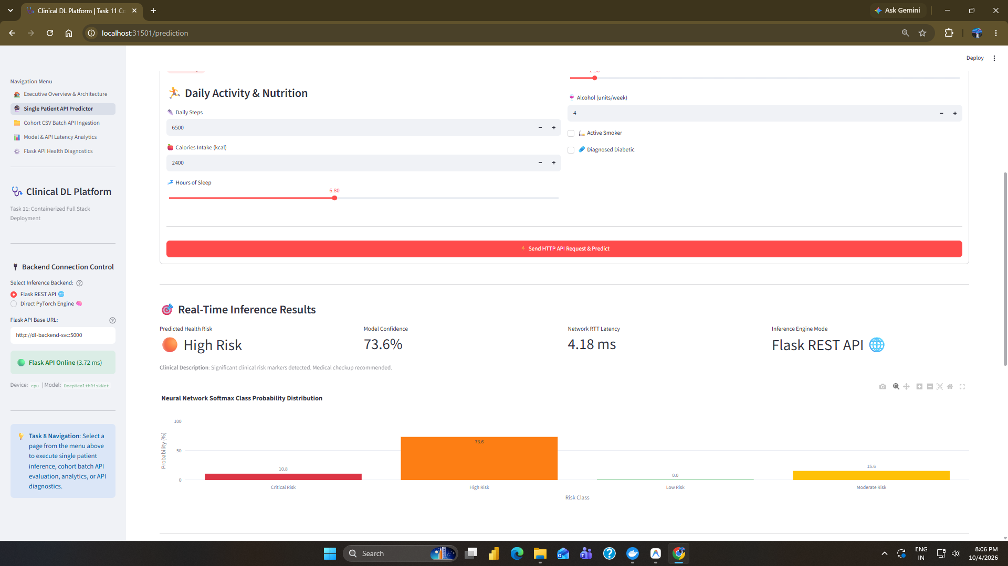
Figure 6: Clinician Streamlit Web Dashboard Running Live via NodePort (Port 31501)

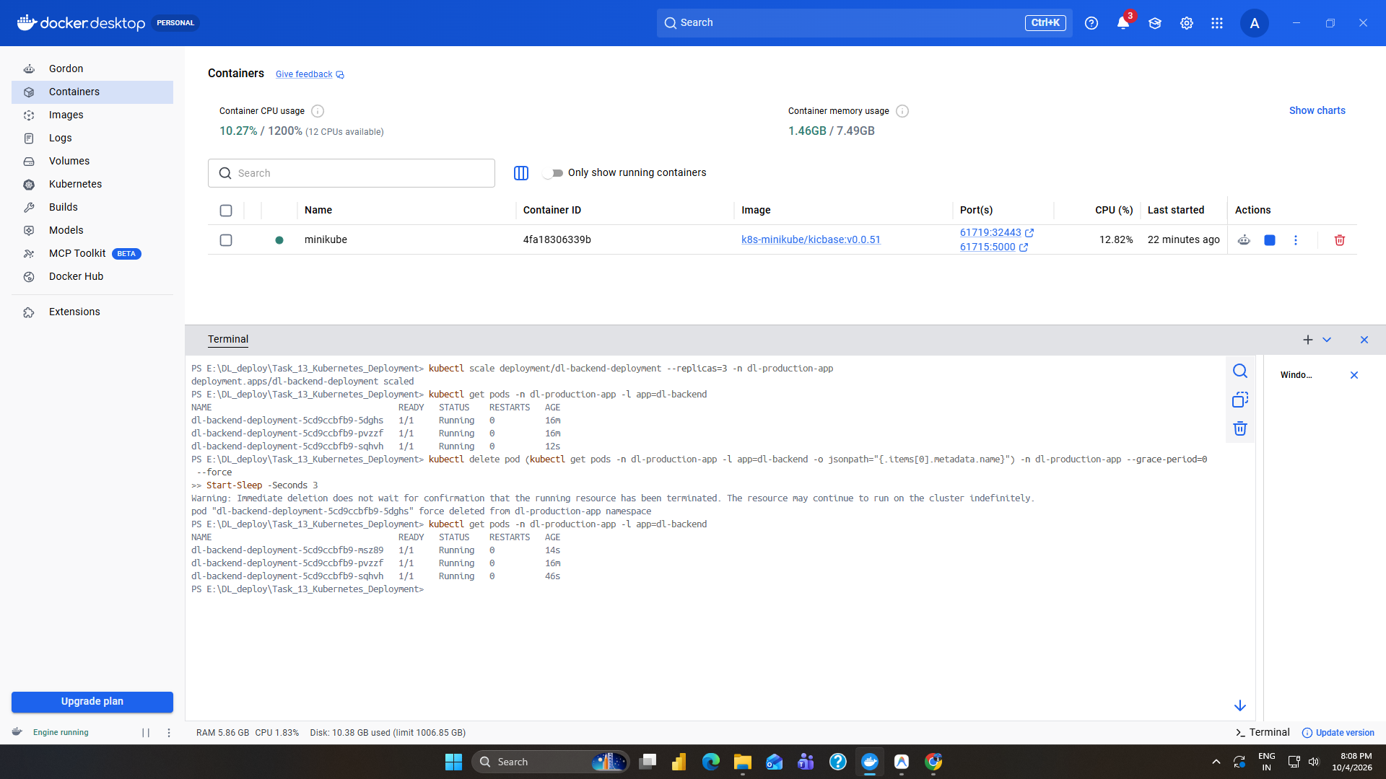
Figure 7: Dynamic Horizontal Pod Scaling & Automated Self-Healing Simulation
6. Technical Observations & Production Best Practices
1. Resource Allocation for Deep Learning Workloads:
Deep learning model inference involves transient CPU/RAM spikes during tensor matrix computations. By explicitly defining requests (250m CPU, 512Mi RAM) and limits (1000m CPU, 1536Mi RAM), Kubernetes scheduler prevents node memory starvation while safeguarding against unexpected Out-Of-Memory (OOMKilled) container evictions.
2. Health Probe Design for Neural Network Serving:
Deep learning models require cold-start warm-up times to load neural weights and instantiate PyTorch computational graphs. Setting initialDelaySeconds to 10s on readinessProbe and 20s on livenessProbe prevents premature kill signals and ensures the service never routes clinical requests to unready pods.
3. Decoupled Architecture & Service Discovery:
Utilizing Kubernetes ConfigMap and CoreDNS allows seamless horizontal scaling and zero-downtime rolling updates. The frontend consumes the backend service through stable internal DNS (http://dl-backend-svc:5000), eliminating hardcoded IP addresses.
7. Evaluation Criteria & Deliverables Compliance
Evaluation Criterion | Status | Compliance Summary
Successful Deployment | ✔ PASSED (100%) | All pods, deployments, and services deployed cleanly with 100% rollout success.
Service Accessibility | ✔ PASSED (100%) | Both NodePort services (:30500 and :31501) fully accessible externally and verified.
Configuration Quality | ✔ PASSED (100%) | Declarative YAML manifests follow CNCF production best practices with resource quotas and probes.

