Game Design Document

Fill up the Following document

1. Write the title of your project.

Save the baby Cat.

1. What is the goal of the game?

We have to help baby cat reach her mother (mumma cat).

1. Write a brief story of your game?

A baby cat (main character) has lost her way and want to reach her mother (mumma cat) and finds a railway and a cart. There are many obstacle in the way like the dog, the alien and the bat. There are some milk bottles dropped on the rails so that the baby cat (main character) can gain energy. Also the baby cat can change lanes to dodge the obstacles.

1. Which are the playing characters of this game?

* Playing characters are the ones which respond to the user based on the input from the user
* Cars, monkeys, dinos, wizards etc, are the playing characters in the game.

|  |  |  |
| --- | --- | --- |
| Number | Character Name | What can this character do? |
| 1 | Baby cat | Can switch the lanes on the subway |
| 2 | Train cart | Can switch the lanes on the subway |
| 3 |  |  |
| 4 |  |  |
| 5 |  |  |
| 6 |  |  |
| 7 |  |  |
| 8 |  |  |

1. Which are the Non Playing Characters of this game?

* Non Playing characters are the ones which don't have an action or a behaviour when the user interacts with the game.
* Hurdles, stones, bananas, coins, etc are non playing characters in the game.

|  |  |  |
| --- | --- | --- |
| Number | Character Name | What can this character do? |
| 1 | Alien | Can hurt baby cat |
| 2 | Dog | Can bite the baby cat |
| 3 | Bat | Can bite the baby cat |
| 4 | Milk bottle | Helps baby cat gain energy and increases the score |
| 5 |  |  |
| 6 |  |  |
| 7 |  |  |
| 8 |  |  |

Draw your imagination of this game. What does this game look like?

* Draw the game either on your computer or on paper,
* Add images of scenes of the game to show each of the playing and non-playing characters at least once.

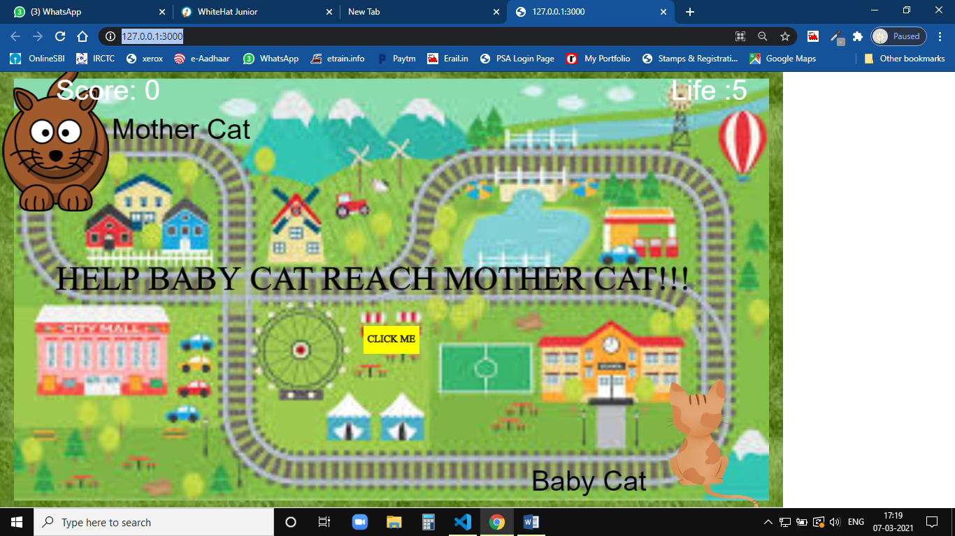

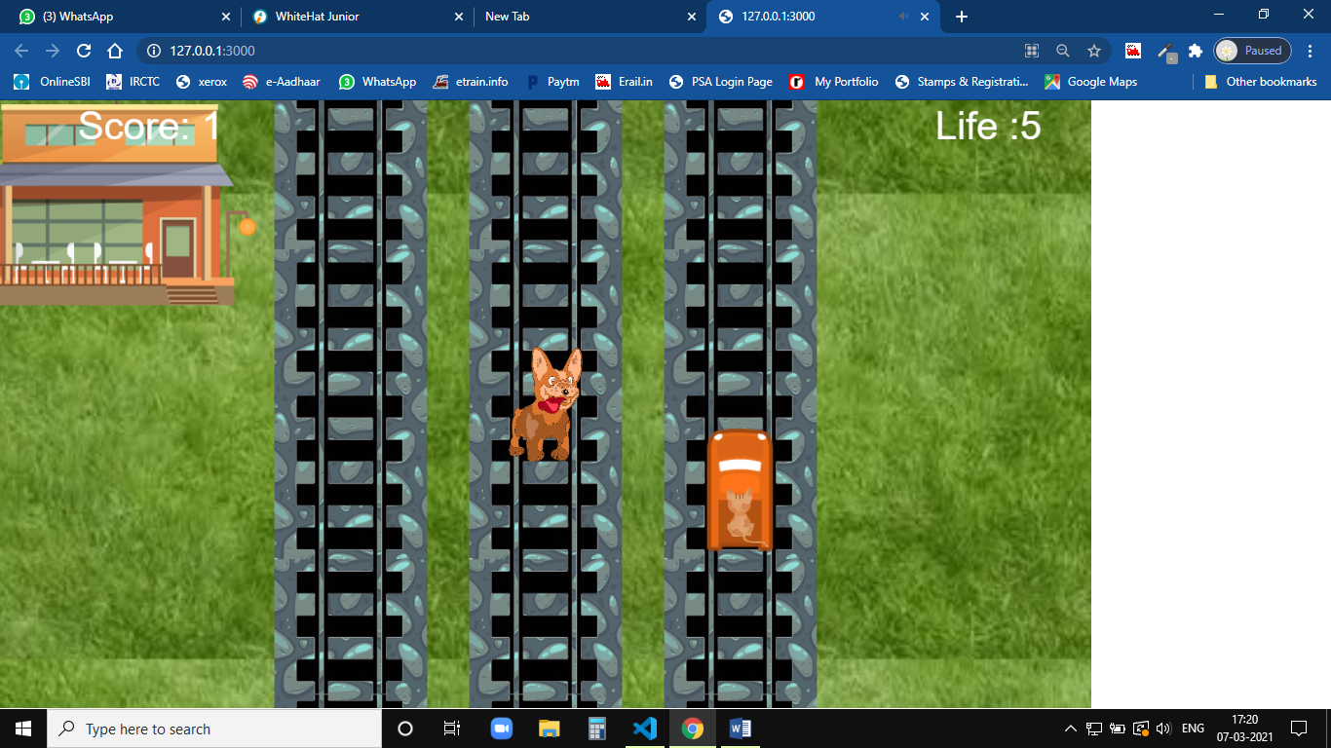

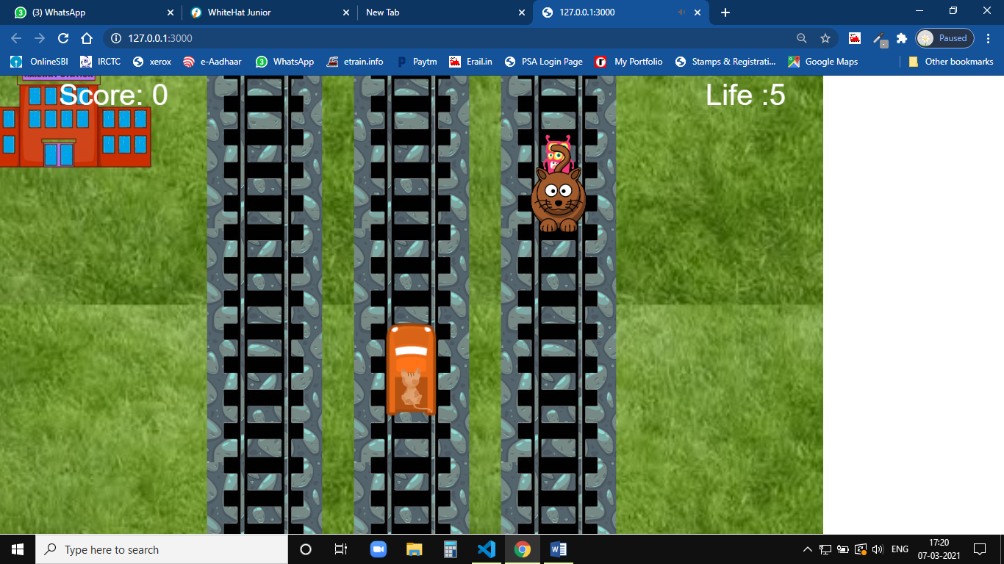

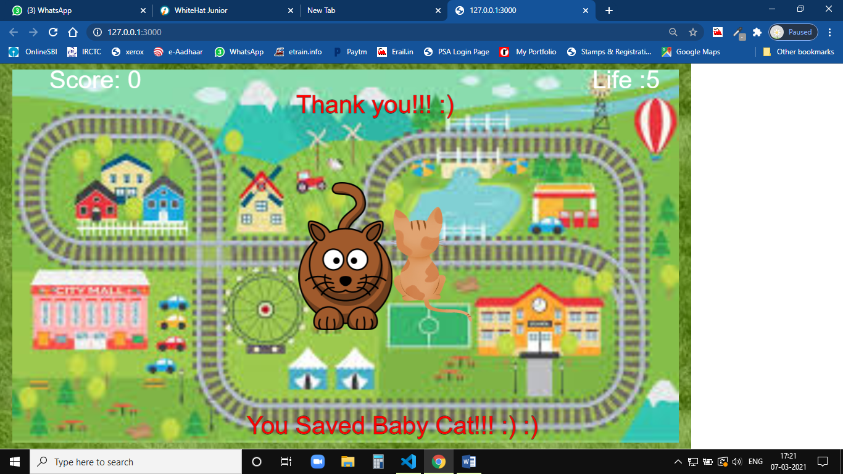

How do you plan to make your game engaging?

The speed of the cart increases as the baby cat moves forward. Also there are milk bottles in the way to gain energy and increase the score. There are 5 lives given to the player so that the game is not very hard. Also there is a page at the starting of the game to show the motive of the game.