**“Complaint Management System”**

**Web Programming Lab Mini Project Report**

***Submitted by:***

Aditya Bhawsar (2017CA)

Sarvesh Nagar (2017CA33)

Vivek Shukla (2017CA59)

Yash Bakliwal (2017CA29)

Yash Sharma (2017CA78)



**MOTILAL NEHRU NATIONAL INSTITUTE OF TECHNOLOGY**

**ALLAHABAD – 211004 (INDIA)**

2018

**M.C.A IIIrd Semester**

*in*

**CSE Department**

**Group Members Name and It’s Contribution on the Mini Project**

|  |  |
| --- | --- |
| **Group Members** | **Contributions** |
| Aditya Bhawsar |  |
| Sarvesh Nagar |  |
| Vivek Shukla |  |
| Yash Sharma |  |
| Yash Bakliwal |  |

**Table of Contents**

1. Introduction
2. Software requirements
3. Problem discussion
4. Results Snapshots

# Introduction

## Purpose

The purpose of this document is to present a detailed description of the College Complaint Management System. It will explain the purpose and features of the system, the interfaces of the system, what the system will do, the constraints under which it must operate and how the system will react to external stimuli.

## 1.2 Intended Audience

This document is intended for both the users and the developers of the system.

## 1.3 Product Scope

This College Complaint Management System has been designed to

solve complaints regarding both academic and hostel section. The

purpose of this system is to completely automate the

process of solving college complaints which would otherwise have to be

performed manually.

Moreover the details regarding the complainant are kept

confidential unlike in the manual processes.

All the official requests and orders seeking permissions of the HOD will

be directly notified and quick responses will be sent to concerned

persons which will therefore reduce the waiting time of complains

which are pending just for permissions.

Moreover the status of complaints can be quickly

checked by entering the complain id.

**2.Software Requirments:-**

**2.1 Xamp:**

Xamp is required to run local host in order to make data connectivity and run php codes by creating a local server

**2.2 Mysql**:

Mysql is required in order to run sql queries

and also make tables that stores data values

**2.3 Sublime Editor:-**

Sublime editor is a platform that deals with the all the files of php and html and css code to be written and edited if needed

**3.Problem Discussion:**

**3.1 Introduction:-**

Complaint Management System solves real life problem of a student that face difficulties in many ways of putting there problems that may be related to hostel or may be related to department so by this they may solve this problem

**3.2 Problem Attributes:-**

**3.2.1 Student**

* Register a complaint.
* Check status of complaint.
* Timeline of complaint.
* Assignment of complain id upon successful registration of complaint.

**3.2.2Technician**

* Every technician has login id.
* Separate complaints management section.
* Privilege to update the status of complain upon completion

**3.3.3DMPC**

* Option to either Approve a complaint
* Forward a complaint to Head for permission or further issues.
* Complaints according to category.
* Complaints statistics section.

**3.3.4 HOD**

* It is the head of the department complaint management.
* It supervises each and every complaint that is been removed approved or is been transferred
* Can be accessed only through login id/password
* It is the last level at which complaint can be evaluated.

**3.4 Problem Special Features:**

## 3.4.1 Check Status:

Status is one of the key feature that keeps updated individual that at which

level its complain is been received and where is it currently residing

with proper date and time Status is important key as it connects one who

have registered complain and who are solving them as it also provide date

and time of solving

## 3.4.2 All complaint Approved

All complaint approved is another intresting feature that gives history of all the complaint that were approved either by DMPC or by HOD which could help analyzing the system. It is important to know the kind of work that is happening in each departments

## 3.4.3 Delete Feature:-

In delete feature each department has got authority to delete unnecessary complaint from there database which ensures that right person is treated rightly. Delete feature is important as it handles all the unwanted complaint which are either not related to that department or not possible for that department

**3.4.4 Complaint Forwarding Feature**

Complaint Forwarding is a feature that gives authority to pass complaint to relative authority concerned to that complaint It help to throw complain to relative department where solution of that department can be solved

**3.4.5 Category and Sub Category Division Feature:**

Category division feature deals with the different types of categories of complaint that gives users options which makes it more appropriate as some of them may not have idea what to write in complaint. The most important thing about this feature is that it gives individual different options which provide suitable number of option in complain registering.

**4.Results Snapshot:**

**4.1 Front Page**

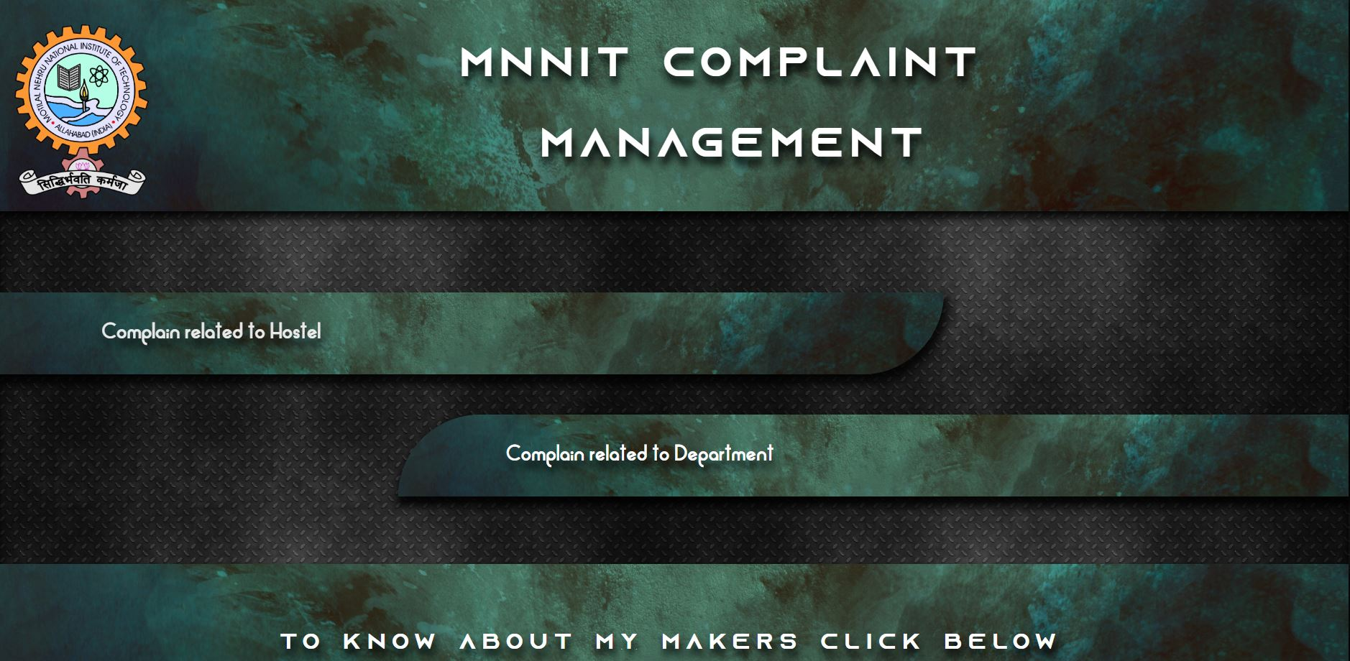

**4.2 Hostel Front Page:-**

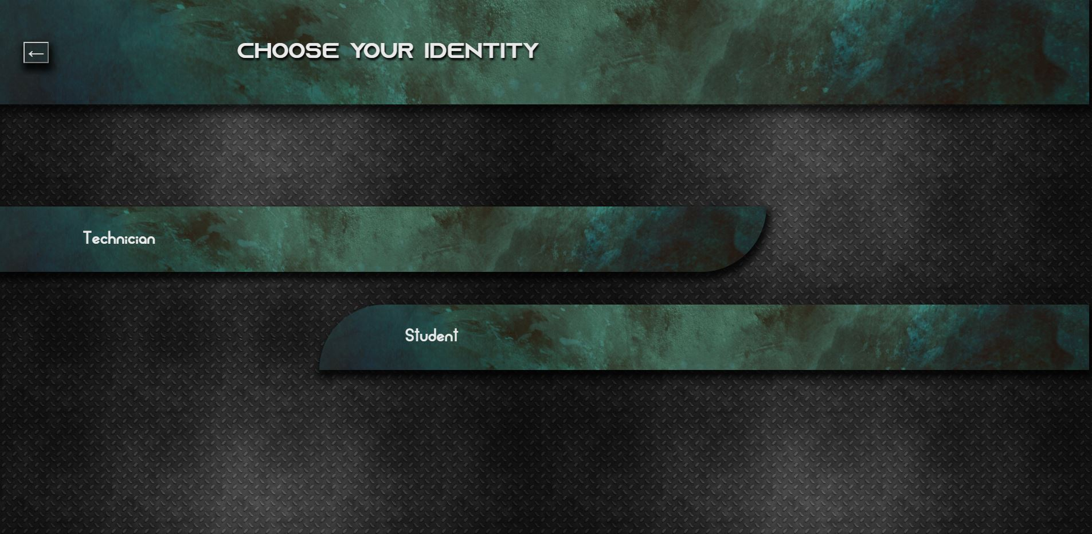

**-**

**4.3 Technician Login Page**

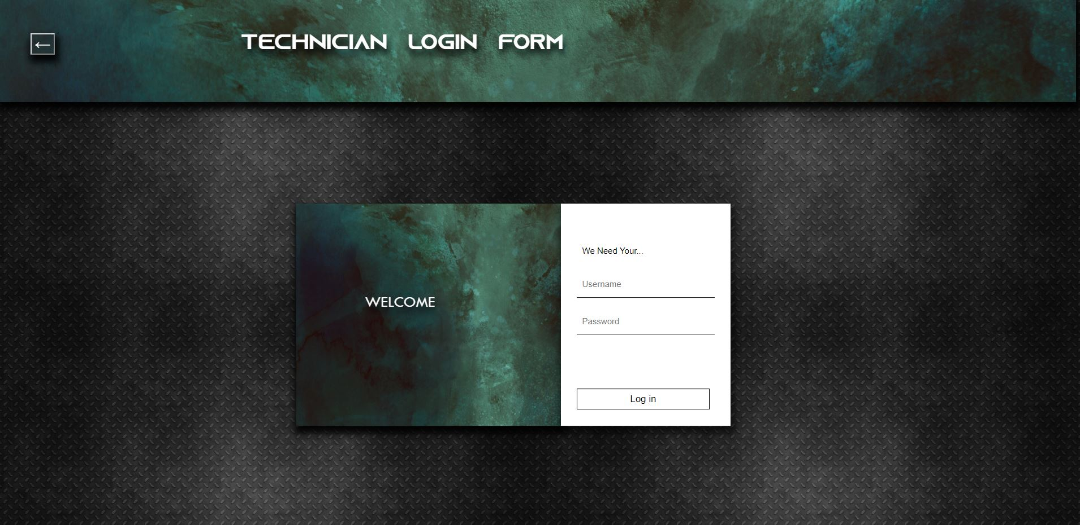

**4.4 Technician Desk:-**

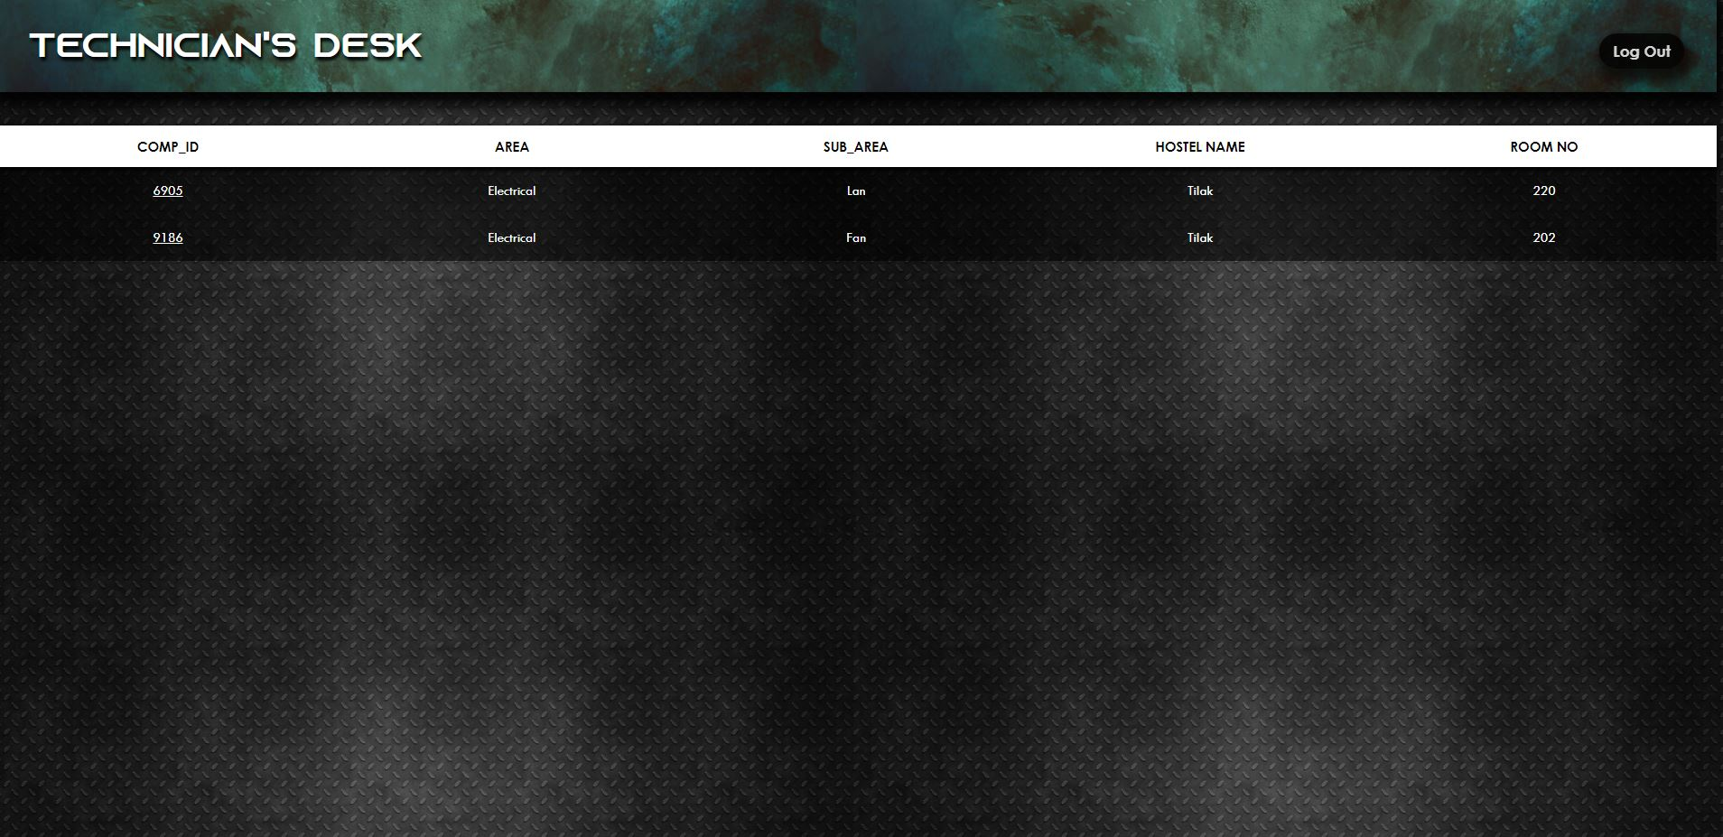

**4.5 Student Details in Hostel:-**

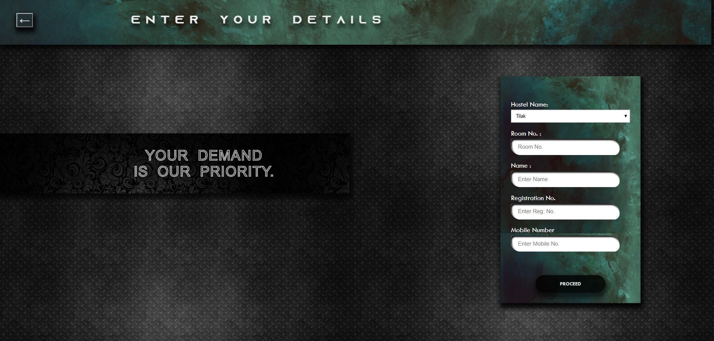

**4.6 Complaint Registration:-**

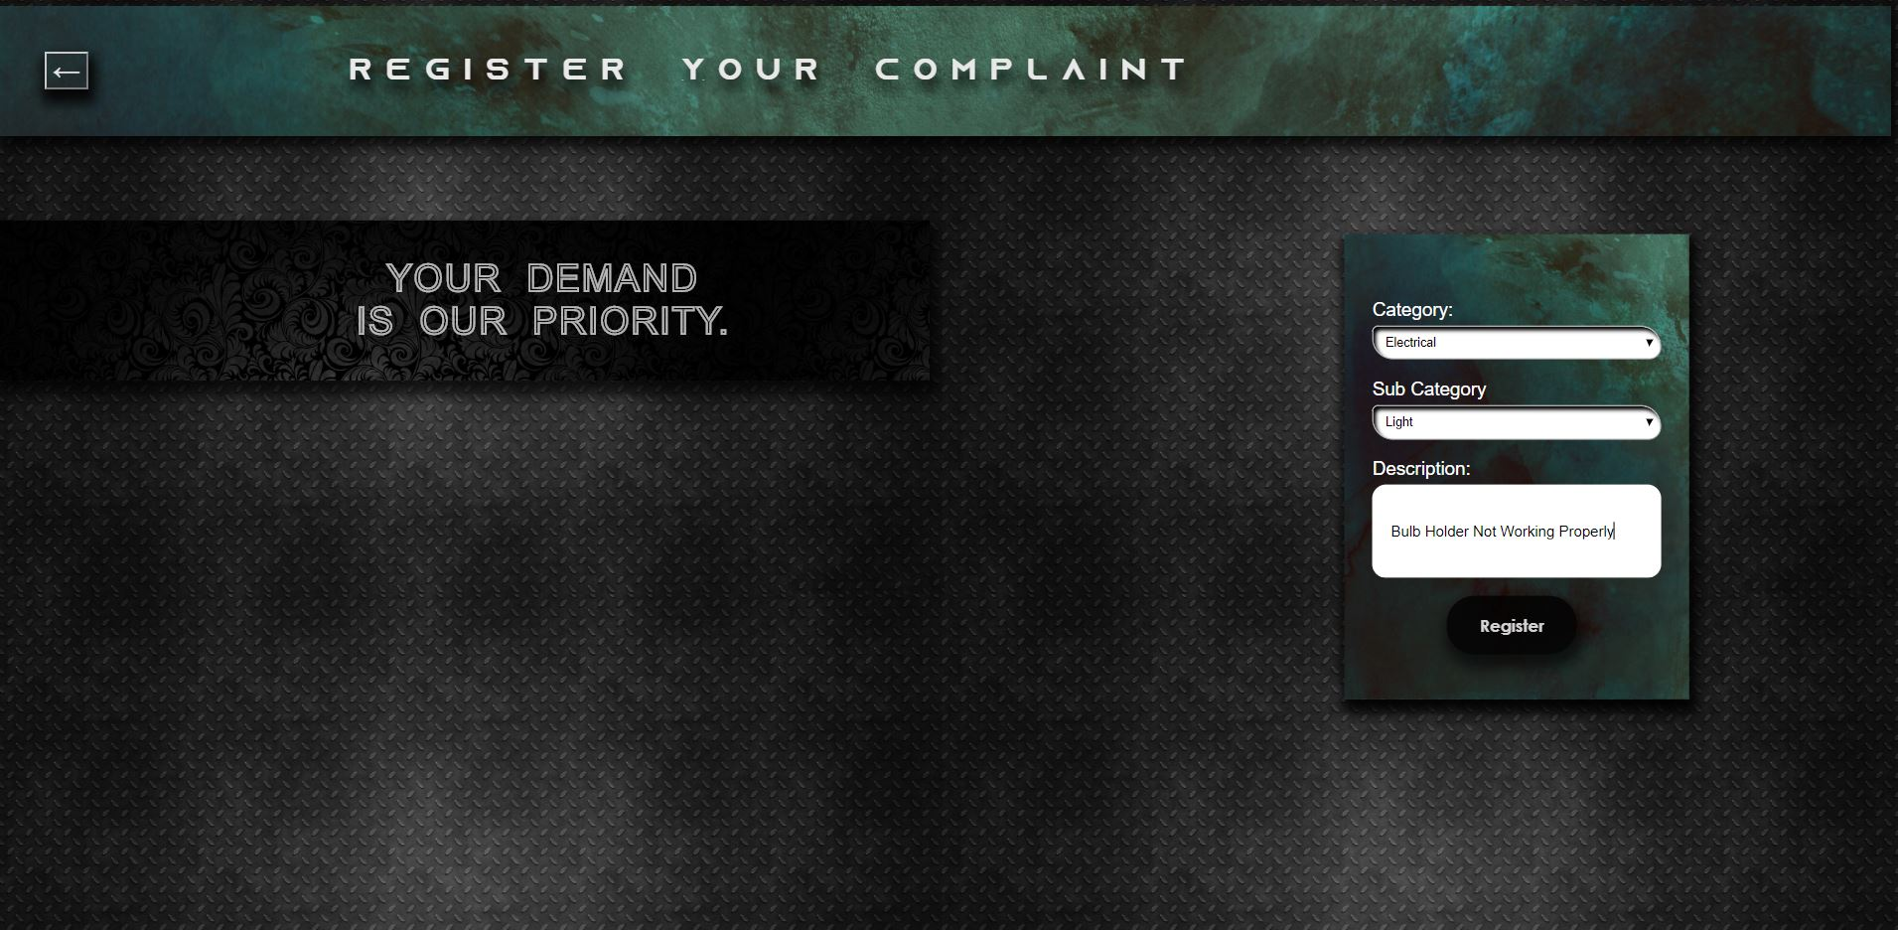

**4.7 Complaint Id Generator:-**

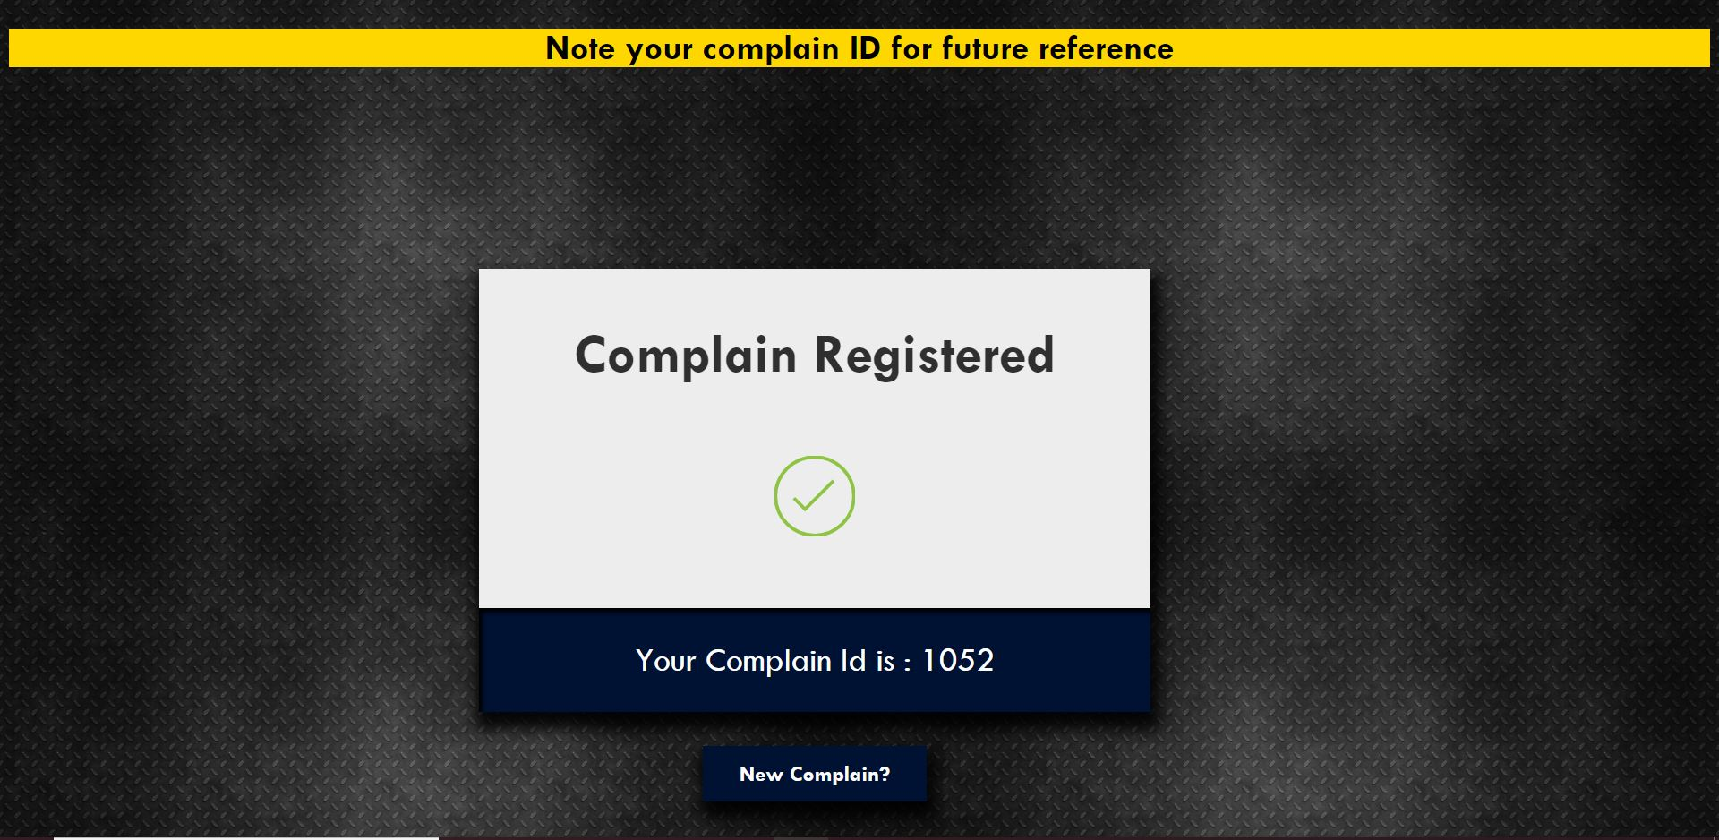

**4.8 Department Front page:-**

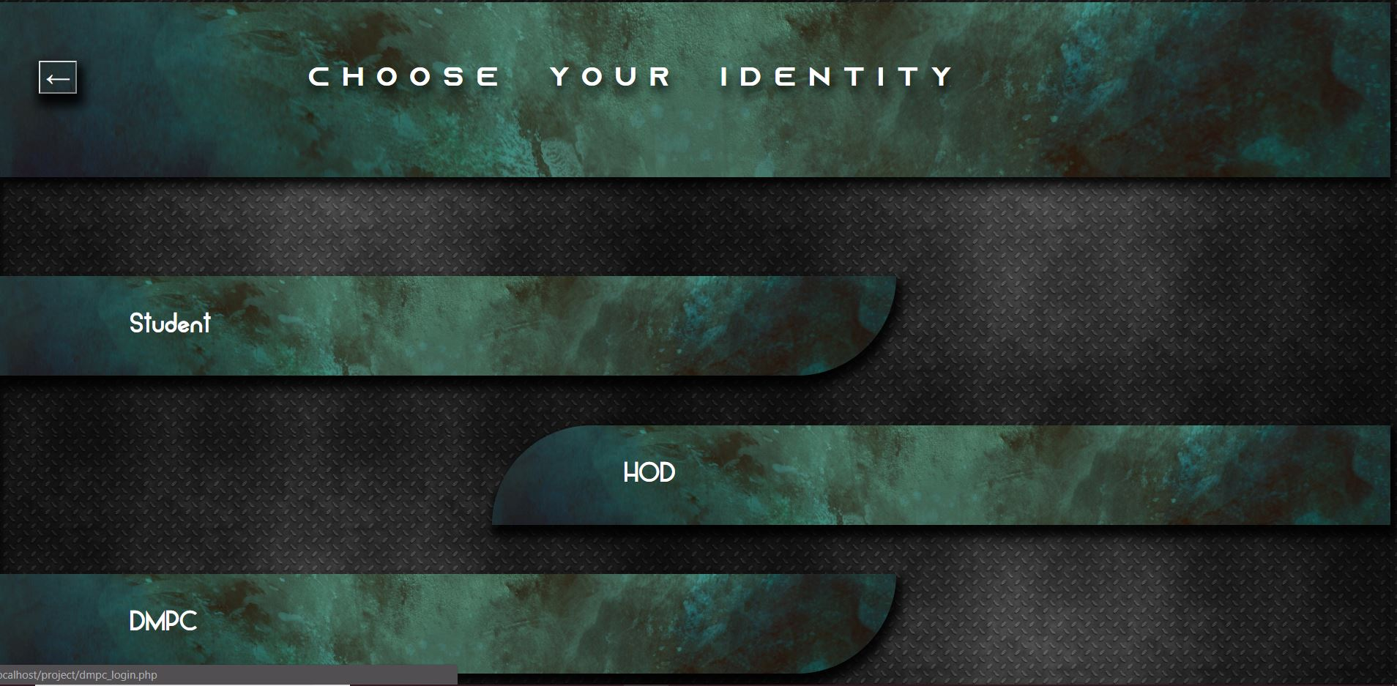

**4.9 DMPC login page:-**

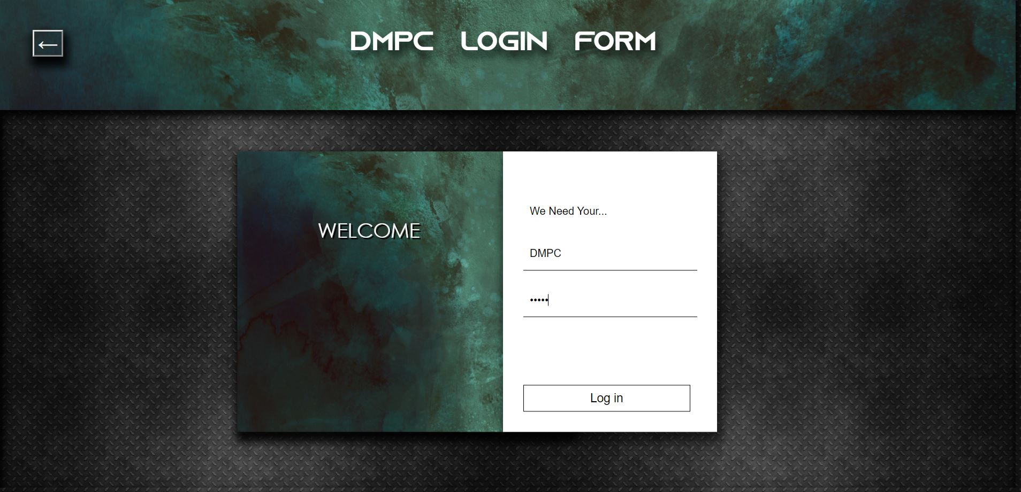

**4.10 DMPC Desk Work:-**

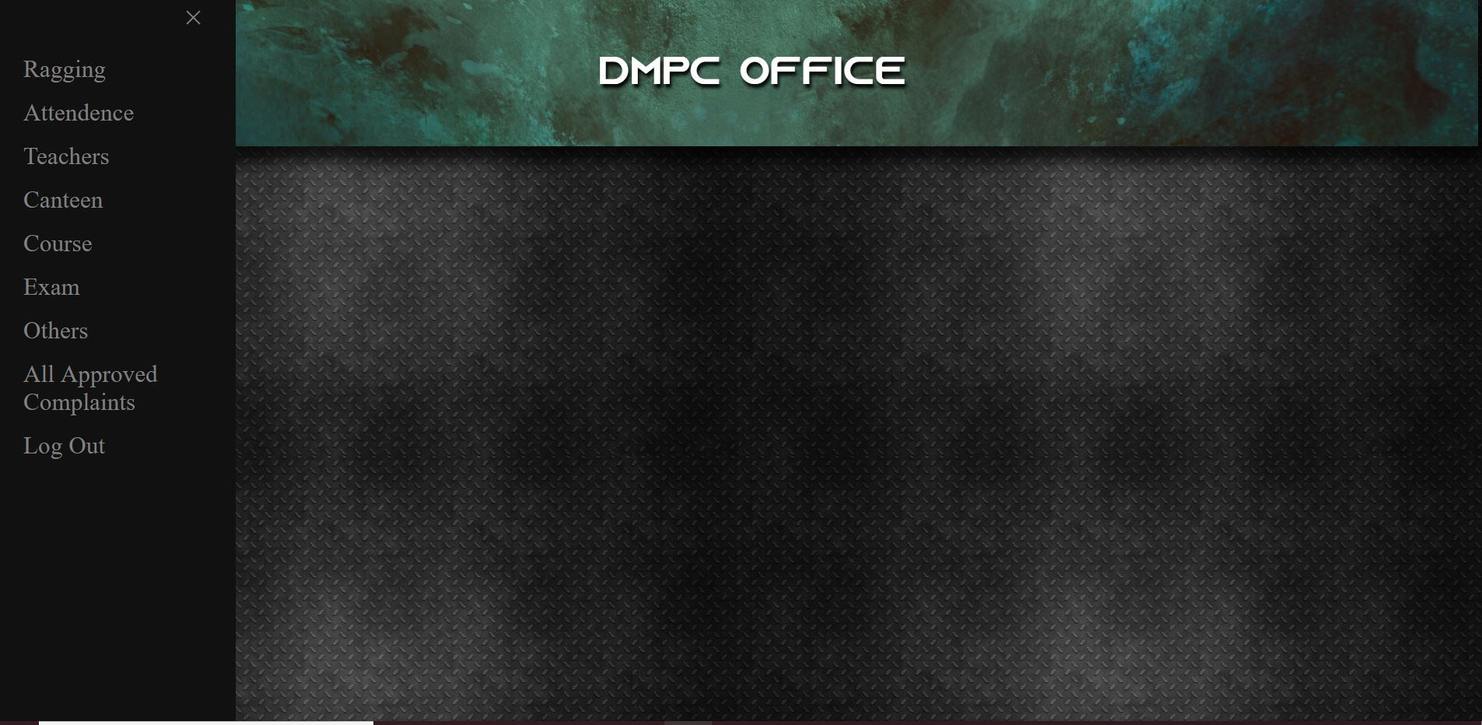

**4.11 Department Complaint Registration Page:-**

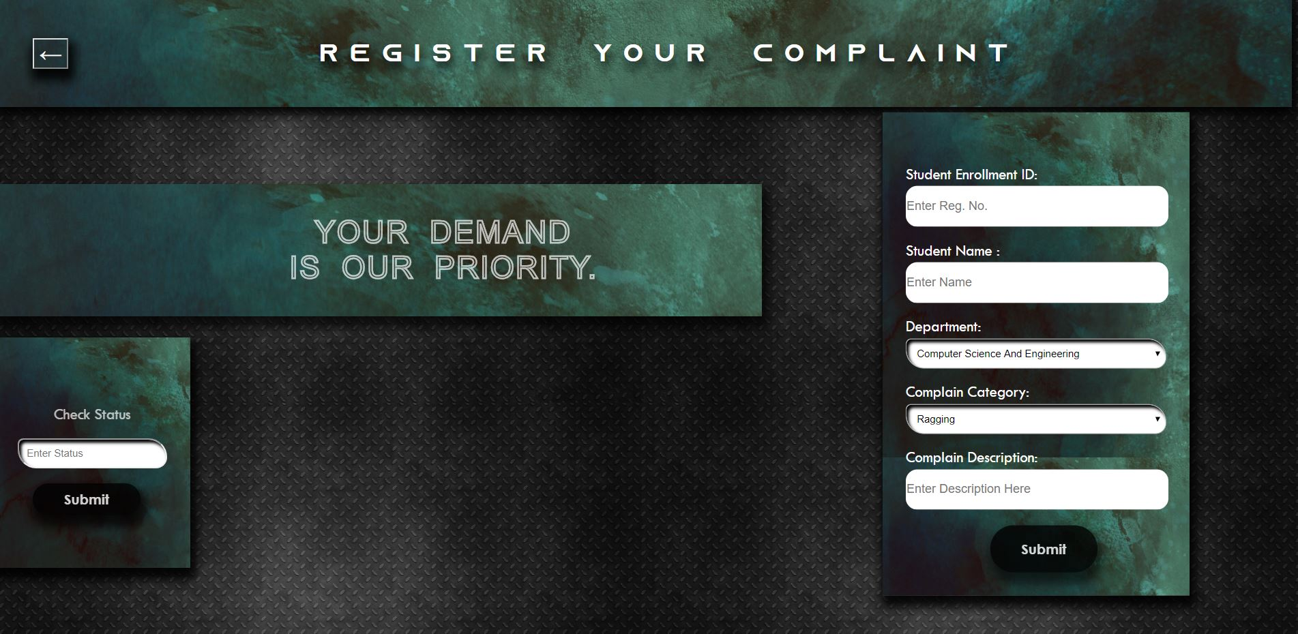

**4.12 Department Complaint registration Id Generator:-**

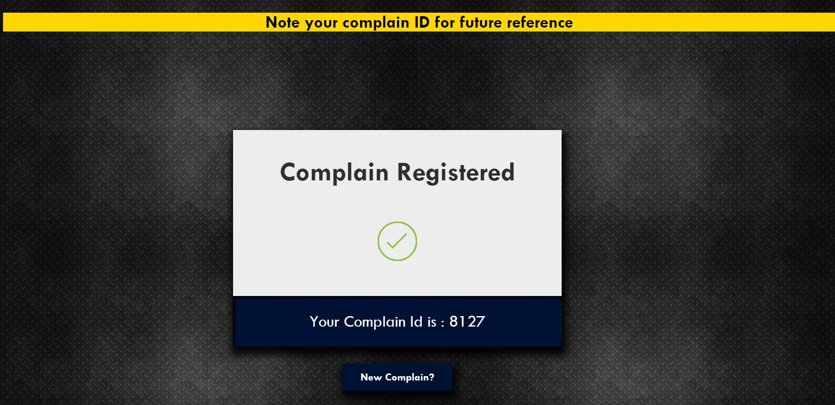

**4.13 HOD Login page :-**

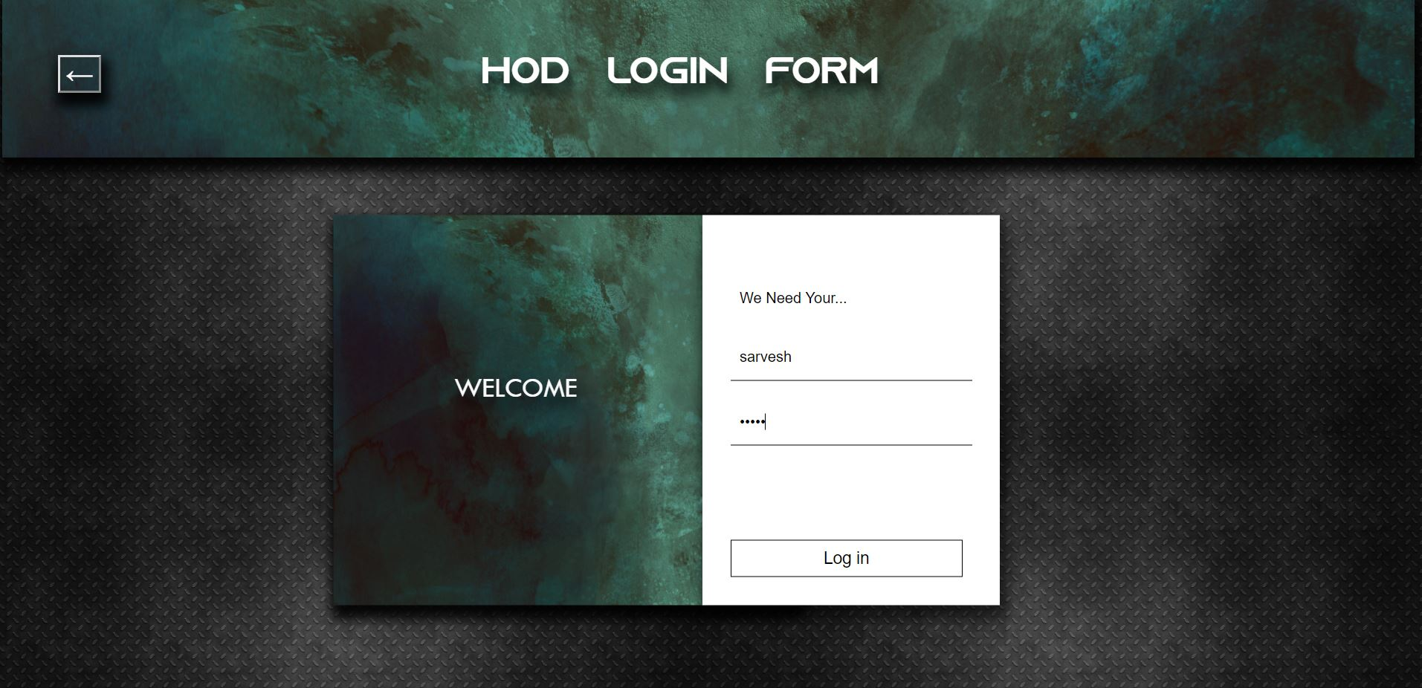

**4.14 HOD Office Page:-**

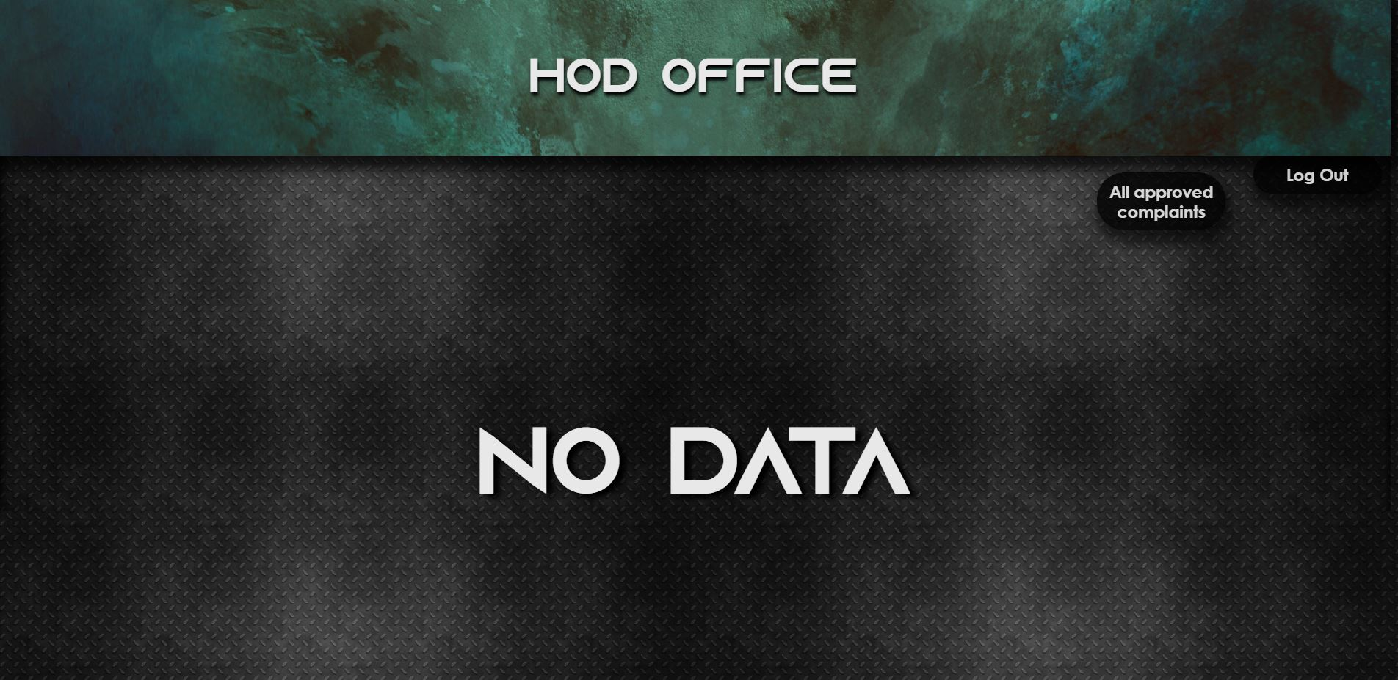

**4.15 HOD view to All Approved Complaints:-**

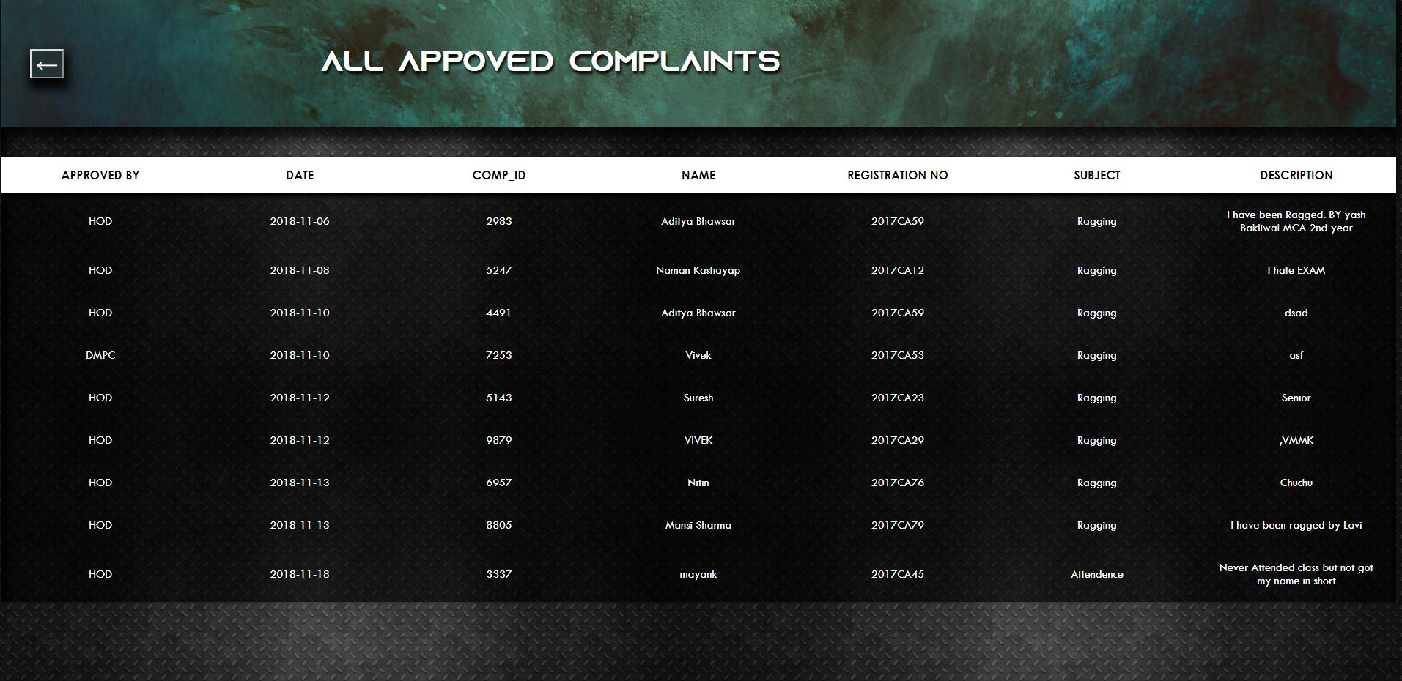

**4.16:-Status of Complaint:-**

