Assignment No: 1

Aim: To develop any distributed application through implementing client-server communication programs based on Java Sockets and RMI techniques.

Tools and Technologies: Java Programming Environment, rmiregistry, jdk 1.8, Eclipse IDE.

Part A: Using Java Socket

1. Theory:
Socket: In distributed computing, network communication is one of the essential parts of any
system, and the socket is the endpoint of every instance of network communication. In Java
communication, it is the most critical and basic object involved.
A socket is a handle that a local program can pass to the networking API to connect to another
machine. It can be defined as the terminal of a communication link through which two programs
/processes/threads running on the network can communicate with each other. The TCP layer can
easily identify the application location and access information through the port number assigned
to the respective sockets.

1.1 Java Socket Programming
- Java Socket programming is used for communication between the applications running on different JRE.
- Java Socket programming can be connection-oriented or connection-less.
- Socket and ServerSocket classes are used for connection-oriented socket programming and DatagramSocket and DatagramPacket classes are used for connection-less socket programming.
- The client in socket programming must know two information:
- IP Address of Server, and
- Port number.

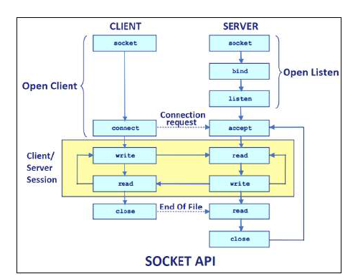

1.2 Socket class:
A socket is simply an endpoint for communications between the machines. The Socket class can be used to create a socket.

Important methods

Method | Description
1) public InputStream getInputStream() | returns the InputStream attached with this socket.
2) public OutputStream getOutputStream() | returns the OutputStream attached with this socket.
3) public synchronized void close() | closes this socket

1.3 ServerSocket class:

The ServerSocket class can be used to create a server socket. This object is used to establish communication with the clients.

Important methods:

Method | Description
1) public Socket accept() | returns the socket and establish a connection between server and client.
2) public synchronized void close() | closes the server socket.

1.4 Example of Java Socket Programming
Creating Server:
To create the server application, we need to create the instance of ServerSocket class. Here, we are using 6666 port number for the communication between the client and server. You may also choose any other port number. The accept() method waits for the client. If clients connects with the given port number, it returns an instance of Socket.
ServerSocket ss=new ServerSocket(6666);
Socket s=ss.accept(); //establishes connection and waits for the client
Creating Client:
To create the client application, we need to create the instance of Socket class. Here, we need to pass the IP address or hostname of the Server and a port number. Here, we are using "localhost" because our server is running on same system.
Socket s=new Socket("localhost",6666);

File: MyServer.java
import java.io.*;
import java.net.*;
public class MyServer {
public static void main(String[] args){
try{
System.out.println("Server is Ready");
ServerSocket ss=new ServerSocket(6666);
Socket s=ss.accept();//establishes connection
DataInputStream dis=new DataInputStream(s.getInputStream());
String str=(String)dis.readUTF();
System.out.println("message= "+str);
ss.close();
}catch(Exception e){System.out.println(e);}
}
}

File: MyClient.java
import java.io.*;
import java.net.*;
public class MyClient {
public static void main(String[] args) {
try{
System.out.println("I am Client, sending message to Server");
Socket s=new Socket("localhost",6666);
DataOutputStream dout=new DataOutputStream(s.getOutputStream());
dout.writeUTF("Hello Server");
dout.flush();
dout.close();
s.close();
}catch(Exception e){System.out.println(e);}
}
}

2.3 Execution of Program

For running this rmi example,
1) compile all the java files
javac *.java
2)start the server in another command prompt
java MyServer
3)start the client application in another command prompt
java MyClient

Part B: Using RMI Techniques

Theory:

The RMI (Remote Method Invocation) is an API that provides a mechanism to create distributed application in java. The RMI allows an object to invoke methods on an object running in another JVM.
The RMI provides remote communication between the applications using two objects stub and skeleton.

2.1 Understanding stub and skeleton
RMI uses stub and skeleton object for communication with the remote object.
A remote object is an object whose method can be invoked from another JVM. Let's understand the stub and skeleton objects:

stub
The stub is an object, acts as a gateway for the client side. All the outgoing requests are routed through it. It resides at the client side and represents the remote object. When the caller invokes method on the stub object, it does the following tasks:
- It initiates a connection with remote Virtual Machine (JVM),
- It writes and transmits (marshals) the parameters to the remote Virtual Machine (JVM),
- It waits for the result
- It reads (unmarshals) the return value or exception, and
- It finally, returns the value to the caller.

skeleton
The skeleton is an object, acts as a gateway for the server side object. All the incoming requests are routed through it. When the skeleton receives the incoming request, it does the following tasks:
- It reads the parameter for the remote method
- It invokes the method on the actual remote object, and
- It writes and transmits (marshals) the result to the caller.

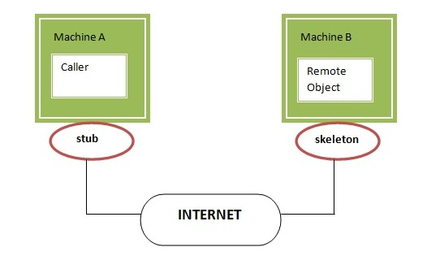

Understanding requirements for the distributed applications
If any application performs these tasks, it can be distributed application.

- The application need to locate the remote method
- It need to provide the communication with the remote objects, and
- The application need to load the class definitions for the objects.

The RMI application have all these features, so it is called the distributed application.

2.2 Java RMI Example
The is given the 6 steps to write the RMI program.
- Create the remote interface
- Provide the implementation of the remote interface
- Compile the implementation class and create the stub and skeleton objects using the rmic tool
- Start the registry service by rmiregistry tool
- Create and start the remote application
- Create and start the client application

It is an example of a remote interface. Here we have defined an interface with the name Hello and it has a method called printMsg().

import java.rmi.Remote;
import java.rmi.RemoteException;

// Creating Remote interface for our application
public interface Hello extends Remote {
void printMsg() throws RemoteException;
}
- Developing the Implementation Class (Remote Object)
To develop an implementation class −
- Implement the interface created in the previous step.
- Provide implementation to all the abstract methods of the remote interface.
It is an implementation class. Here, we have created a class named ImplExample and implemented the interface Hello created in the previous step and provided body for this method which prints a message.
// Implementing the remote interface
public class ImplExample implements Hello {

// Implementing the interface method
public void printMsg() {
System.out.println("This is an example RMI program");
}
}
- Developing the Server Program
An RMI server program should implement the remote interface or extend the implementation class. Here, we should create a remote object and bind it to the RMIregistry.
To develop a server program −
- Create a client class from where you want invoke the remote object.
- Create a remote object by instantiating the implementation class as shown below.
- Export the remote object using the method exportObject() of the class named UnicastRemoteObject which belongs to the package java.rmi.server.
- Get the RMI registry using the getRegistry() method of the LocateRegistry class which belongs to the package java.rmi.registry.
- Bind the remote object created to the registry using the bind() method of the class named Registry. To this method, pass a string representing the bind name and the object exported, as parameters.
- Example of an RMI server program.
import java.rmi.registry.Registry;
import java.rmi.registry.LocateRegistry;
import java.rmi.RemoteException;
import java.rmi.server.UnicastRemoteObject;

public class Server extends ImplExample {
public Server() {}
public static void main (String args[]) {
try {
// Instantiating the implementation class
ImplExample obj = new ImplExample();

// Exporting the object of implementation class
// (here we are exporting the remote object to the stub)
Hello stub = (Hello) UnicastRemoteObject.exportObject(obj, 0);

// Binding the remote object (stub) in the registry
Registry registry = LocateRegistry.getRegistry();
registry.bind("Hello", stub);

System.out.println("Server ready");

} catch (Exception e) {
System.err.println("Server exception: " + e.toString());
e.printStackTrace();
}
}
}

Create and run the server application
Now rmi services need to be hosted in a server process. The Naming class provides methods to get and store the remote object. The Naming class provides 5 methods.

public static java.rmi.Remote lookup(java.lang.String) throws java.rmi.NotBoundException, java.net.MalformedURLException, java.rmi.RemoteException; | It returns the reference of the remote object.
public static void bind(java.lang.String, java.rmi.Remote) throws java.rmi.AlreadyBoundException, java.net.MalformedURLException, java.rmi.RemoteException; | It binds the remote object with the given name.
public static void unbind(java.lang.String) throws java.rmi.RemoteException, java.rmi.NotBoundException, java.net.MalformedURLException; | It destroys the remote object which is bound with the given name.
public static void rebind(java.lang.String, java.rmi.Remote) throws java.rmi.RemoteException, java.net.MalformedURLException; | It binds the remote object to the new name.
public static java.lang.String[] list(java.lang.String) throws java.rmi.RemoteException, java.net.MalformedURLException; | It returns an array of the names of the remote objects bound in the registry.
- Developing the Client Program
Write a client program in it, fetch the remote object and invoke the required method using this object.
To develop a client program −
- Create a client class from where your intended to invoke the remote object.
- Get the RMI registry using the getRegistry() method of the LocateRegistry class which belongs to the package java.rmi.registry.
- Fetch the object from the registry using the method lookup() of the class Registry which belongs to the package java.rmi.registry.
To this method, you need to pass a string value representing the bind name as a parameter. This will return you the remote object.
- The lookup() returns an object of type remote, down cast it to the type Hello.
- Finally invoke the required method using the obtained remote object.

- Example of an RMI client program.
Following is an example of an RMI client program.
import java.rmi.registry.LocateRegistry;
import java.rmi.registry.Registry;

public class Client {
private Client() {}
public static void main(String[] args) {
try {
// Getting the registry
Registry registry = LocateRegistry.getRegistry(null);

// Looking up the registry for the remote object
Hello stub = (Hello) registry.lookup("Hello");

// Calling the remote method using the obtained object
stub.printMsg();

// System.out.println("Remote method invoked");
} catch (Exception e) {
System.err.println("Client exception: " + e.toString());
e.printStackTrace();
}
}
}

2.3 Execution of Program

For running this rmi example, in windows OS
1) compile all the java files
javac *.java
2)create stub and skeleton object by rmic tool in another command prompt
start rmiregistry
3)start the server in another command prompt
java Server
4)start the client application in another command prompt
java Client

CONCLUSION:
In this way we have studied the all methods of communication between client and server in java language. We implemented socket communication program by doing operations on Server side code and implemented RMI Technique for Client and Server communication.

FAQs:
- What is Socket?
- What is the Process of Socket Client Server Communication?
- What are the Primitives of Socket at Client & Server Side?
- What is Use of Bind and Listen in Socket?
- What is difference between Socket & ServerSocket?
- What is DataInputStream & DataOutputStream?
- What is RMI? And How RMI Works?
- What is Stub and Skeleton?
- How to Implement Java RMI?
- What is RMI Registry?

