Assignment No: 3

--------------------------------------------------------------------------------------------------------------------------

Title of the Assignment: To develop any distributed application with CORBA program using JAVA IDL for reversal of a String.

-------------------------------------------------------------------------------------------------------------------

Objective of the Assignment:

The Objective of the Assignment is to learn the Fundamentals involved in CORBA Communication.
-------------------------------------------------------------------------------------------------------------------

Scope: The scope of the assignment is to cover the following issues:

- Client-Server communication using ORB

- To Learn about Stubs and Skeletons

Theory:

Common Object Request Broker Architecture (CORBA):

CORBA is an acronym for Common Object Request Broker Architecture. It is an open source, vendor-independent architecture and infrastructure developed by the Object Management Group (OMG) to integrate enterprise applications across a distributed network. CORBA specifications provide guidelines for such integration applications, based on the way they want to interact, irrespective of the technology; hence, all kinds of technologies can implement these standards using their own technical implementations.

When two applications/systems in a distributed environment interact with each other, there are quite a few unknowns between those applications/systems, including the technology they are developed in (such as Java/ PHP/ .NET), the base operating system they are running on (such as Windows/Linux), or system configuration (such as memory allocation). They communicate mostly with the help of each other's

network address or through a naming service. Due to this, these applications end up with quite a few issues in integration, including content (message) mapping mismatches.
An application developed based on CORBA standards with standard Internet Inter-ORB Protocol (IIOP), irrespective of the vendor that develops it, should be able to smoothly integrate and operate with another application developed based on CORBA standards through the same or different vendor.

Except legacy applications, most of the applications follow common standards when it comes to object modeling, for example. All applications related to, say, "HR&Benefits" maintain an object model with details of the organization, employees with demographic information, benefits, payroll, and deductions. They are only different in the way they handle the details, based on the country and region they are operating for. For each object type, similar to the HR&Benefits systems, we can define an interface using the Interface Definition Language (OMG IDL). The contract between these applications is defined in terms of an interface for the server objects that the clients can call. This IDL interface is used by each client to indicate when they should call any particular method to marshal (read and send the arguments).
The target object is going to use the same interface definition when it receives the request from the client to unmarshal (read the arguments) in order to execute the method that was requested by the client operation. Again, during response handling, the interface definition is helpful to marshal (send from the server) and unmarshal (receive and read the response) arguments on the client side once received
The IDL interface is a design concept that works with multiple programming languages including C, C++, Java, Ruby, Python, and IDLscript. This is close to writing a program to an interface, a concept we have been discussing that most recent programming languages and frameworks, such as Spring. The interface has to be defined clearly for each object. The systems encapsulate the actual implementation along with their respective data handling and processing, and only the methods are available to the rest of the world through the interface. Hence, the clients are forced to develop their invocation logic for the IDL interface exposed by the application they want to connect to with the method parameters (input and output) advised by the interface operation.

The following diagram shows a single-process ORB CORBA architecture with the IDL configured as client stubs with object skeletons, The objects are written (on the right) and a client for it (on the left), as represented in the diagram. The client and server use stubs and skeletons as proxies, respectively. The IDL interface follows a strict definition, and even though the client and server are implemented in different technologies, they should integrate smoothly with the interface definition strictly implemented.

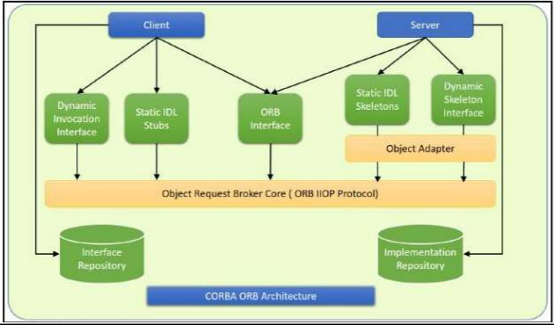

In CORBA, each object instance acquires an object reference for itself with the electronic token identifier. Client invocations are going to use these object references that have the ability to figure out which ORB instance they are supposed to interact with. The stub and skeleton represent the client and server, respectively, to their counterparts. They help establish this communication through ORB and pass the arguments to the right method and its instance during the invocation.

Inter-ORB communication

The following diagram shows how remote invocation works for inter-ORB communication. It shows that the clients that interacted have created IDL Stub and IDL Skeleton based on Object Request Broker and communicated through IIOP Protocol

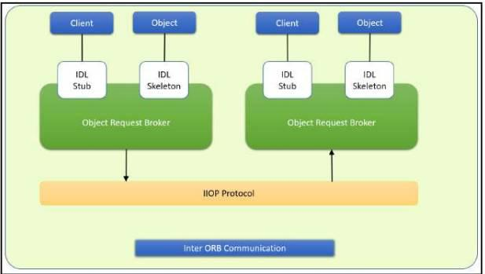

To invoke the remote object instance, the client can get its object reference using a naming service. Replacing the object reference with the remote object reference, the client can make the invocation of the remote method with the same syntax as the local object method invocation. ORB keeps the responsibility of recognizing the remote object reference based on the client object invocation through a naming service and routes it accordingly.

Java Support for CORBA, CORBA complements the Java™ platform by providing a distributed object framework, services to support that framework, and interoperability with other languages. The Java platform complements CORBA by providing a portable, highly productive implementation environment, and a very robust platform. By combining the Java platform with CORBA and other key enterprise technologies, the Java Platform is the ultimate platform for distributed technology solutions. CORBA standards provide the proven, interoperable infrastructure to the Java platform. IIOP (Internet Inter-ORB Protocol) manages the communication between the object components that power the system. The Java platform provides a portable object infrastructure that works on every major operating system. CORBA provides the network transparency, Java provides the implementation transparency. An Object Request Broker (ORB) is part of the Java Platform. The ORB is a runtime component that can be used for distributed computing using IIOP communication. Java IDL is a Java API for interoperability and

integration with CORBA. Java IDL included both a Java-based ORB, which supported IIOP, and the IDL-to-Java compiler, for generating client-side stubs and server-side code skeletons. J2SE v.1.4 includes an Object Request Broker Daemon (ORBD), which is used to enable clients to transparently locate and invoke persistent objects on servers in the CORBA environment. When using the IDL programming model, the interface is everything! It defines the points of entry that can be called from a remote process, such as the types of arguments the called procedure will accept, or the value/output parameter of information returned. Using IDL, the programmer can make the entry points and data types that pass between communicating processes act like a standard language. CORBA is a language-neutral system in which the argument values or return values are limited to what can be represented in the involved implementation languages. In CORBA, object orientation is limited only to objects that can be passed by reference (the object code itself cannot be passed from machine-to-machine) or are predefined in the overall framework. Passed and returned types must be those declared in the interface. With RMI, the interface and the implementation language are described in the same language, so you don't have to worry about mapping from one to the other. Language-level objects (the code itself) can be passed from one process to the next. Values can be returned by their actual type, not the declared type. Or, you can compile the interfaces to generate IIOP stubs and skeletons which allow your objects to be accessible from other CORBA-compliant languages.

The IDL Programming Model: The IDL programming model, known as Java™ IDL, consists of both the Java CORBA ORB and the idlj compiler that maps the IDL to Java bindings that use the Java CORBA ORB, as well as a set of APIs, which can be explored by selecting the org.omg prefix from the Package section of the API index.
Java IDL adds CORBA (Common Object Request Broker Architecture) capability to the Java platform, providing standards-based interoperability and connectivity. Runtime components include a Java ORB for distributed computing using IIOP communication.

To use the IDL programming model, define remote interfaces using OMG Interface Definition Language (IDL), then compile the interfaces using idlj compiler. When you run the idlj compiler over your interface definition file, it generates the Java version of the interface, as well as the class code files for the stubs and skeletons that enable applications to hook into the ORB.

Portable Object Adapter (POA) : An object adapter is the mechanism that connects a request using an object reference with the proper code to service that request. The Portable Object Adapter, or POA, is a particular type of object adapter that is defined by the CORBA specification. The POA is designed to meet the following goals:

Allow programmers to construct object implementations that are portable between different ORB products.
Provide support for objects with persistent identities

Designing the solution:

Here the design of how to create a complete CORBA (Common Object Request Broker Architecture) application using IDL (Interface Definition Language) to define interfaces and Java IDL compiler to generate stubs and skeletons. You can also create CORBA application by defining the interfaces in the Java programming language.
The server-side implementation generated by the idlj compiler is the Portable Servant Inheritance Model, also known as the POA(Portable Object Adapter) model. This document presents a sample application created using the default behavior of the idlj compiler, which uses a POA server-side model.

1. Creating CORBA Objects using Java IDL:

1.1. In order to distribute a Java object over the network using CORBA, one has to define it's own

CORBA-enabled interface and it implementation. This involves doing the following:

Writing an interface in the CORBA Interface Definition Language

Generating a Java base interface, plus a Java stub and skeleton class, using an IDL-to-Java compiler
Writing a server-side implementation of the Java interface in Java

Interfaces in IDL are declared much like interfaces in Java.

1.2. Modules

Modules are declared in IDL using the module keyword, followed by a name for the module and an opening brace that starts the module scope. Everything defined within the scope of this module (interfaces, constants, other modules) falls within the module and is referenced in other IDL modules using the syntax modulename::x. e.g.

- IDL module jen

{

module corba

{

interface NeatExample ...

};

};

1.3. Interfaces The declaration of an interface includes an interface header and an interface body. The header specifies the name of the interface and the interfaces it inherits from (if any). Here is an IDL interface header:

interface PrintServer : Server { ...

This header starts the declaration of an interface called PrintServer that inherits all the methods and data members from the Server interface.
1.4 Data members and methods

The interface body declares all the data members (or attributes) and methods of an interface.

Data members are declared using the attribute keyword. At a minimum, the declaration includes a name and a type.
readonly attribute string myString;

The method can be declared by specifying its name, return type, and parameters, at a minimum. string parseString(in string buffer);
This declares a method called parseString() that accepts a single string argument and returns a string value.
1.5 A complete IDL example

Now let's tie all these basic elements together. Here's a complete IDL example that declares a module within another module, which itself contains several interfaces: module OS { module services { interface Server

{ readonly attribute string serverName; boolean init(in string sName);
};

interface Printable {

boolean print(in string header); };
interface PrintServer : Server

{ boolean printThis(in Printable p); }; }; };

The first interface, Server, has a single read-only string attribute and an init() method that accepts a string and returns a boolean. The Printable interface has a single print()method that accepts a string header. Finally, the PrintServer interface extends the Server interface and adds a printThis() method that accepts a Printable object and returns a boolean. In all cases, we've declared the method arguments as input-only (i.e., pass-by-value), using the in keyword.

2. Turning IDL Into Java

Once the remote interfaces in IDL are described, you need to generate Java classes that act as a starting point for implementing those remote interfaces in Java using an IDL-to-Java compiler. Every standard IDL-to-Java compiler generates the following 3 Java classes from an IDL interface:

A Java interface with the same name as the IDL interface. This can act as the basis for a Java implementation of the interface (but you have to write it, since IDL doesn't provide any details about method implementations).

A helper class whose name is the name of the IDL interface with "Helper" appended to it (e.g., ServerHelper). The primary purpose of this class is to provide a static narrow() method that can safely cast CORBA Object references to the Java interface type. The helper class also provides other useful static methods, such as read() and write() methods that allow you to read and write an object of the corresponding type using I/O streams.
A holder class whose name is the name of the IDL interface with "Holder" appended to it (e.g., ServerHolder). This class is used when objects with this interface are used as out or inout arguments in remote CORBA methods. Instead of being passed directly into the remote method, the object is wrapped with its holder before being passed. When a remote method has parameters that are declared as out or inout, the method has to be able to update the argument it is passed and return the updated value. The only way to guarantee this, even for primitive Java data types, is to force out and inout arguments to be wrapped in Java holder classes, which are filled with the output value of the argument when the method returns.

The idltoj tool generate 2 other classes:

A client stub class, called _interface-nameStub, that acts as a client-side implementation of the interface and knows how to convert method requests into ORB requests that are forwarded to the actual remote object. The stub class for an interface named Server is called _ServerStub.

A server skeleton class, called _interface-nameImplBase, that is a base class for a serverside implementation of the interface. The base class can accept requests for the object from the ORB and channel return values back through the ORB to the remote client. The skeleton class for an interface named Server is called _ServerImplBase.

So, in addition to generating a Java mapping of the IDL interface and some helper classes for the Java interface, the idltoj compiler also creates subclasses that act as an interface between a CORBA client and the ORB and between the server-side implementation and the ORB.

This creates the five Java classes: a Java version of the interface, a helper class, a holder class, a client stub, and a server skeleton.

3. Writing the Implementation

The IDL interface is written and generated the Java interface and support classes for it, including the client stub and the server skeleton. Now, concrete server-side implementations of all of the methods on the interface need to be created.

CONCLUSION:

CORBA provides the network transparency, Java provides the implementation transparency. CORBA complements the Java™ platform by providing a distributed object framework, services to support that framework, and interoperability with other languages. The Java platform complements CORBA by providing a portable, highly productive implementation environment. The combination of Java and CORBA allows you to build more scalable and more capable applications than can be built using the JDK alone.

