**To install virtual fedora following steps need to follow.**

1. Install virtual box using virtual box installer.
2. Open virtual box click on new.

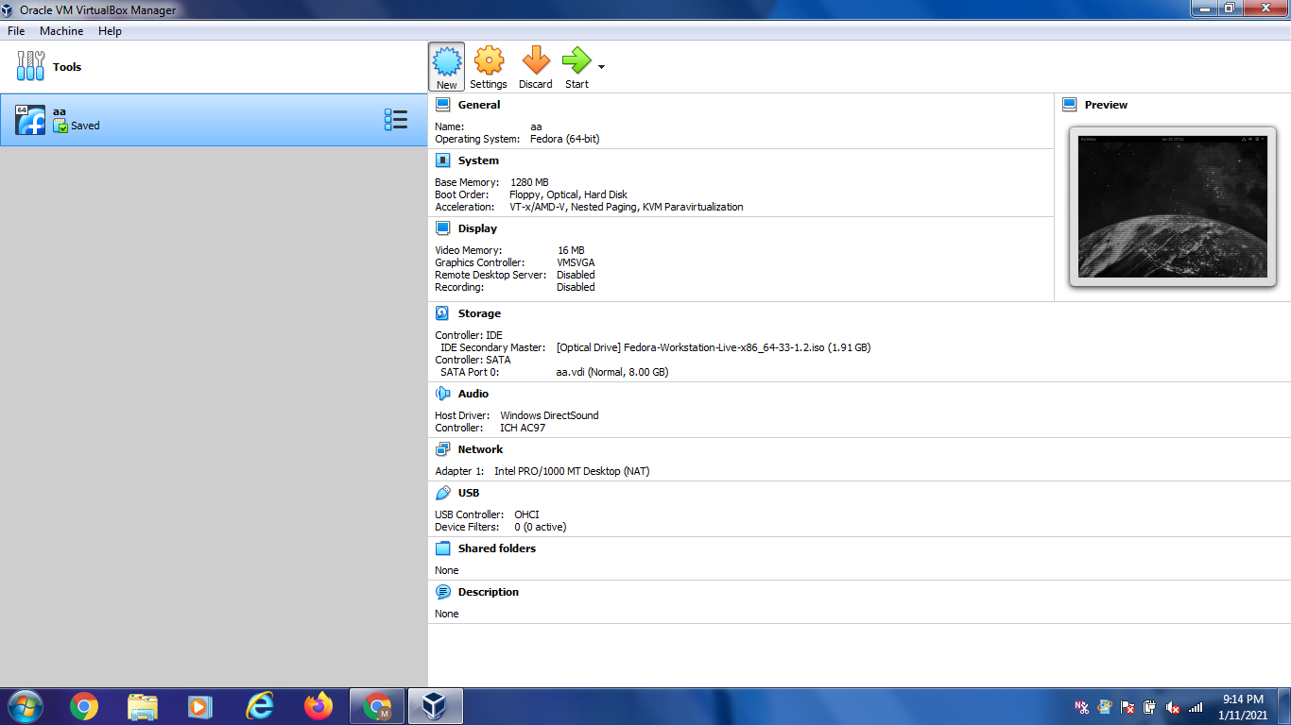

1. Give name to the operating system and select Linux and fedora 64 bit.

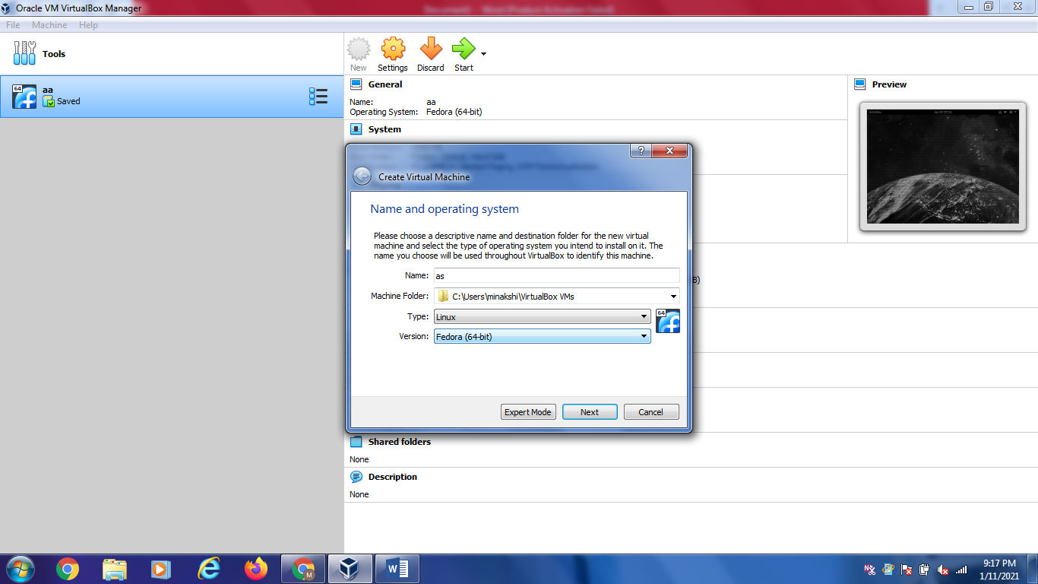

1. click next and select minimum size 1MB.

We can seect upto green part.

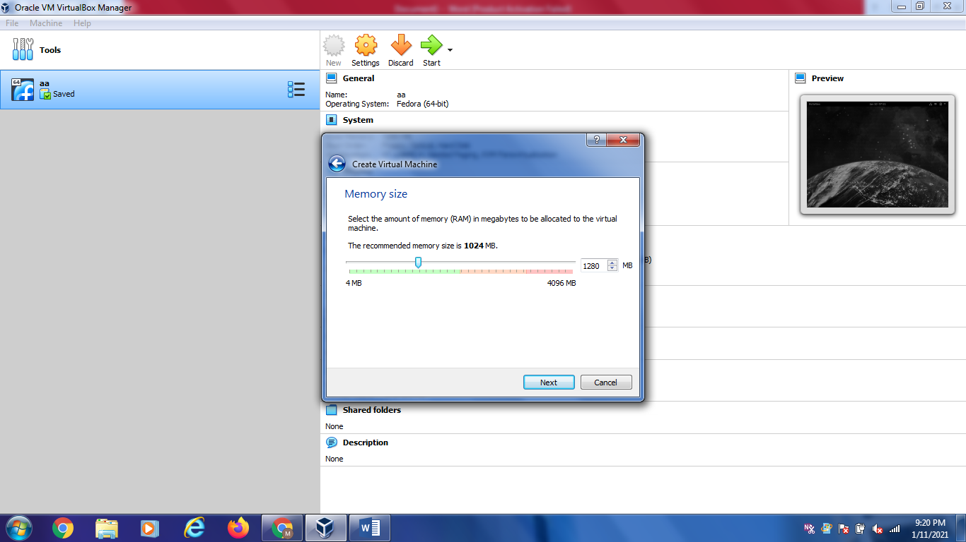

1. click next and select create virtual disk now and click on create

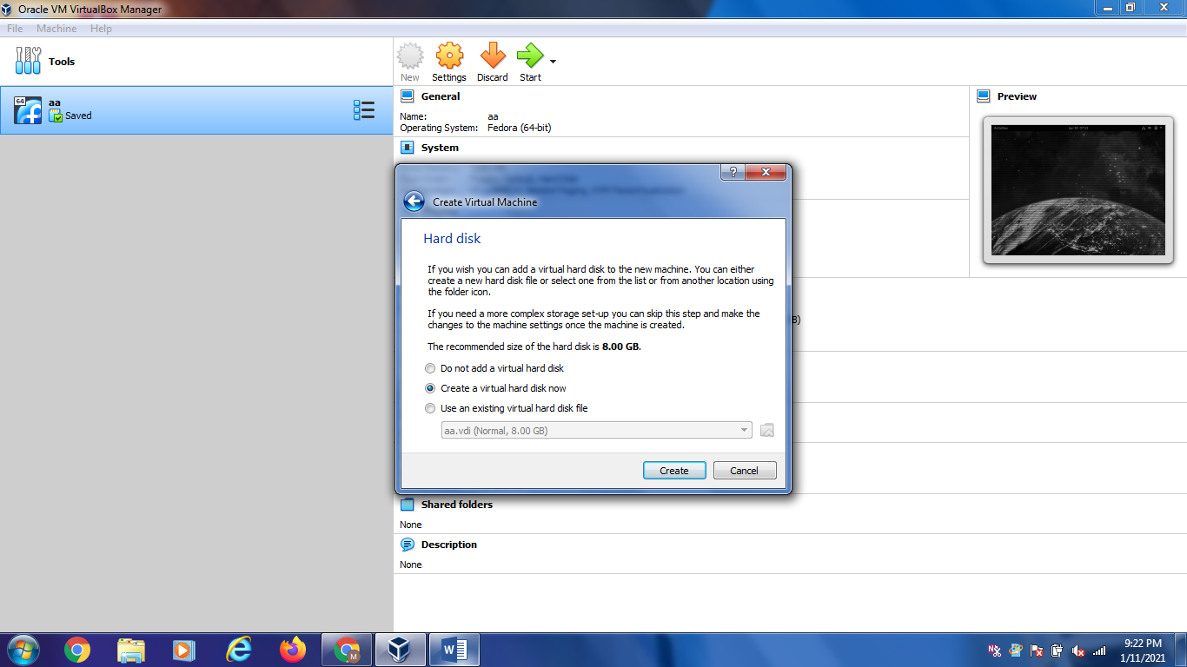

1. Select VDI (Hard disk file) and click on next.

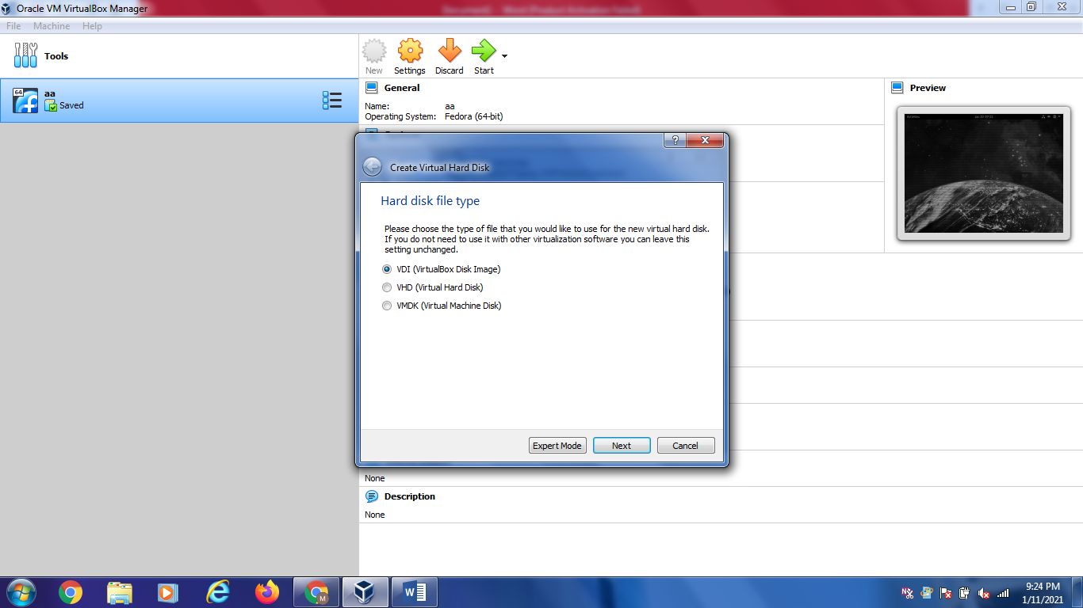

1. Select dynamically allocated storage on physical hard disk click on next.
2. Select file location and size. It should be minimum 8GB. And Click on create.

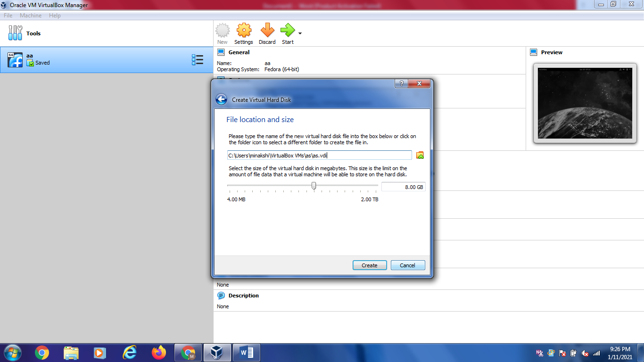

1. After this we will get following screen.

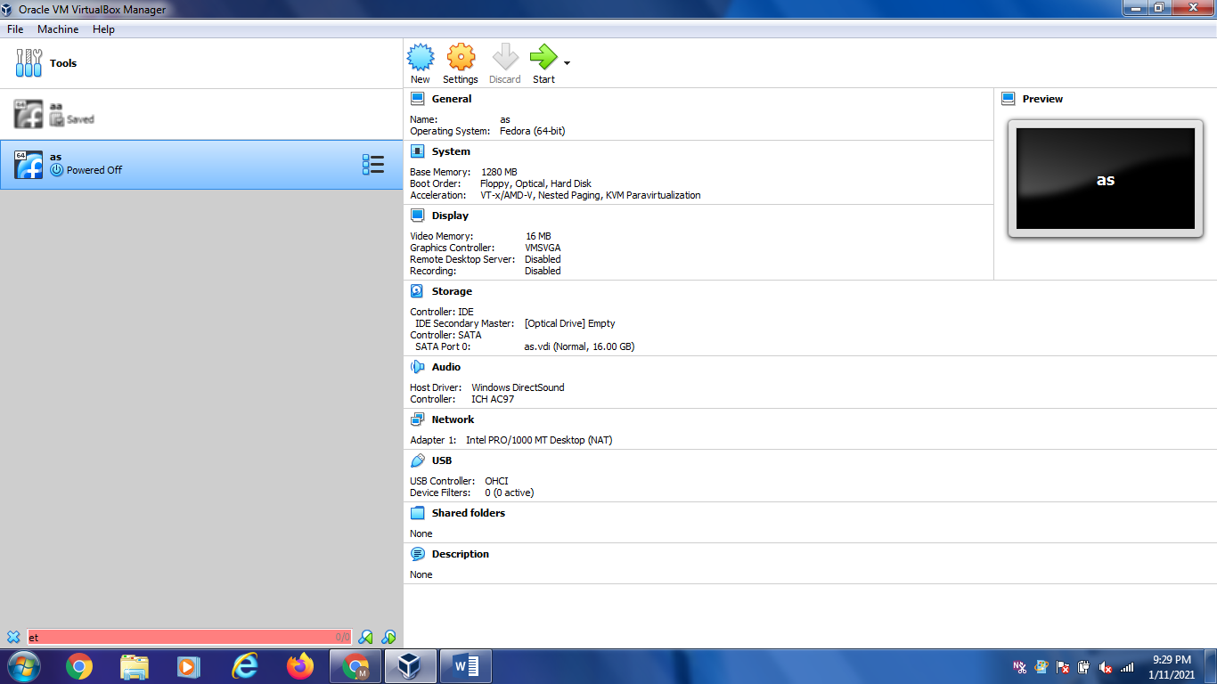

1. Select setting and click on storage.

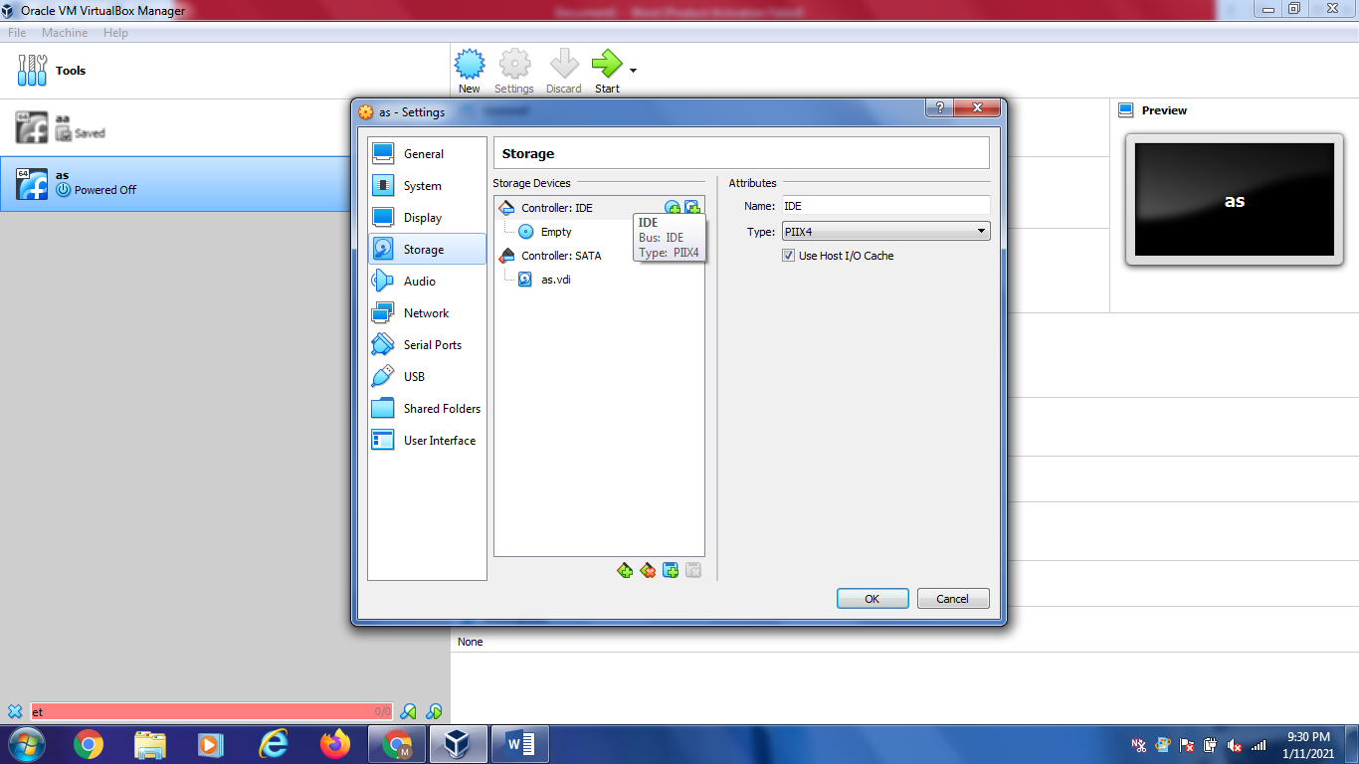

1. Select controller IDE and select empty clock on CD icon.

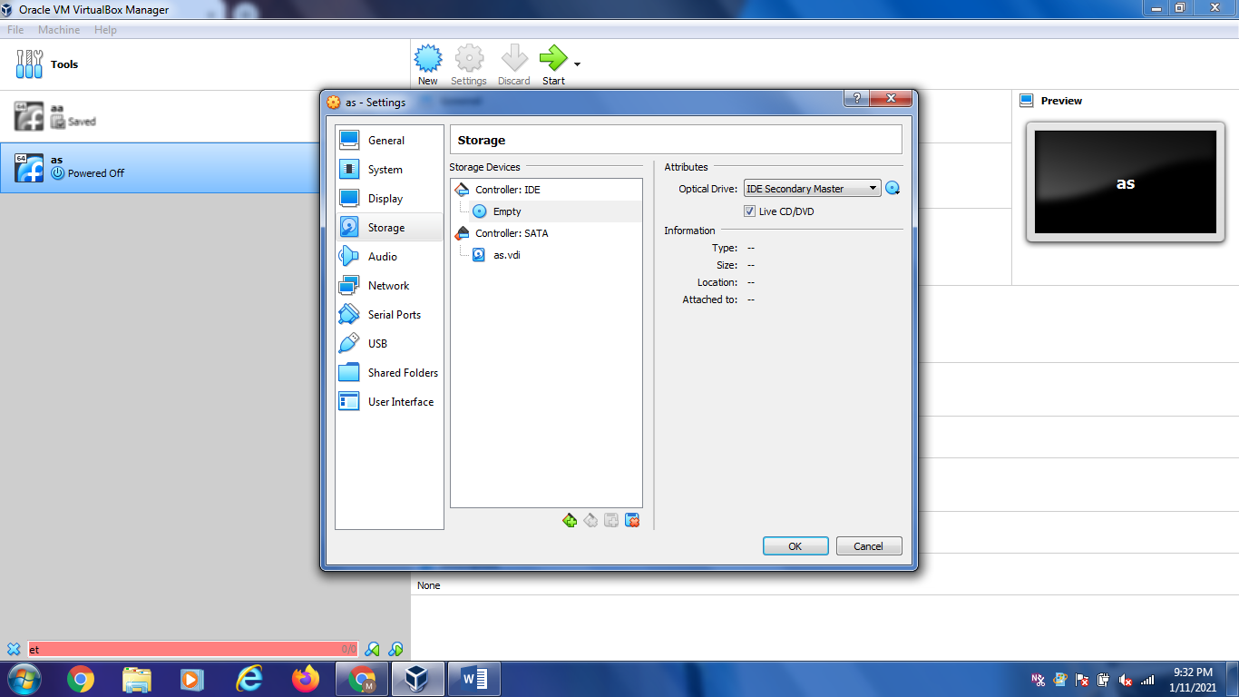

1. Click on cd icon and choose a disk file

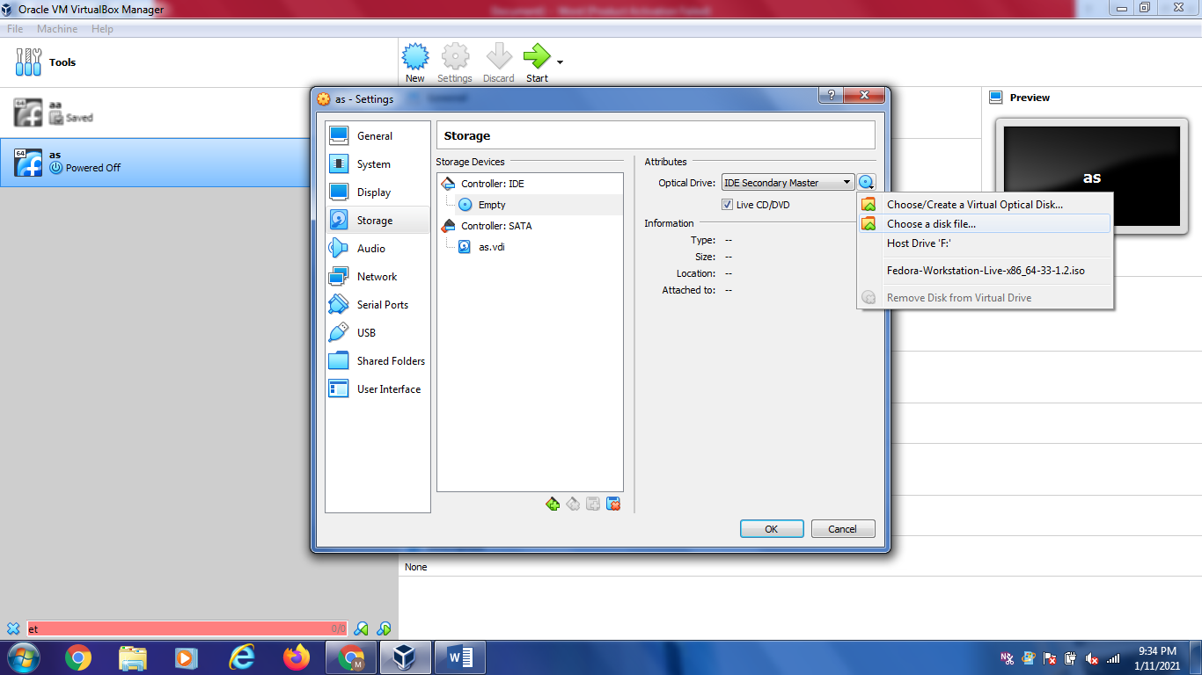

13.Select fedora _workstation Live(Fedora iso file) and open.and click on ok

14. Click on start

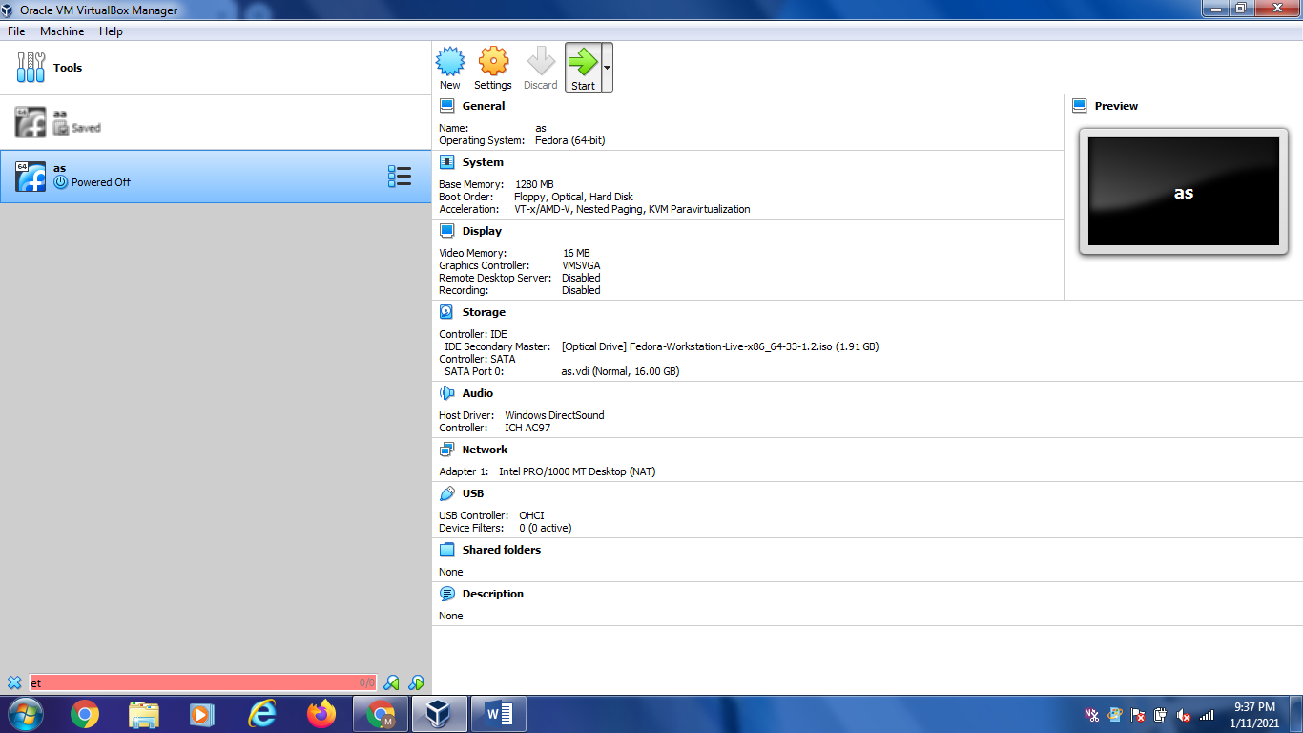

1. New fedora icon will generate and then select start up disk fedora work station and start.

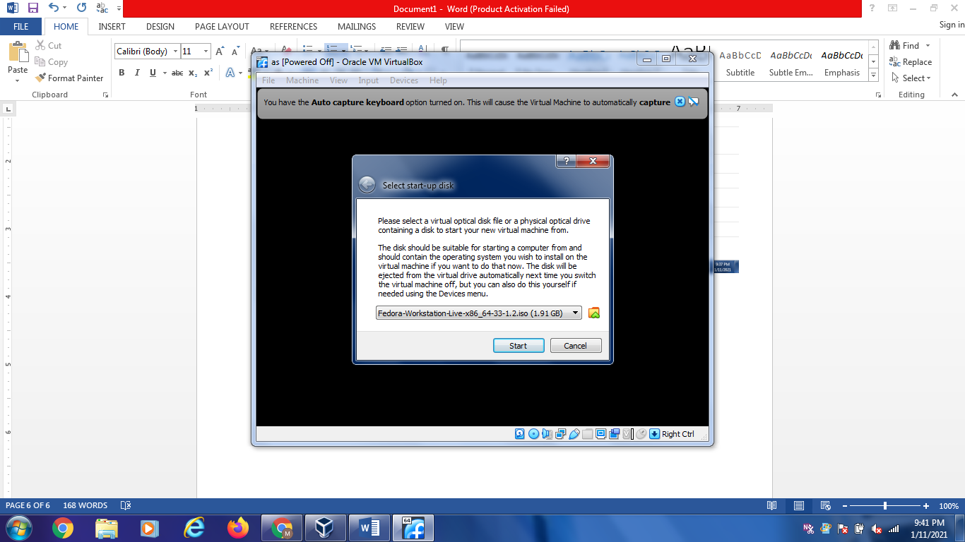

This will install fedora as virtual operating system.

1. To install Nasm

Open fedora terminal

Type

Type su to enter into root

Then type

dnf install nasm on terminal

It will install nasm