**EXPERIMENT-5**

# ADDER, SUBTRACTOR, COMPARATOR, INTEGRATOR AND DIFFERENTIATOR USING OP-AMP

-----------------------------------------------------------------------------------------------------------------------------------------------------------------------------------------------------------------------------------------------------------------------------------------------------------------------------------------------

1. To Design a Adder, Subtractor, Comparator, Integrator & Differentiator using OP-AMP.
2. To Verify the functionality of above circuits.
3. **Aim:**
4. **Specification:** circuit uses LM741 IC
5. **Apparatus**

**Hardware:**

1. Resistors (1k $Ω$)
2. Capacitor (0.1uF)
3. DSO
4. Signal generator
5. Bread board
6. **Theory:**

**About operational amplifier:**

LM741 is an operational amplifier (op-amp). Op-amps are versatile integrated circuits that can be used for a variety of applications including:

* Inverting signals
* Summing multiple inputs
* Filtering signals
* Comparing voltages

**O****perational amplifier as an adder:**

The adder is a fundamental circuit in analog electronics that combines multiple input voltages into a single output voltage. The inverting input is at a virtual ground potential due to the grounding of the non-inverting input. Op-amp serves as an electrical node to add all the currents passing through it.

**Operational amplifier as a subtractor:**

An operational amplifier (op-amp) configured as a subtractor is used to output the difference between two input voltages. This configuration typically involves both inverting and non-inverting inputs of the op-amp.

**Operational amplifier as a comparator:**

An operational amplifier used as a comparator is an application in analog electronics where the op-amp compares two input voltages and outputs a signal indicating which input is higher. In this configuration, the op-amp operates in an open-loop mode, there is no feedback loop.

**Operational amplifier as an integrator:**

An operational amplifier used as an integrator is a circuit in analog electronics that performs mathematical integration of the input signal. In its basic configuration, an integrator includes an op-amp, a resistor, and a capacitor. The input signal is applied through the resistor to the inverting input, while the feedback loop consists of the capacitor.

**Operational amplifier as a differentiator:**

An operational amplifier used as a differentiator is a circuit that produces an output voltage proportional to the rate of change of the input voltage. In this configuration, the input signal is applied through a capacitor to the inverting input of the op-amp, while a resistor connects the inverting input to the output.

**Operational Amplifier as an Integrator:**

An operational amplifier (op-amp) can be configured to function as an integrator, a circuit that produces an output voltage proportional to the integral of the input voltage. This configuration is achieved by using a resistor in series with the input voltage and a capacitor in the feedback loop from the output to the inverting input of the op-amp.

1. **Procedure:**
2. Connect the circuit as per the circuit diagram
3. Apply input as per the requirements and observe the outputs.
4. Observe the outputs of adder, subtractor using multimeter and that of comparator, integrator and differentiator using a CRO
5. Note the outputs and compare the theoretical outputs with the practical values and also note the saturation values of op-amp.

**Design:**

1. Adder: Resistors (1k $Ω)$, OP-AMP(LM741), multimeter, supply voltages.
2. Subtractor: Resistors (1k $Ω)$, OP-AMP(LM741), multimeter, supply voltages.
3. Comparator: DSO, OP-AMP(LM741), AC and DC supply voltages.
4. Differentiator: Resistors (1k $Ω)$,Capacitors (0.1µF) OP-AMP(LM741), DSO, supply voltages.
5. Integrator: Resistors (1k $Ω)$,Capacitors (0.1µF) OP-AMP(LM741), DSO, supply voltages.
6. **Circuit schematic of each application and their responses:**
7. **ADDER:**

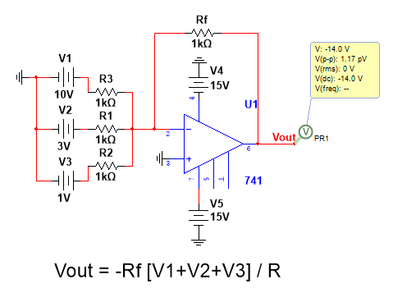

Fig-1: Adder circuit

**CONCLUSION:**

From the above response we can conclude that the adder circuit adds the input voltages and the sum is available at the output port.

1. **SUBTRACTOR:**

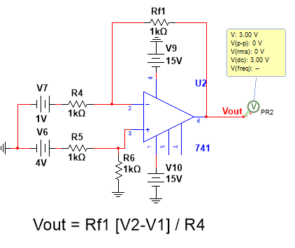

Fig-2. Response of a Subtractor circuit

**CONCLUSION:**

From the above response we can conclude that the subtractor circuit subtracts two inputs which are applied at inverting and non-inverting terminals and the difference of the two is the output terminal voltage.

1. **COMPARATOR:**

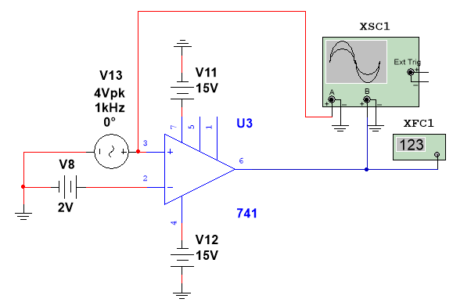 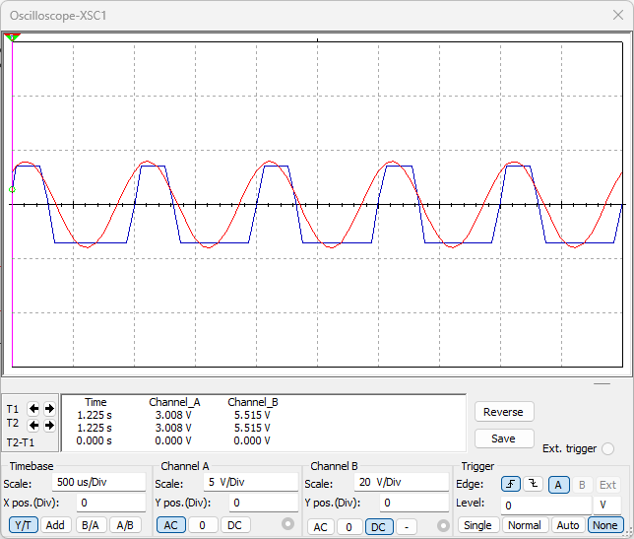

Fig-3. Response of a comparator circuit

**CONCLUSION**:

From the above response we can conclude that the comparator circuit compares two inputs which are applied at inverting and non-inverting terminals. When the voltage at the non-inverting input (+) is greater than the voltage at the inverting input (-), the op-amp's output saturates to its positive supply voltage and if the inverting input (-) voltage is higher, the output saturates to the negative supply voltage.

1. **DIFFERENTIATOR:**

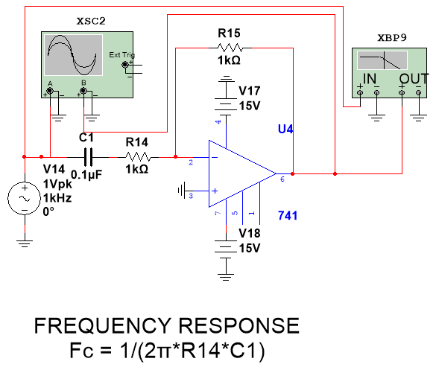 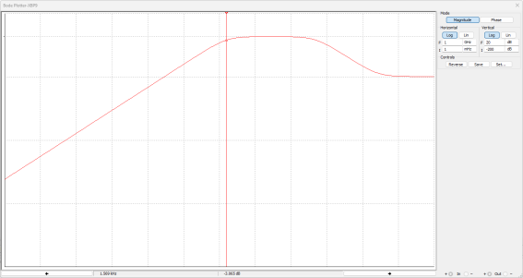

Fig-4. Frequency Response of a differentiator circuit

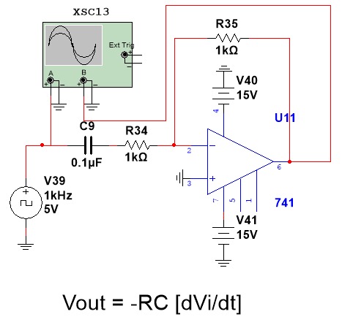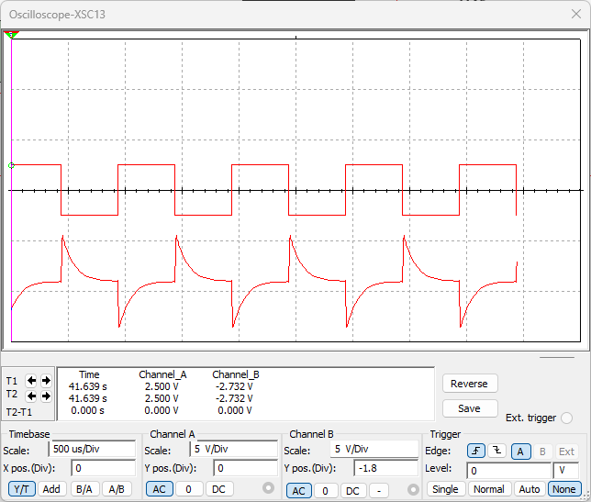

Fig-5. Response of a Differenciator circuit

**CONCLUSION:**

From the above discussion, we can conclude that an operational amplifier configured as a differentiator produces an output voltage that is proportional to the rate of change of the input voltage. In this circuit, the input signal is applied through a capacitor to the inverting input, and a resistor connects the inverting input to the output. This configuration allows the differentiator to generate an output that represents the derivative of the input signal, making it a valuable tool in applications requiring the detection of rapid changes in the input, such as edge detection in signal processing and control systems.

1. **INTEGRATOR:**

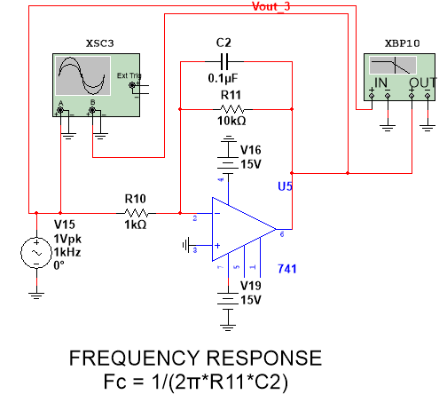 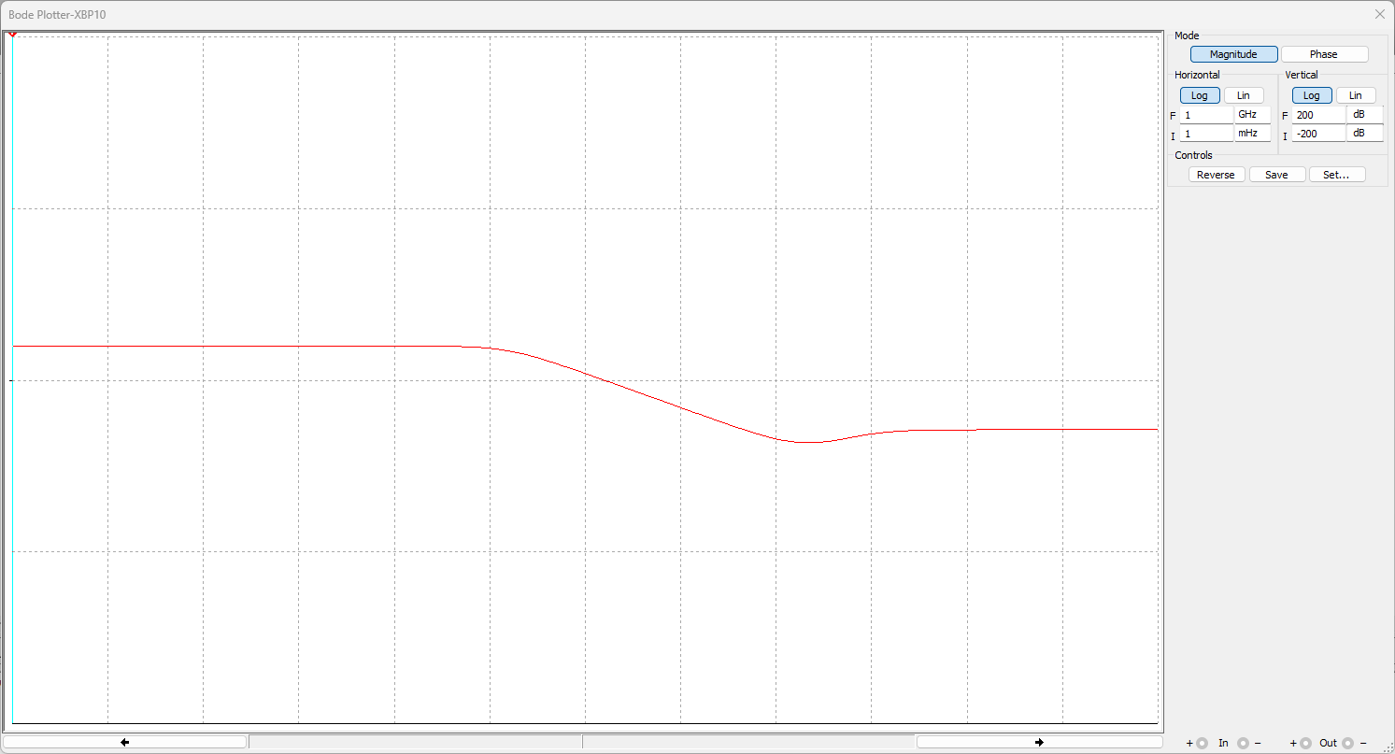

Fig-6. Frequency Response of a Integrator circuit

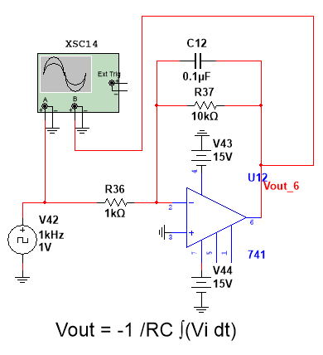 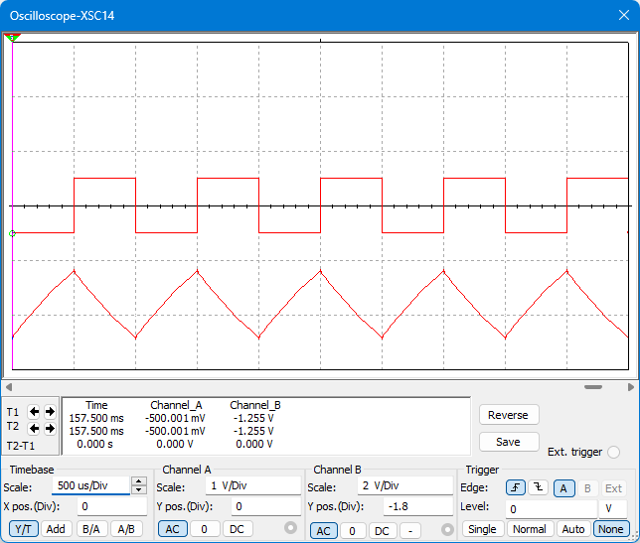

Fig-7. Response of a Integrator circuit

**CONCLUSION:**

From the above discussion, we can conclude that an operational amplifier configured as an integrator produces an output voltage that is proportional to the integral of the input voltage. In this circuit, the input signal is applied through a resistor to the inverting input, and a capacitor connects the inverting input to the output. This configuration allows the integrator to generate an output that represents the accumulated sum of the input signal over time, making it a crucial component in applications such as signal processing, analog computing, and control systems where integrating a signal is required.

1. **Result:**

We have designed and implemented applications of OP-AMP [LM741].

Signature of the Faculty