**EXPERIMENT-9**

**Voltage Controlled Oscillator**

-----------------------------------------------------------------------------------------------------------------------------------------------------------------------------------------------------------------------------------------------------------------------------------------------------------------------------------------------

1. To Design a Voltage Controlled Oscillator.
2. **Aim:**
3. **Apparatus [Hardware]:**
4. Resistors (1k $Ω$, 100k $Ω$,10k $Ω$)
5. Capacitors (50nF)
6. OPAMP [LM 741]
7. Regulated Power Supply
8. Transistor (BC107)
9. DSO
10. **Theory:**

A Voltage-Controlled Oscillator (VCO) is an electronic oscillator whose oscillation frequency is controlled by a voltage input. The frequency of the output signal varies in relation to the amplitude of the input control voltage. VCO’s are widely used in signal generators, phase-locked loops, and frequency modulation applications.

1. **Procedure:**
2. Connect the circuit as per the circuit diagram
3. Apply input as per the requirements and observe the outputs.
4. Observe the outputs of VCO using a DSO.
5. Check the voltage and frequency of the generated waveform(square).
6. **Simulation Observation:**

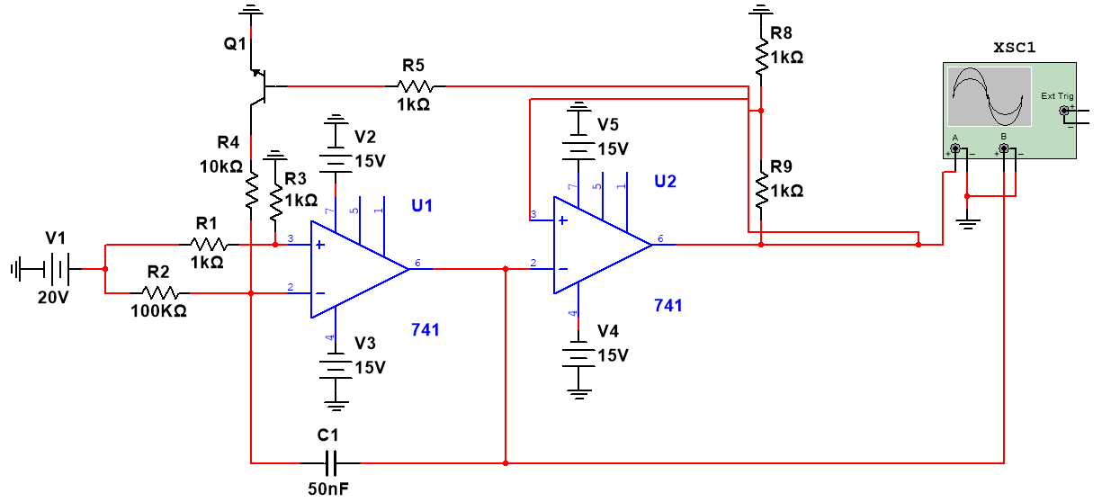 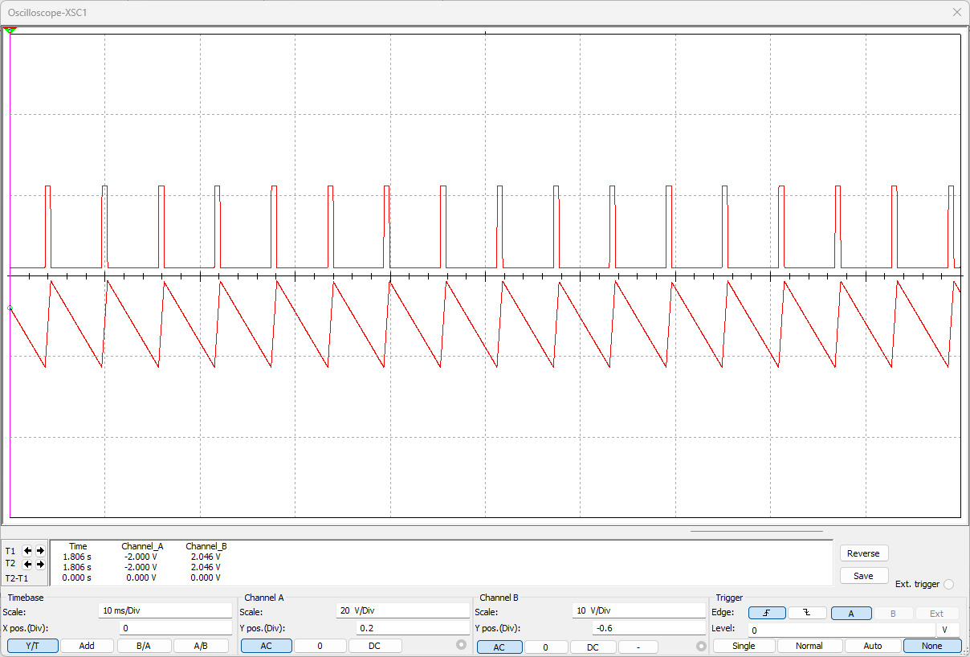

**Fig 1: VCO circuit**

**Case 1: $V_{in}$ = 9V**

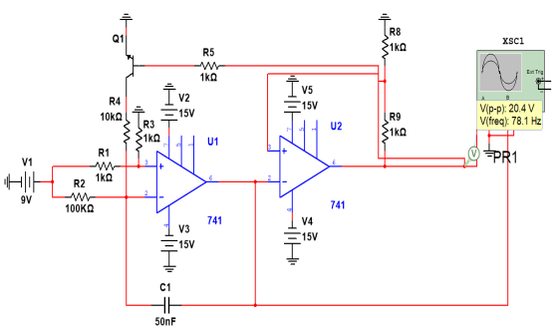

For input $V_{in}$ = 9V, Square wave of frequency 78.1Hz is generated.

**Case 2: $V_{in}$ = 15V**

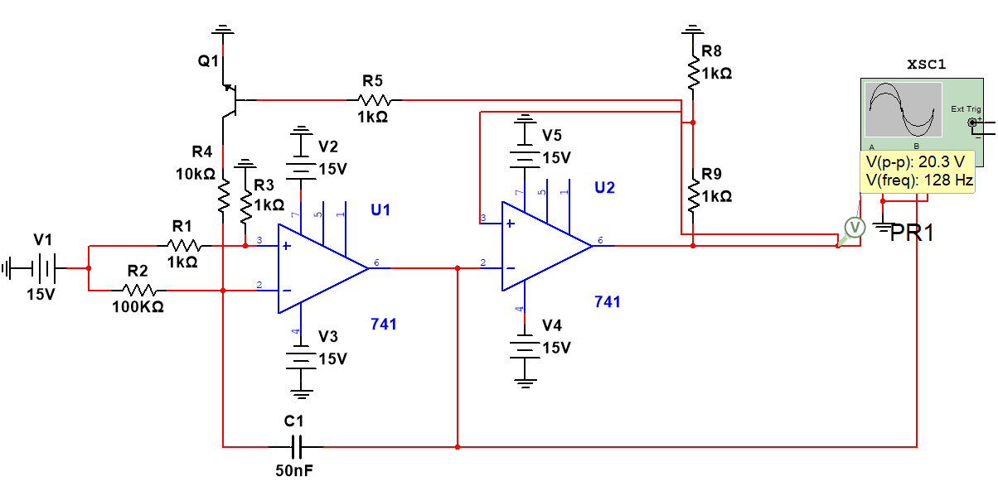

For input $V_{in}$ = 15V, square wave of frequency 128Hz is generated.

**Case 2: $V_{in}$ = 20V**

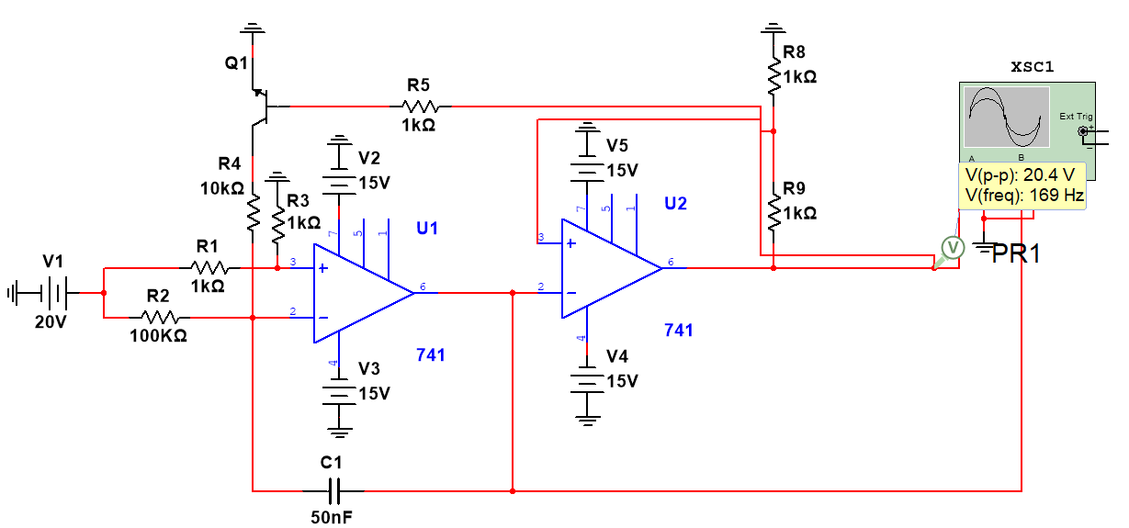

For input $V_{in}$ = 20V, square wave of frequency 169Hz is generated.

**CONCLUSION:**

From above cases we have observed that as input $V_{in}$ is increases, frequency of square wave is increases.

1. **Result:**

Hence, we have designed, implemented and verified VCO.

Signature of the Faculty