**EXPERIMENT-4**

**Clippers**

-----------------------------------------------------------------------------------------------------------------------------------------------------------------------------------------------------------------------------------------------------------------------------------------------------------------------------------------------

To study different types of Clippers and their transfer characteristics.

1. **Aim:**
2. Resistance-1kΩ
3. Diode-1N4007
4. CRO
5. DSO Probes
6. Function Generator
7. Regulated Power Supply
8. Bread board
9. **Hardware:**

**.**

1. **Theory:**

A clipper in electronics is a circuit created to stop a signal from going over a specific reference voltage level. The remaining portion of the waveform that is applied is not distorted by a clipper. The clipping of a portion of a wave from an input signal is done with Clipper Circuits. A diode is the main component, and it can be used in series or parallel. Clippers have the benefit of removing the unwanted noise that is present in an AC signal’s amplitude.

The connection and orientation of the diode with the input voltage and the load are used to categorize the different types of clippers. Series clippers, parallel clippers, and double clippers are the three different types of clippers. Positive and negative clippers are additional categories for the series and parallel clippers.

1. **Types of Clippers:**
2. **Shunt Clippers:**
3. +ve Clipper with 0 reference Voltage
4. +ve Clipper with +ve reference Voltage
5. +ve Clipper with -ve reference Voltage
6. -ve Clipper with 0 reference Voltage
7. -ve Clipper with +ve reference Voltage
8. -ve Clipper with -ve reference Voltage
9. **Series Clippers:**
10. +ve Clipper with 0 reference Voltage
11. +ve Clipper with +ve reference Voltage
12. +ve Clipper with -ve reference Voltage
13. -ve Clipper with 0 reference Voltage
14. -ve Clipper with +ve reference Voltage
15. -ve Clipper with -ve reference Voltage
16. **Dual Diode Clippers:**
17. +ve Clipper with 0 reference Voltage
18. +ve Clipper with Vr and -Vr reference Voltage
19. **Procedure:**
20. Connect input signal in one channel and output signal to other channel of CRO. Adjust both the channel of CRO to ground position. Put them to DC position.
21. Give a sine wave input (Vin) of amplitude 5Vpk at a frequency of 1KHz.Observe output waveforms.
22. Press XY mode & Observe transfer Characteristics of Circuits and note down the diode cutoff Voltages for all Cases.
23. **Simulation Observations:**
24. **Shunt Clippers:**
25. **+**ve Clipper with 0 reference Voltage

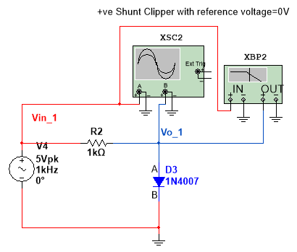

**Waveform**:

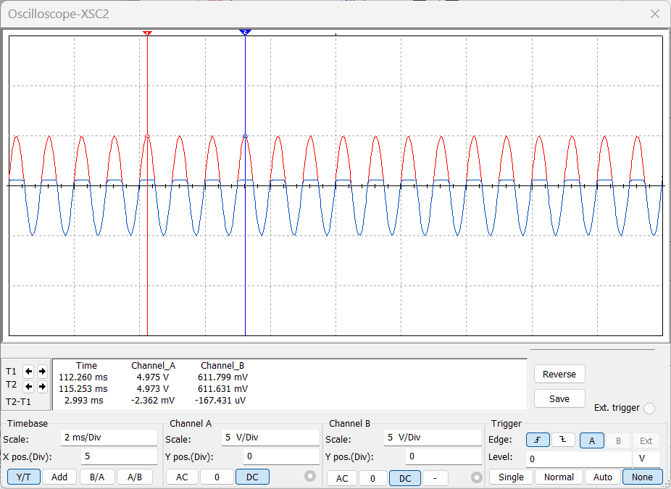

Diode Cut off Voltage = 611.799mV

**Transfer Characteristics**:

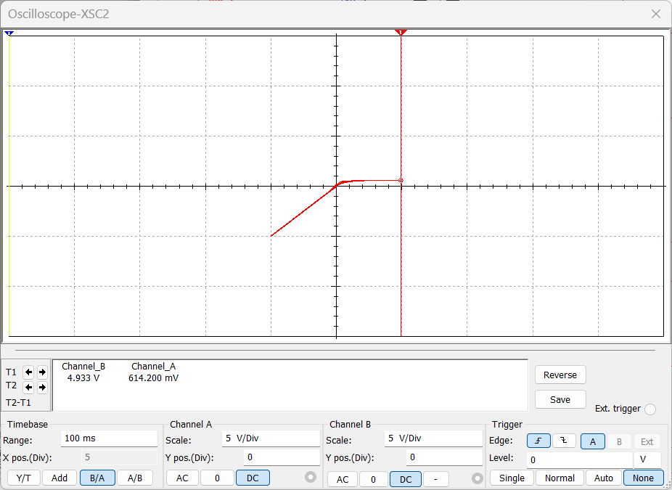

Diode Cut off Voltage = 614.2mV

**Conclusion:**

The input waveform’s positive half cycle is clipped by the shunt positive clipper. The diode is forward-biased during the positive half cycle (Vin > 0.7V) because the voltage at point A is higher than the voltage at point B. As a result, the diode conducts the input signal and there is no voltage difference at the output.

The voltage polarity of the input signal at points A and B reverses during the negative half-cycle, causing the diode to become reverse biased. As a result, the diode blocks the input signal, and the voltage across the diode is used as the clipper’s output. In this manner, the positive half of the input cycle is clipped or removed by the shunt-positive clippers, leaving the negative half to run.

1. +ve Clipper with +ve reference Voltage

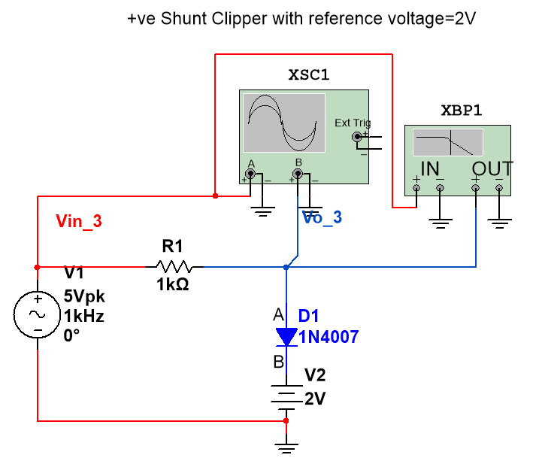

**Waveform**:

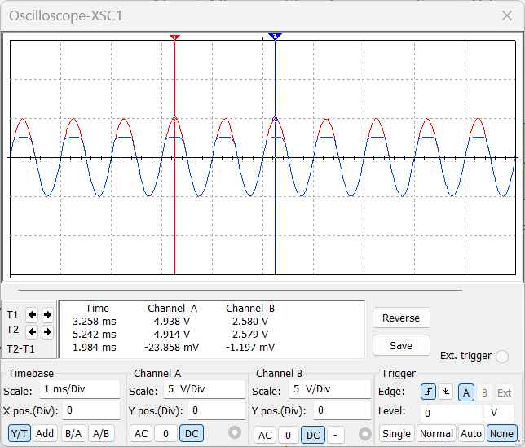

Diode Cut off

Voltage =

2.580V

**Transfer Characteristics**:

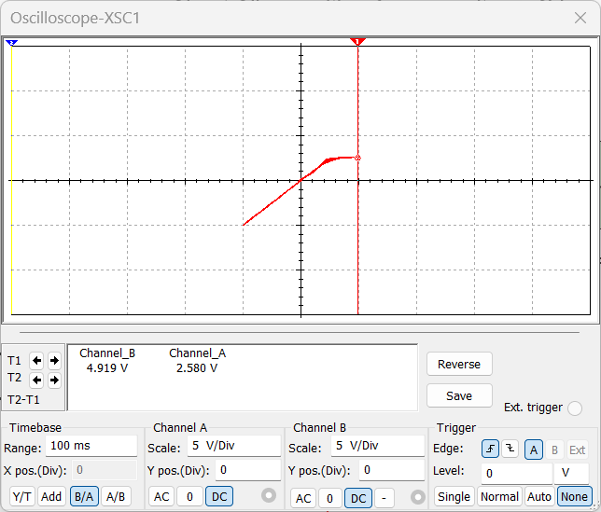

Diode Cut off Voltage

= 2.580V

**Conclusion:**

The input voltage causes the diode to be forward-biased during the positive half cycle. However, the voltage of the battery causes it to be biased in the opposite direction. The diode’s state will be determined by the sum of the two voltages. The diode will be forward-biased if the input voltage is higher than the battery voltage; otherwise, it will remain reverse-biased. The diode is reverse biased when the input signal initially falls below the battery voltage, causing the output signal to appear. However, if the voltage rises above that of the battery, the diode begins to conduct the signal and only the battery voltage can be seen at the output.

The diode is reverse biased during the negative half cycle as a result of input voltage and battery voltage. As a result, the output displays the input signal for the entire negative half-cycle.

1. +ve Clipper with -ve reference Voltage

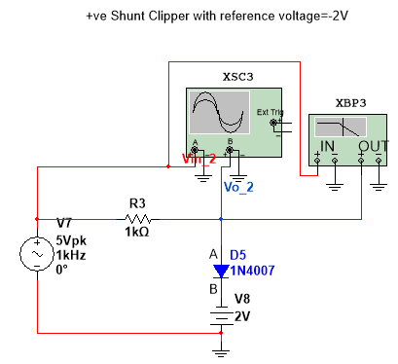

**Waveform**:

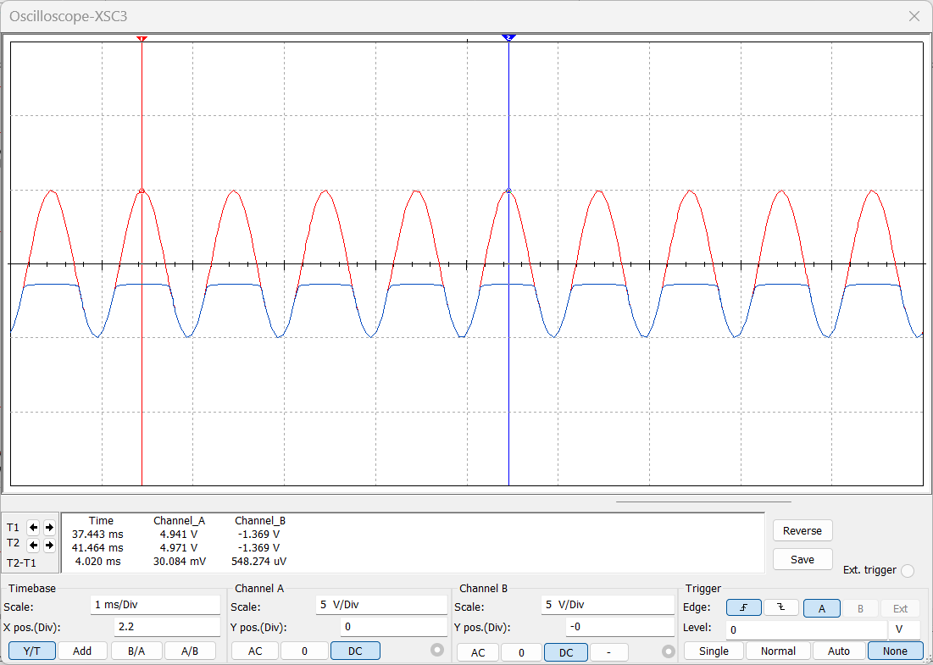

Diode Cut off Voltage = -1.369V

**Transfer Characteristics**:

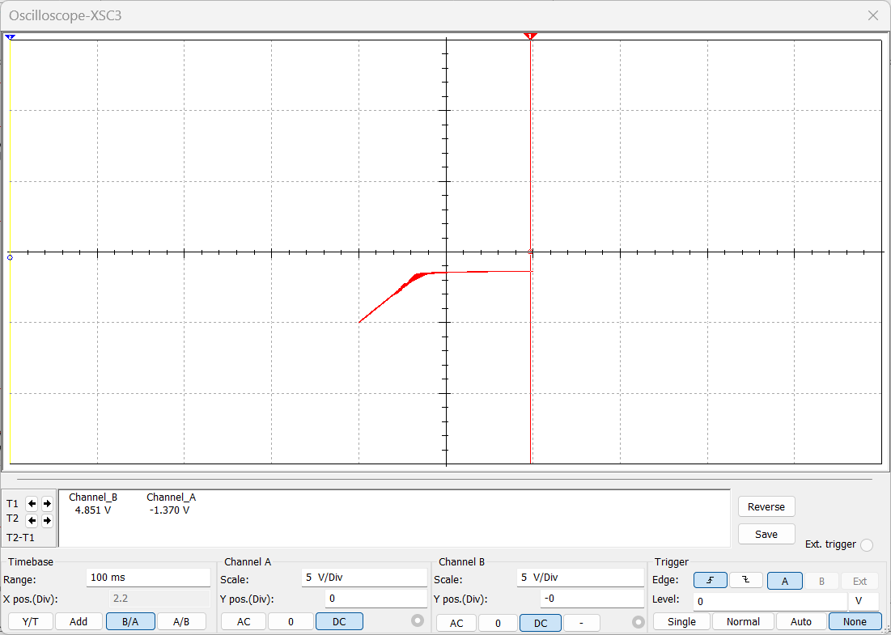

Diode Cut off Voltage = -1.370V

**Conclusion:**

The diode is forward-biased for both the input signal and the battery voltage during the positive half cycle. As a result, the diode conducts throughout the cycle, displaying only the battery voltage at the output. The diode is forward biased for battery voltage and reverses biased for input signal during the negative half cycle. The diode is forward-biased because the input signal is greater than the battery voltage at first. As a result, the output displays the battery voltage. The diode becomes reverse-biased when the input voltage less than the battery voltage, the input signal begins to appear at the output.

1. -ve Clipper with 0 reference Voltage

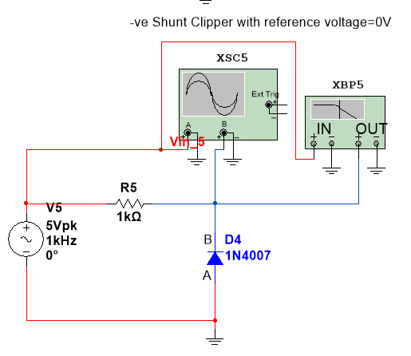

**Waveform**:

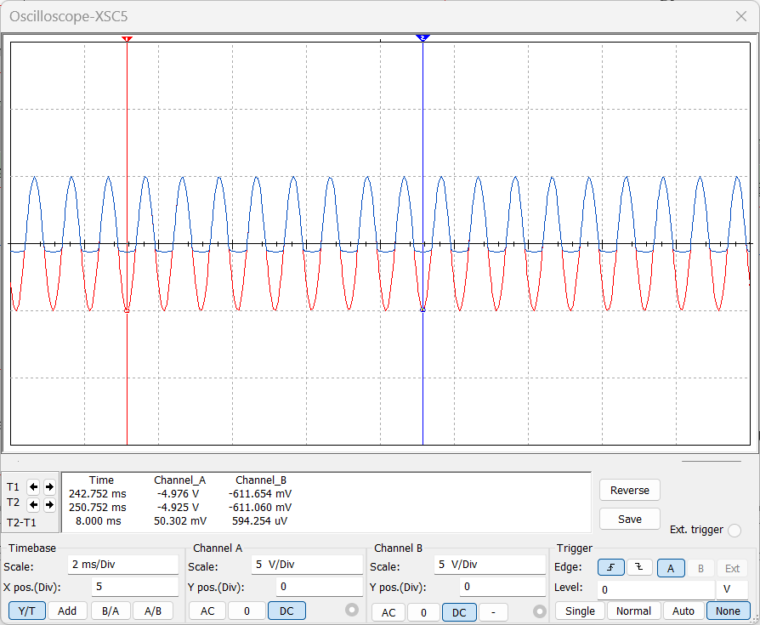

Diode Cut off Voltage=-611.654mV

**Transfer Characteristics**:

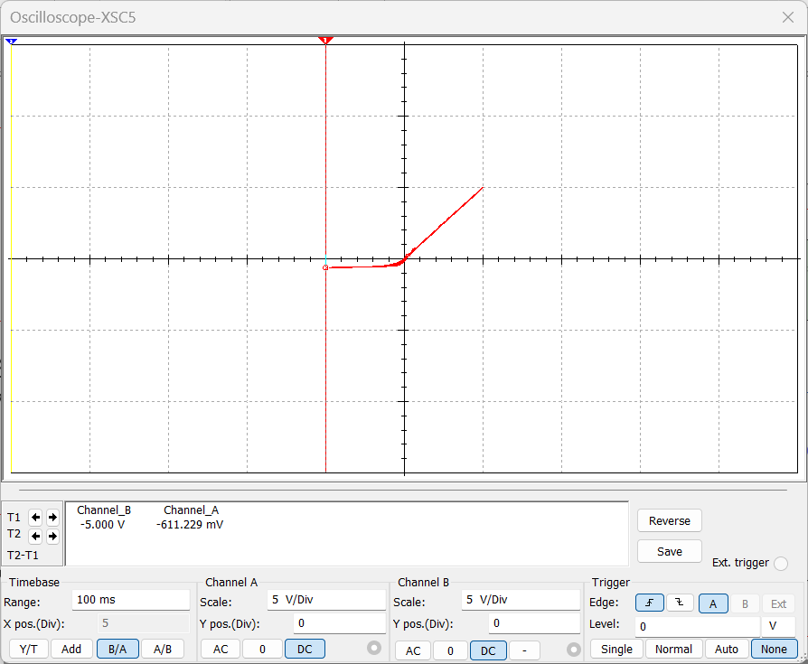

Diode Cut off Voltage = -611.229mV

**Conclusion:**

The negative half of the input waveforms is clipped off using the negative shunt clippers. The diode is reverse-biased during the positive half cycle, blocking the signal that crosses it. Consequently, the output also displays the positive half.

The signal is carried by the forward-biased diode during the negative half cycle. For the negative half cycle, there is only 0.7V of cut off voltage of Diode at the output. As a result, the negative half of the input waveform is clipped or removed by the shunt negative clipper.

1. -ve Clipper with +ve reference Voltage

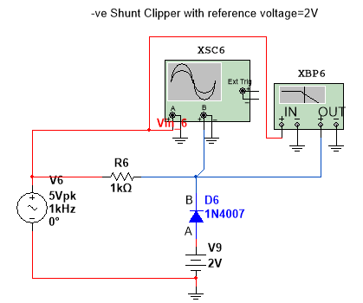

**Waveform**:

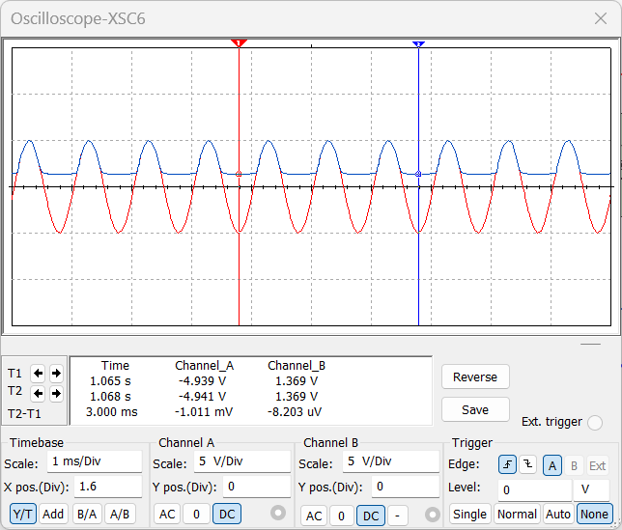

Diode Cut off

Voltage

=1.369V

P

**Transfer Characteristics**:

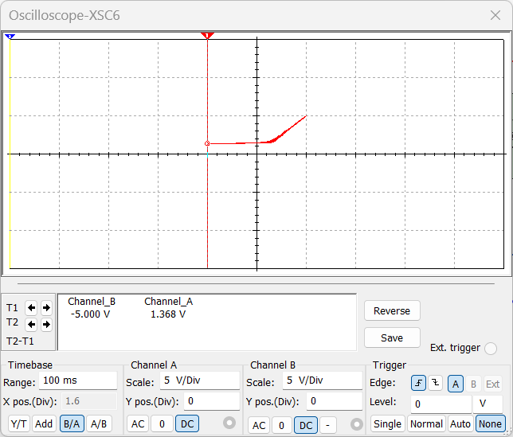

Diode Cut off Voltage

= 1.368V

**Conclusion:**

The diode is forward biased for battery voltage but reversed for input voltage during the positive half cycle. Therefore, the only time the input voltage exceeds the battery voltage will cause the diode to be reversely biased, at which point the input signal will be output. The diode is forward biased and conducts the signal when the signal is initially lower than the battery’s capacity. As a result, the output only displays the battery voltage. However, the diode becomes reverse biased and the signal appears at the output as shown in the figure when the input signal is greater than the battery voltage.

The diode is forward biased for both the input signal and the battery voltage during the negative half cycle. The diode conducts as a result, and only the battery voltage is visible at the output throughout the entire negative cycle.

1. -ve Clipper with -ve reference Voltage

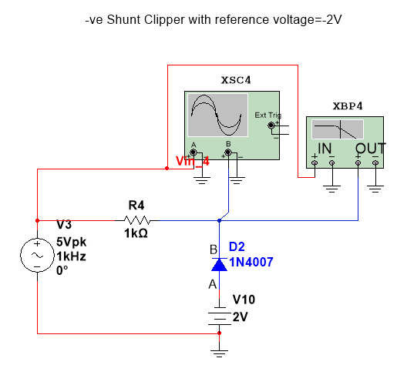

**Waveform**:

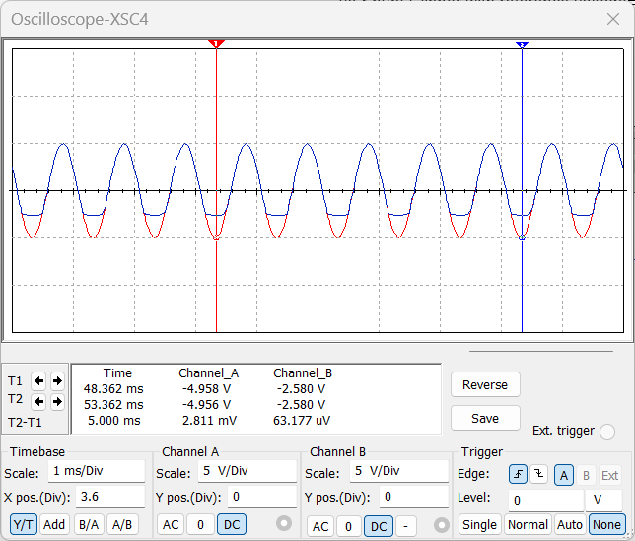

Diode Cut off

Voltage

=-2.580V

P

**Transfer Characteristics**:

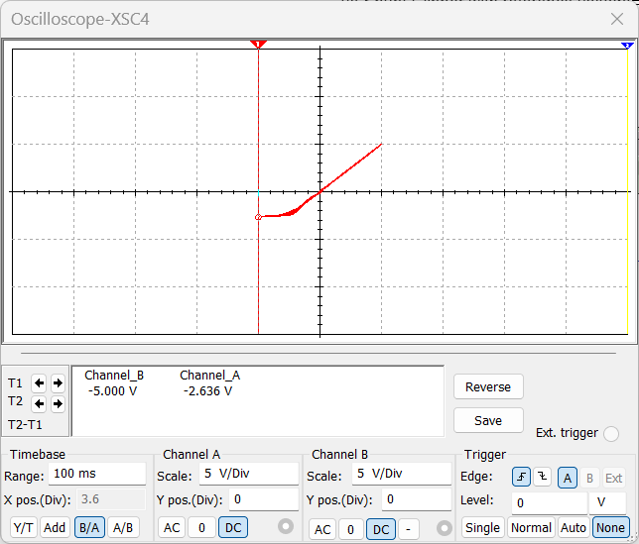

Diode Cut off Voltage

= -2.636V

**Conclusion:**

The diode is reverse-biased for both input voltage and battery voltage during the positive half cycle. As a result, the voltage is blocked by the diode, and the signal remains at the output throughout the entire positive half cycle. When the input voltage is higher than the battery voltage during the negative half cycle, the diode conducts. As a result, the diode blocks and the signal is output when the voltage is lower than the battery voltage. Only the battery voltage is visible at the output when the input voltage exceeds; the diode then begins to conduct.

1. **Series Clippers:**
2. +ve Clipper with 0 reference Voltage

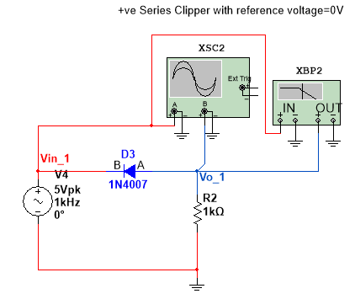

**Waveform**:

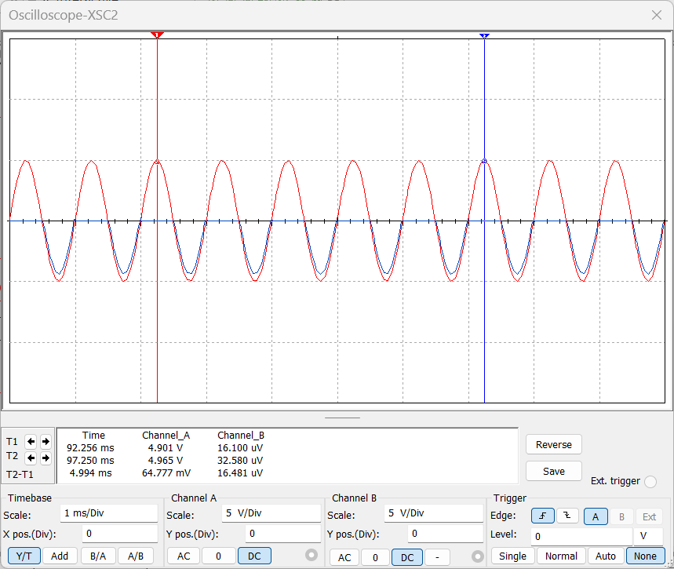

P

Diode Cut off Voltage = 0V

**Transfer Characteristics**:

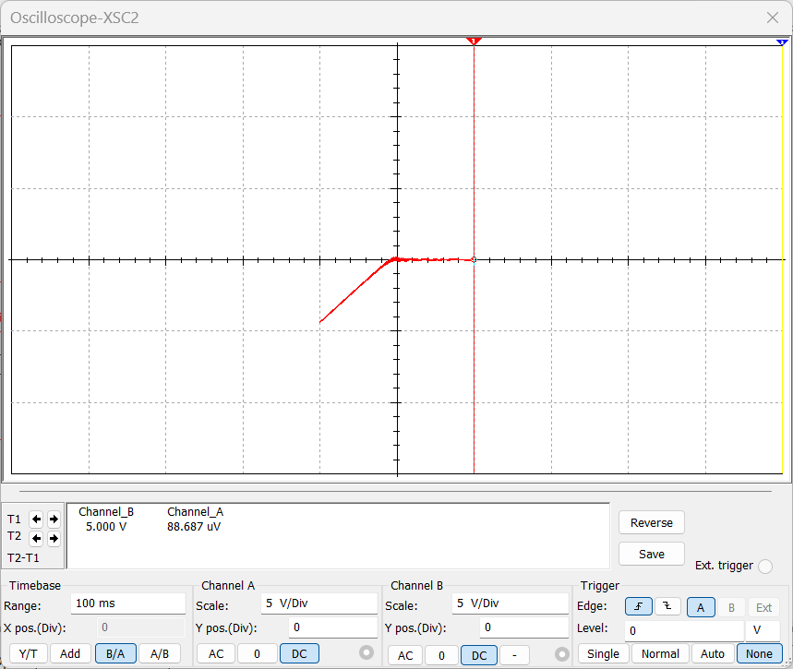

Diode Cut off Voltage = 0V

**Conclusion:**

The positive half of the waveform is removed or clipped with a series of positive clippers. The diode is reverse-biased and connected in series with the output in a series positive clipper. Vin is applied as the input signal, and the load resistor receives the output. The voltage at point B is higher than point A during the input’s positive half-cycle. As a result, there is no current conduction and the diode is in reverse bias. There is no voltage drop at the Resistor because the input signal cannot pass. As a result, the output does not display the positive half cycle. The voltage at point B is lower than that at point A during the negative half-cycle, causing the diode to become forward-biased and the signal to pass through it. The signal is visible throughout the Resistor. As a result, the negative half cycle appears at the output after passing through the circuit.

1. +ve Clipper with +ve reference Voltage

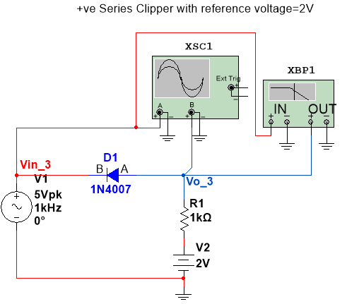

**Waveform**:

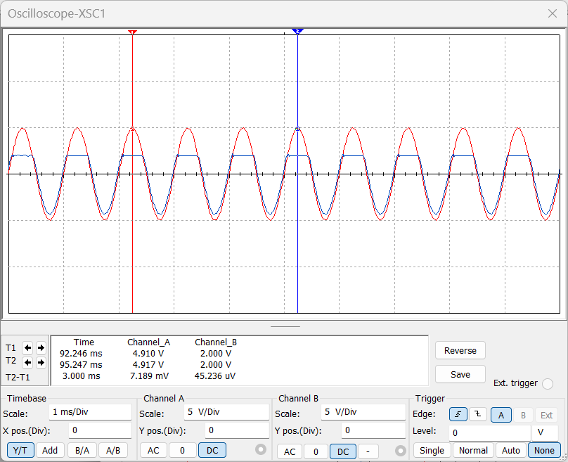

P

Diode Cut off Voltage = 2V

**Transfer Characteristics**:

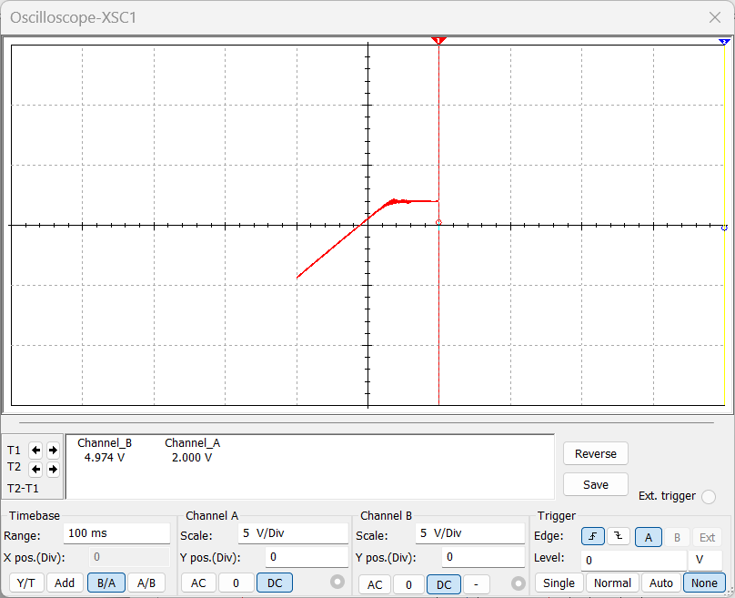

Diode Cut off Voltage = 2V

**Conclusion:**

The diode is switched off because the voltage at point B is higher than that at point A during the positive half cycle. However, the positive of yet another voltage source is connected to the diode’s P side. The diode is biased forward by the voltage source or battery = 2V. The diode continues to be in forward bias and conducts if the input voltage is lower than the battery voltage. As a result, the output displays the signal. The diode becomes reverse-biased and ceases to transmit the input signal when the input voltage exceeds the battery voltage. As a result, the output displays the battery voltage V2.

The input and battery voltage causes the diode to be forward biased during the negative half cycle. Consequently, the output signal is produced after the input signal has passed through the diode.

1. +ve Clipper with -ve reference Voltage

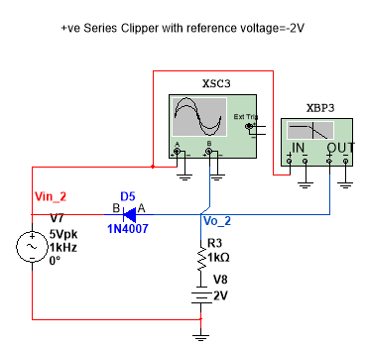

**Waveform**:

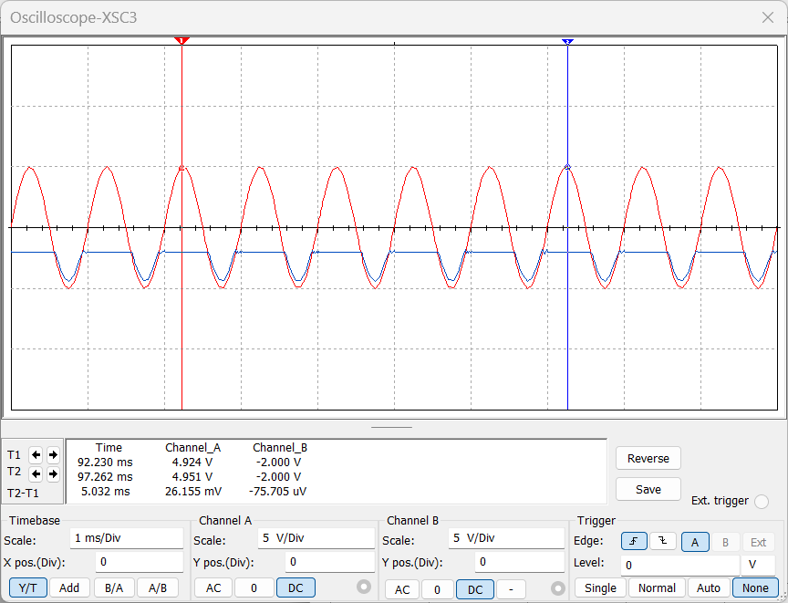

P

Diode Cut off Voltage = -2V

**Transfer Characteristics**:

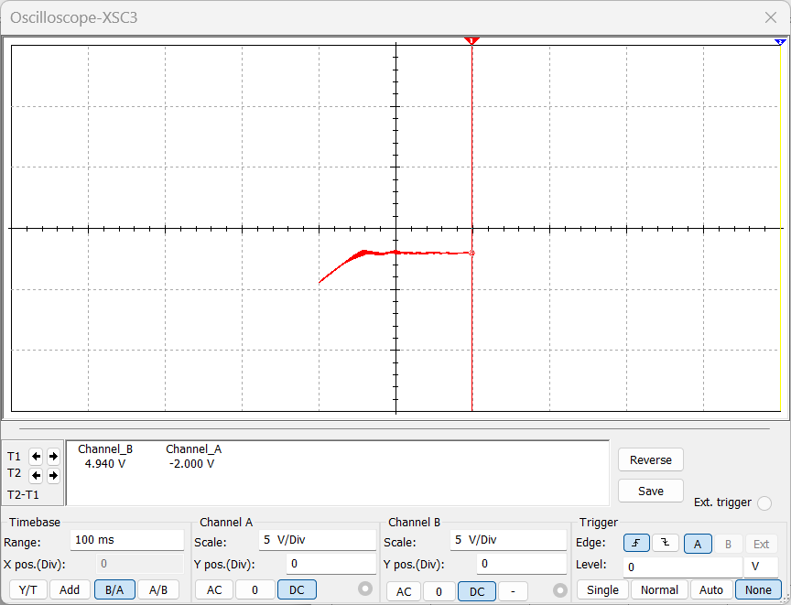

Diode Cut off Voltage = 2V

**Conclusion:**

The diode is switched off because the voltage at point B is higher than that at point A during the positive half cycle. However, the positive of yet another voltage source is connected to the diode’s P side. The diode is biased forward by the voltage source or battery = 2V. The diode continues to be in forward bias and conducts if the input voltage is lower than the battery voltage. As a result, the output displays the signal. The diode becomes reverse-biased and ceases to transmit the input signal when the input voltage exceeds the battery voltage. As a result, the output displays the battery voltage V2.

The input and battery voltage causes the diode to be forward biased during the negative half cycle. Consequently, the output signal is produced after the input signal has passed through the diode.

1. -ve Clipper with 0 reference Voltage

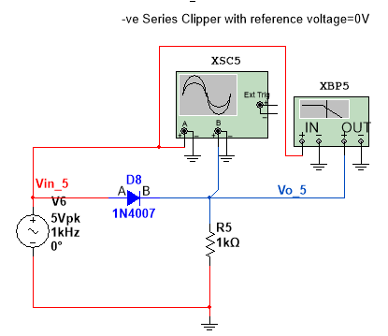

**Waveform**:

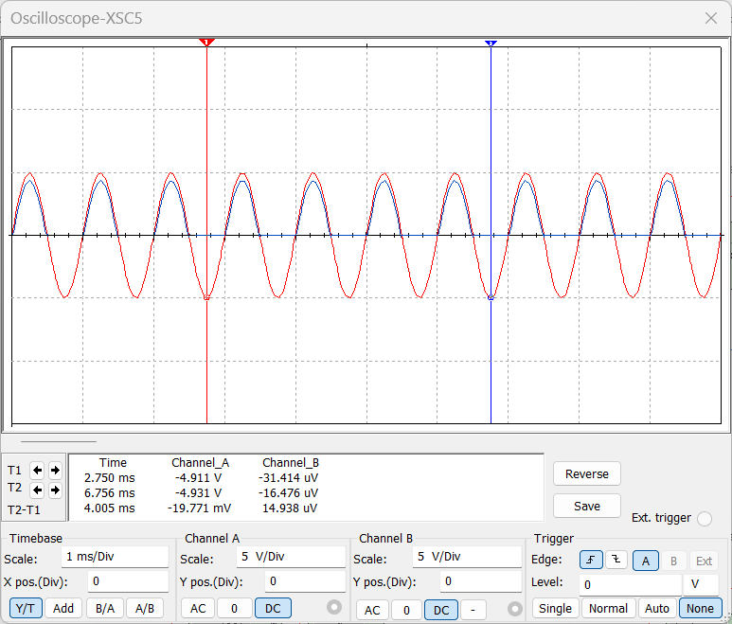

P

Diode Cut off Voltage = 0V

**Transfer Characteristics**:

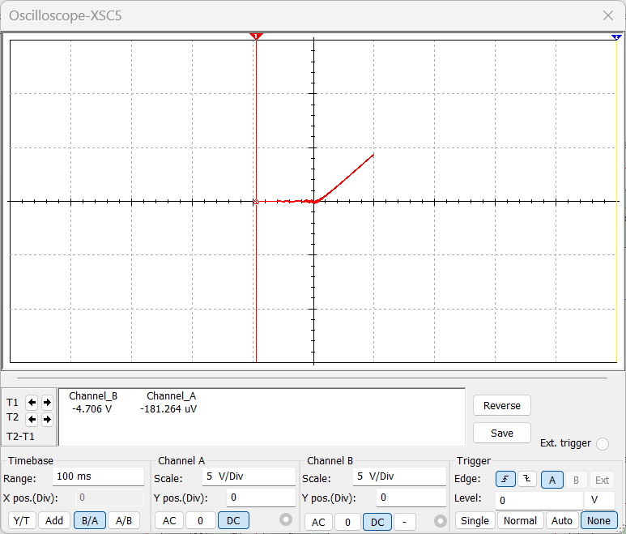

Diode Cut off Voltage = 0V

**Conclusion:**

The input voltage causes the diode to be forward-biased during the positive half cycle. Subsequently, the info signal goes through the diode and shows up in the result. The diode becomes reverse-biased and does not conduct during the negative half cycle. As a result, the negative half cycle of the input waveform is clipped, and there is no voltage at the output.

1. -ve Clipper with +ve reference Voltage

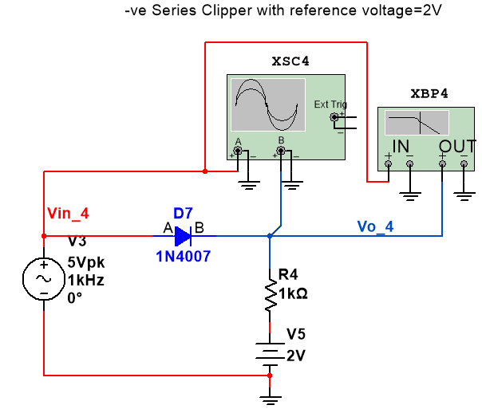

**Waveform**:

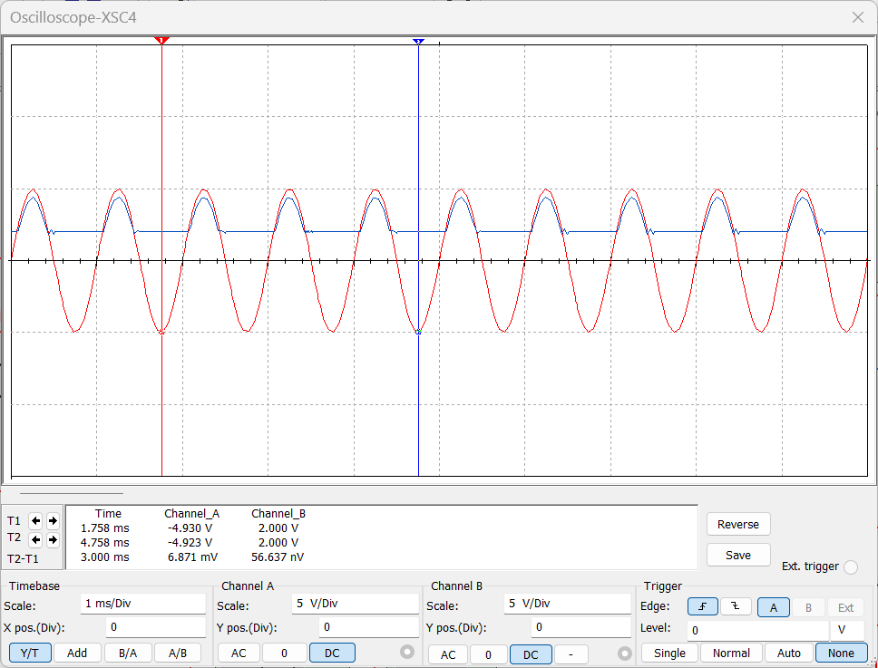

P

Diode Cut off Voltage = 2V

**Transfer Characteristics**:

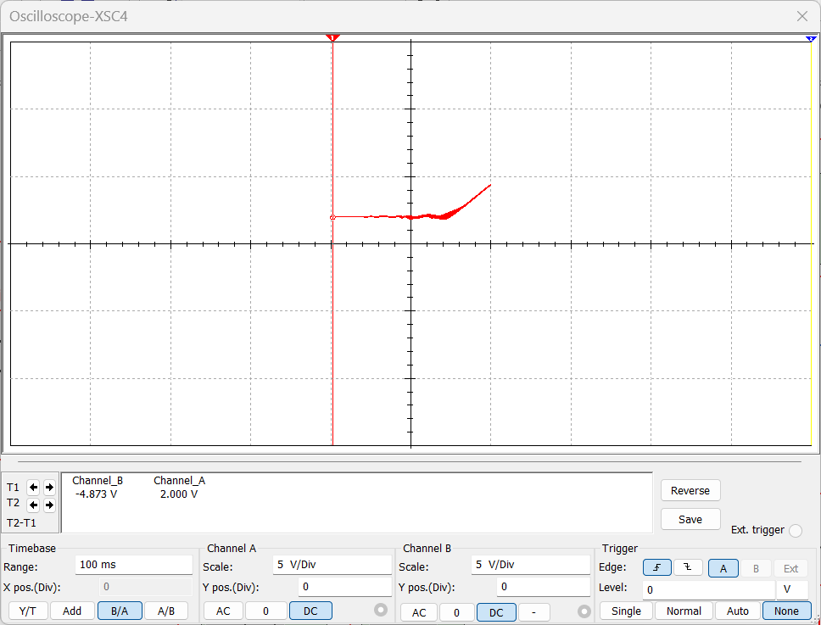

Diode Cut off Voltage = 2V

**Conclusion:**

The voltage of the input signal causes the diode to be forward-biased during the positive half cycle. Nonetheless, the battery voltage causes it to be biased in the opposite direction. The diode’s state is influenced by both voltage sources. As a result, the diode will only conduct when the input voltage exceeds the battery voltage because it will be forward-biased.

The input voltage is initially lower than the battery voltage, causing the diode to be reverse biased and not conduct. As a result, the output shows the battery voltage. When the input signal rises above the battery voltage, as depicted in the figure, the input signal is visible at the output for that portion.

The battery voltage and the input voltage cause the diode to be reversed and biased during the negative half of the cycle. Consequently, during the entire negative half cycle, the output displays only battery voltage.

1. -ve Clipper with -ve reference Voltage

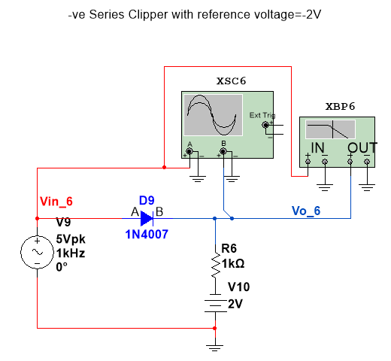

**Waveform**:

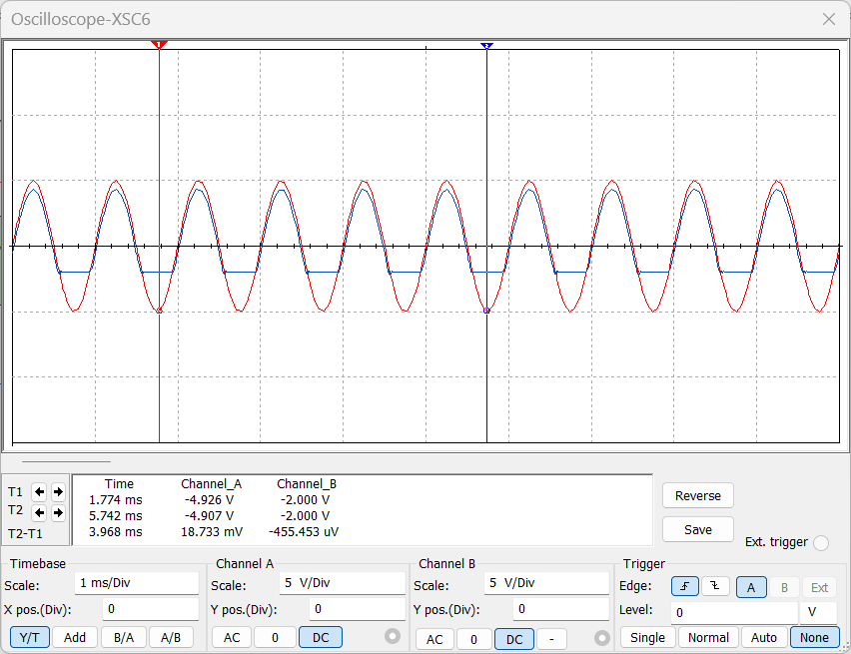

P

Diode Cut off Voltage = -2V

**Transfer Characteristics**:

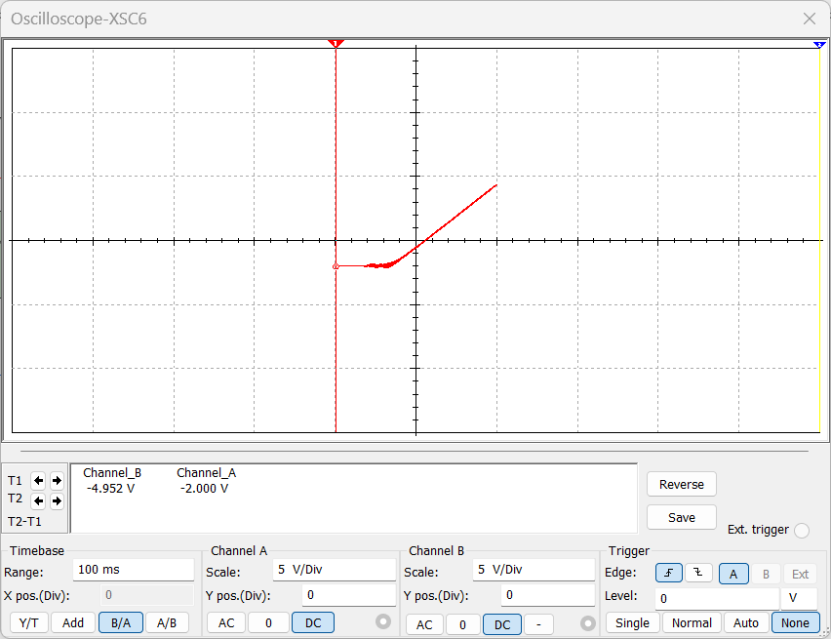

Diode Cut off Voltage = -2V

**Conclusion:**

The battery voltage and the input signal cause the diode to be forward-biased during the positive half cycle. As a result, the signal flows through the diode for the entire positive half cycle, resulting in the same output as the input. The input voltage forces the diode into reverse bias during the negative half-cycle, but the battery voltage continues to forward bias the diode. Only when the battery voltage exceeds the input voltage does the diode conduct throughout the entire cycle.

The diode conducts when the input voltage is initially lower than the battery voltage, and the signal appears at the output. However, as depicted in the figure, when it exceeds the battery voltage, the diode blocks the input signal and the battery voltage begins to appear at the output.

1. **Dual Diode Clippers:**
2. +ve Clipper with 0 reference Voltage

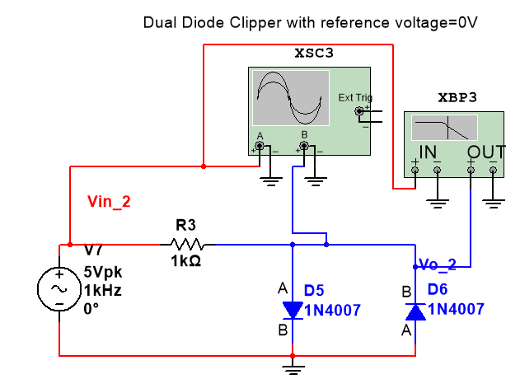

**Waveform**:

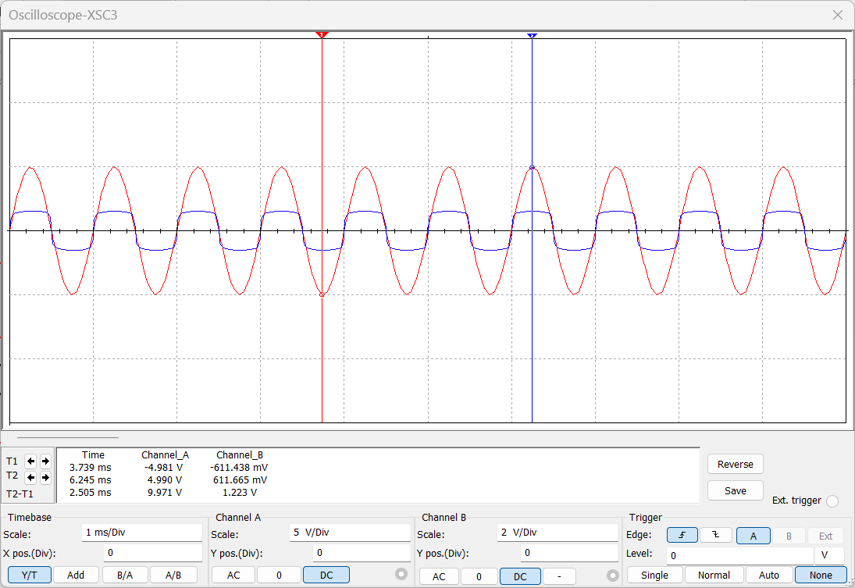

P

Diode D5 Cut off Voltage = +611.438mV

Diode D6 Cut off Voltage = -611.665mV

**Transfer Characteristics**:

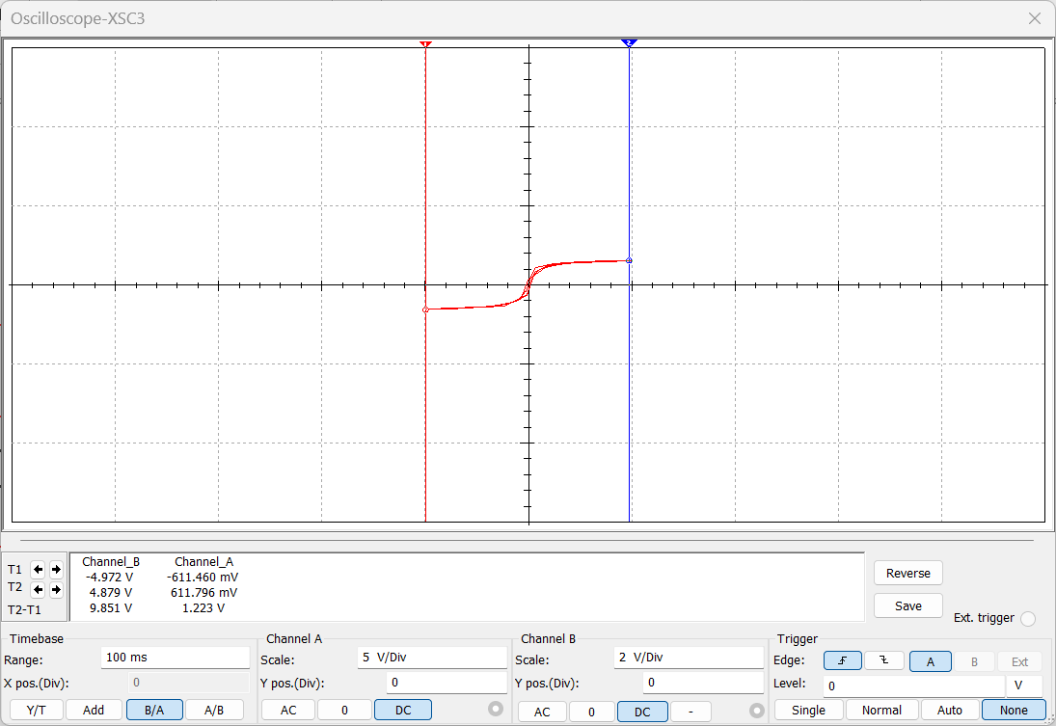

Diode D5 Cut off Voltage = +611.460mV

Diode D6 Cut off Voltage = -611.796mV

**Conclusion:**

The diode D1 is forward biased for input voltage during the positive half cycle. The diode D1 is initially reverse biased because the input voltage is lower than the cutoff voltage VB1=+0.7V. Consequently, the output displays the input signal. Diode D1 begins to conduct when the input voltage exceeds VB1, and VB1 begins to appear at the output.

The diode D1 is reverse biased during the negative half cycle. Due to input voltage, the diode D2 is forward biased, but cutoff voltage VB2=-0.7V causes it to be reverse biased. The diode D2 is initially biased in the reverse direction and does not conduct because the input voltage is lower than VB2. Reverse bias is already present in diode D1. As a result, the output signal is the input signal. The battery voltage VB2 manifests itself at the output when the input voltage exceeds VB2, at which point the diode begins to conduct.

1. +ve Clipper with Vr and -Vr reference Voltage

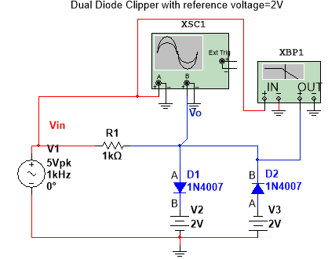

**Waveform**:

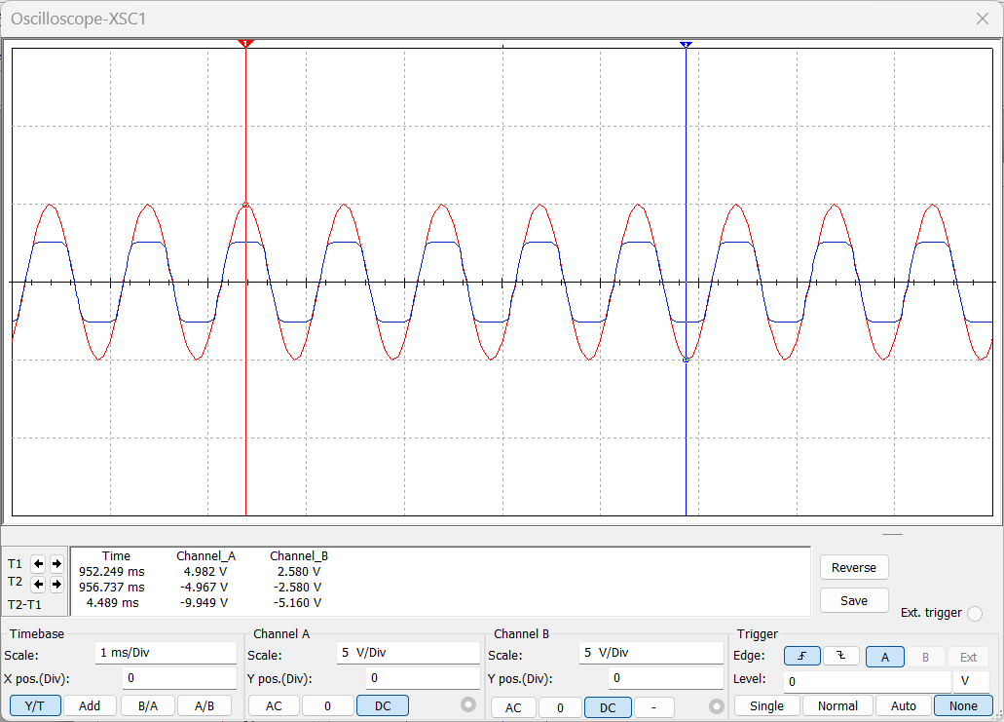

P

Diode D1 Cut off Voltage = 2.580V

Diode D2 Cut off Voltage = -2.580V

**Transfer Characteristics**:

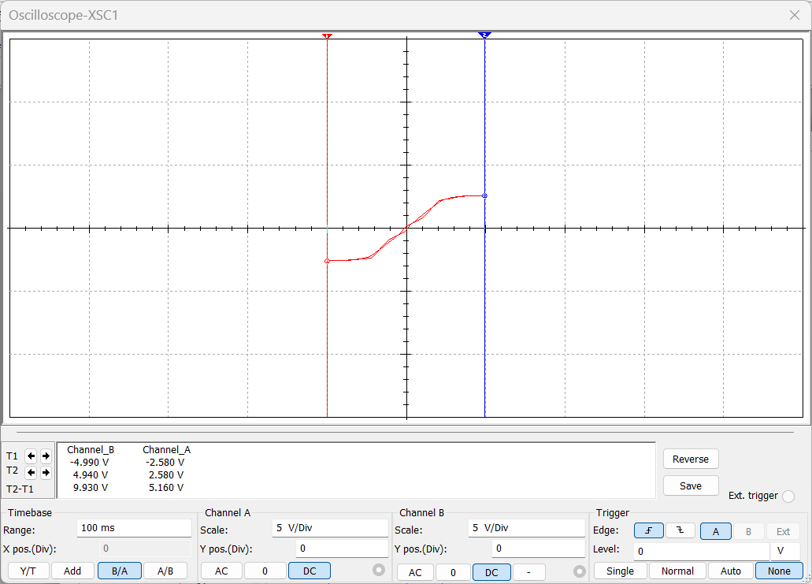

Diode D1 Cut off Voltage = +2.580V

Diode D2 Cut off Voltage = -2.580V

**Conclusion:**

The diode D1 is forward biased for input voltage during the positive half cycle. The diode D1 is initially reverse biased because the input voltage is lower than the cutoff voltage VB1=+2V+ 0.7V. Consequently, the output displays the input signal. Diode D1 begins to conduct when the input voltage exceeds VB1, and VB1 begins to appear at the output.

The diode D1 is reverse biased during the negative half cycle. Due to input voltage, the diode D2 is forward biased, but cutoff voltage VB2=-2V-0.7V causes it to be reverse biased. The diode D2 is initially biased in the reverse direction and does not conduct because the input voltage is lower than VB2. Reverse bias is already present in diode D1. As a result, the output signal is the input signal. The battery voltage VB2 manifests itself at the output when the input voltage exceeds VB2, at which point the diode begins to conduct.