Assignment 3:

1)

Ping is used to test the reachability of a host on an IP network. It sends ICMP (Internet Control Message Protocol) Echo Request messages to the target host and listens to Echo Reply messages.

Syntax for using ping:

ping [options] destination

for example: ping google.com  
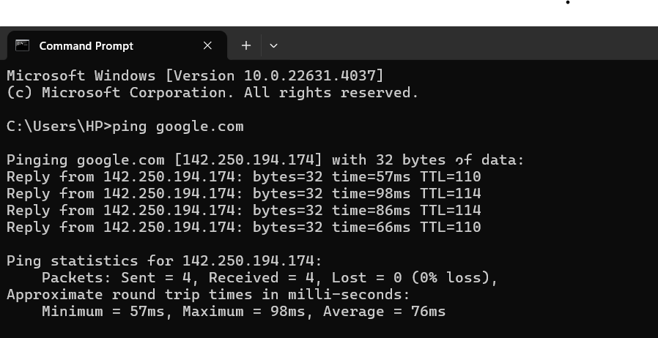

In case of localhost, we get the same output, but the RTT is less. This is because we are sending the request on the same system.

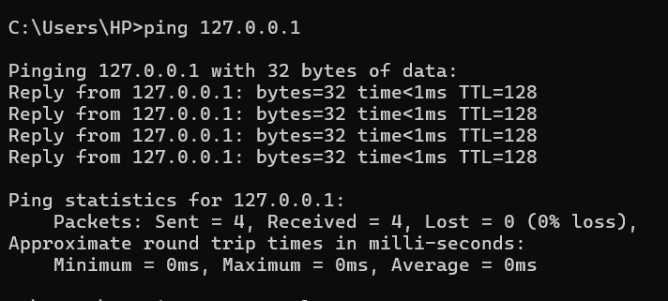

2)

If the target host exists, we get the output as visible in the image above.

TTL (Time to Live): A numerical value that indicates how long a packet can exist in a network before being discarded by a router.

RTT (Round Trip Time):  The time it takes for a network request to go from a starting point to a destination and back again to the starting point

Packet Loss: The scenario when one or more packets fail to reach their respective destinations during transmission over a network.

In the case when the target host doesn’t exist, we get the following output:



3)

Ping Options

1. -c/-n : Specifies the number of packets to send.  
   for example : ping -n 5 google.com  
   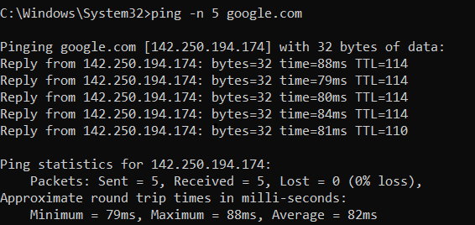
2. -s/-l : Specifies the size of packet to be sent  
   for example : ping -l 128 google.com  
   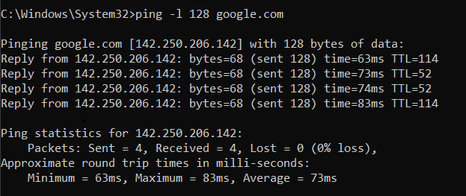
3. -t/-i : you can use the -i option followed by the TTL value you want to set.  
   for example : ping -I 128 google.com  
   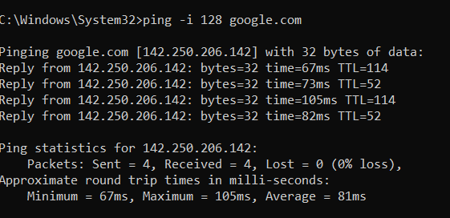
4. -w : set the timeout for each reply in milliseconds  
   for example : ping google.com -w 10  
   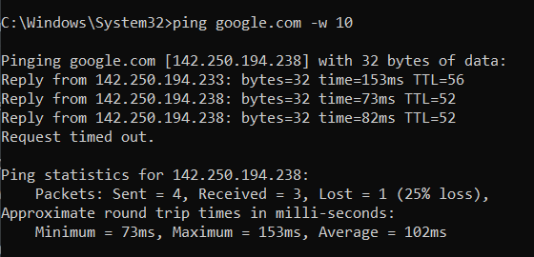

4)

Scenario:

Let's say you're experiencing connectivity issues with a server or another device on your network. You're unable to access a website hosted on your local network, and you suspect there may be a problem with the connection between your computer and the server.

Using Ping to Diagnose the issue:

1. Use the pig command to check if your computer can reach the server.  
   for example : ping <google.com>
2. If you notice intermittent connectivity or slow response times, use the ping command with the -c option to send a specific number of packets and measure packet loss.  
   for example : ping -c 10 < google.com>
3. To diagnose slow network speeds, examine the round-trip time (RTT) for the packets.  
   for example : ping -c 10 <google.com>
4. If you need to monitor the connection over time to diagnose intermittent issues, use the ping command without specifying the count.  
   for example : ping <google.com>
5. If you suspect DNS issues, try pinging the server by its hostname and by its IP address.  
   for example : ping <server_hostname>  
   ping <server_ip>
6. For more detailed analysis, you can use options like -i to set the interval between pings or -s to specify the packet size.  
   for example : ping -i 0.5 -s 1000 <google.com>

5)

