**ASSIGNMENT NO 1**

1. Create three variables in a single line and assign different values to them and make sure their data types are different. Like one is int, another one is float and the last one is a string.

Ans1)

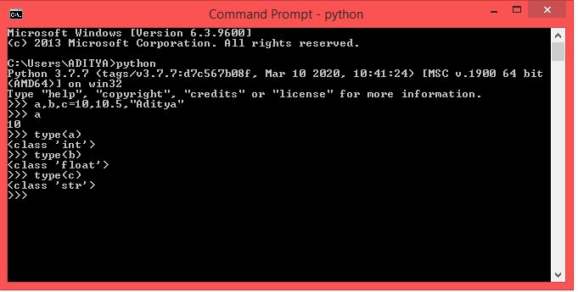

2. Create a variable of value type complex and swap it with another variable whose value is an integer.

Ans2)

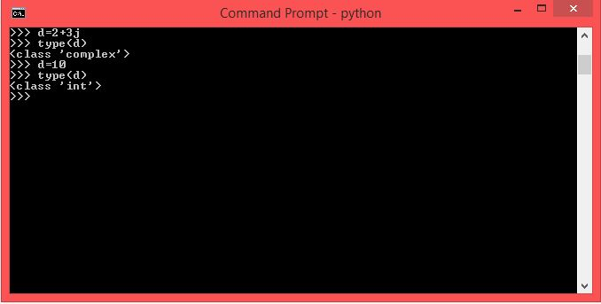

3.Swap two numbers using the third variable as result name and do the same task without using any third variable.

Answer no 3)

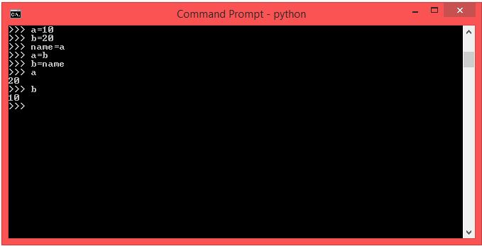

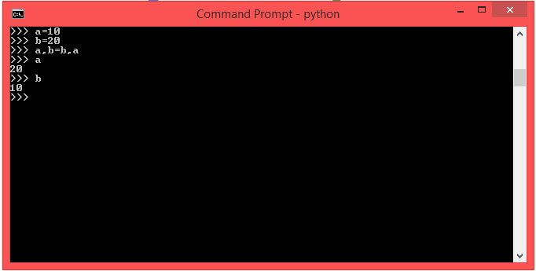

4)

Write a program to print the value given by the user by using both Python 2.x and Python 3.x Version.

Answer4)

This is 3.X version.

The value appears in string format as I did not put eval and the default type of input in 3.x is String.

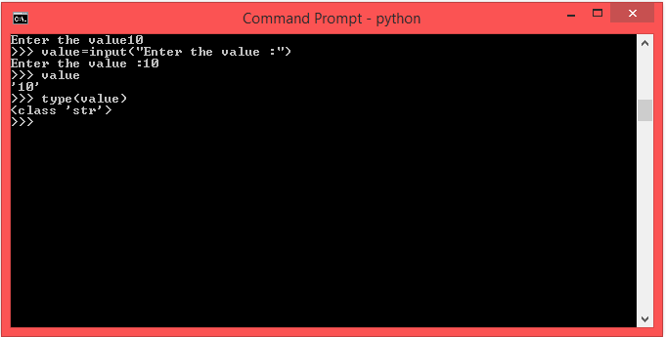

The value appears in integer format.

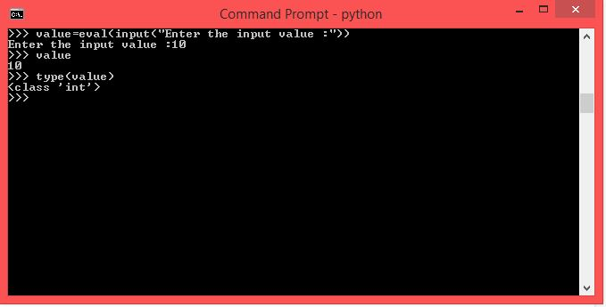

Now in python2.x version:

Here the value is by default in String format.

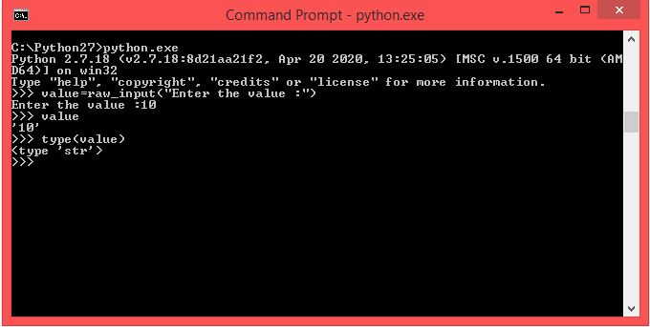

Here we again put eval to get the value in integer format.

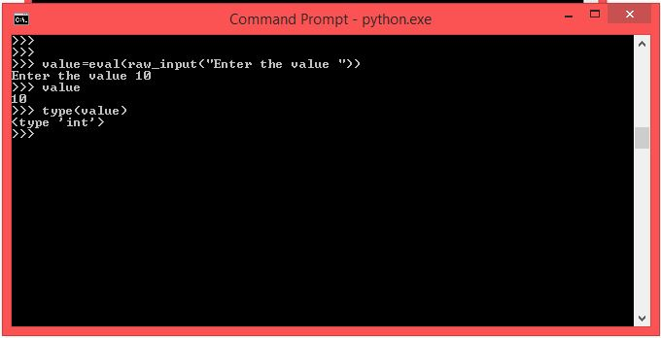

5. Write a program to complete the task given below:

* Ask the user to enter any 2 numbers in between 1-10 and add both of them to another variable call z.
* Use z for adding 30 into it and print the final result by using variable result.

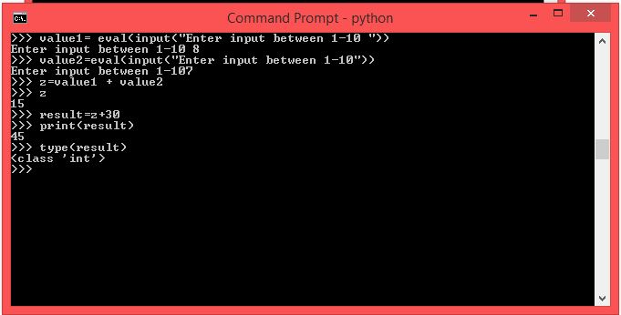

6)

Write a program to check the data type of the entered values. HINT: Printed output should say -  The input value data type is: int/float/string/etc

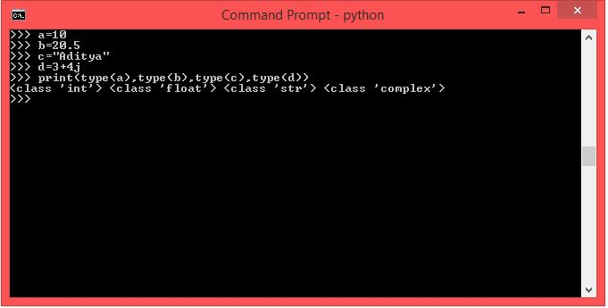

7)

Create Variable using CamelCase, LadderCase and UPPERCASE. (Refer:   <https://capitalizemytitle.com/camel-case/>) - Variable Conventions to write

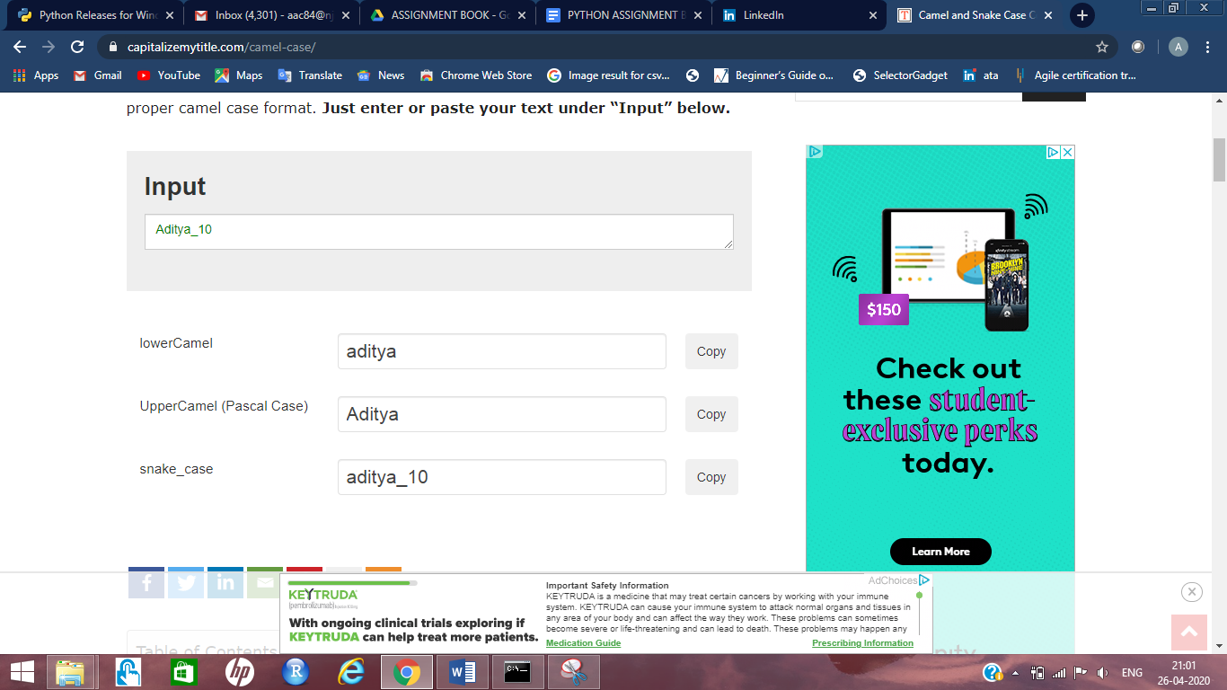

8)If one data type value is assigned to ‘a’ variable and then a different data type value is assigned to ‘a’ again. Will it change the value. If Yes then Why?

Ans8)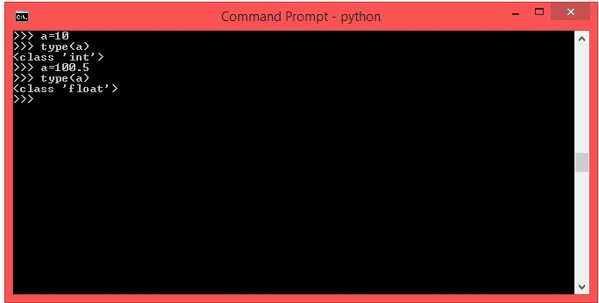

As you can see in the screenshot the value of variable ‘a’ is updated.

This is because a is assigned a new value and the initial value of the variable “a” is lost.

It always keeps the most recent value assigned to it and all the previous values are lost.

Thank You

RIYAZ UL HAQUE

Created by: Aditya Chavan