APPROACH -3
->Using PyPDF2 to rotate and read from the PDFs
ISSUE:
->PyPDF2 rotates it only by an angle of 90degrees and it couldn't detect Wall 3
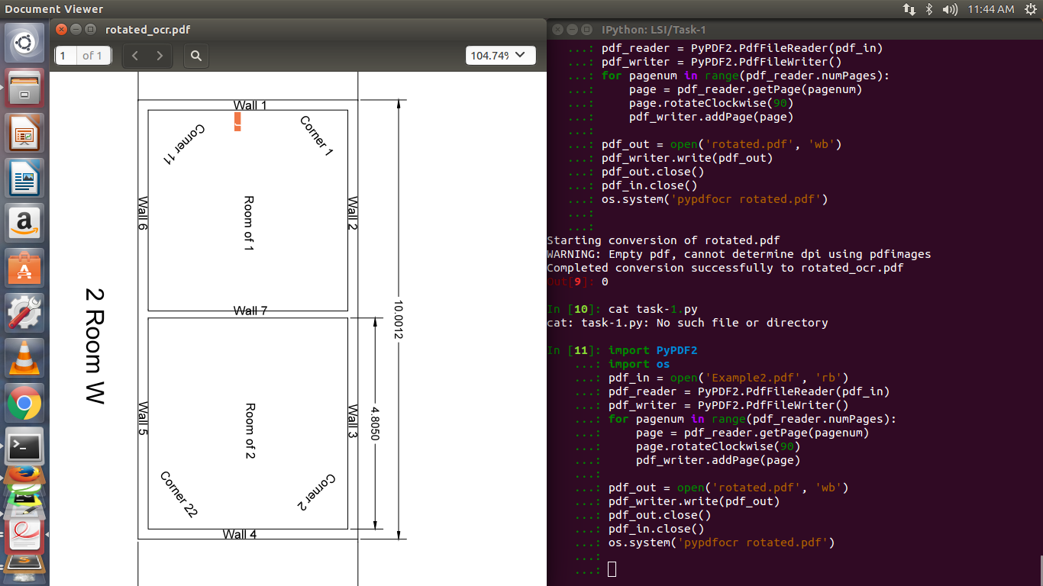
NEXT STEP:
Attaching Semantic value to the text from the library.

