CARECONNECT
SOFTWARE REQUIREMENTS
SPECIFICATION
Web-Based Electronic Health Record (EHR) System

DOCUMENT PROFILE | DETAILS
Project | CareConnect — Patient–Provider EHR
Institution | ABES Engineering College, Ghaziabad
Department | Computer Science and Engineering
Academic Year | 2026–27
Document Type | Software Requirements Specification
Version | 1.1 • Enhanced submission edition

Prepared for academic review and project evaluation

Document Control
Item | Description
Purpose | Defines the intended capabilities, interfaces, constraints, and quality requirements of CareConnect.
Audience | Project guide, evaluators, developers, testers, and future maintainers.
System boundary | Patient, Doctor, and Administrator portals for healthcare information workflows.
Version note | This edition improves structure and diagrams while retaining the source SRS requirements. Implementation status is explicitly distinguished from planned capabilities.

Contents
1. Introduction
2. Overall Description
3. Functional Requirements
4. External Interface Requirements
5. Non-Functional Requirements
6. Data Model and UML Diagrams
7. System Workflow and Future Scope
8. Acceptance Criteria
9. Conclusion
Note: In Microsoft Word, update the contents or add page numbers after final formatting if required by the submission template.

1. Introduction

1.1 Purpose
This Software Requirements Specification (SRS) defines the requirements for CareConnect, a web-based Electronic Health Record system designed to organize patient information and support routine interactions between patients, doctors, and administrators. It provides a shared reference for implementation, testing, demonstration, and evaluation.

1.2 Scope
CareConnect brings key healthcare workflows into one role-based interface. Patients can manage profile information, book appointments, and review medical history, prescriptions, and test results. Doctors can review patient history, manage appointments, document consultations, prescribe medicines, order tests, and record results. Administrators manage user accounts and patient/doctor records.
Implementation note: The supplied SRS describes a browser-based Angular demonstration using LocalStorage and dummy data. The project direction also includes a Spring Boot REST API and PostgreSQL persistence. Features should be described as implemented only when verified in the submitted build; LocalStorage/demo behavior must not be represented as production-grade clinical data storage.

1.3 Intended Audience
- Project guide and academic evaluators reviewing scope, design, and completeness.
- Developers implementing the Angular user interface and service layer, with backend/API integration where available.
- Testers validating role workflows, data relationships, input validation, and error handling.

1.4 Definitions and Abbreviations
Term | Meaning
EHR | Electronic Health Record: a structured digital record of health-related information.
CPOE | Computerized Physician Order Entry: entering medical test orders electronically.
SRS | Software Requirements Specification.
RBAC | Role-Based Access Control: permissions based on a user’s assigned role.
FR / NFR | Functional Requirement / Non-Functional Requirement.
API | Application Programming Interface used for communication between software components.
PK / FK | Primary Key / Foreign Key in a relational data model.

1.5 Document Organization
Section 2 describes the product and its users; Section 3 lists functional requirements; Sections 4 and 5 define interfaces and quality constraints; Section 6 presents the data model and UML use cases; Sections 7–9 cover workflow, acceptance criteria, and conclusion.

2. Overall Description

2.1 Problem Statement
Healthcare information can become fragmented when appointments, consultation notes, prescriptions, and reports are maintained separately. This makes it harder for patients to find their information and for clinicians to review relevant history efficiently. CareConnect aims to present these workflows in a single, organized application.

2.2 Product Perspective
CareConnect is organized around three portals—Patient, Doctor, and Administrator. The front end is designed with Angular, TypeScript, Angular Router, Reactive Forms, and RxJS. The source SRS describes LocalStorage for demo persistence; the planned/target architecture uses a Spring Boot REST API and PostgreSQL database. The final report and demonstration should accurately reflect which persistence path is active in the submitted version.
Patient / Doctor / Administrator → Angular Web Interface → Service/API Layer → Healthcare Data Store

2.3 Major Product Functions
- Patient registration, sign-in, profile access, and role-specific navigation.
- Appointment booking and appointment status management.
- Patient medical history and consultation documentation.
- Prescription creation and patient-side prescription viewing.
- Medical test ordering and test-result recording/viewing.
- Administrator management of users, patients, doctors, and system information.
- Clear validation and missing-record messages.

2.4 User Classes
User class | Responsibilities | Primary needs
Patient | Maintains profile and accesses own care information. | Book appointments; view history, prescriptions, results, and appointment status.
Doctor | Reviews patient history and documents care. | Manage appointments; record diagnosis and notes; prescribe medicines; order tests and enter results.
Administrator | Maintains system user and reference records. | Manage user accounts, patient records, doctor records, and system information.

2.5 Operating Environment
- Modern desktop and mobile browsers such as Chrome, Edge, Firefox, and Safari.
- Frontend development environment: Node.js and Angular CLI.
- Target backend architecture, where enabled: Spring Boot REST services and PostgreSQL.
- Network access is required for API-backed features; a LocalStorage-only demo can run locally in the browser.

2.6 Constraints and Assumptions
- Users have JavaScript enabled and use a supported browser.
- Demonstration data must be fictional; the application is not intended for real patient data unless security, privacy, and compliance controls are implemented and validated.
- Role-based navigation in the client alone is not sufficient security for a deployed healthcare system; backend authorization is required.
- The final build’s persistence and authentication behavior must be documented truthfully.

3. Functional Requirements
The requirements below use “shall” to express expected system behavior. Requirements should be verified through demonstration or testing against the submitted implementation.

3.1 Authentication and Role Management
ID | Requirement
FR-1.1 | The system shall allow a patient to register with required basic details.
FR-1.2 | The system shall allow registered users to sign in using valid credentials.
FR-1.3 | The system shall validate registration and sign-in inputs and display actionable validation messages.
FR-1.4 | The system shall direct users to the portal associated with their role: Patient, Doctor, or Administrator.
FR-1.5 | The system shall provide a sign-out action.
FR-1.6 | In a deployed version, authentication and authorization shall be enforced by the server, not solely by client-side route checks.

3.2 Patient Module
ID | Requirement
FR-2.1 | The patient shall be able to view and update permitted profile fields.
FR-2.2 | The patient shall be able to view their available medical history.
FR-2.3 | The patient shall be able to book an appointment with a selected doctor.
FR-2.4 | The patient shall be able to view appointment details and status.
FR-2.5 | The patient shall be able to view prescriptions, including medicine, dosage, frequency, and duration when recorded.
FR-2.6 | The patient shall be able to view test results associated with their records when results have been entered.
FR-2.7 | The patient portal shall show a clear empty state when no relevant record is available.

3.3 Doctor Module
ID | Requirement
FR-3.1 | The doctor shall be able to view the patient list and permitted patient details.
FR-3.2 | The doctor shall be able to view and manage assigned appointments.
FR-3.3 | The doctor shall be able to review a patient’s available history before consultation.
FR-3.4 | The doctor shall be able to record diagnosis, observations, treatment plans, and clinical notes.
FR-3.5 | The doctor shall be able to create a prescription for a patient with medicine, dosage, frequency, and duration fields.
FR-3.6 | The doctor shall be able to order medical tests (CPOE).
FR-3.7 | The doctor shall be able to add a result to an existing test order.
FR-3.8 | The system shall associate consultation, prescription, and test information with the correct patient and relevant appointment/consultation.

3.4 Administrator Module
ID | Requirement
FR-4.1 | The administrator shall be able to view and manage user accounts.
FR-4.2 | The administrator shall be able to view and manage patient records.
FR-4.3 | The administrator shall be able to view and manage doctor records.
FR-4.4 | The administrator shall be able to view system information.
FR-4.5 | Administrative actions shall be restricted to authorized administrator accounts.

3.5 Data Handling and Feedback
ID | Requirement
FR-5.1 | In the LocalStorage demonstration mode, the system shall save demo data in browser LocalStorage.
FR-5.2 | The system shall load available saved demo data when the application starts.
FR-5.3 | The system shall display clear messages when input is invalid or a record cannot be found.
FR-5.4 | When API-backed persistence is enabled, the system shall handle loading, success, empty, and error states for data requests.
FR-5.5 | The system shall avoid displaying one patient’s private records in another patient’s portal.

4. External Interface Requirements

4.1 User Interface
- Use a consistent healthcare-inspired palette based on navy blue, white, and light teal.
- Provide a separate dashboard and navigation menu for each role.
- Use clear labels, readable typography, responsive layouts, and inline form validation.
- Present medical information in structured, scannable sections and use empty states when no data exists.
- Keep important actions and status messages visually consistent across portals.

4.2 Hardware Interface
No specialized hardware is required. A computer, tablet, or phone capable of running a modern browser is sufficient.

4.3 Software Interfaces
Interface / component | Purpose
Web browser | Runs the Angular single-page application.
Angular / TypeScript | Implements role-specific views, forms, navigation, and client-side state.
Browser LocalStorage | Stores demonstration data only when the demo persistence mode is active.
Spring Boot REST API | Target server-side interface for application data and business operations, where implemented.
PostgreSQL | Target relational data store for persistent records, where integrated.
HTTPS | Required for secure network communication in a deployed environment.

4.4 Communication Interface
The source SRS specifies no backend network calls in its frontend-only version. In an API-backed version, the Angular application communicates with REST endpoints; deployed communication should use HTTPS and appropriate authentication and authorization.

5. Non-Functional Requirements
Category | Requirement
Usability | A user should be able to complete common tasks—such as booking an appointment or viewing a prescription—without extensive training.
Performance | Views and client-side navigation should respond promptly on a typical supported device. API-backed requests should show loading feedback and handle delays gracefully.
Security | Use role-based access; validate input; protect credentials; enforce authorization server-side in deployed versions. LocalStorage is not secure storage for sensitive clinical data.
Privacy | Use fictional data in academic demonstrations. Access to real patient data requires appropriate privacy, security, consent, and compliance safeguards.
Reliability | The application should handle missing or empty records without crashing and provide understandable error messages.
Maintainability | Keep Angular components, services, models, and routes modular. Keep API and persistence concerns separated from presentation logic.
Portability | The application should operate on supported modern browsers and common operating systems.
Scalability | The service/data layer should allow demo storage to be replaced by API-backed persistence without major redesign of the user interface.
Accessibility | Use meaningful labels, adequate contrast, keyboard-operable controls, and readable status messages wherever practical.

5.1 Security Boundary
CareConnect is an academic project, not a certified clinical system. Client-side route guards and browser storage alone do not provide production-grade security. Before real-world use, the system would need validated server-side access controls, secure credential handling, auditability, backups, privacy controls, and applicable legal/compliance review.

6. Data Model and UML Diagrams

6.1 Core Data Entities
Entity | Key attributes / responsibility
User | user_id (PK), name, email, role, status; identity and role information.
Patient | patient_id (PK), user_id (FK), contact details, medical summary.
Doctor | doctor_id (PK), user_id (FK), specialization, availability.
Appointment | appointment_id (PK), patient_id (FK), doctor_id (FK), date/time, status.
Consultation | consultation_id (PK), appointment_id (FK), diagnosis, observations, treatment plan, notes.
Prescription | prescription_id (PK), consultation_id (FK), medicine, dosage, frequency, duration.
Test Order | test_order_id (PK), consultation_id (FK), test name, order date, status.
Test Result | result_id (PK), test_order_id (FK), result value, remarks, result date.

6.2 Entity–Relationship (ER) Diagram
The ER model below represents the main logical relationships for CareConnect. PK denotes Primary Key and FK denotes Foreign Key. It is a conceptual model for the SRS; exact table names and cardinalities should be aligned with the implemented database schema.
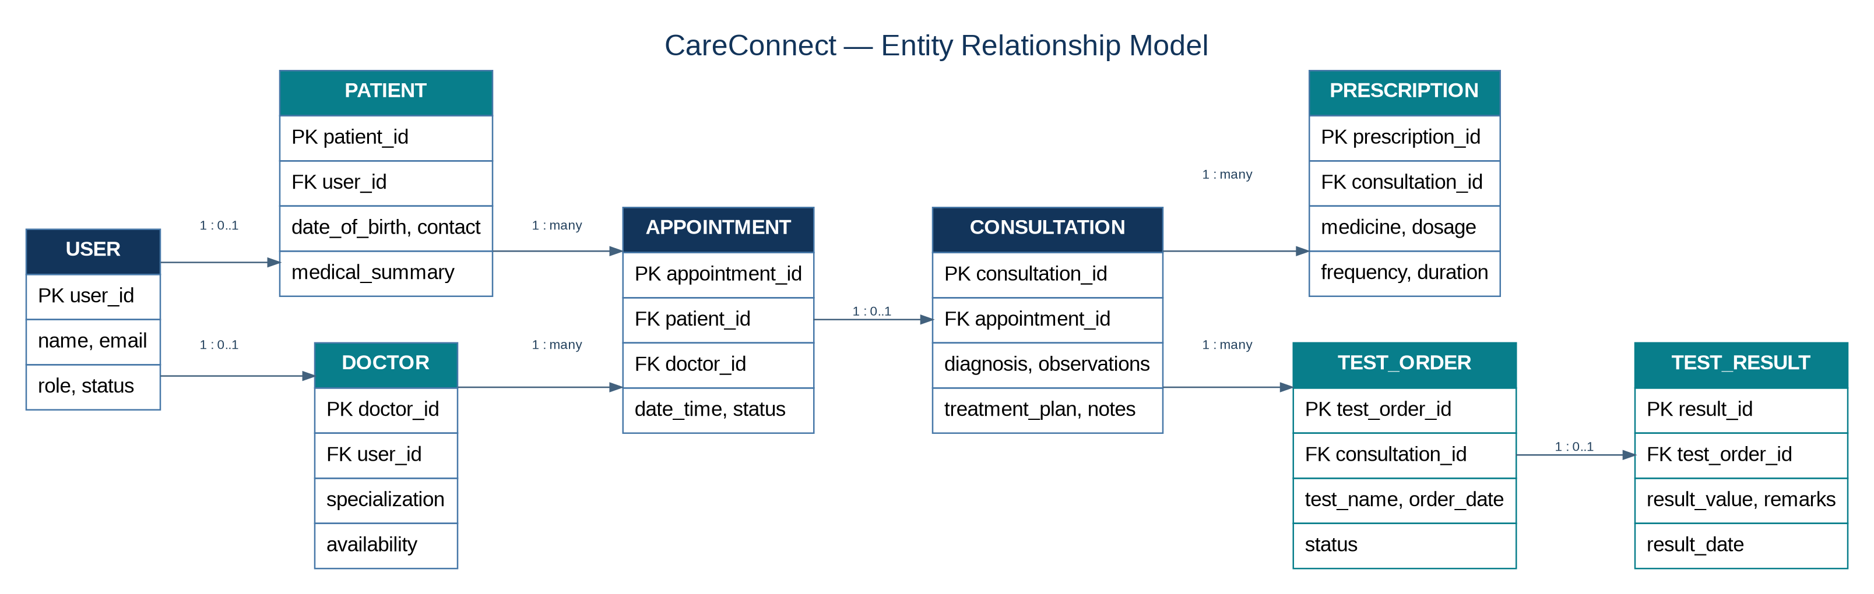
Figure 1. Logical ER model for users, care workflows, prescriptions, and test results.

6.3 Relationship Notes
- A user account may be associated with a patient profile or a doctor profile; the role determines portal access.
- A patient can have multiple appointments, and a doctor can handle multiple appointments.
- An appointment may have a consultation record. A consultation can generate prescriptions and test orders.
- A test order may have a corresponding result record. The implementation should enforce valid foreign-key associations.
- The ER model is logical and may be adjusted to match the final database normalization and schema decisions.

6.4 UML Use-Case Diagram
This diagram summarizes the primary interactions between the three actors and the CareConnect system boundary.
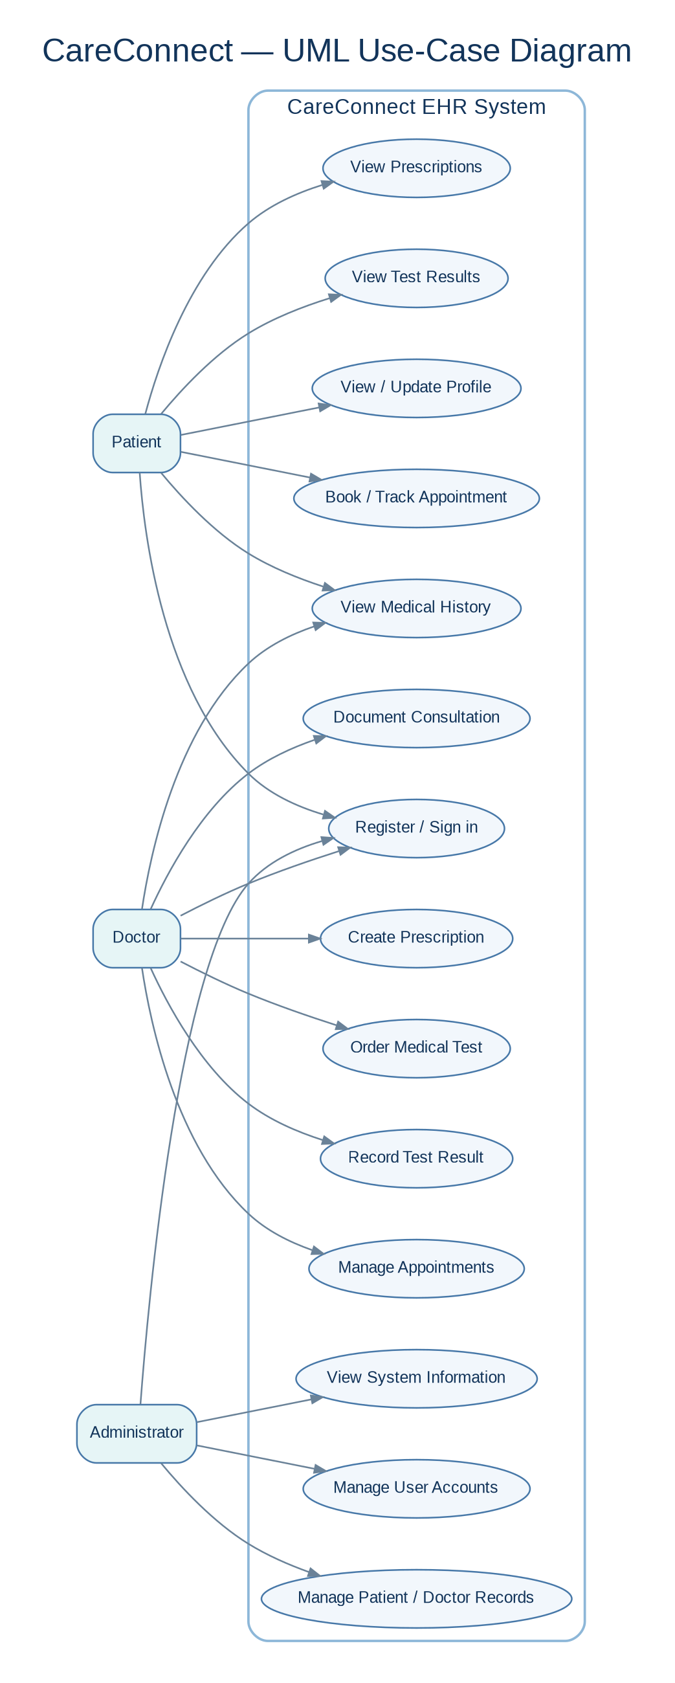
Figure 2. UML use-case view of patient, doctor, and administrator capabilities.

6.5 Use-Case Summary
Use case | Primary actor | Expected outcome
Register / sign in | Patient; Doctor; Administrator | User enters the appropriate role-based portal.
Book / track appointment | Patient | Appointment is created and its status can be reviewed.
Review history and document consultation | Doctor | Relevant history is reviewed and consultation details are recorded.
Create prescription | Doctor | Prescription details are linked to the relevant consultation/patient.
Order test and record result | Doctor | Test order and result are stored and associated correctly.
View medical information | Patient | Patient can access available history, prescriptions, and test results.
Manage users and records | Administrator | User, patient, and doctor records are maintained.

7. System Workflow and Future Scope

7.1 Primary Workflow
01 Patient registers or signs in.
02 Patient selects a doctor and books an appointment.
03 Doctor reviews appointment details and available patient history.
04 Doctor documents consultation details, diagnosis, and treatment plan.
05 Doctor creates a prescription and/or orders medical tests.
06 Doctor records test results when available.
07 Patient views the available prescription and test-result information in their portal.

7.2 Planned Enhancements
- Complete and validate Spring Boot REST API and PostgreSQL integration, if not already included in the submitted build.
- Server-side authentication and authorization, such as Spring Security with a suitable token/session strategy.
- Appointment email/SMS notifications.
- Laboratory and pharmacy integrations.
- Telemedicine capabilities and a mobile-friendly application.
- Cloud deployment, monitoring, backups, and audit trails.
- AI-assisted summaries or analytics only with appropriate safeguards, clinician oversight, and privacy controls.

7.3 Risks and Mitigations
Risk | Mitigation
Patient records linked to the wrong account | Use stable identifiers and verify patient/appointment relationships in service logic.
Missing or empty prescription/result data | Show explicit empty states; validate associations when saving and retrieving records.
Client-side role checks mistaken for security | Enforce permissions on the server for any deployed/API-backed version.
Demo data mistaken for real clinical records | Use fictional sample data and label the project as an academic demonstration.
Scope exceeds available time | Prioritize core workflows and clearly distinguish implemented features from future scope.

8. Acceptance Criteria
ID | Acceptance criterion | Verification
AC-1 | Valid users can access the correct role portal. | Demonstrate sign-in and role-specific navigation.
AC-2 | A patient can book an appointment and review its status. | Create an appointment and inspect the patient portal.
AC-3 | A doctor can review available history and record consultation details. | Use a test patient and verify saved consultation details.
AC-4 | A prescription is associated with the intended patient/consultation and can be viewed by that patient. | Create a prescription and verify patient-side retrieval.
AC-5 | A test order can be created and a result recorded against it. | Create test order, add result, and verify linkage.
AC-6 | Missing data and invalid input produce clear feedback rather than a crash. | Test empty lists, invalid forms, and unknown record IDs.
AC-7 | Administrative functions are restricted to authorized administrators. | Verify role access; for deployed versions, test server-side authorization.

9. Conclusion
CareConnect proposes a unified, role-based interface for organizing key patient–provider workflows: appointments, medical history, consultation documentation, prescriptions, and test results. This SRS defines the expected behavior, quality considerations, interfaces, and logical data relationships. The ER and UML use-case diagrams provide complementary views of the information structure and user interactions. The document distinguishes the original LocalStorage demonstration scope from the planned API-backed architecture so that the final submission remains both compelling and technically accurate.

GITHUB LINK : CareConnect

