Sanjivani College of Engineering, Kopargaon
(Autonomous Institute Affiliated to SPPU Pune)
Department of Computer Engineering
(UG Programme NBA Tier-1 Accredited)
MINI PROJECT PROPOSAL
T.Y. B.Tech — Computer Engineering | Academic Year: [ 2026–2027 ] | Div-A



Project Title:
CivicConnect – Smart Public Issue Reporting & Tracking System
Submitted By
Name of Student | Roll No. / PRN
Akanksha Pradip Asane | 63
Sai Sandip Deokar | 66
Vaishnavi Khanderao Raut | 71
Aditya Sandip Deokar | 166
Under the Guidance of
Dr. B.J. Dange, Associate Professor

CERTIFICATE OF APPROVAL
This is to certify that the mini project proposal entitled “” has been sub CivicConnect – Smart Public Issue Reporting & Tracking System” submitted by the following students of T.Y. B.Tech (Computer Engineering) in partial fulfilment of the requirement for the Mini Project – [ Semester V ] during the academic year [ 2026–2027 ].
1.Akanksha Pradip Asane - 63
2.Sai Sandip Deokar - 66
3.Vaishnavi Khanderao Raut - 71
4.Aditya Sandip Deokar - 166
The proposal has been found satisfactory and is approved for further execution as a mini project under the guidance of the undersigned.
Dr B.J. Dange  Project Guide | Dr. M.A. Jawale  Head of Department

1. Title of the Project
CivicConnect: Smart Public Issue Reporting and Tracking System for Efficient Municipal Complaint Management

2. Team Details
Sr. No. | Name of Student | Roll No. | Email ID / Contact No.
1 | Asane Akanksha Pradip | 63 | 9623499204
2 | Deokar Sai Sandip | 66 | 8055107422
3 | Raut Vaishnavi Khanderao | 71 | 8766047198
4 | Deokar Aditya Sandip | 166 | 9529718407

Guide Name | Dr B.J.Dange
Class / Division | TY B.Tech Comp Engg – Div A
Academic Year / Semester | 2026-27 / Sem V

3. Introduction / Background

Rapid urbanization has significantly increased the number of civic issues faced by citizens in cities and towns. Common public issues such as potholes, garbage overflow, water leakage, broken streetlights, damaged roads, illegal dumping of waste, blocked drainage systems, and open manholes directly affect public safety, environmental cleanliness, and the overall quality of life. Although municipal corporations work continuously to address these issues, citizens often face difficulties while reporting complaints and tracking their resolution.

At present, most complaints are reported through phone calls, WhatsApp messages, emails, social media posts, or by visiting municipal offices. These methods are often inefficient because they lack a centralized complaint management system. Citizens usually do not receive acknowledgement, cannot monitor the progress of their complaints, and have no assurance that the reported issue has been assigned to the appropriate department. In many cases, duplicate complaints are submitted for the same issue, resulting in unnecessary workload and delayed resolution. Furthermore, there is limited transparency regarding complaint handling, making it difficult to ensure accountability among municipal departments.

With the advancement of web technologies, cloud computing, and secure authentication systems, digital governance has become an important part of smart city initiatives. Modern web applications enable citizens to report issues quickly, upload supporting images, share accurate location details, and receive real-time updates regarding complaint status. Such systems improve communication between citizens and government authorities while increasing transparency and operational efficiency.

To address these challenges, the proposed system, CivicConnect – Smart Public Issue Reporting & Tracking System, aims to provide a centralized web-based platform that connects citizens, municipal officers, and administrators through a secure and efficient complaint management process. The system enables citizens to register, submit complaints with photographs and location details, and track the progress of their complaints. Municipal officers can view assigned complaints, update their status, provide remarks, and close resolved cases. Administrators can manage users, departments, monitor complaint statistics, and generate analytical reports.

The proposed platform incorporates secure user authentication, role-based access control, complaint tracking, image uploading, departmental assignment, dashboard analytics, and reporting features. These functionalities ensure transparency, accountability, faster issue resolution, and improved citizen engagement. In the future, the system can be enhanced by integrating Artificial Intelligence for automatic issue classification, duplicate complaint detection, priority scoring, interactive map-based reporting, and predictive analytics, making it suitable for Smart City and Digital India initiatives.

4. Problem Statement
Urban areas frequently experience civic issues such as potholes, garbage overflow, water leakage, damaged roads, broken streetlights, blocked drainage systems, illegal dumping of waste, and open manholes. These issues directly affect public safety, environmental hygiene, traffic management, and the overall quality of life. Although municipal authorities receive complaints through phone calls, emails, WhatsApp messages, and social media platforms, these methods lack a centralized and transparent complaint management mechanism.
Existing complaint reporting methods do not provide real-time complaint tracking, proper departmental assignment, accountability, or timely updates to citizens. Citizens are often unaware of the status of their complaints, leading to dissatisfaction and reduced public trust. Furthermore, duplicate complaints, inefficient communication between departments, and the absence of analytical reporting significantly affect the efficiency of civic issue resolution.
Therefore, there is a need for a secure, centralized, and role-based digital platform that enables citizens to report civic issues, allows municipal officers to manage and resolve complaints efficiently, and provides administrators with analytical insights for better decision-making and urban governance.

5. Objectives

The primary objectives of the proposed system are:

To design and develop a secure web-based Smart Public Issue Reporting and Tracking System for efficient civic complaint management.

To provide citizens with a simple and user-friendly platform for reporting civic issues by uploading images, descriptions, and location details.

To implement secure user authentication and role-based access control using Spring Security and JWT Authentication.

To enable municipal officers to view assigned complaints, update complaint status, assign departments, add remarks, and monitor ongoing complaint resolution.

To provide real-time complaint tracking so that citizens can monitor the progress of their submitted complaints.

To generate administrative dashboards and analytical reports for monitoring complaint statistics, departmental performance, issue categories, and resolution time.

To improve transparency, accountability, communication, and efficiency in municipal complaint management.

To provide a scalable platform that can be extended with Artificial Intelligence, GIS mapping, duplicate complaint detection, predictive analytics, and Smart City integration in future versions.

6. Scope of the Project

6.1 In Scope
The proposed system includes the following functionalities:
- User Registration, Login, Password Management, and Authentication.
- Role-based access for Citizens, Municipal Officers, and Administrators.
- Complaint registration with issue category, description, location, and image upload.
- Complaint status tracking with stages such as Pending, Assigned, In Progress, Resolved, and Closed.
- Department-wise complaint assignment.
- Officer dashboard for complaint handling and status updates.
- Administrator dashboard for user management, department management, analytics, and report generation.
- Complaint history and search functionality.
- Dashboard statistics showing complaint trends, pending issues, completed complaints, and department performance.
- Secure database management using MySQL.
- REST API-based backend developed using Spring Boot.

6.2 Out of Scope
The following features are outside the scope of the current project:
- AI-based automatic issue detection from uploaded images.
- Automatic duplicate complaint detection using Machine Learning.
- GPS-based live complaint tracking.
- SMS Gateway integration.
- Integration with Government Smart City APIs.
- IoT sensor integration for automatic issue reporting.
- Mobile application development (Android/iOS).
- Predictive maintenance using Artificial Intelligence.
- Blockchain-based complaint verification.
- Multi-city municipal integration.

7. Literature Survey
[ Summarize at least 4–6 relevant research papers / existing systems. Cite using IEEE format in the References section. ]
Sr. No. | Title / Author / Year | Technique Used | Key Findings / Limitations
1 | Smart City Complaint Management System (2023)  Web Technologies, MySQL | Web Technologies, MySQL | Developed an online complaint portal for citizens but lacked complaint analytics and AI-based prioritization.
2 | Online Grievance Redressal System (2022) | Java, Spring Boot | Provided complaint registration and status tracking but did not support image upload or location-based reporting.
3 | Municipal Complaint Management using GIS (2024) | GIS, Web Application | Improved location-based complaint reporting but lacked role-based dashboards and secure authentication.
4 | Citizen Complaint Portal using Spring Boot (2023) | Spring Boot, MySQL | Enabled complaint management and officer updates but had limited reporting and visualization features.

8. Proposed System / Methodology
The proposed system, CivicConnect – Smart Public Issue Reporting & Tracking System, is a secure web-based application designed to provide an efficient, transparent, and centralized platform for reporting, managing, and tracking public civic issues. The system bridges the communication gap between citizens and municipal authorities by allowing real-time complaint registration, status tracking, departmental assignment, and administrative monitoring through a role-based access mechanism.
Unlike conventional complaint reporting methods such as phone calls, emails, WhatsApp messages, or social media posts, CivicConnect offers a structured workflow where every complaint is digitally recorded, assigned to the appropriate department, continuously monitored, and updated until its successful resolution. The system maintains complete transparency by allowing citizens to view the progress of their complaints while enabling municipal officers to efficiently manage assigned tasks.
The application consists of three major stakeholders:
1. Citizen
Citizens can register themselves, securely log into the system, submit civic complaints by selecting the issue category, entering a detailed description, uploading supporting photographs, and specifying the exact location of the issue. After successful submission, the system generates a unique Complaint ID that can be used to track complaint progress. Citizens also receive updates whenever the complaint status changes.
2. Municipal Officer
Municipal officers are responsible for viewing complaints assigned to their respective departments. They can verify complaint details, update complaint status, assign field staff if required, add remarks regarding the ongoing work, and mark complaints as resolved after completion.
3. Administrator
The administrator manages the overall functioning of the system. Administrative responsibilities include managing users, departments, complaint categories, monitoring complaint statistics, generating reports, and evaluating departmental performance using analytical dashboards.
The proposed system ensures that every complaint follows a predefined workflow from complaint registration to final closure, thereby improving transparency, reducing manual effort, minimizing duplicate complaints, and increasing accountability within municipal departments.
Overall Workflow
- User Registration
- Secure Login using Spring Security and JWT
- Citizen Dashboard
- Submit Civic Complaint
- Upload Image and Location Details
- Complaint Stored in MySQL Database
- Complaint Assigned to Appropriate Department
- Municipal Officer Reviews Complaint
- Officer Updates Complaint Status
- Officer Adds Progress Remarks
- Citizen Tracks Live Complaint Status
- Complaint Resolved
- Administrator Generates Reports and Analytics
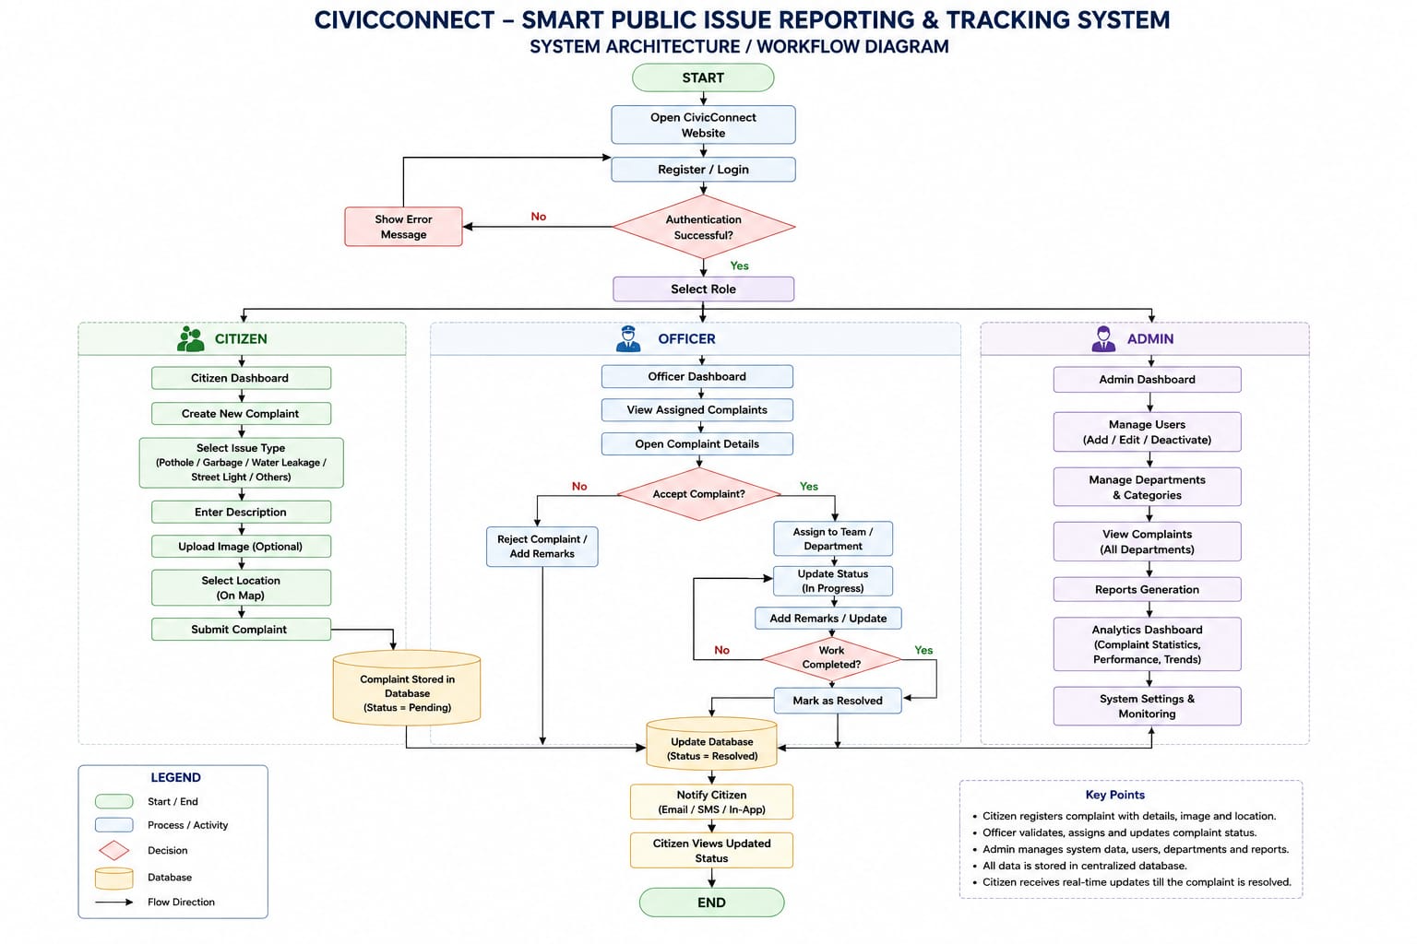v

8.1 Modules Description
- Module 1: Authentication Module
This module provides secure authentication and authorization using Spring Security and JWT Authentication. Users can register, log in, reset passwords, and securely access the system according to their assigned roles.
Functions
- User Registration
- Login
- Password Encryption
- JWT Token Generation
- Role-Based Access Control

- Module 2: Complaint Management Module
This module enables citizens to report civic issues by entering complaint details along with supporting evidence.
Users can provide:
- Issue Category
- Complaint Description
- Location
- Image Upload
- Contact Details
After successful submission, the system generates a Complaint ID and stores all information in the database.

- Module 3: Complaint Tracking Module
This module allows citizens to monitor complaint progress in real time.
Complaint Status Flow:
Pending
↓
Assigned
↓
In Progress
↓
Resolved
↓
Closed
The complete complaint history remains available for future reference.

- Module 4: Municipal Officer Dashboard
Municipal officers can efficiently manage assigned complaints through an interactive dashboard.
Features include:
- View Assigned Complaints
- Update Complaint Status
- Add Remarks
- Assign Work Teams
- Monitor Pending Complaints
- Close Completed Complaints

- Module 5: Administrator Dashboard
The administrator has complete control over the system.
Responsibilities include:
- User Management
- Department Management
- Complaint Category Management
- Dashboard Monitoring
- Complaint Statistics
- Report Generation
- Performance Analysis

- Module 6: Reports & Analytics Module
This module generates graphical reports that help municipal authorities analyze complaint trends and improve service quality.
Reports include:
- Total Complaints
- Resolved Complaints
- Pending Complaints
- Department-wise Complaints
- Monthly Complaint Analysis
- Average Resolution Time
- Most Frequently Reported Issues
- Area-wise Complaint Distribution

9. Tools and Technologies
Programming Language(s) | Java,kotlin
Framework(s) / Library(ies) | Spring Boot 3.x
Database | MySQL
IDE / Development Tools | VS Code, Android Studio
Other Tools / APIs | Postman

10. Hardware and Software Requirements

10.1 Hardware Requirements
- [ Processor, RAM, Storage, or special hardware (sensors / boards) ]

10.2 Software Requirements
- [ Operating System, Software Stack, Version details ]

11. Expected Outcomes
The proposed CivicConnect – Smart Public Issue Reporting & Tracking System is expected to provide a centralized, secure, and transparent platform for civic complaint management.
The expected outcomes are:
- Development of a fully functional web-based complaint management system.
- Secure role-based authentication for Citizens, Municipal Officers, and Administrators.
- Easy complaint registration with image upload and location details.
- Real-time complaint tracking from submission to closure.
- Department-wise complaint assignment for efficient resolution.
- Improved transparency and accountability in complaint handling.
- Administrative dashboards for complaint monitoring and analysis.
- Graphical reports showing complaint trends and department performance.
- Reduced manual paperwork and faster complaint resolution.
- A scalable platform that can be enhanced with AI, GIS mapping, and Smart City integration in future.

12. Project Timeline / Work Plan
Sr. No. | Task / Milestone | Duration | Deliverable
1 | Literature Survey & Requirement Analysis | [ Week 1–2 ] | [ Survey report ]
2 | System Design & Architecture | [ Week 3–4 ] | [ Design document ]
3 | Module 1 Development | [ Week 5–6 ] | [ Module 1 build ]
4 | Module 2 Development | [ Week 7–8 ] | [ Module 2 build ]
5 | Integration & Testing | [ Week 9–10 ] | [ Integrated system ]
6 | Documentation & Final Presentation | [ Week 11–12 ] | [ Final report & demo ]

13. Feasibility Study

13.1 Technical Feasibility

The proposed system is technically feasible because it utilizes well-established technologies such as Java, Spring Boot, Spring Security, MySQL, HTML, CSS, Bootstrap, and JavaScript. These technologies are open source, widely adopted in industry, and supported by extensive documentation, making the implementation practical within the available project duration.

13.2 Economic Feasibility
The project is economically feasible because it relies primarily on free and open-source software tools, including Spring Boot, MySQL Community Edition, GitHub, Maven, and Visual Studio Code or IntelliJ IDEA Community Edition. Consequently, development costs are minimal and limited mainly to internet access and general computing resources.

13.3 Operational Feasibility
The proposed application is operationally feasible as it offers a simple and user-friendly interface for all stakeholders. Citizens can easily submit and monitor complaints, municipal officers can efficiently process assigned issues, and administrators can oversee the entire complaint management process through centralized dashboards and reports.

14. Sustainable Development Goals (SDG) Mapped:-
The proposed CivicConnect – Smart Public Issue Reporting & Tracking System supports the United Nations Sustainable Development Goals (SDGs) by promoting efficient civic governance, transparent public services, and sustainable urban development. The system empowers citizens to actively participate in reporting civic issues while enabling municipal authorities to resolve complaints efficiently through a centralized digital platform.
- SDG 11 – Sustainable Cities and Communities
CivicConnect contributes to building cleaner, safer, and more sustainable cities by providing a centralized platform for reporting and tracking civic issues such as potholes, garbage overflow, water leakage, damaged roads, broken streetlights, illegal dumping, and open manholes. The system enables faster issue resolution, improves urban infrastructure management, and enhances the overall quality of life for citizens.
- SDG 16 – Peace, Justice and Strong Institutions
The proposed system promotes transparency, accountability, and efficient governance by maintaining digital records of complaints, enabling real-time status tracking, and providing role-based access for citizens, municipal officers, and administrators. It strengthens public trust in government services by ensuring that complaints are managed systematically and resolved in a transparent manner.
Contribution to Sustainable Development
- Encourages active citizen participation in improving civic infrastructure.
- Promotes transparent and accountable municipal governance.
- Reduces complaint resolution time through a centralized digital system.
- Improves communication between citizens and municipal departments.
- Supports data-driven decision-making using reports and analytics.
- Enhances the efficiency of public service delivery through digital transformation.

15.Future Scope:-
The proposed system can be further enhanced by incorporating advanced technologies to improve automation, intelligence, and decision-making.
Future enhancements include:
- AI-based automatic issue detection using uploaded images.
- Duplicate complaint detection using Machine Learning.
- Interactive GIS and Google Maps integration.
- GPS-enabled complaint location tracking.
- Email and SMS notifications.
- Complaint priority prediction using Artificial Intelligence.
- Predictive analytics for identifying high-risk civic areas.
- Mobile application development for Android and iOS.
- IoT sensor integration for automatic issue reporting.
- Smart City and Government Portal integration.

16. References
[1] A. Sharma and R. Gupta, "Smart City Complaint Management System Using Web Technologies," International Journal of Computer Applications, vol. 185, no. 12, pp. 15–22, 2023.
[2] P. Kumar and S. Verma, "Online Grievance Redressal System Using Spring Boot Framework," International Journal of Scientific Research in Engineering and Management, vol. 7, no. 4, 2022.
[3] M. Singh, A. Patel, and R. Joshi, "Municipal Complaint Management System Using GIS Technology," International Journal of Advanced Research in Computer Science, vol. 15, no. 2, pp. 88–96, 2024.
[4] Oracle Corporation, Java SE Documentation. Available: https://docs.oracle.com/
[5] VMware, Spring Boot Official Documentation. Available: https://spring.io/projects/spring-boot
[6] Oracle Corporation, MySQL Official Documentation. Available: https://dev.mysql.com/doc/
[7] Bootstrap Team, Bootstrap Documentation. Available: https://getbootstrap.com/
[8] Postman Inc., Postman API Platform Documentation. Available: https://www.postman.com/

