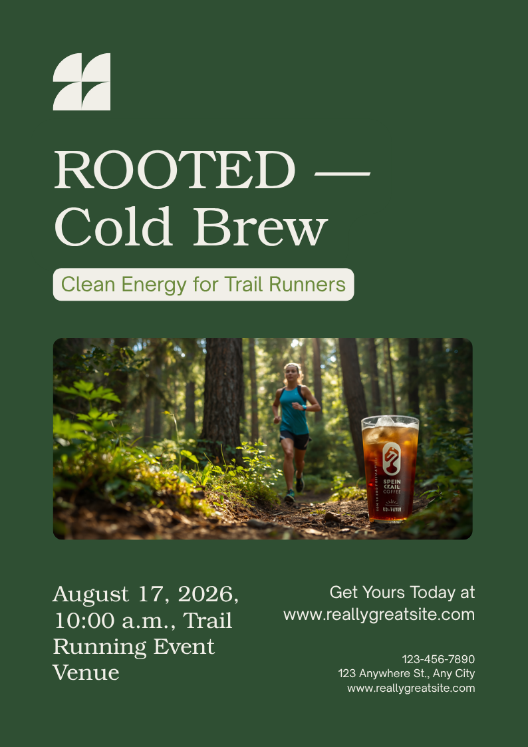

ROOTED — Cold Brew
Fuel for the Path Less Traveled

Product Overview
ROOTED is more than just coffee; it’s a high-performance energy solution crafted specifically for those who thrive in the wild. Our small-batch, slow-steeped cold brew provides clean, sustained energy without the jitters or crash associated with synthetic boosters. Designed for the trail, the mountain, and everything in between.

Why Trail Runners Choose ROOTED
- Sustained Energy: Naturally occurring caffeine released slowly to power long endurance runs.
- Clean Ingredients: Organic beans, pristine mountain water. No sugars, no additives, no compromises.
- Portable & Rugged: Convenient, lightweight packaging designed to fit in any hydration vest or trail pack.
- Recovery-Friendly: Packed with natural antioxidants to help combat oxidative stress post-run.

Event Marketing Calendar (Q3-Q4 2026)
Event | Date | Location
Sierra Peaks 50k | Sept 12 | Truckee, CA
Autumn Trail Marathon | Oct 20 | Boulder, CO
Winter Gear Expo | Dec 5 | Denver, CO

Contact & Ordering
Ready to bring ROOTED to your shelves? Connect with our team to discuss wholesale opportunities.
Sales Contact: hello@rootedcoldbrew.com | (555) 012-3456
Ordering Portal: wholesale.rootedcoldbrew.com

Brand Guidelines
Our visual identity is grounded in the environment we explore. Please adhere to our brand palette when creating co-marketing materials:
#2f4f33
#7e8865
#303821
#454f2e
#2e4f33

