
VIBE2SHIP · CODING NINJAS × GOOGLE FOR DEVELOPERS
MuniPeople
AI-powered hyperlocal civic-issue reporting — see it, snap it, solve it.
Problem: Community Hero — Hyperlocal Problem Solver · Powered by Google Gemini + Firebase · Submission: June 29, 2026
Live: https://junkcivicsense.web.app
MuniPeople turns every citizen into a civic hero. Snap a photo of a pothole, garbage pile, broken streetlight or water leak — and an AI agent (Google Gemini) instantly understands the image, classifies the problem, judges its severity, merges duplicate reports from neighbours, drafts a formal complaint, and tracks it on a live map until the local authority fixes it. Authorities get a jurisdiction-scoped dashboard where the AI verifies the actual fix by comparing before/after photos — so “resolved” means genuinely resolved, not a rubber stamp.
At a Glance
11  ISSUE CATEGORIES | 3-layer  AI FALLBACK CHAIN | 60 m  SMART DEDUP RADIUS | Real-time  LIVE MAP SYNC
4  SEVERITY TIERS | 5  LIFECYCLE STATES | 100%  GOOGLE AI STUDIO (GEMINI) | PWA  INSTALLABLE, MOBILE-FIRST
Problem Statement Selected
Selected problem statement: “Community Hero — Hyperlocal Problem Solver.”
Reporting a civic issue in India today is broken: complaints get lost across siloed portals and phone lines, the same pothole gets reported fifty times with no way to merge them, authorities can't tell what's urgent from what's trivial, and citizens never find out whether anything actually happened. The feedback loop between the person who sees the problem and the office that can fix it is missing.
The hackathon brief — “Community Hero — Hyperlocal Problem Solver” — asks for a platform that lets ordinary people surface neighbourhood problems and get them solved. MuniPeople answers that with an AI agent sitting in the middle of the loop, doing the triage, deduplication, drafting and verification work that no human has time to do at city scale.
Solution Overview
MuniPeople is a mobile-first Progressive Web App that closes the loop between citizens who spot civic problems and the authorities who fix them — with a Google Gemini AI agent doing the heavy lifting in the middle. A citizen photographs an issue; Gemini classifies it, rates its severity, and writes the report. Smart geospatial deduplication merges repeat sightings into a single crowd-weighted issue, so priority rises with public concern instead of drowning in duplicates. Reports stream live onto a severity-coded map. Pre-authorised municipal officials work a dashboard scoped strictly to their own jurisdiction, and when they claim a fix, Gemini compares the before/after photos and only permits “resolved” if the fix is real. Everything runs on Google's stack — Gemini for intelligence, Firebase for data, auth, and hosting.
Key Features
📸 AI photo triage  Gemini reads the photo, writes a title + description, picks one of 11 categories, and rates severity from low to critical. A selfie or non-issue is rejected at the gate. | 🧠 Smart deduplication  A new report within 60 m of an existing open issue of the same category is merged as a corroboration instead of a duplicate — crowd weight escalates priority automatically.
🗺️ Live severity map  Every report appears in real time on an OpenStreetMap-based map, colour-coded by severity, so the whole community and the authority see hotspots as they form. | ✍️ Auto-drafted complaints  One tap turns an issue into a polite, formal complaint letter to the municipal authority — written by Gemini, addressed and worded correctly.
✅ AI-gated resolution  An authority can't just mark something done. They upload an after photo; Gemini compares it to the original and only allows resolved if the fix genuinely matches. | 🏛️ Authority dashboard  Pre-authorised officials get a dashboard scoped to their own city only — Mumbai never sees Karnataka's reports — sorted by severity, with acknowledge / start-work / resolve actions.
🔔 Status notifications  Reporters and everyone who corroborated an issue get notified at each stage — acknowledged, in progress, resolved, reopened. | 🎙️ Voice + camera + GPS  Web Speech API for voice notes, live camera capture, and one-tap geolocation with address search — full hyperlocal context on every report.
How It Works — Citizen Report Flow
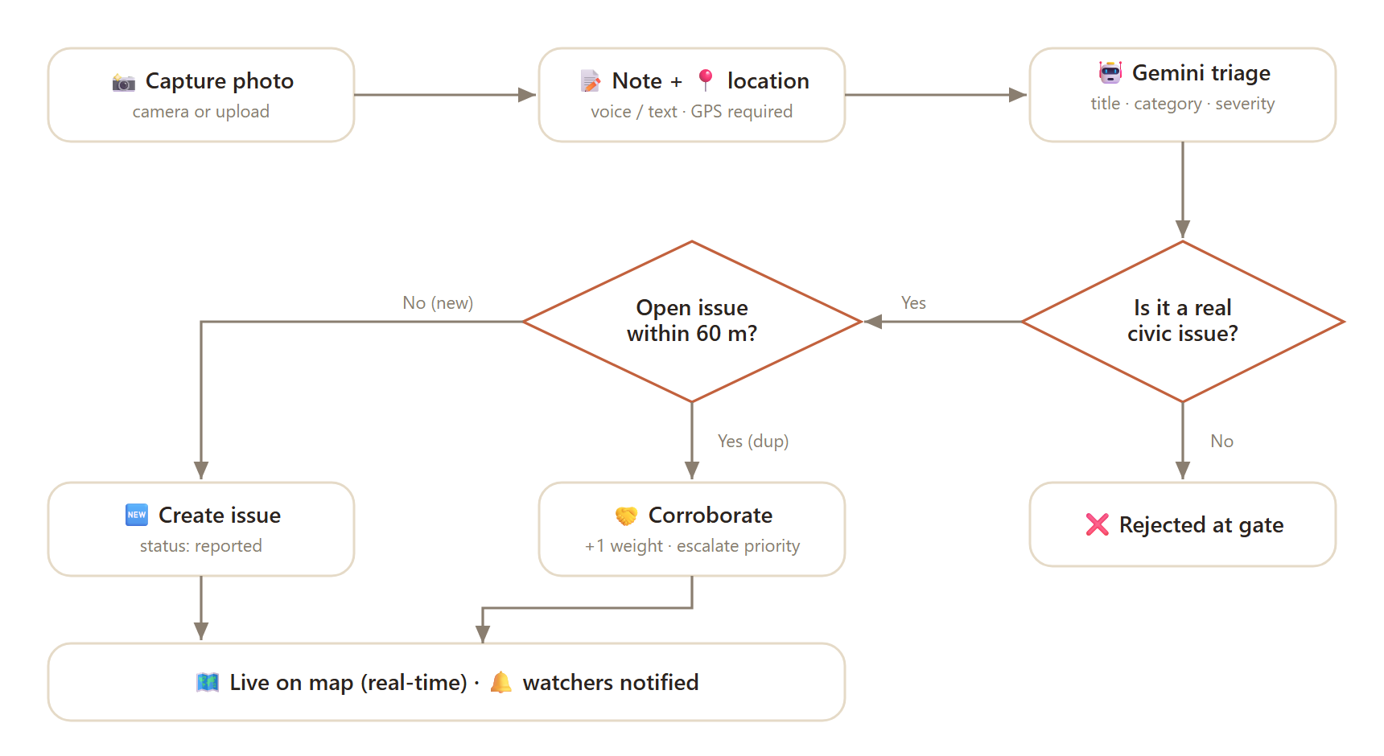
Figure 1 — From snapshot to live, deduplicated, mapped issue in a single AI-driven pipeline.
Authority Resolution Flow (AI-Gated)
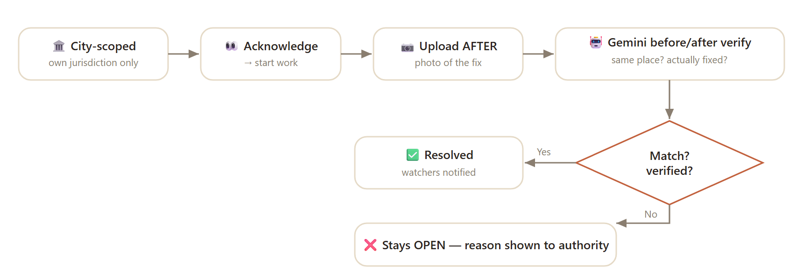
Figure 2 — “Resolved” is earned: the AI must confirm the fix before the status can change.
AI Reliability — 3-Layer Fallback Chain
The AI never hard-fails the user. Every classification and verification call flows through a graceful cascade: primary Google model first, a free vision model as backup, and a deterministic heuristic as a last resort — so a rate-limit or outage degrades quality, never availability.
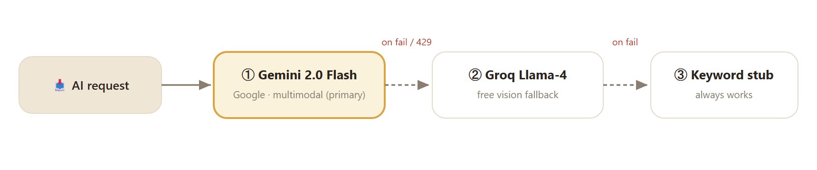
Figure 3 — Google Gemini leads; Groq and a heuristic guarantee the app stays up.
System Architecture
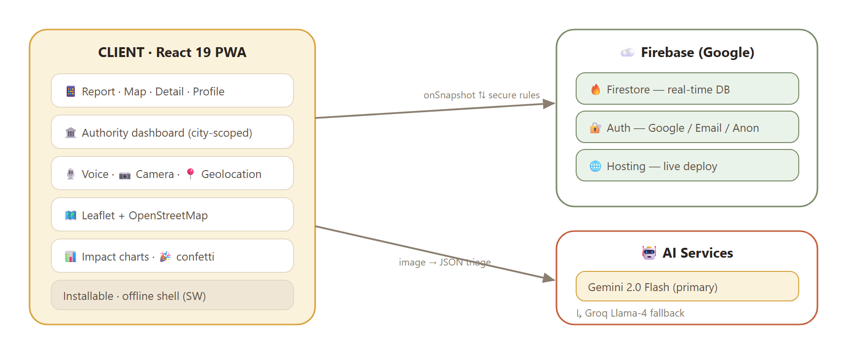
Figure 4 — A client-only architecture: the browser talks directly to Google's managed services.
Data Model (Firestore)
issues | title, description, category, severity, status, location{lat,lng,city,address}, imageData, afterImageData, reportCount, corroborators[], fixVerified, fixNote, reporterId
users | displayName, email, role (citizen / authority), jurisdiction, points, badges — owner-write only
notifications | userId, issueId, title, status, read, createdAt — owner-read only; created on every status change
Security rules | Issues: public read, auth-only write, delete blocked. Users: owner-write. Notifications: owner-read, delete blocked. Authority access gated by a pre-approved email allow-list.
Severity & Category Model
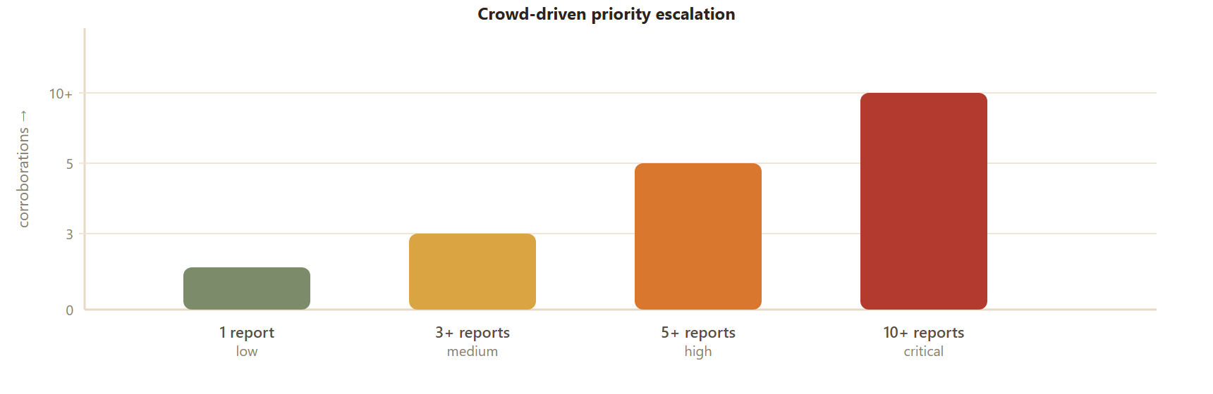
Figure 5 — The more neighbours corroborate an issue, the higher the AI escalates its priority.
11 categories: pothole · garbage · streetlight · water leakage · drainage · sewage · road damage · fallen tree · stray animals · public toilet · other. Lifecycle: reported → acknowledged → in progress → resolved (↺ reopened).
Technologies Used
Google Technologies Utilized
- Google Gemini 2.0 Flash — via Google AI Studio
- Firebase Firestore (real-time database)
- Firebase Authentication (Google / Email / Anonymous)
- Firebase Hosting (live deployment)
Frontend & supporting
React 19 · TypeScript · Vite (rolldown) · React Router · Leaflet + OpenStreetMap · Web Speech API · getUserMedia (camera) · Nominatim geocoding · PWA (manifest + service worker) · canvas-confetti · Groq Llama-4 (AI fallback).
Hackathon Compliance
MuniPeople is built to meet the VIBE2SHIP General Guidelines in full:
✓ | Eligibility — solo project. MuniPeople is the original, individual work of a single participant, registered before the deadline. No team involvement.
✓ | Mandatory tool — Google AI Studio. The product's intelligence is powered by Google Gemini, accessed through Google AI Studio (model gemini-2.0-flash via the @google/genai SDK). Gemini drives image triage, complaint drafting, and before/after fix verification — it is the core of the solution, not an add-on.
✓ | Originality & fair use. All application code is original. Third-party building blocks — React, Firebase, Leaflet/OpenStreetMap, Nominatim, Groq, canvas-confetti — are open-source or publicly available APIs, used per their licenses and credited here and in the repository.
✓ | No plagiarism / fresh build. Built from scratch for this hackathon; not a resubmission of a prior project. Source history is available for originality checks.
✓ | Additional tech. Supplementary tools beyond Google AI Studio are used as permitted by the problem statement, with Google technologies remaining central.
Google-tech weighting: Beyond the mandatory Google AI Studio requirement, the entire backend and AI layer runs on Google's stack — Gemini for intelligence and Firebase for data, auth, and hosting — maximising the use-of-Google-technology scoring criterion.
Demo & Links
RESOURCE | LINK
Live application | https://junkcivicsense.web.app
Submission label | MuniPeople
Problem statement | Community Hero — Hyperlocal Problem Solver
Core AI | Google Gemini 2.0 Flash (Google AI Studio)
Platform | Firebase (Firestore · Auth · Hosting)
Try it in 30 seconds
- Open the live link on your phone → sign in (Google / email / anonymous).
- Tap Report → snap a photo of any civic issue → watch Gemini classify it instantly.
- See it appear on the live map, colour-coded by severity.
- Sign in as the pre-authorised authority → resolve it with an after photo → watch the AI verify the fix.
MuniPeople · Built for VIBE2SHIP (Coding Ninjas × Google for Developers) · Powered by Google Gemini & Firebase · Generated June 28, 2026

