SonarQube
SonarQube is an open-source platform for continuous inspection of code quality.
It gives development teams a single place to track the health of their source code — surfacing bugs, code smells, security vulnerabilities, and other maintainability issues before they make it into production
SonarQube automates a large portion of the review process by running a rules engine against your codebase every time you build or commit.
Purpose and Benefits
SonarQube's core purpose is to make code quality visible, measurable, and actionable throughout the software development lifecycle.
Benefits:
Early detection of issues: Problems are caught close to the point, when they're cheapest to fix.
Improved maintainability: Complexity, duplication, and inconsistent style are flagged
Stronger security posture: Common vulnerability classes are detected automatically.

Objective, consistent feedback: Every commit is measured against the same rule set, removing subjectivity from parts of code review
Faster, more focused reviews: — Automating the mechanical checks frees human reviewers to focus on design and logic rather than style nits.

Historical tracking: — Because results are stored over time, teams can see whether quality is trending up or down across releases.

The "Clean as You Code" Principle

"Clean as you code" is SonarQube's guiding philosophy for managing quality sustainably
- Every new or changed line of code must meet quality standards before it's merged.
- Quality Gates are evaluated primarily against the "new code" introduced since a defined baseline (e.g., since the last release or over the last N days).
- Over time, as new code is written cleanly and old code is gradually touched and improved, the overall codebase quality rises organically — without requiring a disruptive, all-at-once remediation effort.

This makes quality improvement incremental and sustainable rather than a one-time cleanup project.

Static Code Analysis vs. Runtime Testing

Static code analysis: examines source code without executing it. SonarQube parses code into an abstract syntax tree and applies rules that look for known bug patterns, insecure constructs, complexity thresholds, duplication, and style violations.

This is SonarQube's primary mode of operation — it can find issues that would only otherwise surface during a very specific runtime path, or never surface at all until production.

Runtime testing (unit tests, integration tests, load tests, etc.) actually executes the code to verify behaviour . It catches logical errors, performance problems, and issues dependent on real data or environment state — things static analysis cannot see.

SonarQube doesn't replace runtime testing; it complements it. It ingests the *results* of your test runs (such as code coverage reports produced by tools like JaCoCo ) and folds those metrics into its overall quality picture, giving you one dashboard that reflects both static analysis findings and how well your code is actually tested.

SonarQube Architecture

SonarQube is composed of several cooperating components:

Web Server — The front-end application that serves the SonarQube UI (dashboards, issue lists, project settings, quality gate configuration) and exposes the web API that scanners and integrations use to submit and retrieve data.

Compute Engine — A background processing component that consumes analysis reports submitted by scanners, processes them (calculating metrics, applying quality profiles, evaluating quality gates), and persists the results. Analysis is asynchronous: the scanner uploads a report, and the Compute Engine processes it in the background, which is why results don't appear on the dashboard the instant a scan finishes.

Search Server (Elasticsearch) — An embedded Elasticsearch instance that indexes issues and other searchable data, powering the fast filtering, searching, and sorting you see in the SonarQube UI ( filtering issues by severity, type, or file).

SonarQube Database— A relational database that stores configuration, quality profiles, quality gates, historical measures, and issue data persistently. This is the system of record — Elasticsearch's index can be rebuilt from it if needed.
SonarQube Client and Server — The "server" is the combination of the Web Server, Compute Engine, Search Server, and Database described above, typically running as one logical deployment.
The "client" refers to the **scanners** — command-line tools or build-tool plugins (SonarScanner CLI, the Maven plugin, the Gradle plugin, SonarScanner for .NET, SonarLint in the IDE, etc.) that run against your source code, perform the actual analysis pass, and upload the resulting report to the server for processing.

At a high level, the flow is: a scanner analyzes your code locally → it uploads a report to the Web Server → the Compute Engine processes that report → results are written to the Database and indexed in Elasticsearch → the Web Server UI reads from both to display your dashboard.

Quality Profiles

A Quality Profile is a named collection of rules used to analyze code in a given programming language. Each rule can check for a specific bug pattern, code smell, or vulnerability. Profiles let teams:

- Enable or disable specific rules.
- Adjust rule severity.
- Maintain different rule sets for different projects or teams (e.g., a stricter profile for a security-critical service).

Every project is analyzed against exactly one Quality Profile per language present in that project.

Quality Gates

A **Quality Gate** is a set of pass/fail conditions a project's analysis must satisfy to be considered acceptable — for example, "zero new bugs," "code coverage on new code ≥ 80%," or "no new critical vulnerabilities." The Quality Gate is what turns SonarQube from a passive reporting tool into an active gatekeeper: it produces a single, unambiguous **Passed** or **Failed** status that can be wired into CI/CD pipelines to block merges or deployments when code quality regresses.

Integrating SonarQube with Maven

For Maven-based Java projects, SonarQube integrates through the SonarQube Scanner for Maven (the `sonar-maven-plugin`), which runs as part of your normal build lifecycle.

Adding the SonarQube Maven Plugin

Add the plugin to the `<build><plugins>` section of your `pom.xml`:

```xml
<build>
<plugins>
<plugin>
<groupId>org.sonarsource.scanner.maven</groupId>
<artifactId>sonar-maven-plugin</artifactId>
<version>3.11.0.3922</version> </plugin>
</plugins>
</build>
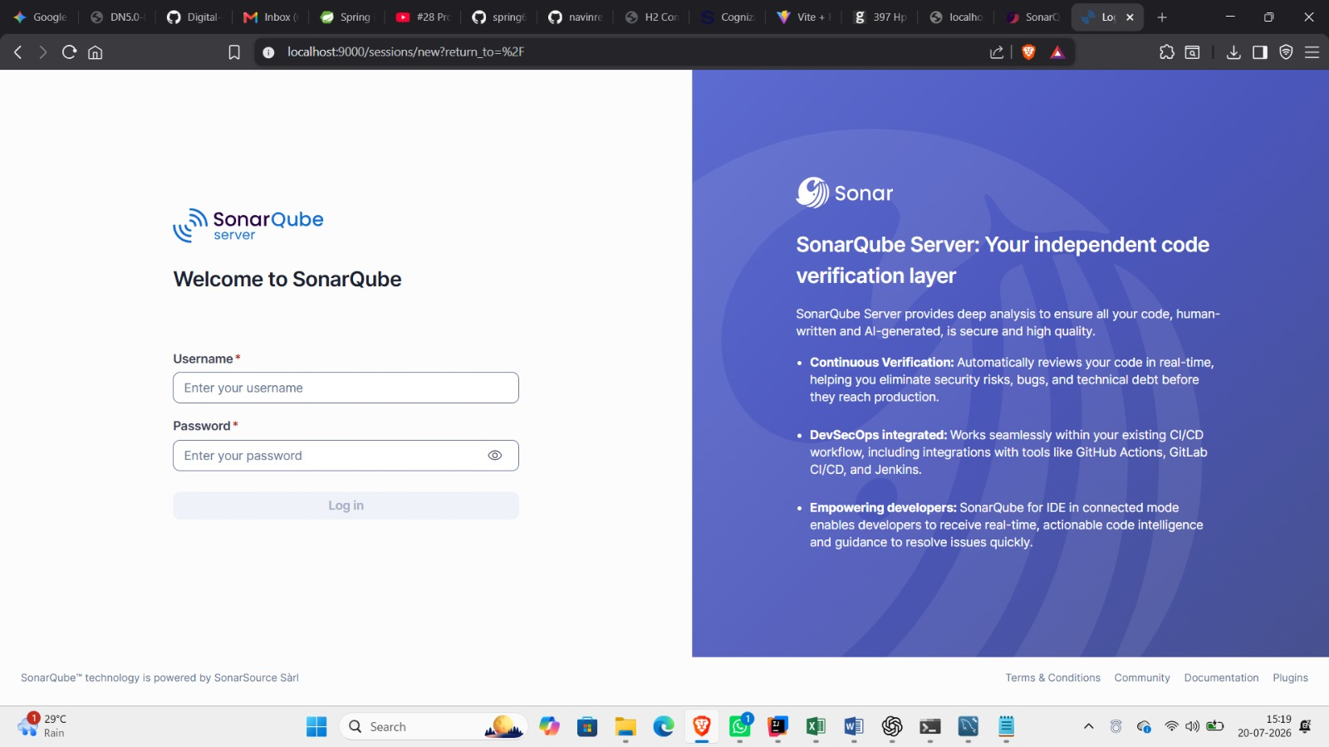

Running the Analysis: `mvn clean verify sonar:sonar
- `clean — Wipes out artifacts from any previous build (the `target/` directory), ensuring the analysis runs against a fresh build rather than stale compiled classes or reports.

- `verify` — Runs the full build lifecycle up through the verify phase, which includes compiling the code and executing unit/integration tests. This step is what actually produces the test and coverage reports that SonarQube will later consume — skipping it means SonarQube analyzes your code with no test data attached.

- `sonar:sonar` — Invokes the Sonar Maven plugin's goal, which gathers everything (source code, compiled bytecode, test results, coverage reports) and submits it as an analysis report to the SonarQube server

Interpreting Sonar Logs

The console output produced during `mvn clean verify sonar:sonar` is your first troubleshooting resource when something goes wrong:

- **Successful run** — Look for `ANALYSIS SUCCESSFUL` along with the dashboard link and, often, a "background task" URL you can check for processing status.
- **Authentication errors** — Messages like `401 Unauthorized` or `Not authorized` usually mean an invalid, expired, or missing token.
- **Connectivity errors** — Timeouts or `Connection refused` typically point to an incorrect `sonar.host.url`, a firewall/proxy blocking the connection, or the SonarQube server being down.
- **Quality Gate failures reported in CI** — If you've enabled the "wait for Quality Gate" behavior in your pipeline, the build itself will fail with a message pointing to which condition(s) weren't met; the linked dashboard gives the specifics.
- **Background task failures** — Occasionally the scanner succeeds in uploading a report, but processing fails server-side (e.g., due to a corrupted report or a server-side plugin error). The dashboard will show the analysis as failed even though the Maven build printed success

SonarQube Code Analysis

Once an analysis completes, SonarQube's real value is in the depth and specificity of what it reports. Understanding each issue category — and how to interpret it — is key to actually improving your codebase rather than just accumulating a dashboard full of red numbers.

### Duplicate Code

SonarQube scans for blocks of code that are identical or near-identical across the codebase (typically requiring a minimum number of consecutive duplicated tokens/lines to count, so trivial repetition like boilerplate getters usually isn't flagged). Duplication matters because:

- A bug fixed in one copy is often left unfixed in the others.
- It inflates the codebase and makes refactoring riskier.
- It's usually a signal that a shared function, base class, or utility should be extracted.

The dashboard reports a duplication percentage per file/project and highlights exactly which blocks match which other blocks.

### Cyclomatic Complexity

**Cyclomatic complexity** measures the number of linearly independent execution paths through a piece of code — in practice, it's calculated by counting decision points (`if`, `else if`, `for`, `while`, `case`, `&&`, `||`, `catch`, ternary expressions, etc.) plus one. Each branch adds a path the code could take, and each additional path adds to the number of test cases needed to fully exercise the method.

Spaghetti Design / Code Smells

"Code smells" is SonarQube's umbrella term for structural issues that don't necessarily cause incorrect behavior today but make the code harder to maintain and more likely to cause bugs later. Common examples include:

- Excessively long methods or classes doing too many unrelated things.
- Deeply nested conditional logic ("spaghetti" control flow that's hard to trace).
- Methods with too many parameters.
- Classes with high coupling to many other classes ("feature envy").
- Dead or unreachable code left in place.
- Magic numbers/strings instead of named constants.

Lack of Unit Tests / Coverage Metrics

SonarQube doesn't run your tests itself — it consumes coverage reports generated by tools like JaCoCo (for Java, via Maven) and displays them alongside its static analysis findings. Key metrics include:

- **Line coverage** — Percentage of executable lines exercised by at least one test.
- **Branch/condition coverage** — Percentage of decision branches (both the true and false paths of an `if`, for instance) exercised by tests.
- **Coverage on new code** — Under the "clean as you code" model, this is usually the metric that actually gates builds, rather than overall project coverage.

Low coverage doesn't mean the code is broken, but it does mean regressions in that area are less likely to be caught automatically before release.

### Improper Coding Standards

These are violations of language- and team-specific style and convention rules — naming conventions, formatting, use (or misuse) of specific language constructs, import ordering, and similar concerns. They're generally lower severity than bugs or vulnerabilities individually, but consistency across a large codebase meaningfully affects how quickly developers can read and understand code they didn't write.

### Potential Bugs and Security Vulnerabilities

SonarQube separates functional defects from security concerns:

- **Bugs** are code constructs highly likely to produce incorrect behavior — null pointer dereferences, resource leaks, off-by-one errors, incorrect exception handling, unreachable code, and similar patterns.
- **Vulnerabilities** are constructs that could be exploited — SQL injection, cross-site scripting (XSS), insecure deserialization, hardcoded credentials or secrets, weak cryptography, and insecure configuration defaults.
- **Security Hotspots** are a related-but-distinct category: code that *uses* a security-sensitive API or pattern correctly in some cases and incorrectly in others (e.g., constructing a query with string concatenation). SonarQube flags these for **manual human review** rather than auto-classifying them as a confirmed vulnerability, since determining safety often requires understanding the surrounding context.

Both bugs and vulnerabilities are assigned a severity (Blocker, Critical, Major, Minor, Info) that factors into Quality Gate evaluation.

### Insufficient Comments

SonarQube doesn't mandate a specific comment style, but it can flag files or complex methods with unusually sparse documentation — particularly where complexity is high enough that a reader would reasonably need explanation to follow the logic. This is generally treated as a lower-priority signal than bugs or vulnerabilities, more of a maintainability nudge than a hard requirement.

### Interpreting the Quality Gate

The Quality Gate condenses everything above into a single **Passed** or **Failed** verdict, based on a configured set of conditions such as:

- New Bugs ≤ 0
- New Vulnerabilities ≤ 0
- New Code Coverage ≥ 80%
- New Duplicated Lines ≤ 3%
- Security Hotspots Reviewed = 100%

**Passed** means the analyzed code (typically the "new code" since the baseline, per the clean-as-you-code model) meets every configured threshold. **Failed** means at least one condition was violated — the dashboard identifies exactly which one(s), including the actual measured value versus the required threshold, so you can see precisely what needs to change.

In a properly configured CI/CD pipeline, a failed Quality Gate should block the merge or deployment, turning SonarQube from an informational dashboard into an enforced quality checkpoint rather than something teams can quietly ignore.

