PL/SQL Assignment Report
Name: __Aditya Dixit__________________
Email:optional1618@gmail.com

Prerequisite
The required database schema and sample data were created before executing the following PL/SQL programs.

Exercise 1: Control Structures

Scenario 1
Scenario:
The bank wants to apply a discount to loan interest rates for customers above 60 years old.
Question:
Write a PL/SQL block that loops through all customers, checks their age, and if they are above 60, apply a 1% discount to their current loan interest rates.

PL/SQL Code
SET SERVEROUTPUT ON;
BEGIN
FOR cust IN (
SELECT c.CustomerID,
c.Name,
c.DOB,
l.LoanID
FROM Customers c
JOIN Loans l
ON c.CustomerID = l.CustomerID
)
LOOP

IF MONTHS_BETWEEN(SYSDATE, cust.DOB)/12 > 60 THEN

UPDATE Loans
SET InterestRate = InterestRate - 1
WHERE LoanID = cust.LoanID;

DBMS_OUTPUT.PUT_LINE(
cust.Name || ' received 1% interest discount.'
);

END IF;

END LOOP;

COMMIT;

END;
/

Screenshot 1 - DBMS Output
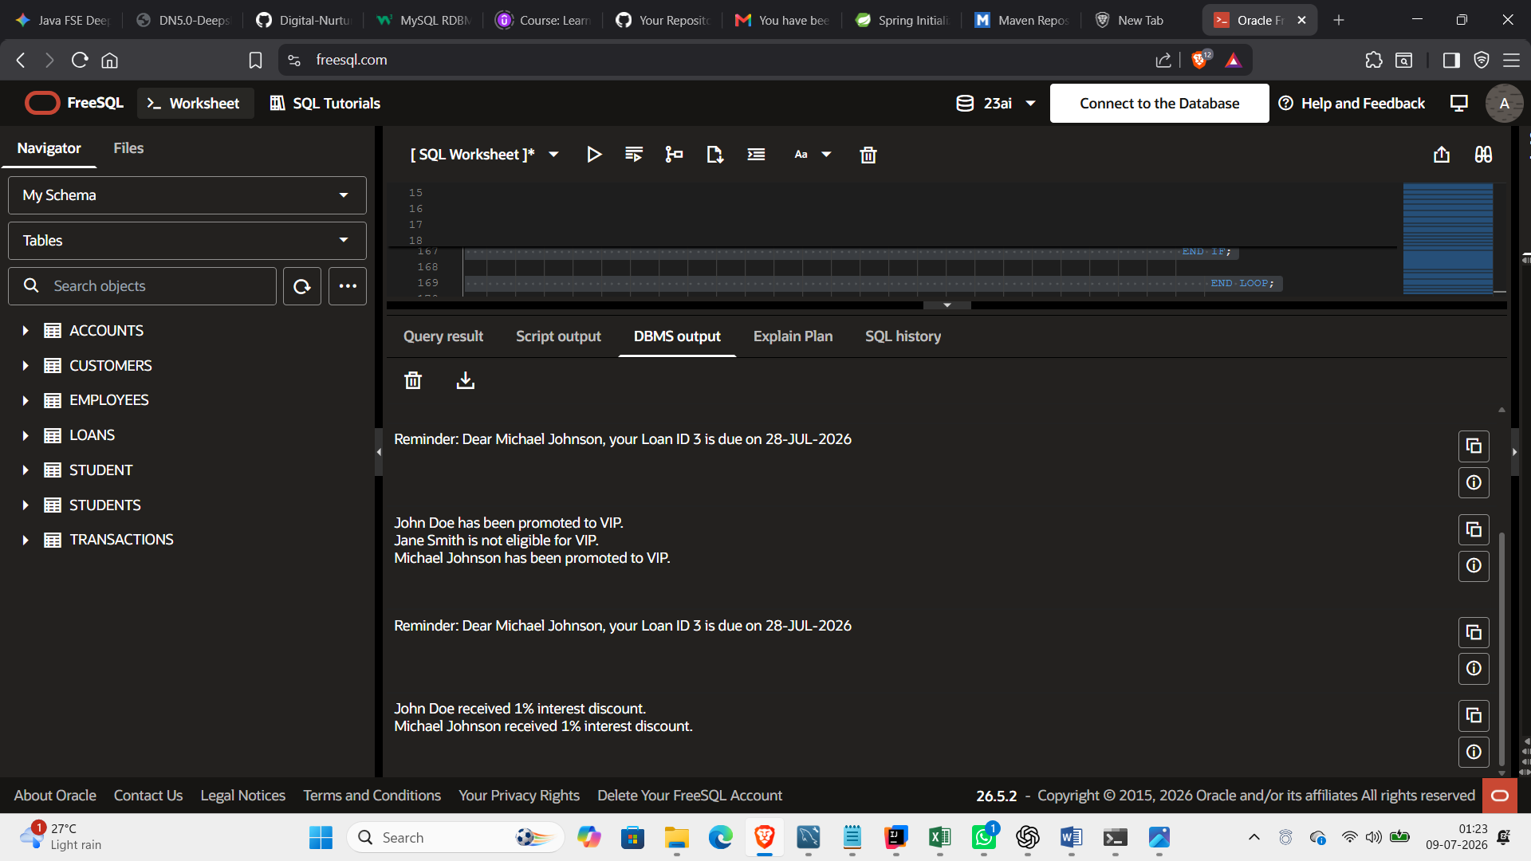

Screenshot 2 - Verification Query Output
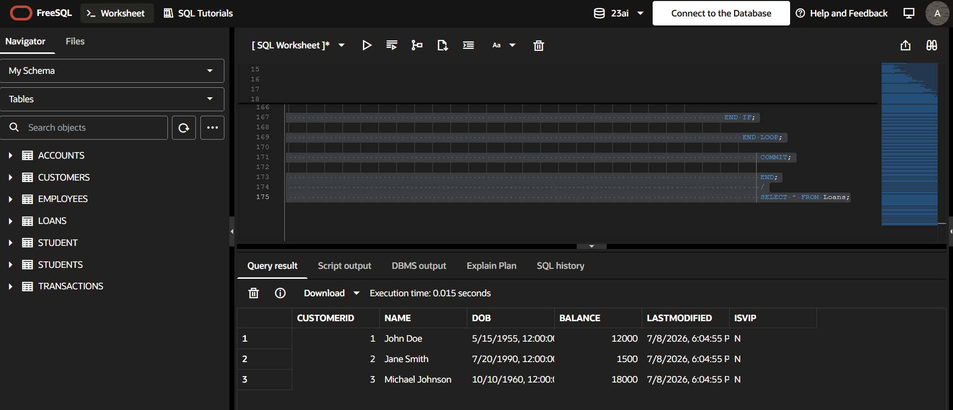

Scenario 2
Scenario:
A customer can be promoted to VIP status based on their balance.
Question:
Write a PL/SQL block that iterates through all customers and sets a flag IsVIP to TRUE for those with a balance over $10,000.

PL/SQL Code
SET SERVEROUTPUT ON;
BEGIN
FOR cust IN (
SELECT CustomerID,
Name,
Balance
FROM Customers
)
LOOP
IF cust.Balance > 10000 THEN
UPDATE Customers
SET IsVIP='Y'
WHERE CustomerID=cust.CustomerID;
DBMS_OUTPUT.PUT_LINE(
cust.Name || ' promoted to VIP.'
);
END IF;
END LOOP;
COMMIT;
END;/

Screenshot 1 - DBMS Output
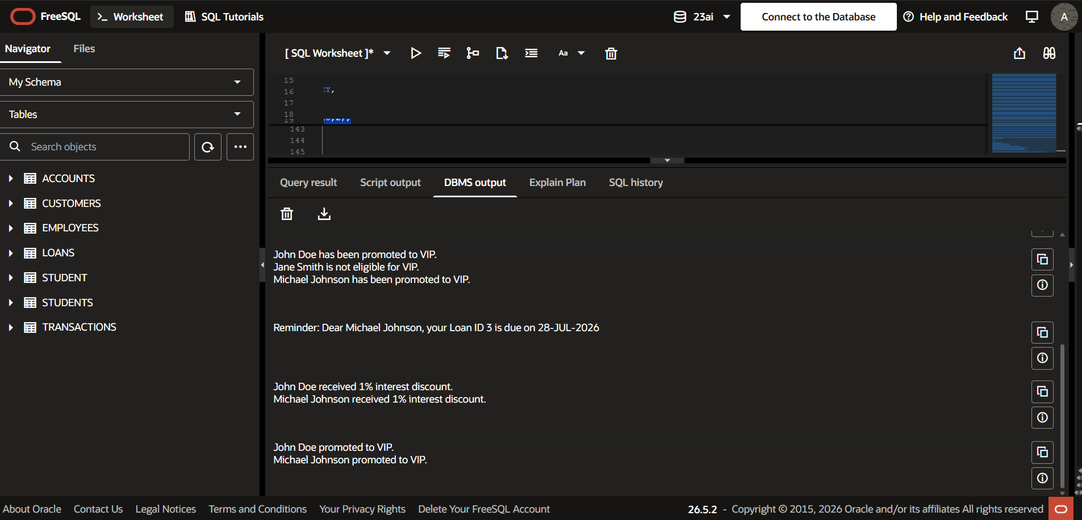

Screenshot 2 - Verification Query Output

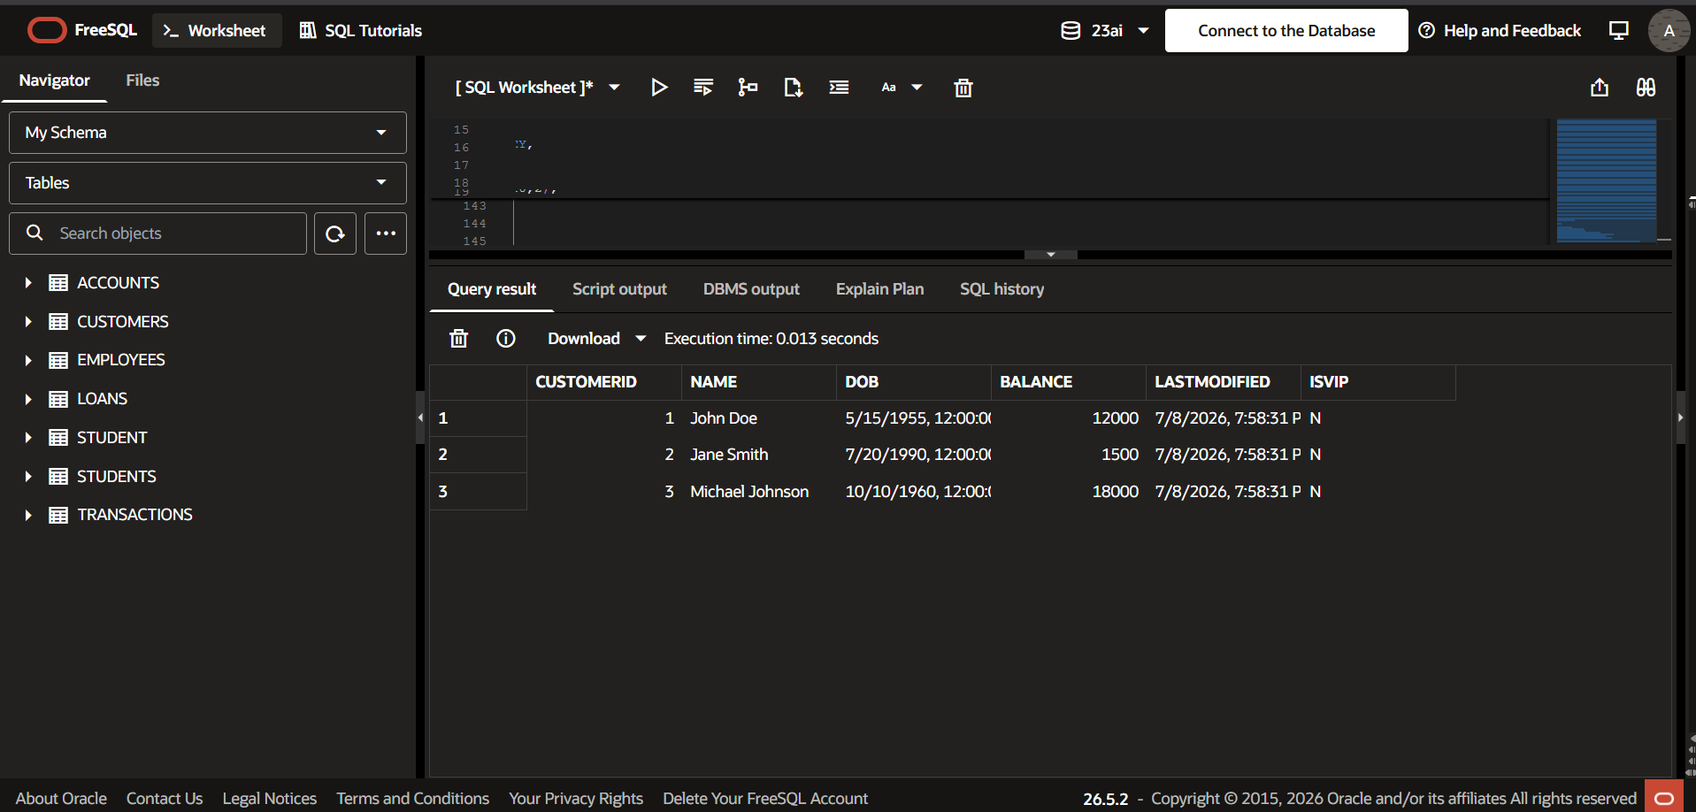

Scenario 3
Scenario:
The bank wants to send reminders to customers whose loans are due within the next 30 days.
Question:
Write a PL/SQL block that fetches all loans due in the next 30 days and prints a reminder message for each customer.

PL/SQL Code
SET SERVEROUTPUT ON;
BEGIN
FOR loan IN (
SELECT c.Name,
l.LoanID,
l.EndDate
FROM Customers c
JOIN Loans l
ON c.CustomerID=l.CustomerID
WHERE l.EndDate BETWEEN SYSDATE AND SYSDATE+30
)
LOOP
DBMS_OUTPUT.PUT_LINE(
'Reminder: Dear '
|| loan.Name
|| ', your Loan ID '
|| loan.LoanID
|| ' is due on '
|| TO_CHAR(loan.EndDate,'DD-MON-YYYY')
);END LOOP;END;/

Screenshot 1 - DBMS Output
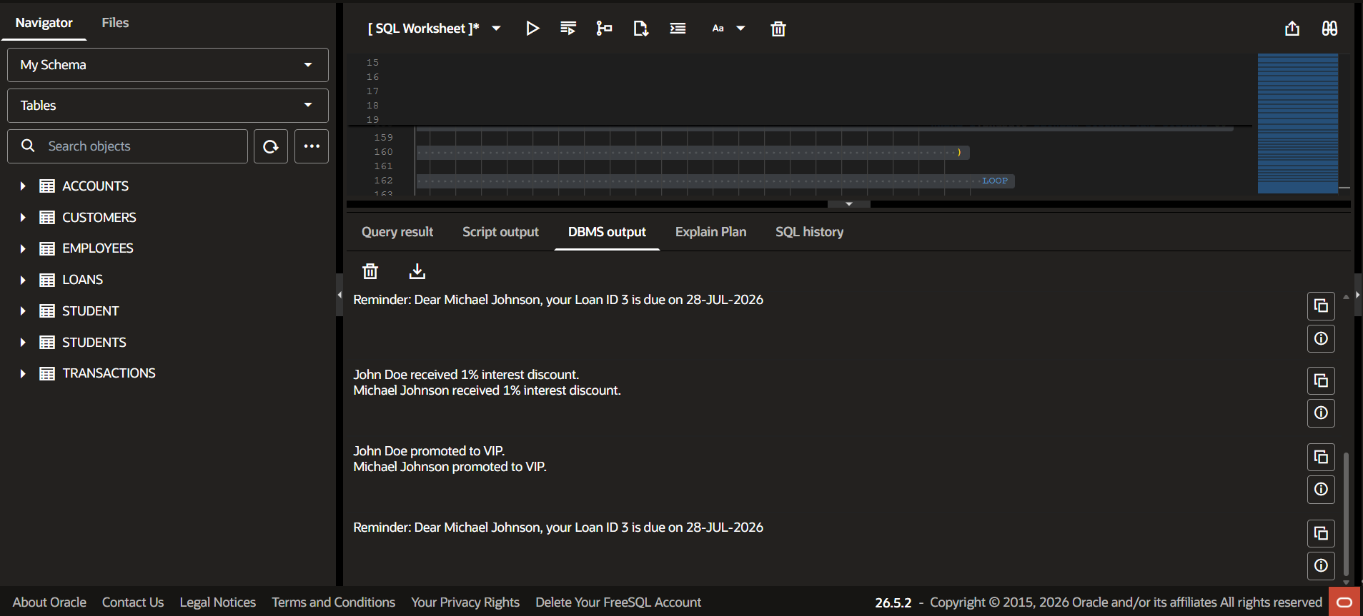
Screenshot 2 - Verification Query Output
