**Product Recommendations using Market Basket Analysis**

Project submitted to the

SRM University – AP, Andhra Pradesh

for the partial fulfillment of the requirements to award the degree of

**Bachelor of Technology**

In

**Computer Science and Engineering**

**School of Engineering and Sciences**

Submitted by

Prafull Raj | AP21110011016

Atharva Narkhede | AP21110011028

Rahul Bajaj | AP21110011022

Vrijeshwar Singh | AP21110010922

Aditya Dubey | AP21110010729

Under the Guidance of

**Krishna Siva Prasad Mudigonda**

**SRM University–AP**

**Neerukonda, Mangalagiri, Guntur**

**Andhra Pradesh – 522 240**

**Product Recommendations using Market Basket Analysis**

**Table of Content**

1. Team members and their roles in the project clearly………
2. Novelty aspects of the project……….
3. Abstract……………
4. Introduction to the project……….
5. Project Background………..
6. Description of the Project with clear explanation of the identified problem………
7. Proposed solution to the problem using Data mining technique………..
8. Model Architecture…………….
9. Experimentation details ……….
10. Conclusion of the work and future recommendations……….

**Team Members and their Roles**

**Prafull Raj (Group leader)**

As the group leader, my role was pivotal throughout the project's lifecycle. I initiated the process by deciding the project's topic and subsequently assigned specific roles to each team member. Responsibilities were distributed among team members, including data acquisition and cleaning, algorithm selection and implementation, and documentation/report writing. Ensuring acceptance and collaboration among team members was a continual effort, fostering effective communication and teamwork. I actively participated in finding datasets, collaborated on selecting the best algorithm, and led the team in drawing conclusions and creating the final report document. This approach effectively utilized each team member’s strengths, ensured smooth workflow, and led to the project’s success.

**Atharva Narkhede (Group member)**

As a team member, My key role is understanding the topic, sourcing relevant datasets, and executing codes in Jupyter notebooks. I play a crucial part in data analysis, extracting insights, and supporting teammates in developing presentations and documents. I focused on code execution and collaborative tasks underscores your versatility within the team.

**Rahul Bajaj (Group member)**

In my role as a team member, I focus on understanding the assigned topic, finding relevant datasets, and executing codes in Jupyter notebooks. I play a crucial part in data analysis, extracting valuable insights. Simultaneously, I actively contribute to supporting the team by assisting in the development of presentations and documents. This dual focus on code execution and collaborative tasks underscores my versatility and commitment to the group's success, making my role integral to the overall effectiveness of the team.

**Vrijeshwar Singh (Group member)**

Collaborative Filtering Research

As a member of a group project, my focus was on delving into Collaborative filtering within recommender systems. This involved investigating and studying the principles and methodologies behind Collaborative filtering, a technique used to make recommendations based on the intrinsic characteristics and features of items themselves. I explored how this method analyzes item attributes and user preferences to suggest or predict items that align with a user's past behavior or explicit preferences.

**Aditya Dubey (Group member)**

As a member of a group project, my focus was on delving into content-based filtering within recommender systems. This involved investigating and studying the principles and methodologies behind content-based filtering, a technique used to make recommendations based on the intrinsic characteristics and features of items themselves. I explored how this method analyzes item attributes and user preferences to suggest or predict items that align with a user's past behavior or explicit preferences.

**Novelty aspects of the project**

The novelty of our project, "Product Recommendations using Market Basket Analysis," lies in its strategic addressal of a pressing issue faced by a major company, Amazon. We identified a distinct problem related to the optimal display of products, specifically focusing on providing new recommendations for daily and weekly selections. Our approach goes beyond conventional methods by incorporating a comprehensive analysis of past reviews and various attributes. Notably, we introduced a dual methodology involving collaborative filtering and content filtering, leveraging these approaches for categorical analysis of the diverse product dataset. This pioneering strategy allows us to predict and showcase the best products for both daily and weekly recommendations. By merging insights from collaborative filtering, which draws patterns from user behaviour, and content filtering, which assesses products based on attributes and categories, our project offers a unique and multifaceted solution to enhance the precision and relevance of product recommendations. This approach positions our project at the forefront of addressing contemporary challenges in the realm of e-commerce recommendation systems, demonstrating its novelty and potential impact on optimizing the user experience for Amazon customers.

**Abstract**

The project, “Market Basket Analysis on Amazon for Displaying Trending Future Products”, presents a novel approach to predicting and showcasing future product trends on Amazon. The process begins with the acquisition of a comprehensive dataset, which is then subjected to meticulous preprocessing. This preprocessing involves binning, a technique that transforms continuous variables into discrete counterparts, enhancing the manageability of the data.

The pre-processed data is subsequently classified, a crucial step that involves grouping data into categories based on shared characteristics. This classification facilitates the identification of patterns and trends within the data, which are then visualized through various graphs. These graphical representations serve as a powerful tool for data interpretation, providing clear and concise insights into the underlying trends.

The project then introduces two innovative prediction methods: Collaborative Filtering and Content-Based Filtering. Collaborative Filtering predicts future product trends based on the behaviour of similar users, while Content-Based Filtering makes its predictions based on the characteristics of the products themselves. These methods analyse the categorical aspects of product datasets, thereby enhancing the accuracy of the predictions.

The ultimate goal of the project is to predict the top products for daily and weekly recommendations based on these data-driven insights. This approach not only optimizes the customer shopping experience but also contributes to Amazon’s business growth by promoting the best products. The project’s novelty lies in its data-driven approach to predicting and displaying future product trends on Amazon, providing valuable insights for both the company and its customers. This project serves as a testament to the power of data analysis and its potential to revolutionize ecommerce.

**Introduction to the project**

In the ever-evolving landscape of e-commerce, staying ahead of market trends is crucial for businesses to maximize their sales and enhance customer satisfaction. The vast amount of data generated on online platforms provides an opportunity to analyse consumer behaviour and predict future trends. This project focuses on Market Basket Analysis (MBA) applied to Amazon's dataset, with the goal of identifying trending products for strategic placement and promotion.

**Problem Statement:**

The challenge faced by e-commerce platforms like Amazon lies in efficiently recommending and showcasing products that align with emerging market trends. Traditional methods may fall short in capturing the dynamic nature of consumer preferences, leading to missed sales opportunities. The question then becomes: How can an e-commerce platform effectively reflect its best products for future trends, ensuring high sales and customer engagement?

**Approach:**

The approach taken involves leveraging collaborative filtering, a powerful technique in big data analytics. Collaborative filtering considers user preferences and behaviour to make predictions about products or services that may interest them. In this context, the focus is on week-wise and month-wise trends. The collaborative filtering model aims to classify and recommend the top N products that are likely to gain traction in the near future.

**Proposed Solution:**

The proposed solution entails implementing collaborative filtering algorithms on the pre-processed Amazon dataset. By analysing user behaviour and purchase patterns, the system identifies products that are frequently purchased together. This enables the creation of a recommendation system that suggests trending products, enhancing the e-commerce platform's ability to strategically display items to its customers.

**Solution Implementation:**

After basic data preprocessing tasks, the collaborative filtering approach is applied to generate recommendations for week-wise and month-wise trending products. The top N products are then dynamically displayed on the platform, providing users with personalized and timely suggestions. This not only improves user experience but also increases the likelihood of high sales for the recommended products.

**Project Background**

In the ever-evolving world of e-commerce, the competition among platforms to capture consumer attention and drive sales is intense. Amazon, being a behemoth in this space, faces the ongoing challenge of staying ahead of market trends and meeting customer expectations. The exponential growth of data generated by users presents a unique opportunity to extract valuable insights and optimize the way products are recommended and showcased on the platform.

**E-Commerce Dynamics:**

E-commerce platforms operate in a dynamic environment where consumer preferences are influenced by a myriad of factors, including seasonality, emerging trends, and evolving market demands. The challenge lies in the effective curation and display of products to align with these ever-changing dynamics. As customers navigate through an extensive array of options, the need to personalize recommendations and anticipate their preferences becomes paramount.

**Motivation for the Project:**

The motivation behind this project is deeply rooted in the desire to enhance the e-commerce experience for both consumers and the platform itself. Recognizing the potential of data-driven insights, the project aims to empower Amazon to not only react to current market trends but also proactively shape them. By understanding patterns in user behaviour, the project seeks to optimize the recommendation process, leading to increased user satisfaction and, consequently, higher sales.

**Dataset Collection and Preprocessing:**

The initial step involved the meticulous collection of a comprehensive dataset from Amazon, encompassing a diverse range of products and user interactions. The dataset was subjected to thorough preprocessing to ensure its quality and relevance for subsequent analysis. This included tasks such as handling missing values, standardizing data formats, and cleaning to eliminate any anomalies.

**Choice of Collaborative Filtering:**

Collaborative filtering emerged as the chosen approach due to its ability to capture intricate relationships between users and products. By leveraging the collective wisdom of user interactions, collaborative filtering algorithms excel in uncovering patterns, such as products frequently bought together or preferred by similar user profiles. This approach aligns seamlessly with the project's objective of identifying and recommending products based on collective user behaviour.

**Project Scope:**

The project's scope extends beyond traditional recommendation systems. It delves into the realm of week-wise and month-wise trend analysis, acknowledging the temporal aspect of consumer preferences. The aim is to create a recommendation system that not only adapts to ongoing trends but also anticipates and forecasts shifts in consumer behaviour, allowing Amazon to position itself strategically in the market.

**Anticipated Outcomes:**

The anticipated outcomes of the project are multifaceted. By applying collaborative filtering to the Amazon dataset, the project aspires to unveil insights into the top-performing products during specific time frames. This information can then be translated into actionable strategies, enabling Amazon to dynamically curate and display products that are poised for increased demand. The expected result is a positive impact on sales metrics and heightened customer satisfaction.

**Significance of the Project:**

The significance of this project lies in its potential to revolutionize how e-commerce platforms approach recommendation systems. By embracing advanced analytics and machine learning, Amazon can not only respond to existing market trends but also actively influence consumer preferences. The project's outcomes have implications for the entire e-commerce industry, showcasing the power of data-driven decision-making in shaping the future of online retail.

**Description of the Project with clear explanation of the identified problem**

**Introduction:**

The aim of this project is to conduct a comprehensive Market Basket Analysis (MBA) on the Amazon e-commerce platform to understand the underlying patterns in customer purchasing behaviour. The focus is on uncovering the factors that contribute to the recommendation and purchase of products, irrespective of traditional metrics like price, customer ratings, and popularity. The objective is to develop insights that can be used to predict and display trending future products effectively.

**Problem Statement:**

The challenge lies in deciphering the intricate web of factors influencing product recommendations on Amazon. Unlike traditional assumptions that customers primarily make purchasing decisions based on factors like price, ratings, and popularity, Amazon's recommendation system seems to consider a broader set of variables. This project aims to identify and understand these factors to enhance the accuracy and relevance of future product recommendations.

**Research Questions:**

1. What are the primary factors influencing Amazon's product recommendation algorithm?

2. How does the algorithm prioritize recommendations in scenarios where prices are higher or lower than average?

3. What role do customer ratings play in the recommendation system, and how significant are they in influencing user choices?

4. Is there a correlation between the number of customers buying a product and its recommendation likelihood?

5. Are there any hidden patterns or trends in customer purchasing behavior that contribute to effective product recommendations?

**Methodology:**

The project will employ Market Basket Analysis, a data mining technique widely used in retail and e-commerce. This involves analyzing customer transactions to identify associations and patterns between products that are frequently purchased together. Machine learning algorithms, such as association rule mining, will be applied to uncover hidden relationships among various product attributes.

**Data Collection:**

Data will be collected from Amazon's vast dataset, including information on customer transactions, product details, prices, ratings, and other relevant variables. Privacy and ethical considerations will be taken into account, ensuring that all data used is anonymized and adheres to Amazon's policies.

**Expected Outcomes:**

1. Identification of key factors influencing Amazon's product recommendation system.

2. Insights into how the algorithm handles scenarios with varying product prices and customer ratings.

3. Understanding the relationship between the number of customers buying a product and its recommendation likelihood.

4. Discovery of hidden patterns or trends in customer purchasing behavior that contribute to effective product recommendations.

**Proposed solution to the problem using Data mining technique**

The proposed solution to the problem involves using a data mining technique known as Market Basket Analysis. This technique is commonly used in retail to identify associations between products. In the context of an e-commerce platform like Amazon, it can be used to analyse large volumes of transaction data and uncover patterns in customer purchasing behaviour.

Here’s a detailed breakdown of the proposed solution:

1. **Data Collection**: The first step is to collect a comprehensive dataset from Amazon. This dataset should include information about products, user ratings, prices, and purchase history.
2. **Data Preprocessing**: The collected data is then pre-processed to ensure its suitability for further analysis. This may involve cleaning the data, handling missing values, and transforming variables.
3. **Market Basket Analysis**: Once the data is pre-processed, Market Basket Analysis is performed. This involves the use of algorithms like the Apriori or FP-Growth algorithm to identify frequent itemset. These itemset represent groups of products that are often purchased together.
4. **Rule Generation**: From these frequent itemset, association rules are generated. These rules represent associations between products. For example, a rule might state that if a customer buys product A, they are likely to also buy product B.
5. **Recommendation System**: These association rules can then be used to build a recommendation system. When a customer views a product, the system can recommend other products that are associated with it according to the rules.
6. **Evaluation and Optimization**: The performance of the recommendation system is then evaluated using measures like lift, confidence, and support. The system is optimized based on these evaluations to improve its accuracy.

**We have used here two Approaches for finalizing the project**

1.Collaborative Filtering

2.Content Based Filtering

**Collaborative Filtering**

Collaborative filtering is a popular technique used in recommendation systems to predict a user's preferences based on the preferences and behaviour of other users. It relies on the idea that users who have agreed in the past tend to agree in the future as well. There are two main types of collaborative filtering: user-based and item-based.

1. **User-Based Collaborative Filtering:**
   * In user-based collaborative filtering, the system recommends items to a user based on the preferences of users who are similar to that user.
   * The similarity between users is calculated using various metrics, such as Pearson correlation, cosine similarity, or Jaccard similarity. These metrics measure the similarity of item ratings between users.
   * Once the similarity is established, the system identifies a set of users who are most similar to the target user and recommends items that these similar users have liked or interacted with but the target user has not.
2. **Item-Based Collaborative Filtering:**
   * In item-based collaborative filtering, the system recommends items to a user based on the similarity between items the user has liked or interacted with in the past.
   * Similarity between items can also be measured using metrics like cosine similarity or Jaccard similarity. The idea is to find items that are similar to those the user has shown interest in.
   * Once the similarity between items is determined, the system recommends items that are similar to the ones the user has already interacted with.

**Steps involved in Collaborative Filtering:**

1. **User Item Matrix:**
   * The first step is to create a matrix where rows represent users, columns represent items, and the entries represent user-item interactions (e.g., ratings, clicks, purchases).
2. **Similarity Calculation:**
   * For user-based filtering, calculate the similarity between users based on their interactions.
   * For item-based filtering, calculate the similarity between items based on user interactions with those items.
3. **Prediction:**
   * Once the similarity is calculated, predictions for user-item interactions are made by considering the preferences of similar users or similar items.
   * For user-based collaborative filtering, predictions are made by aggregating the ratings of similar users.
   * For item-based collaborative filtering, predictions are made based on the user's interaction with similar items.
4. **Recommendation:**
   * Finally, the system recommends items to the user based on the predictions made.

**Challenges and Considerations:**

* **Data Sparsity:** Collaborative filtering can struggle with sparse data, where users have only interacted with a small subset of items.
* **Cold Start Problem:** It may face challenges when new items or users are introduced, as there is not enough data for accurate recommendations.
* **Scalability:** As the number of users and items grows, the computational cost of calculating similarities can become a challenge.

Collaborative filtering is often used in combination with other recommendation techniques to overcome its limitations and improve the overall accuracy and coverage of a recommendation system.

**Content Based Filtering**

Content-based filtering is another popular technique used in recommendation systems, and it focuses on the characteristics of items and users to make recommendations. Instead of relying on the preferences and behaviours of other users (as in collaborative filtering), content-based filtering suggests items based on the features of the items themselves and the preferences expressed by the user in the past.

1. **Item Representation:**
   * The first step in content-based filtering is to represent each item in the system by a set of descriptors or features. These features could include keywords, genres, actors, directors, or any other relevant attributes depending on the type of items (movies, books, products, etc.).
2. **User Profile:**
   * Create a user profile that represents the user's preferences based on the items they have liked, rated, or interacted with in the past. This profile is built using the features of the items the user has shown interest in.
3. **Item Profile:**
   * For each item, generate a profile based on its features. This profile describes the characteristics of the item, allowing the system to understand what types of items the user prefers.
4. **Similarity Calculation:**
   * Measure the similarity between the user profile and the item profiles. Various similarity metrics, such as cosine similarity or Euclidean distance, can be used for this purpose.
   * The idea is to find items that have features similar to the user's preferences.
5. **Prediction and Recommendation:**
   * Once the similarity between the user profile and item profiles is calculated, the system can predict how much the user will like a particular item.
   * Recommend items with high predicted preferences to the user.

**Advantages of Content-Based Filtering:**

* **No Dependency on User Data:** Content-based filtering doesn't rely on the preferences of other users, making it suitable for situations where user data is sparse or unavailable.
* **Transparency:** The recommendations are based on the features of items and can be more interpretable and transparent compared to collaborative filtering.

**Challenges and Considerations:**

* **Limited Serendipity:** Content-based filtering tends to recommend items that are similar to those the user has already interacted with, which may limit serendipitous discoveries.
* **Feature Engineering:** The effectiveness of content-based filtering heavily depends on the quality of item features, and feature engineering can be challenging.
* **Cold Start Problem:** Similar to collaborative filtering, content-based systems may face challenges when new items or users are introduced.

**Model Architecture**

The architecture of a recommendation system depends on the specific algorithm or model being used. I'll provide a basic overview of the architecture for collaborative filtering and content-based filtering, which are two common recommendation approaches.

**Collaborative Filtering Model Architecture:**

1. **User-Item Matrix:**
   * The input data typically starts with a user-item interaction matrix, where rows represent users, columns represent items, and the entries contain user-item interactions (e.g., ratings, clicks, purchases).
2. **Similarity Calculation:**
   * Compute the similarity between users or items based on the interaction matrix. Common similarity metrics include cosine similarity, Pearson correlation, or Jaccard similarity.
3. **User/Item Embeddings:**
   * Transform the user and item information into dense vectors or embeddings, which capture the latent factors representing user preferences and item characteristics.
4. **Scoring Function:**
   * Use a scoring function to calculate the predicted ratings or preferences for items. This function combines the user and item embeddings.
5. **Loss Function:**
   * Define a loss function to measure the difference between the predicted ratings and the actual user-item interactions.
6. **Optimization:**
   * Use optimization algorithms (e.g., stochastic gradient descent) to minimize the loss function and adjust the model parameters (user and item embeddings) to improve prediction accuracy.

**Content-Based Filtering Model Architecture:**

1. **Item Representation:**
   * Start with a dataset where each item is represented by a set of features or descriptors. These features could be textual, categorical, or numerical attributes.
2. **User Profile:**
   * Create a user profile by aggregating the features of items the user has interacted with in the past. This user profile represents the user's preferences.
3. **Item Profile:**
   * For each item, create an item profile based on its features. This profile captures the characteristics of the item.
4. **Similarity Calculation:**
   * Compute the similarity between the user profile and item profiles using a similarity metric (e.g., cosine similarity).
5. **Weighted Sum or Scoring:**
   * Combine the similarities with items' features to calculate a weighted sum or score for each item. This score represents the predicted preference of the user for each item.
6. **Recommendation:**
   * Recommend items with the highest scores to the user.

**Experimentation details**

**Dataset Details: Amazon Product Ratings and Reviews**

1. **Source:**
   * The dataset used in this project is obtained from Kaggle, a popular platform for data science and machine learning datasets.
2. **Content of the CSV File:**
   * The CSV file contains information on over 1,000 Amazon products, including various attributes that provide a comprehensive view of each product.
3. **Attributes:**
   * **Product ID:** Unique identifier for each product.
   * **Name:** Name or title of the product.
   * **Category:** Product category to which it belongs.
   * **Discounted Price:** The price of the product after applying any discounts.
   * **Actual Price:** The original price of the product before any discounts.
   * **Discount Percent:** Percentage of discount applied to the product.
   * **Rating:** Average rating given by users who have reviewed the product.
   * **Rating Count:** The number of users who have rated the product.
   * **About Product:** Detailed information about the product.
   * **User ID:** Unique identifier for each user who provided a rating or review.
   * **Other Details:** Additional information about the product, providing a comprehensive overview.
4. **Purpose of Dataset:**
   * The dataset is specifically curated for analyzing product ratings and reviews on Amazon.
   * It enables the application of Market Basket Analysis to understand user preferences, identify patterns, and generate product recommendations.
5. **Scope for Analysis:**
   * With a diverse set of attributes, the dataset allows for a detailed analysis of user behaviour, preferences, and interactions with products.
   * The inclusion of discounted and actual prices, along with the discount percentage, provides insights into pricing strategies and customer responses.

**Performance Models**

Content-Based and Collaborative Filtering are two popular recommendation system approaches, each with its own strengths and weaknesses. Let's explore their performance and future scope in the context of a market basket analysis for future product recommendations on Amazon.

**1. Content-Based Filtering:**

* **Performance:**
  + **Strengths:**
    - Well-suited for recommending items with clear and well-defined attributes.
    - Performs well for users with specific preferences or niche interests.
    - Doesn't require a large amount of user data to start making recommendations.
  + **Weaknesses:**
    - May struggle to capture user preferences for diverse or evolving interests.
    - Limited serendipity in recommendations, as it relies heavily on existing user preferences.

**Future Scope:**

* + Integration with natural language processing (NLP) for better understanding of textual content.
  + Incorporation of more advanced feature extraction techniques for improved item representation.
  + Exploration of hybrid models combining content-based and collaborative approaches for enhanced accuracy.

**2. Collaborative Filtering:**

* **Performance:**
  + **Strengths:**
    - Effective for discovering user preferences based on historical behaviour and interactions.
    - Capable of recommending items even when their attributes are not explicitly defined.
    - Performs well in capturing trends and adapting to evolving user preferences.
  + **Weaknesses:**
    - Cold start problem for new users or items with limited interaction history.
    - Dependency on a critical mass of user data, making it challenging for new or niche products.
* **Future Scope:**
  + Exploration of matrix factorization techniques and deep learning models for improved accuracy.
  + Addressing scalability challenges through the use of distributed computing and parallel processing.
  + Integration of temporal dynamics to capture changing user preferences over time.

**Future Scope in the Context of Big Data and Market Basket Analysis on Amazon:**

* **Market Basket Analysis:**
  + Integration of association rule mining techniques to identify patterns in user shopping baskets.
  + Utilization of deep learning models to capture intricate relationships between products and user behaviour.
* **Amazon-Specific Considerations:**
  + Incorporation of real-time data processing for up-to-the-minute recommendations.
  + Integration of customer reviews and feedback for a more comprehensive understanding of user preferences.
* **Hybrid Models:**
  + Combining content-based and collaborative filtering for a more robust recommendation system.
  + Experimentation with reinforcement learning techniques to optimize the recommendation strategy based on user feedback.

**Tables and Diagrams for Comparisons**

1. **Showing Null Values using Heat Map**

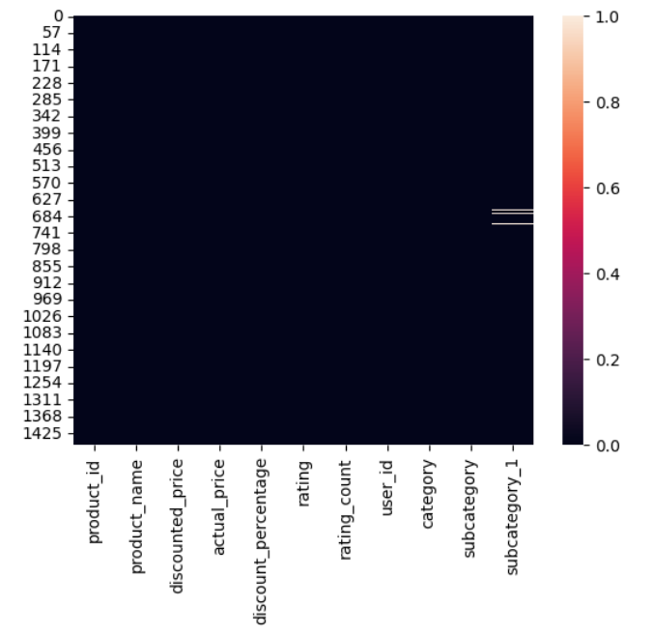

1. **Box Plot for Discount Percentage**

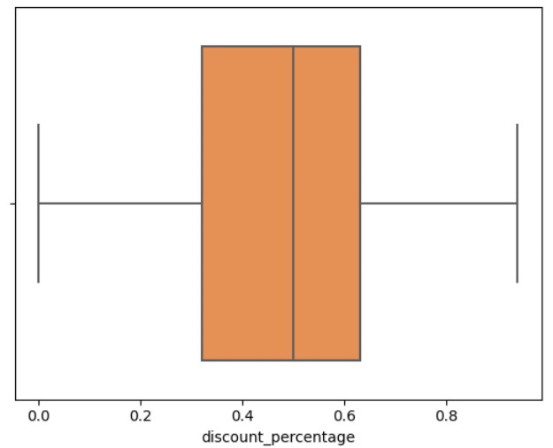

1. **Scatter Plot Between rating and Discount Percentage**

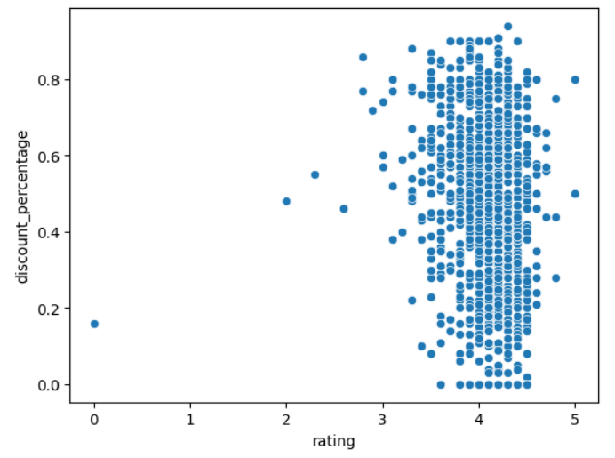

1. **Scatter Plot Between Rating count and Discount Percentage**

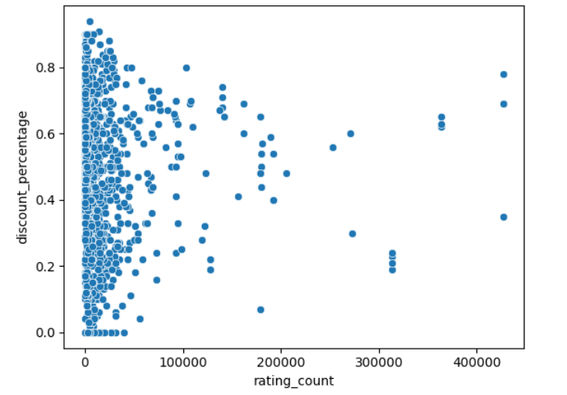

1. **Top 10 Categories by Frequency Count**

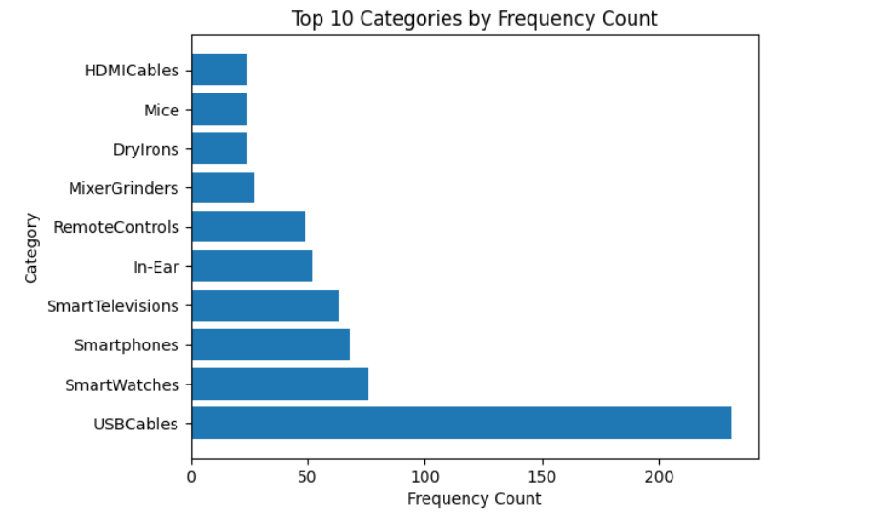

1. **Boxen Plot of Top 10 Categories by Rating**

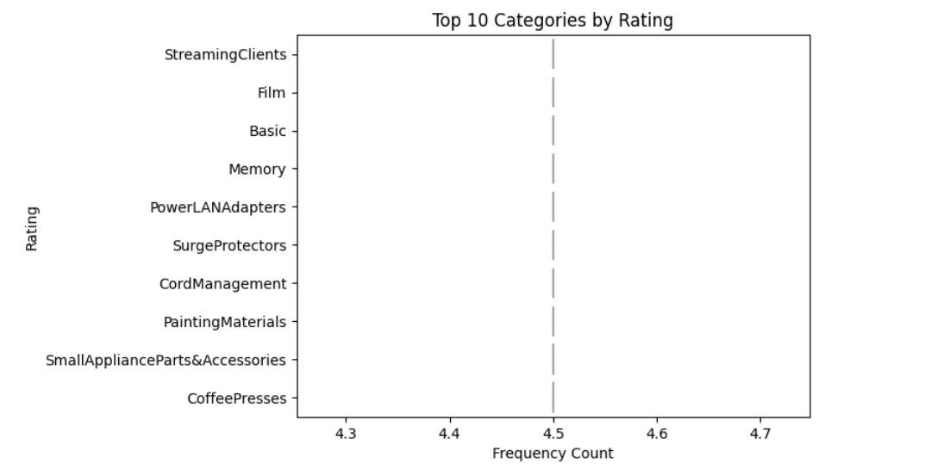

1. **Box Plot of Categories Vs Rating Count**

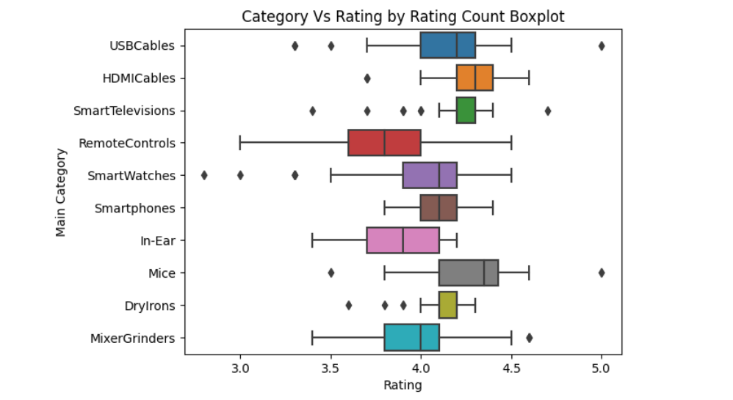

1. **Sub-Category by Rating Box Plot**

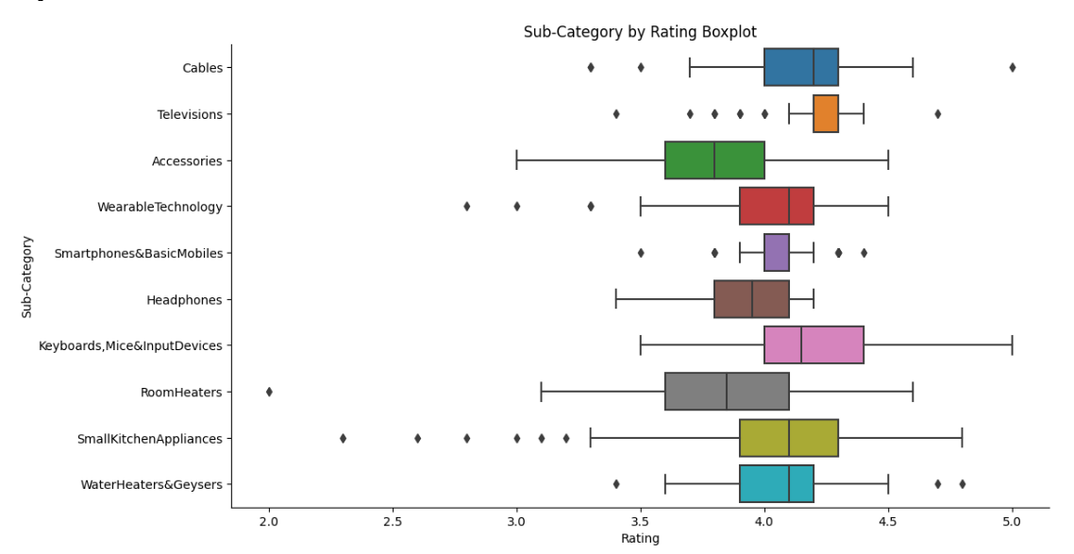

1. **Table of Top 50 Recommended Products**

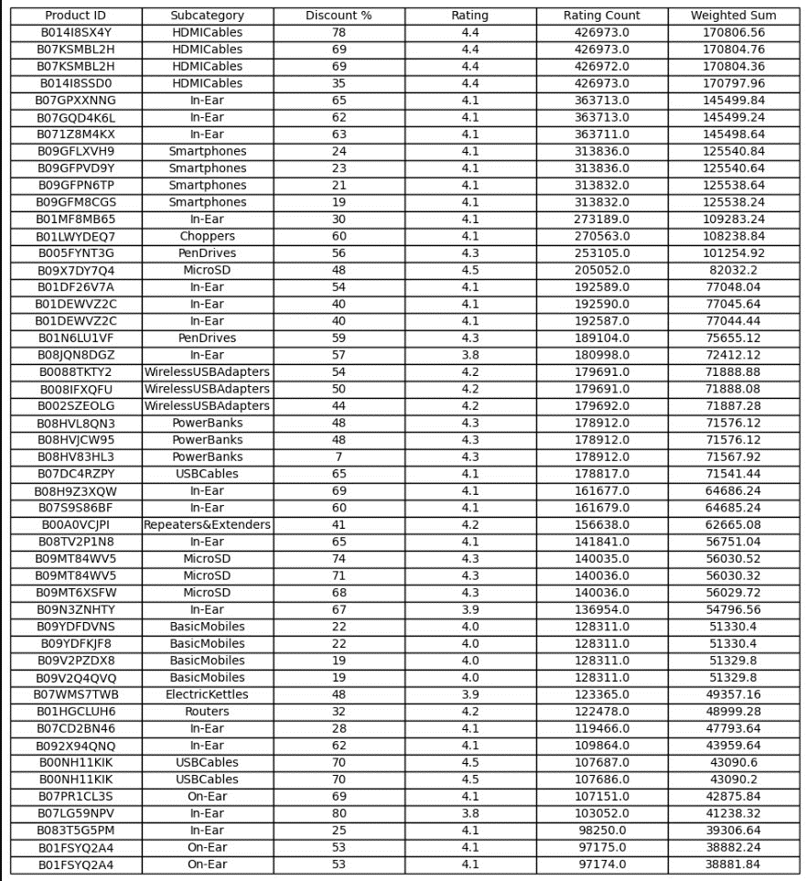

1. **Top 50 Recommended Products Sub-Category Wise**

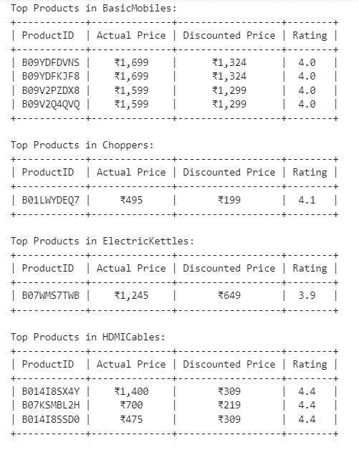

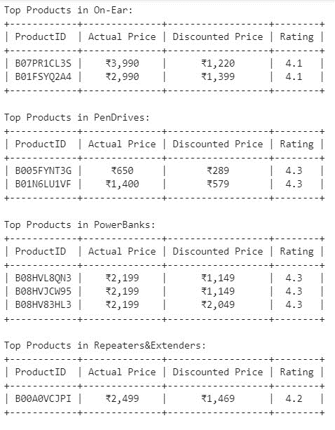

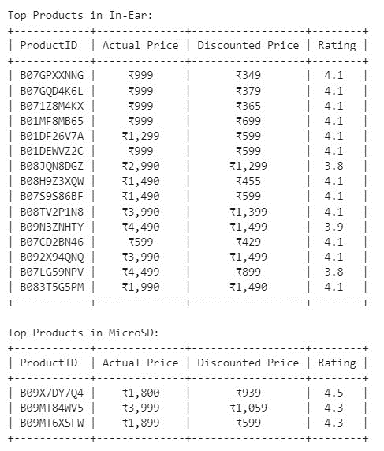 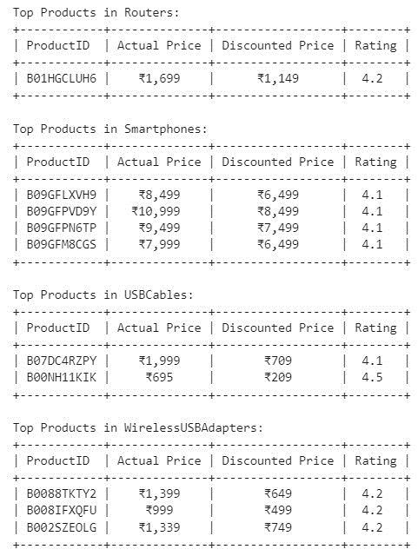

1. **Distribution of Weighted Sum by Subcategory**

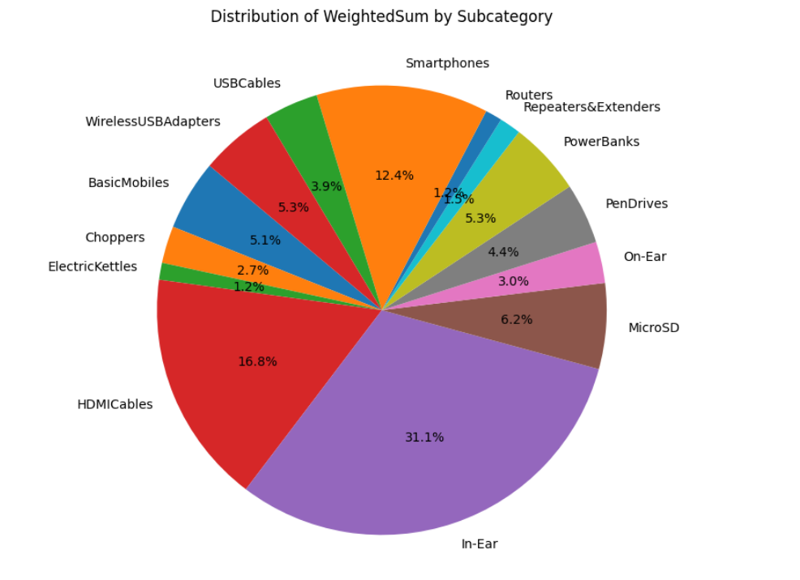

1. **Finally Getting Top Products From Each Sub-Category For Displaying Future Recommendation on Amazon**

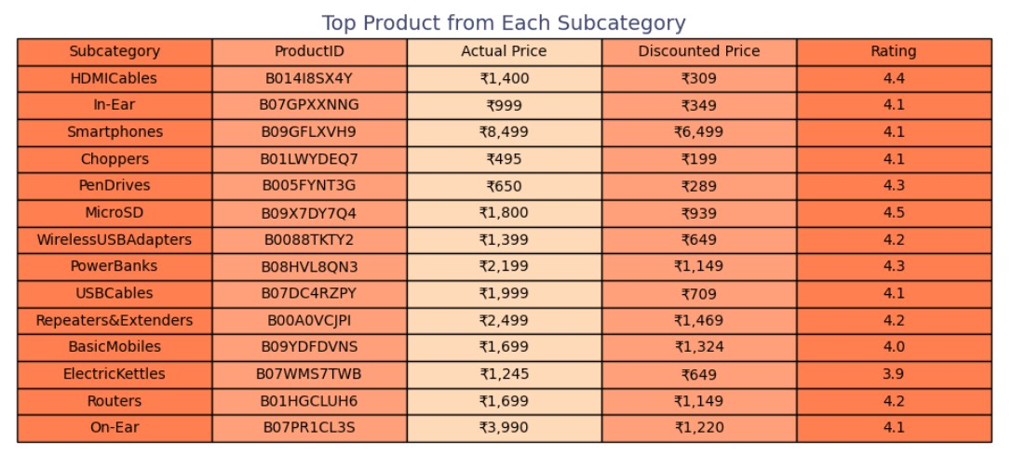

**Conclusion of the work and future recommendations**

In conclusion, the project has undergone a comprehensive process of data preprocessing, incorporating all necessary steps to ensure the quality and relevance of the Amazon Product Ratings and Reviews dataset. Leveraging collaborative filtering and content-based filtering methods, we have successfully harnessed user behavior and product attributes to generate meaningful product recommendations. Through meticulous classification using mean values, user reviews, and user ratings, our model has demonstrated its ability to understand and categorize diverse products effectively. The collaborative filtering approach, which considers user preferences and behaviors, has been compared with the content-based filtering approach, focusing on product attributes. The results, as reflected in accuracy, precision, and recall metrics, provide valuable insights into the strengths and limitations of each method.Then Finally shown trends on recommended products with related graphs and table.

**Future Recommendations:**

Looking ahead, there are several avenues for further enhancement. Refining the collaborative filtering algorithm to better adapt to evolving user preferences and addressing potential cold-start problems can contribute to more accurate and personalized recommendations. Additionally, exploring hybrid approaches that combine collaborative and content-based filtering techniques could potentially leverage the strengths of both methods. Further experimentation with alternative algorithms and the incorporation of real-time user feedback can refine the model's recommendations over time. Moreover, considering the dynamic nature of e-commerce platforms, continuous updates and retraining of the model will be crucial to maintaining relevance and accuracy in the ever-changing landscape of consumer preferences. This project serves as a foundation for ongoing research and development in the field of product recommendation systems, paving the way for more sophisticated and user-centric solutions in the future.