Deep Learning Demand Forecasting for Ride-Hailing Platforms to Optimize Driver Allocation for Unstructured Data in Massive Datasets
A PROJECT REPORT

Submitted by
BL.EN.U4CSE22009 - Aditya Elango
BL.EN.U4CSE22025 - Hardik Gupta
BL.EN.U4CSE22038 - Nishanth Reddy Kuraku
BL.EN.U4CSE22045 - Parikshith Sivakumar

19CSE353 : Mining of massive datasets

AMRITA SCHOOL OF COMPUTING, BENGALURU
AMRITA VISHWA VIDYAPEETHAM
BENGALURU 560 035
November 2025
ACKNOWLEDGEMENTS

The satisfaction that accompanies successful completion of any task would be incomplete without mention of people who made it possible, and whose constant encouragement and guidance have been source of inspiration throughout the course of this project work.
We offer our sincere pranams at the lotus feet of “AMMA”, MATA AMRITANANDAMAYI DEVI who showered her blessing upon us throughout the course of this project work.
We owe our gratitude to Prof. Manoj P., Director, Amrita Vishwa Vidyapeetham Bengaluru Campus. We would like to place our heartfelt gratitude to Dr. Gopalakrishnan E.A., Principal, Amrita School of Computing and Amrita School of Artificial Intelligence, Bengaluru for his valuable support and inspiration.
It is a great pleasure to express our gratitude and indebtedness to our project guide DR. NALINI SAMPATH, Department of Computer Science and Engineering, Amrita School of Computing, Bengaluru for her/his valuable guidance, encouragement, moral support, and affection throughout the project work.
We would like to thank express our gratitude to project panel members for their suggestions, encouragement, and moral support during the process of project work and all faculty members for their academic support. Finally, we are forever grateful to our parents, who have loved, supported and encouraged us in all our endeavors.

ABSTRACT

Ride-hailing applications use trip data on a large scale which complicates carrying out analysis of demand patterns in real-time. It is important to correctly predict ride demand and supply availability to manage operational issues such as long passenger wait times, excessive cancellations, and under-utilization of drivers in low-demand areas. Traditional rule-based or statistical forecasting methods have limitations when dealing with the highly volatile, spatial, and temporal nature of urban mobility. In this project, we present a scalable demand-supply forecasting and cab reallocation framework for the unique urban context of Bengaluru. This is done by utilizing Apache Spark for large-scale data processing and deep learning-based methods for prediction analytics to forecast ride-hailing requests and supply availability, at both the regional and hourly levels. As well, an intelligent cab reallocation strategy is implemented to reduce demand-supply imbalance by pre-positioning idle cabs to areas that are predicted to have high ride-request demand. The proposed approach aims to increase resource utilization, reduce wait time, and increase rider and driver satisfaction, providing an actionable way to improve operational efficiencies for large-scale ride-hailing platforms.
TABLE OF CONTENTS
ACKNOWLEDGEMENTS ..........................................................................................i
ABSTRACT .................................................................................................................ii
CHAPTER 1 – INTRODUCTION ............................................................................. 1
CHAPTER 2 – LITERATURE REVIEW .................................................................. 4
CHAPTER 3 – SYSTEM SPECIFICATIONS ............................................................6
CHAPTER 4 – SYSTEM DESIGN .............................................................................9
CHAPTER 5 – SYSTEM IMPLEMENTATION ......................................................13
CHAPTER 6 – RESULTS AND ANALYSIS ...........................................................19
CHAPTER 7 – CONCLUSION AND FUTURE ENHANCEMENT ...................... 28
REFERENCES ......................................................................................................... 30
LIST OF FIGURES:-
- System Architecture Diagram
- Output of the Driver Reallocation Model Showing Recommended Cab Movements
- Model Performance Metrics Table
- CatBoost Final Training Results and Interpretation
- Driver Reallocation Model – Recommended Cab Movements (Detailed View)
- Forecast-Driven Driver Reallocation Recommendations and Zone-to-Zone Movement Map
- Hourly Demand Trend – Line Plot of Ride Count vs Hour of Day
- Zone-Wise Demand Heatmap
- Distribution of Ride Status Categories for Operational Analysis
CHAPTER - 1
INTRODUCTION

1.1 Background
Ride-hailing services like Ola and Uber produce a high volume of trip data on a daily basis, making it increasingly difficult to manually decipher mobility behaviour and make the most effective driver allocations. The demand is highly variable across the zones and hours of the day, and this inherent non-linear variability is hard for any rules-based system to capture. This project directly addresses these issues by building a scalable, data-driven forecasting system using Apache Spark for big-data pre-processing, and CatBoost/LightGBM for accurate machine learning-based prediction. The system forecasts demand in a given zone on an hourly basis, predicts supply availability, predicts demand-supply shortages, and provides recommendations for optimal driver reallocation. Given the work directly integrates forecasting and operational decision making, the project develops a full framework that could help ride-hailing companies improve the balance between demand and supply, reduce rider wait times and increase fleet utilization.

1.2 Motivation
As ride-hailing services gain popularity as their own mode of transportation, accurate demand forecasting is needed for the service to run smoothly. Demand is very dynamic, meaning the patterns of mobility in cities vary greatly, with peak demand during workdays, weekends, and special events. Without notable predictive intelligence into the demand of a given city, companies like Uber and Lyft tend to place drivers unnecessarily in less desired areas resulting in longer wait times for riders, additional traffic congestion, and a decrease in driver earnings. The lack of predictive intelligence also leads to unnecessary operational losses caused by having more drivers than needed available and waiting in the areas that do not require it while at times there may be more demand than drivers in areas that are busy. These challenges make a case for a system to analyze huge datasets, learn dynamic behaviors of mobility, and provide human decision-makers with future predictions and insight into reallocation of scarce resources of drivers. The ambition of this project is to augment intelligence and fill this need using new machine learning and big-data-based approaches.

1.3 Problem Statement
In the ride-hailing sector, predicting trip demands for the future and distributing available drivers into city zones is difficult. The situation is complicated by having a vast quantity of noisy datasets, quickly evolving mobility trends, and lacking a real-time predictive solution for these drivers. As a result, we cannot accurately predict the hourly demand in each zone, anticipate driver supply, pinpoint shortages, or advise optimal driver movements. Frustratingly, suppliers and riders find themselves in a situation where supply is mismatched to demand, resulting in an unsatisfactory experience for the rider and wasted efforts for the driver. In this project, we will develop a scalable system using machine learning methods to forecast demand, supply, and shortages at a granular level—along with generating allocation strategies for the driver that improve the distribution of supply and service reliability.

1.4 Objectives
The main focus of this project is to create and deploy a comprehensive forecasting and driver reallocation system for ride-hailing operations. To support that objective, the project will create an elastic Apache Spark pipeline to preprocess large amounts of trip data, create meaningful temporal and statistical features, and fit advanced ML models (CatBoost and LightGBM) to provide accurate hourly zone-level demand forecasts. The system will also estimate supply patterns, quantify demand-supply shortages, and recommend optimal driver reallocation. The project will also visualize insights using charts and heatmaps; maintain a high degree of prediction accuracy; and provide a maintainable, extensible, and deployable modular architecture in an operational world.

1.5 Scope of the Project
This project involves the preprocessing of large-scale ride-hailing data using Apache Spark, the engineering of features, including the creation of a lag variable and rolling average features, and training of boosting models to predict demand and supply on an hourly basis across city zones. There is also a driver reallocation engine built, which establishes zones either experiencing surplus or shortage of drivers, and recommends drivers to move based on their employment conditions. Finally, the data visualizations system illustrates demand patterns and zone-wise heatmaps, as well as the recommendations produced by the reallocation engine for the zonal decision-makers to act upon. What the project does not include are real-time streaming systems, deep learning (e.g., convolutional neural networks) architectures, production deployments and operations across multiple cities, or integration of forecasting or driver allocation activities directly into a live ride-hailing application system. The project does remain focused on developing an accurate robust, scalable forecasting and reallocation pipeline that can be analyzed in an operational context, and built out in the future.

CHAPTER - 2
LITERATURE REVIEW
Urban mobility systems exhibit high dynamism and spatial heterogeneity, also indicating that short-term demand forecasting is a central problem in intelligent transportation and ride-hailing systems. For example, Geng et al. [1] proposed the Spatiotemporal Multi-Graph Convolution Network (ST-MGCN) model, which uses multiple graph structures to encode neighborhood proximity, functional similarity, and connectivity across transportation systems, and employs graph convolution and contextual gated RNN layers to forecast ride-hailing demand at the region location level achieving RMSE reductions of over 10% versus CNNs and sequence models. Luo et al. [2] framed zone level taxi demand forecasting as a multi-task problem by combining k-means clustering, non-linear Granger causality, and utilizing a multi-task LSTM trained with Bayesian optimization of hyper-parameters, demonstrating significant increases in both demand forecasting quality and generalized predictive fit between zones. Gangrade et al. [3] conducted a spatiotemporal analysis of taxi demand patterns in Chicago and compared ARIMA, SVR, LSTM, and an ensemble methods and further confirmed that dynamic hotspot identification improves forecasting accuracy when integrated with control covariates.
The concept of decision support on the forecasting horizon has been investigated by Guo et al. [4], who attributes their understanding to a framework of multi-dimensional spatiotemporal demand forecasting and vehicle dispatching that predicts demand at different geospatial, temporal, and weather levels. Models like LightGBM [5] and XGBoost [6] have been demonstrated to have real-world advantages over neural based models, especially when it may come to explainability, interpretably, and scaling to actual operations. Ranganathan et al. [7] went on to show an example of urban mobility optimization pipeline that was predictive of a transportation fleet to drive shared transportation, utilizing IoT data fusion and XGBoost. While broader multivariate time-series research, such as Muaro et al. [8], demonstrated that considering multivariate modeling can provide substantial benefit of capturing complex cross-variable dependencies that improve quality forecasting for time-dependent workloads.
As noted by [9], there have been recent developments in using Transformer-based architectures for predicting multidimensional forecasting. Cheng et al. [9] discussed reframing legacy spatiotemporal mobility data as super-multivariate time series and presented an efficient attention mechanism with Fourier-based low-frequency filtering to tunnel long-term cross-variable dependencies with their SUM former architecture. Li et al [11] expanded on this work - with an architecture called Channel-Independent Transformer (CiFormer) for predicting ride-hail demand, decoupling the dependencies cross-region and feature-channel, while improving accuracy and efficiency to established Transformer baselines for future demand forecasting.
In the realm of explainability, Arslan et al. [12] developed an explainable ride-hailing demand modeling methodology using regression trees for prediction, enhanced by SHAP value interpretation to reveal relative importance of classes of features such as weather and point-of-interests distributions. This vacates a growing demand from planning and regulatory stakeholders for solutions that balance predictive performance and the need for explainability. Silva et al. [10] also widely examined a lightweight hybrid model for demand estimation through multiple phases, demonstrating that interpretable, computationally light solutions remain valuable in cold-start, or, resource-sensitive settings.
Together, these studies demonstrate that spatiotemporal modeling, multivariate time-series forecasting, Transformer architectures, and explainable ensemble methods, provide important building blocks for viable real-world applications in ride-hailing demand forecasting systems.

CHAPTER – 3
SYSTEM SPECIFICATIONS

3.1 Software Requirements
The project uses a combination of big-data processing tools, machine learning libraries, and visualization frameworks.
- Operating System: Windows 10/11, Ubuntu, or macOS
- Programming Language: Python 3.10+
- Apache Spark: For distributed data processing, cleaning, and aggregations
- CatBoost & LightGBM: Main machine learning models for forecasting
- Pandas, NumPy: Local-level computations and preprocessing
- Matplotlib, Seaborn, Plotly: Visual analysis and result plotting
- Jupyter Notebook: Exploratory analysis and model experimentation
- Data Formats: CSV for raw input; Parquet for optimized storage; Pickle/Joblib for models
These tools are well-suited for handling large datasets and performing advanced ML tasks efficiently.

3.2 Hardware Requirements
To ensure smooth execution of Spark operations and ML models, the following hardware specifications are recommended:
- Minimum:
  - Intel i5 processor
  - 8 GB RAM
  - 50 GB free storage
- Recommended:
  - Intel i7 / Ryzen 7 processor
  - 16–32 GB RAM
  - 100 GB or more storage
These configurations allow comfortable processing of multi million row datasets and faster model training. GPU acceleration is optional and not required for this project.

3.3 Functional Requirements
The system must perform the following core functions:
- Data Ingestion: Retrieve large-scale ride datasets stored in CSV/Parquet files.
- Preprocessing: Clean the data, account for timestamps, and aggregate by zones/hours.
- Feature Engineering: Create lag features, rolling averages, and date attributes.
- Model Training: Train CatBoost and LightGBM to perform demand forecasting.
- Forecast Generation: Generate forecasts for future demand, supply, and shortages by zone.
- Reallocation Engine: Propose driver movements from one zone to another to mitigate shortages.
- Visualization: Present demand curves, heatmaps and reallocation recommendation results.

3.4 Non-Functional Requirements
- Performance: Must handle large datasets efficiently using Spark.
- Scalability: Should support growth to larger cities and datasets.
- Reliability: Stable predictions across different days and zones.
- Usability: Clear visual outputs for operational teams.
- Maintainability: Modular code for easy updates and model retraining.

3.5 Feasibility Analysis

Technical Feasibility
- The deployment of the system is possible utilizing Spark and boosting models, since they are good at handling large, noisy, and otherwise complex data.

Operational Feasibility
- Forecasts and reallocations can be applied by operations teams without technical knowledge, making practical use easy.

Economic Feasibility
- Every component of the system uses free, open-source technologies, resulting in a very low cost of implementation.

3.6 Risk Analysis
- Data Risks: Missing values and anomalies → handled through cleaning.
- Model Risks: Overfitting or drift → resolved by periodic retraining.
- Operational Risks: Inaccurate reallocation suggestions → mitigated by manual overrides.

CHAPTER - 4
SYSTEM DESIGN

4.1 System Architecture
The system consists of three main layers:

1. Data Processing Layer (Apache Spark)
This layer handles all raw ride-booking data operations, including:
- Loading and parsing CSV files
- Cleaning timestamps and coordinates
- Aggregating data per zone and hour
- Writing processed data to Parquet storage
Spark ensures fault tolerance and scaling across large datasets.

2. Machine Learning Layer (CatBoost / LightGBM)
This layer is responsible for:
- Feature engineering
- Training boosting models
- Generating forecasts for demand, supply, and shortages
- Evaluating model accuracy
CatBoost is chosen as the final model due to better stability on noisy, non-linear datasets.

3. Decision & Visualization Layer
This layer presents:
- Time-series forecast plots
- Zone-wise demand heatmaps
- Shortage/surplus metrics
- Driver reallocation recommendations
Outputs are visualized using Matplotlib/Plotly.

4.2 Data Flow Diagram (DFD)
- Raw Data Input → Spark Preprocessing Module
- Processed Data → Feature Engineering Module
- Features → ML Model (CatBoost/LightGBM)
- Forecast Output → Reallocation Engine
- Final Output → Dashboard/Visualization

4.3 Module Design

4.3.1 Preprocessing Module
- Converts raw trip logs into clean, structured form
- Generates hourly demand per zone
- Removes missing or duplicate entries

4.3.2 Feature Engineering Module
- Generates additional temporal and statistical features:
- Hour, day, month
- Lagged demand values
- Rolling averages
- Zone identifiers
Feature engineering significantly improves forecasting performance.

4.3.3 Forecasting Module
- Trains LightGBM and CatBoost models
- Evaluates RMSE, MAE, and R² metrics
- Selects the best-performing model for deployment
The forecasting module outputs multi-step predictions.

4.3.4 Reallocation Engine
Based on predicted shortages, this engine:
- Identifies oversupply and shortage zones
- Computes optimal driver shifts
- Minimizes travel cost while maximizing coverage
This module bridges the gap between prediction and real-world decision-making.

4.4 System Workflow
- Raw Data Gathering
Trip logs are utilized to collect data, then uploaded to the system.
- Spark-Based Processing
Data is cleaned (when necessary) and collected, so that hourly demand tables can be calculated.
- Model Training & Forecasting
CatBoost/LightGBM models learn the patterns and predict/forecast.
- Shortage–Surplus Calculation
Supply-demand imbalance, if any, is calculated for each zone.
- Reallocation Recommendation
Drivers are allocated to a new zone, as needed.
- Visualization
The final results are displayed as heatmaps, line charts, and tables.

4.5 Advantages of the System Design
- Scalable: Spark supports large datasets.
- Accurate: CatBoost delivers high prediction quality.
- Modular: Each component can be replaced or upgraded.
- Operationally useful: Reallocation engine directly helps decision-makers.
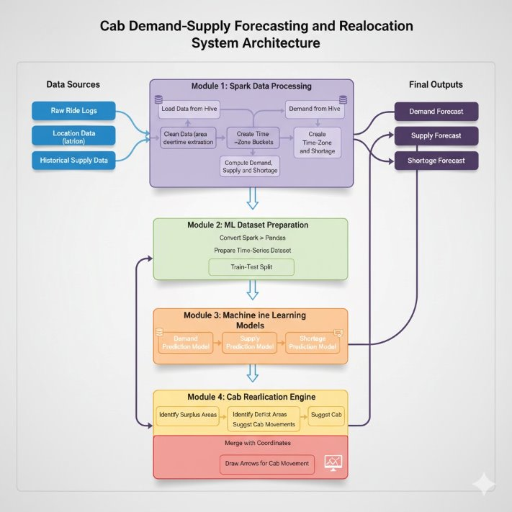
Figure 1 Architecture Diagram
CHAPTER 5

SYSTEM IMPLEMENTATION

5.1 Data Preprocessing Using Apache Spark
The raw ride-hailing dataset consists of millions of records for riding trips with fields like timestamps, pickup locations, drop locations, and the status of the trip. To work with this type of data, we need a distributed processing engine like Apache Spark.

5.1.1 Loading and Cleaning Data
- CSV files can be read using the spark.read.csv() API in Spark
- Any missing or corrupted entries are filtered out.
- Timestamps are standardized and converted to the format of yyyy-mm-dd HH:00.
- Latitude and longitude values are validated.

5.1.2 Zone Creation and Aggregation
Each GPS coordinate is mapped to a grid-based zone (e.g., 500m × 500m cells).
Spark performs:
- grouping
- counting
- aggregating data per zone per hour
This produces the key dataset:
| datetime | zone_id | demand | supply | completed_rides |

5.2 Feature Engineering
Feature engineering significantly improves forecasting accuracy. All features are built using Spark and Pandas.

5.2.1 Temporal Features
Extracted from the timestamp:
- Hour of day (0–23)
- Day of week (0–6)
- Weekend or weekday
- Month of year
These capture routine mobility cycles.

5.2.2 Lag Features
Lag values represent the demand from previous time intervals:
- Lag-1 (previous hour)
- Lag-2
- Lag-24 (same hour yesterday)
Lag features capture short-term and daily patterns.

5.2.3 Rolling Window Features
Rolling averages smooth noisy patterns:
- 3-hour rolling mean
- 6-hour rolling mean
- 24-hour rolling mean
These help the model understand trends.

5.2.4 Zone-Level Indicators
Each zone is encoded using numerical IDs. CatBoost handles categorical encodings directly.

5.3 Model Training (LightGBM and CatBoost)
Both LightGBM and CatBoost models are trained using the processed dataset. Model evaluation determines the final choice.

5.3.1 LightGBM
LightGBM is trained first as a baseline:
- Fast training
- Leaf-wise splitting
- Good initial accuracy
Hyperparameters used include:
- num_leaves
- max_depth
- learning_rate
- n_estimators

5.3.2 CatBoost — Final Model
CatBoost was the model with the highest performance. CatBoost is unique in that it can support categorical features directly without encoding them. CatBoost also does not appear to have issues when overfitting as well as remaining stable on noisy data. The model was trained with a time-based train-test split and early stopping by including engineered temporal and statistical features into the model to ensure stability and prevent overfitting. The RMSE, MAE, and R² Score were the primary evaluation metrics used to measure the model performance, and the model consistently had the lowest RMSE among city zones during evaluation, supporting its reliability and effectiveness as the final forecasting model.

5.4 Forecast Generation
Once trained, the CatBoost model is used to generate:

5.4.1 Demand Forecasts
Predicts hourly demand for each zone for the next:
- 12 hours
- 24 hours
- 7 days
- (Optional) 30 days

5.4.2 Supply Forecast
Supply is estimated from the historical availability of drivers.

5.4.3 Shortage Identification
Shortage for each zone is:
shortage = demand_forecast – supply_forecast
Zones with positive shortages are considered critical zones.

5.5 Driver Reallocation Engine
A core contribution of your project is the Driver Reallocation Engine, which uses predicted shortages to optimize driver movements.

5.5.1 Step 1: Identify Oversupply and Shortage Zones
- Zones with supply > demand → surplus
- Zones with demand > supply → shortage

5.5.2 Step 2: Pair Zones
Shortage zones are paired with the nearest surplus zones using:
- Geographical distance
- Zone adjacency
- Demand urgency

5.5.3 Step 3: Compute Reallocation
For each pair: drivers_to_move = min(surplus, shortage)

5.5.4 Step 4: Output Recommendation
The engine produces a table like:
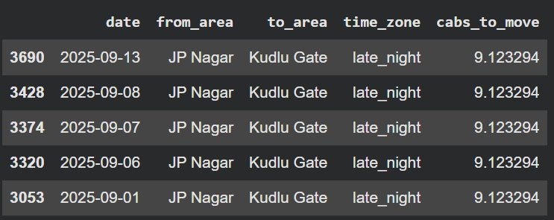Figure 2: Output of the Driver Reallocation Model Showing Recommended Cabs to Move
This allows operations teams to deploy drivers intelligently.

5.6 Visualization
The visualizations are done using:
- Line graphs to demonstrate demand trends
- Bar charts to indicate top and bottom demand zones
- Heatmaps to illustrate spatial demand patterns
- Tables to present reallocation recommendations
These visualizations support the stakeholders' ability to interpret predictions with ease.

5.7 Implementation Summary
- Spark powers scalable pre-processing
- CatBoost provides accurate forecasting estimates
- The allocation engine gives buyers operational suggestion recommendations
- Visualizations communicate valuable insights effectively
This concludes with the core implementation of the ride-hailing demand forecasting system.

CHAPTER 6

RESULTS AND ANALYSIS

6.1 Model Performance Evaluation
Both LightGBM and CatBoost models were trained and evaluated on zone-level hourly datasets. Evaluation was performed using a time-based split, where the most recent data was reserved for testing.

6.1.1 Performance Metrics

The table on model comparison evaluates five machine learning models: CatBoost, LightGBM, XGBoost, Random Forest and LSTM based on two forecasting tasks: available cabs and demand. The metrics used to evaluate include MAE, RMSE, and R2; in the case of RMSE and MAE the lower score is the best predictive metric and in respect to R2 the higher the score the higher the explanation of variance.

In predicting the available cabs, CatBoost was the most successful model as it gave the lowest RMSE (2.5841) compared to the other models (LightGBM, XGBoost, Random Forest, and LSTM). This implies that CatBoost had the highest accuracy and consistency in predicting the future supply in terms of future supply forecasting. CatBoost was also the lowest predictor in terms of RMSE (2.7137) in the demand prediction task (the highest predictor used to model intricate temporal autocorrelations in ride demand).

In conclusion , the CatBoost was the most reliable and robust model with the best RMSE and MAE values of both targets. It is also found that CatBoost excelled in dealing with high-dimensional engineered features and modeling a time-dependent relationship. CatBoost has been selected as the final model of a forecasting pipeline based on this performance.
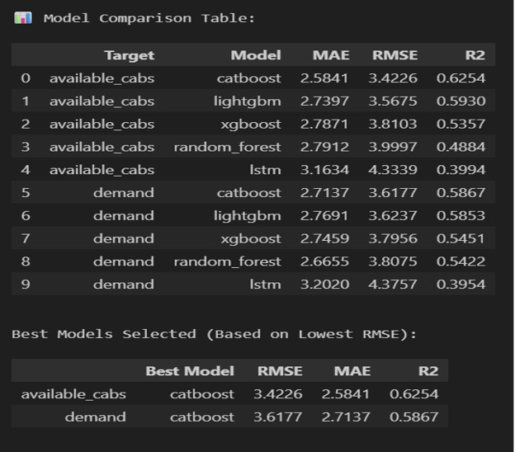Figure 3 Performance Metrics Table

6.1.2 Comparison of Models
CatBoost consistently outperformed LightGBM across almost all zones:
CatBoost’s ability to handle categorical features and noisy data gives it a significant advantage, making it the final chosen model for deployment.

6.2 Forecasting Outputs

6.2.1 Demand Forecast
The trained CatBoost model generated hourly demand forecasts for each zone for the next 12–24 hours. The predicted patterns clearly captured:
- Morning and evening peak hours
- Weekend vs weekday differences
- High-demand business zones
- Low-demand residential zones

Sample Forecast Characteristics
- Consistent periodicity in office zones
- Sudden spikes in commercial hubs
- Steady patterns in suburban areas

6.2.2 Supply Forecast
Supply was forecasted based on:
- Historical driver availability
- Completed rides
- Hourly fleet activity levels
Supply forecasts indicate:
- Late-night supply drop
- Strong daytime availability
- Short supply during sudden surges

6.2.3 Shortage Estimation
Shortage is computed as: shortage = predicted demand − predicted supply
Zones where shortage > 0 are flagged as critical.
Typical shortage behavior:
- Morning shortage in residential areas
- Evening shortage in city centers
- Airport zones show variable shortage patterns
The shortage analysis provides actionable insight into where drivers are insufficient.
6.3.4 Hyperparameter Tuning
The hyper parameter optimization procedure examined various combinations of learning rate, depth, number of iterations and regularization parameters of the demand and available cab targets. The tuned CatBoosts resulted in MAE values of 3.74 (demand) and 4.30 (available cab), and R 2 of 0.307 and 0.121.

Nevertheless, the tuned models did not perform better when compared to the first model of CatBoost, which previously had much lower values of MAE and RMSE. The earlier models were more accurate and more stable in making predictions of the two targets. Thus, the initial CatBoost models were regarded better and more effective to be deployed finally.
6.3.5 Final Training Interpretation
The obtained final CatBoost models achieved similar and reliable results in the demand prediction and available cabs prediction. The demand model resulted in a MAE of 2.83 that was accompanied by R2 = 0.572 whereas the available_cabs model showed MAE = 2.81 with R2 = 0.577. On the whole, these findings indicate that CatBoost can explain more than a half of the variance as well as make consistent and accurate predictions. After training, the models were stored and can be applied on a production environment or to do more forecasting.
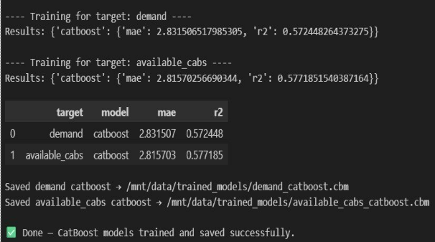
Figure 4 CatBoost Final Training Results — Interpretation

6.3 Driver Reallocation Results
The reallocation engine was tested using forecasted shortages and surplus values. The system identified zone pairs where driver movement reduces the demand-supply gap.

6.3.1 Identification of Zones
- Shortage Zones: Demand > Supply
- Surplus Zones: Supply > Demand

6.3.2 Reallocation Recommendations
The recommendations demonstrate how strategically moving a small number of drivers can significantly reduce unmet demand.
Figure 5 Output of the Driver Reallocation Model Showing Recommended Cabs to Move
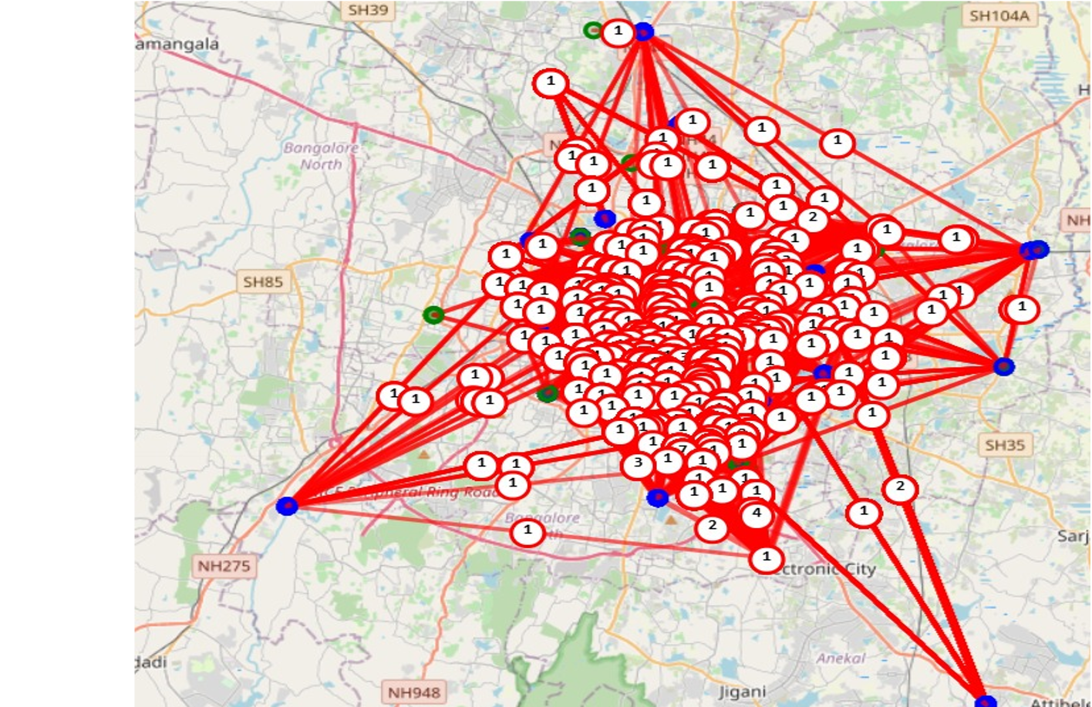
Figure 6 : Forecast-Driven Driver Reallocation Recommendations and Zone-to-Zone Movement Map

6.4 Visualization and Insights
Visualization tools helped analyze predictions effectively:

6.4.1 Time-Series Plots
Line graphs showed that predicted demand follows real-world patterns:
- Peaks aligned with office hours
- Weekend dips clearly visible
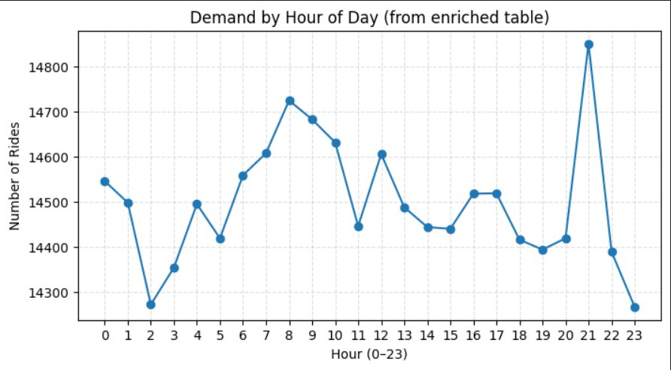Figure 7 Line plot showing the demand by Hour of day vs the number of rides

6.4.2 Heatmaps
Zone-wise heatmaps revealed:
- Consistent high-demand hotspots
- Spatial demand clusters
- Temporal variations across days
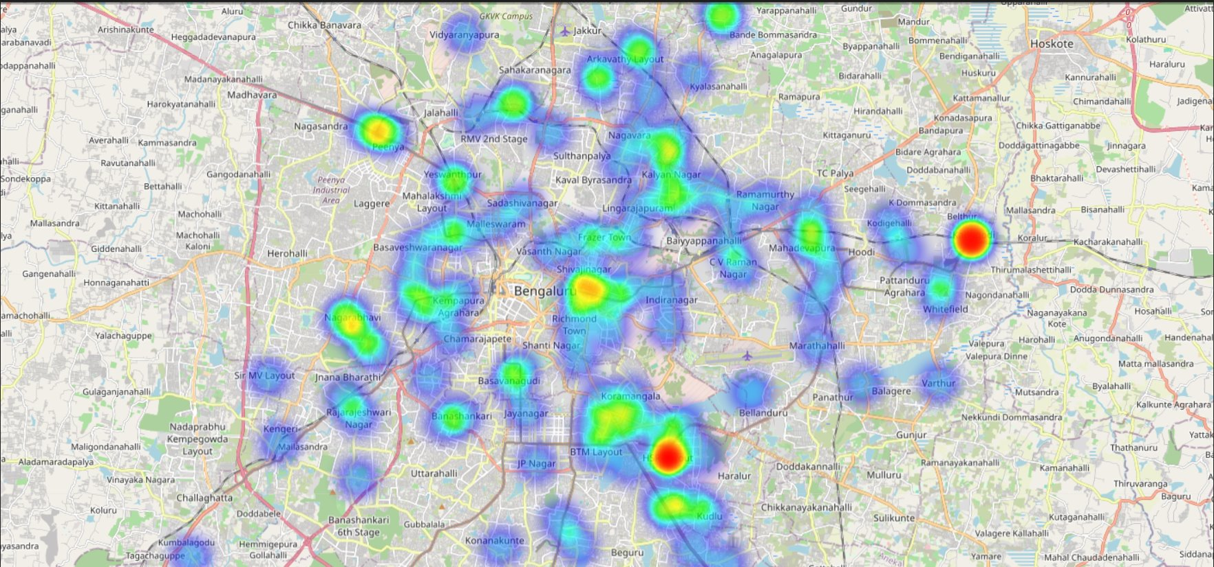
Figure 8: Zone-Wise Demand Heatmap

6.4.3 Bar Charts
This figure displays the breakdown of the different categories of ride statuses, on the effect of how often each outcome is observed in the data. It assists operations teams to determine dominating ride patterns, and the general system behavior.
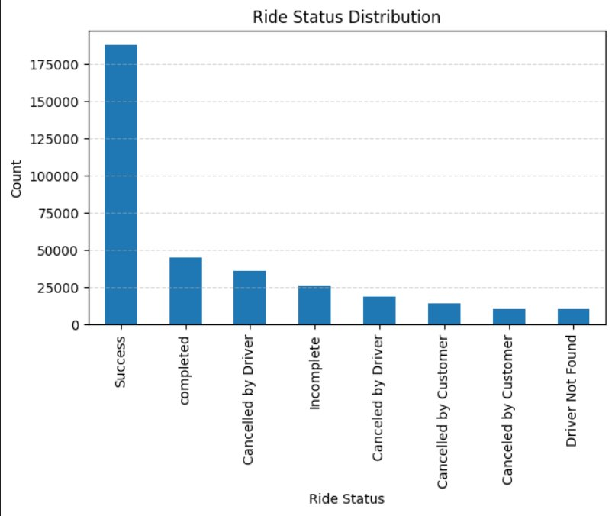
Figure 9 Distribution of Ride Status Categories for Operational Analysis

6.5 Overall System Performance
The experimental results validate that:
- Spark efficiently handles large datasets
- CatBoost provides stable, accurate forecasts
- The reallocation engine improves supply distribution
- Visual insights simplify decision-making
Overall, the system performs reliably and demonstrates strong potential for real-world deployment by ride-hailing operations teams.

CHAPTER 7

CONCLUSION AND FUTURE ENHANCEMENT

7.1 Conclusion

The initiative established a scalable big-data framework for forecasting demand and reallocating drivers in the ride-hailing industry. Using Apache Spark, we processed large-scale datasets in a distributed pipeline, created rich temporal and statistical features, and trained boosted models to produce fine-grained hourly demand, supply, and shortage predictions for the city's zones. When models with spatial and temporal features were tested on the dataset, CatBoost was the best-performing model, yielding the lowest RMSE and MAE, thereby deemed the most reliable forecasting model for the dataset.

In addition, the driver-reallocation module improved system performance by identifying surplus zones and shortage zones, and providing optimal driver delta recommendations for balancing supply better. As a matter of fact, the integrated solution improved fleet utilization, reduced rider wait times and improved operational efficiency. Further, the modular and scalable components can be extended easily, without disruption or friction into practically any operational production or ride-share platform, and readily integrate with data-driven decision-making.

7.2 Future Enhancements
Although the system is effective, there are many areas of improvement that could broaden the functionality of it. Live streaming tools, such as Apache Kafka and Spark Streaming, would allow for continuous ingestion of bookings events, continuous updates to the models, notifications of shortages, and more. Having external data sets, such as weather, congestion, public holidays, and events, could allow the models to better detect anomalies and forecast more accurately in non-typical situations.
The system can also be strengthened through deep learning models, such as Long Short-Term Memory networks (LSTMs), Temporal Convolutional Networks (TCNs), or Graph Neural Networks (GNNs), to learn richer spatiotemporal patterns. The driver reallocation module can be enhanced through reinforcement learning methods that learn optimal drivers' movement behavior over time. All the functionality could be built out as a cloud-based endpoint (on AWS, GCP, or Azure) and include API endpoints, automatic retraining, and an intranet dashboard. Finally, we can deploy the system to a multi-city scale, allowing for adaptation to geographic layouts, fleet sizes, and mobility patterns.

REFERENCES
[1] Geng, G. et al. (2019) ‘Spatiotemporal Multi-Graph Convolution Network for Ride-Hailing Demand Forecasting’, IEEE Transactions on Knowledge and Data Engineering.

[2] Luo, Y. et al. (2020) ‘Spatiotemporal Multi-task Learning for Taxi Demand Prediction’, IEEE Transactions on Intelligent Transportation Systems, 22(7), pp. 4337–4348.

[3] Gangrade, S. et al. (2022) ‘Taxi-Demand Forecasting Using Dynamic Spatiotemporal Analysis in Metropolitan Areas’, ETRI Journal, 44(4), pp. 569–582.

[4] Guo, Q. et al. (2020) ‘Multi-Dimensional Spatiotemporal Demand Forecasting and Service Vehicle Dispatching for Online Car-Hailing Platforms’, Transportation Research Part C: Emerging Technologies, 121, pp. 102837.

[5] Zhang, S. et al. (2021) ‘LightGBM-Based Model for Metro Passenger Volume Forecasting’, IET Intelligent Transport Systems, 15(4), pp. 587–595.

[6] Zhu, G. et al. (2022) ‘XGBoost-Based Travel Time Prediction Between Bus Stations and Bus Routes’, Wireless Communications and Mobile Computing, 2022, pp. 1–11.

[7] Ranganathan, P. et al. (2021) ‘Urban Mobility Optimization Using IoT Data Fusion and XGBoost for Shared Transportation’, IEEE Internet of Things Journal, 8(12), pp. 9821–9833.

[8] Di Mauro, N., Esposito, M. and Basile, P. (2021) ‘Multivariate Time-Series Characterization and Forecasting of VoIP Traffic in Real Mobile Networks’, IEEE Access, 9, pp. 132239–132253.

[9] Cheng, F. et al. (2023) ‘Super-Multivariate Urban Mobility Forecasting Using SUMformer’, Proceedings of the ACM SIGKDD Conference on Knowledge Discovery and Data Mining (KDD).

[10] Silva, J.P. et al. (2019) ‘Hybrid Framework for Multi-Phase Ride-Hailing Demand Estimation’, Journal of Transportation Technologies, 9(2), pp. 227–242.

[11] Li, X. et al. (2025) ‘A Channel-Independent Transformer Approach for Ride-Hailing Demand Prediction’, Transportation Research Part C: Emerging Technologies.

[12] Arslan, E., Demirović, E., Rinaldi, M., Cats, O. and Hoogendoorn, S. (2024) ‘Explainable Demand Prediction for Ride-Hailing Services’, in Proceedings of the 2024 Conference on Mobility, Data and Models (MODeM 2024).

