Celebal Summer Internship 2026

Week 2 Assignment

(E-Commerce Sales Database using SQL)
Submitted By: Aditya Kumar

Objective
The objective of this assignment is to analyse an e-commerce sales database using SQL by performing data retrieval, filtering, aggregation, joins, and transaction management. The assignment demonstrates practical use of SQL queries to generate business insights while applying concepts such as constraints, indexes, CASE statements, and ACID properties.

Database Overview
A relational database named celebal_task2 was created to simulate an e-commerce sales management system.
The database consists of the following four tables:
- customers
- products
- orders
- order_Items

Implementation

Section A – SQL Basics

Q1 – Write a query to display all columns and rows from the customer's table.

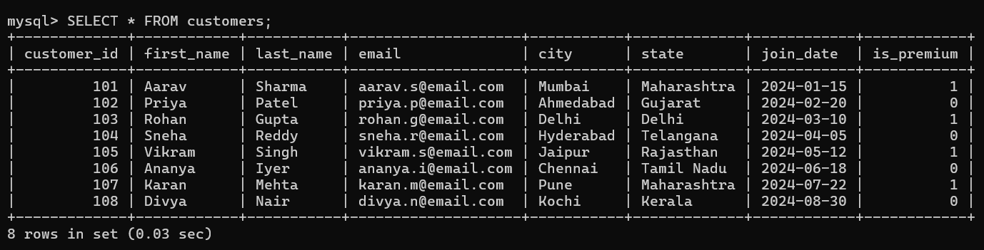

Q2 – Retrieve only the first_name, last_name, and city of all customers.
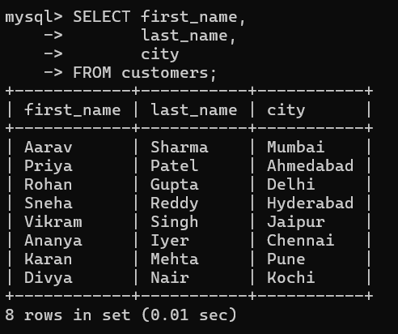

Q3 – List all unique categories available in the products table.
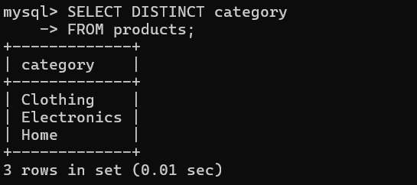

Q4 – Identify the Primary Key of each table in the schema. Explain why a Primary Key must be unique and NOT NULL.
Explanation
Primary Keys identified:
- customers → customer_id
- products → product_id
- orders → order_id
- order_items → item_id
A Primary Key uniquely identifies each record and cannot contain NULL or duplicate values.

Q5 – What constraints are applied to the email column in the customers table? What would happen if you tried to insert a duplicate email?
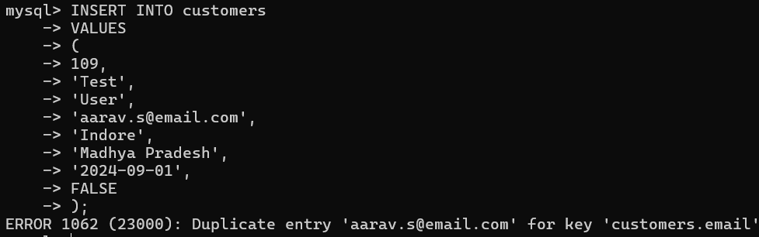Observation
The UNIQUE constraint prevents duplicate email addresses while the NOT NULL constraint ensures every customer has an email.

Q6 – Try inserting a product with unit_price = -50. What happens and which constraint prevents it? Write both the INSERT statement and explain the error.
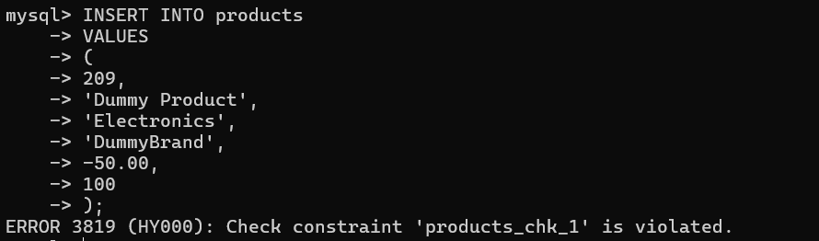Observation
The CHECK constraint prevented insertion of a product with a negative price.

Section B – Filtering & Optimization

Q7 - Retrieve all orders with status = 'Delivered'.
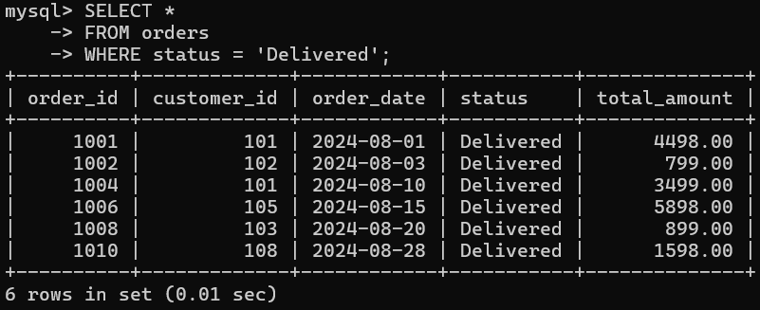

Q8 - Find all products in the 'Electronics' category with a unit_price greater than ₹2000.
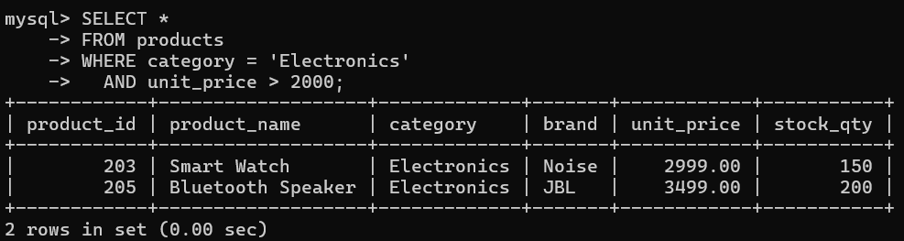

Q9 - List all customers who joined in the year 2024 and belong to the state 'Maharashtra'.
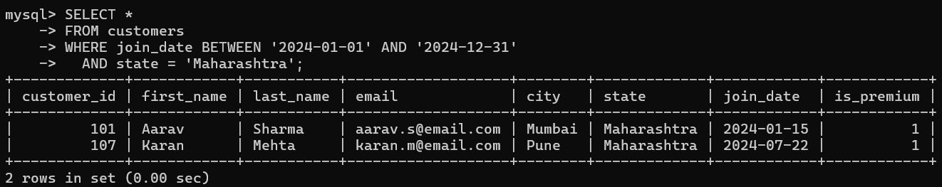

Q10 - Find all orders placed between '2024-08-10' and '2024-08-25' (inclusive) that are NOT cancelled.
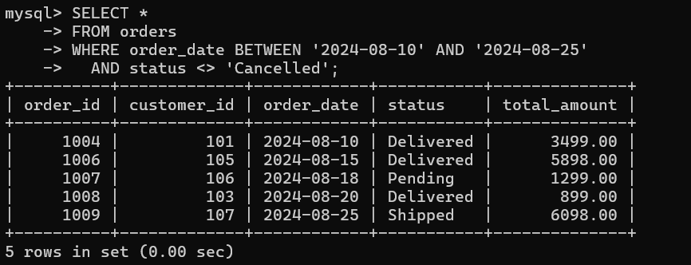

Q11 - Explain what the index idx_orders_date does. How would it improve the performance of a query that filters orders by order_date? Write a sample query that would benefit from this index.

The index 'idx_orders_date' is created on the order_date column.

It speeds up queries that search, filter, sort, or retrieve records based on order_date by reducing the number of rows the database engine must scan.
- Without an index, MySQL performs a full table scan.
- With the index, MySQL can directly locate the matching rows, improving query performance, especially for large datasets.

-- Sample Query:

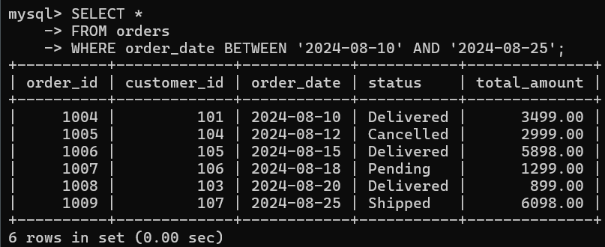

-- Observation:
The index on order_date improves the performance of date-based filtering by reducing the number of scanned rows.

Q12 - If you run: SELECT * FROM customers WHERE YEAR(join_date) = 2024; — would the index on join_date be used? Explain why or why not, and rewrite the query to be index-friendly (SARGable).
No, the given query will not use an index on join_date.
Applying the YEAR() function to the join_date column prevents MySQL from using an index efficiently because the function must be evaluated for every row. This results in a full table scan.
-- Index-Friendly Query:
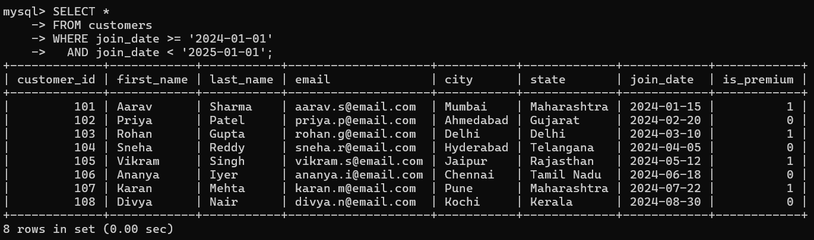

-- Observation:
This query compares the column directly without applying any function, allowing MySQL to use an index on join_date if one exists, resulting in faster query execution.

Section C – Aggregation

Q13 - Count the total number of orders in the orders table.
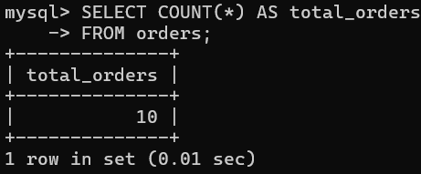

Q14 - Find the total revenue (SUM of total_amount) from all 'Delivered' orders.
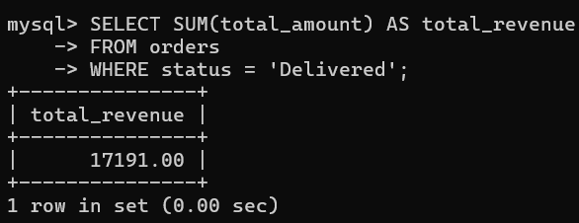

Q15 - Calculate the average unit_price of products in each category.
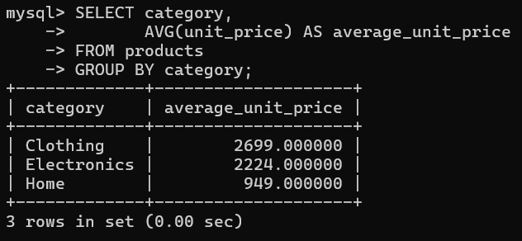

Q16 - For each order status, find the count of orders and the total revenue. Sort the result by total revenue in descending order.
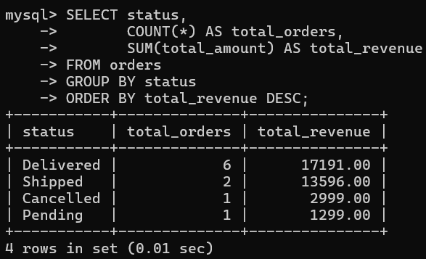

Q17 - Find the most expensive (MAX) and cheapest (MIN) product in each category.
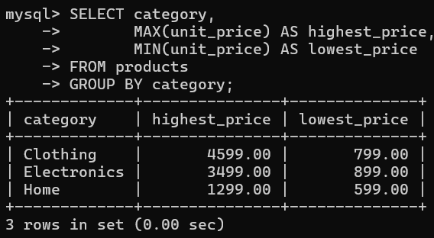

Q18 - List all product categories where the average unit_price is greater than ₹2000. (Hint: Use HAVING clause)
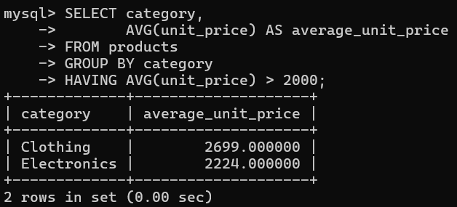

Section D – Joins & Relationships

Q19 - Write an INNER JOIN query to display each order along with the customer's first_name and last_name. Show: order_id, order_date, first_name, last_name, total_amount.
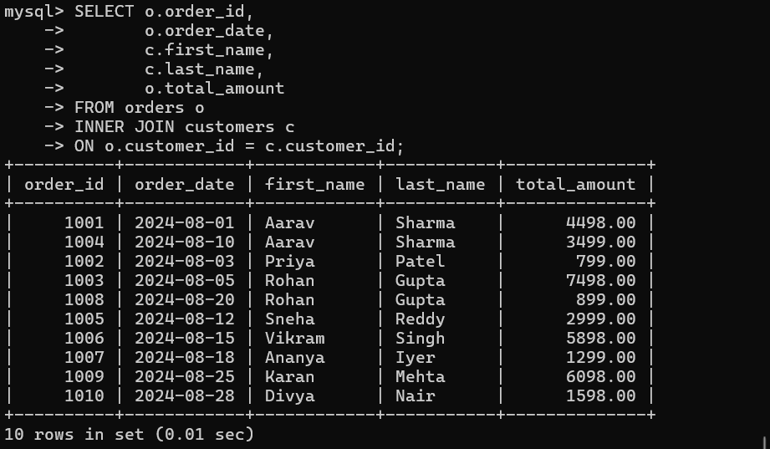

Q20 - Using a LEFT JOIN, list ALL customers and their orders (if any). Customers with no orders should still appear with NULL values for order columns.
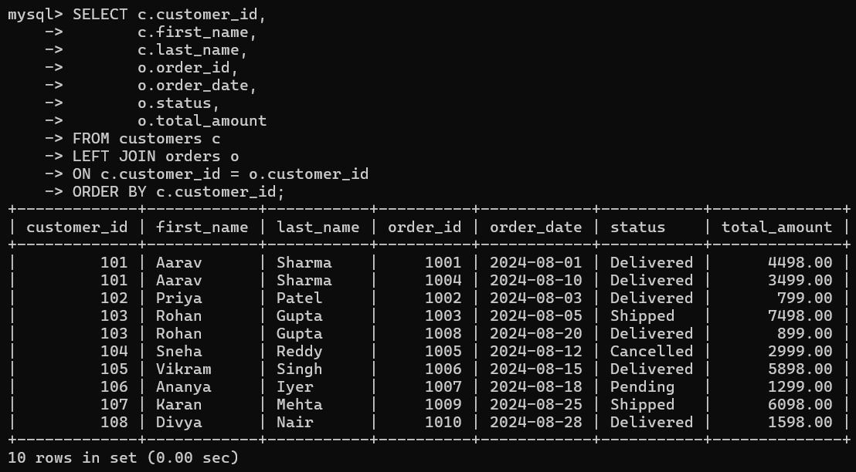

Q21 - Write a query using JOINs across three tables (orders → order_items → products) to show: order_id, product_name, quantity, unit_price, and discount_pct for each order item.
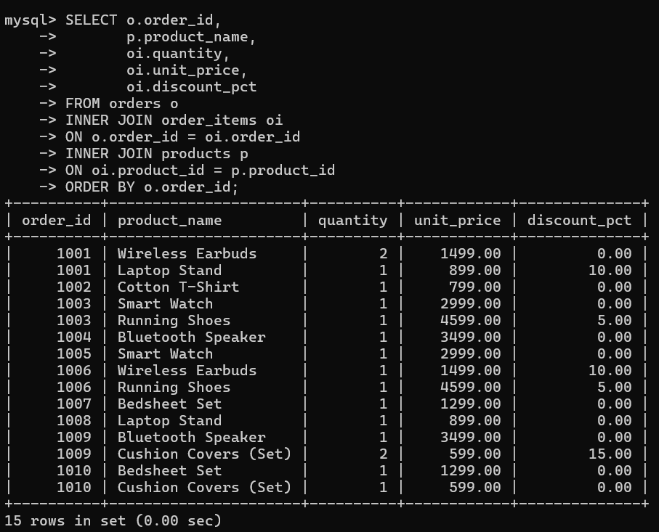

Q22 - Explain the difference between LEFT JOIN and RIGHT JOIN with an example from this schema. When would you use a FULL OUTER JOIN?
LEFT JOIN:
Returns all rows from the left table and the matching rows from the right table. If no matching row exists, NULL values are returned for the right table columns.

RIGHT JOIN:
Returns all rows from the right table and the matching rows from the left table. If no matching row exists, NULL values are returned for the left table columns.

FULL OUTER JOIN:
Returns all rows from both tables. Matching rows are combined, while non-matching rows from either table are returned with NULL values.
- MySQL does not support FULL OUTER JOIN directly. However, it can be simulated using a UNION of LEFT JOIN and RIGHT JOIN.

Q23 - Identify all Foreign Key relationships in the schema. Explain what would happen if you tried to insert an order with customer_id = 999 (which doesn't exist in customers).

Foreign Key Relationships:

orders.customer_id

REFERENCES customers(customer_id)

order_items.order_id

REFERENCES orders(order_id)

order_items.product_id

REFERENCES products(product_id)
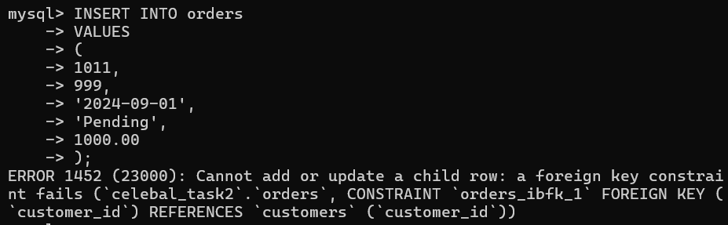
Explanation:
customer_id = 999 does not exist in the customers table. The FOREIGN KEY constraint enforces referential integrity and prevents insertion of invalid references.

Section E – Advanced SQL

Q24 - Write a query using CASE to classify products into price tiers:
- 'Budget' → unit_price < 1000
- 'Mid-Range' → unit_price BETWEEN 1000 AND 3000
- 'Premium' → unit_price > 3000 Display: product_name, unit_price, price_tier.
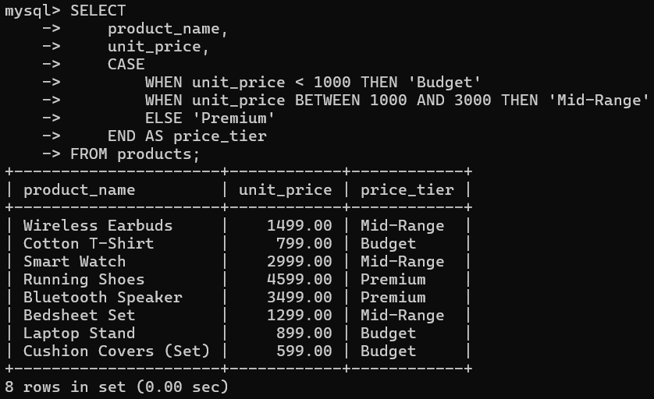

Q25 - Using a CASE statement inside an aggregate function, count how many orders are 'Delivered' vs 'Not Delivered' (all other statuses). Display the result in a single row.
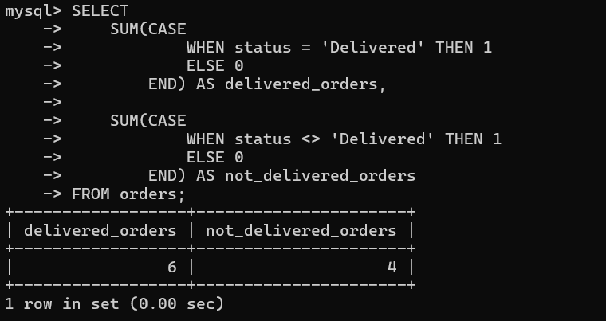

Q26 - Explain each letter of ACID:

A – Atomicity

C – Consistency

I – Isolation

D – Durability
ACID stands for:
- A - Atomicity
- A transaction is treated as a single unit of work.
- Either every operation succeeds or none of them are applied.
- C - Consistency
- A transaction always takes the database from one valid state to another while maintaining all rules and constraints.
- I - Isolation
- Multiple transactions execute independently without interfering with one another.
- D - Durability
- Once a transaction is committed, the changes become permanent, even if the database server crashes immediately afterward.

Q27 - Write a SQL transaction that does the following atomically:

1. Insert a new order (order_id=1011, customer_id=102, today's date, 'Pending', 1598.00)

2. Insert two order items for that order

3. Update the stock_qty of the purchased products

4. If any step fails, ROLLBACK the entire transaction. Otherwise, COMMIT. Write the complete BEGIN...COMMIT/ROLLBACK block.

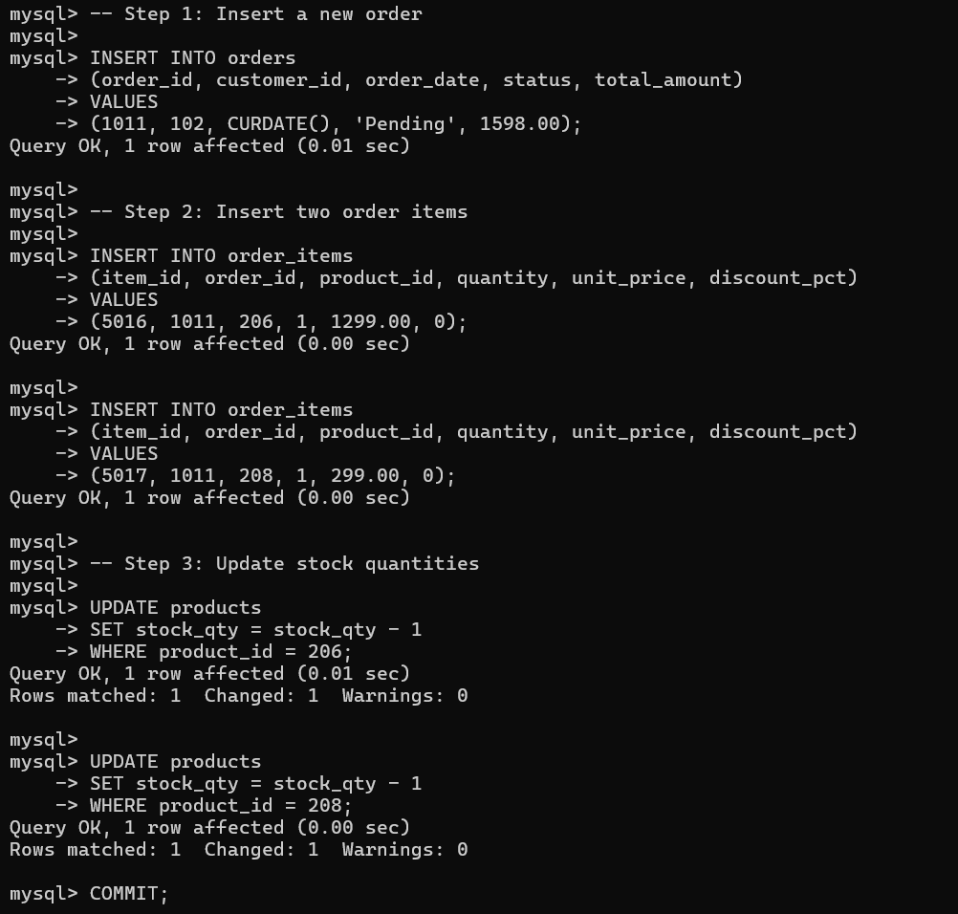
Observation:
Implemented a SQL transaction demonstrating INSERT, UPDATE, COMMIT, and ROLLBACK concepts to ensure atomic execution.

8. GitHub Repository
Repository Name:
Celebal-Summer-Internship-2026
Folder:
Celebal_Task_2_SQL
Repository Link:
(Paste your GitHub repository URL here after pushing the project.)

