TradeWise: Stock Strategy Analysis
Moving Average Crossover (20/50) backtest on the top 20 Nifty 50 stocks
EDA Project Report: objective answers, subjective analysis and investment recommendations
Analysis window: 24 June 2018 to 23 June 2023 (last 5 years in the dataset)
Prepared by: Adi

1. Executive Summary
We backtested a long-only 20/50 day moving average crossover on the 20 most liquid Nifty 50 stocks over five years, starting each stock with Rs 1,00,000. The headline findings are:
- The strategy makes money but lags buy and hold. 18 of 20 stocks made a positive annualized return (mean 13.5%, median 7.6%), but buy and hold did better on raw return in 14 of 20 stocks (mean 18.2% a year). The five-year window was a strong bull market, which punishes any strategy that sits in cash.
- Its real value is risk control. An equal-weight portfolio of the 20 strategies returned 14.9% a year with a maximum drawdown of -17.4% and a Sharpe ratio of 1.22. Equal-weight buy and hold returned 21.8% a year but suffered a -43.3% drawdown (Sharpe 0.99). The crossover traded about 7 points of annual return for far less pain in the March 2020 crash.
- Most trades lose. Only 123 of 269 trades (46%) were profitable, a win/loss ratio of 0.84. The strategy works because winners are much bigger than losers, not because it is right often.
- Recommended stocks: Bajaj Finserv, ITC, Tata Steel and ICICI Bank rank best on a composite of Sharpe, return, drawdown and win rate. Adani Enterprises has the highest raw numbers but carries extreme event risk. Hindustan Unilever, Kotak Mahindra and HDFC Bank were the weakest fits for this strategy.

2. Introduction and Objectives
Moving average crossovers are one of the oldest rule-based trading approaches: buy when short-term momentum overtakes long-term momentum, exit when it fades. This project tests whether that rule would have worked on large Indian stocks, and which stocks suit it.
- Clean and prepare the Nifty 50 price history.
- Implement the 20/50 SMA/LMA crossover and compute total return, annualized return, maximum drawdown, Sharpe ratio, win/loss ratio and number of trades, including a yearly breakdown.
- Answer the 12 objective and 5 subjective questions with charts and data-backed reasoning.
- Recommend stocks for investment based on the backtest.

3. Data Overview and Cleaning
The file combined_nifty_50_data.csv has 238,885 rows and 10 columns (Date, Open, High, Low, Close, Adj Close, Volume, VWAP, Stock, Price) covering 47 series. The data runs to 23 June 2023.
Issue found | Treatment
One completely blank row (attached to NIFTY_50_STOCKS) | Dropped
NIFTY_50_STOCKS is an index series, not a stock | Removed from the stock universe
Date stored as text in dd-mm-yyyy | Converted to datetime with an explicit format
VWAP stored as text, with a #VALUE! error (HDFC_LIFE) | Converted to numeric; the bad cell became NaN (VWAP is not used in the strategy)
Price column ~99% empty | Dropped
Missing Close rows (400) and Volume (4,257, mostly the index rows) | Rows without Close dropped; remaining Volume gaps set to 0
Different history lengths across stocks (2000 to 2023, newer listings such as SBI_LIFE) | Restricted to the last 5 years; only stocks with a full history are eligible
Corporate-action jumps | Checked: no daily move above 50% in the window, so Close is consistent

Defining the "top 20". The brief does not say how to rank stocks. We ranked the 46 eligible stocks by average daily traded value (Close x Volume) over the window and took the top 20. This favours liquid stocks where a crossover strategy is realistically tradable. Where the questions say "first stocks after sorting", we sorted the 20 selected stocks alphabetically.
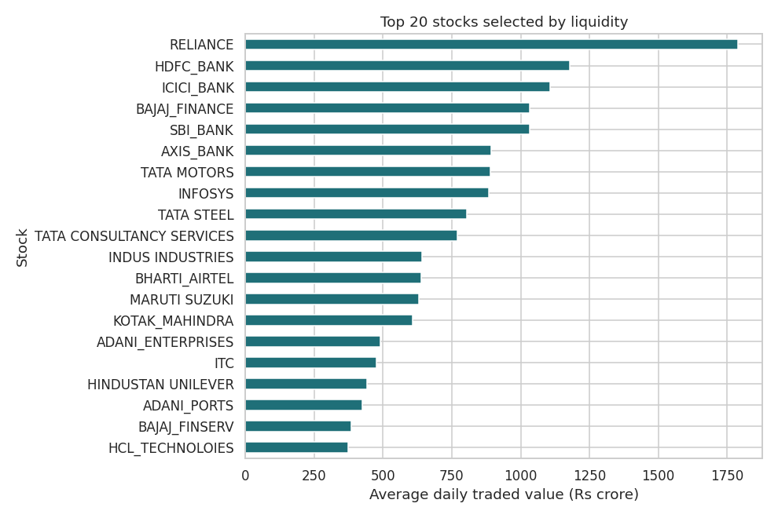

4. Methodology
- SMA = 20-day moving average of Close; LMA = 50-day moving average of Close. Averages are computed on the full history so signals are valid from the first day of the window.
- Buy signal when SMA crosses above LMA; sell signal when it crosses below. The strategy is long-only and in cash otherwise.
- To avoid look-ahead bias, the position is taken the day after a signal (signal shifted by one day).
- Capital of Rs 1,00,000 is fully invested on a buy and fully exited on a sell. Trades still open on the last day are closed at the last price. Brokerage, taxes and slippage are ignored.
- Total return = final value / initial value - 1. Annualized return = (1 + total return)^(252/days) - 1. Max drawdown = largest peak-to-trough fall of the equity curve. Sharpe = mean daily return / standard deviation x sqrt(252), with risk-free rate 0. Win/loss ratio = winning trades / losing trades. A trade wins if its exit price is above its entry price.
- Yearly breakdown uses five 12-month windows (Y1 = Jun-2018 to Jun-2019 through Y5 = Jun-2022 to Jun-2023), re-basing equity each year. Full yearly tables are in the notebook and outputs/yearly_metrics.csv.
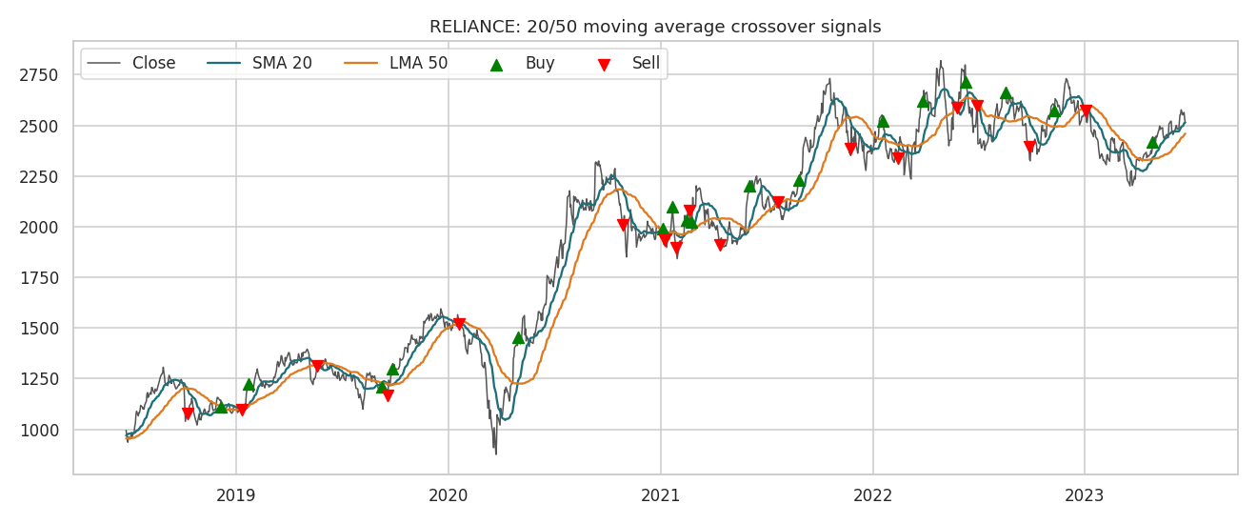

Backtest scorecard (top 20 stocks)
Stock | Total % | Ann. % | Max DD % | Sharpe | W/L | Trades | B&H %
ADANI_ENTERPRISES | 1,917.1 | 84.6 | -47.9 | 1.67 | 1.50 | 10 | 2,641.0
ADANI_PORTS | 43.0 | 7.6 | -35.8 | 0.40 | 0.88 | 15 | 104.3
AXIS_BANK | 57.0 | 9.6 | -35.8 | 0.50 | 0.86 | 13 | 86.0
BAJAJ_FINANCE | 74.2 | 12.0 | -37.3 | 0.55 | 1.40 | 12 | 192.4
BAJAJ_FINSERV | 191.0 | 24.4 | -28.5 | 1.03 | 4.00 | 10 | 143.6
BHARTI_AIRTEL | 41.2 | 7.3 | -25.8 | 0.41 | 1.17 | 13 | 148.8
HCL_TECHNOLOIES | 50.5 | 8.7 | -29.1 | 0.51 | 0.88 | 15 | 156.4
HDFC_BANK | 1.7 | 0.3 | -35.5 | 0.11 | 0.42 | 17 | 56.9
HINDUSTAN UNILEVER | -27.6 | -6.4 | -46.7 | -0.27 | 0.89 | 17 | 63.6
ICICI_BANK | 131.3 | 18.7 | -30.7 | 0.87 | 1.17 | 13 | 218.8
INDUS INDUSTRIES | 26.0 | 4.8 | -37.8 | 0.31 | 0.57 | 11 | -34.1
INFOSYS | 43.4 | 7.6 | -39.2 | 0.46 | 0.50 | 12 | 98.8
ITC | 102.9 | 15.5 | -23.0 | 0.89 | 1.40 | 12 | 69.4
KOTAK_MAHINDRA | -7.6 | -1.6 | -31.6 | 0.01 | 0.25 | 15 | 37.7
MARUTI SUZUKI | 41.7 | 7.4 | -24.4 | 0.44 | 1.14 | 15 | 6.1
RELIANCE | 28.4 | 5.2 | -42.2 | 0.35 | 0.70 | 17 | 152.7
SBI_BANK | 41.3 | 7.3 | -32.1 | 0.42 | 0.86 | 13 | 106.6
TATA CONSULTANCY SERVICES | 7.7 | 1.5 | -30.9 | 0.17 | 0.88 | 15 | 76.8
TATA MOTORS | 247.2 | 28.9 | -44.9 | 0.87 | 0.56 | 14 | 93.4
TATA STEEL | 207.8 | 25.8 | -29.8 | 0.96 | 0.67 | 10 | 96.2

Yearly breakdown (average across the 20 stocks)
Year | Total return % | Annualized % | Max DD % | Sharpe | Avg trades
Y1 (Jun-18) | 3.2 | 3.4 | -20.1 | 0.18 | 1.9
Y2 (Jun-19) | 7.8 | 8.1 | -20.1 | 0.35 | 2.4
Y3 (Jun-20) | 90.4 | 91.1 | -18.7 | 1.36 | 2.3
Y4 (Jun-21) | -3.5 | -3.5 | -25.7 | -0.14 | 3.6
Y5 (Jun-22) | 10.6 | 10.8 | -16.0 | 0.49 | 3.4
Year 3 (Jun-2020 to Jun-2021, the post-crash recovery) averaged +90% and carried the whole five years. Year 4 (Jun-2021 to Jun-2022) was slightly negative at -3.5%, with the most trades per stock (3.6): the choppy, sideways market produced whipsaws.

5. Objective Questions

Q1a. Total returns of the top 20 stocks over time
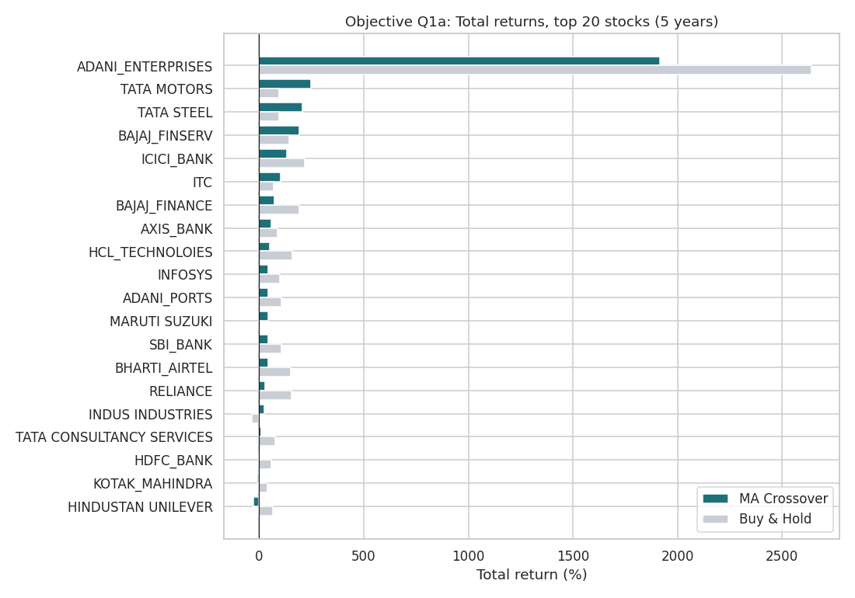
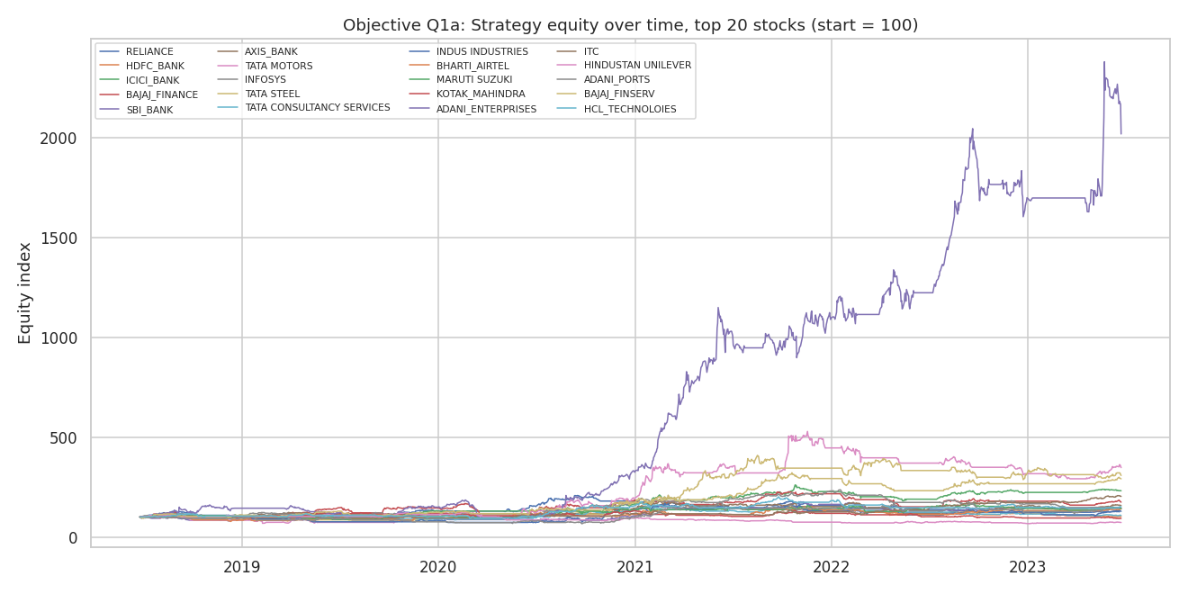
Observation:
- Adani Enterprises (+1,917%), Tata Motors (+247%), Tata Steel (+208%) and Bajaj Finserv (+191%) lead; Hindustan Unilever (-27.6%) and Kotak Mahindra (-7.6%) lost money.
- Equity curves cluster flat through 2018 and 2019, jump after the March 2020 crash and then diverge: the strategy earns most of its money in a few strong trends.
- The strategy total return is below buy and hold in 14 of 20 stocks, and exceeds it in only six: Tata Steel, Tata Motors, Bajaj Finserv, ITC, Maruti Suzuki and Indus Industries (+26% vs -34%). These were stocks with sharp falls or choppy phases that the exit signal sidestepped.

Q1b. Cumulative returns of the first five stocks after sorting
First five alphabetically: Adani Enterprises, Adani Ports, Axis Bank, Bajaj Finance, Bajaj Finserv.
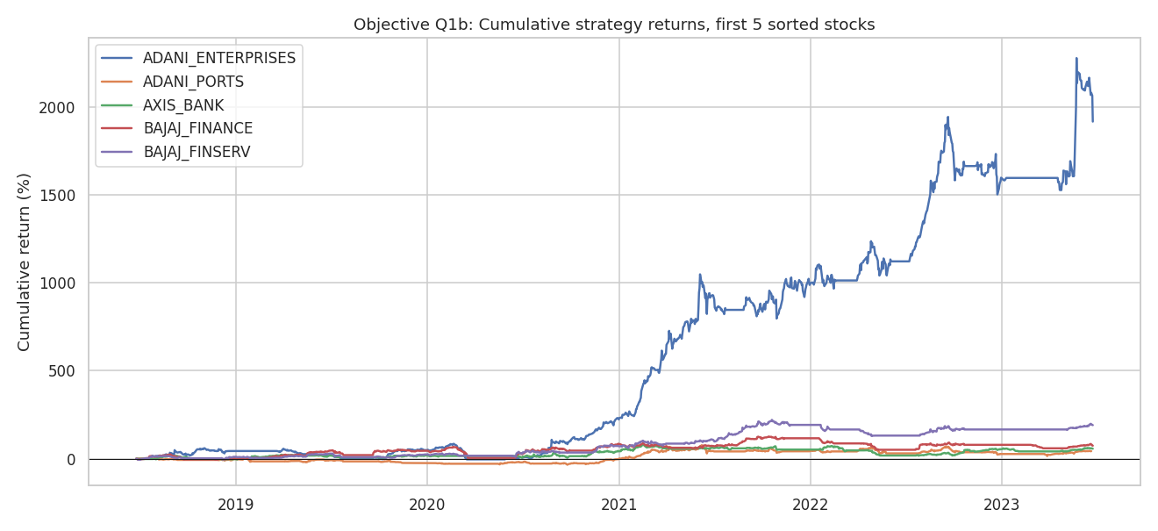
Observation:
- Adani Enterprises dwarfs the group; the other four finish between +43% and +191%.
- All five are flat or negative until mid-2020, then rise sharply, confirming the strategy is driven by the post-COVID trend.
- Bajaj Finance and Bajaj Finserv move together, which is expected given the shared parent.

Q1c. Sharpe ratio vs total return
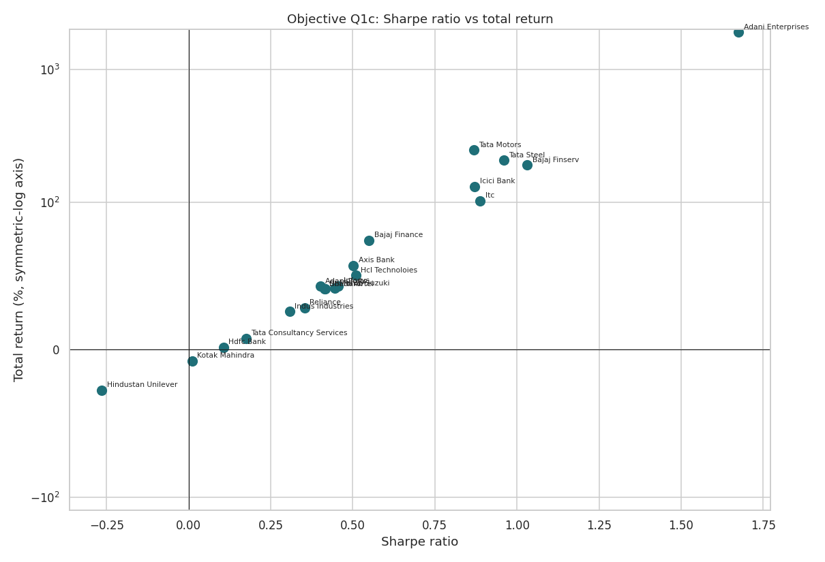
Observation:
- Correlation between Sharpe ratio and total return is 0.74: stocks that earn more tend to do so more efficiently.
- Adani Enterprises (Sharpe 1.67) and Bajaj Finserv (1.03) are in the top corner; Hindustan Unilever (-0.27) and Kotak (0.01) at the bottom.
- Tata Motors has a high return (+247%) but a Sharpe of only 0.87, signalling a bumpier ride.

Q2. Pair plot: total return, Sharpe ratio, max drawdown
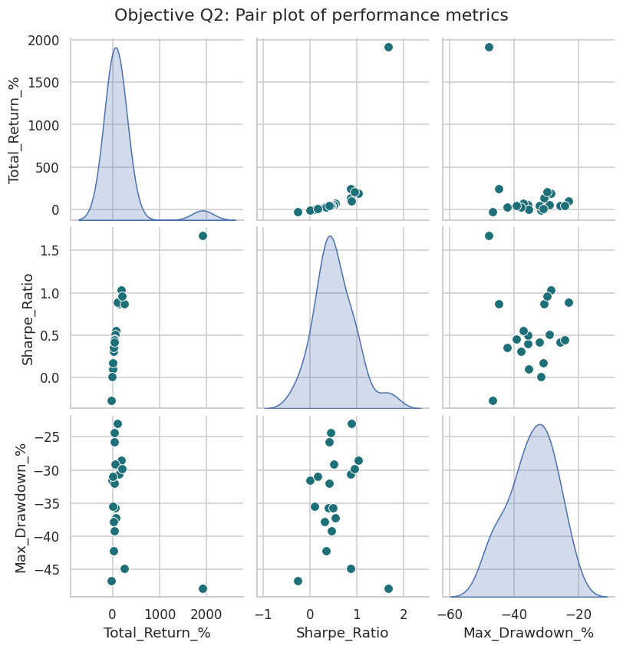
Observation:
- Total return and Sharpe ratio: correlation 0.74 (strong positive).
- Total return and max drawdown: correlation -0.42. Because drawdown is negative, this means higher-return stocks tended to suffer deeper drawdowns: return is paid for with risk (Adani, Tata Motors).
- Sharpe ratio and max drawdown: correlation of about 0, so a high Sharpe does not guarantee a shallow drawdown. ITC combined a respectable return with the shallowest drawdown, a rare mix.
- Insight: rank stocks on both Sharpe and drawdown, never on return alone.

Q3. Highest total return
Adani Enterprises: +1,917% (Rs 1,00,000 became about Rs 20.2 lakh), an annualized 84.6%. Buy and hold would have returned +2,641%, so even here the crossover left money on the table. Next best: Tata Motors (+247%), Tata Steel (+208%), Bajaj Finserv (+191%).

Q4. Lowest maximum drawdown
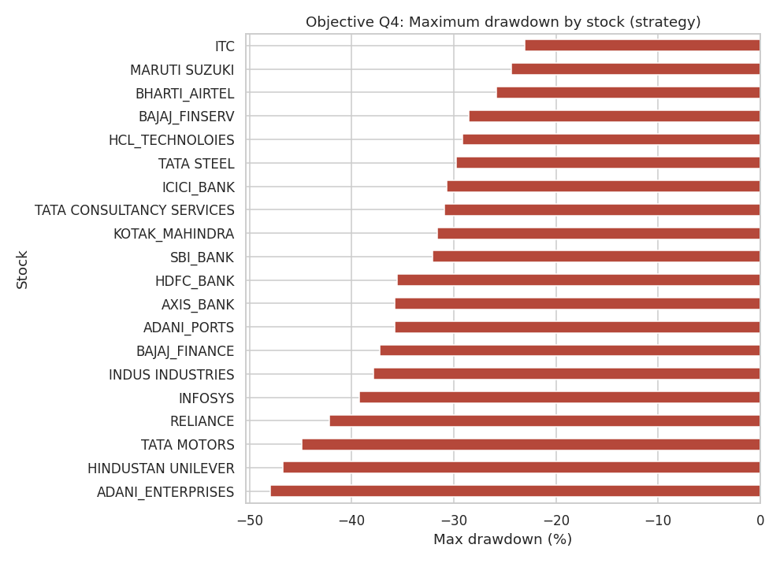
ITC has the lowest strategy max drawdown at -23.0%, followed by Maruti Suzuki (-24.4%) and Bharti Airtel (-25.8%). The weakest were Adani Enterprises (-47.9%), Hindustan Unilever (-46.7%) and Tata Motors (-44.9%). For buy and hold, TCS had the shallowest drawdown (-28.2%), showing the crossover improves stability on most stocks.

Q5. Best and worst months for each stock
Stock | Best month | Return % | Worst month | Return %
ADANI_ENTERPRISES | Jul-2018 | 72.7 | Feb-2023 | -54.1
ADANI_PORTS | Feb-2021 | 32.6 | Mar-2020 | -26.6
AXIS_BANK | Oct-2022 | 23.6 | Mar-2020 | -45.6
BAJAJ_FINANCE | Nov-2020 | 48.3 | Mar-2020 | -50.4
BAJAJ_FINSERV | Nov-2020 | 57.2 | Mar-2020 | -49.3
BHARTI_AIRTEL | Aug-2021 | 18.2 | Sep-2020 | -18
HCL_TECHNOLOIES | Jul-2020 | 26.6 | Mar-2020 | -18.3
HDFC_BANK | Nov-2020 | 21.7 | Mar-2020 | -26.8
HINDUSTAN UNILEVER | Jul-2022 | 18.2 | Oct-2021 | -11.4
ICICI_BANK | Nov-2020 | 20.6 | Mar-2020 | -34.9
INDUS INDUSTRIES | Nov-2020 | 46.4 | Mar-2020 | -68.2
INFOSYS | Jul-2020 | 31.3 | Apr-2022 | -17.8
ITC | Nov-2020 | 17.2 | Feb-2020 | -16
KOTAK_MAHINDRA | Nov-2020 | 23.2 | Mar-2020 | -20
MARUTI SUZUKI | Apr-2020 | 25 | Mar-2020 | -31.7
RELIANCE | Apr-2020 | 31.6 | Mar-2020 | -16.2
SBI_BANK | Feb-2021 | 38.3 | Mar-2020 | -35
TATA CONSULTANCY SERVICES | Aug-2021 | 19.5 | Oct-2018 | -11.2
TATA MOTORS | Oct-2019 | 51.3 | Mar-2020 | -44.9
TATA STEEL | Nov-2020 | 40.6 | Mar-2020 | -29.4
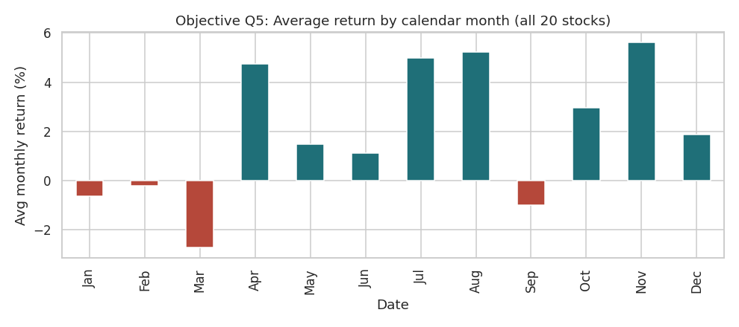
Observation:
- March 2020 was the worst month for 14 of 20 stocks (Indus Industries -68%, Bajaj Finance -50%, Bajaj Finserv -49%).
- November 2020 was the best month for 8 of 20 stocks, including Bajaj Finance, Bajaj Finserv, HDFC Bank, ICICI Bank, Kotak and ITC, reflecting the vaccine-news rally.
- Best and worst months cluster in 2020, which is why crossover timing around that crash drove results.

Q6. Highest average trading volume
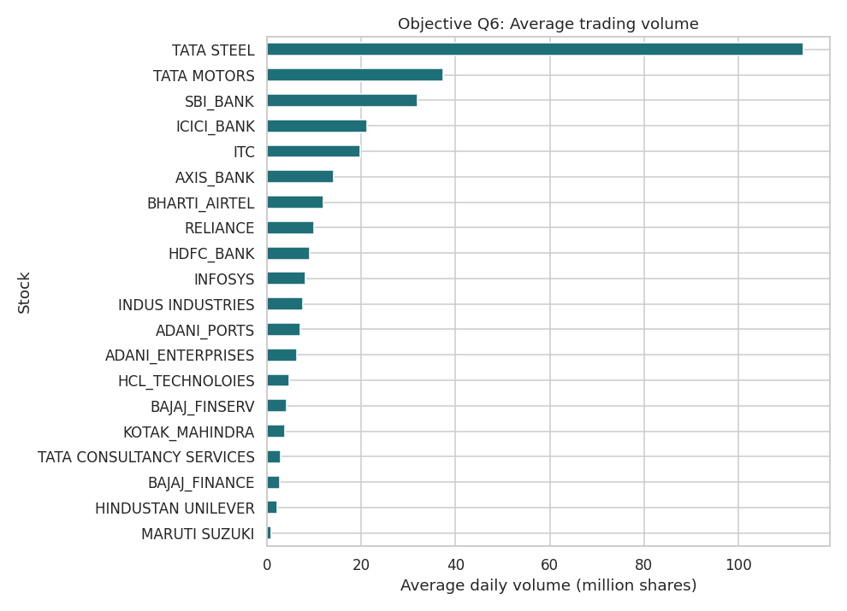
Tata Steel: about 113.9 million shares a day, followed by Tata Motors (37.3m), SBI (32.0m), ICICI Bank (21.2m) and ITC (19.7m). Maruti Suzuki is lowest (0.9m). Note that low-priced stocks trade more shares, so share volume is not the same as rupee liquidity.

Q7. Number of trades executed
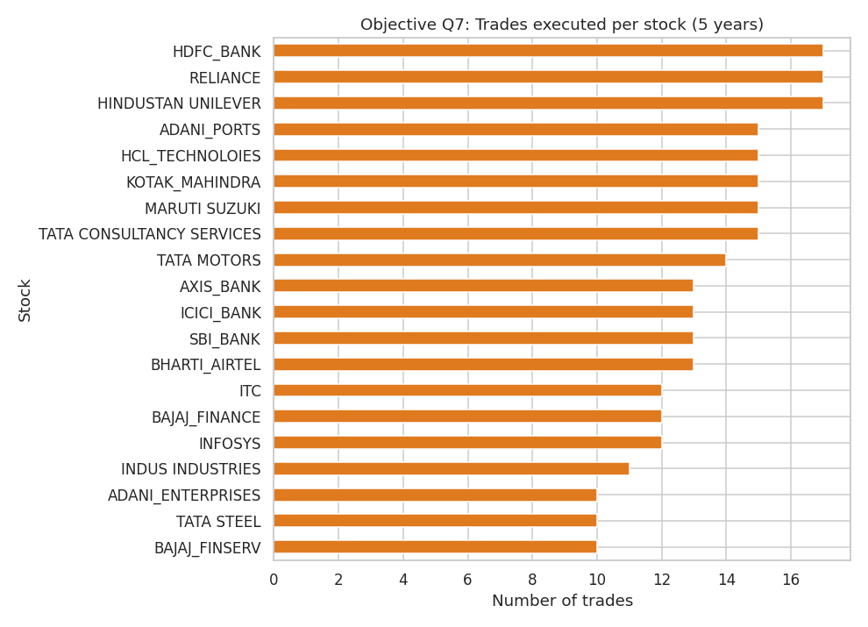
269 trades in total, 13.4 per stock on average (about 2.7 a year). Reliance, HDFC Bank and Hindustan Unilever traded the most (17 each); Adani Enterprises, Bajaj Finserv and Tata Steel the least (10 each). Frequent trading was a warning sign: the three most active stocks include two of the weakest performers (HDFC Bank +1.7%, HUL -27.6%), pointing to whipsaw losses.

Q8 and Q9. Maximum single-day loss and gain
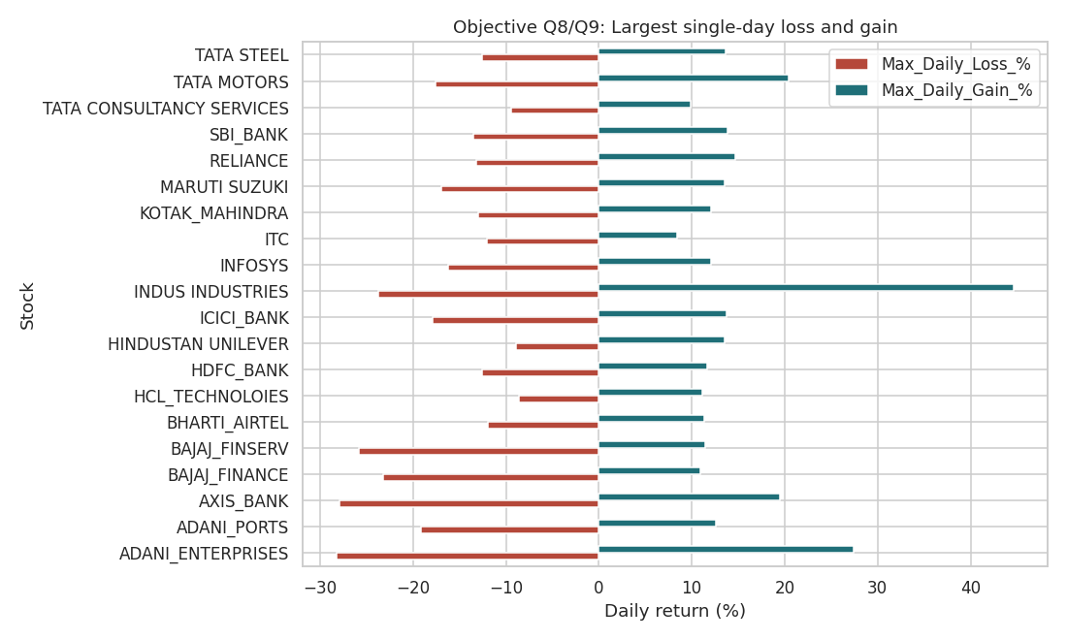
Maximum single-day loss: Adani Enterprises, -28.20% on 1 February 2023 (during the sell-off that followed the short-seller report on the group; it fell a further -26.7% the next day).
Maximum single-day gain: Indus Industries, +44.67% on 26 March 2020 (a relief rally after the COVID crash, in the same stock that fell -68% that March).

Q10. Lowest average closing price
Tata Steel, about Rs 77, followed by ITC (Rs 260), Tata Motors (Rs 284) and SBI (Rs 377). A low share price says nothing about value: it also reflects stock splits and the share count (Tata Steel did a 10-for-1 split).

6. Subjective Questions

S1. How do annualized returns compare across the top 20 stocks?
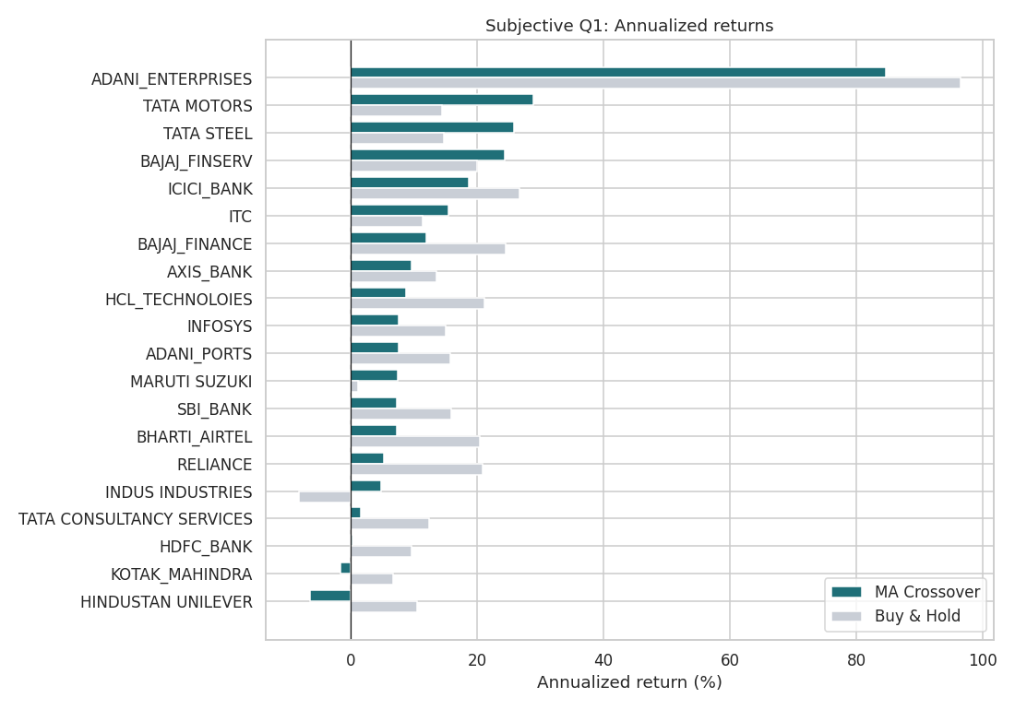
Insights:
- The distribution is heavily skewed: mean 13.5% but median only 7.6%, because Adani Enterprises (84.6%) pulls the average up. Without it, the mean of the other 19 is about 10%.
- Three groups: leaders (Adani 84.6%, Tata Motors 28.9%, Tata Steel 25.8%, Bajaj Finserv 24.4%), a middle pack of 5% to 19% (ICICI 18.7%, ITC 15.5%, Bajaj Finance 12.0%, Axis 9.6%), and laggards (HUL -6.4%, Kotak -1.6%, HDFC Bank 0.3%).
- Cyclical, high-volatility names (steel, autos, financials) trended strongly and suit crossover rules; defensives with range-bound prices (HUL, TCS) generate false signals.
- The strategy beat buy and hold annualized return in just 6 of 20 stocks (mean 13.5% vs 18.2%).
Recommendations:
- Use crossover timing on trending cyclicals; hold defensive, range-bound stocks directly or use a different approach.
- Judge by median and by stock-level results, not by the average that one outlier inflates.

S2. What is the relationship between total return and trading volume?
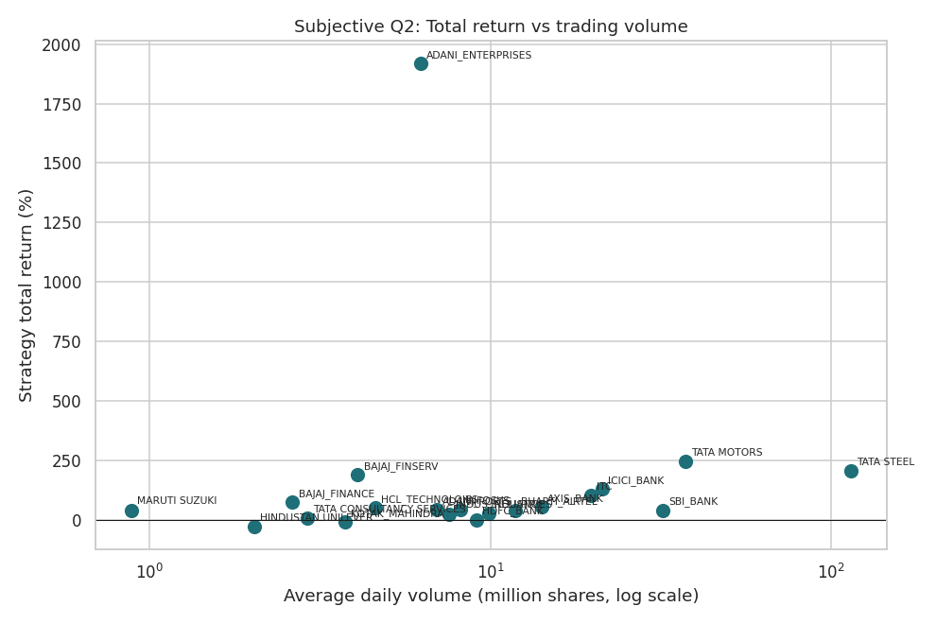
Insights:
- The relationship is weak. Pearson correlation is 0.02, Spearman rank correlation 0.40 for strategy returns and 0.17 for buy and hold, based on only 20 points, so none of these is statistically reliable.
- Heavily traded stocks include winners (Tata Steel, Tata Motors) and mediocre performers (SBI +41%, Reliance +28%). The lowest-volume stock (Maruti) returned +42%.
- Share volume is distorted by share price: Tata Steel looks extremely liquid mainly because its price is low.
Recommendations:
- Do not use volume as a stand-alone predictor of return. Use it as a liquidity filter, so trades can be executed without moving the price.
- If volume is used, prefer rupee traded value or volume change (a breakout on rising volume) over raw average shares.

S3. Correlation heatmap of closing prices
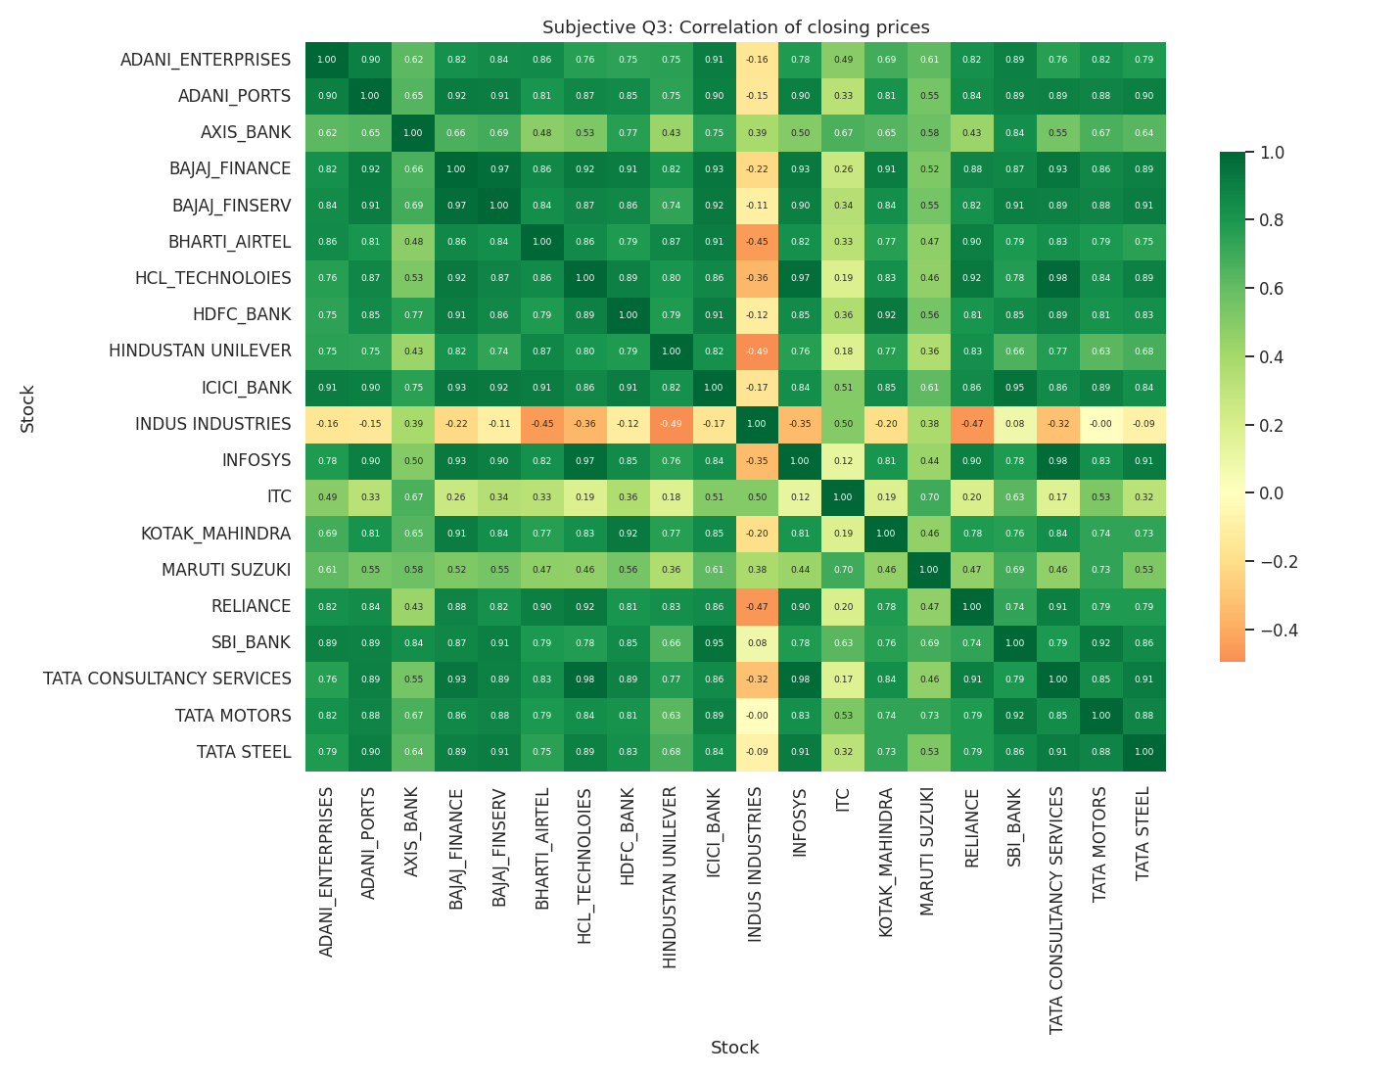
Insights:
- Most correlated pairs: HCL Tech and TCS (0.98), Infosys and TCS (0.98), Bajaj Finance and Bajaj Finserv (0.97), HCL and Infosys (0.97), ICICI Bank and SBI (0.95). Same-sector or same-group stocks move together.
- Price levels trend upward, which inflates correlation. On daily returns the picture is more modest: Bajaj Finance and Finserv 0.83, Axis and ICICI 0.74, ICICI and SBI 0.68.
- Indus Industries is the standout diversifier (average price correlation -0.12), then ITC (0.37) and Maruti (0.53). ICICI Bank has the highest average correlation (0.79).
Recommendations:
- Do not hold both stocks of a highly correlated pair (the IT trio, the Bajaj pair, the banks) and call it diversification.
- Pair a growth holding with a low-correlation one such as ITC to dampen portfolio swings.

S4. Backtest of the top 20 stocks: full performance evaluation
The scorecard in Section 4 gives all six metrics per stock. The key patterns:
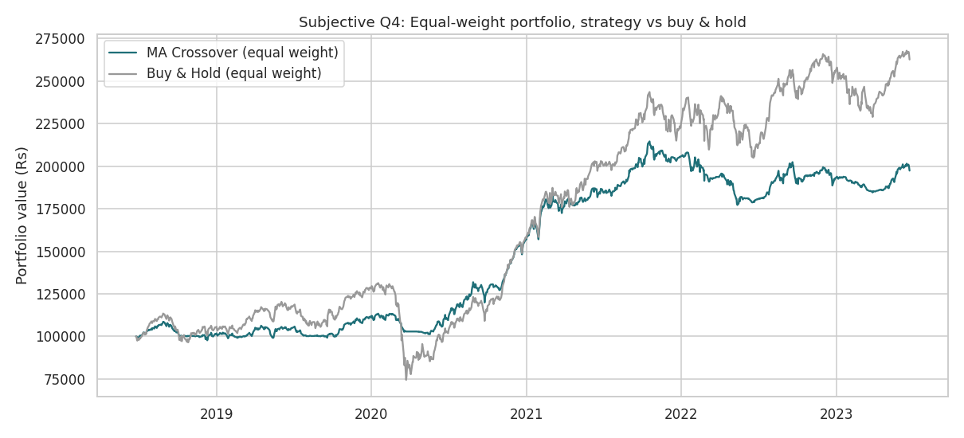
- Total returns range from -27.6% (HUL) to +1,917% (Adani Enterprises); 18 of 20 are positive.
- Maximum drawdowns range from -23.0% (ITC) to -47.9% (Adani Enterprises); the median is about -34%.
- Sharpe ratios: Adani 1.67, Bajaj Finserv 1.03, Tata Steel 0.96, ITC 0.89, ICICI 0.87, Tata Motors 0.87. Six stocks sit below 0.4.
- Win/loss ratio exceeded 1 for only 7 stocks (Bajaj Finserv 4.0 best, Adani Enterprises 1.5, Bajaj Finance and ITC 1.4). Across all stocks, 123 wins and 146 losses (0.84); the strategy relies on large winners offsetting many small losses.
- Equal-weight portfolio: strategy 14.9% a year, max drawdown -17.4%, Sharpe 1.22; buy and hold 21.8%, -43.3%, 0.99. Better risk-adjusted performance but lower absolute return.
- Trades per stock: 10 to 17, so the strategy is low-turnover and transaction costs would be modest.
Recommendation: Treat the crossover as a defensive overlay: it is most useful for avoiding crashes, not for beating a rising market. Combine it across many stocks to benefit from diversification.

S5. Which stocks would be recommended for investment?
We built a composite score (0-100) from four ranks: Sharpe ratio (35%), annualized return (30%), max drawdown (25%) and win rate (10%). Weights favour risk-adjusted return over raw return.
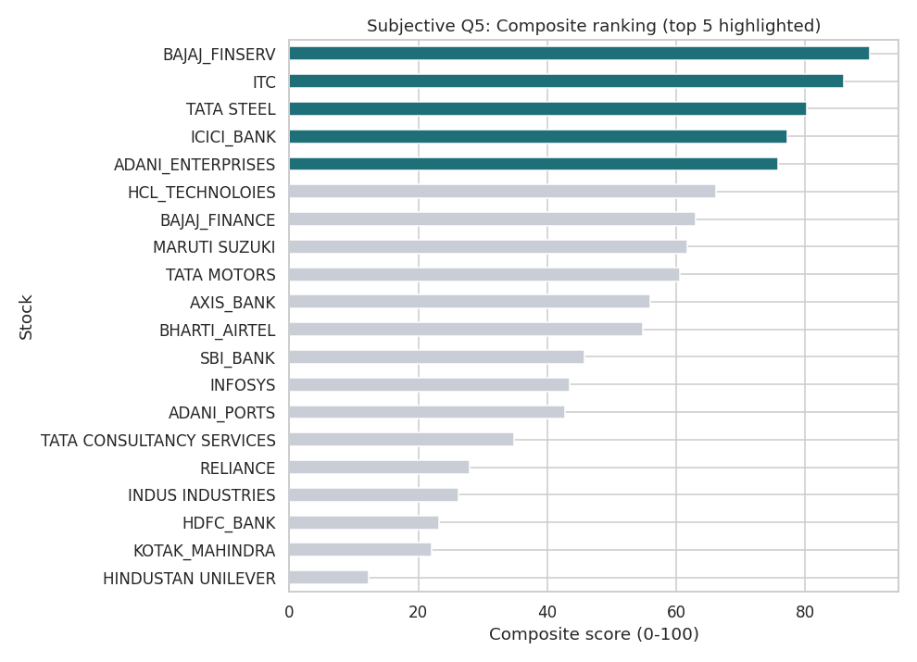
Rank | Stock | Score | Ann. % | Max DD % | Sharpe | Win rate %
1 | BAJAJ_FINSERV | 90.0 | 24.4 | -28.5 | 1.03 | 80.0
2 | ITC | 86.0 | 15.5 | -23.0 | 0.89 | 58.3
3 | TATA STEEL | 80.2 | 25.8 | -29.8 | 0.96 | 40.0
4 | ICICI_BANK | 77.2 | 18.7 | -30.7 | 0.87 | 53.8
5 | ADANI_ENTERPRISES | 75.8 | 84.6 | -47.9 | 1.68 | 60.0
6 | HCL_TECHNOLOIES | 66.2 | 8.7 | -29.1 | 0.51 | 46.7
7 | BAJAJ_FINANCE | 63.0 | 12.0 | -37.3 | 0.55 | 58.3
8 | MARUTI SUZUKI | 61.7 | 7.4 | -24.4 | 0.45 | 53.3
9 | TATA MOTORS | 60.5 | 28.9 | -44.9 | 0.87 | 35.7
10 | AXIS_BANK | 56.0 | 9.6 | -35.8 | 0.50 | 46.2

Recommended (best fit for this strategy):
- Bajaj Finserv (score 90): highest win rate (80%) and win/loss ratio (4.0), Sharpe 1.03, annualized 24.4%, drawdown -28.5%.
- ITC (86): shallowest drawdown (-23.0%), 15.5% annualized, Sharpe 0.89, and low correlation to the rest: the stability pick.
- Tata Steel (80): 25.8% annualized, Sharpe 0.96, drawdown -29.8%, and very liquid. Win rate is low (40%) so expect many small losses.
- ICICI Bank (77): 18.7% annualized, Sharpe 0.87, drawdown -30.7%; consistent, though correlated with SBI and Axis.
- Adani Enterprises (76), high risk: top return (84.6% annualized) and Sharpe (1.67), but a -47.9% drawdown and a -28% single-day crash in February 2023. Suitable only as a small, risk-capped position.
Avoid this strategy on: Hindustan Unilever, Kotak Mahindra, HDFC Bank, Indus Industries and Reliance. These ranked lowest here. This does not mean they are bad companies: Reliance (+153%) and HDFC Bank (+57%) rose on a buy-and-hold basis. The crossover simply got whipsawed by their sideways, range-bound trading.
Suggested portfolio idea: hold the top four (Bajaj Finserv, ITC, Tata Steel, ICICI Bank) in roughly equal weights, with at most a small satellite position in Adani Enterprises. This spreads across financials, a defensive consumer name and a cyclical, limiting the correlation issue.

7. Conclusion and Limitations
The 20/50 crossover is a reasonable risk-control tool but not a way to beat a bull market. It delivered positive returns on 18 of 20 stocks and cut portfolio drawdown from -43% to -17%, at the cost of about 7 points of annual return. Choosing the right stocks matters more than the signal: trending cyclicals and strong compounders worked; range-bound defensives did not.
Limitations: no brokerage, taxes or slippage; one fixed parameter pair (20/50) with no optimisation; a five-year window dominated by the 2020 crash and recovery; the top-20 list is defined by liquidity, not by official Nifty weights; and past performance does not guarantee future results. This is an academic analysis, not financial advice.

8. Acknowledgements and References
- Dataset: combined_nifty_50_data.csv (Nifty 50 daily prices, supplied with the project).
- Tools: Python (pandas, NumPy, Matplotlib, Seaborn) in Jupyter.
- Project brief, task list and submission guidelines supplied with the assignment.

