Pricing A/B Test: Delivery Fee Set-up
EDA 2 project report | Control (flat fee) vs Test (tiered fee) | July 2021 data, 18,006 orders
Bottom line
Recommendation: roll out the Test fee set-up. It delivered +18.7% more orders and +21.3% more total revenue, and revenue per order did not fall (+2.1%, p = 0.008). The goal, same revenue with more orders, is met with room to spare.
How it works: Test waives the delivery fee on baskets of 33 or more and charges a slightly higher fee (about 2.63 vs 2.29) on smaller baskets. Big baskets give up about 1.80 of revenue each, but 3,336 of them arrive vs 2,268 in Control (+47%), so that segment still earns +28% more in total.
Main caveat: the two arms have different order counts, and the file has no exposure (visitor) counts. The order lift is only valid if both arms received similar traffic. Section 6 explains how to confirm this before roll-out.

1. Data and method
The file holds 18,006 orders from 1 to 31 July 2021: 8,232 in Control and 9,774 in Test. There are no missing values or duplicate order codes. I confirmed that revenue = order value × 20% + delivery fee holds for every row. That check also shows that "order value" is a currency amount (basket value), not an item count as the dataset note says.
- Control: every order pays a flat fee of 2.29.
- Test: a tiered fee. 24% of orders have a zero fee, and all of them have an order value of 33 or more. Smaller baskets pay between 1.99 and 3.29, mostly 2.49 to 2.89.
Because order value and revenue are right-skewed (a few very large baskets), I report Welch t-tests for means with confidence intervals, and cross-check with Mann-Whitney, log-scale tests, bootstrap intervals and Levene's test for variance. Significance level is 5%. For the 14 hour-by-hour comparisons I apply a Bonferroni correction (0.05 / 14 = 0.0036).

KPI scorecard
KPI | Control | Test | Change
Orders | 8,232 | 9,774 | +18.7%
Average order value | 29.32 | 31.90 | +8.8%
Average delivery fee | 2.29 | 1.95 | -14.9%
Total delivery fee collected | 18,851 | 19,053 | +1.1%
Total revenue | 67,131 | 81,415 | +21.3%
Revenue per order | 8.15 | 8.33 | +2.1%
Orders per day | 266 | 315 | +18.7%
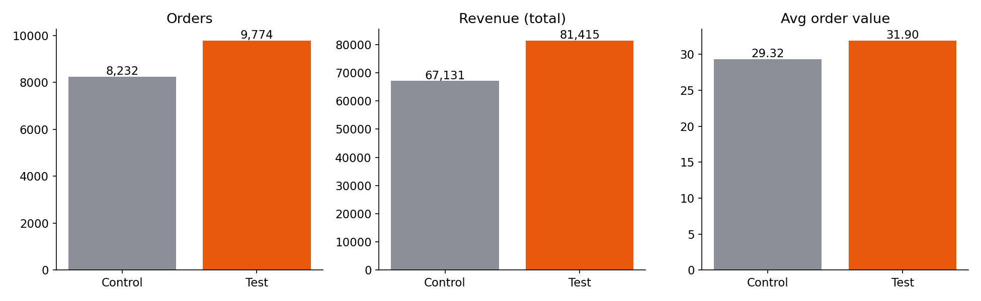

2. Exploratory data analysis
Q1. How is order value distributed across hours? Which hours are significantly higher or lower?
Order value is strongly right-skewed (median 24.35 vs mean 30.72), and it differs significantly by hour (Kruskal-Wallis p < 0.001). The highest average basket is at 9:00 (35.55), followed by 15:00 (34.52), 13:00 (34.24) and 12:00 (33.80). The lowest are at 8:00 (26.82), 10:00 (27.38), 18:00 (28.03) and 21:00 (28.06); 10:00 is also the lowest on a median basis (19.40).
The pattern is: smaller baskets at the breakfast peak (8:00) and the late-evening peak (21:00, which is also the busiest hour with 2,862 orders), and larger baskets around lunch and mid-afternoon. The gap between the best and worst hours is about 30% in the mean, but the spread inside every hour is large (standard deviation close to the mean), so hour alone is a weak predictor of basket size.
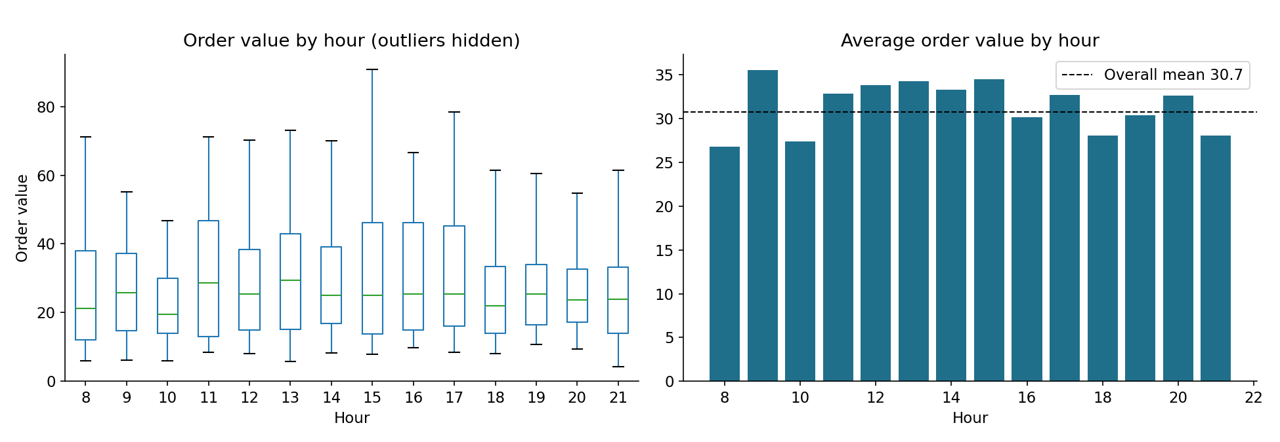
Q2. How does revenue differ between morning (before noon) and evening (6 PM onward)?
Morning orders average 7.90 revenue (median 7.15, n = 4,644); evening orders average 8.05 (median 7.27, n = 6,942). Evening is only 1.8% higher. The result is borderline: Mann-Whitney p = 0.0004 but Welch p = 0.069. In practice the two distributions are almost the same, both with a long right tail. Evening matters for volume (6,942 orders vs 4,644), not for revenue per order.
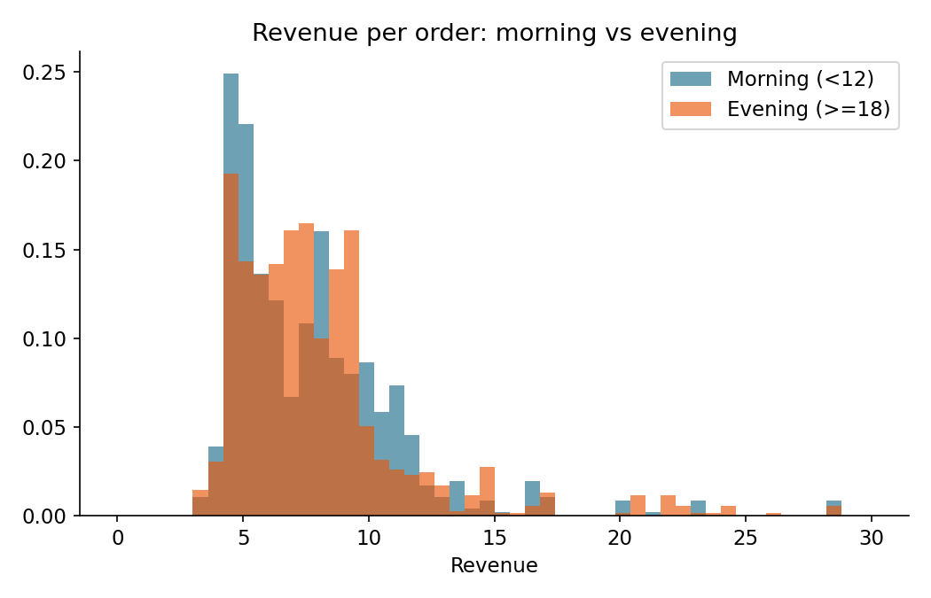
Q3. How does the delivery fee affect revenue? Do higher or lower fees correlate with revenue changes?
Across all orders, fee and revenue are negatively correlated (Pearson -0.40, Spearman -0.32). This must not be read as "higher fees reduce revenue". It happens because zero-fee orders in Test are the biggest baskets (average order value 62.74), so they earn the most commission (average revenue 12.55), while paid orders are small baskets averaging about 21 and earning 6.6 to 8.4.
Among the paid tiers, revenue per order rises mildly with the fee (2.49: 6.63, 2.59: 6.86, 2.89: 7.16, 3.29: 7.66), but basket size also rises slightly across these tiers, and tiers were not randomised, so the data cannot say whether higher fees cost orders. Delivery fees make up 28% of Control revenue and 23% of Test revenue. Commission (20% of order value) is the larger driver in both arms, so basket size and order count matter more than the fee itself.
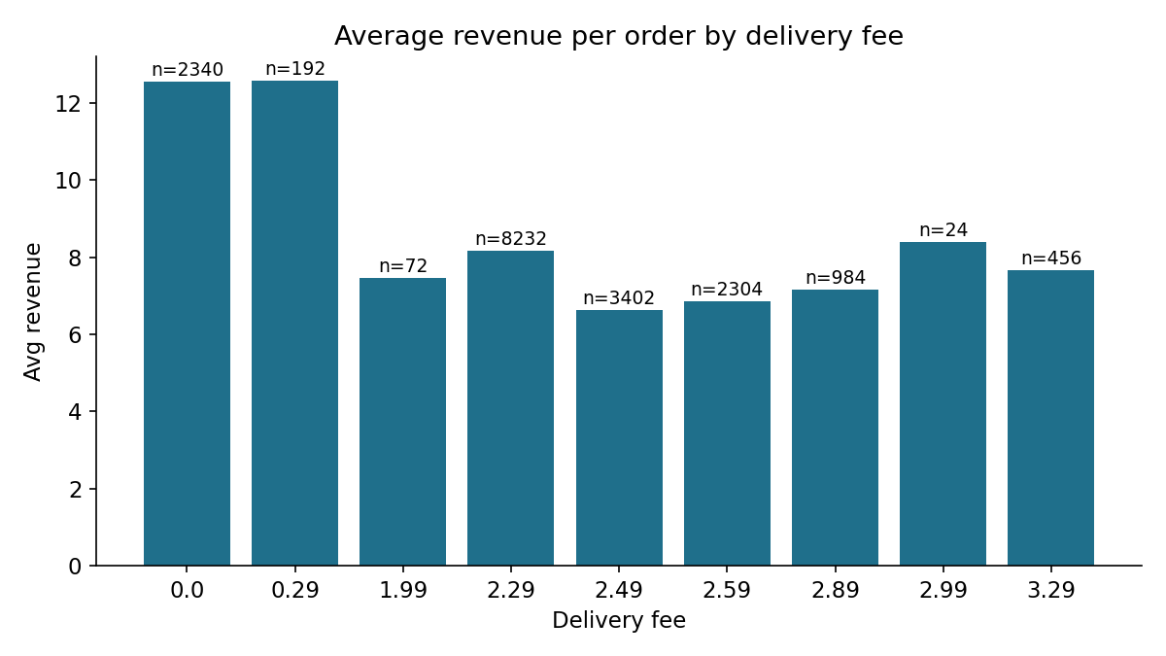

3. A/B testing questions
Q1. Is there a statistically significant difference in revenue between Control and Test?
Yes. Revenue per order is 8.15 in Control and 8.33 in Test, a difference of 0.175 (+2.1%), 95% CI [0.05, 0.30], Welch t = 2.64, p = 0.008. A bootstrap interval gives the same answer [0.05, 0.30]. Total revenue is 67,131 vs 81,415 (+21.3%).
On a daily basis Test earns 2,626 per day vs 2,166 (paired t-test p < 0.001) and beats Control on 26 of 31 days. The Mann-Whitney p-value is extremely small, but that test compares whole distributions, not means: Test has a higher median (7.64 vs 7.09) and a different shape, so I rely on the t-test and the intervals for the mean question.
Q2. How does the variant affect order value? Does one variant lead to higher order values?
Yes, Test is higher. Average order value is 29.32 vs 31.90 (+2.58, +8.8%), 95% CI [1.88, 3.28], p < 0.001. The log-scale test and Mann-Whitney agree.
The reason matters. Within each basket-size group the average basket is the same in both arms (orders of 33 or more: 57.39 vs 56.65; below 33: 18.65 vs 19.08). What changed is the mix: 34.13% of Test orders are 33 or more vs 27.55% in Control. So the higher average comes from more large-basket orders (consistent with the free-delivery threshold pulling them in), not from bigger baskets at each level.
Q3. Does the variant influence the delivery fee charged?
Yes, strongly. The average fee is 2.29 in Control (fixed) and 1.95 in Test (-14.9%), p < 0.001. The average hides a split: 24% of Test orders pay nothing, while the rest pay about 2.63 on small baskets, 15% above the Control fee.
Q4. Does time of day change the treatment effect? When does Test outperform Control on revenue?
Yes, the effect varies a lot by hour. Test earns more total revenue in 11 of 14 hours and less in hours 14, 17, 19. The biggest gains are at 16:00 (+100%), 20:00 (+93%), 8:00 (+64%) and 18:00 (+63%), where Test also had 33% to 80% more orders.
On revenue per order, Test is significantly better at 8, 10, 12, 16, 18 and 20 (+11% to +30%) and significantly worse at 11, 13, 15, 17 and 21 (-7% to -26%); hours 9, 14 and 19 show no significant difference. The hours where Test lost revenue (14:00, 17:00, 19:00) all had fewer Test orders than Control. The zig-zag pattern from hour to hour is unusual for a real traffic pattern, so treat hour-level results as directional and confirm them with a longer test. Full table in the appendix.
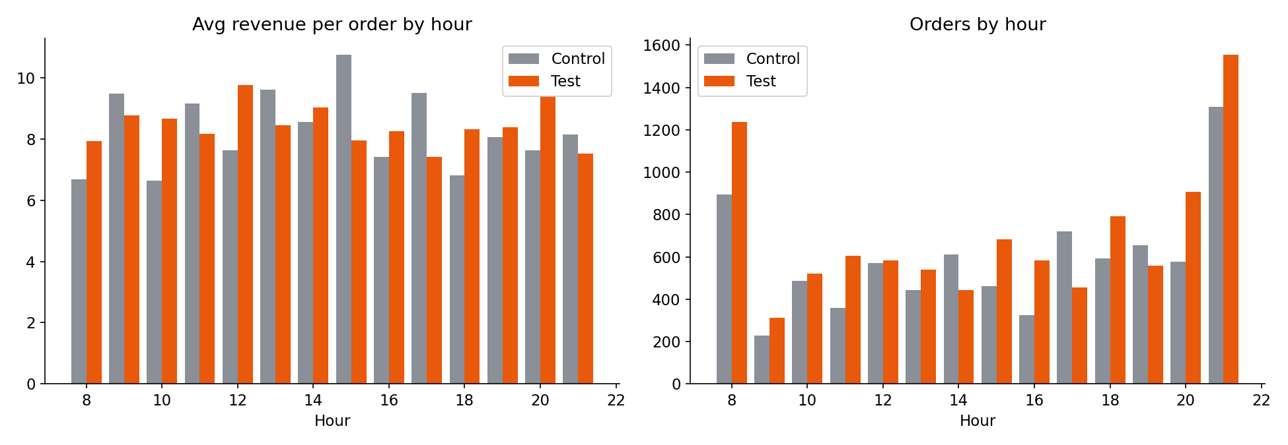
Q5. Is order value more variable in Control or Test? What does it imply?
Test is somewhat more variable. Standard deviation is 24.67 vs 23.11 (variance 609 vs 534, +14%); Levene's test p = 0.002, and the middle 50% of orders spans 29.33 in Test vs 20.70 in Control.
Relative to the mean the spread is the same (coefficient of variation 0.77 vs 0.79), and the 95th percentile is actually lower in Test (68.47 vs 72.99). So Test is not "riskier": the wider spread is a shift of the whole distribution, with more mid-to-large baskets (33+) and the same long tail. Order values are moderately less consistent in Test, which makes revenue forecasting slightly harder, but not materially so.
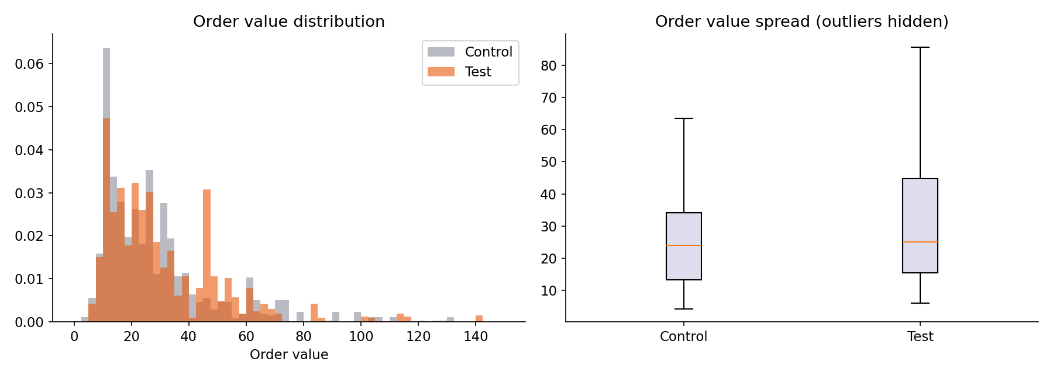

4. Additional questions
A1. How does order value vary by hour across Control and Test?
Control swings widely, from 21.76 (10:00) to 42.31 (15:00). Test is flatter, from 27.05 (21:00) to 40.78 (12:00). Test has the higher average basket in 8 of 14 hours, with the largest gaps at 12:00 (40.78 vs 26.68), 10:00 (32.61 vs 21.76) and 20:00 (36.39 vs 26.76). Control is higher at 9, 11, 13, 15, 17 and 21, with 15:00 the biggest (42.31 vs 29.25). Test therefore evens out the weak hours (breakfast, mid-morning, early evening) without a single hour dominating.
A2. Does the presence or absence of a delivery fee affect total revenue?
Only Test has a fee-free group, because Control always charges 2.29. In Test, free-delivery orders earn 12.55 each vs 7.00 for paid orders (p < 0.001), and they bring 29,364 in total, 36% of Test revenue. This is not a fee effect: free orders are all baskets of 33 or more (average 62.74), so they earn commission, not fees.
The like-for-like view is more informative:
Basket size | Orders (Ctl / Test) | Revenue per order (Ctl / Test) | Total revenue (Ctl / Test)
33 or more (Test: free) | 2,268 / 3,336 (+47%) | 13.77 / 11.96 (-13%) | 31,227 / 39,913 (+28%)
Below 33 (Test: ~2.63 fee) | 5,964 / 6,438 (+8%) | 6.02 / 6.45 (+7%) | 35,904 / 41,502 (+16%)
Waiving the fee costs about 1.80 of revenue per large order, but the volume gain more than covers it. Charging small baskets about 0.34 more gives a 7% rise in revenue per order and does not reduce their order count (+8%). Both halves of the design contribute.
A3. Is there a significant correlation between order value and revenue, and how does it differ by group?
Yes, near-perfect in both. In Control r = 1.00 because revenue is exactly 0.20 × order value + 2.29 (a fixed fee). In Test r = 0.982 (R² = 0.96), a little weaker because the fee varies. The Test slope is 0.166 per unit of order value vs 0.200 in Control: as baskets grow the fee shrinks, so each extra unit of basket earns less than the 20% commission. This is the revenue given up on big baskets.
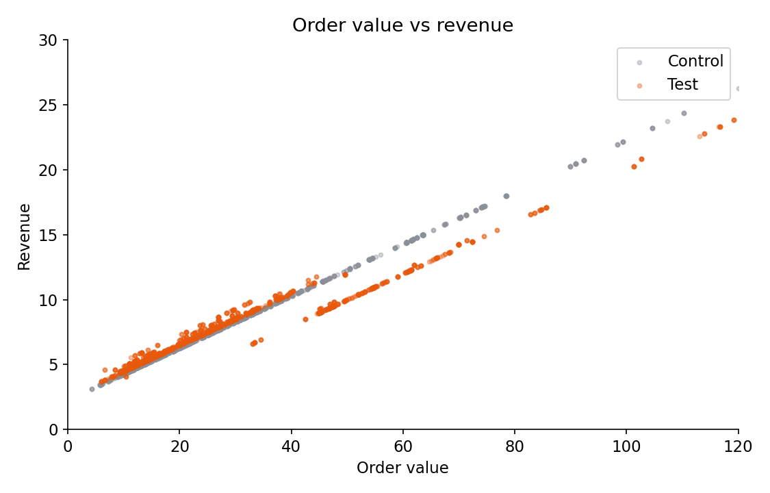
A4. Does time of day affect revenue in each group? Where does one group outperform?
Revenue per order in Control is higher at 9, 11, 13, 15, 17 and 21 (the hours with bigger baskets), peaking at 10.75 at 15:00. Test is higher at 8, 10, 12, 16, 18 and 20, peaking at 9.77 at 12:00. In total revenue, Test leads in 11 of 14 hours; Control leads only at 14:00, 17:00 and 19:00. Test is more even across the day (average revenue per order stays between 7.43 and 9.77) than Control (6.64 to 10.75), which fits the flatter basket sizes in A1.
A5. Is the difference in average order value between the groups statistically significant?
Yes: +2.58 (+8.8%), p < 0.001, with a confidence interval that excludes zero [1.88, 3.28]. As shown in Section 3 Q2, this is a mix effect (more orders of 33 and above) rather than larger baskets in each segment.
A6. Does a delivery fee influence order value, and how does this differ by group?
In Control the fee never changes, so its effect on order value cannot be measured. In Test, fee and order value are strongly negatively related (Spearman -0.57): free-delivery orders average 62.74 against 22.19 for orders that pay a fee. Part of this is mechanical, because the free-delivery rule is set by basket size. The part that is behavioural shows up in the mix: 34.13% of Test orders reach 33 or more vs 27.55% in Control (+6.58 points), consistent with customers adding items to unlock free delivery. The data cannot separate "topping up the basket" from "large-basket customers ordering more often", which is something the next test should isolate.
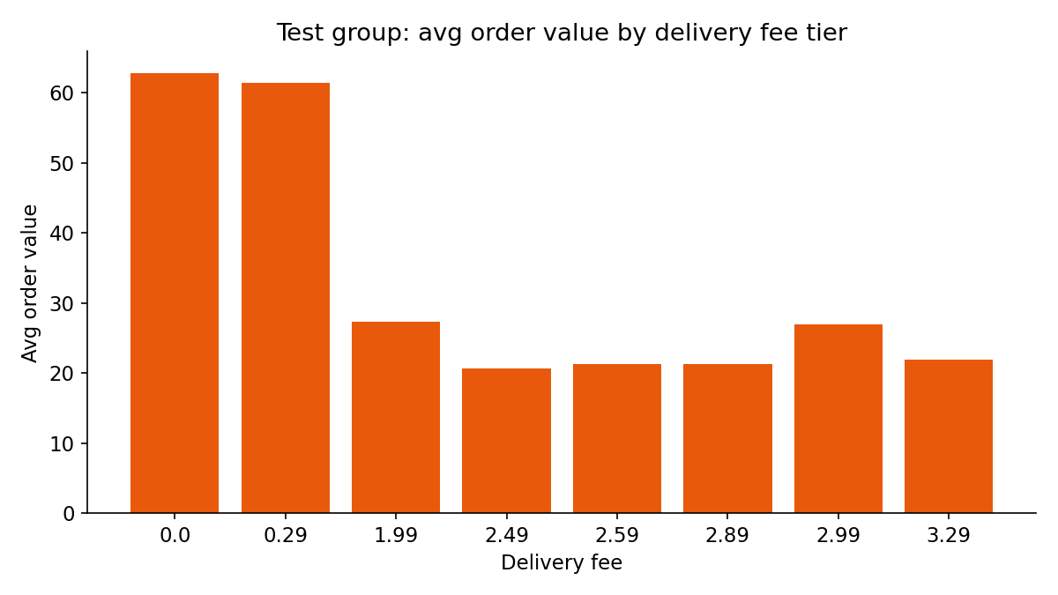
A7. Is variance in order value greater in Control or Test, and what does it indicate?
Test has the greater variance (609 vs 534, Levene p = 0.002), as in Section 3 Q5. The relative spread (CV 0.77 vs 0.79) and the long right tail (skewness 3.0 vs 2.5) are similar in both. Order values are therefore about equally consistent in a relative sense; Test has a wider middle because more orders sit in the 33 to 80 range.

5. Recommendation
Adopt the Test (tiered) delivery fee. It keeps revenue at or above the Control level while adding about 19% more orders, which is the stated objective.
- Keep the free-delivery threshold at about 33. It is the main driver: +47% orders in the large-basket segment and +28% revenue there.
- Keep a fee of roughly 2.49 to 2.89 on smaller baskets. Small-basket revenue per order rose 7% and their order count still grew 8%. Do not push to 3.29 broadly yet: that tier appears mostly at 20:00 and 21:00 and no tier-level demand test was run.
- Watch the afternoon dip. Test lost orders and revenue at 14:00, 17:00 and 19:00. Check whether these hours need a different fee or a promotion.
- Run a follow-up multi-arm test with thresholds of, for example, 25, 33 and 40 and small-basket fees of 2.29, 2.49 and 2.89, randomised by customer. This will find the best settings instead of one tested combination.

6. Limitations and checks before roll-out
- Unequal arm sizes. Test has 9,774 orders vs 8,232 (a 50/50 split would be rejected, p < 0.001). Without visitor or exposure counts I cannot tell whether this is the treatment working or an uneven traffic split. Please confirm the allocation (sample-ratio check). If Test received more traffic, compare conversion per visitor instead, and the order lift of +18.7% would shrink. Revenue per order (+2.1%) and basket-mix findings do not depend on this.
- Short window. One month only. The daily order counts repeat exactly week after week from 7 July, so the days are not fully independent and the daily p-values are likely too optimistic. Check whether the file is aggregated or simulated.
- Revenue is not profit. Free delivery lowers fee income, and courier cost per order is not in the data. If more orders raise delivery cost, profit could be lower than revenue suggests.
- No randomisation inside Test. Fee tiers depend on basket size and hour, so we cannot give a causal price elasticity for any single tier.
- Novelty effect. A free-delivery offer may lift orders at first and fade; track the next 4 to 8 weeks.

Appendix: hour-by-hour A/B results
Orders and revenue are totals over the month; average revenue is per order. p-value is Welch t-test on revenue per order; * marks significance after Bonferroni correction (p < 0.0036).
Hour | Orders Ctl | Orders Test | Orders lift | Avg rev Ctl | Avg rev Test | Rev/order change | Total rev Ctl | Total rev Test | p
8:00 | 894 | 1,236 | +38% | 6.69 | 7.94 | +19% | 5,980 | 9,818 | <0.001*
9:00 | 228 | 312 | +37% | 9.50 | 8.77 | -8% | 2,165 | 2,735 | 0.156
10:00 | 486 | 522 | +7% | 6.64 | 8.67 | +30% | 3,228 | 4,524 | <0.001*
11:00 | 360 | 606 | +68% | 9.16 | 8.17 | -11% | 3,298 | 4,951 | 0.001*
12:00 | 570 | 582 | +2% | 7.63 | 9.77 | +28% | 4,346 | 5,687 | <0.001*
13:00 | 444 | 540 | +22% | 9.62 | 8.46 | -12% | 4,272 | 4,567 | 0.002*
14:00 | 612 | 444 | -27% | 8.57 | 9.03 | +5% | 5,244 | 4,011 | 0.061
15:00 | 462 | 684 | +48% | 10.75 | 7.95 | -26% | 4,968 | 5,438 | <0.001*
16:00 | 324 | 582 | +80% | 7.43 | 8.26 | +11% | 2,406 | 4,808 | <0.001*
17:00 | 720 | 456 | -37% | 9.51 | 7.43 | -22% | 6,849 | 3,387 | <0.001*
18:00 | 594 | 792 | +33% | 6.81 | 8.32 | +22% | 4,042 | 6,590 | <0.001*
19:00 | 654 | 558 | -15% | 8.08 | 8.39 | +4% | 5,281 | 4,682 | 0.121
20:00 | 576 | 906 | +57% | 7.64 | 9.40 | +23% | 4,401 | 8,512 | <0.001*
21:00 | 1,308 | 1,554 | +19% | 8.14 | 7.53 | -7% | 10,648 | 11,704 | <0.001*

