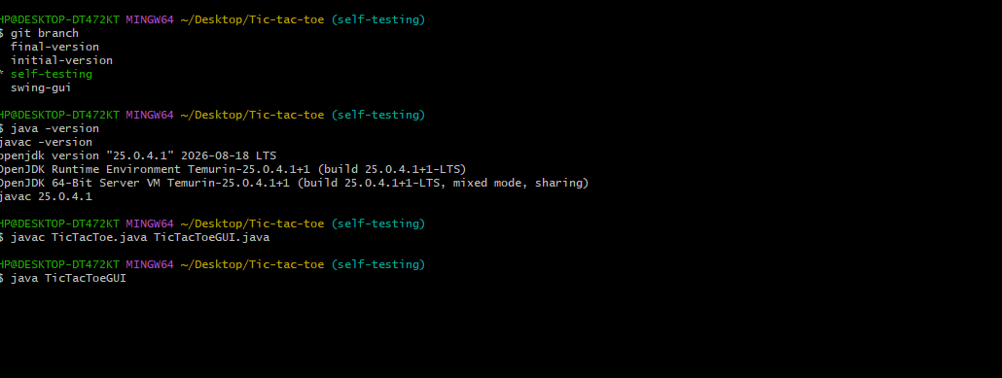
The screenshot above shows the terminal command and the presence of java version. It shows the version of jdk installed in our system.

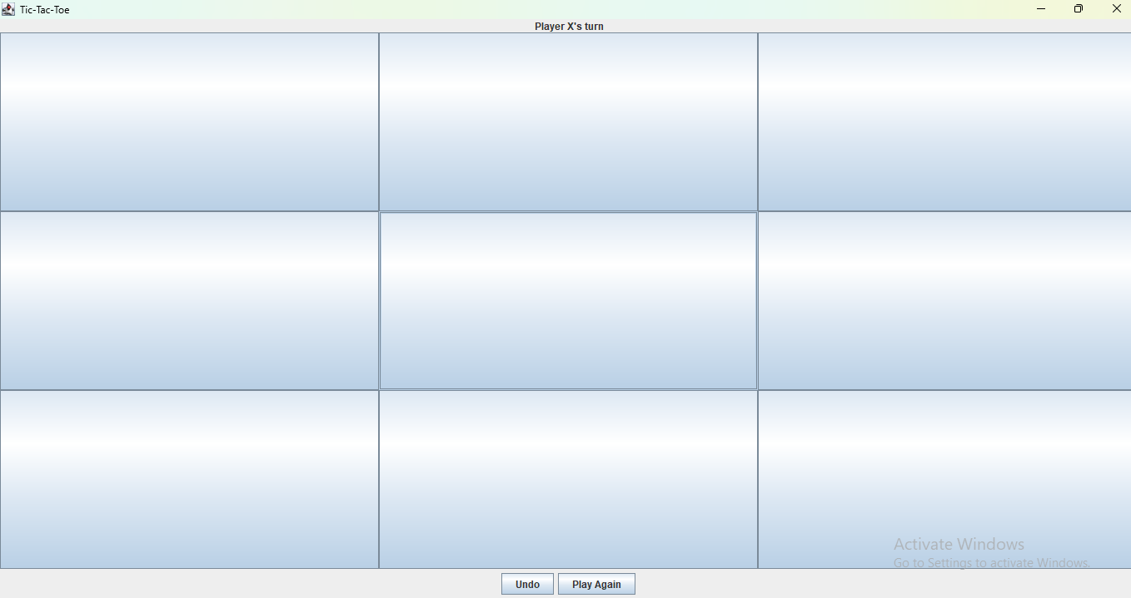
The screenshot above shows the empty board and the starting turn of player X. The Tic-Tac-Toe window opened with an empty 3×3 board.

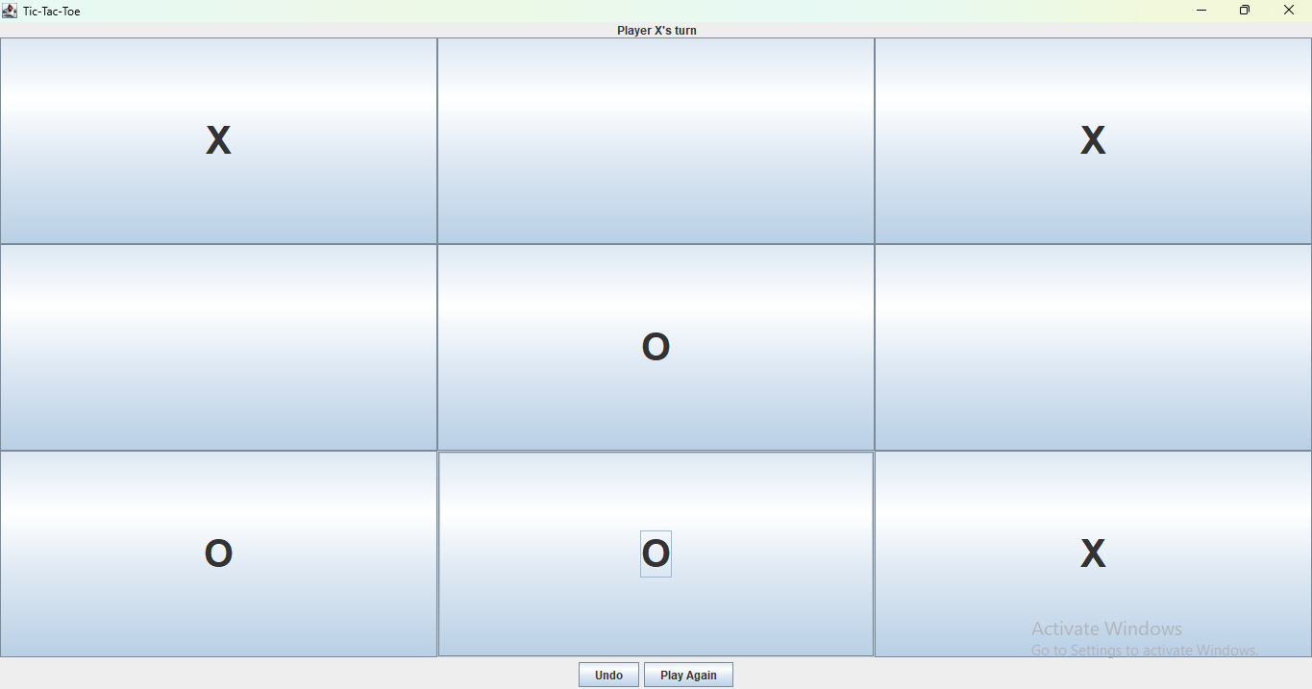
The screenshot shows several moves of two players: X and O. I played several moves and confirmed that X and O appeared correctly.
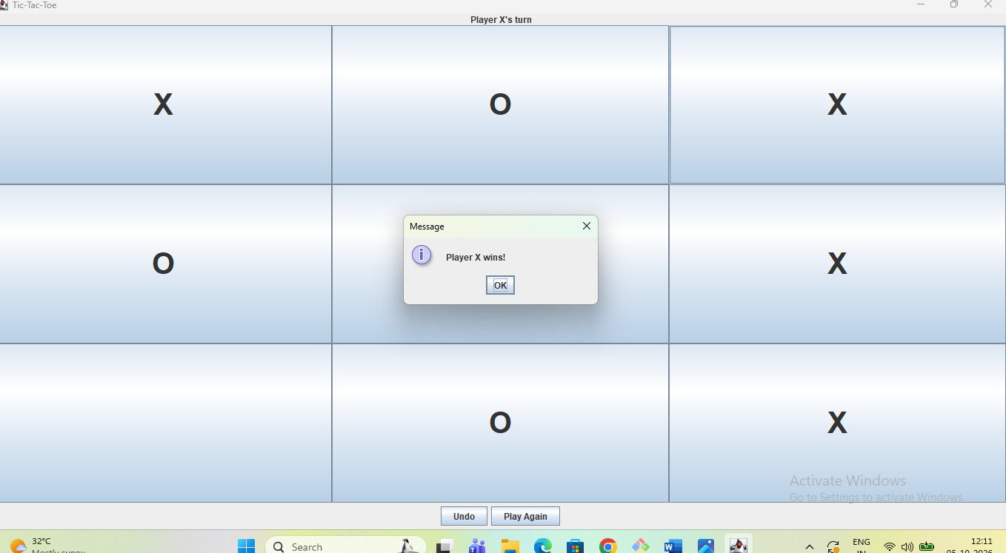

The screenshot shows several moves of player X and O . The win message appear : Player X wins. Player X completed a winning combination and the win message appeared.

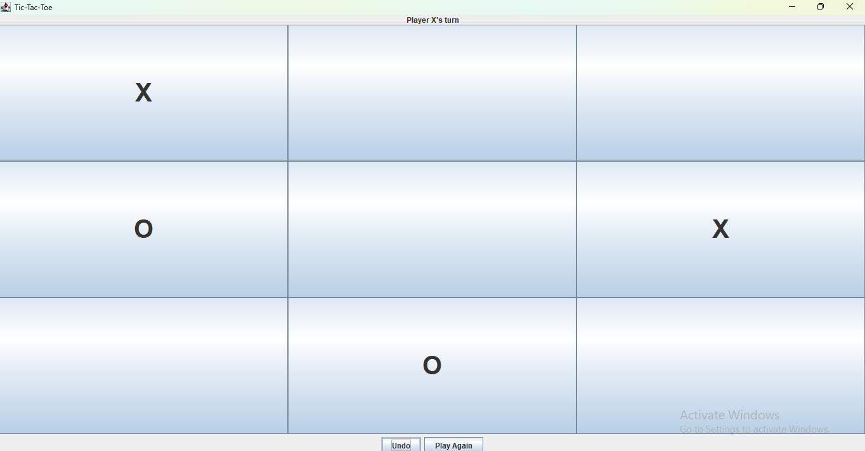
The screenshot shows the board before undo button is pressed.

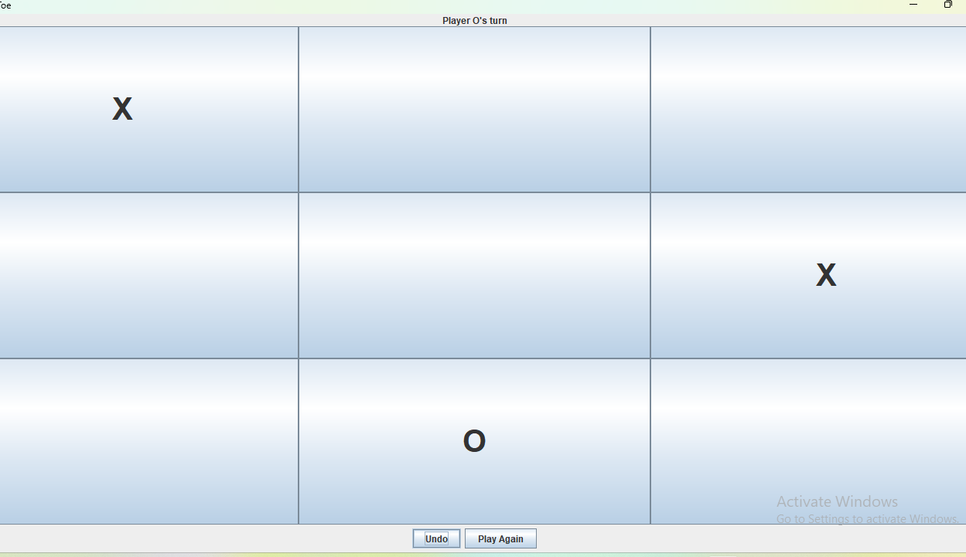
The screenshot shows the board after the undo button is pressed.
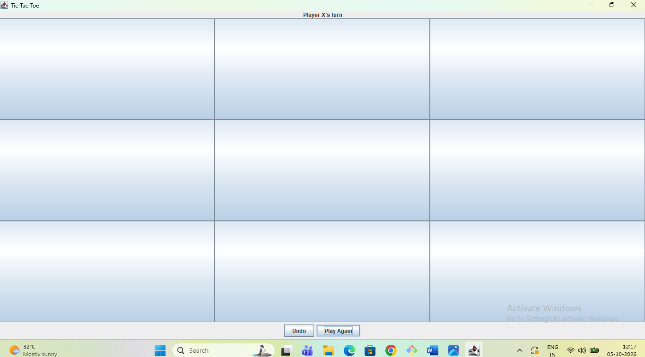
The screenshot shows the board after the play again button is pressed. Play Again reset the game and displayed a fresh empty board.

