Report
Of
Data Science Master Virtual Internship
Submitted
To
School of Computer Science and Engineering
IILM University, Greater Noida, U.P.
In partial fulfilment of the requirement of degree of
B.Tech CSE

By
Roll Number of Student: 2410031133
Name of Student: ADITYA KUMAR
Batch: 2026-27

CANDIDATE’S DECLARATION
I, Aditya Kumar, do hereby declare that the internship report titled “Data Science Master Virtual Internship” has been completed by me to fulfil the requirement for the award of the degree of Bachelor of Technology in Computer Science and Engineering. All the references have been quoted and I have not taken as such any material from any other source. I affirm that this report is my own work and has not been submitted to any other institute for any degree/diploma requirement, and I shall be solely responsible for any kind of copyright violation in this regard.

Signature
Student Name: Aditya Kumar
Roll No.: 2410031133
ACKNOWLEDGEMENT
I am using this opportunity to express my gratitude to everyone who supported me throughout the Internship Program. I am thankful for their aspiring guidance, invaluably constructive criticism and friendly advice during this work. I am sincerely grateful to them for sharing their truthful and illuminating views on a number of issues related to this work.
I express my gratitude to my parents for their blessings.

Signature
Student Name: Aditya Kumar
Roll No.: 2410031133
TABLE OF CONTENTS
Chapter No. | Chapter Name | Page Nos.
 | Cover Page | ----
1. | Candidate’s Declaration | i
2. | Acknowledgement | ii
3. | Internship Completion Certificate | vi
4. | Project Description | 1
 | 4.1 Introduction | 1
 | 4.2 Organization Profile | 1
 | 4.3 Problem Statement | 2
 | 4.4 Project Objectives | 2
 | 4.5 Scope of the Project | 2
 | 4.6 Technologies and Tools Used | 3
 | 4.7 System Architecture | 3
 | 4.8 Methodology | 4
 | 4.9 Expected Outcomes | 4
 | 4.10 Certificates of completion and other communication mail proof | 5
5. | Bibliography/References | 9
LIST OF TABLES
Table No. | Title | Page No.
4.1 | Technologies and Tools Used | 3
LIST OF FIGURES
Figure No. | Title | Page No.
4.1 | RapidMiner AI Hub – End-to-End Data Science Workflow | 4
INTERNSHIP COMPLETION CERTIFICATE
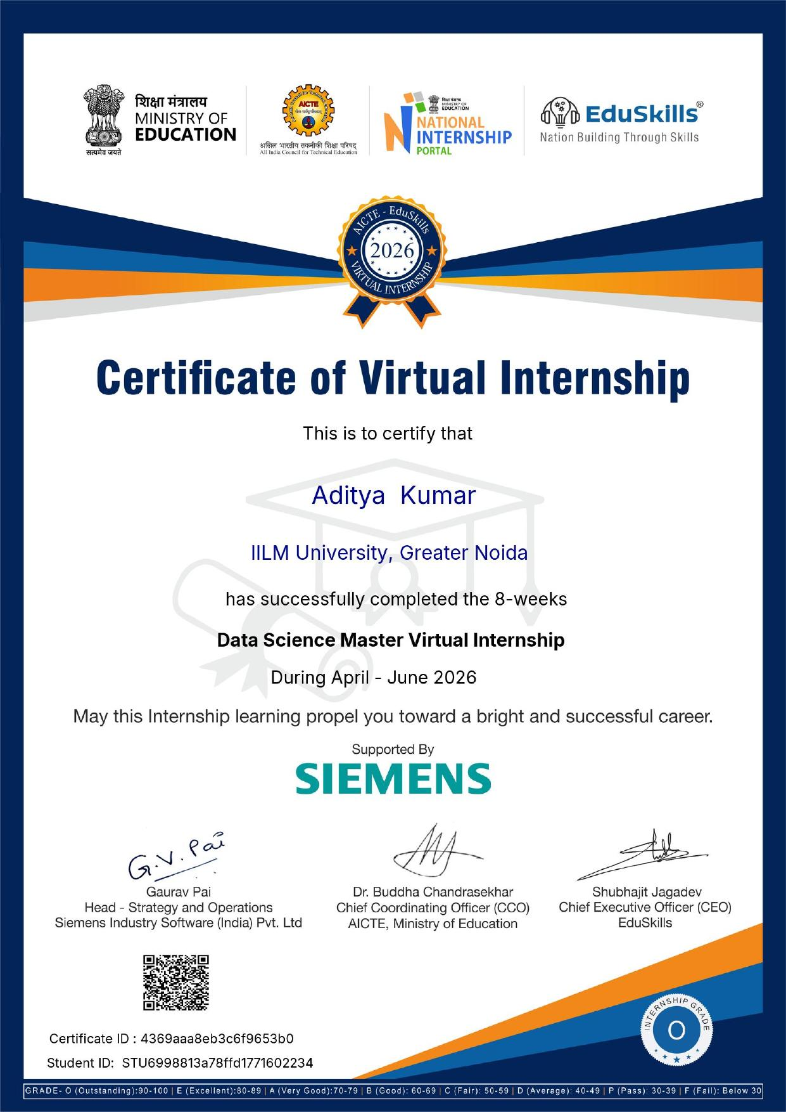

CHAPTER 4: PROJECT DESCRIPTION
4.1 Introduction
This report presents the work undertaken during the Data Science Master Virtual Internship, an 8-week program conducted under the AICTE–EduSkills National Internship Portal in association with Siemens Industry Software and delivered on the RapidMiner (an Altair company) data science platform. The internship was undertaken between April 2026 and June 2026 while pursuing the Bachelor of Technology in Computer Science and Engineering at IILM University, Greater Noida.
The program followed a week-wise structured learning plan combining conceptual instruction with hands-on exercises in RapidMiner Studio and RapidMiner AI Hub. Progress was tracked through weekly assessments, project documentation and assignments, culminating in a Final Assessment Test in the last week. Upon successful completion of all assessment requirements, the internship was awarded an overall grade of “O – Outstanding” (90–100), and seven industry-recognized RapidMiner certifications were earned across the Professional and Master levels.
4.2 Organization Profile
Siemens Industry Software (India) Pvt. Ltd. is part of Siemens Digital Industries Software, a global provider of software and services for product design, manufacturing and industrial automation. As part of its skill-development initiatives, Siemens supported the Data Science Master track offered under this internship.
The internship was delivered through the National Internship Portal, an initiative of the All India Council for Technical Education (AICTE) under the Ministry of Education, Government of India, in partnership with EduSkills Foundation — a not-for-profit organization focused on building industry-relevant skills among engineering students through structured virtual internships.
The hands-on component of the internship was built entirely on RapidMiner, a data science and machine learning platform developed by Altair Engineering Inc. RapidMiner provides an end-to-end visual environment for data access, preparation, modeling, validation, deployment and platform administration, and was used throughout the internship for all exercises, projects and certification examinations.
4.3 Problem Statement
Organizations increasingly rely on data-driven decision-making, yet a significant gap often exists between the theoretical data science knowledge gained in academic coursework and the practical, tool-based skills required to design and operate real-world data science pipelines. Students frequently lack structured, industry-mentored exposure to the complete lifecycle of a data science project — from identifying a suitable business problem, through data engineering and model building, to deployment and platform administration.
This internship was designed to address that gap by providing a structured, certification-driven curriculum that progressively builds competency from foundational business-use-case identification to advanced machine learning, deployment and enterprise platform administration, using an industry-standard tool (RapidMiner) rather than isolated academic exercises.
4.4 Project Objectives
- Identify real-world business problems suitable for Artificial Intelligence and Machine Learning solutions.
- Build strong data engineering skills — accessing, loading, transforming and cleansing data.
- Develop foundational and advanced Machine Learning capabilities using RapidMiner.
- Master model deployment, monitoring and complex predictive modeling techniques.
- Learn RapidMiner AI Hub administration and enterprise-level platform operations.
- Earn industry-recognized RapidMiner certifications at Professional and Master levels.

4.5 Scope of the Project
The scope of the internship was limited to the structured 8-week virtual curriculum defined by the AICTE–EduSkills National Internship Portal and Siemens Data Science Master track. It covered guided, exercise-based learning across seven modules — Applications & Use Cases, Data Engineering, Machine Learning, Data Preparation and Platform Administration — at Professional and Master certification levels, assessed through weekly tests, project submissions and a Final Assessment Test.
The internship did not involve deployment to a live client environment or a paid engagement; it was unpaid and entirely virtual/self-paced within the weekly schedule. The scope was therefore focused on individual skill-building and certification rather than delivering a production system for an external client.
4.6 Technologies and Tools Used
Table 4.1 below summarizes the key technologies and tools used during the internship.
Category | Tool / Technology | Purpose
Core Platform | RapidMiner Studio | Visual workflow design for data preparation, modeling and evaluation
Platform Administration | RapidMiner AI Hub | Deployment, scheduling, monitoring and enterprise administration of models
Big Data Processing | RapidMiner Radoop | Execution of data workflows on big-data / Hadoop-based environments
Scripting & Automation | Regular Expressions, Macros, Scripting | Advanced text processing, automation and reusable process logic
Model Integration | R and Python Integration | Embedding custom R and Python scripts within RapidMiner processes
Connectivity | Web APIs | Connecting external data sources and services to RapidMiner workflows
Delivery Platform | AICTE National Internship Portal | Registration, curriculum delivery and credential validation

Table 4.1: Technologies and Tools Used
4.7 System Architecture
RapidMiner AI Hub follows a structured, end-to-end data science workflow that was used as the working architecture throughout the internship. Figure 4.1 illustrates this workflow, which was applied consistently across all module exercises: data is first accessed from various sources, prepared and cleansed, used to build predictive models, validated and optimized against benchmark metrics, and finally deployed and monitored through the AI Hub platform.
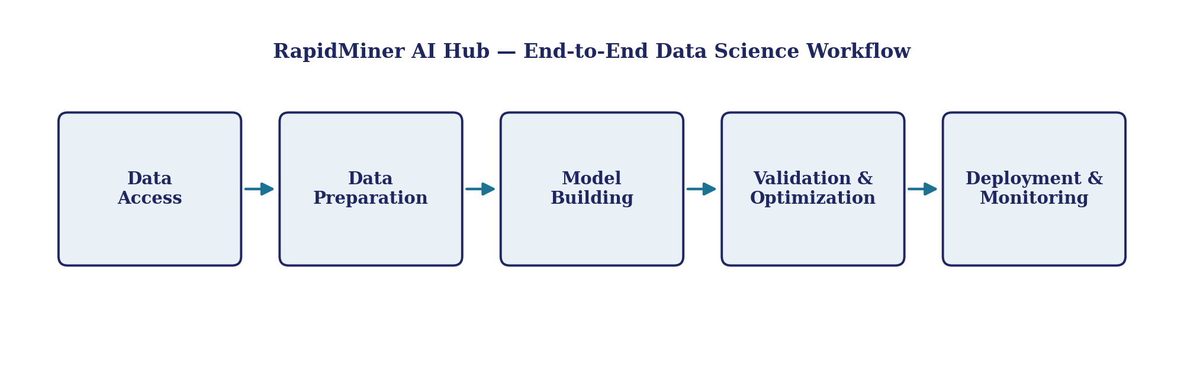
Figure 4.1: RapidMiner AI Hub – End-to-End Data Science Workflow
The Platform Administration Master module additionally covered the administrative layer surrounding this workflow — installation and configuration of RapidMiner Studio, management of the AI Hub server, Radoop integration for big-data execution, real-time scoring services, and the RapidMiner Marketplace — enabling the workflow above to be operated reliably at an enterprise scale.
4.8 Methodology
The internship followed the widely-used CRISP-DM (Cross-Industry Standard Process for Data Mining) methodology, which was formally introduced in the Applications & Use Cases Professional module and applied implicitly across subsequent modules. This methodology structures a data science project into business understanding, data understanding, data preparation, modeling, evaluation and deployment — closely mirroring the week-wise curriculum design of the internship itself.
Learning was delivered through a combination of guided instruction, hands-on RapidMiner exercises, weekly online assessments and project documentation submissions. Each of the eight weeks focused on a specific certification module, with the final week reserved for credential validation and an overall Internship Grade Point Assessment.
4.9 Expected Outcomes
- A working, practical understanding of the end-to-end data science lifecycle using an industry-standard platform.
- Seven RapidMiner (Altair) certifications spanning Applications & Use Cases, Data Engineering, Machine Learning and Platform Administration.
- Improved employability and confidence in applying AI/ML techniques to real business problems.
- A documented internship report, presentation and certification portfolio suitable for academic evaluation and future job applications.

4.10 Certificates of Completion and Other Communication / Mail Proof
This section contains the internship offer letter and all certificates of completion earned during the internship, provided as documentary proof of participation and successful completion.

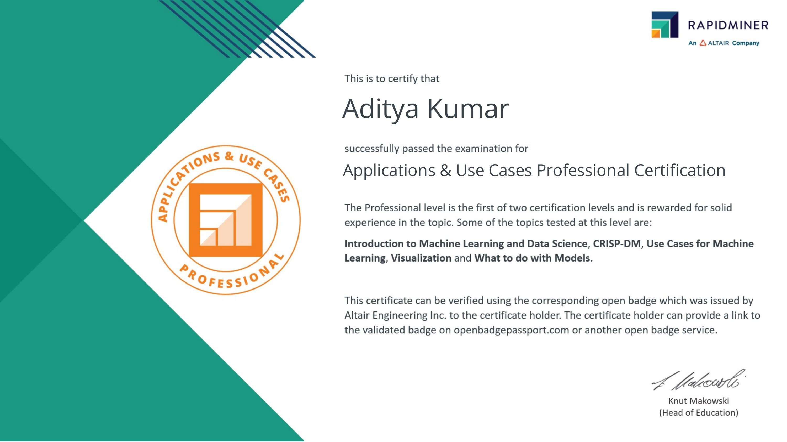
Applications & Use Cases – Professional Certification
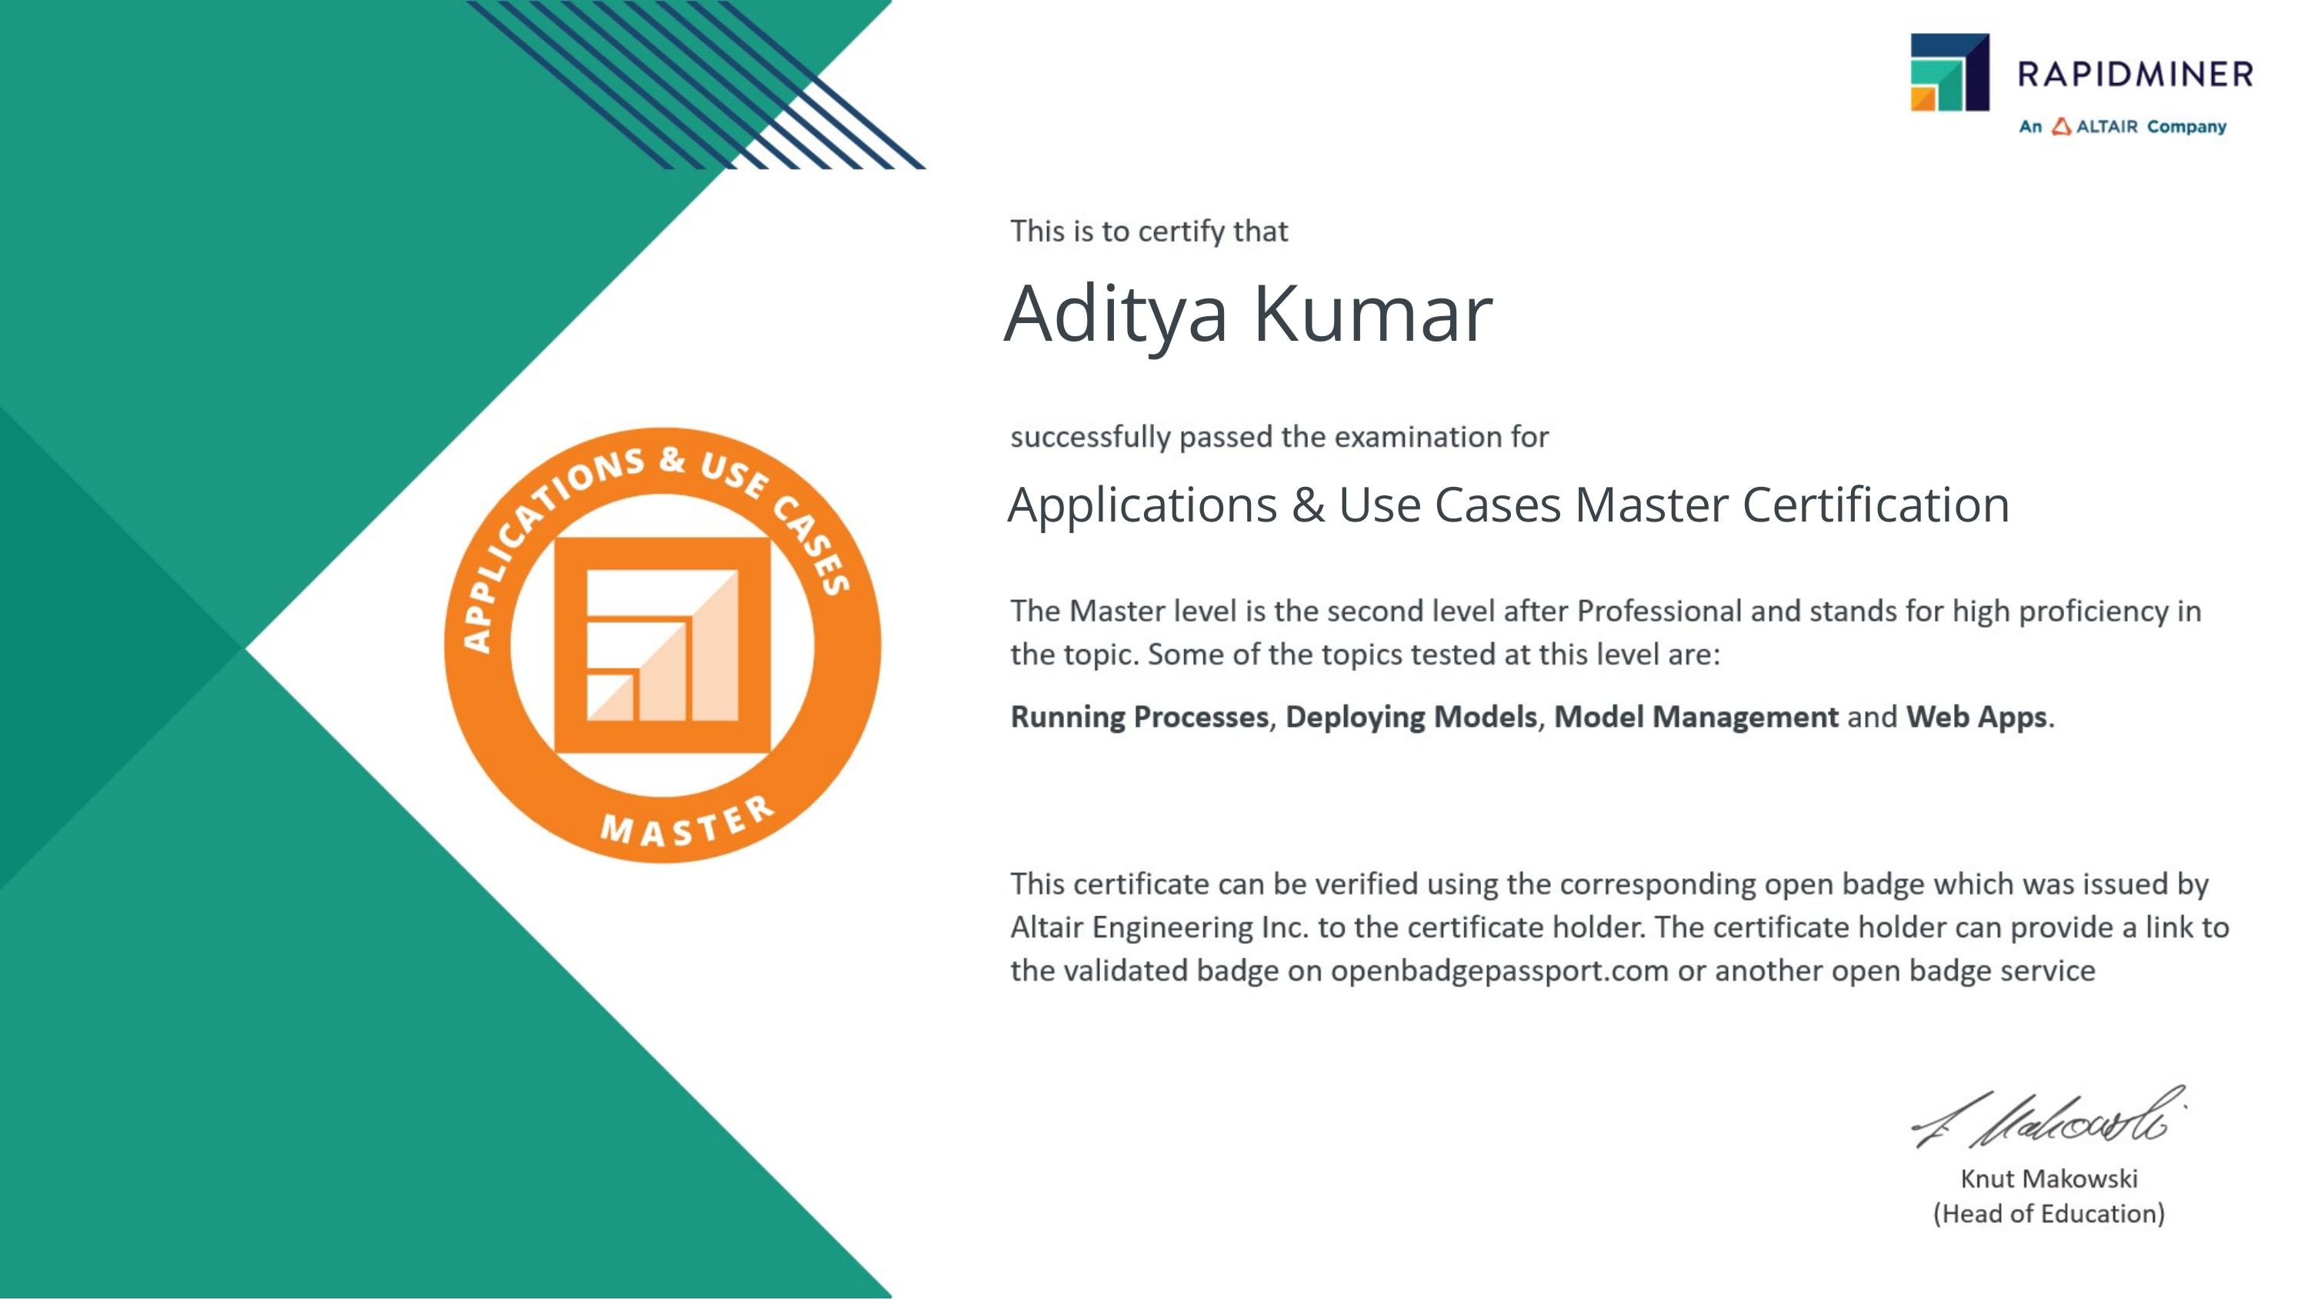
Applications & Use Cases – Master Certification
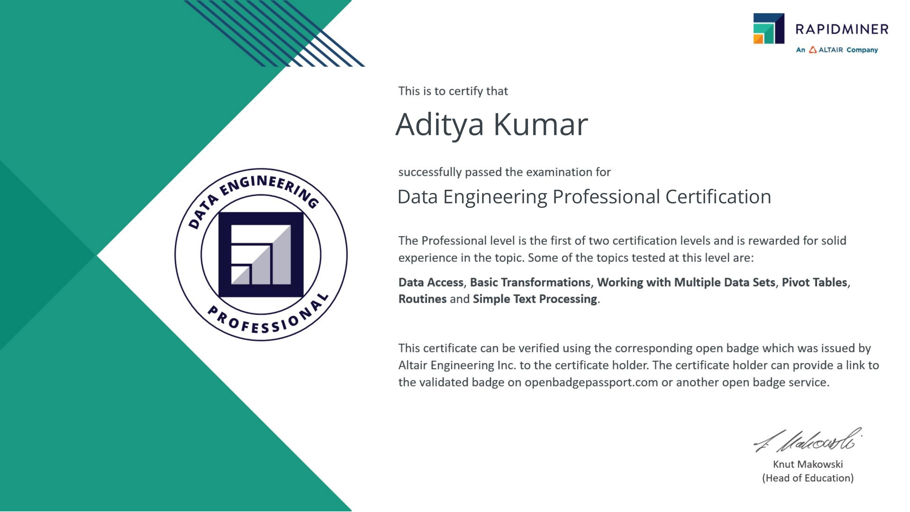
Data Engineering – Professional Certification
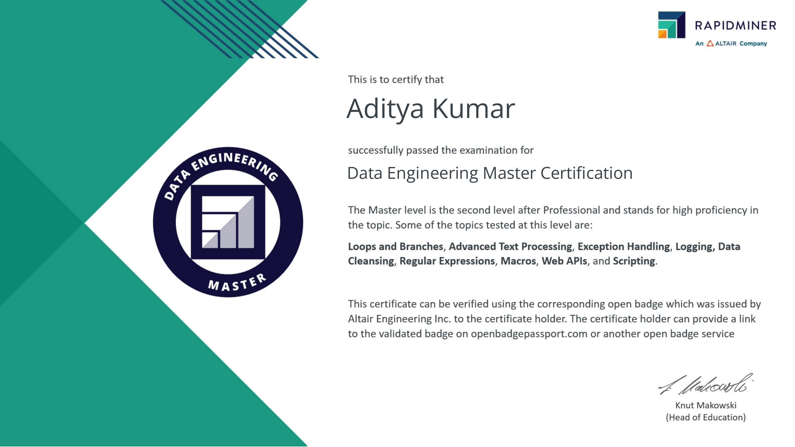
Data Engineering – Master Certification
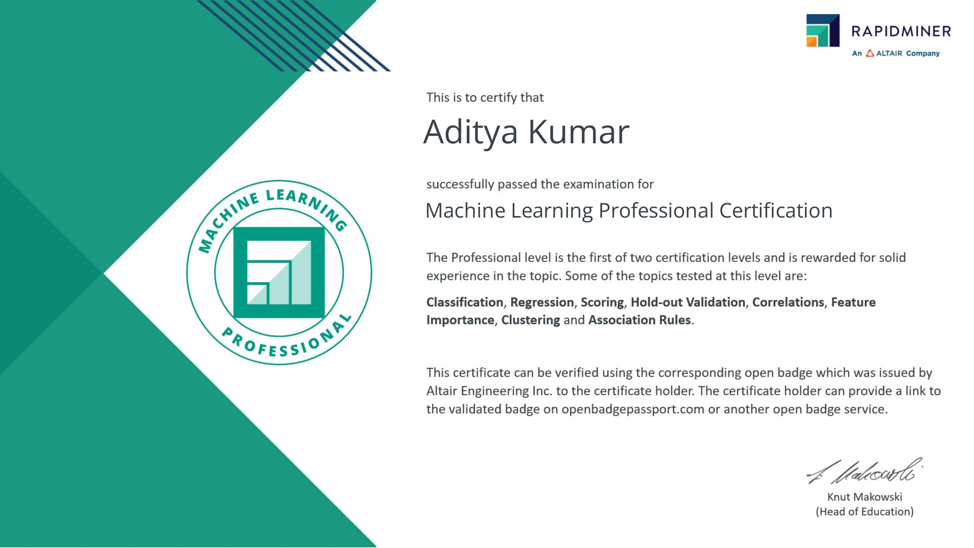
Machine Learning – Professional Certification
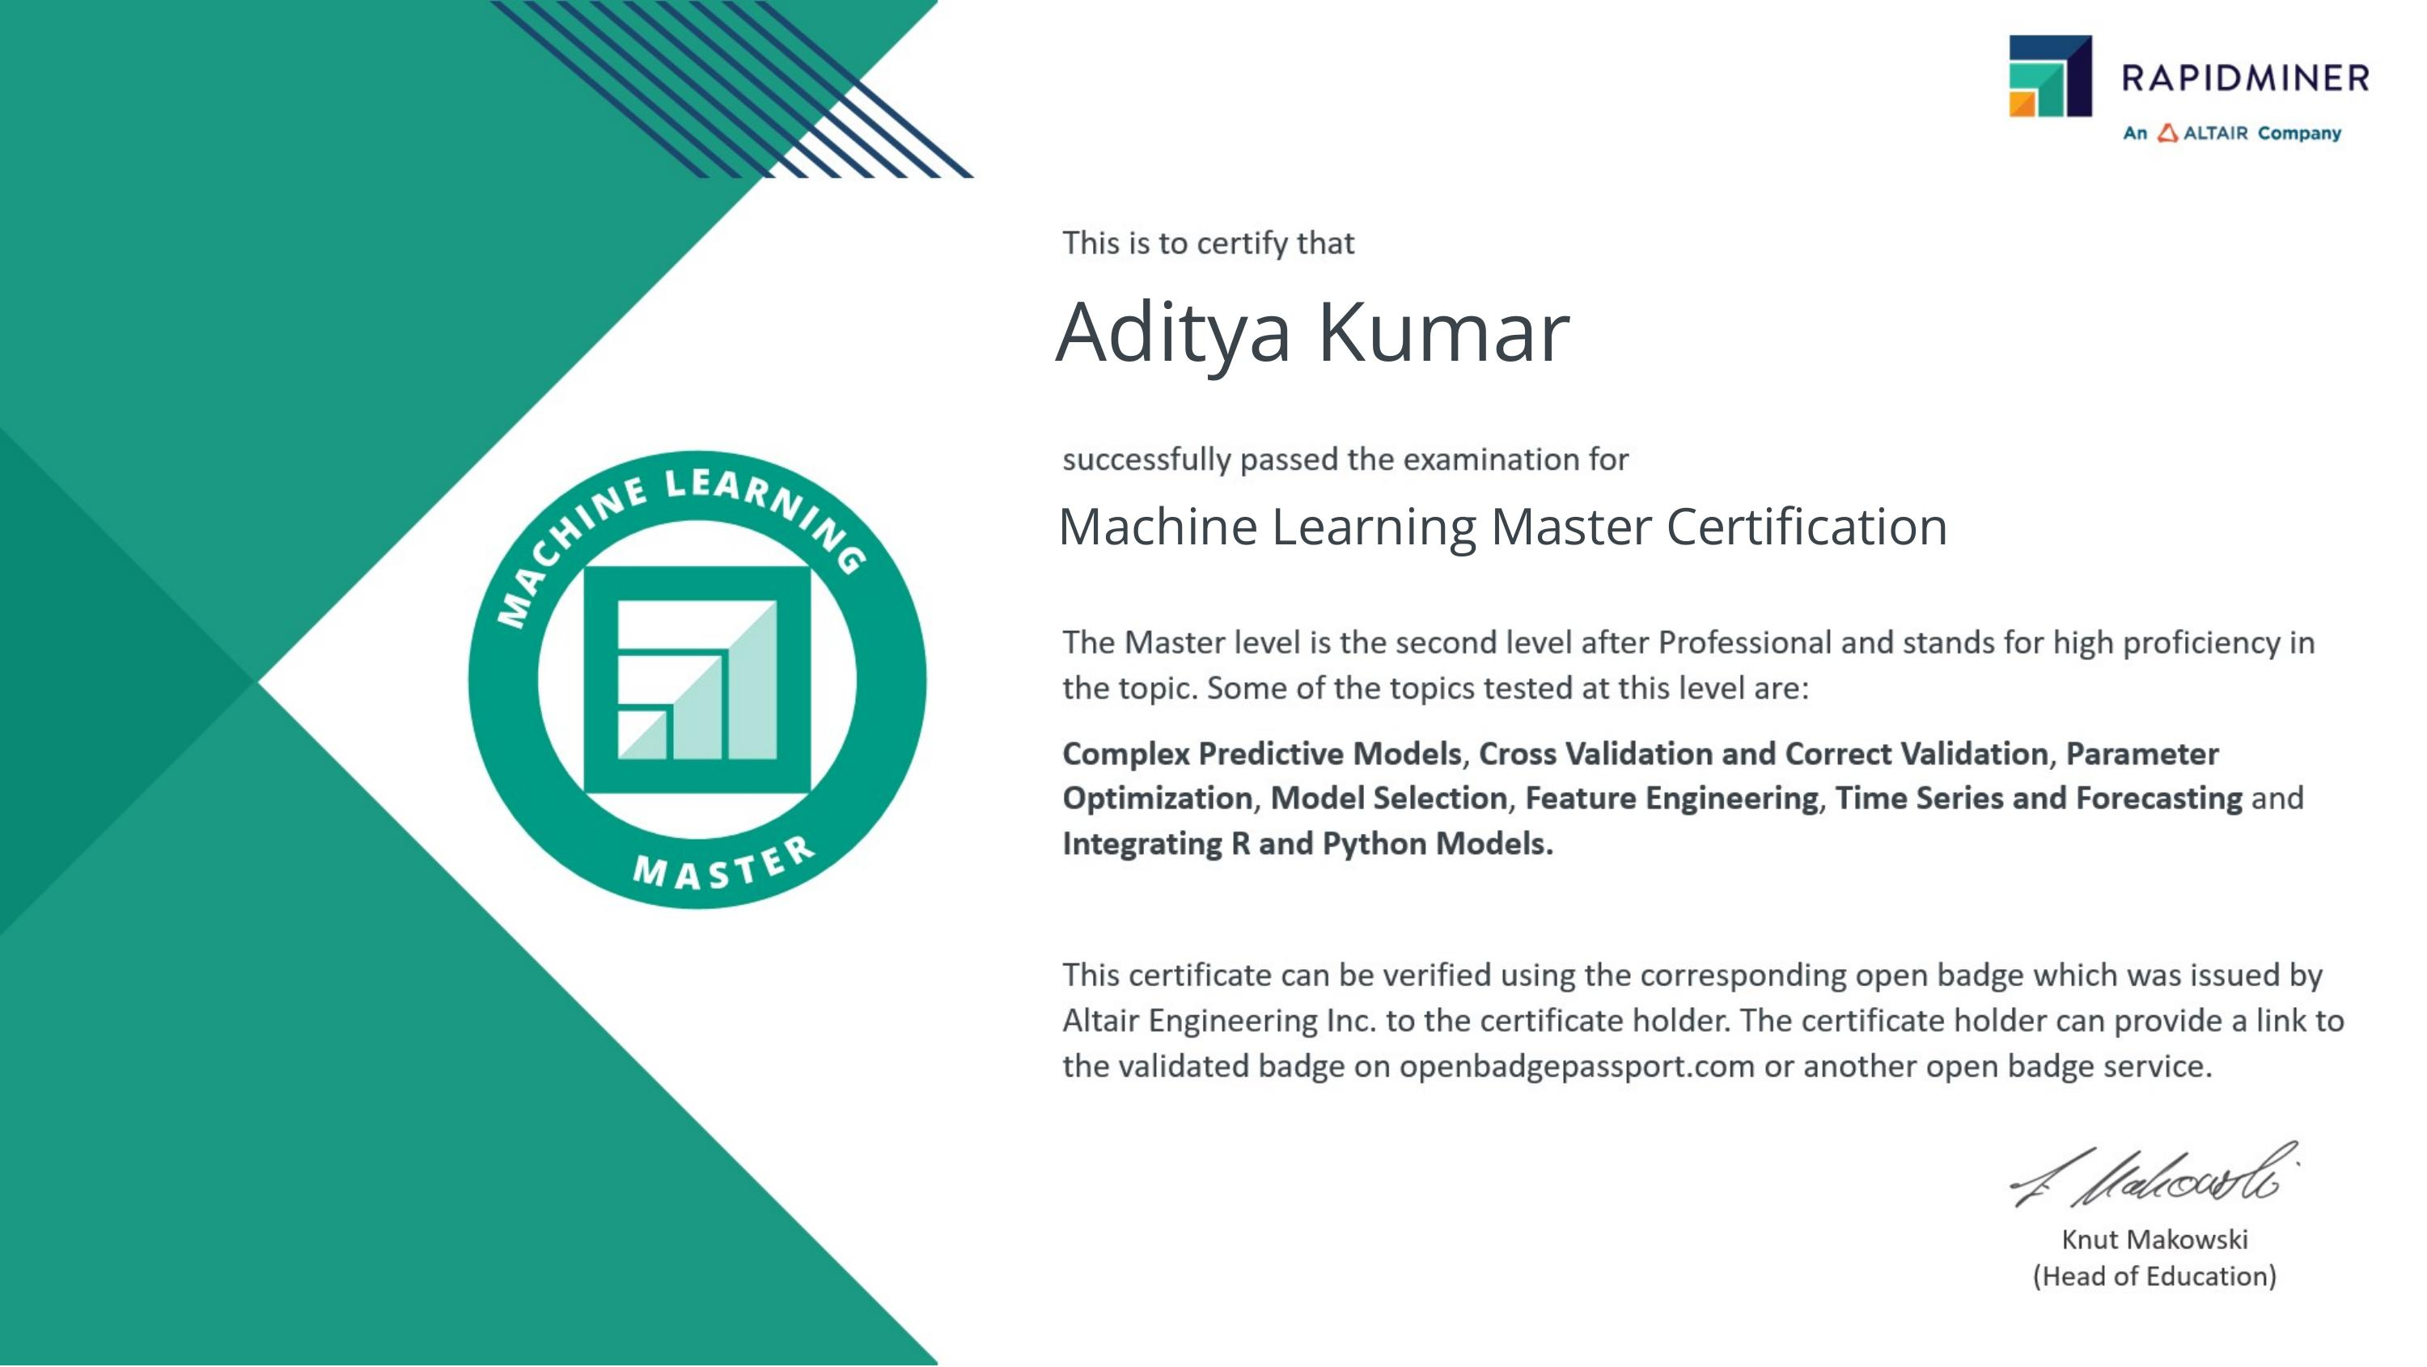
Machine Learning – Master Certification
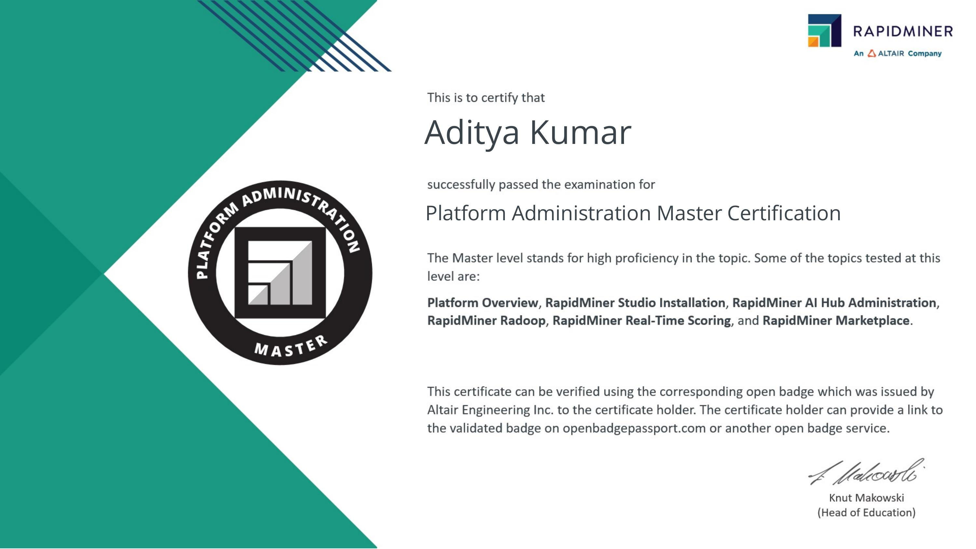
Platform Administration – Master Certification
CHAPTER 5: BIBLIOGRAPHY/REFERENCES
1. Altair Engineering Inc. RapidMiner Documentation. Available at: https://docs.rapidminer.com (accessed 2026).
2. AICTE – EduSkills National Internship Portal. Available at: https://internship.aicte-india.org (accessed 2026).
3. EduSkills Foundation. Nation Building Through Skills. Available at: https://eduskillsfoundation.org (accessed 2026).
4. Siemens Digital Industries Software. Available at: https://www.sw.siemens.com (accessed 2026).
5. Chapman, P., Clinton, J., Kerber, R., Khabaza, T., Reinartz, T., Shearer, C., & Wirth, R. (2000). CRISP-DM 1.0: Step-by-step Data Mining Guide. SPSS Inc.
6. RapidMiner Open Badge Passport – Certificate Verification. Available at: https://openbadgepassport.com (accessed 2026).

