**BATCH REACTOR WITH THREE SPECIES**

1. **PROBLEM STATEMENT:**

Batch reactors are widely used in industry, and are the preferred reactor in laboratories and pharmaceutical industries. The performance of a batch reactor can be analyzed via mole balance. For each species in the reactor, there is a 1 mol balance equation that yields a differential equation:

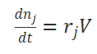

 Let’s consider now a somewhat more challenging problem with multiple chemical species. As a concrete example, consider the reversible reaction and the irreversible reaction in a constant-volume batch reactor. The rate constants k1 and k−1 refer to the forward and reverse reaction rates for the first reaction, while the rate constant k2 is the forward reaction rate constant for the second reaction.

1. **TASK TO DO:**

Write differential equations for concentration as a function of time t for each component and hence find the solution for them. Also, plot a graph of concentration vs time for each species. Assume the kinetic rate constants k1 = k−1 = 2 and k2 = 3 and the initial conditions cA(0) = 1, cB(0) = 0, cC(0) = 0.

1. **OVERVIEW OF SOLUTION :**

We write the differential forms of the rate as follows.

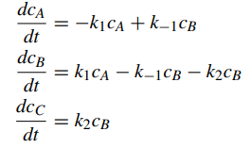

Then converting them into the matrix form of ODE-IVP we get.

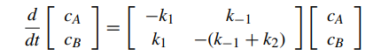

We then Discretize the domain and use Implicit Euler Method to get equations. The solution for these can be found by Jacobian Method. Finally, we plot the concentrations of the component with time.

1. **TEAM 11**:

Akshat Srivastava (220104) Punam Singh (220835)

Sakshi Dargu (220323) Saurabh Kumar (220989)

Akansha Ratnakar (220093) Vishal Kumar (221202)

Charu Chhipeshwar (220306) Aditya Gupta (220066)

Satvik Pratap Singh (220981)