Boat Lifestyle Project Documentation

**Project Title: BOAT Lifestyle Clone App  
  
Team Members:**

1. Aditya Gupta
2. Adarsh Kumar
3. Harshita Labhala
4. Pavan Reddy Suggu
5. Shanmukh Sai Pavan

**Project Introduction**

**Project Title:** BOAT Lifestyle Clone Application

**Software Requirements:** HTML, CSS, JavaScript, React, Node, JSON- Server and Bootstrap

**Project Description**: The main aim of creating the BOAT lifestyle Application is to provide a user-friendly interface to customers to have browse and shop through different products listed on the website and maintain their border history.

It is an e-commerce end-to-end application which supports good UI for users to browse through different products listed on the website and buy those that suit their needs in the best possible way.

The customer initially lands on the home page where they can browse

through the best and top selling products on the website. They can add

the product of their choice to the cart and proceed to buy all at once

by making the payment through the payment gateway.

# Login and Register Module

Login Functionality:

* The user must register on the website in order to place an order.
* The login page is dynamic for both user as well as admin access.
* Depending on the credentials, the person will be able to route through either the admin page or home page.
* The details and history of the user will be saved till the user is logged into the system.

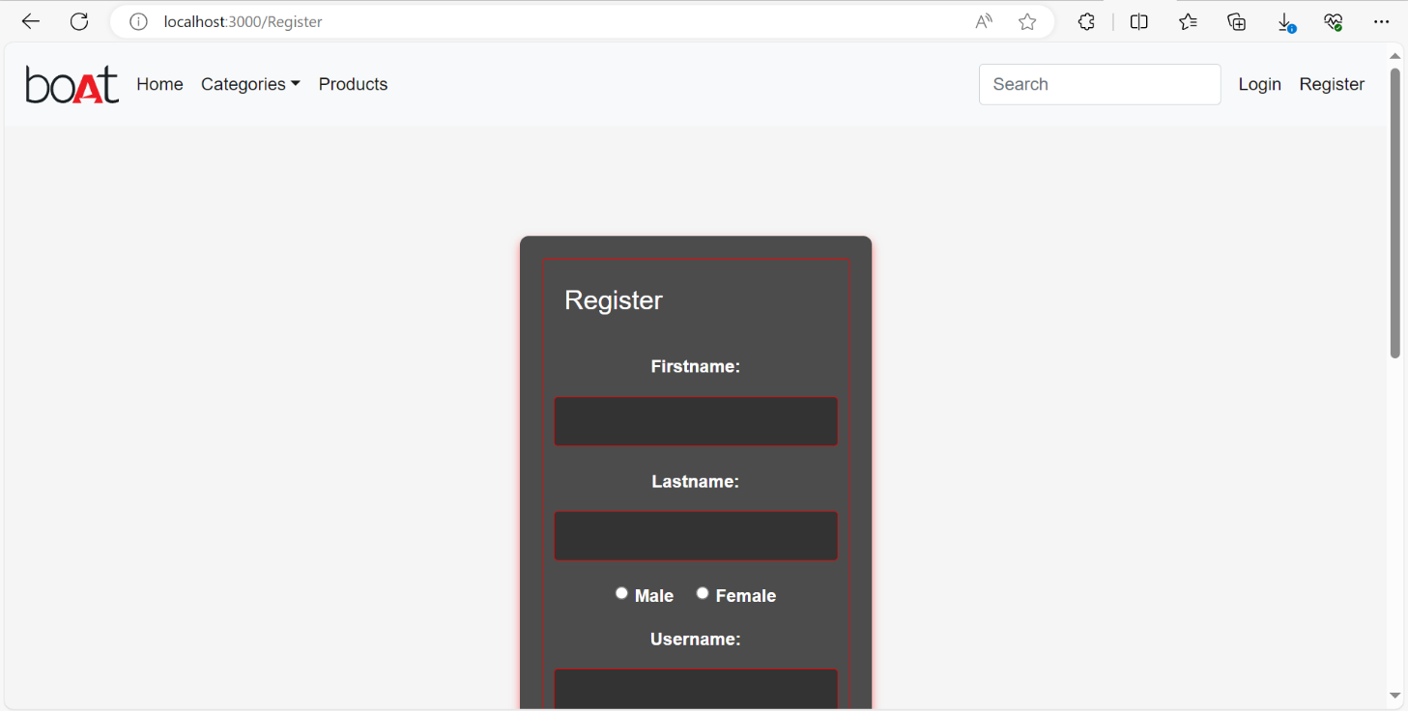

# Admin Module

Admin Activities:

* Add new products to database.
* Edit the existing products details and price.
* Delete the outdated/out-of-stock products.
* View All details of products.
* Admin can perform CRUD operations on products data.
* Admin Module is secured, we need to authenticate Admin to perform admin activates.

## Made sure that admin route is a protected route.

# Customer Module

Customer Activities:

* View the bestsellers on the home page
* View all existing products in the store
* Browse the products based on the selected category
* Select and view the details of selected product
* Add products of choice to the shopping cart
* **Required Components**: Home, Browse, Products Store

## Home Component:

* + Display categories so that user can browse through products based on category.
  + Display Top Products
  + Search the product of choice and sort them according to price.

## Products Component

* + Display all products available in the store
  + User can see the product details

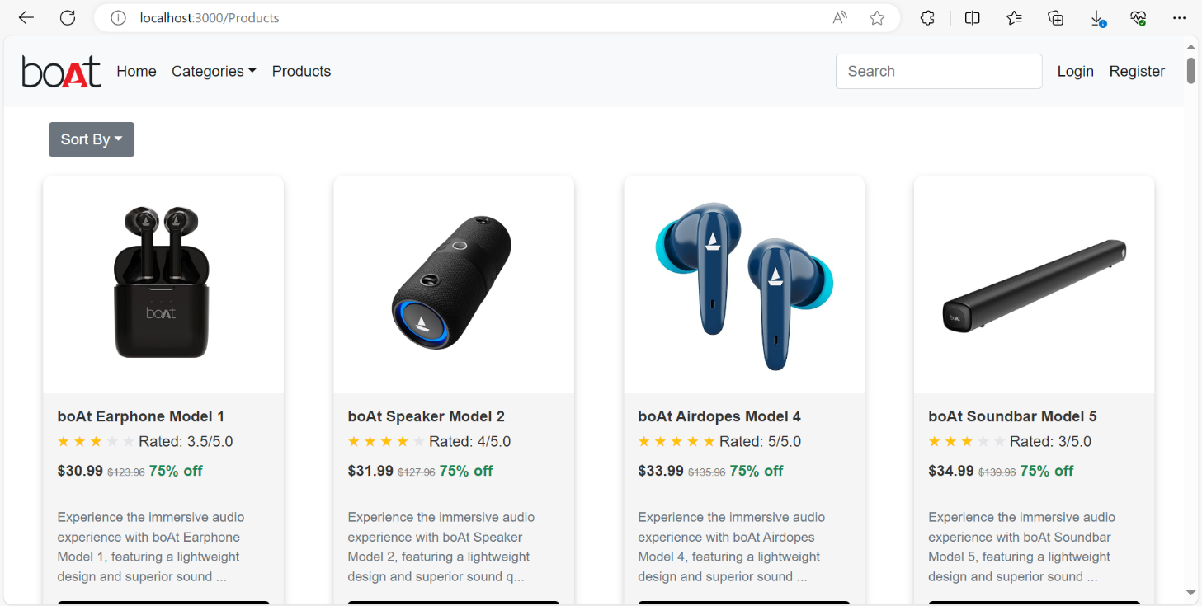

# Cart

## Cart Component

* + Display the products that are added to cart
  + Show Grand total of all products that exists in the cart
  + Customer can remove any item from cart
  + If adding items to cart is done, customer navigate to checkout page.

