EnduroSense
Uncertainty-Aware Mission Feasibility Prediction for UAVs

A machine-learning system that decides whether a drone can safely complete a specific mission on its current battery. It predicts the energy left in the battery and the energy the mission will need, each with an honest error range, and combines them into a probability of success that a fleet scheduler uses to assign tasks.
Built on real flight data from 209 delivery-drone flights, it extends the project brief “ML-Based UAV Battery / Remaining Flight-Time Prediction”.
Project plan for review

1. The problem and our idea
What the brief asks for. Predict how much flight time a drone has left from battery voltage, current, battery percentage, speed, altitude, payload, wind and distance travelled. Compare Linear Regression, Random Forest, XGBoost, LSTM and GRU on MAE, RMSE, R² and inference latency. Feed the prediction into a task scheduler (for example, “UAV2 has 5 minutes left, so don’t assign a 10-minute inspection”). The suggested research extension is uncertainty-aware scheduling.
Why “minutes left” is not enough. A minutes-left number assumes the drone keeps doing what it is doing now, but battery drain depends on what it does next. In our dataset, flights on the same ≈470 m route use anywhere from 17 Wh to 30 Wh depending on speed and payload (Figure 2a). Whether UAV2 can do the inspection depends on the inspection itself: its distance, payload, the wind and the trip home.
Our improvement. EnduroSense splits the single prediction into two and compares them:
- Model A: energy available. From battery telemetry, predict the watt-hours (Wh) the battery can still deliver before hitting a safe reserve.
- Model B: energy required. From the planned mission (distance, speed, payload, altitude, wind, plus the return leg), predict the watt-hours it will use.
- Feasibility layer. Combine both predictions and their uncertainty into P(success) = P(energy available ≥ energy required). The scheduler assigns a task only if P(success) ≥ 95%; otherwise the task goes to another drone, or this one recharges first.
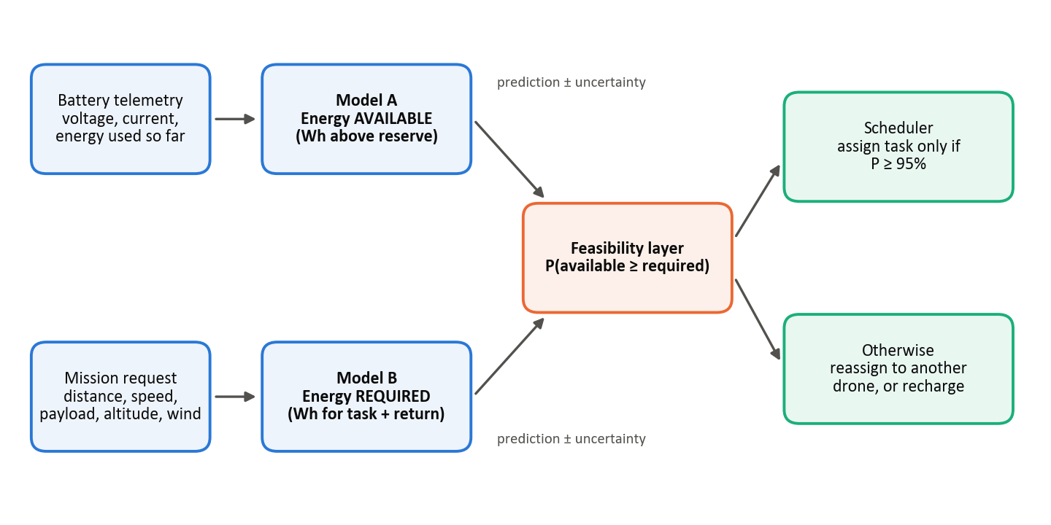
Figure 1. EnduroSense system overview.
In plain words
A fuel gauge (Model A) tells you what’s in the tank; a trip planner (Model B) tells you what this trip will use. EnduroSense compares the two, allows for the fact that neither is perfectly accurate, and says “go” or “don’t go”. The brief’s minutes-left output is still produced, as energy available ÷ expected power draw.

2. Objectives and research questions
The project will build and compare the brief’s five algorithms for both models, add calibrated uncertainty, and test whether probability-based scheduling is safer than the minutes-left approach. It will answer four questions:
# | Research question | How we answer it
RQ1 | How accurately can usable energy remaining be predicted from battery telemetry, and which algorithm gives the best accuracy-versus-speed trade-off? | Model A: five algorithms vs. simple baselines (MAE, RMSE, R², latency)
RQ2 | How accurately can a mission’s energy be predicted, including for settings not seen in training? | Model B: five algorithms, with tests on unseen speeds, payloads, days and longer routes
RQ3 | Are the uncertainty ranges trustworthy? | Coverage and calibration of prediction intervals
RQ4 | Does probability-based scheduling make safer, less wasteful decisions than minutes left? | Replay real battery-state and mission pairs; compare unsafe approvals and wasted refusals

Out of scope: new flight tests, deployment on a drone’s flight computer, long-term battery ageing, other drone types, and trajectory optimisation (EnduroSense could later supply its energy constraint).

3. Dataset
Data Collected with Package Delivery Quadcopter Drone (Rodrigues et al., Carnegie Mellon University; Scientific Data, 2021; DOI 10.1184/R1/12683453). The dataset is openly available and has already been downloaded and profiled.
Item | Detail
Aircraft | DJI Matrice 100 quadcopter; 4,500 mAh 6-cell battery (≈100 Wh)
Flights | 209 recordings (196 cruise flights, 4 hover tests, 9 ground tests); April–October 2019; 18 flying days
Readings | 257,896 time-stamped rows at about 8 per second: battery voltage and current, wind sensor, GPS position, velocity, orientation, acceleration
Planned settings | Speed 4–12 m/s (5 levels) × payload 0/250/500 g × altitude 25–100 m (4 levels)

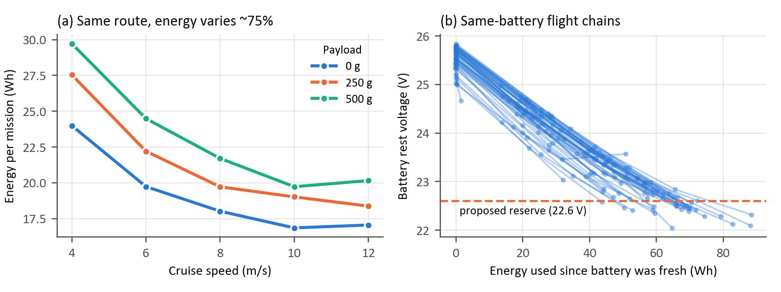
Figure 2. Real data. (a) Mean energy per mission by speed and payload: slow flights cost more because the drone spends longer holding its own weight up. (b) Each line is one battery flown on consecutive flights; the spread shows why voltage alone is not a reliable guide to the energy left.
What profiling has shown:
- Balanced design. All 60 speed × payload × altitude combinations are present, each with 3–5 flights.
- Energy use. A typical mission lasts about 3 minutes and uses about 21 Wh (a fifth of the battery): about 50% in cruise, 23% climbing and 18% descending. Cruise draws about 510 W and hovering about 475 W.
- Wind. The wind sensor rides on the drone, so we estimate true wind from moments when the drone climbs or descends without moving sideways. Flights cover about 1.3–6.7 m/s; nothing above 7 m/s.
- Battery chains (key finding). When a flight starts at the voltage the previous one ended at, the same battery was reused. Linking these gives 62 same-battery chains (168 flights), 25 of which run from nearly full to near reserve, using up to 88 Wh. This gives Model A real, measured training labels without simulation (Figure 2b).
Data limitations and how we handle them:
Limitation | How we handle it
Only one drone model; wind only up to ≈7 m/s | State the tested range clearly; the method transfers, but the numbers apply to this drone
182 of 196 flights use the same ≈470 m route | Model energy per flight phase and assemble missions from the parts; test on the longer ≈540 m and ≈840 m routes
No battery ID, temperature, cycle count or battery % | Use rest voltage, energy used so far and voltage sag under load (a battery-health proxy) instead
Battery chains are inferred, not logged (one suspicious chain found) | Verify every chain visually; test sensitivity to the 0.3 V matching threshold
About 200 flights in total | Regularise the LSTM and GRU; report honestly if simpler models win

4. Technical approach

4.1 Data preparation
Clean the data (fix the mixed-type altitude column, separate the ground and hover tests, check for time gaps and sensor spikes). Label every reading as ground, climb, cruise, descent or hover from height, vertical speed and horizontal speed. Compute the distance flown from GPS, one wind estimate per flight, and energy (voltage × current × time). Link and verify the battery chains.

4.2 Model A: energy available
Plain idea: look at the battery now and predict how many more watt-hours it can give before reaching the safe reserve.
- Target: usable energy remaining (Wh) above a reserve, proposed as a rest voltage of 22.6 V (≈3.77 V per cell).
- Labels: for every moment in a chain that reaches the reserve, the label is the energy actually drawn from then until the reserve was reached, measured rather than simulated. Chains ending slightly off the reserve are corrected using the fitted voltage-to-energy curve.
- Inputs: voltage, current and power; their 10 s and 30 s averages, variation and trend; voltage sag and internal-resistance estimate; rest voltage at the start of the flight; energy used since the battery was fresh; flight phase.
- Baselines ML must beat: a voltage lookup curve, and energy counting (nominal capacity minus energy used, as a basic battery management system does).
- Algorithms: Linear Regression, Random Forest and XGBoost on the engineered features; LSTM and GRU on the raw last 30–60 s of readings.

4.3 Model B: energy required
Plain idea: add up the mission’s parts (climb, cruise there and back, descent). Because nearly every recorded flight uses the same route, a whole-flight model could never learn the effect of distance; modelling each phase fixes this:
E(mission) = E(climb) + P(cruise) × distance ÷ speed + E(descent) + E(return) + hover allowance
ML learns cruise power (W) from thousands of short cruise windows, and climb and descent energy per flight, using speed, airspeed, payload, altitude and wind as inputs. The baseline is a standard physics model of rotor power with a few fitted coefficients; a physics-informed hybrid is an optional extension.

4.4 Uncertainty
Plain idea: every prediction comes with a range, such as “52 ± 4 Wh”, and we check that the ranges are honest. We use quantile regression (predicting the 5th, 50th and 95th percentiles) for Linear Regression and XGBoost, the spread across trees for Random Forest, and a deep ensemble of about 5 networks for LSTM and GRU. A final conformal calibration step uses held-out data to adjust each model’s ranges so that a 90% range really contains the true value about 90% of the time.

4.5 Feasibility and scheduling
Margin M = E(available) − E(required); P(success) = P(M ≥ 0), estimated by sampling from both predicted ranges. The mission is a GO if P(success) ≥ τ, with τ = 0.95 by default. We will check that the two models’ errors are independent; if they are not, we switch to a more conservative combination.
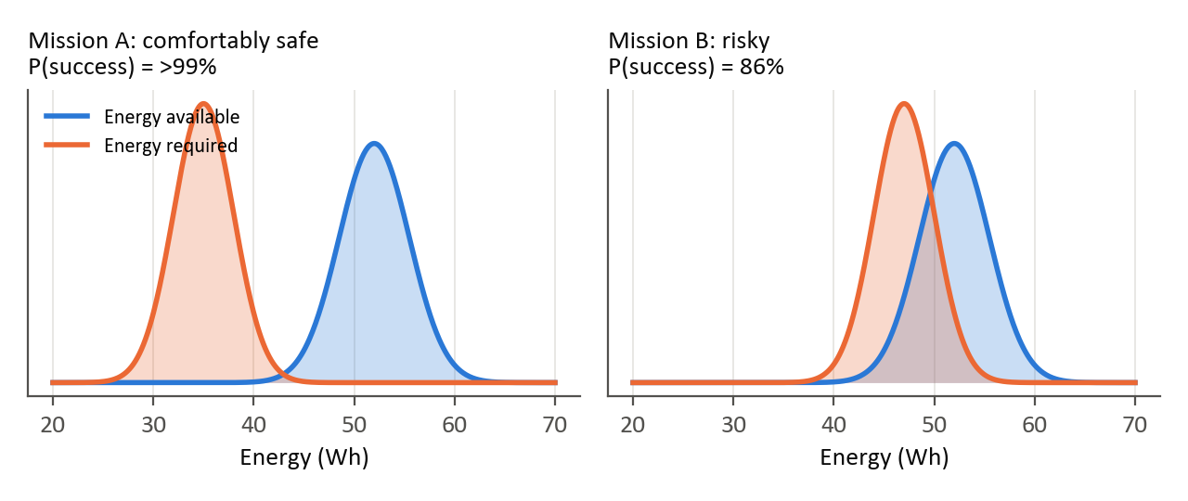
Figure 3. Illustration (not real data). Left: the ranges barely overlap, so the mission is safe. Right: likely fine, but there is a 14% chance of running short, so it is not approved at τ = 95%.
Scheduler demo: about 4 simulated drones start from real held-out battery states and work through a queue of delivery and inspection tasks. We compare four policies: P1 minutes left (the brief), P2 energy with no uncertainty, P3 EnduroSense (P(success) ≥ τ), and P4 an oracle that knows the true values (the upper bound). The comparison reports tasks completed, unsafe assignments, recharges and battery left over.

5. Evaluation plan
- Fair splits: data is split by whole battery chain (Model A) or whole flight (Model B), so the model is never tested on a battery or flight it trained on. We use grouped 5-fold cross-validation for model selection, and a locked test set of about 20% set aside before any modelling. Extra tests leave out one speed, one payload or one flying day, and use the longer routes.
- Model metrics: MAE, RMSE and R² (in Wh); inference latency (ms) and model size; interval coverage, width and pinball loss for the uncertainty ranges.
- Decision testing on real “what-if” pairs: pair a real held-out battery state (true energy left is known) with a real held-out flight as the mission (true energy used is known). Whether the mission would have succeeded therefore comes from measurements. Thousands of pairs let us control the mix of safe and unsafe cases and focus on borderline ones. The key numbers are the unsafe approval rate (approved, but the battery would have gone below reserve) and the wasted refusal rate (refused, but it was actually safe), plotted as τ varies.
Proposed success criteria: Model A beats both baselines; Model B’s whole-mission error is about 5% or less, including on the longer routes; 90% ranges achieve 88–92% coverage; EnduroSense has fewer unsafe approvals than the minutes-left approach, with no more wasted refusals.

6. Timeline and deliverables
Weeks | Phase | Output
1 | Setup and short literature review (UAV energy models, battery state estimation, uncertainty methods) | Repository, literature notes
1–2 | Data preparation and validation; lock the test set (profiling already done) | Clean dataset, data report
2–3 | Labels and features for both models | Model-ready tables
3–4 | Model A: baselines and five algorithms | Model A comparison
4–5 | Model B: physics baseline, five algorithms, unseen-condition tests | Model B comparison
5–6 | Uncertainty and calibration | Calibrated models, coverage plots
6–7 | Feasibility layer, what-if evaluation, fleet simulation | Decision results, trade-off curves
7–8 | Demo, report and slides | Final deliverables

Deliverables: a reproducible code repository (Python, pandas, scikit-learn, XGBoost, PyTorch; fixed seeds; raw data never modified), comparison tables for all five algorithms, an evaluation report, an interactive Streamlit demo (pick a drone state and a mission to see both energy ranges, P(success) and the decision) and slides. Stretch goals: a physics-informed hybrid for Model B, a clearly labelled simulated high-wind test, and latency measured on a Raspberry Pi-class device.

7. Risks
Risk | Mitigation
Only 25 chains reach the reserve, so Model A has limited labels | Use every moment in each chain (thousands of samples); report cross-validation confidence ranges
LSTM/GRU overfit the small dataset | Small models, regularisation and early stopping; report honestly
Model B does not generalise to other distances | Phase-based modelling with a physics baseline; test on the longer routes
Uncertainty ranges are over- or under-confident | Conformal calibration and coverage checks
Scope creep in the scheduler | Keep it simple; the contribution is the feasibility signal

8. What is new beyond the brief
- Reframes “minutes left” as energy available versus energy required for a specific mission, a quantity that stays well defined and directly supports decisions.
- Real, measured training labels for remaining battery energy, obtained by reconstructing same-battery flight chains, with no simulation needed.
- A phase-based mission energy model that generalises beyond the single route in the data.
- Calibrated uncertainty and a mission success probability, turning the brief’s suggested research extension into a working, testable system.
- Decision-level evaluation on real what-if pairs, measuring the safety-versus-efficiency trade-off rather than prediction error alone.

9. Points for review
- Is it acceptable to make energy available, energy required and P(success) the main contribution, while still delivering the brief’s minutes-left output?
- Is a 22.6 V rest-voltage reserve (≈3.77 V per cell) appropriate, or should the reserve be a percentage of capacity?
- Is τ = 95% a sensible default approval threshold?
- Are clearly labelled simulated high-wind scenarios acceptable, if they are kept out of the headline results?
- Is laptop CPU latency enough, or is an embedded-device measurement expected?
- What are the deadline and the expected final format (report, demo, slides)? Is a formal literature review expected?
Key references
[1] Rodrigues, T. A., et al. (2021). In-flight positional and energy use data set of a DJI Matrice 100 quadcopter for small package delivery. Scientific Data. Dataset: doi.org/10.1184/R1/12683453
[2] Chen, T., & Guestrin, C. (2016). XGBoost: A scalable tree boosting system. KDD.
[3] Lakshminarayanan, B., Pritzel, A., & Blundell, C. (2017). Simple and scalable predictive uncertainty estimation using deep ensembles. NeurIPS.
[4] Angelopoulos, A. N., & Bates, S. (2021). A gentle introduction to conformal prediction and distribution-free uncertainty quantification. arXiv:2107.07511.

