|  |  |  |
| --- | --- | --- |
| **No** | **BRS requirement ID** | **Description** |
| **2.1** | **Admin Module** | |
| **2.1.1** | **F1** | **Login** |
| **2.1.2** | **F2** | **Verification** |
| **2.1.3** | **F3** | **Remove Theatres** |
| **2.1.4** | **F4** | **View Feedback** |
| **2.1.5** | **F5** | **Logout** |
| **2.2** | **Theatre owner Module** | |
| **2.2.1** | **F6** | **Registration** |
| **2.2.2** | **F7** | **Login** |
| **2.2.3** | **F8** | **Add movies** |
| **2.2.4** | **F9** | **Remove movies** |
| **2.2.5** | **F10** | **Logout** |
| **2.2.6** | **F11** | **Delete** |
| **2.2.7** | **F12** | **Payment** |
| **2.2.8** | **F13** | **Ticket generation** |
| **2.3 Customer Module** | | | |
| **2.3.1** | **F14** | **Registration** |
| **2.3.2** | **F15** | **Login** |
| **2.3.3** | **F16** | **Search Movie** |
| **2.3.4** | **F17** | **Search theatre** |
| **2.3.5** | **F18** | **Seat Viewing** |
| **2.3.6** | **F19** | **Ticket Booking** |
| **2.3.6** | **F20** | **Payment** |
| **2.3.6** | **F21** | **Download Ticket** |
| **2.3.6** | **F22** | **Ticket cancelling** |
| **2.3.6** | **F23** | **Logout** |
| **2.3.6** | **F24** | **Feedback** |

#### 1.5 Use Case Diagram

**Admin:**

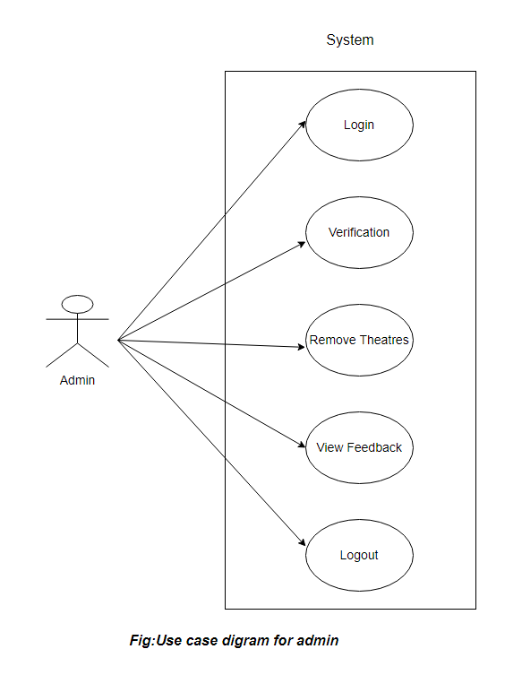

*Fig. Use case diagram for Admin*

1. In Admin use case diagram Admin is the Actor.
2. Admin can handle following use cases:
3. Login
4. Verification
5. Remove Theatres
6. View Feedback
7. Logout

**Theatre owner:**

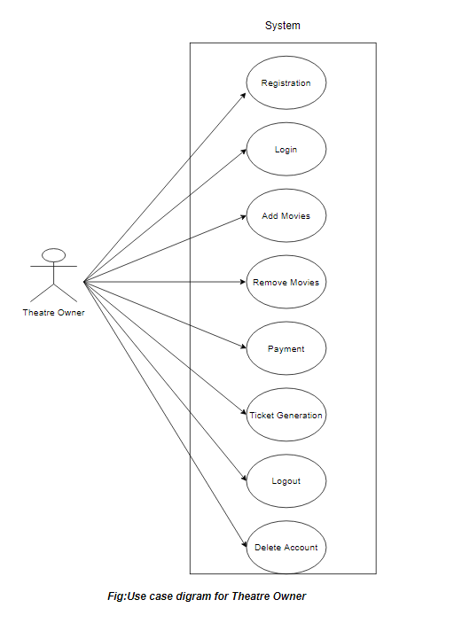

*Fig. Use case diagram for Theatre owner*

1. In Theatre owner use case diagram owner is the Actor.
2. Theatre owner can handle following use cases:
3. Registration
4. Login
5. Add movies
6. Remove movies
7. Logout
8. Delete
9. Payment
10. Ticket generation

**Customer Module:**

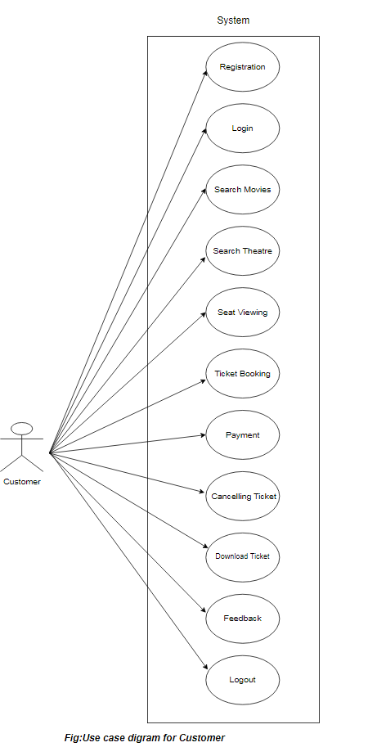

*Fig. Use case diagram for Customer*

1. In Customer use case diagram Customer is the Actor**.**
2. Customer can handle following use cases:
3. Registration
4. Login
5. Search Movie
6. Search theatre
7. Seat Viewing
8. Ticket Booking
9. Payment
10. Download Ticket
11. Ticket cancelling
12. Logout
13. Feedback