DAA-1: Fibonacci Numbers (Recursive and Non-recursive)

Aim
Write a non-recursive and recursive program to calculate Fibonacci numbers and analyze their time and space complexity.
Program: d1_fibonacci.py
# DAA-1 : Fibonacci numbers - non-recursive (iterative) and recursive, with time/space analysis import time

calls = 0

def fib_iterative(n):
"""Time O(n), Space O(1)""" a, b = 0, 1
for _ in range(n): a, b = b, a + b
return a

def fib_recursive(n):
"""Time O(2^n), Space O(n) (depth of recursion stack)""" global calls
calls += 1 if n <= 1:
return n
return fib_recursive(n - 1) + fib_recursive(n - 2)

if name == " main ":
n = int(input("Enter n : "))
print(f"\nFibonacci series (first {n} terms): ", end="") print(*[fib_iterative(i) for i in range(n)])
print(f"\n{'n':>4} {'fib(n)':>10} {'iter time(s)':>14} {'recur time(s)':>15} {'recursive calls':>16}")
for k in (5, 10, 15, 20, 25, 30):
t1 = time.perf_counter(); r1 = fib_iterative(k); t1 = time.perf_counter() - t1 calls = 0
t2 = time.perf_counter(); r2 = fib_recursive(k); t2 = time.perf_counter() - t2 assert r1 == r2
print(f"{k:>4} {r1:>10} {t1:>14.7f} {t2:>15.7f} {calls:>16}")
print("\nComplexity:")
print(" Iterative : Time O(n) , Space O(1)")
print(" Recursive : Time O(2^n) , Space O(n) (call stack)")

Output
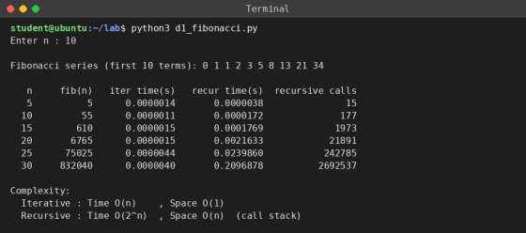

DAA-2: Huffman Encoding (Greedy Strategy)

Aim
Write a program to implement Huffman encoding using a greedy strategy.
Program: d2_huffman.py
# DAA-2 : Huffman encoding using greedy strategy (always merge the two least frequent nodes) import heapq
from collections import Counter

class Node:
def init (self, ch, freq, left=None, right=None):
self.ch, self.freq, self.left, self.right = ch, freq, left, right

def lt (self, other):
return self.freq < other.freq

def build_tree(text):
heap = [Node(c, f) for c, f in Counter(text).items()] heapq.heapify(heap)
while len(heap) > 1: # greedy choice
a = heapq.heappop(heap)
b = heapq.heappop(heap)
heapq.heappush(heap, Node(None, a.freq + b.freq, a, b)) return heap[0]

def make_codes(node, code="", table=None): table = {} if table is None else table if node.ch is not None:
table[node.ch] = code or "0" else:
make_codes(node.left, code + "0", table) make_codes(node.right, code + "1", table)
return table

def decode(bits, root): out, node = [], root for b in bits:
node = node.left if b == "0" else node.right if node.ch is not None:
out.append(node.ch) node = root
return "".join(out)

if name == " main ":
text = input("Enter text to encode : ") root = build_tree(text)
codes = make_codes(root) print("\nChar Freq Huffman code")
for ch, f in sorted(Counter(text).items(), key=lambda x: (-x[1], x[0])): print(f"{repr(ch):<5} {f:<5} {codes[ch]}")
encoded = "".join(codes[c] for c in text) print("\nEncoded bits :", encoded)
print("Original size :", len(text) * 8, "bits (8 bits per char)") print("Encoded size :", len(encoded), "bits")
print(f"Saving : {100 - len(encoded) * 100 / (len(text) * 8):.1f} %") print("Decoded text :", decode(encoded, root))

Output

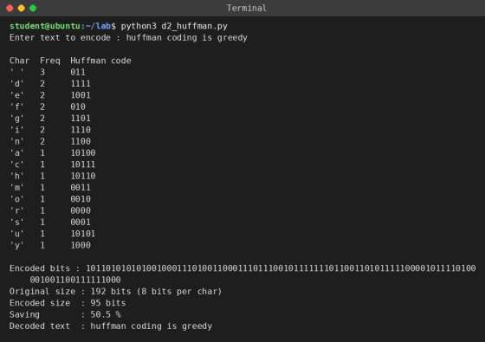

DAA-3: Fractional Knapsack (Greedy Method)

Aim
Write a program to solve a fractional knapsack problem using a greedy method.
Program: d3_fractional_knapsack.py
# DAA-3 : Fractional knapsack using greedy method (highest value/weight ratio first) def fractional_knapsack(values, weights, capacity):
items = sorted(zip(range(1, len(values) + 1), values, weights), key=lambda x: x[1] / x[2], reverse=True)
total, remaining = 0.0, capacity print(f"{'Item':<5}{'Value':<7}{'Weight':<8}{'Ratio':<8}{'Taken':<10}") for no, v, w in items:
if remaining == 0: break
take = min(w, remaining) total += v * take / w remaining -= take
print(f"{no:<5}{v:<7}{w:<8}{v / w:<8.2f}{take}/{w}") return total

if name == " main ":
n = int(input("Enter number of items : "))
values = [int(x) for x in input("Enter values : ").split()] weights = [int(x) for x in input("Enter weights : ").split()] cap = int(input("Enter knapsack capacity : "))
print()
best = fractional_knapsack(values, weights, cap) print(f"\nMaximum value in knapsack = {best:.2f}") print("Time complexity: O(n log n) (sorting)")

Output
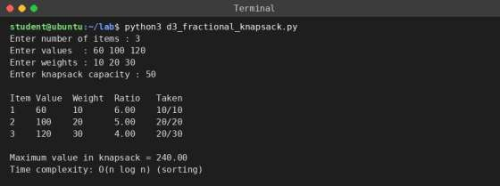

DAA-4: 0-1 Knapsack (Dynamic Programming)

Aim
Write a program to solve a 0-1 knapsack problem using dynamic programming.
Program: d4_knapsack_dp.py
# DAA-4 : 0-1 Knapsack using dynamic programming def knapsack_01(values, weights, W):
n = len(values)
dp = [[0] * (W + 1) for _ in range(n + 1)] for i in range(1, n + 1):
for w in range(W + 1): dp[i][w] = dp[i - 1][w]
# do not take item i
if weights[i - 1] <= w: # take item i
dp[i][w] = max(dp[i][w], values[i - 1] + dp[i - 1][w - weights[i - 1]]) # find which items were selected
chosen, w = [], W
for i in range(n, 0, -1):
if dp[i][w] != dp[i - 1][w]: chosen.append(i)
w -= weights[i - 1] return dp, sorted(chosen)
if name == " main ":
n = int(input("Enter number of items : "))
values = [int(x) for x in input("Enter values : ").split()] weights = [int(x) for x in input("Enter weights : ").split()] W = int(input("Enter knapsack capacity : "))
dp, chosen = knapsack_01(values, weights, W)
print("\nDP table (rows = items 0..n, columns = capacity 0..W):") for row in dp:
print(" ".join(f"{x:>4}" for x in row)) print(f"\nMaximum value = {dp[n][W]}") print("Items selected (1-based):", chosen) print("Time complexity: O(n*W), Space: O(n*W)")

Output
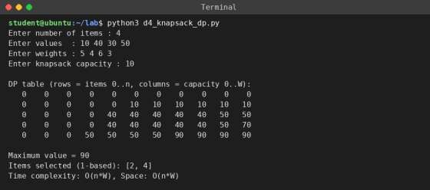

ML-1: Uber Fare Prediction

Aim
Predict the price of an Uber ride: pre-process the dataset, identify outliers, check correlation, implement linear regression and random forest regression, and compare R2 and RMSE.
Dataset: uber.csv from https://www.kaggle.com/datasets/yasserh/uber-fares-dataset. The output below is from sample data with the same columns.
Program: m1_uber_fare.py
# ML-1 : Predict Uber fare - preprocessing, outliers, correlation, Linear Regression vs Random Forest import sys
import numpy as np import pandas as pd import matplotlib matplotlib.use("Agg")
import matplotlib.pyplot as plt import seaborn as sns
from sklearn.model_selection import train_test_split from sklearn.linear_model import LinearRegression from sklearn.ensemble import RandomForestRegressor
from sklearn.metrics import r2_score, mean_squared_error, mean_absolute_error

path = sys.argv[1] if len(sys.argv) > 1 else "uber.csv" df = pd.read_csv(path)
print("Shape of dataset :", df.shape) print("\nColumns:", list(df.columns))

# 1. Pre-processing
df = df.drop(columns=[c for c in ("Unnamed: 0", "key") if c in df.columns])
print("\nMissing values before cleaning:\n", df.isnull().sum()[df.isnull().sum() > 0].to_string()) df = df.dropna()
df["pickup_datetime"] = pd.to_datetime(df["pickup_datetime"]) df["year"] = df.pickup_datetime.dt.year
df["month"] = df.pickup_datetime.dt.month df["day"] = df.pickup_datetime.dt.day df["hour"] = df.pickup_datetime.dt.hour df["weekday"] = df.pickup_datetime.dt.weekday

def haversine(lat1, lon1, lat2, lon2):
lat1, lon1, lat2, lon2 = map(np.radians, (lat1, lon1, lat2, lon2))
a = np.sin((lat2 - lat1) / 2) ** 2 + np.cos(lat1) * np.cos(lat2) * np.sin((lon2 - lon1) / 2) ** 2 return 6371 * 2 * np.arcsin(np.sqrt(a))

df["distance_km"] = haversine(df.pickup_latitude, df.pickup_longitude,
df.dropoff_latitude, df.dropoff_longitude)
n0 = len(df)
bad = ((df.fare_amount <= 0) | (df.passenger_count < 1) | (df.passenger_count > 6) | (df.pickup_latitude.abs() < 1) | (df.pickup_longitude.abs() < 1) | (df.dropoff_latitude.abs() < 1) | (df.dropoff_longitude.abs() < 1) | (df.distance_km == 0))
df = df[~bad].drop(columns="pickup_datetime")
print(f"\nInvalid records removed (fare<=0, passengers, bad GPS) : {n0 - len(df)}")

# 2. Outliers (IQR rule) print("\nOutlier detection using IQR rule:") for col in ("fare_amount", "distance_km"):
q1, q3 = df[col].quantile([.25, .75])
lo, hi = q1 - 1.5 * (q3 - q1), q3 + 1.5 * (q3 - q1)
print(f" {col:<12} Q1={q1:.2f} Q3={q3:.2f} limits=({lo:.2f}, {hi:.2f}) outliers={((df[col] < lo)
| (df[col] > hi)).sum()}")
fig, ax = plt.subplots(1, 2, figsize=(9, 3.5))
sns.boxplot(y=df.fare_amount, ax=ax[0]); ax[0].set_title("fare_amount (with outliers)") sns.boxplot(y=df.distance_km, ax=ax[1]); ax[1].set_title("distance_km (with outliers)") plt.tight_layout(); plt.savefig("uber_boxplot.png", dpi=110); plt.close()
q1, q3 = df.fare_amount.quantile([.25, .75])
df = df[(df.fare_amount >= q1 - 1.5 * (q3 - q1)) & (df.fare_amount <= q3 + 1.5 * (q3 - q1))] print("Rows after removing fare outliers :", len(df))

# 3. Correlation
corr = df.corr()
print("\nCorrelation of every feature with fare_amount:") print(corr["fare_amount"].sort_values(ascending=False).round(3).to_string())

plt.figure(figsize=(8, 6)); sns.heatmap(corr, annot=True, fmt=".2f", cmap="coolwarm", annot_kws={"size": 7})
plt.title("Correlation heatmap"); plt.tight_layout(); plt.savefig("uber_heatmap.png", dpi=110); plt.close()
#
4. Models
X = df.drop(columns="fare_amount"); y = df.fare_amount
Xtr, Xte, ytr, yte = train_test_split(X, y, test_size=0.2, random_state=1) models = {"Linear Regression": LinearRegression(),
"Random Forest": RandomForestRegressor(n_estimators=100, random_state=1, n_jobs=-1)}
#
5. Evaluation
print(f"\n{'Model':<20}{'R2':>8}{'RMSE':>9}{'MAE':>9}")
res = {}
for name, m in models.items(): m.fit(Xtr, ytr)
p = m.predict(Xte)
res[name] = (r2_score(yte, p), np.sqrt(mean_squared_error(yte, p)), mean_absolute_error(yte, p)) print(f"{name:<20}{res[name][0]:>8.4f}{res[name][1]:>9.4f}{res[name][2]:>9.4f}")
best = max(res, key=lambda k: res[k][0])
print(f"\nBest model (highest R2, lowest RMSE): {best}")

Output
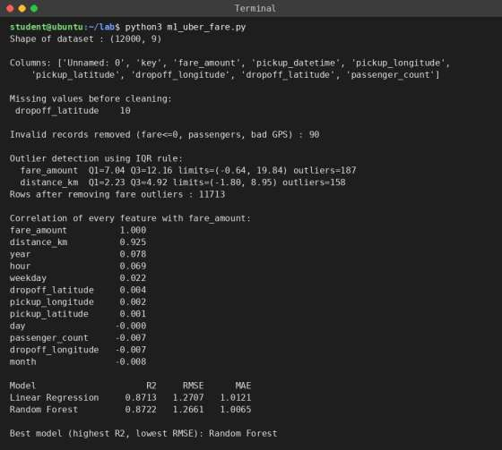

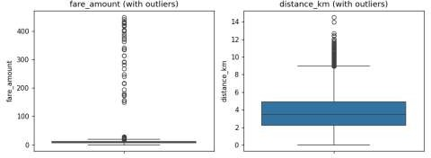
Box plots used to identify outliers
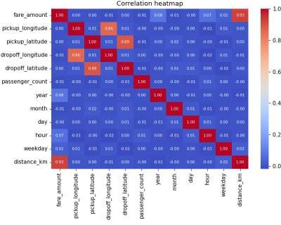
Correlation heatmap

ML-2: Email Spam Detection (KNN and SVM)

Aim
Classify emails as Not Spam (normal state) or Spam (abnormal state) using K-Nearest Neighbors and Support Vector Machine, and analyze their performance.
Dataset: emails.csv from https://www.kaggle.com/datasets/balaka18/email-spam-classification-dataset-csv. The output below is from sample data with the same format (Email No., word counts, Prediction).
Program: m2_spam_knn_svm.py
# ML-2 : Email spam detection using K-Nearest Neighbors and Support Vector Machine import sys
import pandas as pd
from sklearn.model_selection import train_test_split from sklearn.neighbors import KNeighborsClassifier from sklearn.svm import SVC
from sklearn.metrics import accuracy_score, precision_score, recall_score, f1_score, confusion_matrix

path = sys.argv[1] if len(sys.argv) > 1 else "emails.csv" df = pd.read_csv(path)
print("Shape:", df.shape)
print("Not Spam (0):", (df.Prediction == 0).sum(), "| Spam (1):", (df.Prediction == 1).sum()) print("Missing values:", int(df.isnull().sum().sum()))

X = df.drop(columns=["Email No.", "Prediction"]) y = df["Prediction"]
Xtr, Xte, ytr, yte = train_test_split(X, y, test_size=0.25, random_state=0, stratify=y) print("Training emails:", len(Xtr), "| Testing emails:", len(Xte))

models = {"KNN (k=5)": KNeighborsClassifier(n_neighbors=5), "SVM (linear)": SVC(kernel="linear", C=1.0)}
rows = []
for name, m in models.items(): m.fit(Xtr, ytr)
p = m.predict(Xte)
cm = confusion_matrix(yte, p) print(f"\n=== {name} ===")
print("Confusion matrix [rows = actual, cols = predicted]") print(" Not Spam Spam")
print(f" Not Spam {cm[0][0]:>6} {cm[0][1]:>6}")
print(f" Spam {cm[1][0]:>6} {cm[1][1]:>6}") rows.append((name, accuracy_score(yte, p), precision_score(yte, p),
recall_score(yte, p), f1_score(yte, p)))

print(f"\n{'Model':<14}{'Accuracy':>10}{'Precision':>11}{'Recall':>8}{'F1':>8}") for r in rows:
print(f"{r[0]:<14}{r[1]:>10.4f}{r[2]:>11.4f}{r[3]:>8.4f}{r[4]:>8.4f}")
best = max(rows, key=lambda r: r[1]) print(f"\nBetter model on this data: {best[0]}")

Output

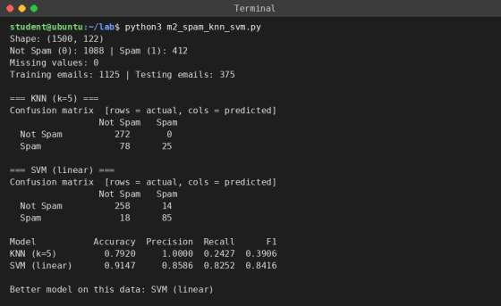

ML-3: Bank Customer Churn Prediction (Neural Network)

Aim
Build a neural network classifier to determine whether a bank customer will leave in the next 6 months.
Dataset: Churn_Modelling.csv from https://www.kaggle.com/barelydedicated/bank-customer-churn-modeling. The output below is from sample data with the same 14 columns. The network is built with scikit-learn MLPClassifier because TensorFlow/Keras is not installed here; with Keras use Sequential, Dense layers and model.fit() for the same steps.
Program: m3_churn_nn.py
# ML-3 : Bank customer churn prediction using a neural network (scikit-learn MLPClassifier) import sys
import warnings import pandas as pd
from sklearn.model_selection import train_test_split from sklearn.preprocessing import StandardScaler from sklearn.neural_network import MLPClassifier
from sklearn.metrics import accuracy_score, confusion_matrix, recall_score from sklearn.utils import resample

warnings.filterwarnings("ignore") # hide ConvergenceWarning messages

# 1. Read the dataset
path = sys.argv[1] if len(sys.argv) > 1 else "Churn_Modelling.csv" df = pd.read_csv(path)
print("Dataset shape:", df.shape)

# 2. Feature / target split and train-test split
X = df.drop(columns=["RowNumber", "CustomerId", "Surname", "Exited"])
X = pd.get_dummies(X, columns=["Geography", "Gender"], drop_first=True) y = df["Exited"]
Xtr, Xte, ytr, yte = train_test_split(X, y, test_size=0.2, random_state=0, stratify=y) print("Features used:", list(X.columns))
print("Train:", Xtr.shape, " Test:", Xte.shape)

# 3. Normalise train and test data sc = StandardScaler()
Xtr = sc.fit_transform(Xtr) Xte = sc.transform(Xte)

def report(title, model, X_fit=None, y_fit=None):
model.fit(Xtr if X_fit is None else X_fit, ytr if y_fit is None else y_fit) p = model.predict(Xte)
cm = confusion_matrix(yte, p) print(f"\n--- {title} ---")
print(f"Accuracy score : {accuracy_score(yte, p) * 100:.2f} %") print(f"Recall (churners caught) : {recall_score(yte, p) * 100:.2f} %") print("Confusion matrix [rows = actual, cols = predicted]:")
print(f" TN={cm[0][0]:<5} FP={cm[0][1]}")
print(f" FN={cm[1][0]:<5} TP={cm[1][1]}")
return accuracy_score(yte, p), recall_score(yte, p)

# 4. Initial model, then improvement
a1, r1 = report("Model 1: basic network (1 hidden layer, 6 neurons)", MLPClassifier(hidden_layer_sizes=(6,), activation="relu", max_iter=200, random_state=1))

# Point of improvement: only ~20 % customers leave (imbalanced data), so the basic model
# misses most leavers. Fix: balance the training set (oversample leavers) + deeper network. Xm, ym = Xtr[ytr.values == 0], ytr[ytr.values == 0]
Xl, yl = Xtr[ytr.values == 1], ytr[ytr.values == 1]
Xl, yl = resample(Xl, yl, replace=True, n_samples=len(ym), random_state=1) import numpy as np
Xb, yb = np.vstack([Xm, Xl]), np.concatenate([ym, yl])
a2, r2 = report("Model 2: improved (balanced training data, hidden layers 16-8, alpha=0.001)", MLPClassifier(hidden_layer_sizes=(16, 8), activation="relu", alpha=0.001,
max_iter=300, early_stopping=True, random_state=1), Xb, yb) print(f"\nSummary: accuracy {a1 * 100:.2f} % -> {a2 * 100:.2f} %, recall of leavers {r1 * 100:.2f} %
-> {r2 * 100:.2f} %")
print("(accuracy alone is misleading on imbalanced data; compare recall as well)")

Output
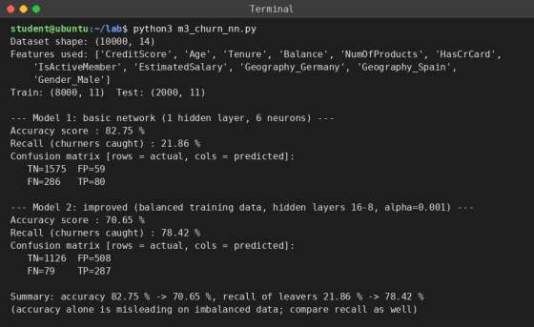

ML-4: Gradient Descent

Aim
Implement the gradient descent algorithm to find the local minimum of y = (x + 3)^2 starting from x
= 2.
Program: m4_gradient_descent.py
# ML-4 : Gradient descent to find the local minimum of y = (x + 3)^2 starting from x = 2 import matplotlib
matplotlib.use("Agg")
import matplotlib.pyplot as plt import numpy as np
def f(x):
return (x + 3) ** 2
def df(x):
return 2 * (x + 3)
# derivative dy/dx = 2(x + 3)
x = 2.0
lr = 0.1 precision = 1e-6 path = [x]
# starting point # learning rate
print(f"Start: x = {x}, learning rate = {lr}\n") print(f"{'Iter':>4} {'x':>12} {'y=f(x)':>14} {'gradient':>12}") for i in range(1, 101):
step = lr * df(x) x_new = x - step path.append(x_new)
if i <= 10 or i % 10 == 0:
print(f"{i:>4} {x_new:>12.6f} {f(x_new):>14.8f} {df(x_new):>12.6f}") if abs(x_new - x) < precision:
x = x_new
print(f"\nConverged after {i} iterations (step < {precision})") break
x = x_new
print(f"\nLocal minimum found at x = {x:.4f}, y = {f(x):.8f}") print("Exact minimum: x = -3, y = 0")
xs = np.linspace(-5, 3, 200)
plt.figure(figsize=(6, 3.6)); plt.plot(xs, f(xs), label="y=(x+3)^2") plt.plot(path, [f(p) for p in path], "ro-", ms=3, label="gradient descent steps")
plt.xlabel("x"); plt.ylabel("y"); plt.legend(); plt.grid(alpha=.3); plt.tight_layout() plt.savefig("gd_plot.png", dpi=110)

Output

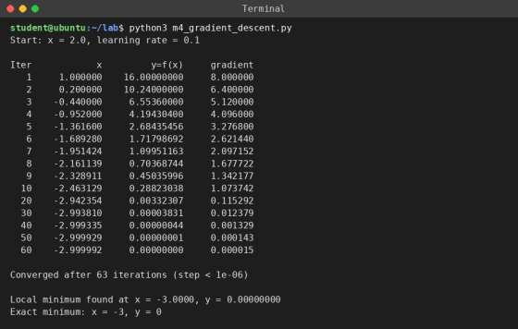
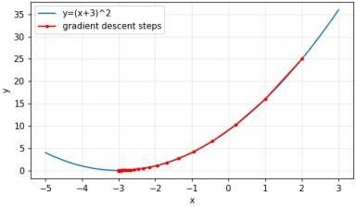

BC-1: Install MetaMask and Study Ether Spent per Transaction

Aim
Install MetaMask and study how much Ether is spent per transaction.

Steps
- Open Chrome and go to metamask.io; click Download and Add to Chrome (Add Extension).
- Click the MetaMask fox icon, choose Create a new wallet, set a password and agree to the terms.
- Write the 12-word Secret Recovery Phrase on paper and confirm it. Never share it.
- Turn on "Show test networks" in Settings > Advanced and select the Sepolia test network.
- Get free test ETH from a Sepolia faucet using your wallet address.
- Send a small amount of test ETH to another account. Before confirming, note the Gas fee shown.
- Open the transaction in the Activity tab and on Sepolia Etherscan to see Gas Used, Gas Price and Transaction Fee.



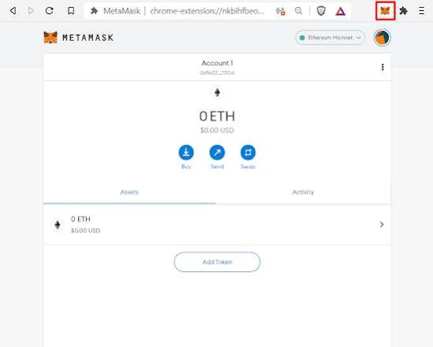

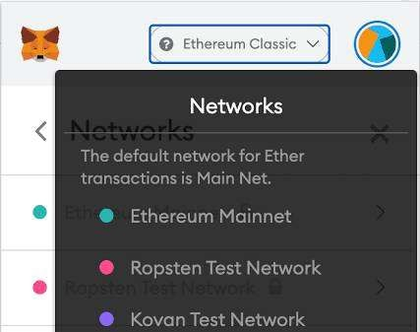
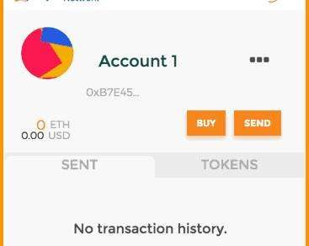
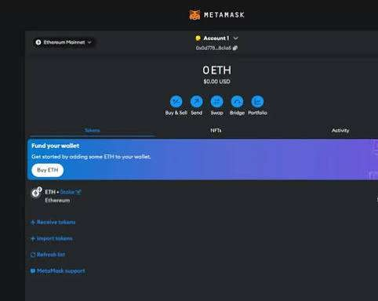

BC-2: Create Your Own Wallet Using MetaMask

Aim
Create a wallet using MetaMask for crypto transactions.

Steps
- Open MetaMask and click Create a new wallet (or Account menu > Add account).
- Set the password and save the Secret Recovery Phrase safely.
- Click on the account name to see and copy the public wallet address (starts with 0x).
- Switch to Sepolia test network and request test ETH from a faucet.
- Check that the balance is shown in the wallet.
- Send test ETH to a second account and confirm the transaction; see it under Activity.





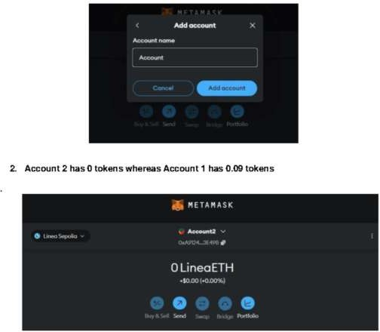

BC-3: Smart Contract for Bank Account

Aim
Write a smart contract on a test network for a customer bank account with deposit, withdraw and show balance operations.

Program: BankAccount.sol
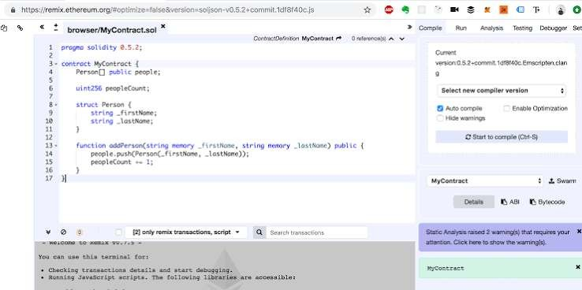
// SPDX-License-Identifier: MIT pragma solidity ^0.8.0;

// Bank account of a customer: deposit, withdraw and show balance contract BankAccount {
address public owner; uint256 private balance;

event Deposited(address indexed from, uint256 amount); event Withdrawn(address indexed to, uint256 amount);

constructor() {
owner = msg.sender; // the customer who deploys the contract
}

modifier onlyOwner() {
require(msg.sender == owner, "Only account owner allowed");
_;
}

// Deposit money (send ETH value along with the call) function deposit() public payable onlyOwner {
require(msg.value > 0, "Deposit amount must be greater than 0"); balance += msg.value;
emit Deposited(msg.sender, msg.value);
}

// Withdraw money (amount in wei)
function withdraw(uint256 amount) public onlyOwner { require(amount > 0, "Amount must be greater than 0"); require(amount <= balance, "Insufficient balance"); balance -= amount; payable(msg.sender).transfer(amount);
emit Withdrawn(msg.sender, amount);
}

// Show balance (in wei)
function showBalance() public view returns (uint256) { return balance;
}
}

BC-4: Student Data Contract (Structure, Array, Fallback)

Aim
Write a Solidity program to create student data using a structure, an array and a fallback function. Deploy it and observe the transaction fee and gas values.

Program: StudentData.sol
// SPDX-License-Identifier: MIT pragma solidity ^0.8.0;

// Student data using Structure, Array and Fallback function contract StudentData {
struct Student { // Structure uint256 rollNo;
string name; string course; uint8 marks;
}
Student[] public students;
// Array of structures
event StudentAdded(uint256 rollNo, string name);
event FallbackCalled(address sender, uint256 value, bytes data);

function addStudent(uint256 _rollNo, string memory _name,
string memory _course, uint8 _marks) public { students.push(Student(_rollNo, _name, _course, _marks));
emit StudentAdded(_rollNo, _name);
}

function getStudent(uint256 index) public view
returns (uint256, string memory, string memory, uint8) { require(index < students.length, "Invalid index"); Student memory s = students[index];
return (s.rollNo, s.name, s.course, s.marks);
}

function totalStudents() public view returns (uint256) { return students.length;
}

// Fallback: runs when a non-existing function is called (or ETH sent with data) fallback() external payable {
emit FallbackCalled(msg.sender, msg.value, msg.data);
}

// receive: runs when plain ETH is sent with empty calldata receive() external payable {
emit FallbackCalled(msg.sender, msg.value, "");
}
}



