DAA 1
#include <iostream>
using namespace std;

// Non-recursive function
void nonRecursive(int n) {
int a = 0, b = 1, c;

for (int i = 0; i < n; i++) {
cout << a << " ";
c = a + b;
a = b;
b = c;
}
}

// Recursive function
int recursive(int n) {
if (n <= 1)
return n;

return recursive(n - 1) + recursive(n - 2);
}

int main() {
int n;

cout << "Enter number of terms: ";
cin >> n;

cout << "Non-recursive Fibonacci: ";
nonRecursive(n);

cout << "\nRecursive Fibonacci: ";
for (int i = 0; i < n; i++) {
cout << recursive(i) << " ";
}

return 0;
}
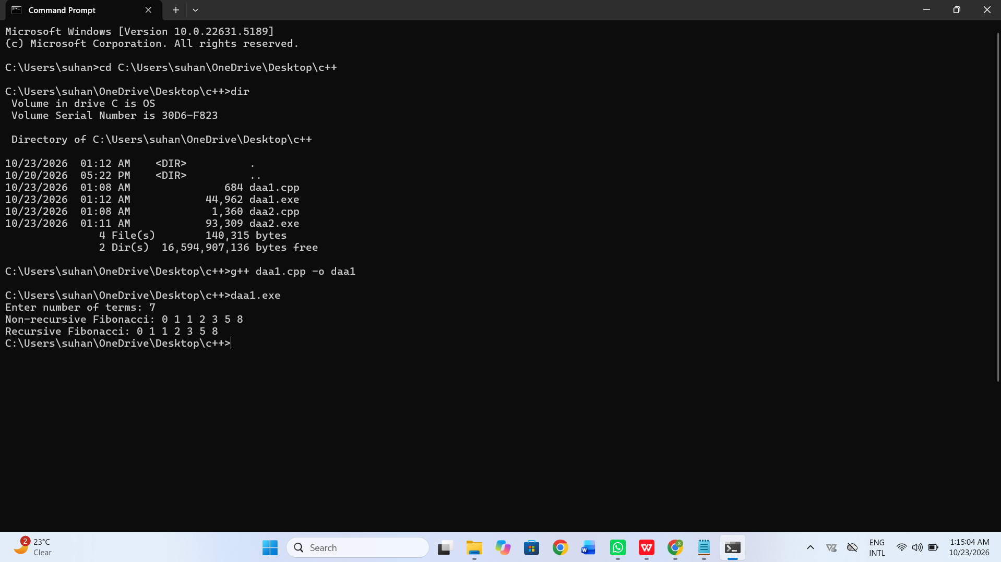
DAA 2
#include <iostream>
#include <queue>
using namespace std;

struct Node {
char ch;
int freq;
Node *left, *right;

Node(char c, int f) {
ch = c;
freq = f;
left = right = NULL;
}
};

struct Compare {
bool operator()(Node* a, Node* b) {
return a->freq > b->freq;
}
};

void printCodes(Node* root, string code) {
if (root == NULL)
return;

if (root->left == NULL && root->right == NULL) {
cout << root->ch << " : " << code << endl;
}

printCodes(root->left, code + "0");
printCodes(root->right, code + "1");
}

int main() {
int n;
char ch;
int freq;

priority_queue<Node*, vector<Node*>, Compare> pq;

cout << "Enter number of characters: ";
cin >> n;

for (int i = 0; i < n; i++) {
cout << "Enter character and frequency: ";
cin >> ch >> freq;
pq.push(new Node(ch, freq));
}

while (pq.size() > 1) {
Node* left = pq.top();
pq.pop();

Node* right = pq.top();
pq.pop();

Node* parent = new Node('$', left->freq + right->freq);
parent->left = left;
parent->right = right;

pq.push(parent);
}

cout << "\nHuffman Codes:\n";
printCodes(pq.top(), "");

return 0;
}
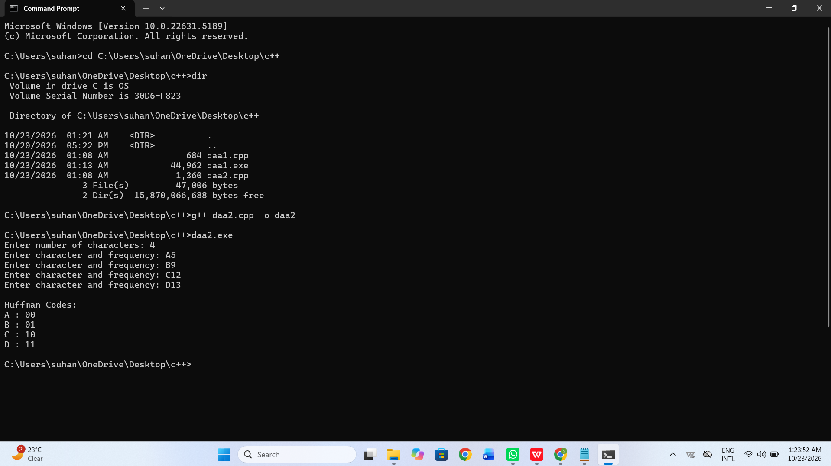
DAA 3
#include <iostream>
#include <algorithm>
using namespace std;

struct Item {
int profit, weight;
float ratio;
};

bool compare(Item a, Item b) {
return a.ratio > b.ratio;
}

int main() {
int n, capacity;
Item item[20];

cout << "Enter number of items: ";
cin >> n;

for (int i = 0; i < n; i++) {
cout << "Enter profit and weight: ";
cin >> item[i].profit >> item[i].weight;

item[i].ratio =
(float)item[i].profit / item[i].weight;
}

cout << "Enter knapsack capacity: ";
cin >> capacity;

sort(item, item + n, compare);

float totalProfit = 0;

for (int i = 0; i < n; i++) {
if (capacity >= item[i].weight) {
totalProfit += item[i].profit;
capacity -= item[i].weight;
} else {
totalProfit += item[i].ratio * capacity;
break;
}
}

cout << "Maximum profit = " << totalProfit;

return 0;
}
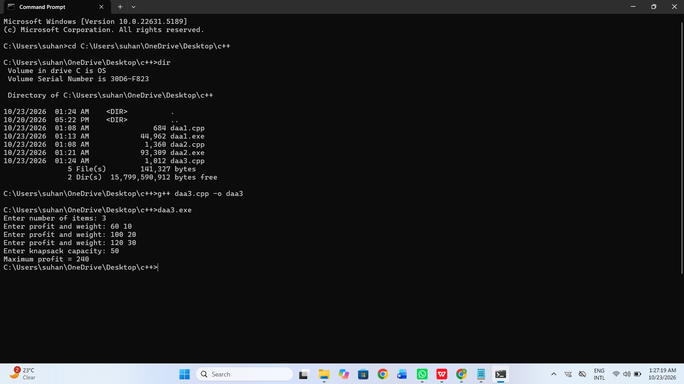
DAA 4
#include <iostream>
using namespace std;

int main() {
int n, capacity;
int profit[20], weight[20];
int dp[21][101];

cout << "Enter number of items: ";
cin >> n;

for (int i = 1; i <= n; i++) {
cout << "Enter profit and weight: ";
cin >> profit[i] >> weight[i];
}

cout << "Enter knapsack capacity: ";
cin >> capacity;

for (int i = 0; i <= n; i++) {
for (int w = 0; w <= capacity; w++) {
if (i == 0 || w == 0) {
dp[i][w] = 0;
}
else if (weight[i] <= w) {
int include = profit[i] +
dp[i - 1][w - weight[i]];
int exclude = dp[i - 1][w];

dp[i][w] = max(include, exclude);
}
else {
dp[i][w] = dp[i - 1][w];
}
}
}

cout << "Maximum profit = " << dp[n][capacity];

return 0;
}
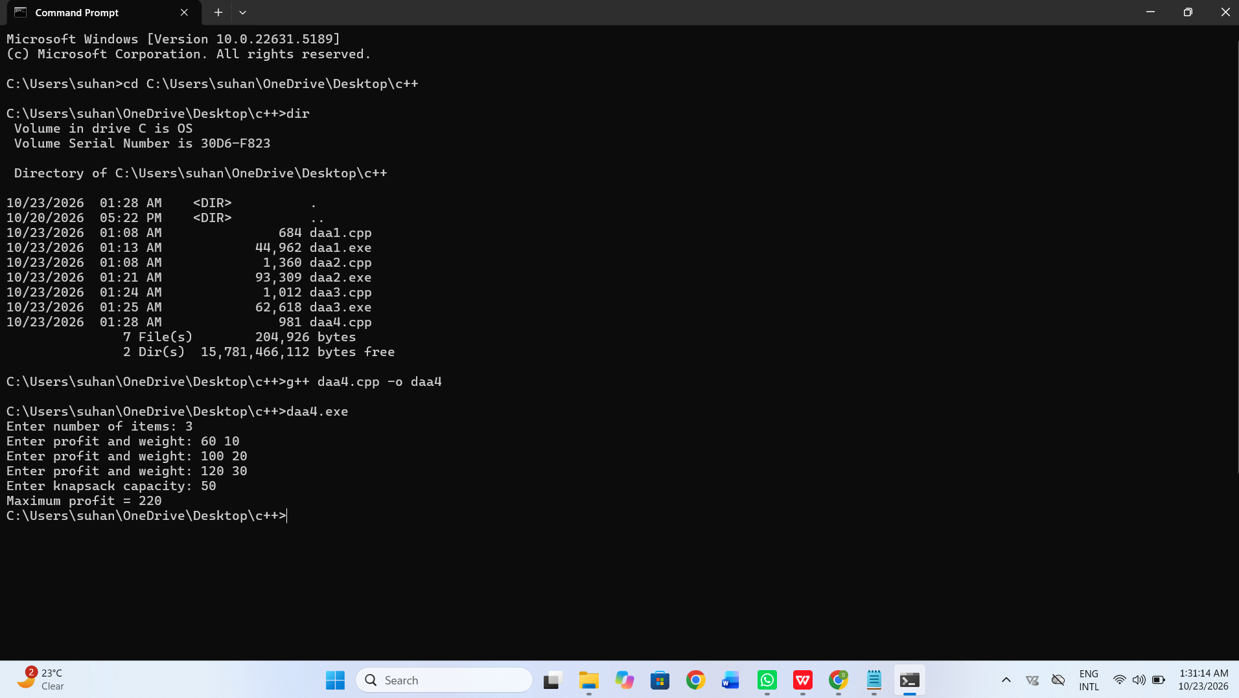
ML 1
import pandas as pd
import numpy as np
import matplotlib.pyplot as plt
import seaborn as sns

from sklearn.model_selection import train_test_split
from sklearn.linear_model import LinearRegression
from sklearn.ensemble import RandomForestRegressor
from sklearn.metrics import r2_score, mean_squared_error, mean_absolute_error

# 1. Load dataset
df = pd.read_csv("uber.csv")

print("First five rows:")
print(df.head())

print("\nDataset shape:", df.shape)
print("\nMissing values:")
print(df.isnull().sum())

# 2. Pre-process the dataset
df = df.drop(columns=["Unnamed: 0", "key"], errors="ignore")
df = df.dropna()

df["pickup_datetime"] = pd.to_datetime(
df["pickup_datetime"], errors="coerce", utc=True
)
df = df.dropna(subset=["pickup_datetime"])

# Extract useful time features
df["hour"] = df["pickup_datetime"].dt.hour
df["day"] = df["pickup_datetime"].dt.day
df["month"] = df["pickup_datetime"].dt.month

# Remove invalid fares, coordinates and passenger counts
df = df[
(df["fare_amount"] > 0) &
(df["fare_amount"] < 500) &
(df["pickup_longitude"].between(-75, -72)) &
(df["dropoff_longitude"].between(-75, -72)) &
(df["pickup_latitude"].between(39, 42)) &
(df["dropoff_latitude"].between(39, 42)) &
(df["passenger_count"].between(1, 6))
].copy()

print("\nRows after preprocessing:", len(df))

# 3. Identify outliers using IQR
Q1 = df["fare_amount"].quantile(0.25)
Q3 = df["fare_amount"].quantile(0.75)
IQR = Q3 - Q1

outliers = df[
(df["fare_amount"] < Q1 - 1.5 * IQR) |
(df["fare_amount"] > Q3 + 1.5 * IQR)
]

print("\nNumber of fare outliers:", len(outliers))

sns.boxplot(x=df["fare_amount"])
plt.title("Fare Amount Outliers")
plt.show()

# 4. Check correlation
features = [
"fare_amount", "pickup_longitude", "pickup_latitude",
"dropoff_longitude", "dropoff_latitude",
"passenger_count", "hour", "day", "month"
]

plt.figure(figsize=(10, 7))
sns.heatmap(df[features].corr(), annot=True, cmap="coolwarm", fmt=".2f")
plt.title("Correlation Heatmap")
plt.tight_layout()
plt.show()

# Calculate distance using latitude and longitude
def distance(lat1, lon1, lat2, lon2):
lat1, lon1, lat2, lon2 = map(
np.radians, [lat1, lon1, lat2, lon2]
)
dlat = lat2 - lat1
dlon = lon2 - lon1

a = (np.sin(dlat / 2) ** 2 +
np.cos(lat1) * np.cos(lat2) *
np.sin(dlon / 2) ** 2)

return 6371 * 2 * np.arcsin(np.sqrt(a))

df["distance"] = distance(
df["pickup_latitude"], df["pickup_longitude"],
df["dropoff_latitude"], df["dropoff_longitude"]
)

# Prepare input and output
X = df[[
"pickup_longitude", "pickup_latitude",
"dropoff_longitude", "dropoff_latitude",
"passenger_count", "hour", "day", "month", "distance"
]]
y = df["fare_amount"]

# Use a smaller sample to run faster on a typical student computer
X = X.sample(n=min(30000, len(X)), random_state=42)
y = y.loc[X.index]

X_train, X_test, y_train, y_test = train_test_split(
X, y, test_size=0.2, random_state=42
)

# 5. Linear Regression
lr = LinearRegression()
lr.fit(X_train, y_train)
pred_lr = lr.predict(X_test)

# Random Forest Regression
rf = RandomForestRegressor(
n_estimators=50, random_state=42, n_jobs=-1
)
rf.fit(X_train, y_train)
pred_rf = rf.predict(X_test)

# Evaluate and compare models
def evaluate(name, actual, predicted):
print("\n", name)
print("R2 Score:", round(r2_score(actual, predicted), 4))
print("RMSE:", round(np.sqrt(mean_squared_error(actual, predicted)), 4))
print("MAE:", round(mean_absolute_error(actual, predicted), 4))

evaluate("Linear Regression", y_test, pred_lr)
evaluate("Random Forest Regression", y_test, pred_rf)

print("\nPractical completed successfully.")
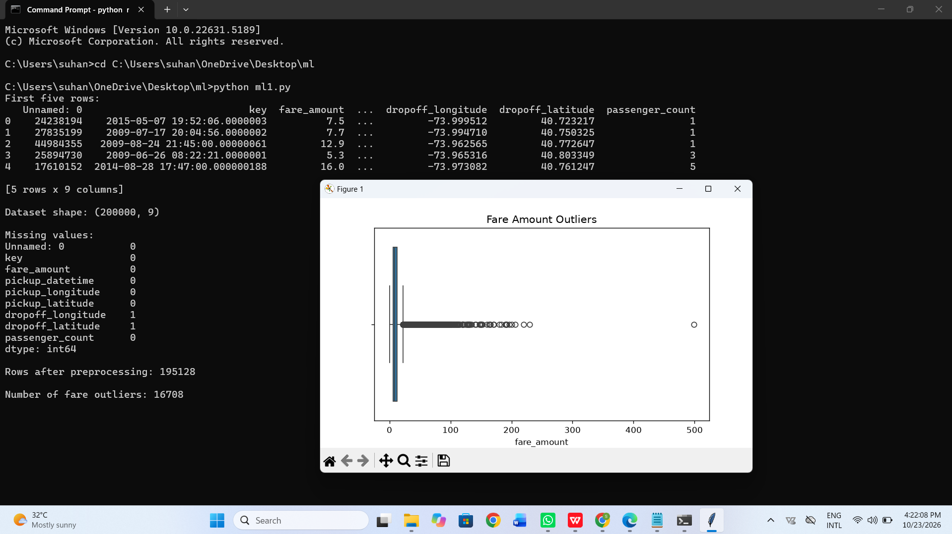
ML 2
import pandas as pd

from sklearn.model_selection import train_test_split
from sklearn.preprocessing import StandardScaler
from sklearn.neighbors import KNeighborsClassifier
from sklearn.svm import LinearSVC
from sklearn.metrics import (
accuracy_score,
precision_score,
recall_score,
f1_score,
confusion_matrix,
classification_report
)

# 1. Load the dataset
df = pd.read_csv("emails.csv")

print("First five rows:")
print(df.head())

print("\nDataset shape:", df.shape)
print("\nMissing values:", df.isnull().sum().sum())

# 2. Remove unnecessary columns
df = df.drop(columns=["Email No."], errors="ignore")
df = df.dropna()

# 3. Separate input and output
X = df.drop(columns=["Prediction"])
y = df["Prediction"]

# 4. Split the dataset into training and testing data
X_train, X_test, y_train, y_test = train_test_split(
X, y, test_size=0.2, random_state=42, stratify=y
)

# 5. Scale the features
scaler = StandardScaler()

X_train = scaler.fit_transform(X_train)
X_test = scaler.transform(X_test)

# 6. K-Nearest Neighbors classification
knn = KNeighborsClassifier(n_neighbors=5)
knn.fit(X_train, y_train)

knn_pred = knn.predict(X_test)

# 7. Support Vector Machine classification
svm = LinearSVC(max_iter=5000, random_state=42)
svm.fit(X_train, y_train)

svm_pred = svm.predict(X_test)

# 8. Analyze model performance
def evaluate_model(name, actual, predicted):
print("\n", name)
print("Accuracy:", round(accuracy_score(actual, predicted), 4))
print("Precision:", round(precision_score(actual, predicted, zero_division=0), 4))
print("Recall:", round(recall_score(actual, predicted, zero_division=0), 4))
print("F1 Score:", round(f1_score(actual, predicted, zero_division=0), 4))

print("Confusion Matrix:")
print(confusion_matrix(actual, predicted))

print("Classification Report:")
print(classification_report(actual, predicted, zero_division=0))

evaluate_model("KNN Classification", y_test, knn_pred)
evaluate_model("SVM Classification", y_test, svm_pred)

print("\nEmail Spam Classification Completed Successfully!")
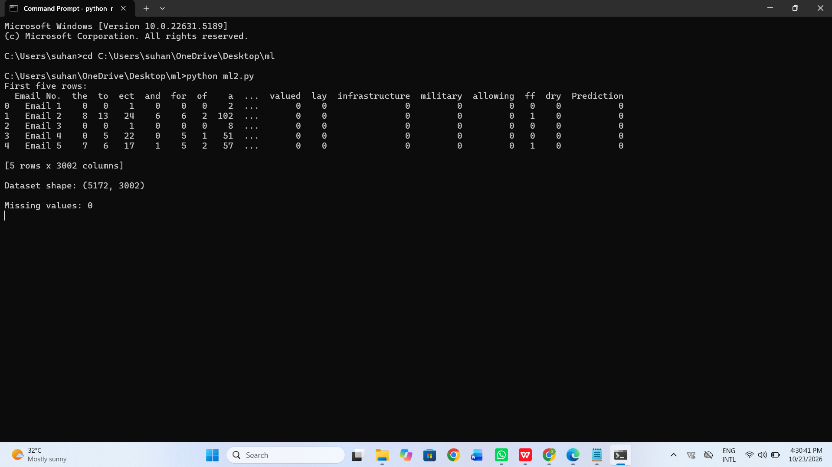
ML 3
import pandas as pd

from sklearn.model_selection import train_test_split
from sklearn.preprocessing import StandardScaler, OneHotEncoder
from sklearn.compose import ColumnTransformer
from sklearn.pipeline import Pipeline
from sklearn.neural_network import MLPClassifier
from sklearn.metrics import accuracy_score, confusion_matrix, classification_report

# 1. Read the dataset
df = pd.read_csv("Churn_Modelling.csv")

print("First five rows:")
print(df.head())

print("\nDataset shape:", df.shape)
print("\nMissing values:", df.isnull().sum().sum())

# 2. Separate features and target
# Remove columns that do not help predict customer churn
X = df.drop(
columns=["RowNumber", "CustomerId", "Surname", "Exited"],
errors="ignore"
)

y = df["Exited"]

# Identify numerical and categorical columns
numeric_cols = X.select_dtypes(include=["int64", "float64"]).columns
categorical_cols = X.select_dtypes(include=["object"]).columns

# 3. Split into training and testing data
X_train, X_test, y_train, y_test = train_test_split(
X, y, test_size=0.2, random_state=42, stratify=y
)

print("\nTraining data:", X_train.shape)
print("Testing data:", X_test.shape)

# Normalize numerical data and encode categorical data
preprocessor = ColumnTransformer([
("numeric", StandardScaler(), numeric_cols),
("categorical", OneHotEncoder(handle_unknown="ignore"),
categorical_cols)
])

# 4. Build the neural network
model = Pipeline([
("preprocessing", preprocessor),
("neural_network", MLPClassifier(
hidden_layer_sizes=(32, 16),
activation="relu",
solver="adam",
max_iter=300,
early_stopping=True,
random_state=42
))
])

# Train the model
model.fit(X_train, y_train)

# Predict on test data
y_pred = model.predict(X_test)

# 5. Print performance
print("\nAccuracy Score:", round(accuracy_score(y_test, y_pred), 4))

print("\nConfusion Matrix:")
print(confusion_matrix(y_test, y_pred))

print("\nClassification Report:")
print(classification_report(y_test, y_pred, zero_division=0))

print("\nBank Customer Churn Prediction Completed!")
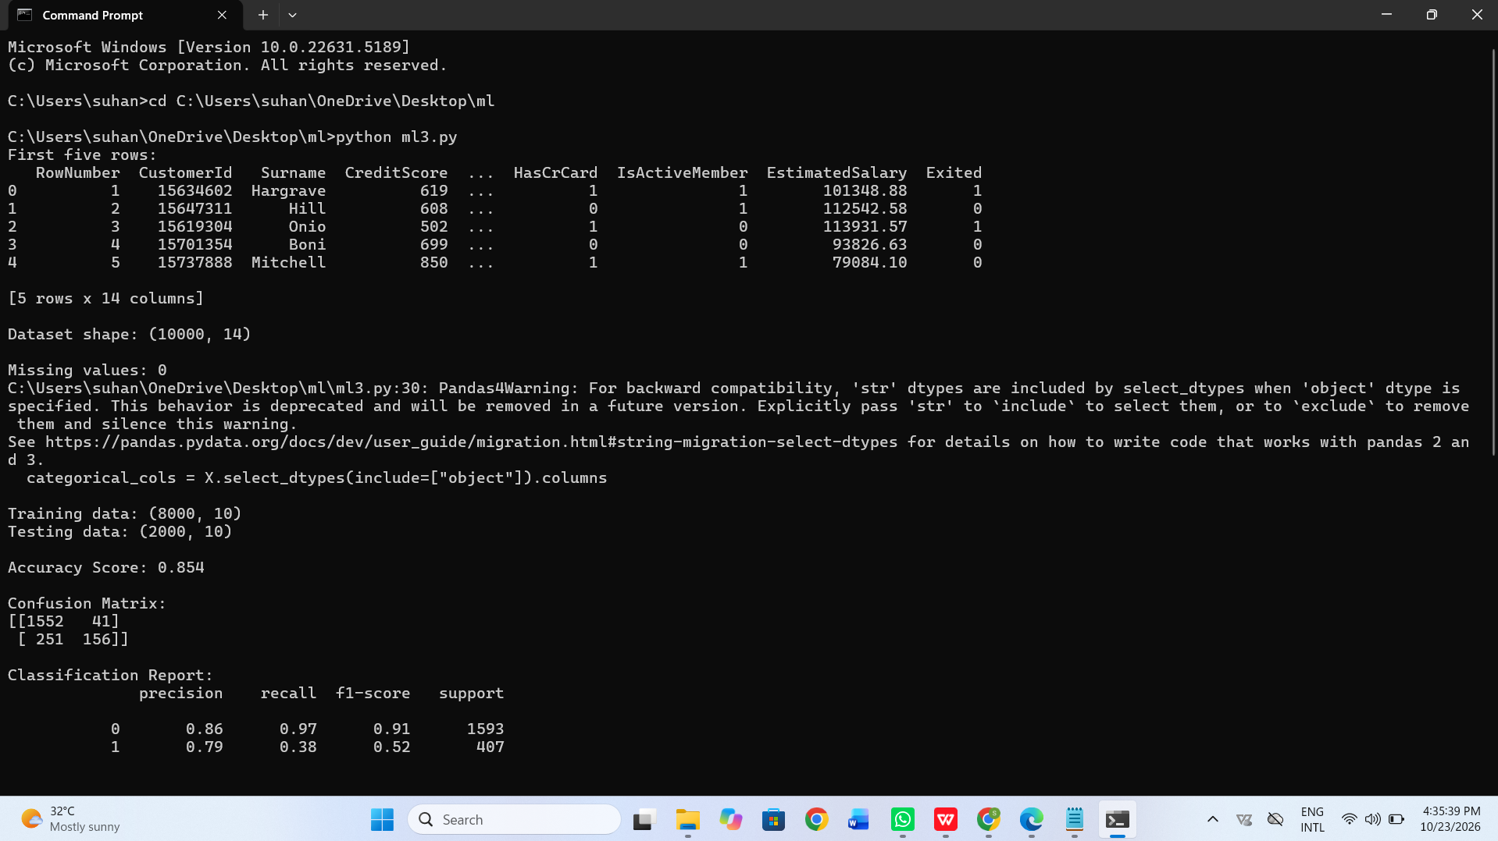
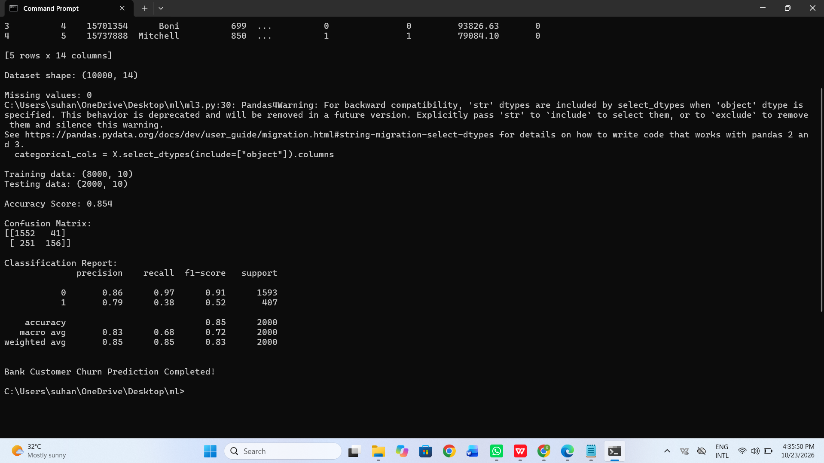
ML 4(means 5)
import pandas as pd

from sklearn.model_selection import train_test_split
from sklearn.preprocessing import StandardScaler
from sklearn.neighbors import KNeighborsClassifier
from sklearn.metrics import (
confusion_matrix,
accuracy_score,
precision_score,
recall_score
)

# 1. Read the dataset
df = pd.read_csv("diabetes.csv")

print("First five rows:")
print(df.head())

print("\nDataset shape:", df.shape)

# 2. Separate features and target
X = df.drop("Outcome", axis=1)
y = df["Outcome"]

# 3. Split the dataset
X_train, X_test, y_train, y_test = train_test_split(
X, y,
test_size=0.2,
random_state=42,
stratify=y
)

# 4. Normalize the data
scaler = StandardScaler()

X_train = scaler.fit_transform(X_train)
X_test = scaler.transform(X_test)

# 5. Create and train KNN model
knn = KNeighborsClassifier(n_neighbors=5)
knn.fit(X_train, y_train)

# 6. Predict the results
y_pred = knn.predict(X_test)

# 7. Calculate performance metrics
cm = confusion_matrix(y_test, y_pred)
accuracy = accuracy_score(y_test, y_pred)
error_rate = 1 - accuracy
precision = precision_score(y_test, y_pred, zero_division=0)
recall = recall_score(y_test, y_pred, zero_division=0)

# 8. Display results
print("\nConfusion Matrix:")
print(cm)

print("\nAccuracy:", round(accuracy, 4))
print("Error Rate:", round(error_rate, 4))
print("Precision:", round(precision, 4))
print("Recall:", round(recall, 4))

print("\nKNN Diabetes Classification Completed!")



