One Day Workshop on

Design and Construction of Stainless Steel Structures

**Jointly organized by**

**Indian Institute of Technology Madras - Chennai**

**National Institute of Technology Karnataka - Surathkal**

**Jindal Stainless Limited**

**Date:** 6th June, 2024 (Thursday)

**Time:** 9:00 AM to 5:30 PM

**Venue:** ICSR Auditorium, IIT Madras, Chennai

For Whom?

This workshop is meant for civil, structural and metallurgy engineers, scientist, research scholars those who are interested in any metal structures, post-graduate students of strurctural engineering and geotechnical engineering and under-graduate students of civil engineering, steel manufacturers, distributors, vendors and contractors.

Why?

If you are interested in

* Understanding the steel materials (mild steel, high carbon steel and stainless steel) comprehensively
* Learning about buckling behaviour of metal structures
* Understanding the right choice of steel/ stainless steel for the construction applications
* Learning the stainless steel rebars
* Cost analysis and the advantages of using stainless steel
* Steel research and looking for new avenues of research
* Networking between students, researchers, faculties, scientists and industries to solve the practical problems

Then this workshop is for you!

Key Discussions and Insights

The workshop is designed to empower engineers and construction professionals with the knowledge and confidence to leverage the full potential of stainless steel in their projects. Through a series of interactive sessions, you will gain a comprehensive understanding of:

* The compelling advantages of stainless steel in construction as structural steel and rebars
* Essential design standards and specifications
* Expert insights from industry leaders

Participants will be provided with resources, including design material and references.

Speakers

|  |  |  |  |
| --- | --- | --- | --- |
|  |  |  |  |
| Dr. Konjengbam Darunkumar Singh | Dr. J Vijaya Vengadesh Kumar | Dr. S Arul Jayachandran | Er. Nagarajan P |
| Professor | Assistant Professor | Professor | GM & Head- Sales Development |
| Department of Civil Engineering,  IIT Guwahati | Department of Civil Engineering,  NITK Surathkal | Department of Civil Engineering,  IIT Madras | Jindal Stainless Ltd. |

Registration Fee

|  |
| --- |
| **Registration fee includes kit, refereshments and lunch.** |

|  |  |
| --- | --- |
| **Students/Researchers** | Rs. 750 (including 18% GST) |
| **All others** | Rs. 1500 (including 18% GST) |

**Registriatoin Last Date:** 04th June, 2024

**Accommodation:** Not Available

Payment and Registration Method

**Step 1: Make payment and keep the payment slip for registration**

**Step 2: Complete the registration**

|  |  |
| --- | --- |
| **Step 1: Payment** | **Step 2: Registration** |
|  |  |
| [Design and Construction of Stainless Steel Structure (iitm.ac.in)](https://code.iitm.ac.in/code-programs/DCS2024/) | [Registration - Design and Construction of Stainless Steel Structure - IIT Madras - NITK - JSL (google.com)](https://docs.google.com/forms/d/e/1FAIpQLSesYju2fssyssdFw-XaNp2S4p6VwzEDeWLTl2dpfJajoE2QCA/viewform) |

**Note:** Cancellation or refund is not possible.

**Location:** ICSR Auditorium, IIT Madras, Chennai – 600 036

[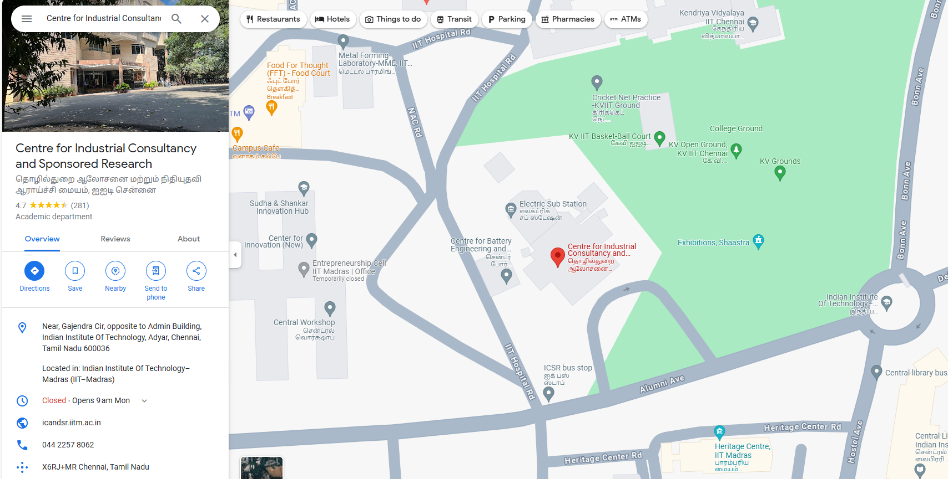](https://maps.app.goo.gl/sSTVgAcjR3CaA2QAA)

[ICSR IIT Madras -Pinned here](https://maps.app.goo.gl/sSTVgAcjR3CaA2QAA)

Contact

Mr. Amoke Shabhari S K R

Mobile: +91 - 77082 80484

Mail: [stainless.randd@gmail.com](mailto:stainless.randd@gmail.com)

**Organizers**

Coordinator

Dr. J Vijaya Vengdesh Kumar,

Assistant Professor,

Department of Civil Engineering,

National Institute of Technology Karnatka,

Surathkal, Mangalore – 575 025

Email: vj@nitk.edu.in

Co-coordinator

Dr. S Arul Jayachandran,

Professor,

Department of Civil Engineering,

Indian Institute of Technology Madras,

Chennai – 600 036

Email: aruls@civil.iitm.ac.in

Technical Support

1. Er. Rosemary Francis – Research Scholar, NITK Surathkal
2. Er. Amoke Shabhari S K R – Research Scholar, NITK Surathkal
3. Er. Fathimath Thasreefa PI – Research Scholar, NITK Surathkal

Website Support

1. Mr. Aditya – IV year, BTech IT, NITK Surathkal
2. Er. Sushant Hegde – II year, MTech Structural Engineering, NITK Surathkal