Karnataka Law Society's   
**GOGTE INSTITUTE OF TECHNOLOGY**

UDYAMBAG, BELAGAVI-590008   
(An Autonomous Institution under Visvesvaraya Technological University, Belagavi)   
**(APPROVED BY AICTE, NEW DELHI)**

Department of Computer Science and Engineering



**A Project Report   
on**

**"TIC TAC TOE"**

*Submitted in the partial fulfillment for the award of the degree of***BACHELOR OF ENGINEERING  
IN   
COMPUTER SCIENCE AND ENGINEERING**Submitted by

**AASHAY PANDIT ADITYA HEGDE AMODH BUDNIMATH**

**USN: 2GI17CS001 USN: 2GI17CS004 USN: 2GI17CS014**

**GUIDE   
 Prof. S. F. Rodd**Gogte Institute of Technology   
Belagavi.

**2018-2019**

**INTRODUCTION**

Tic-tac-toe is a simple, two-player game which, if played optimally by both players, will always result in a tie. The game is also called noughts and crosses or Xs and Os.

Tic-tac-toe is a game that is traditionally played by being drawn on paper, and it can be played on a computer or on a variety of media.

We have here tried to implement the game in c++ language where you play against Bot

Our project name is Tic-Tac-Toe game. This game is very popular and is fairly simple by itself. It is actually a two player game. In this game, there is a board with n x n squares. In our game, it is 3 x 3 squares. The goal of Tic-Tac-Toe is to be one of the players to get three same symbols in a row - horizontally, vertically or diagonally - on a 3 x 3 grid where the 2nd player is Bot.

**OVERVIEW**

This game can be played in a 3x3 grid shown in the figure. The game can be played by two players. There are two options for players:

Human: ‘o’ Player: ‘x’

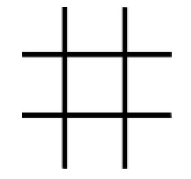

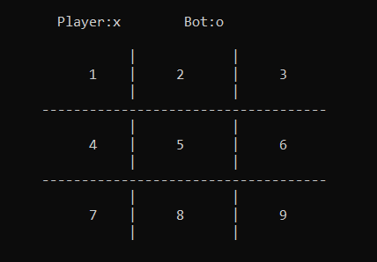

Player needs to enter a position until Player or Bot wins or Draw

