**SNACKS IN SECONDS – A FOOD ORDERING WEB APPLICATION**

**OBJECTIVE** –

TO PROVIDE A CONVENIENT AND EFFICIENT WAY FOR CUSTOMERS TO ORDER AND RECEIVE FOOD ONLINE FROM THEIR LOCATION.THE MAIN FOCUS FROM THIS PROJECT IS TO PROVIDE A SEAMLESS AND ENJOYABLE EXPERIENCE FOR CUSTOMERS, FROM THE MOMENT THEY START BROWSING THE MENU TO THE MOMENT THEY RECEIVE THE FOOD. WE HAVE AIMED TO ACHIEVE SOME SPECIFIC OBJECTIVES LIKE-

1. PROVIDE A USER FRIENDLY INTERFACE
2. OFFER A WIDE VARIETY OF OPTIONS
3. PROVIDE SECURE AND CONVENIENT PAYMENT OPTIONS
4. BUILD A LOYAL CUSTOMER BASE

**TECHNLOGIES INVOLVED-**

1. STREAMLIT- IT IS AN OPEN-SOURCE PYTHON LIBRARY FOR BUILDING AND DEPLOYING CUSTOM WEB APPLICATIONS FOR DATA SCIENE AND ML.IT ALLOWS DEVELOPERS TO QUICKLY CREATE INTERACTIVE AND VISUALLY APPEALING DASHBOARDS, DATA EXPLORATION TOOLS AND ML MODELS, WITHOUT HAVING TO WRITE HTML, CSS OR JAVASCRIPT CODE.
2. PYTHON- IT IS A HIGH LEVEL INETERPRETED LANGUAGE. IT IS KNOWN FOR ITS SIMPLICITY, READABILITY AND VERSATAILITY AND IS WIDELY USED FOR VARIETY OF APPLICATIONS INCLUDING WEB DEVELOPMENT, SCIENTIFIC COMPUTING, DATA ANALYSIS, AI AND MORE.
3. MYSQL- IT IS A POPULAR OPEN SOURCE RELATIONAL DATABSE MANAGEMENT SYSTEM(RDBMS) THAT IS WIDELY USED FOR WEB BASED APPLICATION AND OTHER DATA INTENSIVE PROJECTS
4. PANDAS- IT IS AN OPEN-SOURCE PYTHON LIBRARY FOR DATA MANIPULATION AND ANALYSIS.IT PROVIDES TWO PRIMARY DATA STRUCTURES NAMELY SERIES AND DATA FRAMES WHICH ARE DESIGNED TO HANDLE ONE DIMENSIONAL AND TWO-DIMENSIONAL DATA RESPECTIVELY.
5. FPDF- IT IS A FREE AND OPEN-SOURCE PHP LIBRARY FOR GENERATING PDF DOCUMENTS.IT PROVIDES A SIMPLE AND INTUITIVE API FOR GENERATING PDF DOCUMENTS WITH FUNCTIONS FOR ADDING TEXT, IMAGES, TABLES, AND OTHER ELEMENTS TO THE PAGE.

THE FUNCTIONALITY OF OUR FOOD DELIVERY WEB APPLICATION CAN BE BROKEN DOWN INTO SEVERAL KEY STEPS. HERE IS THE GENERAL OVERVIEW OF THE PROCESS.

1. USER HAS TO CREATE AN ACCOUNT USING THEIR INFORMATION.
2. AFTER THE ACCOUNT IS CREATED USER IS ABLE TO LOGIN INTO THEIR ACCCOUNT USING THE VALID LOGIN CREDENTIALS.
3. AFTER SUCCESSFUL LOG IN USER USED IS REDIRECTED TO THE HOME SCREEN
4. ON THE HOME SCREEN CUSTOMER HAS LIST OF OPTIONS TO SELECT THE FOOD ACCORDING TO THEIR PREFERENCE
5. WHEN THE FOOD SELECTION IS DONE CUSTOMER CAN GO INTO THE CART SECTION WHERE THEY CAN FIND THE DETAILS OF THE ORDER WHICH THEY HAVE CREATED ALONG WITH THE PAYMENT DETAILS.
6. THE PAYMENT CAN BE DONE THROUGH VARIOUS PAYMENT METHODS WHICH IS PREFFEREABLE TO THE CUSTOMER.
7. THE FINAL PROCESS OF PLACING THE ORDER IS TO SUBMIT THE ORDER USING THE ORDER NOW BUTTON.
8. AFTER ALL THE DETAILS ARE GIVEN AND WITH ALL OPTIONS SELECTED CUSTOMER CAN FINALLY PLACE THE ORDER.
9. WHEN THE CUSTOMER SUBMITS THEIR ORDER THEY RECEIVE A TOAST DISPLAYING MESSAGE THAT THEIR ORDER IS PLACED WITH SOME IMPORTANT INFORMATION REQUIRED FOR DELIVERY.
10. THE CUSTOMER ALSO HAS ACCESS TO DOWNLOAD THE INVOICE AS A PDF ONLINE TO ENSURE THAT THE ORDER INFORMATION IS CORRECT.
11. IF CUSTOMER WANTS TO UPDATE HIS PERSONAL INFORMATION HE CAN UPDATE IT IN THE MYACCOUNT SECTION.
12. BELOW IS THE E-R DIAGRAM TO SHOWCASE THE FLOW OF THE APPLICATION WHICH WE HAVE CREATED

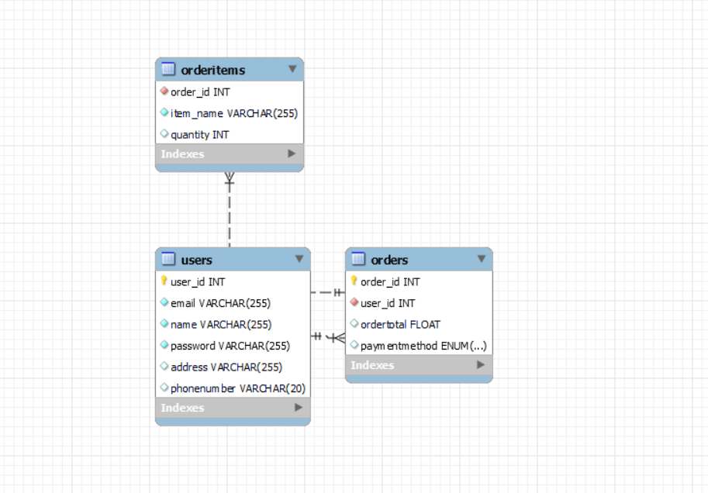

**CONCLUSION-**

IN CONCLUSION, A FOOD DELIVERY WEB APPLICATION IS A POWERFUL PLATFORM FOR CONNECTING CUSTOMERS AND ENABLING FAST AND CONVENIENT FOOD DELIVERY.

WITH THE RIGHT COMBINATION OF TECHNOLOGY, FEATURES AND MARKETING FOOD DELIVERY WEB APPLICATION CAN BE A HIGHLY SUCCESSFUL AND PROFITABLE VENTURE AND CAN HELP TO TRANSFORM THE WAY THAT PEOPLE ORDER AND ENJOY THEIR FAVIOURITE FOOD.