Name- Aditya Jagtap
MIS - 712522002
Assignment 2
Letter Frequency Analysis of Encryption/Decryption Algorithm

Problem Statement – Find the Average frequency of each letter in plain.txt and cipher.txt. Plain.txt should have 10 paragraphs and show interpritation.

Code -

with open("/plain.txt", "r") as f:
text = f.read()
print(text)

count_P = {}

for i in text:
i = i.lower()
if i.isalpha():
if i in count_P:
count_P[i] += 1
else:
count_P[i] = 1

total_letters = sum(count_P.values())

avg_P = {}

for letter, freq in count_P.items():
avg_P[letter] = freq / total_letters

sorted_dict_P = dict(sorted(avg_P.items()))

print("\nPlaintext Frequnecy",count_P)
print("\nAverage Frequnecy",sorted_dict_P)

def encrypt_file(input_file, output_file, key):
with open(input_file, "r") as f:
text = f.read()

encrypted = ""

for i, char in enumerate(text):
if not char.isalpha():
continue

shift = key + (i % 5)
base = ord('a') if char.islower() else ord('A')

if i % 2 == 0:
encrypted += chr((ord(char) - base + shift) % 26 + base)
else:
encrypted += chr((ord(char) - base - shift) % 26 + base)

with open(output_file, "w") as f:
f.write(encrypted)

print("Encryption successful")
return encrypted

count_C = {}

en_txt = encrypt_file("/plain.txt","/cipher.txt",3)

print("\n",en_txt)

for i in en_txt:
i = i.lower()
if i.isalpha():

if i in count_C:
count_C[i] += 1
else:
count_C[i] = 1

total_letters = sum(count_C.values())

avg_C = {}

for letter, freq in count_C.items():
avg_C[letter] = freq / total_letters

sorted_dict_C = dict(sorted(avg_C.items()))

print("\nEncrypted Frequnecy",count_C)
print("\nAverage Frequnecy",sorted_dict_C)

import matplotlib.pyplot as plt

letters = list(sorted_dict_P.keys())
Freq = list(sorted_dict_P.values())

plt.bar(letters,Freq)
plt.xlabel("Alphabets")
plt.ylabel("Frequency")
plt.title("Alphabet Avg Frequency Count of plain text")
plt.show()

import matplotlib.pyplot as plt

letters = list(sorted_dict_C.keys())
Freq = list(sorted_dict_C.values())

plt.bar(letters,Freq)
plt.xlabel("Alphabets")
plt.ylabel("Frequency")
plt.title("Alphabet Avg Frequency Count of Cipher text")
plt.show()

import matplotlib.pyplot as plt
import pandas as pd
import numpy as np

# Assuming these already exist
# sorted_dict_P -> Plain text frequency dictionary
# sorted_dict_C -> Cipher text frequency dictionary

letters = list(sorted_dict_P.keys())
plain_freq = list(sorted_dict_P.values())
cipher_freq = list(sorted_dict_C.values())

x = np.arange(len(letters))
width = 0.4

plt.figure(figsize=(14,6))

plt.bar(x - width/2, plain_freq, width, label="Plain Text")
plt.bar(x + width/2, cipher_freq, width, label="Cipher Text")

plt.xlabel("Alphabets")
plt.ylabel("Frequency")
plt.title("Alphabet Frequency Comparison (Plain vs Cipher)")
plt.xticks(x, letters)
plt.legend()
plt.grid(axis="y", linestyle="--", alpha=0.6)

plt.show()

df = pd.DataFrame({
"Alphabet": letters,
"Plain_Text_Frequency": plain_freq,
"Cipher_Text_Frequency": cipher_freq
})

print(df.to_string(index=False))

Output -

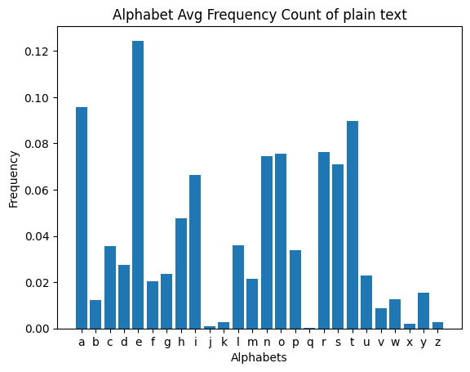

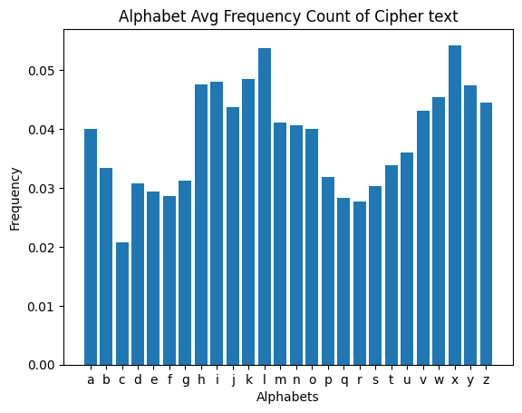

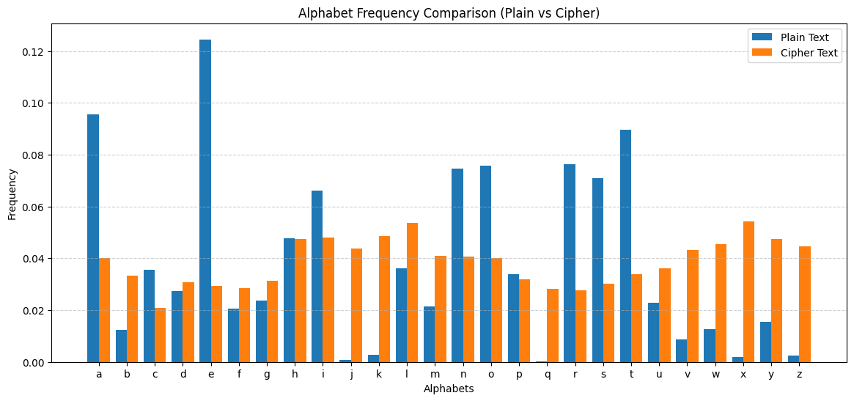

Inference:

The plain text frequency distribution follows typical English language patterns, where letters like e, t, a, o, n, r, and s occur much more frequently than others. This confirms that the plain text analysis is correct.

In contrast, the cipher text shows a much more uniform distribution of letters. No single character dominates the frequency table, and most letters appear within a similar range. High-frequency plain text letters such as e and t no longer stand out in the cipher text.

This indicates that the encryption process successfully hides the natural statistical patterns of the original message. Because the frequency distribution is flattened, traditional frequency analysis attacks become difficult.

Overall, the results show that the encryption approach provides good resistance against basic cryptanalysis and significantly improves security compared to simple substitution ciphers.

Conclusion:

The comparison between plain text and cipher text frequencies shows that the encryption technique effectively removes recognizable language patterns and produces a near-uniform distribution of characters. This makes frequency-based cryptanalysis difficult and demonstrates that the algorithm provides a good level of security for protecting textual data. Overall, the method achieves its objective of transforming readable text into statistically disguised cipher text.

