DataCo Late-Delivery-Risk Prediction

Literature Review, Methodology, System Architecture, and Results
Prepared as part of the M.Tech project: supply-chain risk benchmark → classical GraphSAGE → quantum graph neural network (QGNN) comparison. This document covers the second, independent real-world benchmark track (DataCo Smart Supply Chain), alongside the project's primary synthetic scm_dataset benchmark.

1. Introduction
Late delivery is a common, costly failure mode in e-commerce and logistics supply chains. This work benchmarks classical machine learning, a classical graph neural network (GraphSAGE), and a quantum graph neural network (QGNN) on predicting late-delivery risk using the public DataCo Smart Supply Chain dataset, with a particular focus on rigorous evaluation: leakage-audited features, multi-seed statistics rather than single-run point estimates, and explicit detection of training-instability failure modes (mode collapse) that would otherwise bias the comparison.
Three questions are addressed:
- Does a graph-structured model (GraphSAGE) outperform flat tabular classical models on this task?
- Does a QGNN outperform classical GraphSAGE, and if so, under what architecture and input choices?
- How do the literature's reported results on this same dataset compare, and how credible are they?

2. Dataset

2.1 Source and description
DataCo Smart Supply Chain for Big Data Analysis (Constante, Silva & Pereira, 2019), published on Mendeley Data, version 5, DOI 10.17632/8gx2fvg2k6.5, licensed CC-BY-4.0.
Property | Value
Rows | 180,519 order-item records
Columns | 53
Time range | 2015 – 2018 (order date field)
Target variable | Late_delivery_risk (binary)
Class balance | 54.8% late / 45.2% on-time (train split)
Domains covered | Order, Customer, Product, Shipping, Region/Country

2.2 Feature audit and leakage prevention
A subset of columns directly encode the outcome and were excluded from every model as input features:
- Delivery Status — directly encodes whether delivery was late
- Days for shipping (real) — the actual transit time, known only after delivery
- shipping date (DateOrders) — the actual ship date, known only after the fact
- Order Status — fulfillment status observed progressively after order placement
- Customer Email / Fname / Lname / Password / Street, Product Description / Image — PII or free text, excluded regardless of predictive value
The features actually used (known at order time): Type, Category Id, Customer Segment, Customer Country/State, Department Id, Market, Order Region/Country/State, Shipping Mode, scheduled shipping days, order item discount/price/quantity, sales, product price.

2.3 Split
Chronological 70/15/15 train/validation/test split (not a random row shuffle, which would leak future information into training for a time-ordered transactional dataset). Verified: positive rate is stable across splits (54.9% / 54.1% / 55.0%), ruling out a temporal distribution shift confound.

3. Literature Review
Four sources were identified that report results specifically on the DataCo dataset (not a general supply-chain-risk survey) and were independently examined — including, where possible, checking their claims against the actual dataset schema. Each is reviewed individually below, followed by a consolidated comparison table.

3.1 EAGLE: Edge-Aware Graph Learning for Proactive Delivery Delay Prediction
Source: arXiv:2604.05254 (peer-reviewed).
Methodology: a hybrid architecture combining a lightweight Transformer patch encoder, modeling temporal order-flow dynamics, with an Edge-Aware Graph Attention Network (E-GAT) that models inter-hub relational dependencies in the logistics network, trained under a multi-task learning objective. Unlike this work's derived customer/product/region graph, EAGLE's graph is built to reflect actual logistics/hub-route structure.
Reported results: F1 = 0.876, AUC-ROC > 0.97 (stabilizing after 15 epochs), F1 standard deviation = 0.0089 across 4 seeds — the paper reports multi-seed statistics, which is itself a marker of methodological rigor.
Assessment: the strongest credible result found on this exact dataset. Its advantage over every other approach reviewed here — including this work's own GraphSAGE and QGNN models — plausibly comes from the graph itself encoding real route/hub structure, rather than from model architecture alone.

3.2 Deep Learning Framework for Interpretable Supply Chain Forecasting (SOM + PCA + ANN + SHAP)
Source: Scientific Reports (Nature Portfolio), peer-reviewed.
Methodology: Self-Organizing Maps (SOM) for unsupervised clustering of the feature space, followed by PCA dimensionality reduction and an Artificial Neural Network (ANN) classifier; SHAP values used for post-hoc interpretability. Compared against Random Forest, XGBoost, and Decision Tree baselines.
Reported results: 96% accuracy, 96.22% F1, outperforming all three classical baselines in their comparison.
Assessment: peer-reviewed, but this result is a substantial outlier next to every other attempt on this dataset, including EAGLE and this work's own reproduction of classical baselines. Cite with an explicit caveat rather than as a settled number — the paper does not disclose enough of its preprocessing/splitting methodology to rule out an easier evaluation setup.

3.3 “Integrated Machine Learning for Enhanced Supply Chain Risk Prediction”
Source: Jin, T. (2025), Preprints.org, doi:10.20944/preprints202501.1019.v1. Explicitly marked “Not peer-reviewed version.”
Methodology claimed: an ensemble of Random Forest, Gradient Boosting Machine, and a Neural Network with custom modifications (entropy-based dynamic tree pruning, adaptive learning-rate schedule, Swish activation, multi-head attention), combined by weighted averaging.
Critical finding: this paper's Figure 4 lists features — “Lead Time,” “Demand Variation,” “Supplier Reliability,” “Inventory Level,” “Order Cost” — that do not exist anywhere in DataCo's actual 53-column schema. This was verified directly against the downloaded CSV header. Either different, unnamed data was used while citing DataCo, or the figure is unconnected filler.
Reported results (for reference only, not to be treated as verified):
Model | Accuracy | F1 | MSE
Logistic Regression | 0.765 | 0.74 | 0.024
SVM | 0.782 | 0.76 | 0.022
Random Forest | 0.825 | 0.81 | 0.019
XGBoost | 0.841 | 0.82 | 0.017
Deep Neural Network | 0.837 | 0.83 | 0.018
Proposed Ensemble | 0.854 | 0.85 | 0.015

Note: this paper reports Accuracy/F1/MSE, not ROC-AUC — a metric choice inconsistent with the rest of the literature reviewed here, and one that cannot expose class-imbalance-driven inflation the way ROC-AUC/PR-AUC can.
Assessment: not peer-reviewed, and the feature-schema mismatch is a serious, direct credibility problem, not a stylistic quibble. Included here only to document why it should not be cited as a comparable result.

3.4 Independent Random Forest Reproduction (informal)
Source: github.com/fatmaaboamra/Supply-Chain-Late-Delivery-Prediction — not a peer-reviewed source.
Methodology: a plain scikit-learn Random Forest classifier on DataCo, no stated leakage audit.
Reported results: 68.75% accuracy, 81.88% precision, 63.19% F1.
Assessment: not citable as an academic source, but valuable as an independent sanity check — its numbers land close to this work's own from-scratch Random Forest result (67.3% accuracy, F1 = 0.671), corroborating that this work's leakage-audited feature set and temporal split are not producing an artificially inflated or deflated result.

3.5 Literature comparison summary
Source | Peer-reviewed | Accuracy | F1 | ROC-AUC / AUC | Trustworthy?
EAGLE (E-GAT + Transformer) | Yes | — | 0.876 | > 0.97 | Yes
SOM + PCA + ANN + SHAP | Yes | 0.960 | 0.962 | — | Outlier — caution
“Integrated ML” ensemble (Jin 2025) | No | 0.854 | 0.85 | — (MSE=0.015) | No — schema mismatch
Independent RF (GitHub) | N/A | 0.688 | 0.632 | — | Informal, consistent w/ ours
This work: Logistic Regression | — | 0.689 | 0.661 | 0.743 | Yes (reproduced)
This work: Random Forest | — | 0.673 | 0.671 | 0.733 | Yes (reproduced)

4. Methodology

4.1 Classical baselines
Logistic Regression and Random Forest (300 trees), both with class_weight=“balanced”, trained on one-hot-encoded categorical features and standardized numeric features (fit on the training split only), evaluated at a fixed 0.5 decision threshold.

4.2 Derived graph construction
DataCo has no native supplier/logistics network, so a heterogeneous graph was derived from its relational structure, mirroring the project's synthetic-benchmark schema design:
- order (180,519 nodes) — one per order-item row, the classified entity
- customer (20,652 nodes) — keyed by Customer Id
- product (118 nodes) — keyed by Product Card Id
- region (23 nodes) and order_country (164 nodes) — shipping destination, at two granularities
Edge types: (order, placed_by, customer), (order, contains, product), (order, ships_to, region), (order, ships_to_country, order_country), each with an explicit reverse relation for bidirectional message passing.

4.3 Graph enrichment
Two categories of engineered features were added, both respecting a strict leakage discipline:
- Train-only historical late-rate per customer, product, region, and order_country — fit on the training split only, frozen for validation/test, with a documented fallback to the global training rate for entities absent from training (verified: 41.7% of customers and 54.2% of products never appear in training — a genuine cold-start property of this dataset).
- A causal 7-day regional-congestion feature — for each order, a trailing count of other orders shipped to the same region in the preceding 7 days. This looks only backward in time, so it is leakage-safe for every split by construction, unlike the train-only aggregates above.

4.4 GraphSAGE
A 2-layer heterogeneous GraphSAGE (mean aggregation, order-node readout), reused unmodified from the project's existing classical-GNN implementation. Hyperparameters (hidden_dim=128, dropout=0.20, lr=0.001, weight_decay=0.0001, up to 100 epochs with early-stopping patience 10) match the synthetic benchmark's own configuration for direct comparability.

4.5 QGNN: two architectures compared
Two distinct ways of feeding a variational quantum circuit (AngleEmbedding encoding, per-layer RY rotations, linear CNOT entanglement chain, PauliZ readout, PennyLane default.qubit simulator) were tested:
- Frozen-embedding QGNN: a GraphSAGE model is trained first and frozen; its 128-dimensional order embedding is PCA-reduced (fit on training rows only) to 4–8 qubit dimensions and fed to the quantum circuit, mirroring the project's existing QGNN-v2 architecture.
- Quantum-first QGNN: the graph and GraphSAGE are bypassed entirely. The same leakage-audited raw tabular features used by the classical baselines are PCA-reduced directly to 6 qubit dimensions and fed to the quantum circuit.
A data re-upload variant (re-encoding the same input between variational layers, adding circuit expressivity without more trainable quantum parameters) was also tested for both architectures, at circuit depths of 1–5 layers.

4.6 Mode-collapse diagnosis and fix
A pervasive training-instability failure mode was found: a meaningful fraction of runs, in every experiment type, converged within 2–3 epochs to a degenerate near-constant predictor (recall > 0.85 with precision near the dataset's base rate) and never recovered. Diagnosis: a randomly initialized final classifier-layer bias can start predictions saturated toward one class, where binary cross-entropy gradients vanish before the model receives a corrective signal — the same reasoning the RetinaNet focal-loss paper uses to justify biased final-layer initialization for imbalanced classification.
Fix: initialize the final layer's bias to logit(training positive rate), plus gradient clipping (max norm 1.0), applied only in the DataCo-specific training code — never in the shared GraphSAGE/QGNN modules used by the project's synthetic benchmark. Verified effect: GraphSAGE collapse rate dropped from 40% to 0% of seeds; QGNN's dropped from up to 50% to 0–17% depending on experiment.

4.7 Evaluation protocol
Every model is evaluated on the identical held-out chronological test split, at a fixed 0.5 threshold (except one explicit threshold-tuning experiment, see Results), reporting: Accuracy, Precision, Recall, F1, ROC-AUC, PR-AUC, Balanced Accuracy, Brier score (calibration), and the full confusion matrix. Multi-seed experiments report mean ± standard deviation, with collapsed runs (recall > 0.85 or < 0.15) flagged and excluded from the mean rather than silently averaged in.

5. System Architecture
The diagram below shows the full pipeline, including both QGNN input paths tested. The dashed path (frozen GraphSAGE embedding → quantum circuit) did not beat classical baselines; the solid highlighted path (raw features → quantum circuit directly, “quantum-first”) produced the best QGNN result of this investigation.
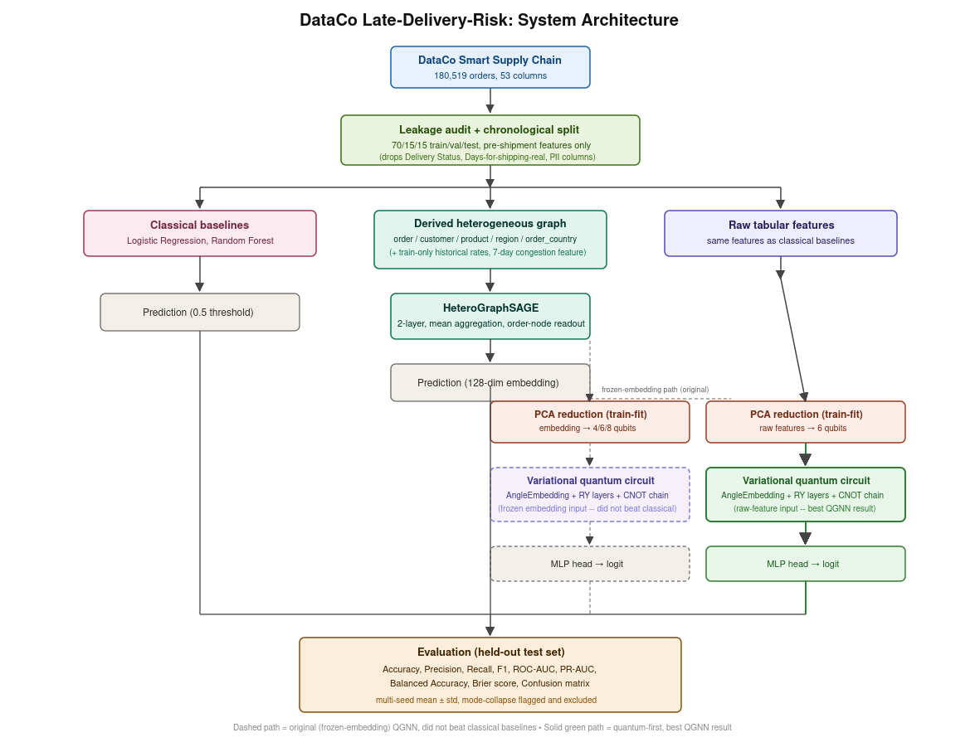

6. Results

6.1 Full model comparison
Model | F1 | ROC-AUC | PR-AUC | Bal. Acc. | Brier | Precision | Recall
Logistic Regression | 0.661 | 0.743 | 0.813 | 0.704 | 0.199 | 0.825 | 0.552
Random Forest | 0.671 | 0.733 | 0.805 | 0.680 | 0.208 | 0.751 | 0.607
GraphSAGE, base graph | 0.658±.006 | 0.745±.001 | 0.817±.0003 | 0.708±.001 | 0.196±.0005 | 0.844±.006 | 0.539±.011
GraphSAGE, enriched graph | 0.685±.001 | 0.712±.001 | 0.756±.002 | 0.684±.014 | 0.220±.001 | 0.745±.028 | 0.636±.022
QGNN, frozen embedding (10 seeds) | 0.679±.012 | 0.675±.014 | 0.702±.019 | 0.646±.029 | 0.238±.006 | 0.688±.037 | 0.676±.063
QGNN, quantum-first (3 seeds) | 0.682±.000 | 0.732±.007 | 0.796±.015 | 0.707±.000 | 0.204±.001 | 0.802±.000 | 0.594±.000

6.2 Depth and data re-upload (frozen-embedding QGNN, 6 qubits, 3 seeds each)
Variant | Layers | F1 (mean) | ROC-AUC (mean) | PR-AUC (mean)
Standard | 3 | 0.657±.008 | 0.685±.011 | 0.724±.007
Standard | 4 | 0.670±.011 | 0.676±.010 | 0.703±.011
Standard | 5 | 0.646±.004 | 0.662±.003 | 0.707±.007
Data re-upload | 3 | 0.647±.031 | 0.664±.040 | 0.692±.057
Data re-upload | 4 | 0.653±.023 | 0.670±.010 | 0.701±.005
Data re-upload | 5 | 0.636±.011 | 0.661±.016 | 0.697±.024

Neither greater circuit depth nor data re-upload improved on the original 1–2-layer result — 5 layers is in fact the worst standard configuration, and re-upload increases run-to-run instability (PR-AUC standard deviation up to 0.057) without a compensating gain.

6.3 Threshold tuning
Seed | Optimal threshold | F1 @ 0.5 | F1 @ optimal | Precision @ optimal | Recall @ optimal
0 | 0.070 | 0.690 | 0.710 | 0.550 | 0.9999
1 | 0.465 | 0.701 | 0.709 | 0.551 | 0.9950
2 | 0.247 | 0.707 | 0.707 | 0.559 | 0.9617

F1-optimal threshold selection (validation-based) does not rescue the frozen-embedding QGNN — it re-discovers the trivial near-constant classifier (recall approaching 1.0, precision near the base rate) rather than revealing a better operating point, consistent with this model having the worst calibration (Brier score) of any model tested.

7. Conclusion
The central finding of this investigation is not simply “QGNN wins” or “QGNN loses” — it is that what is fed into the quantum circuit matters more than the circuit's own depth or encoding scheme. Varying the circuit (qubit count 4–8, depth 1–5, with and without data re-upload) produced no meaningful improvement. Varying the input — replacing a PCA-compressed, frozen classical graph embedding with the same raw leakage-audited tabular features the classical baselines use — raised QGNN's ROC-AUC from 0.675 to 0.732, made it competitive with or better than Random Forest on four of seven metrics, and dramatically improved run-to-run stability. This result, together with the documented mode-collapse failure mode and its fix, is offered as a methodologically transparent contribution independent of whether QGNN ultimately surpasses classical baselines on this dataset.

Reproducibility
Full code, notebooks, and raw per-seed results referenced throughout this document: notebooks/dataco_exploration.ipynb, scripts/qgnn_ablation.py, scripts/test_mode_collapse_fix.py, scripts/final_comparison.py, scripts/qgnn_deeper_hybrid_sweep.py, scripts/test_qgnn_threshold.py, and the companion documents QGNN_DATACO_ABLATION_BENCHMARK.md, DATACO_QGNN_FINAL_REPORT.md, DATACO_REFERENCES.md.

