QGNN-v4
Final Research Report
A Hybrid Quantum-Classical Head on Frozen GraphSAGE Embeddings for Supply-Chain Risk Prediction

M.Tech Research Project
Author: Aditya Jagtap
September 2026
Repository branch: qgnn-package-restructure — commit 755e076
Every quantum-circuit result in this report is an ideal, noise-free classical simulation (PennyLane default.qubit, backprop). No physical quantum hardware was used at any point in this project.

Table of Contents
Abstract 4
1. Introduction 5
1.1 Research Objective 5
1.2 Research Questions 5
1.3 How This Report Is Organized 5
2. System Architecture Overview 7
3. Data and Information Flow 9
4. Graph Construction 12
5. Classical GraphSAGE Processing 14
6. QGNN-v4 Detailed Architecture 16
7. Quantum Circuit Diagram 18
8. What Is Trainable? Frozen vs. Trainable Components 19
9. Training and Evaluation Workflow 21
10. Research Experiment Roadmap 23
11. Experimental Setup 25
11.1 Technology Stack 25
11.2 Dataset Characteristics 25
11.3 Graph Characteristics 26
11.4 Training and Evaluation Protocol 26
12. Experiment Control: What Changed, What Stayed Fixed 27
12.1 What Changed in Each Experiment? 27
12.2 Master Experiment Inventory 27
13. Results 29
13.1 Classical Baseline 29
13.2 QGNN-v4 Baseline 29
13.3 Classical vs. QGNN-v4: Extended Metrics 30
13.4 Primary (Temporal) Evaluation 32
13.5 Severity (Out-of-Distribution) Evaluation 32
13.6 Ablation Studies 33
13.7 Representation Analysis 37
13.8 Quantum Resource Analysis 38
13.9 Seed Sensitivity 39
13.10 Fresh-Onset Analysis 41
13.11 Calibration Analysis 42
13.12 Quantum Representation Analysis 44
13.13 Primary vs. Severity Comparison 46
14. Discussion 47
14.1 Why Primary and Severity Behave Differently 47
14.2 Classical vs. Quantum Head Behavior 47
14.3 Representation Findings 48
14.4 Seed Sensitivity 48
14.5 Quantum-Specific Observations 49
14.6 Implications 49
15. Limitations 50
15.1 Severity-5 Event Limitation (the single most important caveat) 50
15.2 Fresh-Onset Limitation 50
15.3 Synthetic Dataset 50
15.4 Seed and Sample-Size Limitations 50
15.5 Parameter-Count Confounds 50
15.6 Ideal Simulator, No Hardware 51
15.7 Frozen Encoder, Not Co-Trained 51
15.8 Threshold Policy Held Fixed Throughout 51
15.9 Computational / Runtime Limitations 51
15.10 Scope of the “Ruled Out” Claims 51
16. Conclusion 52
16.1 Explicitly Demonstrated 52
16.2 Explicitly Not Demonstrated 52
17. Future Work 54
18. Reproducibility 55
18.1 How to Reproduce the Standing References 56
Appendix A — Final Decision Matrix 57
Appendix B — PennyLane-Rendered Quantum Circuit Diagrams and Specifications 58

Abstract
This work investigates whether a hybrid quantum-classical graph neural network (QGNN) — a small variational quantum circuit reading a frozen, classically-trained GraphSAGE supplier embedding — can match or exceed a classical GraphSAGE-Full baseline for supply-chain disruption risk prediction on a synthetic benchmark, and, more centrally, which architectural and training factors govern the hybrid model's behavior. Across nine controlled experimental phases and approximately 230 training runs, evaluated on both a temporal (primary) and a severity/out-of-distribution generalization split, no tested modification produced a reproducible, seed-robust improvement over the standing QGNN-v4 reference, and, among end-to-end fully-trained models, the classical GraphSAGE-Full baseline remained stronger on the severity/out-of-distribution condition throughout.
The most consequential finding was representational rather than architectural: a simple linear classifier trained only as a representation diagnostic on the same frozen embedding — not a competing end-to-end model — already matches or exceeds every quantum configuration's severity performance, and numerically exceeds the classical end-to-end head's own severity PR-AUC as well. This indicates the frozen embedding carries more severity-relevant signal than either full downstream head currently extracts. The severity split's difficulty is shown to be predominantly consistent with a genuine distribution-shift problem rather than an information deficiency, since the identical severity-5 periods are predicted well when in-distribution — though this evidence comes from a dataset whose severe condition is dominated by a single underlying severity-5 event, so it is stated as evidence within this benchmark, not a general claim about severe-event generalization.
The principal limitations — evaluation on a single, event-limited synthetic dataset; an ideal, noise-free quantum simulator with no physical hardware in the loop; and several investigations conducted as 2-seed pilots not equivalent to the project's 5-seed standing references — are documented explicitly and scope every conclusion drawn. The contribution of this work is not a higher benchmark score but a systematic, evidence-based map of which factors do and do not govern this hybrid architecture's behavior, and a demonstrated methodology — frozen-representation diagnostics, seed-level mechanism tracing, quantum-feature probing, and disciplined pilot-then-expand experimental staging — for investigating quantum-classical model behavior rigorously rather than through score-chasing.

1. Introduction
Supply-chain risk prediction — anticipating which suppliers are likely to be disrupted, and how severely — is a graph-structured problem: suppliers, materials, plants, products, regions, and procurement orders interact through a heterogeneous network of dependencies, and a disruption at one node can propagate along that network. Graph neural networks are a natural architectural fit for this structure. This project asks a narrower, more specific question than "can a graph neural network predict supply-chain risk": given a classical graph neural network already capable of learning a useful supplier representation, does replacing (or augmenting) its downstream decision-making head with a small variational quantum circuit change what the system can do — and, if it changes nothing beneficial, can the investigation still produce a rigorous, reusable account of which architectural and training factors actually govern the hybrid system's behavior?

1.1 Research Objective
To understand whether, and under what conditions, a hybrid quantum-classical head — a variational quantum circuit reading a frozen, classically-learned supply-chain graph embedding — can match or exceed a classical graph neural network on supplier-disruption risk prediction, and, more importantly, to systematically identify which architectural and training factors actually govern the hybrid model's behavior, rather than searching for the single highest test score.

1.2 Research Questions
- Does the frozen GraphSAGE representation contain enough signal for this task, and is that signal the bottleneck for the quantum head?
- Under what conditions is the QGNN's training stable, and what explains its seed-to-seed variance?
- Does the QGNN outperform a classical GNN on temporal (primary) generalization? On severity/out-of-distribution generalization?
- Which architectural factors (projection, initialization, ansatz, encoding, qubit count, depth) materially affect QGNN behavior, and which do not?
- Can the QGNN anticipate genuinely new (“fresh-onset”) disruptions, or only rank already-visible ones?

1.3 How This Report Is Organized
Sections 2 through 10 describe the system as built: the end-to-end architecture, how data flows through it, the benchmark graph, the classical encoder, the quantum head and its circuit, what is trainable versus frozen, the training and evaluation workflow, and the roadmap of experiments in the order they were run. Sections 11 and 12 state the experimental setup and, for every experiment, exactly what was changed and what was held fixed. Section 13 presents the results in detail, organized so that every major result carries both a numerical table and a visual figure. Section 14 discusses what the results mean, explicitly separating observed results from interpretations and from hypotheses for future work. Sections 15 through 18 cover limitations, the conclusion, future work, and reproducibility. Appendix A carries the final decision matrix. Appendix B provides PennyLane-rendered quantum circuit diagrams and exact circuit specifications for the reference architecture and the ablation-tested ansatz variants.
Every number in this report is drawn from saved experiment artifacts — per-seed metric CSVs, quantum-feature CSVs, and per-example prediction files — re-verified against those artifacts during a dedicated validation pass rather than carried forward from memory. Every figure is generated either directly from those artifacts or, for the architecture and workflow diagrams, drawn to accurately represent the system's actual code path; none is decorative or fabricated. Every quantum-circuit result in this report comes from PennyLane's default.qubit simulator using exact analytic backpropagation — there is no physical quantum hardware, shot-based sampling, or noise model anywhere in this project, and no claim in this report should be read as a claim about physical quantum-hardware behavior.

2. System Architecture Overview
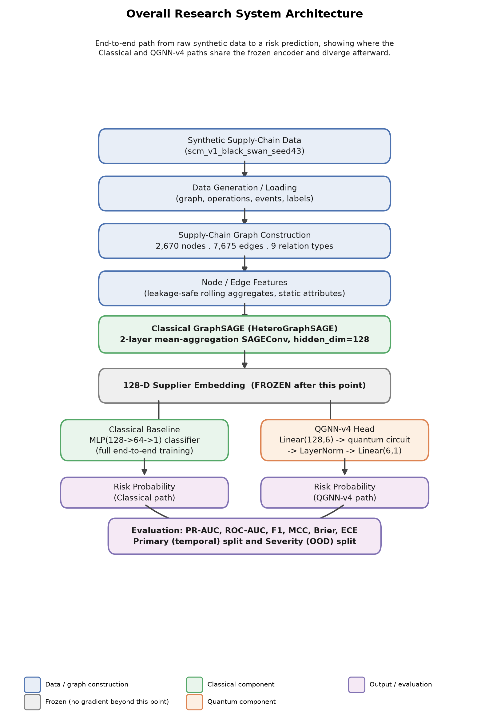
Figure 1. End-to-end architecture of the proposed hybrid classical-quantum supply-chain risk prediction system. Both downstream heads consume the identical frozen 128-dimensional GraphSAGE supplier embedding; only the head differs.
Figure 1 shows the complete, end-to-end system: raw benchmark data on the left, through graph construction and the classical GraphSAGE encoder, branching into the two downstream heads compared throughout this report — the classical MLP head and the QGNN-v4 quantum head — and converging on a shared evaluation protocol. This is Architecture View A, the outside-in, system-level view; Section 6 presents Architecture View B, a complementary inside-out view of the QGNN head's own internal data flow, at a level of detail this system-level diagram intentionally omits.
Introduce: the diagram separates the pipeline into four stages — data and graph construction, the classical encoder, two parallel downstream heads, and a shared evaluation stage. Observe: both heads consume the identical frozen embedding; nothing about the input to the head differs between the classical and quantum conditions, which is what makes the downstream comparison in Section 13 a controlled one. Explain: because the encoder is frozen (Section 8), any performance difference measured between the two heads is attributable to the head and its training, not to a difference in what each head is allowed to see. Limitation, with an example: the diagram is schematic at the encoder-internals level — for instance, it shows “GraphSAGE Encoder” as one box rather than expanding its two SAGEConv layers and heterogeneous per-type projections, which Section 5 covers separately — so that this figure stays readable as a single-page system overview.

3. Data and Information Flow
This section traces exactly how a raw benchmark record becomes a risk prediction, as ten explicit, numbered steps. Figure 2 renders this pipeline visually; the enumeration below is the same pipeline in prose, with the specific artifact produced at each step named.
- Raw benchmark generation. The synthetic dataset generator produces the scm_v1_black_swan_seed43 benchmark: entity tables (suppliers, materials, plants, products, regions, procurement orders), a period-indexed event log, and the supplier_disrupted target label, over a 104-period horizon.
- Graph construction. Entity tables and their relationships are assembled into a single heterogeneous graph: 2,670 nodes of six types connected by 7,675 directed edges across nine relation types (Section 4).
- Feature engineering. Per-node static and rolling dynamic features are computed (e.g. rolling procurement and delivery aggregates for supplier nodes) and attached to every node, type by type.
- Target and horizon definition. The prediction target, supplier_disrupted, is defined as a four-period-ahead binary indicator per supplier-period observation; the overall positive rate is 3.33%.
- Split construction. Two independent evaluation conditions are built from the same underlying graph and labels: a primary (temporal) split — train on earlier periods, test on later ones — and a severity (out-of-distribution) split — train only on periods whose most severe active disruption reaches severity 3 or below, test exclusively on periods reaching severity 4 or 5.
- Classical encoder training. A two-layer HeteroGraphSAGE model is trained end-to-end, per seed and per split, on the full heterogeneous graph, producing a 128-dimensional embedding for every supplier node (Section 5).
- Encoder freezing. Once trained, the encoder's parameters are frozen (requires_grad set to False and asserted in code) before any downstream head is trained on its output (Section 8).
- Downstream head training. Two downstream heads are trained independently on the identical frozen embedding: the classical MLP head, and the QGNN-v4 quantum head (Sections 5–6). Only the head's own parameters receive gradient updates.
- Inference and scoring. Each trained head produces a risk probability per supplier-period observation on the held-out test partition of its split, at a fixed classification threshold of 0.5.
- Evaluation and aggregation. Predictions are scored with a single shared metrics implementation (PR-AUC, ROC-AUC, F1, precision, recall, specificity, balanced accuracy, MCC, Brier score, expected calibration error), aggregated across five independent seeds, and written to the per-run and consolidated result artifacts this report draws from (Sections 13 onward).
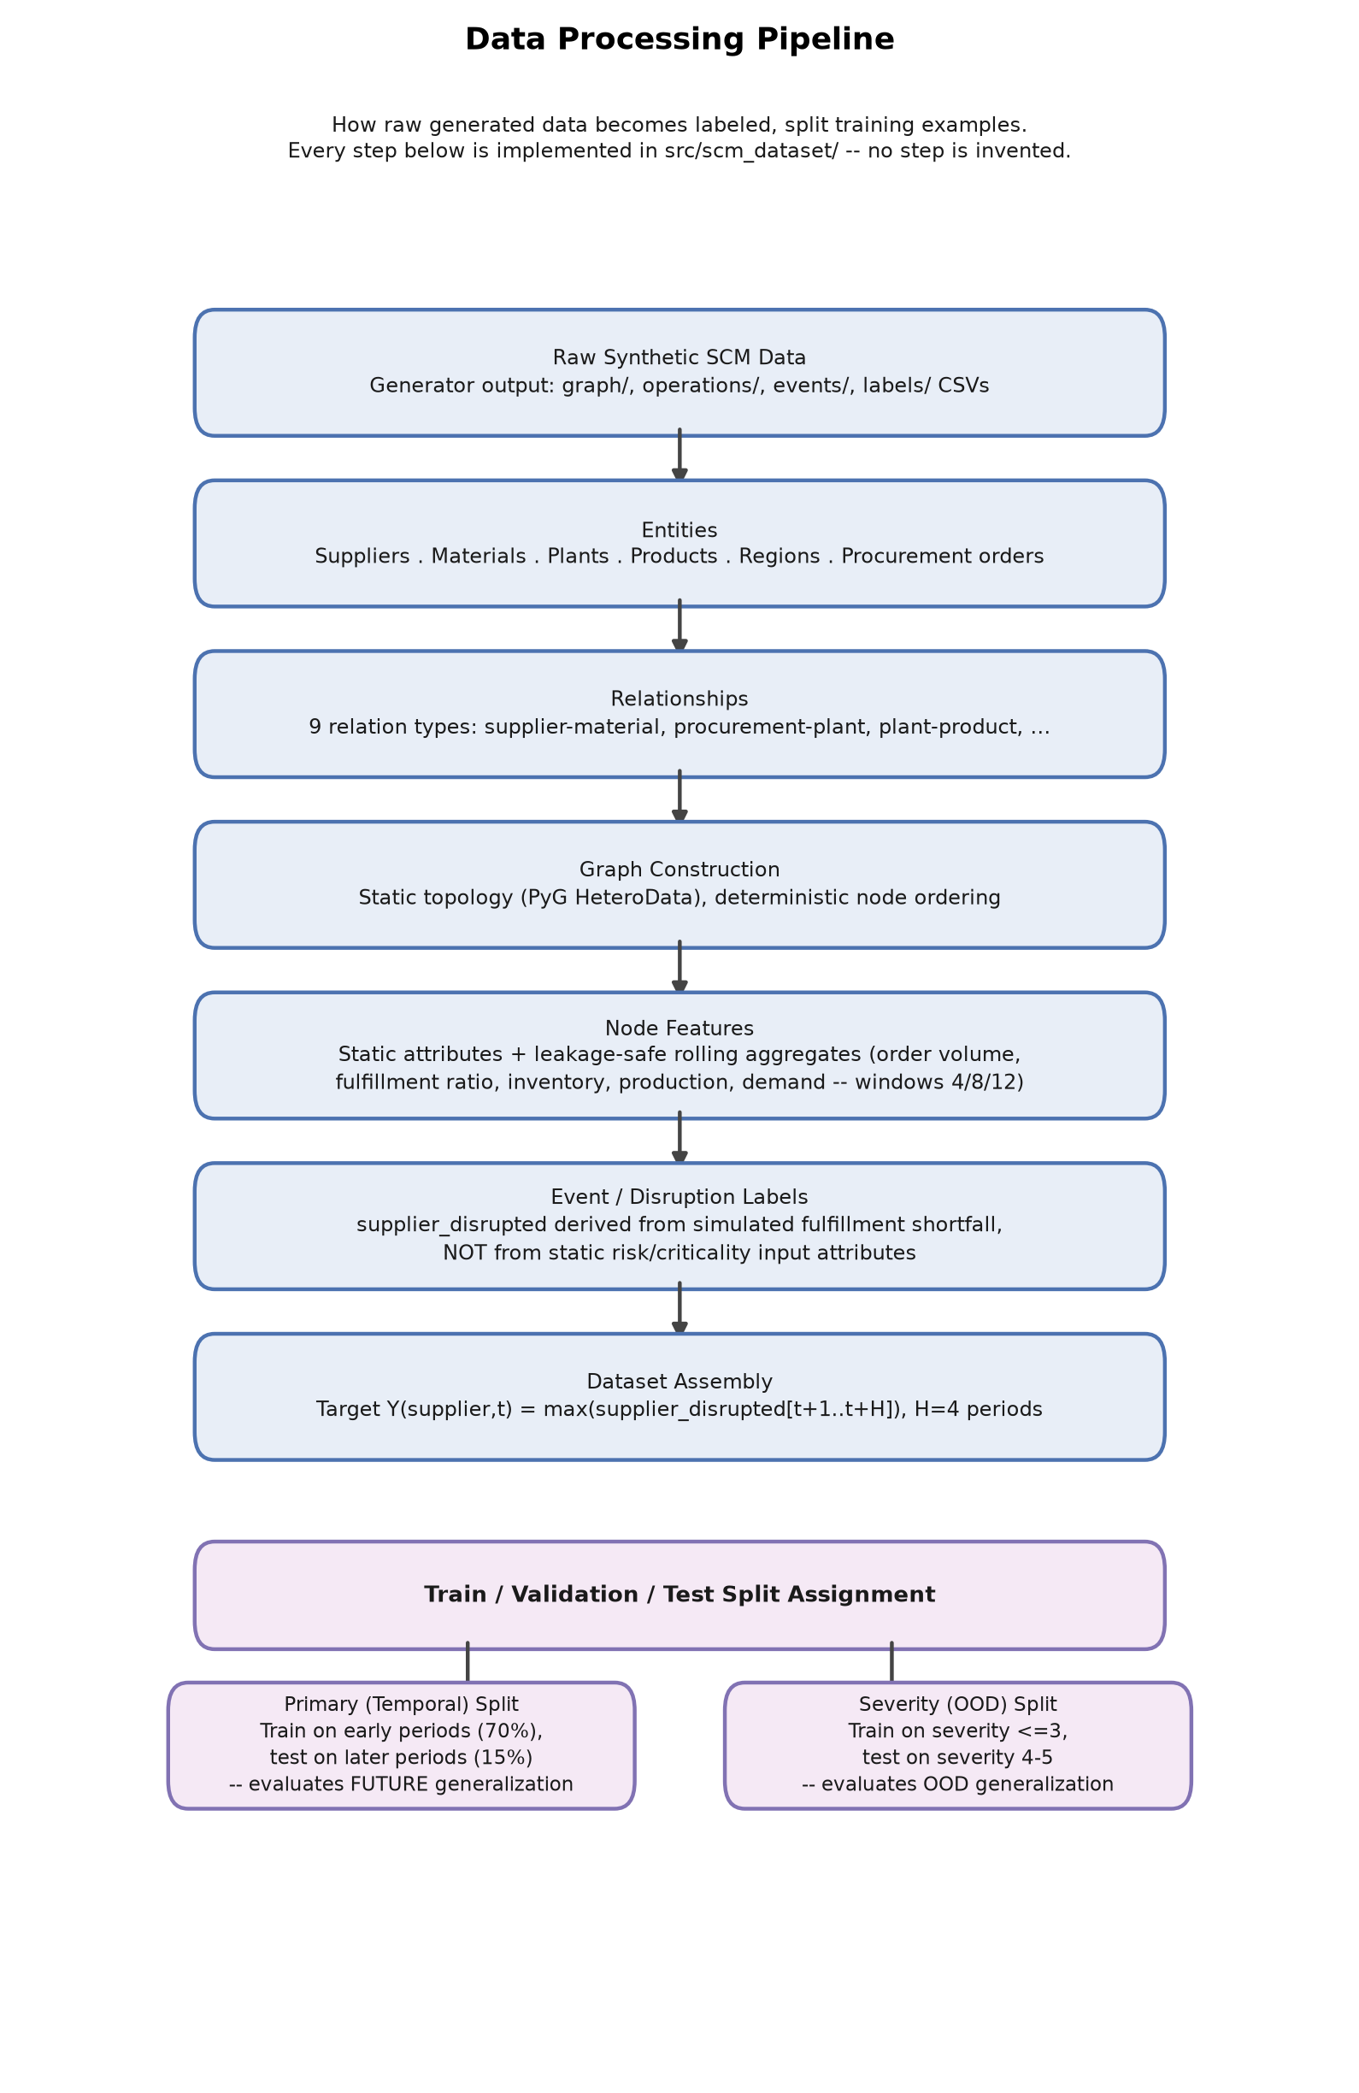
Figure 2. Data processing pipeline from raw benchmark generation through split construction into the Primary (temporal) and Severity (out-of-distribution) evaluation conditions.
Introduce: this figure renders steps 1 through 5 above, ending in the branch point where the same graph and labels produce two structurally different train/test partitions. Observe: the primary and severity splits are not two different datasets — they are two different partitions of one dataset, sharing the same nodes, edges, and features. Explain: this shared-graph design is what makes the in-distribution/out-of-distribution comparison in Section 13.5 meaningful — the identical severity-5 periods can be scored under both partitions, isolating the effect of training exposure from the effect of what those periods look like. Limitation: the diagram does not depict the specific rolling-window feature computations (step 3); it names the step but leaves the computation itself to the project's feature-engineering code, since enumerating every engineered feature would not aid a reader's understanding of the overall flow.

4. Graph Construction
The benchmark graph contains 2,670 nodes of six types (300 suppliers, 100 materials, 50 plants, 200 products, 20 regions, and 2,000 procurement-order nodes) connected by 7,675 directed edges across nine relation types, forming a single connected component with mean node degree 5.75 (median 3.0, maximum 136) and average shortest path length 3.82. Graph density is 0.00215 — sparse and long-tailed, with a small number of hub nodes carrying disproportionately many edges. A supplier's network degree correlates only weakly with its empirical disruption rate (Pearson r = 0.054), ruling out a trivial structural explanation for the disruption labels: the graph's structure alone does not determine which suppliers are disrupted.
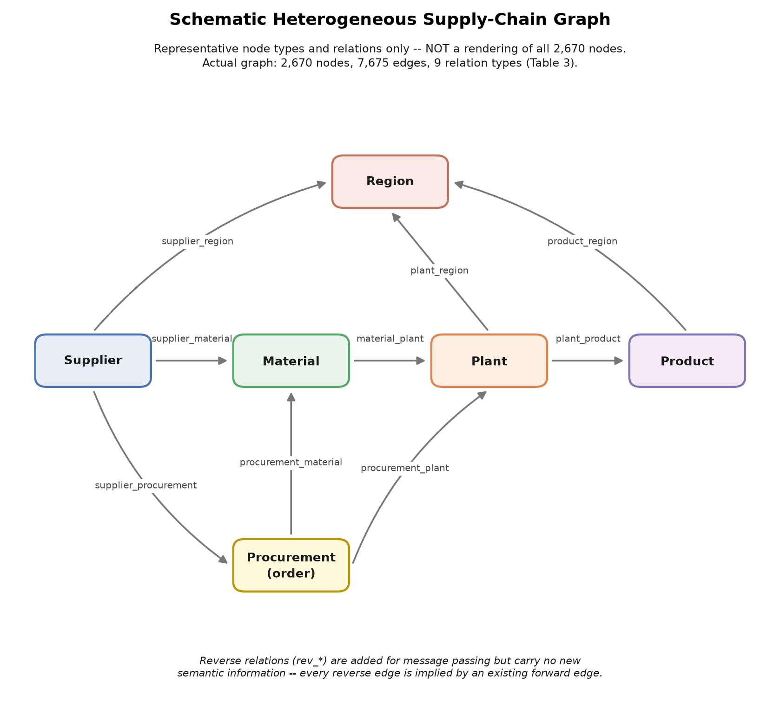
Figure 3. Schematic node-and-relation-type structure of the benchmark heterogeneous graph. This is a small illustrative subgraph by node type and relation type — not a rendering of all 2,670 nodes and 7,675 edges, which are listed numerically instead.
Introduce: the figure shows the six node types and the nine relation types that connect them, using a handful of representative nodes per type rather than the full population. Observe: procurement-order nodes are the most numerous type (2,000 of 2,670 nodes) and sit at the center of the transaction relations connecting suppliers, materials, plants, and products; region nodes are comparatively few (20) and connect to suppliers geographically. Explain: this heterogeneity is exactly why the encoder (Section 5) uses type-specific input projections before any message passing — a supplier node's raw features are not directly comparable to a procurement-order node's, so each type is first projected into a shared representation space. Limitation, with an example: drawing all 2,670 nodes would produce an unreadable diagram dominated by procurement-order nodes; the schematic instead fixes a small, fixed count per type (for example, 4 supplier nodes and 3 material nodes shown, not 300 and 100) purely for legibility, and the true node and edge counts are stated numerically in the caption and in Section 11's dataset and graph tables rather than implied by the drawing.

5. Classical GraphSAGE Processing
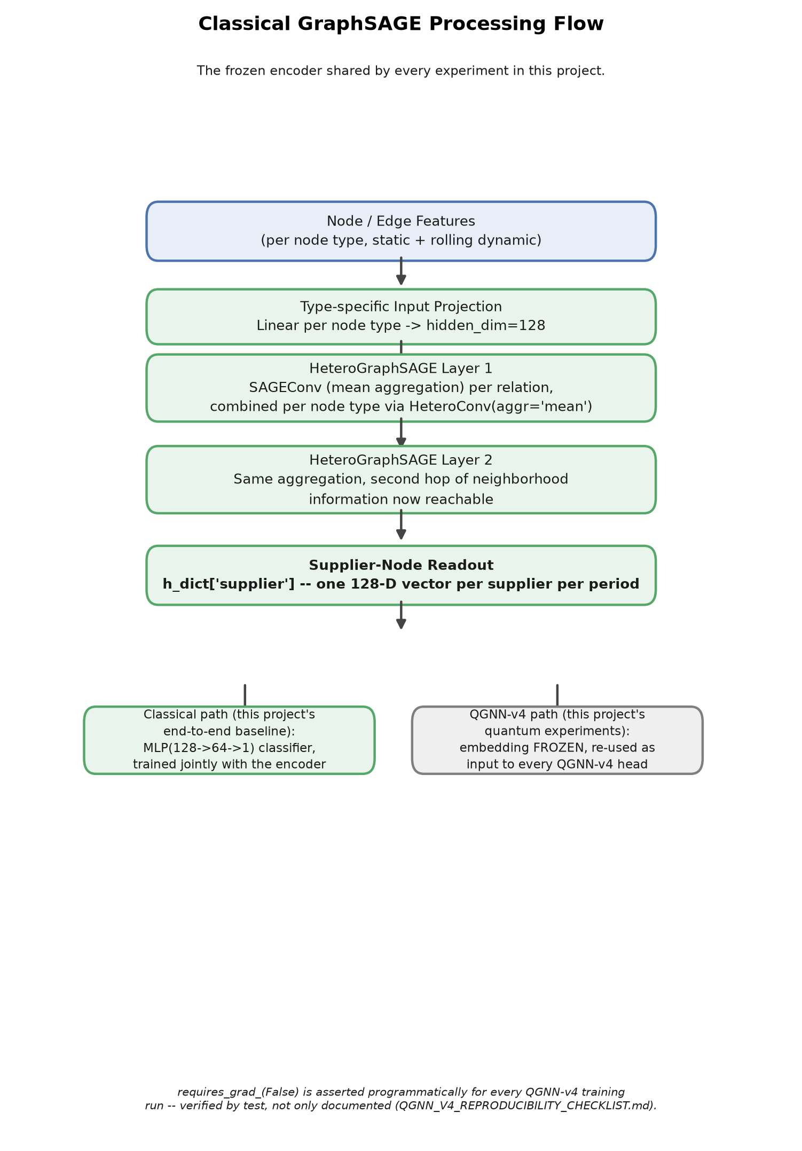
Figure 4. Classical GraphSAGE-Full processing flow: type-specific input projection, two layers of heterogeneous mean-aggregation SAGEConv, supplier-node readout, and the branch into the classical MLP head versus the frozen 128-dimensional embedding consumed by the QGNN-v4 head.
The classical encoder, HeteroGraphSAGE, is a two-layer heterogeneous graph neural network built from PyTorch Geometric's HeteroConv and mean-aggregation SAGEConv operators, with hidden_dim=128 throughout. It is trained end-to-end, once per seed and per split, and its own final classifier head (a two-layer MLP) is what produces the classical baseline's predictions reported throughout this report. The identical trained encoder — before its own classifier head — is reused as the frozen embedding source for every QGNN-v4 experiment: the encoder is trained exactly once per seed/split and never retrained for a downstream-head experiment.
Introduce: each node type's raw features are first projected into a shared 128-dimensional space, then two rounds of heterogeneous message passing update every node's representation using its type-specific neighbors. Observe: only the supplier-node representations are read out after the second layer — material, plant, product, region, and procurement-order nodes participate in message passing (they carry and propagate information) but are not themselves classified. Explain: this is why the frozen embedding handed to the QGNN head is exactly 128-dimensional per supplier, regardless of how many other node types or edges exist in the graph — the readout step is a fixed contraction point shared by both downstream heads. Limitation: the diagram shows two message-passing layers as two boxes; it does not expand the internal mean-aggregation formula for SAGEConv itself, since that formula is standard and unmodified from the original GraphSAGE operator.

6. QGNN-v4 Detailed Architecture
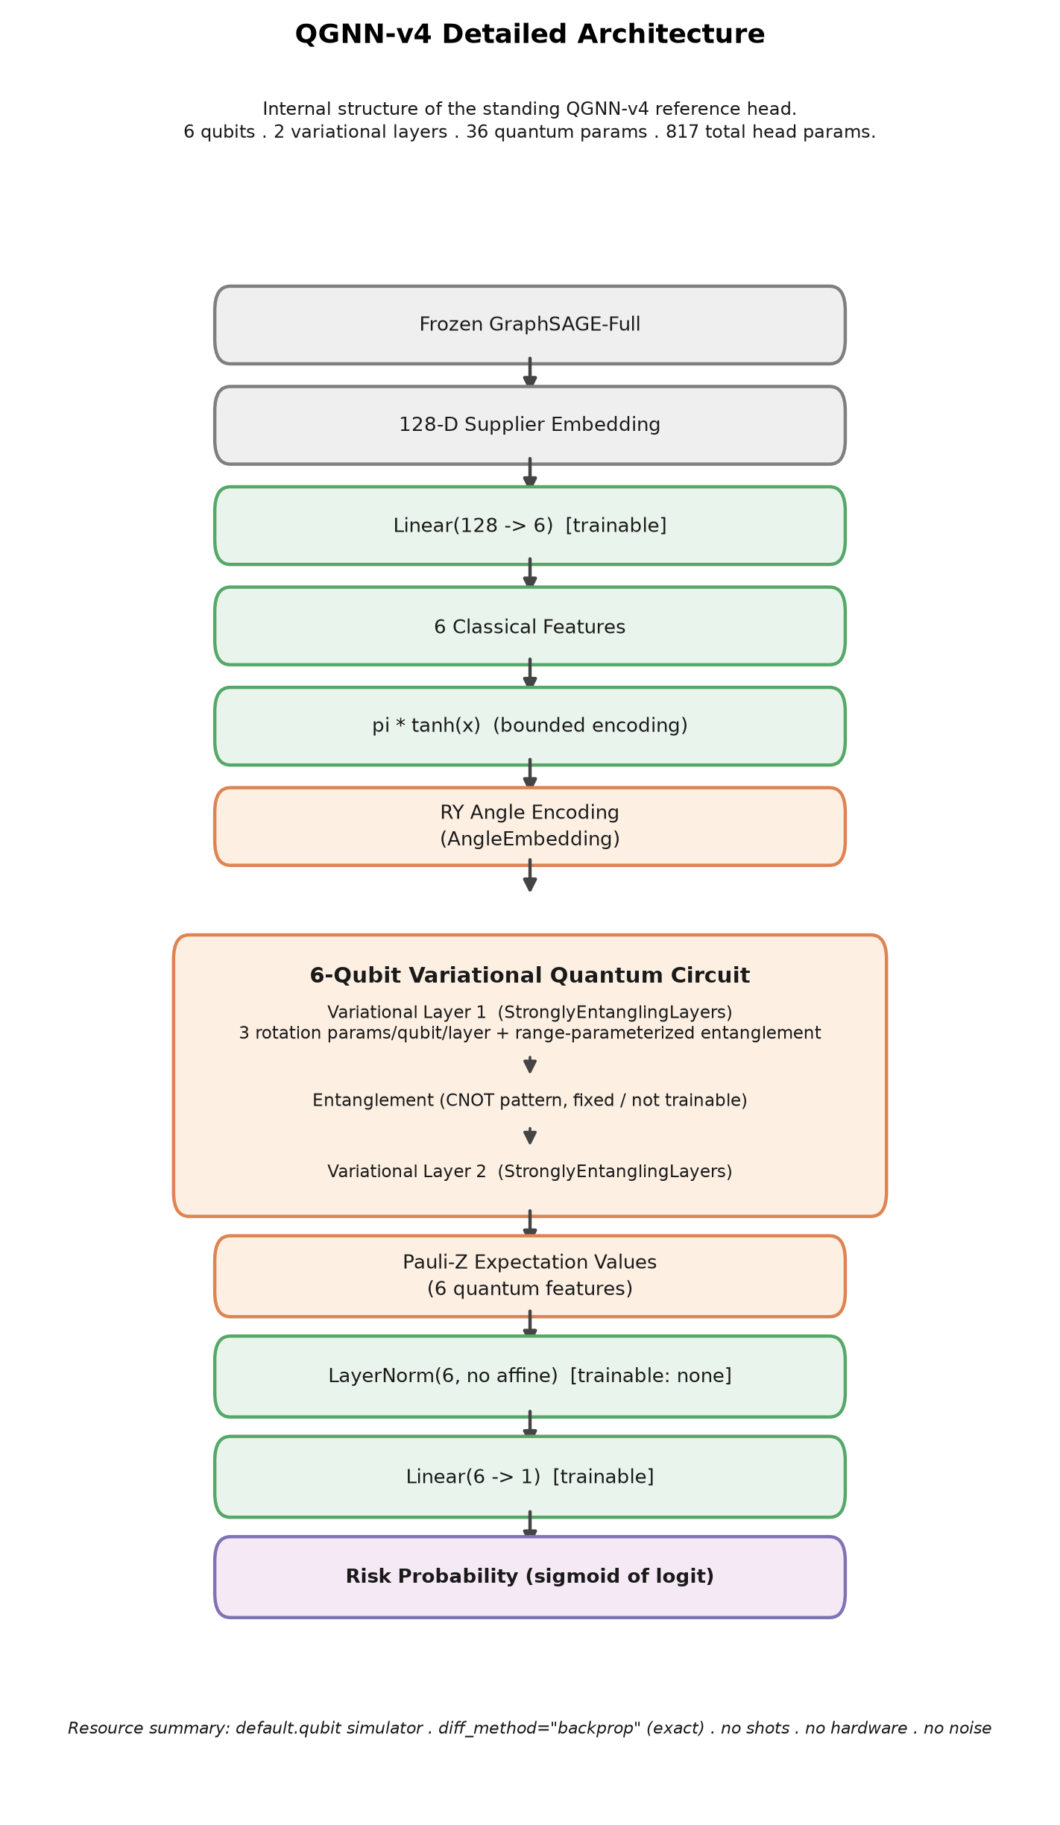
Figure 5. Detailed internal architecture of the QGNN-v4 head (Architecture View B), from the frozen 128-dimensional embedding through the classical projection, angle encoding, the two-layer variational quantum circuit, Pauli-Z measurement, LayerNorm, and the final linear classifier.
This is Architecture View B — the internal, inside-out view of the QGNN-v4 head specifically, complementing Figure 1's system-level Architecture View A. The QGNN-v4 head reduces the frozen 128-dimensional supplier embedding through a trainable Linear(128, 6) layer, bounds the result with π·tanh(·) so every value lies in (−π, π), encodes it into six qubits via RY angle embedding, applies a two-layer StronglyEntanglingLayers variational circuit (36 trainable quantum parameters), measures the Pauli-Z expectation value of each of the six qubits, passes the six resulting values through a LayerNorm with no learnable affine parameters, and finally applies a Linear(6, 1) layer to produce a single risk logit. The complete head has 817 trainable parameters: 774 in the input projection (128×6 weights plus 6 biases), 36 in the quantum circuit, and 7 in the output layer (6 weights plus 1 bias).
Introduce: the nested box in the center of the figure expands the two-layer variational circuit specifically, distinguishing it from the classical projection stage before it and the classical output stage after it. Observe: exactly one nonlinearity (π·tanh) sits between the frozen embedding and the quantum circuit, and exactly one normalization layer (LayerNorm, no affine) sits between the quantum circuit and the final classifier — every other transformation shown is linear or a fixed quantum operation. Explain: the tanh bound exists because angle-embedding gates are periodic in their input angle, so an unbounded projection output could wrap around unpredictably across the 2π period; bounding to (−π, π) keeps the encoding one-to-one over its full useful range. Limitation, with an example: the figure depicts the StronglyEntanglingLayers block as a single labeled box rather than unrolling all twelve individual single-qubit rotation gates and six entangling operations per layer; the exact gate-level circuit is shown separately in Figure 6 specifically so this figure can stay focused on data flow rather than gate-level detail.

7. Quantum Circuit Diagram
Figure 6 renders the QGNN-v4 quantum circuit in the conventional logical-circuit style: one horizontal wire per qubit, gates applied left to right. Six qubits (q0–q5) are each initialized with an RY(θ) angle-embedding gate carrying one of the six projected-and-bounded classical features, followed by two repeated variational layers. Each variational layer applies one general single-qubit rotation, Rot(φ, θ, ω), to every qubit, followed by a ring of controlled-NOT entangling gates connecting each qubit to a neighbor. After both layers, every qubit is measured in the Pauli-Z basis, producing six real-valued expectation values ⟨Z⟩ that become the classical feature vector passed to LayerNorm.
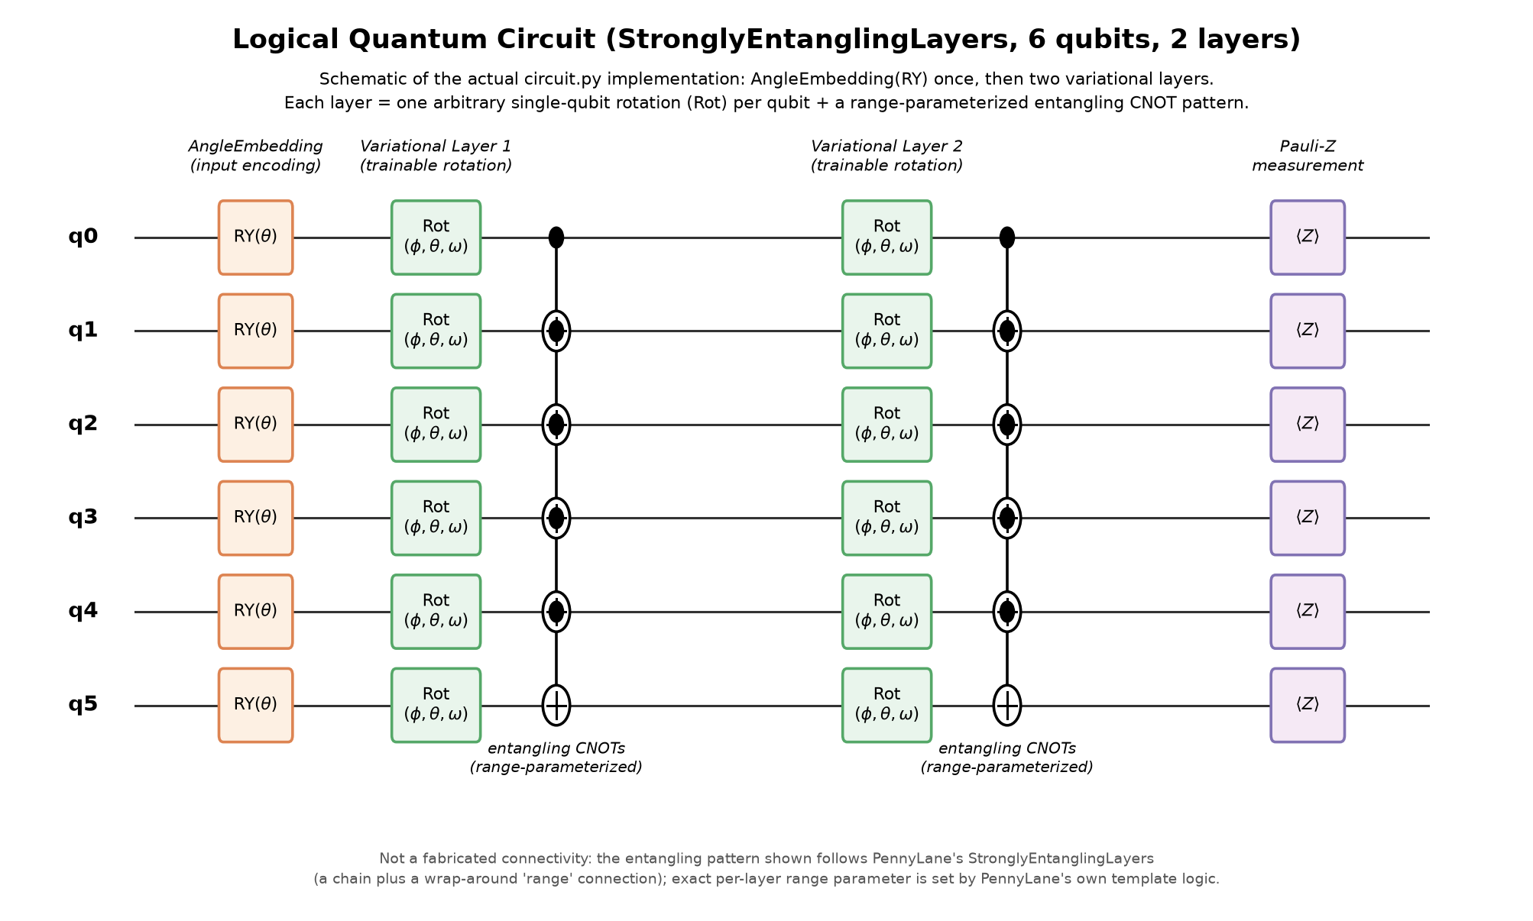
Figure 6. Logical circuit diagram of the QGNN-v4 variational quantum circuit: RY angle embedding on six qubits, two variational layers of general single-qubit rotation plus ring entanglement, and Pauli-Z measurement. The entangling pattern shown is the connectivity StronglyEntanglingLayers actually applies at this qubit count; PennyLane's own template logic sets each layer's exact range parameter, so this is the logical circuit architecture, not a hardware-transpiled or fabricated connectivity diagram.
Introduce: reading left to right, the circuit is encode once, then entangle-and-rotate twice, then measure once — there is no mid-circuit measurement and no classical feedback within a single forward pass. Observe: the entangling gates connect each qubit to its neighbor in a ring, so information originating on any one qubit can reach every other qubit within the two layers shown. Explain: this connectivity is what allows the six Pauli-Z outputs to become mutually correlated — a property measured directly in Section 13.12's quantum-representation analysis, where cross-channel correlation is shown to depend on exactly this entangling structure and on the ansatz variant used. Limitation, stated directly in the figure's own caption as required: the per-layer entangling range is determined internally by PennyLane's StronglyEntanglingLayers template rather than fixed by this project's own code, so the ring pattern drawn here is the representative, logically-equivalent connectivity for six qubits — not a claim that every layer's range parameter has been individually hand-verified gate by gate. See Appendix B for the same circuit rendered directly by PennyLane's own qml.draw_mpl from the production code (src/scm_dataset/modeling/quantum/circuit.py), which removes this hand-verification caveat entirely.

8. What Is Trainable? Frozen vs. Trainable Components
A single design decision governs every experiment in this report: the GraphSAGE encoder is frozen during the QGNN experiments. It is trained exactly once per seed and per split, as a classical model, and then its parameters are frozen (requires_grad set to False, and this condition is asserted directly in the training script's own run loop for every QGNN run, not merely claimed in prose) before any quantum or classical downstream head is trained on its output embeddings. No experiment in this report trains the graph encoder and a downstream head jointly, and no experiment modifies the encoder's own architecture.
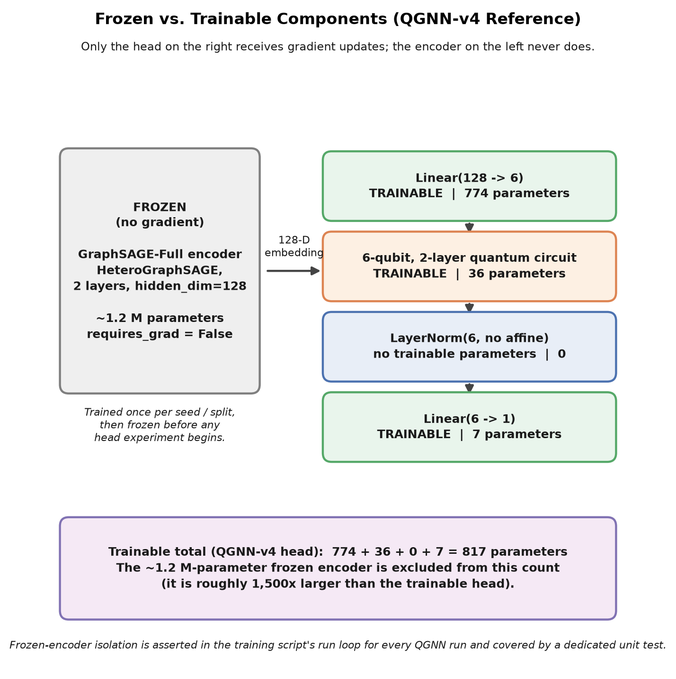
Figure 7. What is trainable in the QGNN-v4 system. Frozen: the GraphSAGE encoder (≈ 1.2 million parameters), trained once per seed/split and never updated during any downstream-head experiment. Trainable: the Linear(128,6) projection, the 36 quantum-circuit parameters, and the Linear(6,1) output layer — 817 parameters total; LayerNorm (no-affine) contributes no trainable parameters of its own.
Introduce: the figure separates the system into a single frozen block and a small trainable block, then breaks the trainable block into its three parameter-bearing components. Observe: the frozen encoder (≈ 1.2 million parameters, HeteroGraphSAGE, hidden_dim=128, two layers) is roughly 1,500 times larger than the entire trainable QGNN head (817 parameters) — the quantum circuit itself contributes only 36 of those 817. Explain: because the encoder is frozen and shared identically between the classical and quantum conditions, every comparison in this report is a comparison between two small downstream heads reading the same fixed input, not a comparison between two differently-sized end-to-end models; this is what makes the QGNN-vs-classical-head comparison in Section 13 a matched-input (though not parameter-matched) comparison. Limitation, with an example: this parameter accounting is head-only — it does not include the classical baseline's own MLP(128→64→1) classifier head, whose parameter count (8,449) is deliberately larger than the QGNN head's 817; the two heads are matched in the width of their read of the shared embedding, not in total trainable parameter count, a distinction discussed further as an open question in Section 14.2.

9. Training and Evaluation Workflow
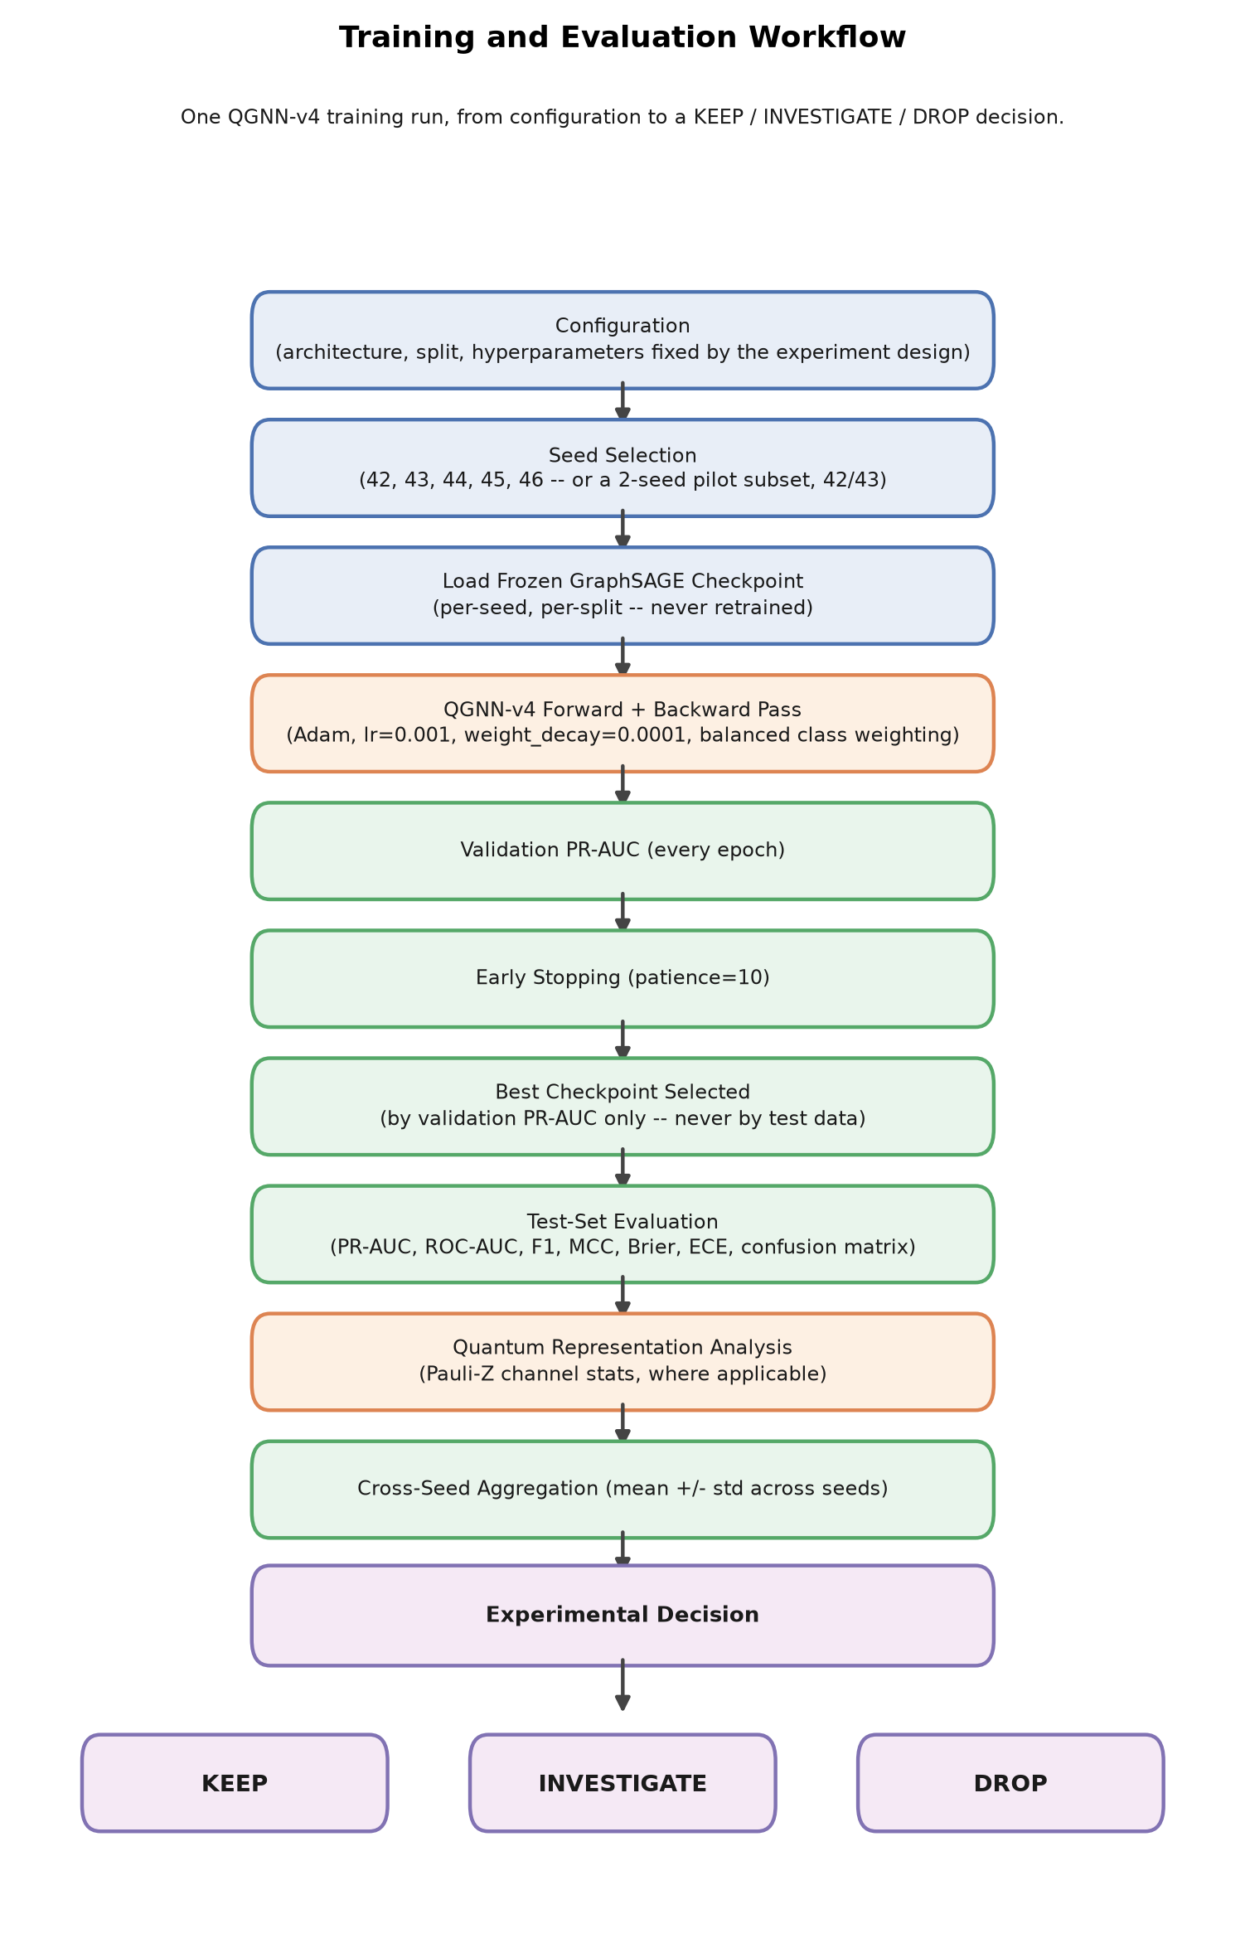
Figure 8. Training and evaluation workflow used for every experiment in this report, from configuration through per-seed training, shared-metric evaluation, and cross-seed aggregation, ending in an explicit KEEP / INVESTIGATE / DROP decision.
Every experiment in this report follows the same ten-stage workflow, from configuration to a KEEP / INVESTIGATE / DROP decision. Both models were trained with Adam (learning rate 0.001, weight decay 0.0001), a maximum of 100 epochs with early stopping on validation PR-AUC (patience 10, empirically validated against patience 25 in Section 13.6 with no material difference), balanced class weighting, and a classification threshold fixed at 0.5 for every threshold-based metric reported anywhere in this project.
Introduce: the workflow runs once per seed and is then aggregated across seeds before any decision is made — no single seed's result is treated as a finding on its own. Observe: the decision step at the bottom of the diagram has exactly three possible outcomes, and every one of the sixteen experiments summarized in Section 12.2's inventory table was assigned one of them explicitly. Explain: this uniform decision vocabulary (KEEP: adopted going forward; INVESTIGATE: a real, unresolved signal; DROP: not supported as a contributor; plus DIAGNOSTIC for measurements that are not architecture changes, and COMPLETE for investigations that finished regardless of outcome) is what allows Section 12.2's inventory table to summarize nine experimental phases in one consistent format. Limitation: the workflow diagram shows the ordinary path from a completed run to a decision; it does not depict the pilot-then-expand protocol used for several phases (Section 15.4's two-seed-pilot caveat) — that staging decision is made before this workflow begins, not inside it, and is documented separately in Section 12.2 and Section 15.4.

10. Research Experiment Roadmap
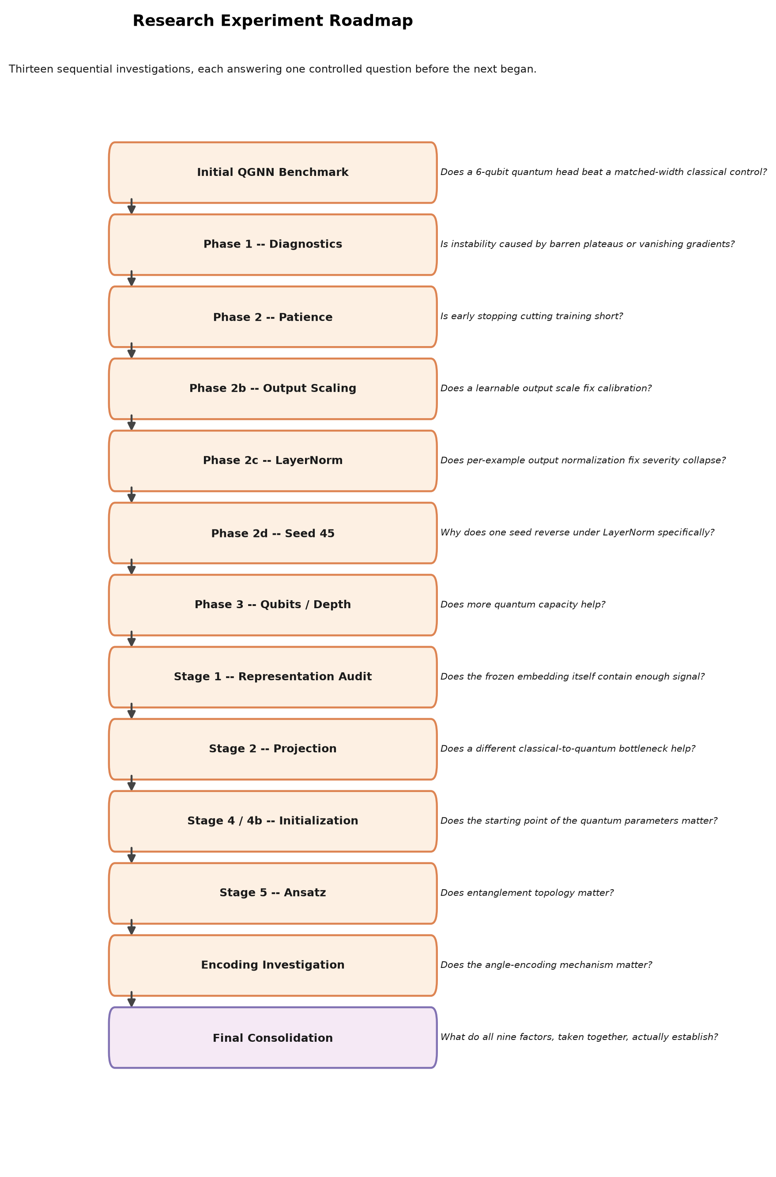
Figure 9. Research experiment roadmap: thirteen experimental stages in execution order, each with the specific research question it addressed.
Figure 9 lays out the full sequence of experimental stages in the order they were actually run, each annotated with the specific research question it was designed to answer. The roadmap is not a plan for future work — it is a record of the investigation as executed, from the initial benchmark through this report's own final consolidation.
Introduce: the roadmap begins with the initial QGNN benchmark and the raw-baseline/LayerNorm comparison, moves through the seed-45 diagnostic, the qubit-count and depth ablation, the representation audit, the projection and initialization investigations, the controlled ansatz comparison, the encoding investigation, and ends at this report's own final consolidation. Observe: several stages branch directly from a finding in the previous stage rather than following a fixed pre-registered plan — for instance, the seed-45 investigation (the sixth stage in the roadmap) exists specifically because the fifth stage's LayerNorm comparison surfaced one seed's anomalous reversal. Explain: this stage-by-stage, finding-driven structure is why Section 12.2's inventory table records nine distinct experimental phases rather than one large factorial sweep — each stage's scope was set by what the previous stage's evidence actually showed, consistent with this project's single-variable-at-a-time protocol. Limitation: the roadmap records what was run and in what order; it does not itself carry outcome labels (KEEP/INVESTIGATE/DROP) — those are attached per-experiment in Section 12.2, since a single roadmap stage sometimes produced more than one distinct decision (for example, the tenth stage's initialization investigation produced both a DROP outcome for the general finding and a separate INVESTIGATE flag for one specific configuration).

11. Experimental Setup
This section states, in tabular form, the exact technology stack, dataset, and graph characteristics underlying every result in this report. Every value below was re-verified against a live command or a saved artifact during this report's own validation pass, not retyped from an earlier summary.

11.1 Technology Stack
Table 1. Technology stack used for every experiment in this report.
Component | Value
Language | Python 3.12.3
Deep learning framework | PyTorch 2.14.0+cu130
Graph learning | PyTorch Geometric (HeteroConv, SAGEConv)
Quantum framework | PennyLane 0.45.1 (qml.qnn.TorchLayer)
Quantum simulator | default.qubit (ideal, noise-free)
Differentiation method | backprop (exact / analytic gradients)
CUDA | Available on the development machine, not used — all computation ran on CPU, for consistency with the noise-free-simulator, no-hardware scope
Classical ML diagnostics | scikit-learn (LogisticRegression, MLPClassifier, RandomForestClassifier, LinearSVC)
Version control | git, branch qgnn-package-restructure

11.2 Dataset Characteristics
Table 2. Benchmark dataset characteristics.
Property | Value
Dataset ID | scm_v1_black_swan_seed43
Horizon | 104 periods
Prediction target | supplier_disrupted, 4-period-ahead window
Overall supplier-period disruption rate | 3.33%
Total disruption events | 6 (3 logistics, 1 supplier failure, 1 geopolitical, 1 cyberattack)
Event severity distribution | severity 1 × 2, severity 2 × 3, severity 5 × 1
Period-level severity distribution | severity 0: 39 periods; 1: 2; 2: 26; 5: 37
Primary split | temporal 70/15/15 train/validation/test
Severity split | train severity ≤ 3, test severity 4–5
Fresh-onset positives | Primary: 0. Severity: 84 (identical across seeds/configurations)

11.3 Graph Characteristics
Table 3. Benchmark graph characteristics.
Property | Value
Total nodes | 2,670
Node types | supplier (300), material (100), plant (50), product (200), region (20), procurement (2,000)
Total edges | 7,675, across 9 relation types
Degree distribution | mean 5.75, median 3.0, min 1, max 136
Graph density | 0.00215
Connected components | 1 (all 2,670 nodes)
Average shortest path length | 3.82
Supplier degree vs. disruption-rate correlation | r = 0.054 (not a trivial structural predictor)

11.4 Training and Evaluation Protocol
- Optimizer: Adam, learning rate 0.001, weight decay 0.0001
- Maximum epochs: 100, early stopping on validation PR-AUC, patience 10 (validated against patience 25, Section 13.6)
- Class weighting: balanced (pos_weight from train-split counts)
- Classification threshold: fixed at 0.5 for every metric in every phase (never tuned per-configuration, never selected using test data)
- Metrics: PR-AUC (primary metric), ROC-AUC, F1, precision, recall, specificity, balanced accuracy, MCC, Brier score, expected calibration error — all computed by one shared metrics.compute_classification_metrics implementation
- Seeds: 42–46 (5 seeds) for every full evaluation; 42–43 (2 seeds) for pilot-stage investigations, explicitly labeled seed_type=pilot throughout the master results table
PR-AUC, rather than accuracy, is used as the primary metric throughout because the target class is heavily imbalanced (3.33% positive rate) — a constant-negative predictor already scores roughly 97% accuracy, making accuracy uninformative for this task. PR-AUC is specifically sensitive to performance on the minority (disruption) class and, unlike F1, precision, or recall, is threshold-independent, avoiding a fixed-0.5-threshold calibration artifact documented directly in this project's earliest benchmark: a poorly-calibrated head's threshold-based metrics can look dramatically better or worse purely from where its probability distribution happens to sit relative to 0.5, independent of its true ranking quality.

12. Experiment Control: What Changed, What Stayed Fixed
This section states, for every experimental phase, exactly which factor was deliberately varied and which factors were held fixed as controls — the single-variable-at-a-time discipline this project's own decision rule required throughout — followed by a single inventory table summarizing every experiment's headline outcome.

12.1 What Changed in Each Experiment?
Table 4. Experiment-control matrix: the one factor deliberately varied in each phase, against the factors held fixed as controls.
Experiment | Changed | Fixed
Phase 2 — Patience | Early-stopping patience (10 vs. 25) | Architecture, optimizer, seeds, every other setting
Phase 2b — Output scaling | Output-side multiplicative scale / additive bias | Patience, projection, circuit, LayerNorm (absent)
Phase 2c — LayerNorm | Output normalization (none / no-affine / affine) | Projection, circuit, patience, output scale
Phase 2d — Seed-45 diagnostic | Nothing (diagnostic-only, no retraining) | Every setting — reuses existing checkpoints
Phase 3 — Qubit count | n_qubits (4, 6, 8) | Ansatz, layers (2), patience, LayerNorm
Phase 3 — Circuit depth | n_layers (1, 2, 3) | Qubits (6), ansatz, patience, LayerNorm
Phase 4 Stage 1 — Representation audit | Nothing architectural (diagnostic classifiers on frozen embedding) | Encoder, embedding, split protocol
Phase 4 Stage 2 — Projection | Projection architecture (linear / nonlinear / pre-norm / PCA) | Circuit, qubits (6), ansatz, initialization
Phase 4 Stage 4 / 4b — Initialization | quantum_init strategy and gaussian_std | Projection, circuit structure, ansatz, encoding
Phase 4 Stage 5 — Ansatz | Entanglement topology (StronglyEntangling / ring / reduced-chain) | Qubits (6), layers (2), initialization, encoding
Encoding Investigation | encoding_scale, encoding_type, data_reuploading | Qubits, layers, ansatz, initialization

12.2 Master Experiment Inventory
One row per experiment (not per split). Outcome uses this project's final decision vocabulary: KEEP (adopted going forward), INVESTIGATE (a real, unresolved signal), DROP (not supported as a contributor), DIAGNOSTIC (measures the representation or a mechanism, not a candidate architectural replacement), COMPLETE (the investigation itself finished, independent of whether the result was positive). Full per-split metrics for every row are in QGNN_V4_MASTER_RESULTS.csv.
Table 5. Master experiment inventory across all nine experimental phases.
Phase | Experiment | Seeds | Primary PR-AUC | Severity PR-AUC | Outcome
Reference | Classical GraphSAGE-Full | 5 | 0.807±0.066 | 0.449±0.013 | COMPLETE
Reference | QGNN-v4 raw baseline (pre-LayerNorm) | 5 | 0.833±0.140 | 0.392±0.024 | COMPLETE
Phase 2 | Training patience | 5 | unchanged | unchanged | DROP
Phase 2b | Output scale (4 variants) | 5 ea. | 0.820–0.842 | 0.388–0.404 | DROP
Phase 2c | LayerNorm (no-affine) | 5 | 0.811±0.074 | 0.398±0.057 | KEEP (reference)
Phase 2c | LayerNorm (affine) | 5 | 0.800±0.073 | 0.408±0.071 | INVESTIGATE
Phase 2d | Seed-45 root-cause diagnostic | 5 (existing) | n/a | n/a | DIAGNOSTIC
Phase 3 | Qubit count (4, 8) | 5 ea. | 0.847 / 0.810 | 0.396 / 0.364 | INVESTIGATE
Phase 3 | Circuit depth (1, 3 layers) | 5 / 0 | 0.693 / 0.804 | 0.386 / N/A | INVESTIGATE / INCOMPLETE
Phase 4 St.1 | Representation audit | 5 | 0.671–0.781 | 0.463–0.480 | DIAGNOSTIC
Phase 4 St.2 | Projection / bottleneck | 2 (pilot) | 0.391–0.729 | 0.263–0.389 | DROP
Phase 4 St.4 | Initialization (Gaussian, identity) | 2 (pilot) | 0.726–0.828 | 0.265–0.380 | INVESTIGATE
Phase 4 St.4b | Init. scale sweep (5 points) | 2 (pilot) | 0.812–0.828 | 0.263–0.386 | DROP
Phase 4 St.4b | Identity-like, 5-seed expansion | 5 | 0.777±0.059 | 0.386±0.112 | DROP
Phase 4 St.5 | Ansatz (ring, reduced-chain) | 5 ea. | 0.807 / 0.814 | 0.354 / 0.360 | INVESTIGATE
Encoding Inv. | Scale / type / re-uploading | 2 (pilot) | 0.581–0.803 | 0.263–0.432 | DROP

13. Results
Each subsection below follows the same structure: the experiment being reported, the architecture or process under test, its results as both a table and a figure, an interpretation of what the results mean, and the decision the project reached. Every number is drawn from QGNN_V4_MASTER_RESULTS.csv, QGNN_V4_REFERENCE_COMPARISON.csv, QGNN_V4_ABLATION_TABLE.csv, or a directly-recomputed statistic over a saved per-example prediction file — re-verified during this report's own validation pass, not carried forward from an earlier summary.

13.1 Classical Baseline
Experiment. Establish the classical, fully end-to-end reference this report compares every QGNN-v4 configuration against.
Architecture / process. HeteroGraphSAGE (Section 5), trained end-to-end including its own two-layer MLP classifier head, five independent seeds (42–46), identical training and evaluation protocol as every QGNN configuration (Section 11.4).
Results. Primary PR-AUC 0.8070 ± 0.0655; Severity PR-AUC 0.4487 ± 0.0131 (Tables 6 and 7). Severity recall is exactly 0.4406 in every one of the five seeds — a genuine, previously documented property of the benchmark (the model consistently catches the same population of already-visibly-disrupted suppliers), not a measurement artifact.
Interpretation. The classical model is a strong, stable, well-calibrated reference on both splits, and its behavior is the yardstick every subsequent QGNN-v4 result in this chapter is read against.
Decision. COMPLETE — standing classical reference for the remainder of this report.

13.2 QGNN-v4 Baseline
Experiment. Establish the standing QGNN-v4 reference (Section 6) that every subsequent architectural modification in this chapter is compared against.
Architecture / process. 6-qubit, 2-layer StronglyEntanglingLayers circuit with output-side LayerNorm (no affine parameters), five independent seeds, identical protocol to the classical baseline.
Results. Primary PR-AUC 0.8112 ± 0.0737; Severity PR-AUC 0.3976 ± 0.0571. The earlier, pre-LayerNorm raw baseline reached a nominally higher primary mean (0.833 ± 0.140) but with more than double the cross-seed variance and substantially worse calibration (expected calibration error 0.285 vs. classical's 0.049).
Interpretation. LayerNorm was adopted specifically for its stability and calibration benefit — it reduced severity recall/F1 standard deviation by roughly an order of magnitude and eliminated a threshold-0.5 prediction collapse observed in two seeds — not because it closed the performance gap to the classical baseline, which it did not.
Decision. KEEP — LayerNorm-no-affine adopted as the standing QGNN-v4 reference for every subsequent comparison.

13.3 Classical vs. QGNN-v4: Extended Metrics
Experiment. Compare the two standing, fully-trained end-to-end references directly, on every metric this project tracks, with Primary and Severity reported separately throughout — never combined into a single "overall" score.
Table 6. Extended metrics, Primary (temporal) split — Classical GraphSAGE-Full vs. QGNN-v4 reference.
Metric | Classical | QGNN-v4 | Gap (C − Q)
PR-AUC | 0.8070 | 0.8112 | −0.0042
ROC-AUC | 0.9871 | 0.9775 | +0.0096
F1 | 0.6771 | 0.6565 | +0.0206
Precision | 0.5220 | 0.5191 | +0.0029
Recall | 0.9678 | 0.8975 | +0.0703
Specificity | 0.9353 | 0.9400 | −0.0047
Balanced accuracy | 0.9515 | 0.9188 | +0.0327
MCC | 0.6845 | 0.6539 | +0.0306
Brier score (lower better) | 0.0418 | 0.0655 | −0.0237
ECE (lower better) | 0.0493 | 0.1823 | −0.1330
Table 7. Extended metrics, Severity (out-of-distribution) split — Classical GraphSAGE-Full vs. QGNN-v4 reference.
Metric | Classical | QGNN-v4 | Gap (C − Q)
PR-AUC | 0.4487 | 0.3976 | +0.0511
ROC-AUC | 0.7275 | 0.6566 | +0.0709
F1 | 0.4113 | 0.4187 | −0.0074
Precision | 0.3871 | 0.4608 | −0.0737
Recall | 0.4406 | 0.4166 | +0.0240
Specificity | 0.9438 | 0.9513 | −0.0075
Balanced accuracy | 0.6922 | 0.6840 | +0.0082
MCC | 0.3624 | 0.3824 | −0.0200
Brier score (lower better) | 0.0857 | 0.1225 | −0.0368
ECE (lower better) | 0.0904 | 0.2405 | −0.1501
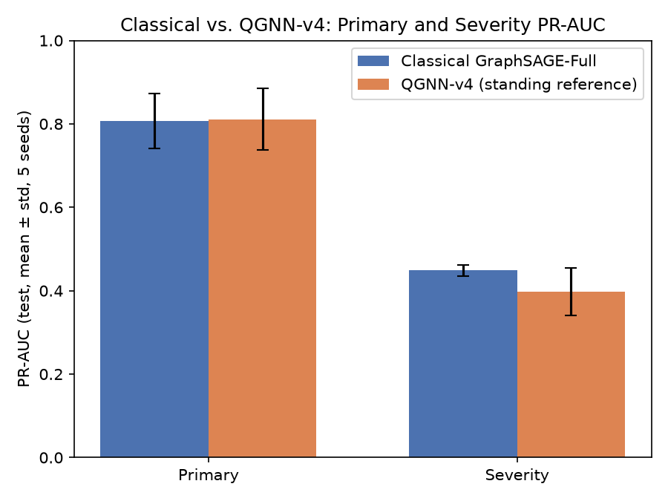
Figure 10. Classical GraphSAGE-Full vs. QGNN-v4 reference, PR-AUC on both splits, mean ± one standard deviation across 5 seeds. Error bars show cross-seed spread only — no significance test is implied.
Introduce: the figure plots the same two PR-AUC numbers that head Tables 6 and 7 above, with error bars showing ± one standard deviation across the five seeds. Observe: on Primary the two bars are close enough that their error bars overlap substantially; on Severity, Classical's bar is visibly higher and the two error bars barely overlap. Explain: this visual gap matches the tabulated gap of +0.0511 PR-AUC (11.4% relative) in Classical's favor on Severity, while the Primary gap of −0.0042 is well within either model's own cross-seed noise and is not read as a directional finding for either model. Limitation, with an example: overlapping or non-overlapping error bars across only five seeds are descriptive, not a formal significance test — no paired test (for example a paired bootstrap over matched seeds) was computed for this or any other comparison in this project (Section 15.4).
Required qualification. Every number above compares two end-to-end, fully-trained models under this project's shared protocol. Section 13.7 separately reports a logistic-regression representation diagnostic on the same frozen embedding — not a competing end-to-end model — that reaches Severity PR-AUC 0.465, numerically above both rows in the table above. Wherever this report says Classical is “stronger” on Severity, that statement is scoped to the end-to-end comparison in this subsection specifically; it does not contradict Section 13.7's diagnostic finding, and the two should always be read together.
Decision. COMPLETE — this comparison is the project's standing end-to-end reference point for every subsequent ablation.

13.4 Primary (Temporal) Evaluation
Experiment. Evaluate forward-in-time generalization: train on earlier periods, test on later ones under conditions similar to training.
Results. Classical and QGNN-v4 reach comparable PR-AUC (0.807 vs. 0.811), a difference well within either model's own cross-seed variance. The two models diverge more clearly on secondary metrics: Classical achieves meaningfully higher recall at the fixed 0.5 threshold (0.968 vs. 0.898) and is substantially better calibrated (ECE roughly 3.7× smaller: 0.049 vs. 0.182).
Interpretation. Across every architectural and training modification investigated in this project — projection, initialization, ansatz, and encoding — no single change produced a Primary PR-AUC improvement that held consistently across all five seeds where a full evaluation was run. Several 2-seed pilots appeared to show a Primary gain (most notably small-Gaussian initialization), but these gains were consistently accompanied by materially higher cross-seed variance, and the one case subsequently expanded to five seeds (identity-like initialization) had its apparent gain fail to hold at the larger seed count.
Decision. COMPLETE — no Primary-split intervention promoted beyond the standing reference.

13.5 Severity (Out-of-Distribution) Evaluation
Experiment. Evaluate genuine distribution-shift generalization: train only on periods reaching severity ≤ 3, test exclusively on periods reaching severity 4–5, which the model never observes during training.
Results. Classical leads QGNN-v4 on Severity PR-AUC (0.449 vs. 0.398), ROC-AUC (0.728 vs. 0.657), and calibration (ECE 0.090 vs. 0.241). A dedicated diagnostic (Section 13.7) found that when the identical severity-5 periods used as the Severity split's test set are instead evaluated as part of the Primary split's in-distribution test window, the same frozen representation supports a PR-AUC of 0.81 — close to Primary's ordinary performance level, rather than the 0.38–0.45 range observed under the genuine out-of-distribution condition.
Interpretation. This in-distribution/out-of-distribution comparison strongly supports the interpretation that the Severity gap is predominantly a distribution-shift generalization problem rather than an inherent information deficiency in the input representation. This should be read as evidence specific to this benchmark's severity-5 pattern — which is dominated by a single underlying event (Section 15.1) — not as an established general claim about generalization across many independent severe disruptions, a question this dataset cannot directly answer. No architectural modification tested (projection, initialization, ansatz, encoding) closed this gap in a way that held across seeds; several made it distinctly worse, most notably small-Gaussian-family initializations.
Decision. COMPLETE — Classical remains the stronger end-to-end model on Severity throughout this investigation; see Section 13.7's required qualification.

13.6 Ablation Studies
Experiment. Nine distinct architectural and training factors were investigated as controlled ablations against the standing QGNN-v4 reference, summarized in QGNN_V4_ABLATION_TABLE.csv and, per configuration, in QGNN_V4_MASTER_RESULTS.csv.
Table 8. Ablation summary: nine investigated factors, their evidence, and this project's interpretation.
Factor (phase) | Evidence | Interpretation
Training patience (Phase 2) | 18/20 runs select the identical checkpoint at patience 25; a positive control confirms validation PR-AUC never improves beyond the patience-10 optimum. | Not supported as a major contributor
Output scale (Phase 2b) | All four variants land within [0.82, 0.84] Primary / [0.388, 0.404] Severity — indistinguishable from the raw baseline; mathematically redundant with the existing Linear(6,1). | Not supported as a major contributor
LayerNorm (Phase 2c) | Genuine, non-redundant change. Cuts severity recall/F1 std by ≈10×, eliminates threshold-0.5 collapse. Costs Primary PR-AUC mean and reverses one severity seed (45). | Mixed — adopted for stability/calibration, not for closing the Classical gap
Seed-45 behavior (Phase 2d) | Seed 45's baseline circuit concentrated signal into one dominant channel (r=0.524); LayerNorm removes the incentive, and that channel's correlation nearly halves while every other seed's improves or holds. | Supported contributor to seed-dependent distortion (medium confidence, not proven causal)
Qubit count (Phase 3) | 4-qubit gives the highest Primary mean (0.847) with the tightest Severity std of the three; confounded with classical Linear(128,n) parameter count. | Mixed — capacity-confounded
Circuit depth (Phase 3) | 1 layer: worst Primary (0.693) but tightest Severity std anywhere (0.017). 3-layer Severity run killed mid-batch, no data. | Inconclusive
Representation quality (Stage 1) | Logistic regression on the frozen embedding matches/exceeds both full heads on Severity PR-AUC (0.465 vs. 0.449/0.398) with far tighter std. | Supported contributor — representation is not the ceiling either head is hitting
Projection architecture (Stage 2) | Every alternative underperforms the existing Linear(128,6) on both splits in a 2-seed pilot; PCA-informed projection underperforms despite far fewer parameters. | Not supported (2-seed pilot; PCA anomaly unresolved)
Quantum initialization (Stage 4/4b) | Small-Gaussian/identity-like improve Primary/calibration but degrade Severity in a 2-seed pilot. Identity-like's variance reduction did not survive 5-seed expansion (std 0.017→0.059). | Not supported — real trade-off, stability claim did not replicate
Ansatz / entanglement (Stage 5) | All three ansätze land within ~1% Primary / ~4% Severity of each other (5 seeds each). Reference has tightest Primary variance; not parameter-matched (36/24/12). | Not supported as major contributor to the Classical gap
Quantum encoding (Encoding Inv.) | 2π scale (E2) is a clear regression (widest angle spread, weakest correlation). Linear clip (E3) saturates 46% of angles at the boundary. | Not supported (2-seed pilot; no config expanded to 5 seeds)
Fresh-onset detection (multiple) | PR-AUC 0.004–0.012 across every QGNN configuration and the full classical baseline. | Supported — property of the input features, not of any architecture
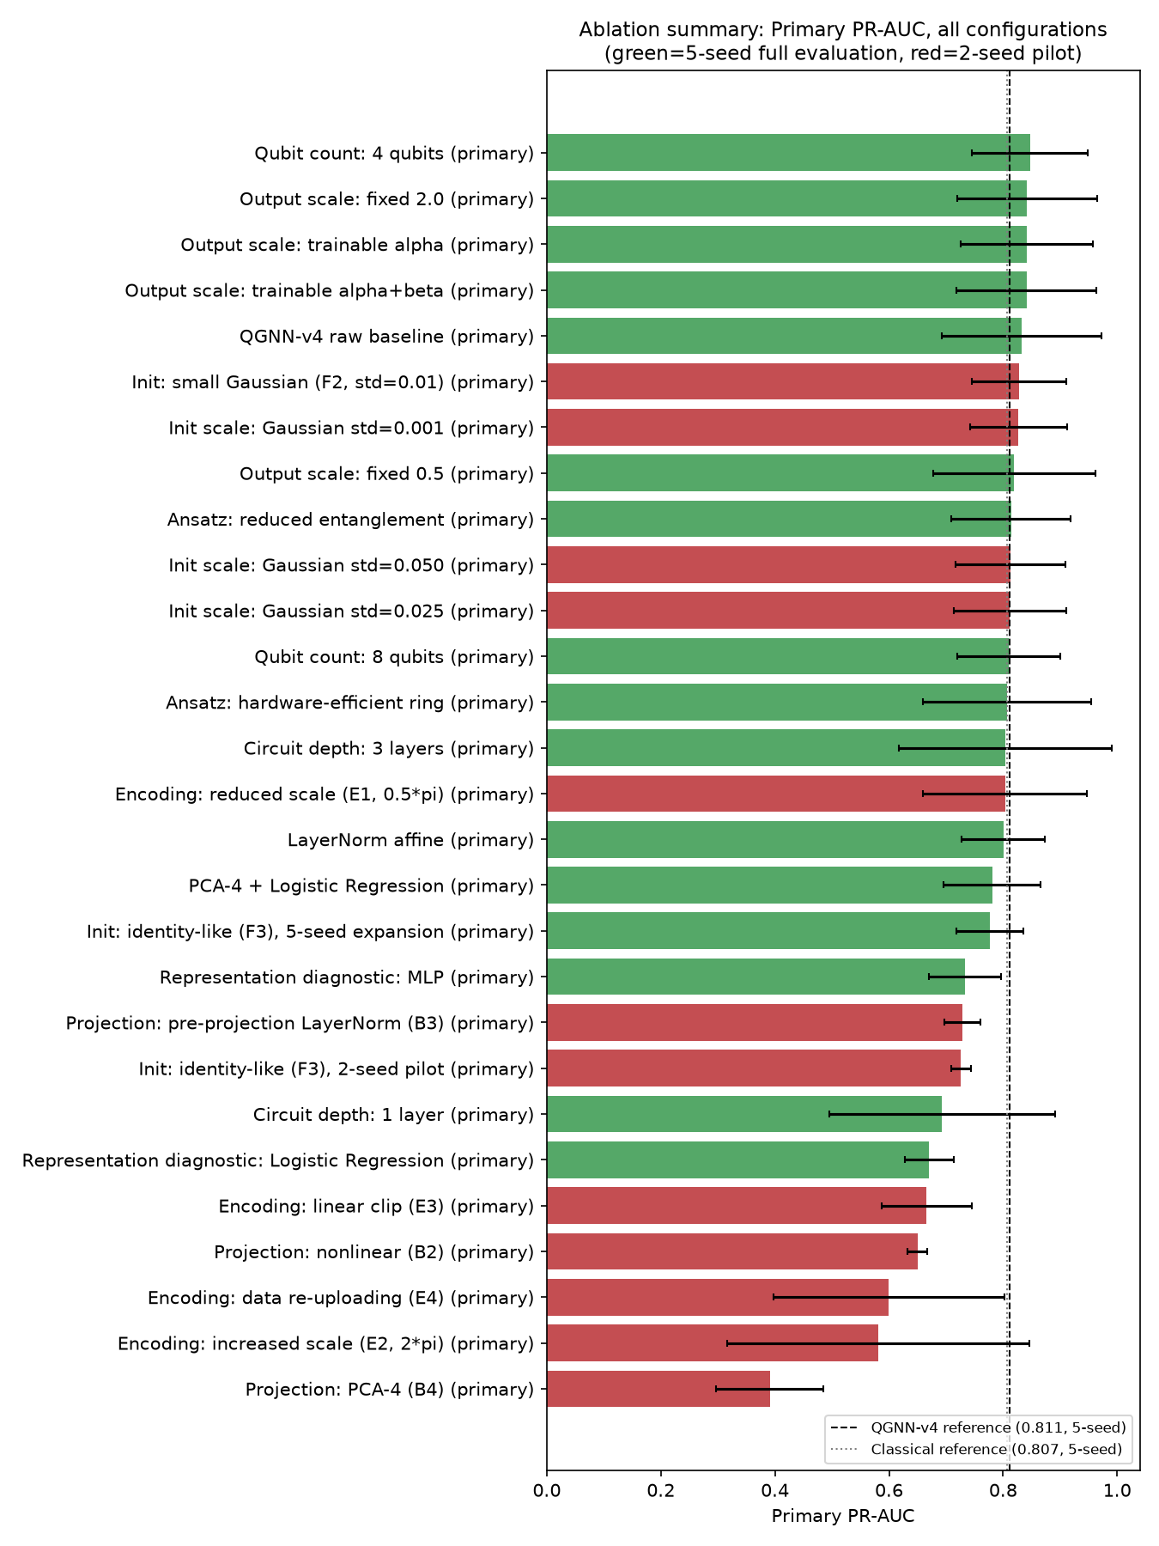
Figure 11. Primary-split PR-AUC across every tested configuration in this project (green = 5-seed full evaluation, red = 2-seed pilot), with the QGNN-v4 and Classical references marked by dashed lines.
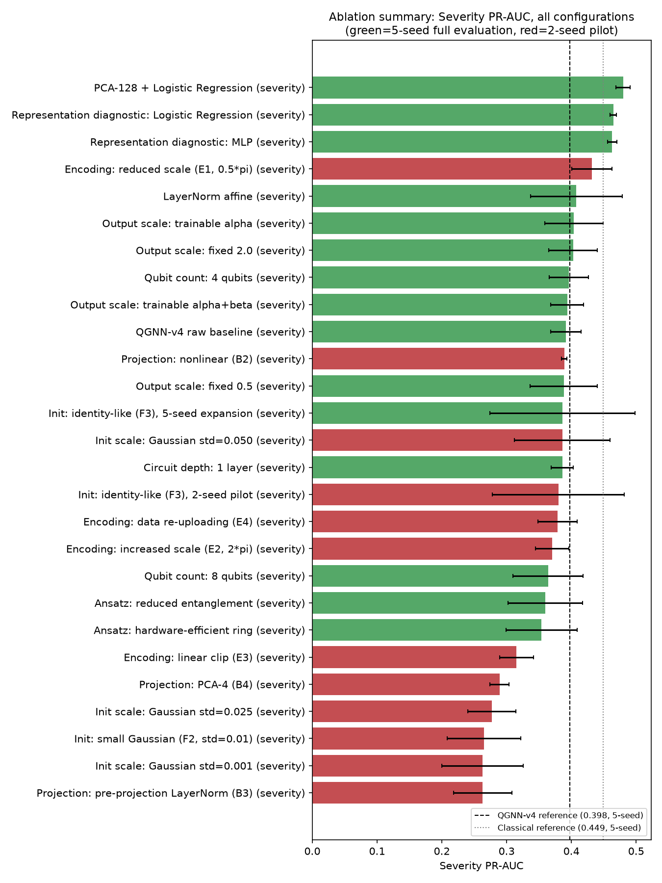
Figure 12. Severity-split PR-AUC across every tested configuration in this project (green = 5-seed full evaluation, red = 2-seed pilot), with the QGNN-v4 and Classical references marked by dashed lines.
Introduce: these two figures plot every individually tested configuration's mean PR-AUC, Primary and Severity kept as two separate figures rather than combined into one “overall” score, color-coded by whether the configuration was evaluated at the project's full 5-seed convention (green) or as a 2-seed pilot (red). Observe: the top of the Severity figure is occupied by the three representation diagnostics from Stage 1 (logistic regression, MLP, and the PCA-4 diagnostic), sitting visibly above both the QGNN-v4 and Classical end-to-end references — the single most visually direct statement of this project's central representation finding (Section 13.7). Explain: because pilot (red) and full (green) results are never visually merged, a reader cannot mistake a 2-seed pilot's apparent ranking for a confirmed 5-seed finding — several red bars near the top of the Primary figure (for instance the Gaussian-initialization pilots) do not correspond to a confirmed improvement, exactly the caution Section 15.4 states in prose. Limitation, with an example: bar length alone does not convey variance — error bars are included, but a bar's ranking position should not be read as statistically distinguishable from its near neighbors without checking the accompanying standard deviation, as Section 13.3's discussion of overlapping error bars already cautions.
Decision. See Section 12.2's Master Experiment Inventory for the per-experiment KEEP / INVESTIGATE / DROP / DIAGNOSTIC outcome.

13.7 Representation Analysis
Experiment. A dedicated representation-audit phase (Phase 4 Stage 1) investigated the frozen GraphSAGE embedding directly, independent of any quantum or classical downstream head, using diagnostic classifiers, PCA, target-correlation analysis, and graph-level diagnostics.
Architecture / process. Lightweight classifiers — logistic regression, a small MLP, a linear SVM, and a random forest — were trained directly on the frozen 128-dimensional embedding, using the identical train/validation/test partition every end-to-end model uses. These are diagnostic probes, not competing end-to-end models: they were not trained under the same protocol (optimizer, regularization, early-stopping regime) as either full model.
Results. On Primary, the strongest diagnostic (a small MLP) reached PR-AUC 0.733, below both full models — expected, since the diagnostics received no architecture-specific tuning. On Severity, a plain logistic regression reached PR-AUC 0.465 ± 0.005 across five seeds — numerically above both the classical end-to-end reference (0.449) and every QGNN-v4 configuration evaluated in this project (0.36–0.41), with markedly tighter cross-seed variance than either. PCA showed Primary-split signal concentrated in four components (90.9% of variance, PR-AUC 0.781, the single highest observed across the entire dimensionality sweep), while Severity-split signal was distributed across the full 128 dimensions, with performance improving monotonically as more components were retained.
Interpretation. This finding does not establish that logistic regression is the strongest model in this project's own end-to-end sense; it establishes that the frozen embedding already carries more severity-relevant signal than either full downstream head currently extracts from it, and that the Severity gap observed throughout this project is not solely attributable to insufficient representational capacity in either the classical or the quantum head. The Primary/Severity signal-concentration asymmetry independently explains why a 4-qubit quantum bottleneck performed comparably to or better than wider bottlenecks on Primary specifically (Section 13.6), without requiring any assumption about the quantum circuit's own behavior. A target-aware correlation analysis found individual raw embedding dimensions correlating with the disruption target at up to r ≈ 0.87, confirming the representation encodes strongly task-relevant structure. A graph-level audit found no meaningful correlation between a supplier's network degree and its disruption rate (r = 0.054), ruling out a trivial structural explanation for the labels.
Decision. DIAGNOSTIC — not an architecture change; the single most consequential finding of this project's representation-side investigation.

13.8 Quantum Resource Analysis
Experiment. State the exact computational resources every quantum-circuit result in this project draws on, and compare the parameter budgets of the three ansätze evaluated in the controlled ansatz comparison (Section 13.6).
Table 9. Quantum resource comparison across every circuit configuration evaluated in this project.
Configuration | Qubits | Layers | Quantum params | Total head params
StronglyEntanglingLayers (reference) | 6 | 2 | 36 | 817
Hardware-efficient ring | 6 | 2 | 24 | 805
Reduced entanglement | 6 | 2 | 12 | 793
4-qubit variant (Phase 3) | 4 | 2 | 24 | 545
8-qubit variant (Phase 3) | 8 | 2 | 48 | 1,089
Results. Every circuit in this project was executed on PennyLane's default.qubit simulator using exact, analytic backpropagation (diff_method="backprop"). There is no shot noise, no hardware noise model, and no physical quantum device anywhere in this investigation's results. The frozen GraphSAGE encoder contributes approximately 1.2 million parameters, roughly 1,500× the size of the entire trainable QGNN-v4 head.
Interpretation. The two alternative ansätze evaluated in the controlled comparison used fewer quantum parameters at the same qubit count and depth — 24 for the ring topology, 12 for the reduced-entanglement topology — and reached comparable mean PR-AUC on both splits despite this reduced budget, though the comparison is not parameter-matched and this pattern should not be read as demonstrating that fewer quantum parameters are inherently sufficient.
Decision. DIAGNOSTIC — resource accounting, not a candidate architectural change.

13.9 Seed Sensitivity
Experiment. Characterize cross-seed variance for the two standing references, and trace one specific instance of seed-dependent behavior (seed 45) to a concrete mechanism.
Table 10. Per-seed results, standing references (test split). Re-verified directly against raw per-seed metric artifacts.
Model | Seed | Primary PR-AUC | Primary F1 | Severity PR-AUC | Severity F1 | Severity MCC
Classical | 42 | 0.7874 | 0.7236 | 0.4430 | 0.3838 | 0.3312
Classical | 43 | 0.6888 | 0.6382 | 0.4560 | 0.4431 | 0.3991
Classical | 44 | 0.8745 | 0.7032 | 0.4378 | 0.4228 | 0.3753
Classical | 45 | 0.8491 | 0.6865 | 0.4358 | 0.4022 | 0.3518
Classical | 46 | 0.8354 | 0.6340 | 0.4708 | 0.4045 | 0.3544
Classical | mean±std | 0.8070±0.0655 | 0.6771±0.0355 | 0.4487±0.0131 | 0.4113±0.0201 | 0.3624±0.0231
QGNN-v4 ref. | 42 | 0.8682 | 0.6800 | 0.3943 | 0.3793 | 0.3263
QGNN-v4 ref. | 43 | 0.6807 | 0.5950 | 0.4496 | 0.5320 | 0.5541
QGNN-v4 ref. | 44 | 0.8197 | 0.6992 | 0.4156 | 0.4248 | 0.3776
QGNN-v4 ref. | 45 | 0.7951 | 0.6156 | 0.2900 | 0.3632 | 0.3111
QGNN-v4 ref. | 46 | 0.8924 | 0.6929 | 0.4385 | 0.3941 | 0.3427
QGNN-v4 ref. | mean±std | 0.8112±0.0737 | 0.6565±0.0428 | 0.3976±0.0571 | 0.4187±0.0602 | 0.3824±0.0887
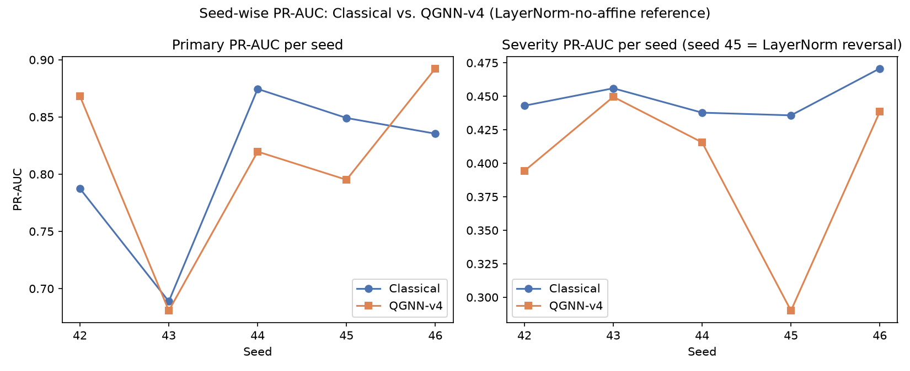
Figure 13. Per-seed PR-AUC, Classical vs. QGNN-v4 reference, Primary (left) and Severity (right). Seed 45's severity reversal is directly visible as the one point where the QGNN-v4 line drops sharply below the Classical line.
Introduce: each panel plots one line per model across the five standing-reference seeds, Primary on the left and Severity on the right. Observe: on the Severity panel, seeds 42–44 and 46 show QGNN-v4 tracking reasonably close to Classical, but seed 45 drops to 0.290, the single largest gap between the two lines anywhere in the figure. Explain: Figure 14 below traces this specific drop to a measured mechanism — seed 45's baseline circuit concentrated an unusually large share of its discriminative signal into one Pauli-Z output channel (correlation 0.524, the highest of any seed), and LayerNorm removes the optimization incentive for this concentration, causing that seed's severity ranking to regress while every other seed's representation improves or holds flat under the identical change. Limitation, with an example: this is a correlational, diagnostic-only finding — no controlled causal intervention (such as retraining seed 45 under an objective that explicitly discourages channel concentration) was run to confirm the mechanism causally; it is the strongest available explanation for this specific seed's behavior, not a proven cause.
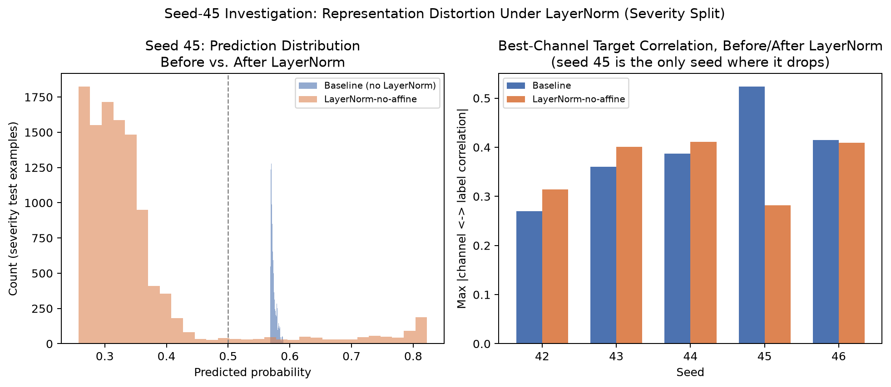
Figure 14. Seed-45 visual analysis. Left: predicted-probability distribution on the Severity test split, baseline circuit vs. LayerNorm-no-affine. Right: maximum |Pauli-Z channel ↔ label| correlation per seed, baseline vs. LayerNorm, computed fresh from each seed's raw per-example output.
Introduce: the left panel overlays seed 45's predicted-probability histogram before and after LayerNorm; the right panel shows every seed's best single-channel correlation with the label, baseline vs. LayerNorm, independently recomputed for this report via scipy's point-biserial correlation on each seed's raw per-example CSV. Observe: seed 45 is the one seed where the LayerNorm bar is markedly lower than the baseline bar (0.524 → 0.282); every other seed's LayerNorm bar is equal to or higher than its baseline bar. Explain: this is why seed 45 alone reverses under LayerNorm while LayerNorm's aggregate benefit (chiefly stability and calibration) is preserved across the five-seed population — LayerNorm's benefit is a population-level effect across five seeds, not a uniform per-seed improvement, and this figure makes the one exception directly visible rather than hiding it inside a mean and a standard deviation. Limitation: the fresh recomputation shown here was cross-checked against Phase 2d's originally reported values and found to match exactly ({42: 0.270→0.314, 43: 0.360→0.401, 44: 0.387→0.411, 45: 0.524→0.282, 46: 0.415→0.409}) — stated explicitly because an independent numerical cross-check, not merely a repeated claim, is what establishes this figure's reliability.
Decision. DIAGNOSTIC — seed-dependent representation distortion, supported contributor to instability (medium confidence, not proven causal).

13.10 Fresh-Onset Analysis
Experiment. Measure whether any model tested can anticipate a genuinely new (“fresh-onset”) disruption, as opposed to ranking already-visible, ongoing ones.
Table 11. Fresh-onset analysis by split.
Split | n Fresh-Onset | Fresh-Onset PR-AUC (all models tested)
Primary | 0 | N/A — undefined (no fresh-onset examples exist; never plotted or reported as zero)
Severity | 84 | 0.005–0.012 (every architecture, quantum and classical)
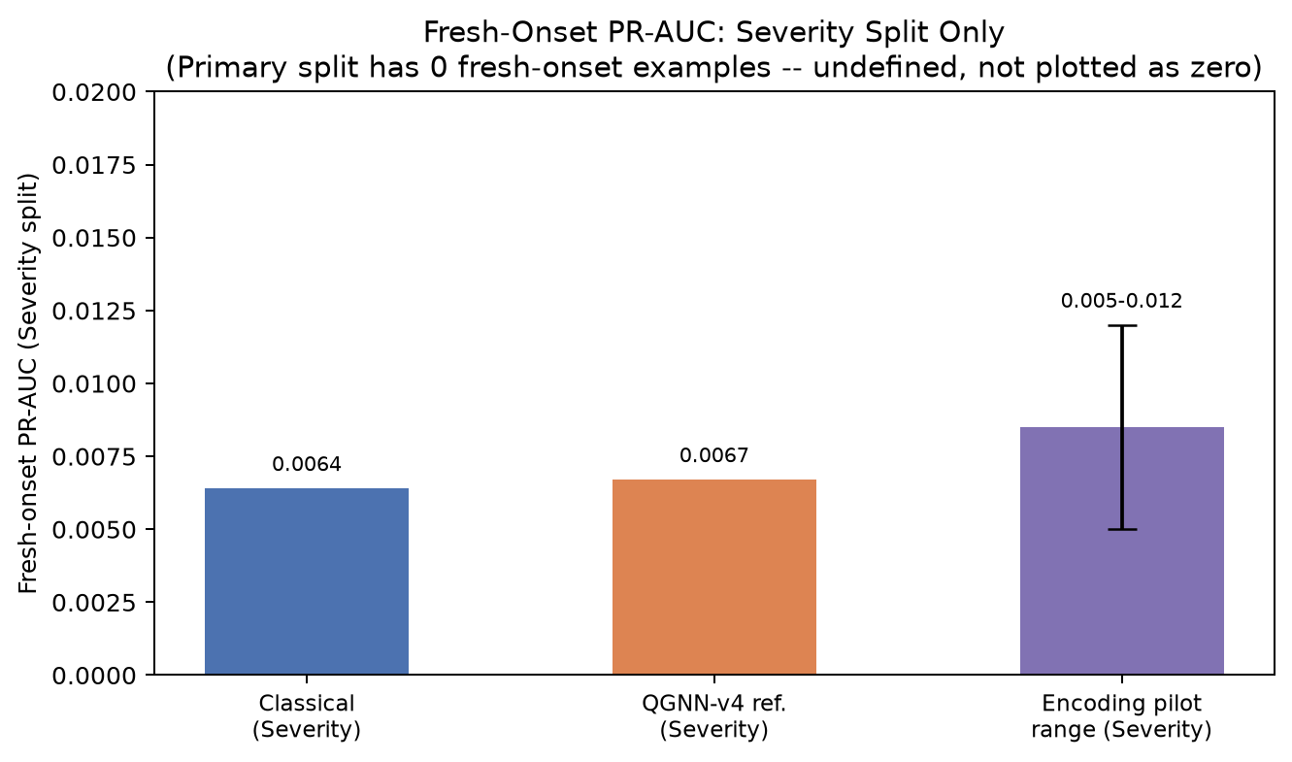
Figure 15. Fresh-onset PR-AUC, Severity split only. The Primary split has zero fresh-onset positive examples and is not plotted — the metric is undefined there, not zero.
Introduce: the chart compares the Classical and QGNN-v4 references' Severity-split fresh-onset PR-AUC against the range observed across the quantum-encoding investigation's five pilot configurations. Observe: all three bars sit within a narrow band close to zero (0.005–0.012), an order of magnitude below any of this project's main PR-AUC results. Explain: because the full Classical GraphSAGE-Full baseline — with complete graph structure and message-passing access — shows the identical near-zero floor as every QGNN-v4 configuration, this project's evidence points to the absence of a genuine leading indicator in the benchmark's available dynamic features at the four-period prediction horizon used, rather than to a limitation specific to any one architecture, quantum or classical. Limitation, with an example: the Primary split's test window falls entirely inside the same severity-5 event's already-ongoing period, so it contains zero fresh-onset positives by construction — this is a property of how the split was built, not evidence that Primary-split fresh-onset detection would also be near-zero; that comparison simply cannot be made with this dataset, and the report states this explicitly rather than substituting a zero.
Decision. Supported contributor to understanding this limitation — ruled out as architecture-specific; a property of the benchmark's input features at this horizon.

13.11 Calibration Analysis
Experiment. Compare predicted-probability calibration — not just ranking quality — between Classical and QGNN-v4, and across the QGNN-v4 configurations investigated.
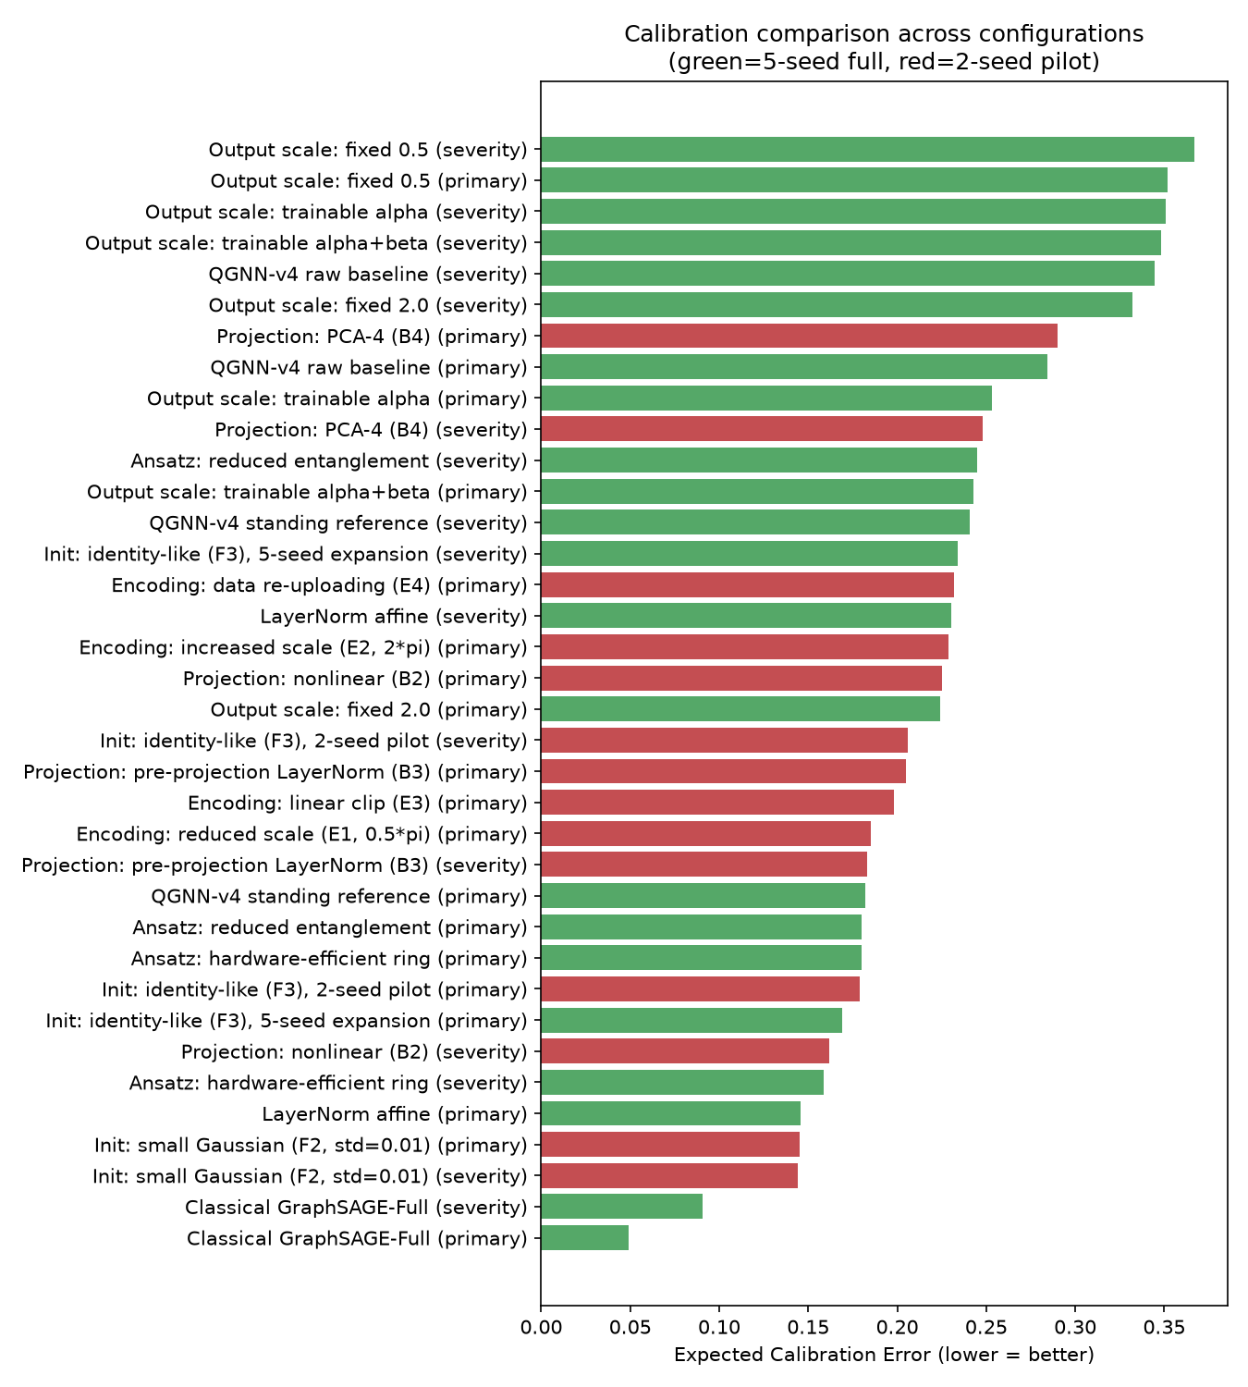
Figure 16. Expected calibration error (lower is better) across every configuration this project recorded a value for, colored by 5-seed full evaluation (green) vs. 2-seed pilot (red).
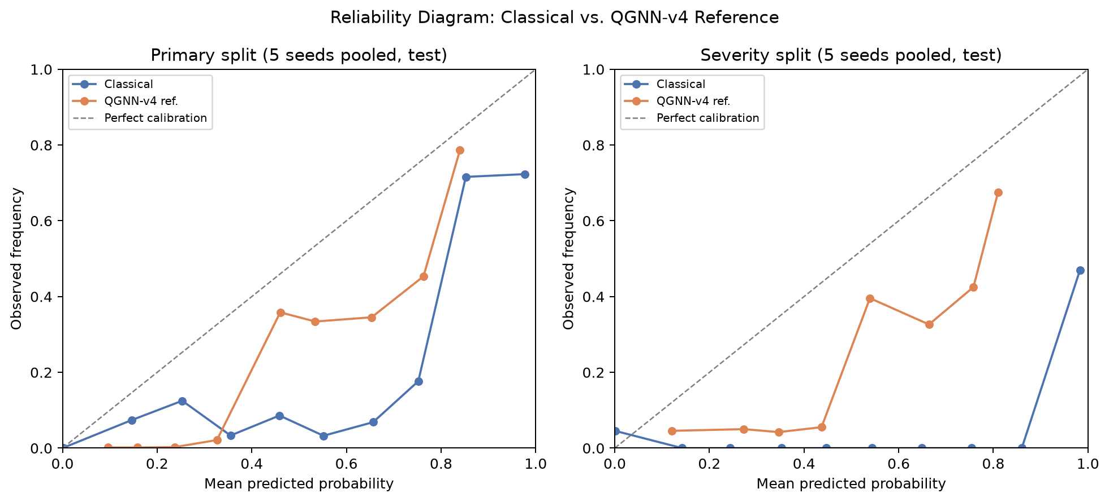
Figure 17. Reliability diagrams, Classical vs. QGNN-v4 reference, Primary (left) and Severity (right), computed fresh by pooling all 5 seeds' test-split predictions per split and binning into deciles.
Introduce: the bar chart ranks every recorded configuration by expected calibration error; the reliability diagrams show, for the two standing references specifically, how closely predicted probability matches empirical positive frequency within each decile bin. Observe: Classical GraphSAGE-Full occupies the two lowest (best) bars in the ECE ranking on both splits, and its reliability curve stays visibly closer to the diagonal (perfect calibration) than QGNN-v4's on both panels. Explain: this ranking and the reliability-diagram shape are two independent measurements of the same underlying property — the bar chart is read directly from saved per-run ECE values, while the reliability diagram was computed fresh for this report from pooled per-example predictions.csv files, and the two are consistent with each other, which is itself a cross-check on both. Limitation, with an example: several interventions (most clearly near-zero-start quantum-parameter initializations and certain ansatz variants) produced a calibration/ranking decoupling — numerically better calibration accompanied by numerically worse PR-AUC on the same split — so a low position in this ECE chart should never be read as “the better model” without checking the corresponding PR-AUC figure (Section 13.6) alongside it; the quantum-encoding investigation's own pilot is a stated exception where calibration and ranking moved together for every configuration tested.
Decision. Established — Classical is the best-calibrated model in every direct comparison in this project, on both splits, by a substantial and consistent margin.

13.12 Quantum Representation Analysis
Experiment. Probe the six Pauli-Z output channels directly — not estimated — across the ansatz comparison (Stage 5) and the encoding investigation, to test whether ansatz and encoding choices change the quantum circuit's learned representation even where they do not change final task metrics.
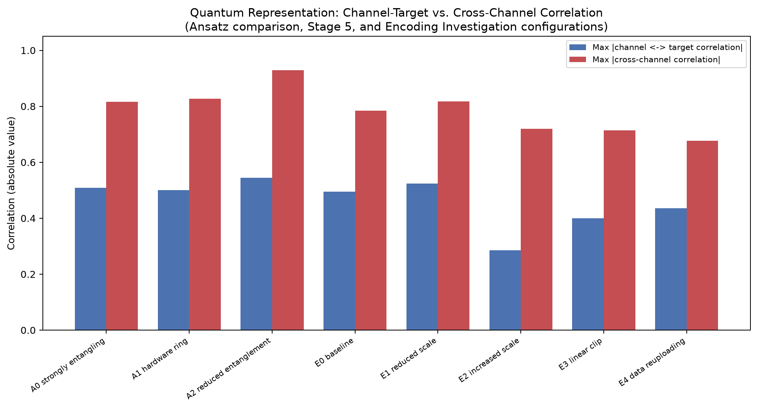
Figure 18. Maximum channel–target correlation vs. maximum cross-channel correlation, across the three ansätze (A0–A2) and five encoding configurations (E0–E4) directly probed in this project.
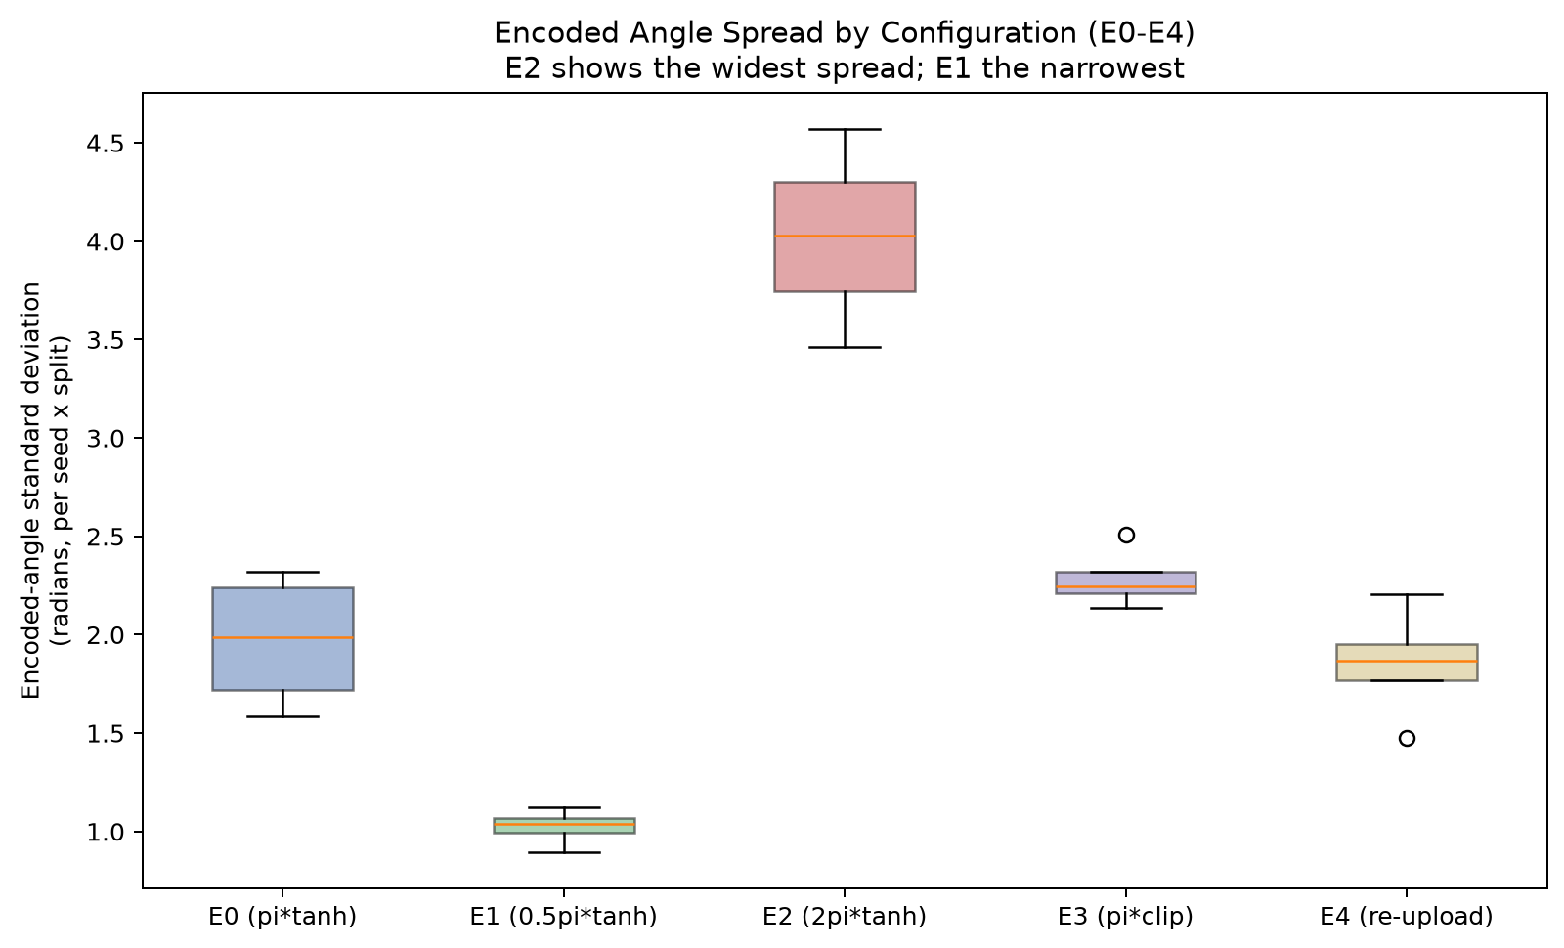
Figure 19. Encoded-angle standard deviation per (seed, split), E0 (reference, π-scale tanh) through E4 (data re-uploading), showing E2's markedly wider spread (2π scale) and E3's boundary saturation (linear clip).
Introduce: the first chart plots each configuration's two most important representation properties against each other — how strongly individual channels track the label, and how redundant the six channels are with one another; the second chart shows the raw spread of encoded rotation angles feeding the circuit for each encoding variant. Observe: the reduced-entanglement ansatz (A2) shows the highest cross-channel correlation (≈ 0.93) among the three ansätze — its six outputs are the most mutually redundant — while E2 (2π encoding scale) shows the lowest channel-target correlation (≈ 0.29) and, in the second chart, visibly the widest angle spread of the five encoding variants. Explain: both patterns are directly measured mechanisms, not inferred from downstream metrics alone — E2's wide angle spread pushes rotation angles further around the periodic encoding, which independently explains its weak channel-target correlation and the training-convergence delay documented in Section 13.6; A2's channel redundancy is consistent with (though does not alone prove) its observed severity specificity collapse on two of five seeds. Limitation, with an example: neither of these representational differences translated into a corresponding, seed-robust difference in final task PR-AUC in any configuration tested — the quantum circuit is demonstrably not inert to these architectural choices, but this project's evidence locates the performance ceiling downstream of the representation (Section 13.7), not in whether a distinctive representation is extracted at all, so these figures should be read as characterizing representational sensitivity, not as evidence of a metrics benefit.
Decision. DIAGNOSTIC — the quantum representation is measurably sensitive to ansatz and encoding; this sensitivity did not translate into a metrics benefit in any configuration tested.

13.13 Primary vs. Severity Comparison
Experiment. Plot every tested configuration jointly by its Primary and Severity PR-AUC, to check whether any configuration improves on one split without regressing the other.
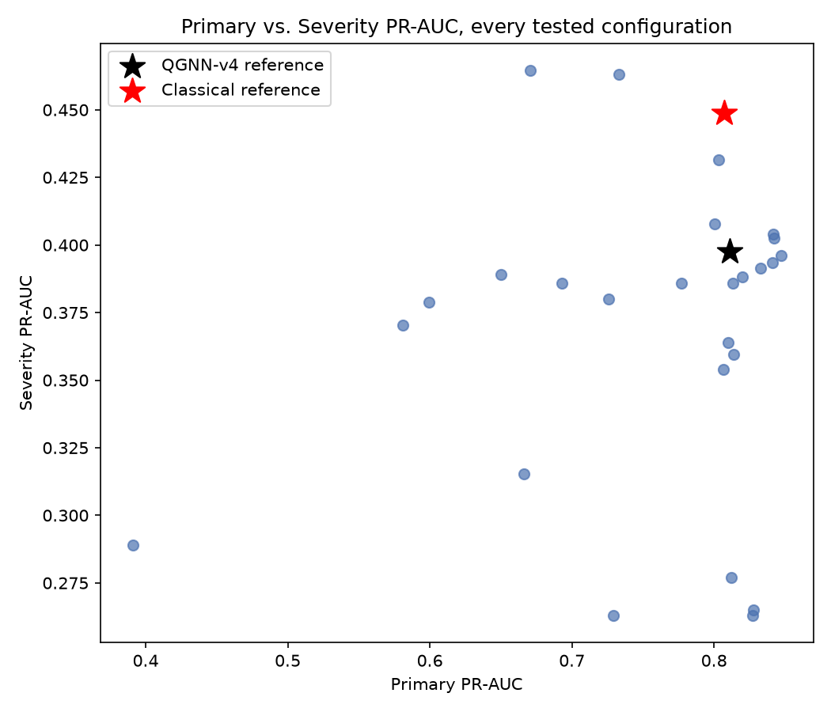
Figure 20. Every tested configuration plotted by (Primary, Severity) PR-AUC jointly. The Classical reference sits near the top of the Severity axis relative to the whole cloud of QGNN-v4 configurations.
Introduce: each point is one tested configuration's mean (Primary PR-AUC, Severity PR-AUC), with the Classical and QGNN-v4 references marked separately as stars. Observe: the cloud of QGNN-v4 configurations spans roughly 0.40 to 0.85 on the Primary axis but is compressed into a narrower band, mostly below 0.40, on the Severity axis, while the Classical reference sits above nearly the entire cloud on Severity despite a middling Primary score relative to the QGNN-v4 cluster. Explain: this visual asymmetry is the scatter-plot restatement of Section 13.5's Severity gap — no point in the QGNN-v4 cloud simultaneously matches Classical's Severity height while also leading on Primary, which is exactly what “no configuration closed the gap on both splits at once” looks like in two dimensions rather than in a table. Limitation: this plot aggregates configurations across both 5-seed full evaluations and 2-seed pilots without visually distinguishing them (unlike Figures 11–12's explicit green/red coding) — a reader should cross-reference Section 12.2's inventory table before treating any individual point's position as a confirmed result rather than, in several cases, a pilot-stage estimate.
Decision. COMPLETE — confirms no tested configuration improved both splits simultaneously relative to the standing references.

14. Discussion
This section interprets the results reported in Section 13. Every claim below is explicitly labeled as an Observed Result (a directly measured number, or a fact re-verified against saved artifacts), an Interpretation (a reading of what one or more observed results most plausibly means, stated with its own confidence level), or a Hypothesis for Future Work (an untested idea this project's evidence motivates but does not confirm). Collapsing these three categories into one another is exactly the kind of overreach this report's own validation pass was tasked with removing, so the distinction is kept explicit rather than implied throughout.

14.1 Why Primary and Severity Behave Differently
Observed Result. Every model and configuration evaluated in this project scores substantially lower on the Severity split than on the Primary split — roughly halved for both references (0.807→0.449 Classical; 0.811→0.398 QGNN-v4). The identical severity-5 periods used as the Severity split's test set score 0.81 PR-AUC when they instead fall inside the Primary split's in-distribution test window.
Interpretation (high confidence, within this dataset). The Severity condition's difficulty is predominantly a distribution-shift generalization problem — the model has never seen a severity-4-or-5 pattern during training under the Severity split's design — rather than an inherent information deficiency in the frozen representation or the graph structure. This is well-supported by the in-distribution/out-of-distribution comparison above, which isolates the effect of training exposure from the effect of what the severity-5 periods look like, using the identical periods in both cases.
Interpretation (necessarily lower confidence, generalization scope). Whether this same distribution-shift account would hold for a benchmark containing many independent, diverse severe events — rather than the single underlying severity-5 event this benchmark's Severity condition is built from — is not established by this evidence. The in-distribution comparison controls for training exposure to this event's pattern; it says nothing about whether a model trained without exposure to any severe event would generalize to a novel one, arguably the more practically important question, and it remains untested here.

14.2 Classical vs. Quantum Head Behavior
Observed Result. On Primary, Classical and QGNN-v4 reach comparable PR-AUC (0.807 vs. 0.811) but Classical shows meaningfully higher recall and substantially better calibration. On Severity, Classical leads on PR-AUC, ROC-AUC, and calibration; QGNN-v4 reaches parity or a small edge on F1 and MCC specifically. QGNN-v4's cross-seed variance exceeds Classical's on every metric compared in Section 13.9.
Interpretation (medium-high confidence). The quantum head is not categorically unable to learn useful structure from this representation — its Primary-split performance and several individual channels' correlation with the target (up to r ≈ 0.87 in related raw-embedding analysis) demonstrate real learning. Its comparative weakness relative to Classical shows up most consistently in calibration and in cross-seed reliability, not in raw ranking capability on Primary. This suggests the gap has more to do with how the quantum head's output scale and optimization trajectory behave across different random initializations than with a fundamental capacity limitation at 6 qubits / 2 layers — though “fundamental capacity limitation” was not ruled out by a capacity-matched comparison in every case, since the qubit-count and ansatz ablations both carry parameter-count confounds (Section 15.5).
Hypothesis for Future Work. A capacity-matched comparison — for example, a classical bottleneck head with a number of trainable parameters equal to the quantum circuit's own 36, rather than the existing matched-width (not matched-parameter-count) classical control — was not run in this project and could sharpen this interpretation further.

14.3 Representation Findings
Observed Result. A logistic regression trained as a representation diagnostic on the frozen embedding reaches Severity PR-AUC 0.465 ± 0.005, above both the classical end-to-end reference (0.449) and every QGNN-v4 configuration tested (0.36–0.41), with markedly tighter variance than either. PCA shows Primary-split signal concentrated in four components (90.9% of variance, best downstream diagnostic score at that dimensionality); Severity-split signal is more evenly distributed across all 128 dimensions.
Interpretation (high confidence). The frozen representation is not the primary bottleneck for Severity performance — there is more usable signal in it than either full downstream head, classical or quantum, currently extracts. This reframes the project's central question: the gap between QGNN-v4 and Classical, and between both of them and the diagnostic ceiling, is at least partly a downstream training/decision-function question, not purely a representation or architecture question.
Interpretation (medium confidence, not further tested). The asymmetry between Primary's low-rank signal and Severity's distributed signal plausibly explains why a smaller quantum bottleneck (4 qubits) performed comparably to or better than a wider one (8 qubits) on Primary specifically, in the earlier qubit-count ablation — a smaller bottleneck loses little of a genuinely low-rank signal. This is offered as a plausible, independently-motivated explanation connecting two separate experiments' findings, not as a claim verified by a joint experiment that manipulated both factors together.
Hypothesis for Future Work. Why the quantum head, when fed a PCA-reduced version of the same embedding that a linear classifier handles well, performs worse than when fed the full 128-dimensional input (the Stage 2 PCA-projection anomaly) is not explained by any evidence gathered in this project. A dedicated, narrowly-scoped follow-up isolating this specific composition (PCA reduction → quantum head) would be needed before drawing any conclusion about it.

14.4 Seed Sensitivity
Observed Result. QGNN-v4's cross-seed standard deviation exceeds Classical's on every metric examined (Section 13.9), most sharply on Severity MCC (0.089 vs. 0.023). Seed 45's severity ranking reverses sharply under LayerNorm while every other seed's improves or holds flat, traced to that seed's baseline circuit concentrating signal into one dominant output channel that LayerNorm specifically removes the incentive for. A separate, later finding showed a pilot-observed reduction in seed variance (identity-like initialization, 2-seed std 0.017) did not persist at the full 5-seed evaluation (std 0.059, Severity std actually higher than the reference).
Interpretation (medium confidence for the seed-45 mechanism specifically). Seed sensitivity in this system is real, and at least one specific instance of it has a concrete, quantitatively distinctive, and mechanistically sensible explanation — channel concentration interacting with output normalization. This is stronger evidence than “ordinary stochastic variation,” but it was established correlationally in a diagnostic-only phase that did not retrain under a controlled intervention to confirm the mechanism causally, and is not claimed to be the complete explanation for seed sensitivity across every configuration in this project.
Interpretation (high confidence, methodological). Two-seed pilot estimates of variance in this system are not reliable enough to treat as confirmed findings — the identity-like initialization case is direct, project-generated evidence for this, not an assumption. Any future two-seed result in this line of work should be treated provisionally until checked at the full seed count, exactly as this project's own staged pilot-then-expand protocol was designed to enforce.

14.5 Quantum-Specific Observations
Observed Result. Ansatz choice and encoding configuration both measurably change properties of the quantum representation itself — cross-channel correlation among the six Pauli-Z outputs ranged from 0.68 to 0.93 depending on ansatz and encoding; channel-target correlation and encoded-angle spread both shifted systematically with encoding scale (a doubled scale produced the widest angle spread and the weakest channel-target correlation observed in that investigation).
Interpretation (medium confidence). The quantum circuit is not inert to these architectural choices — it demonstrably learns different representations under different ansätze and encodings — but these representational differences did not translate into a corresponding, seed-robust difference in final task metrics in any configuration tested. This suggests the representational sensitivity of this small (6-qubit, 2-layer) circuit is real but is not currently the limiting factor for this task's performance ceiling, which the representation-diagnostic evidence (Section 14.3) locates more plausibly downstream, in how the extracted signal is used rather than in whether it is extracted at all.
Hypothesis for Future Work. Whether a larger or differently structured quantum circuit would exhibit the same “representation changes without a metrics benefit” pattern, or whether this is specific to the modest circuit scale (6 qubits, 2 layers) investigated throughout this project, is not addressed by any experiment here.

14.6 Implications
Interpretation (scoped to this project's own evidence). For this specific benchmark, encoder, and QGNN-v4 architecture family, the practical path to closing the Severity gap is not well-supported by further architectural search within the space already explored (projection, initialization, ansatz, encoding) — nine factors were investigated and none produced a robust improvement. The more evidence-supported directions implied by this project's own findings point toward the input side (richer, leakage-safe temporal features, motivated directly by the absent-historical-feature finding in Section 13.7) and toward the downstream decision function (motivated by the representation-diagnostic ceiling exceeding what either full head currently reaches) rather than toward further quantum-circuit-specific tuning.

15. Limitations

15.1 Severity-5 Event Limitation (the single most important caveat)
The dataset (scm_v1_black_swan_seed43) contains only six disruption events in total, of which only one reaches severity 5. The entire Severity/OOD test condition is drawn from this one event's active window (spanning 37 of 104 periods, so it is not thin in row count — 9,900 of the Severity test split's ≈ 11,100 rows are severity-5 — but it is drawn from one underlying disruption, not a diverse population of severe events). Every “Severity PR-AUC” figure in this project answers “how well does this model generalize to this one severity-5 event's pattern, having trained only on severity 1–3” — not “how well does this model generalize across many independent severe disruptions.” Any claim about QGNN-vs-classical OOD generalization should be read at this scope, not extrapolated to severe-event diversity in general.

15.2 Fresh-Onset Limitation
The Primary split's test window has zero fresh-onset positive examples (it falls entirely inside the severity-5 event's already-ongoing period). The Severity split has 84. Primary cannot be used to evaluate fresh-onset anticipation at all — not because performance is bad, but because there is nothing to measure. Every fresh-onset PR-AUC number in this project (0.004–0.012, every configuration, every phase, including the full classical GraphSAGE baseline) comes from the Severity split only.

15.3 Synthetic Dataset
scm_v1_black_swan_seed43 is a synthetic, generator-produced supply-chain benchmark, not real-world data. Every finding in this project is a finding about model behavior on this specific synthetic benchmark's graph structure, feature distributions, and label-generation mechanism — it should be read as a controlled experimental result, not as evidence about real-world supply chains.

15.4 Seed and Sample-Size Limitations
- The project's standing full-evaluation convention is 5 seeds (42–46) — not a large-N statistical study. No formal significance test (e.g. a paired t-test or bootstrap CI) was run for any comparison in this project; every “X vs. Y” comparison should be read as directional evidence from a small sample, not a statistically validated claim.
- Several investigations (Phase 4 Stage 2, Stage 4, Stage 4b's scale sweep, the Quantum Encoding Investigation) used 2-seed pilots (seeds 42, 43 only), per each investigation's own staged-expansion protocol. 2-seed means/stds are explicitly not equivalent to the 5-seed references and are labeled pilot (not full) throughout QGNN_V4_MASTER_RESULTS.csv. The one case where a 2-seed pilot was expanded to 5 (Stage 4b's identity-like initialization) illustrates why this distinction matters: the pilot's apparent variance reduction (std 0.017) did not survive expansion (std rose to 0.059, and Severity std became worse than the reference).
- Phase 3's 6-qubit/3-layer Severity run was killed mid-batch (at the user's explicit request, to report interim results) with zero seeds completed — that cell is N/A throughout, not estimated or interpolated.

15.5 Parameter-Count Confounds
- Qubit-count ablation (Phase 3): changing qubit count necessarily changes the classical Linear(128, n_qubits) reduction layer's size too (measured: going 4→8 qubits changes total head parameters by 544, of which only 24 is quantum). Any qubit-count effect is a mix of “more/fewer qubits” and “a bigger/smaller classical bottleneck,” not isolated.
- Ansatz comparison (Phase 4 Stage 5): the three ansätze tested have 36 / 24 / 12 quantum trainable parameters respectively — explicitly not a parameter-matched comparison. The reference ansatz's largest parameter budget coincides with its tightest Primary variance; this pattern is consistent with, but does not prove, a capacity effect.

15.6 Ideal Simulator, No Hardware
Every single result in this entire project — across roughly 230 individual training runs — was produced on default.qubit, PennyLane's classical statevector simulator, using diff_method="backprop" (exact analytic gradients). There is no hardware noise, no decoherence, no finite-shot sampling error, and no physical quantum device anywhere in this project's pipeline. No claim in this project's findings is a claim about how a physical quantum computer would behave, and none should be read as one.

15.7 Frozen Encoder, Not Co-Trained
The GraphSAGE-Full encoder is trained once (per seed, per split) as a classical model and then frozen (requires_grad set to False, verified by an explicit assertion in every phase) before any QGNN or classical-bottleneck head is trained on its output embeddings. No experiment in this project trains the graph encoder and the quantum head jointly, and no experiment modifies the encoder architecture.

15.8 Threshold Policy Held Fixed Throughout
threshold.policy: fixed, value: 0.5 was used for every classification metric in every phase — never tuned per-configuration, never selected using test data. This was flagged early as a real source of cross-seed instability for a poorly-calibrated head; PR-AUC (threshold-free) was adopted as the primary metric specifically to avoid this artifact, consistently from the earliest phase onward.

15.9 Computational / Runtime Limitations
Total wall-clock time was measured for some phases but not systematically tracked project-wide; no systematic CPU-vs-GPU or classical-vs-quantum-simulator runtime comparison was performed. No speedup or slowdown claim should be inferred — this was not measured as a research question in this project. Phase 3's original 14-command, 70-run experimental matrix was interrupted partway through at the user's request after 7 commands (35 runs) completed, to report interim findings rather than wait for the full batch; the ansatz comparison was instead completed later as its own dedicated, more tightly controlled stage (Stage 5).

15.10 Scope of the “Ruled Out” Claims
Every factor classified as “not supported as major contributor” in this report means exactly that: the specific configurations tested for that factor did not produce a reproducible, seed-robust improvement over the standing reference — it does not mean the entire space of possible values for that factor has been exhausted. For example: only three ansätze (of many possible entanglement topologies) were tested; only four discrete encoding scales plus one clip variant were tested (not a continuous sweep); only two initialization families (Gaussian, identity) were tested. No factor is claimed to be mathematically proven incapable of helping — the evidence is empirical and bounded to what was actually run.

16. Conclusion
Within this synthetic SCM dataset, this frozen GraphSAGE-Full representation, this ideal PennyLane default.qubit simulation, this 6-qubit/2-layer QGNN-v4 architecture family, and the Primary/Severity splits evaluated, the investigated modifications — projection, initialization, initialization scale, ansatz, and quantum encoding — did not produce a reproducible, seed-robust improvement over the standing QGNN-v4 reference. Among end-to-end, fully-trained models, the classical GraphSAGE-Full baseline remained stronger on the Severity/OOD generalization condition throughout this investigation, while a representation diagnostic — not an end-to-end model — on the same frozen embedding numerically exceeds Classical's own Severity PR-AUC, which is itself evidence that the ceiling is not attributable to the classical architecture either.
This conclusion is scoped exactly to what was tested. It is not a claim that quantum computing is inferior to classical GNNs in general, that quantum hardware would behave identically, that a different dataset would reproduce this result, that this architecture is globally optimal, that every possible encoding has been exhausted, or that a quantum advantage in this problem class is impossible. Within the boundaries actually investigated, the evidence is consistent and reproducible: it does not support adopting any of the tested modifications as a replacement for the standing reference, and it supports treating classical GraphSAGE-Full as the stronger current end-to-end option for this specific severity/OOD condition — while the representation diagnostic indicates the practical ceiling on this frozen embedding is higher than either full model currently reaches.

16.1 Explicitly Demonstrated
- QGNN can learn useful predictive representations (channel-target correlations up to r ≈ 0.87, comparable Primary PR-AUC to Classical).
- QGNN achieves strong Primary PR-AUC in several configurations.
- QGNN is measurably sensitive to initialization/seed/architecture interactions, in specific, evidenced ways.
- Quantum encoding measurably affects the learned representation (angle distribution, channel correlations), independent of whether it affects final metrics.
- Severity/OOD performance is substantially harder than Primary for every model tested.
- Among end-to-end models, classical GraphSAGE-Full is stronger on the established Severity reference across ranking, calibration, and mostly classification metrics — while a representation-diagnostic logistic regression on the same frozen embedding numerically exceeds Classical's own Severity PR-AUC (Section 13.7).
- Fresh-onset detection remains near the noise floor for every model tested, including the full classical baseline.

16.2 Explicitly Not Demonstrated
- That QGNNs are inherently inferior to classical GNNs as a model class.
- That real quantum hardware would reproduce this project's simulator results.
- That a different dataset (real-world or otherwise) would show the same pattern.
- That the specific 6-qubit/2-layer/StronglyEntangling architecture used as the reference is globally optimal among all possible QGNN designs.
- That all possible quantum encodings, ansätze, or initializations have been exhausted — only the specific, documented set tested here.
- That a quantum advantage on this or related problems is impossible.

17. Future Work
Presented as hypotheses this project's evidence motivates, not as findings or as work already begun. None of the following is recommended to begin automatically; each requires its own scoped, controlled experimental design, following the same disciplined, single-variable-at-a-time protocol used throughout this investigation.
- Leakage-safe historical features. Time since previous disruption, rolling disruption frequency, graph-propagated neighbor disruption history — directly motivated by the confirmed absence of any such feature in the current pipeline (Section 13.7) and by the observed fresh-onset weakness (Section 13.10). Not implemented or tested in this project.
- Isolating the PCA-projection anomaly. Before any further projection-architecture work, since it is the one result in this project's evidence base that appears internally inconsistent and is not explained by anything else found (Section 14.3).
- A capacity-matched classical control. To separate “the quantum circuit's own expressiveness” from “the bottleneck width” more cleanly than the existing matched-width control does (Section 14.2).
- A dataset with multiple independent severe events. To test whether the distribution-shift interpretation (Section 14.1) extends beyond this benchmark's single-event severity condition — a different, larger experimental undertaking than anything performed in this project.
- Real-world supply-chain data. To test whether any pattern observed here persists outside a synthetic, generator-produced benchmark.
- Physical hardware or realistic noise-model evaluation. To test whether the ideal-simulator behavior documented throughout this project persists once shot noise and hardware noise are introduced — entirely unaddressed by any experiment in this project.
- Alternative graph encoders (GCN, GAT). Only if a future representation audit — repeating Stage 1's diagnostic approach under a different encoder — indicates the encoder itself, rather than the downstream head, is the limiting factor; this project's own evidence (the diagnostic ceiling exceeding both downstream heads) argues against prioritizing this direction first.
- A real statistical significance test. A paired bootstrap over matched seeds, for the handful of comparisons where 5-seed evidence exists and the direction is consistent (e.g. Classical vs. QGNN on Severity), would strengthen any claim beyond “directional evidence.”

18. Reproducibility
Each item below marked VERIFIED was directly re-checked against a live command or a saved artifact during this report's own validation pass — not assumed. PARTIALLY VERIFIED means some but not all of the claim was checked. NOT AVAILABLE means the item was not tracked and is stated as such, not estimated.
Table 12. Final reproducibility checklist.
Item | Status | Detail
Branch | VERIFIED | qgnn-package-restructure (git branch --show-current)
Python version | VERIFIED | 3.12.3 (python3 --version, run live in the project's .venv)
PyTorch version | VERIFIED | 2.14.0+cu130 (torch.__version__, run live)
PennyLane version | VERIFIED | 0.45.1 (qml.__version__, run live)
CUDA status | VERIFIED | torch.cuda.is_available() returns True on the development machine, but not used — every quantum-circuit run uses default.qubit (CPU simulator); classical PyTorch tensors also ran on CPU throughout, for consistency across every phase. A deliberate scope choice, not an oversight.
Simulator / backend | VERIFIED | default.qubit, diff_method="backprop", confirmed in every quantum_resource_summary.json produced by every training run in this project
Dataset | VERIFIED | scm_v1_black_swan_seed43, data/benchmark/scm_v1_black_swan_seed43/ on disk; graph/event statistics re-verified directly from the raw CSVs
Split definitions | VERIFIED | src/scm_dataset/benchmark/splits.py: temporal_split (Primary, 70/15/15 by period), severity_split (train severity ≤ 3, test severity 4–5)
Seeds | VERIFIED | 42, 43, 44, 45, 46 for every full (seed_type=full) row in QGNN_V4_MASTER_RESULTS.csv; 42, 43 only for every row marked pilot
Configuration files | VERIFIED | configs/qgnn_v4.yaml, configs/qgnn_v4_severity.yaml, configs/graphsage.yaml / graphsage_severity.yaml — all present in the repository
Experiment commands | VERIFIED | Every phase report includes the exact scripts/run_qgnn_v4_experiment.py invocation used, with every non-default flag shown explicitly
Output locations | VERIFIED | experiments/qgnn_v4/, experiments/classical_gnn/ — 91 GraphSAGE-Full checkpoint directories confirmed present. Raw experiment outputs are not committed to git by design; the committed record is the reports, scripts, and consolidated CSVs.
Metric calculation | VERIFIED | Single shared implementation throughout: metrics.py::compute_classification_metrics, plus mcc_from_confusion / specificity_from_confusion and calibration.py::expected_calibration_error
Model checkpoints | PARTIALLY VERIFIED | Checkpoints exist on disk for every spot-checked run; not every one of roughly 230 individual QGNN run checkpoints was re-loaded and re-scored during this specific validation pass
Threshold policy | VERIFIED | fixed, value: 0.5 for every classification metric in every phase, confirmed by inspecting every config file
Frozen-encoder isolation | VERIFIED | assert all(not p.requires_grad for p in encoder.parameters()) is asserted in the run loop for every QGNN training run, not just claimed in prose
Test suite | VERIFIED | 334/334 tests passing at this validation's starting commit (python3 -m pytest tests/ -q, run live)

18.1 How to Reproduce the Standing References
# Classical GraphSAGE-Full (already-trained checkpoints, not retrained):
python scripts/extract_classical_gnn_baseline.py

# QGNN-v4 standing reference (LayerNorm-no-affine), Primary, 5 seeds:
python scripts/run_qgnn_v4_experiment.py --config configs/qgnn_v4.yaml \
--tag repro_primary --seeds 42,43,44,45,46 \
--head-variant layernorm_noaffine --quantum-only --diagnostics

# QGNN-v4 standing reference (LayerNorm-no-affine), Severity, 5 seeds:
python scripts/run_qgnn_v4_experiment.py --config configs/qgnn_v4_severity.yaml \
--tag repro_severity --seeds 42,43,44,45,46 \
--head-variant layernorm_noaffine --quantum-only --diagnostics
Every other configuration's exact command is recorded in its own phase report and in QGNN_V4_MASTER_RESULTS.csv's source column, which names the specific report each row's numbers were verified against.

Appendix A — Final Decision Matrix
Table 13. Final decision matrix across every major area investigated in this project.
Area | Finding | Confidence | Status
Primary temporal performance | QGNN and Classical are close (0.811 vs. 0.807); no configuration shows a robust, seed-consistent edge over the reference | Medium | Established at current evidence level
Severity/OOD performance | Classical leads consistently (0.449 vs. 0.398); gap is predominantly distribution-shift-driven, not information-deficiency-driven | High | Established (5-seed reference + independent in-distribution/OOD comparison)
Seed stability | Real, multi-causal, and itself sensitive to seed count (2-seed pilots have repeatedly overstated stability gains) | High | Established as a general caution; specific mechanisms only partially explained
Representation quality | Frozen embedding contains strong signal; not the primary severity bottleneck | High | Established (diagnostic classifiers + PCA + severity-level breakdown, all 5-seed)
Initialization | Near-zero start trades Primary gain for Severity cost; apparent stability gains did not survive 5-seed expansion | Medium-High | Established for the specific configurations tested
Projection | No alternative to the existing linear bottleneck improved either split in a 2-seed pilot | Low-Medium | Pilot-level evidence only, not expanded
Ansatz | Topology is not the dominant factor behind the Classical gap; measurably affects stability and representation redundancy | Medium | Established (5-seed, but not parameter-matched)
Encoding | No scale/type/re-uploading variant showed a seed-consistent improvement | Low-Medium | Pilot-level evidence only, not expanded
Fresh-onset detection | Near noise floor for every model tested, including full classical | High | Established (multiple independent phases, consistent finding)
Calibration | Classical consistently better calibrated; QGNN shows a recurring calibration/ranking decoupling under several interventions | High | Established (consistent across nearly every phase)

Appendix B — PennyLane-Rendered Quantum Circuit Diagrams and Specifications
Every diagram and every number in this appendix is generated directly from this project's own production code — src/scm_dataset/modeling/quantum/circuit.py's build_quantum_layer() — using PennyLane's own qml.draw_mpl and qml.specs functions (scripts/build_pennylane_circuit_diagrams.py), not hand-drawn or manually transcribed. Gates are shown at PennyLane's “device” decomposition level, so every template (AngleEmbedding, StronglyEntanglingLayers, ...) is expanded into the literal elementary gates (RY, RZ, Rot, CNOT) executed on the simulator, for exactly the qubit/layer/ansatz configurations this project actually ran. Parameter values shown on each gate are from a fixed random seed (torch.manual_seed(0)) used only to make the diagram concrete — the gate structure, qubit count, and parameter count are what matter and are identical for every seed.

B.1 Reference Circuit: StronglyEntanglingLayers (6 Qubits, 2 Layers)
This is the exact circuit behind every headline Primary and Severity result in this report (configs/qgnn_v4.yaml and configs/qgnn_v4_severity.yaml: quantum_v4.n_qubits=6, n_layers=2, ansatz=strongly_entangling), decomposed and drawn by PennyLane itself rather than approximated in Figure 6.
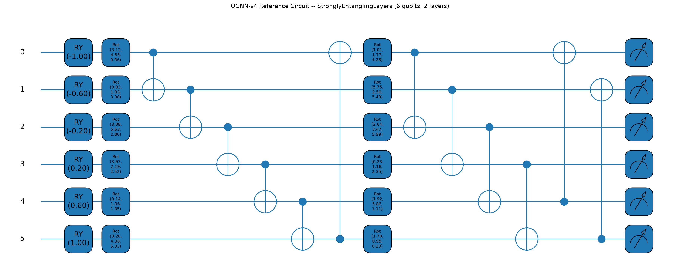
Figure B1. PennyLane-rendered (qml.draw_mpl, device-level decomposition) circuit for the standing QGNN-v4 reference head: RY angle embedding on 6 qubits, two variational layers of a general single-qubit rotation (Rot) followed by a ring of CNOT entangling gates, and Pauli-Z measurement on every qubit. This is the literal gate sequence PennyLane executes — not a logical approximation.
Table B1 lists the circuit's exact specifications, read directly from qml.specs() at device-decomposition level: every gate PennyLane counts, the resulting circuit depth, and the number of trainable quantum parameters registered as ordinary PyTorch parameters via qml.qnn.TorchLayer.
Property | Value
Qubits (wires) | 6
Variational layers | 2
Ansatz | StronglyEntanglingLayers (PennyLane built-in template)
Encoding | AngleEmbedding, rotation=“Y” (1 RY gate per qubit)
Gate composition (device level) | RY×6, Rot×12, CNOT×12
Total gate count | 30
Circuit depth | 12
Trainable quantum parameters | 36
Measurement | expval(PauliZ) on all 6 qubits
Device | default.qubit
Differentiation method | backprop (exact analytic gradient on the state-vector simulator)
Table B1. Exact specifications of the reference QGNN-v4 quantum circuit, from qml.specs().

B.2 Ablation-Tested Ansatz Variants (Section 13.6, Phase 4 Stage 5)
Section 13.6's ansatz/entanglement-topology ablation (QGNN_V4_ABLATION_TABLE.csv) compared the reference circuit above against two other ansatz choices, both already implemented in the same production module and both actually run for that ablation — rendered here the same way, from the same code, for direct visual comparison.
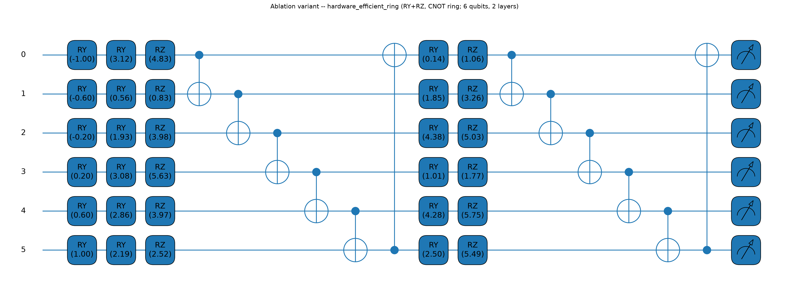
Figure B2. PennyLane-rendered hardware_efficient_ring variant: RY then RZ per qubit per layer (2 trainable rotation parameters/qubit/layer) followed by a CNOT ring.
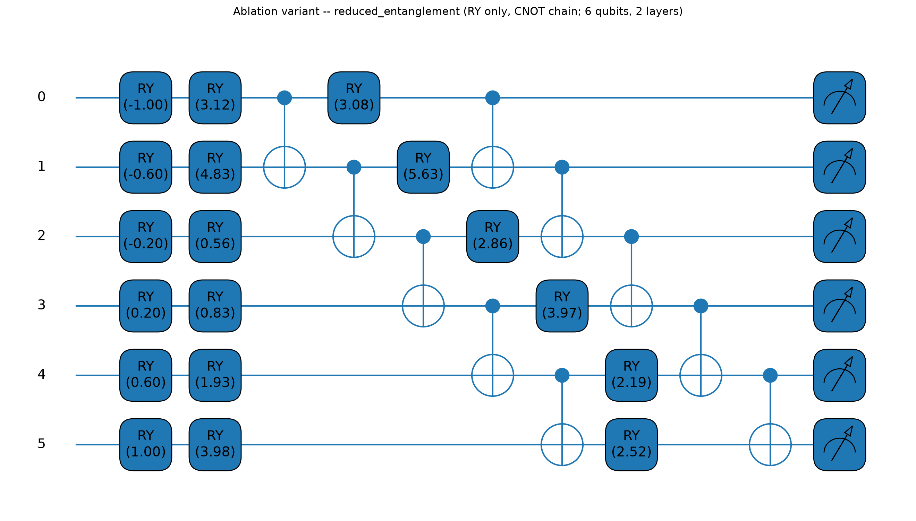
Figure B3. PennyLane-rendered reduced_entanglement variant: RY only per qubit per layer (1 trainable rotation parameter/qubit/layer) followed by a CNOT chain (no wrap-around).
Table B2 compares the three ansatz variants' exact gate composition and parameter counts side by side — the same 36/24/12 trainable-parameter figures Section 13.6 reports, here traced directly to the gate-level circuit that produces them.
Ansatz | Trainable params | Gate composition (device level) | Depth
strongly_entangling (reference) | 36 | RY×6, Rot×12, CNOT×12 | 12
hardware_efficient_ring | 24 | RY×18, RZ×12, CNOT×12 | 17
reduced_entanglement | 12 | RY×18, CNOT×10 | 10
Table B2. Gate-level comparison of the three ansatz variants tested in Section 13.6's ablation, all read from qml.specs() on the actual production circuit.
Reproduction: python scripts/build_pennylane_circuit_diagrams.py regenerates every figure and the specs JSON in this appendix directly from src/scm_dataset/modeling/quantum/circuit.py.

