Understanding Cosmos DB Agent Reliability Checkpoints
What the entries in the Azure Cosmos DB container mean
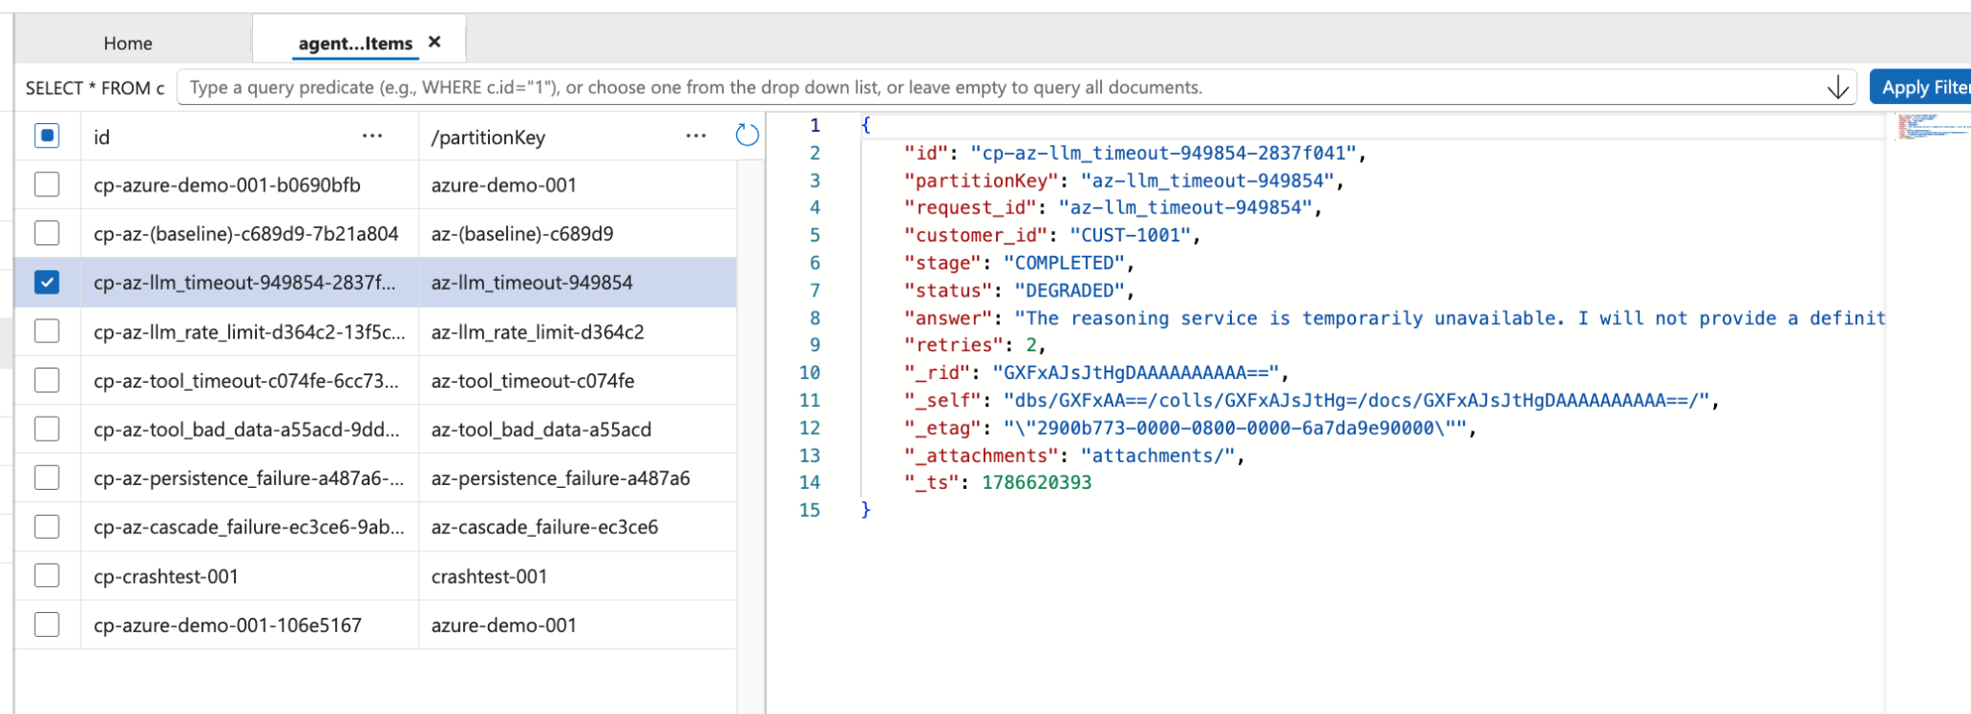

1. What are these records?
The screenshot shows documents stored in an Azure Cosmos DB for NoSQL container. In the Agent Reliability Lab, Cosmos DB is used as durable persistence for an AI agent's execution state. Each document represents a checkpoint from an agent execution or a stage of that execution.
The important idea is that the agent does not rely only on in-memory Python variables. It writes important state to Cosmos DB so that the state can be inspected, recovered after a restart, and used to diagnose failures.

2. The entries shown in the left-hand list
Entry example | Meaning | Why it matters
cp-azure-demo-001-b0690bfb | Checkpoint from the Azure demo run. | Shows that an execution was persisted.
cp-az-(baseline)-c689d9-7b21a804 | Baseline or normal-path checkpoint. | Provides a control case for comparison.
cp-az-llm_timeout-949854-2837f041 | Run where an LLM timeout was injected. | Tests behavior when the model service fails.
cp-az-llm_rate_limit-d364c2-13f5c... | Run where an LLM rate-limit/429 condition was simulated. | Tests bounded retry behavior.
cp-az-tool_timeout-c074fe-6cc73... | Run with a downstream tool timeout. | Tests safe behavior when required data cannot be retrieved.
cp-az-tool_bad_data-a55ac-9dd... | Run involving invalid or untrusted tool data. | Tests semantic validation.
cp-az-persistence-failure-a487a6-... | Run where checkpoint persistence was fault-injected. | Tests resilience when the state store itself fails.
cp-az-cascade-failure-ec3ce6-9ab... | Run with a cascading dependency failure. | Tests containment and escalation.
cp-crashtest-001 | Deliberately named crash/recovery test. | Used to demonstrate recovery after process interruption.
cp-azure-demo-001-106e5167 | Another checkpoint for the Azure demo request. | Repeated executions can create separate checkpoints.

3. Understanding the selected document
The selected record is an example of an LLM-timeout experiment. It contains application fields describing the execution plus system-managed Cosmos DB metadata.
{
"id": "cp-az-llm_timeout-949854-2837f041",
"partitionKey": "az-llm_timeout-949854",
"request_id": "az-llm_timeout-949854",
"customer_id": "CUST-1001",
"stage": "COMPLETED",
"status": "DEGRADED",
"answer": "The reasoning service is temporarily unavailable...",
"retries": 2
}

4. Meaning of the application fields
Field | Meaning | Example / interpretation
id | Unique identifier of the Cosmos DB document. | Uniquely identifies this checkpoint.
partitionKey | Value used to determine the logical partition for the document. | Here it groups the checkpoint using the execution/fault identifier.
request_id | Application-level identifier for the agent request. | Ties related execution information to one request.
customer_id | Business entity involved in the simulated task. | CUST-1001 is the simulated customer.
stage | Lifecycle stage when the checkpoint was written. | COMPLETED means the run reached its completion checkpoint.
status | Outcome produced by the reliability policy. | DEGRADED means normal capability was reduced, but the failure was handled safely.
answer | The agent's user-facing response. | The response explicitly avoids claiming success when the reasoning service failed.
retries | Number of retry attempts consumed. | 2 shows that the configured retry budget was used.

5. Why status = DEGRADED is important
This is one of the central reliability concepts in the lab. The LLM failed, but the agent did not simply return an invented or falsely successful answer. It moved to a degraded state and told the caller that the reasoning service was temporarily unavailable.
In other words: a dependency failure does not automatically have to become an unsafe system failure. The system can continue with reduced capability while protecting the business outcome.

6. Why retries = 2 is important
The lab deliberately uses a bounded retry policy. The agent can try again, but it does not retry forever. Unlimited retries can increase latency and cost, put additional load on an unhealthy dependency, and create cascading failures.
The checkpoint therefore provides evidence that the retry budget was consumed. This is valuable during post-incident diagnosis.

7. Cosmos DB system-generated fields
Field | What it is | How to use it
_rid | Internal Cosmos DB resource identifier. | Normally leave it to Cosmos DB.
_self | Internal/self-link representation for the resource. | System metadata; normally not part of application logic.
_etag | Entity tag representing the current version of the document. | Useful for optimistic concurrency and conditional updates.
_attachments | Internal/legacy attachment metadata. | Usually irrelevant for this lab.
_ts | Cosmos DB server-side timestamp value for the document. | Useful for basic timing inspection; production telemetry should also record explicit application timestamps.

8. Why multiple records exist
The container is effectively becoming a history of reliability experiments. A request can be executed repeatedly, and different fault modes can create different checkpoints. This allows the team to compare normal and failure paths.
Baseline | LLM timeout | Reliability lesson
SUCCESS | DEGRADED | The agent distinguishes normal operation from reduced capability.
Normal retry count | retries = 2 | Retry behavior becomes observable.
Normal answer | Safe unavailable-service message | The agent avoids false claims.
Normal completion | Controlled degraded completion | The failure is contained rather than hidden.

9. Mapping to the four-part lab
Lab part | Cosmos DB evidence | Learning objective
Part 1 — Failure Mode Drills | Checkpoint IDs contain the fault-mode names. | Prove that failures can be injected deterministically.
Part 2 — Graceful Degradation | status, retries and answer show the resulting behavior. | Prove that the agent fails safely.
Part 3 — Persistence Deep-Dive | Checkpoint documents remain after the Python process ends. | Prove that execution state is durable and recoverable.
Part 4 — Observability & Scoring | Checkpoint metadata provides evidence for diagnosis. | Prove what happened and measure reliability.

10. The key message for learners
Cosmos DB is not merely storing customer data in this lab. It is acting as a durable memory and checkpoint layer for the agent.
That means the database gives us an execution trail: which request was processed, which customer was involved, which stage was reached, whether the run degraded, how many retries were consumed, and what response was produced.
The reliability principle is simple: if an agent can fail, we should be able to reconstruct what happened and, where possible, resume safely from durable state.

Suggested classroom question
If the Python process crashed immediately after the LLM timeout but before the response was displayed, what information in Cosmos DB would allow us to understand what happened and decide whether the request can be safely resumed?

