AZURE COSMOS DB
RU Economics & Data-Model Design
FDE Walkthrough • Examples • Scenarios • Probing Questions • Case Studies

Core lesson In Cosmos DB, design the database around how the application asks questions—not merely around how the data looks.
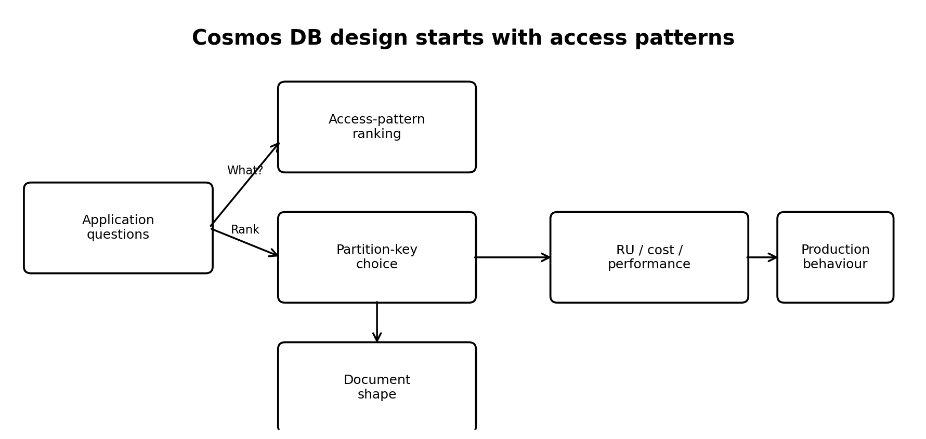

1. Learning outcomes
By the end of this walkthrough, an FDE trainee should be able to:
- Translate business requirements into explicit Cosmos DB access patterns.
- Explain RU (Request Units) as the performance/throughput currency of Cosmos DB.
- Choose and defend a partition key using workload frequency, cardinality, and distribution.
- Explain why cross-partition queries can consume substantially more RU than point reads.
- Diagnose hot-partition symptoms such as throttling even when container-level capacity appears available.
- Design document shape around change frequency and document size.
- Use intentional duplication/materialized views or projections to serve secondary access patterns.
- Explain what the Change Feed can and cannot prove, especially for audit/history requirements.
- Discuss serverless, provisioned, and autoscale capacity choices using workload evidence.
- Defend the final design in an ADR-style decision statement.

2. The mental model: from question to cost
The sequence:
- List the questions the application will ask.
- Rank them by frequency and identify latency-sensitive paths.
- Choose a partition key that makes the dominant pattern efficient while distributing workload.
- Shape documents around what changes often versus what rarely changes.
- Create projections/materialized views for important secondary access patterns.
- Measure RU consumption and use it to inform throughput/cost decisions.
- Decide whether Change Feed is for projections, downstream processing, history, or some combination.
- Record the decision and define a review trigger for new access patterns or changing scale.
Lesson that lands A Cosmos DB design is a workload decision. The schema is the consequence of the workload.

3. Concept 1 — RU economics
RU means Request Unit. Cosmos DB normalizes the resource cost of database operations into RUs. RU/s is the throughput currency used to provision or measure capacity.
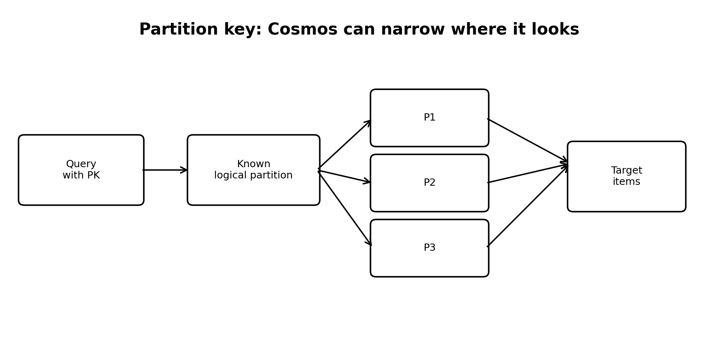
Operation | Mental model | Teaching point
Point read | Go directly to one known item | Requires item id + partition key; usually the most efficient read.
Single-partition query | Search one logical partition | Cheaper than searching all partitions, but still depends on query shape and data.
Cross-partition query | Search across many/all partitions | Can examine much more data than the number of rows returned.
Write | Persist an item | RU rises with item size and other operation complexity.

1 RU for a point read, roughly 3–10 RU for a single-partition query, and roughly 1 RU/document as a mental model for a cross-partition scan.
Current-product grounding Microsoft's current documentation describes RU as a performance currency abstracting CPU, I/O and memory. Actual RU consumption depends on factors such as item size, query shape, result size, indexing and scans; point-read RU also depends on persisted item size. 

Example: same answer, very different work
Suppose there are 4,000 case documents and only 6 are pending.
- Point-read path: GET a known case_id with the partition key → Cosmos can go directly to the target logical partition.
- Cross-partition path: WHERE status = 'PENDING' without the partition key → Cosmos may need to inspect many documents/partitions to find the 6 matches.
- The number returned (6) is therefore not a safe proxy for the amount of database work performed.
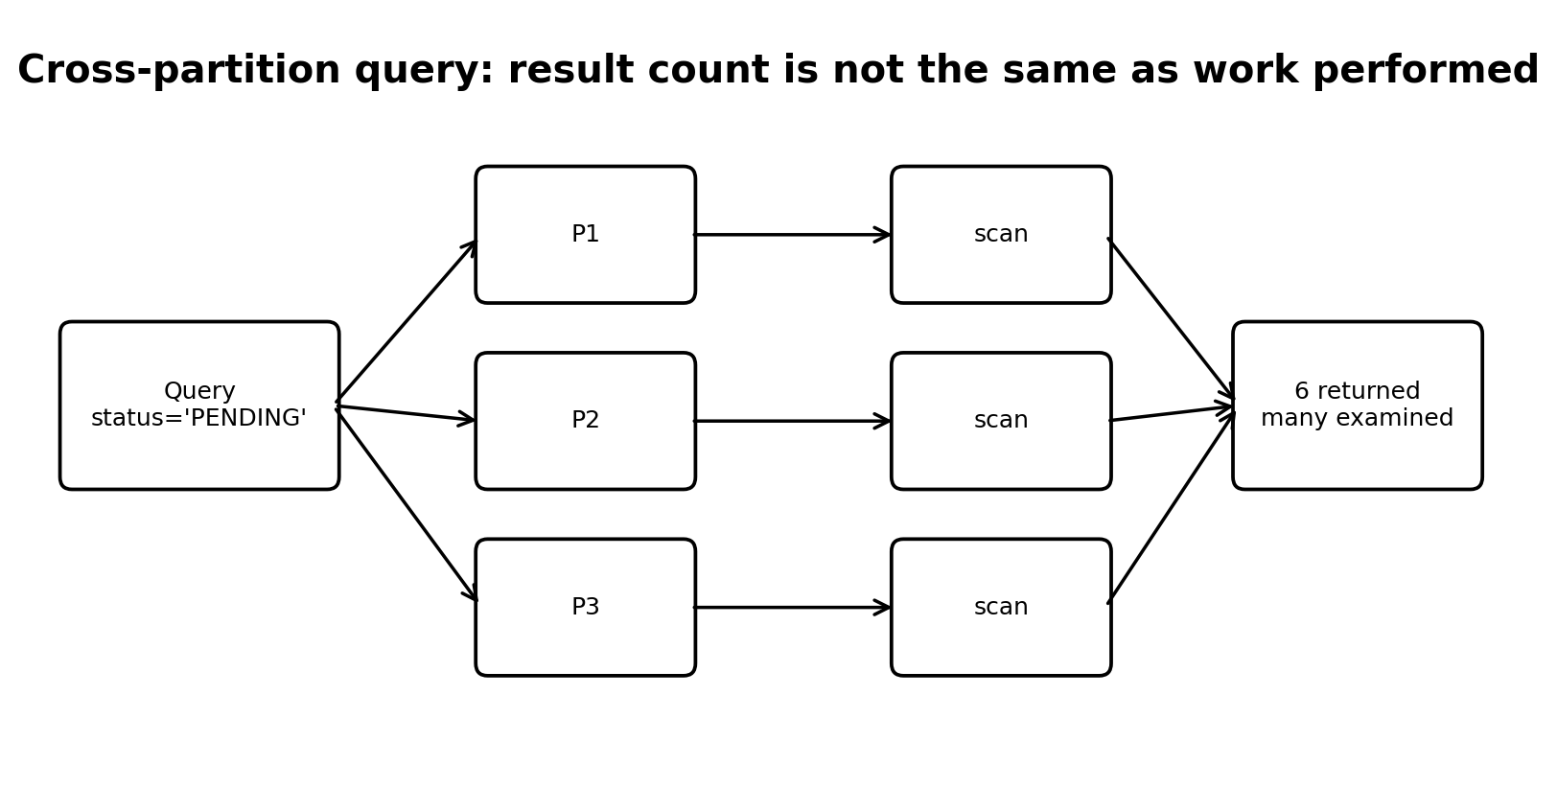
Probing question: If a query returns only 6 records, why could it still be expensive?
Answer / expected reasoning: Because RU consumption is driven by the work required to evaluate the query: source data examined, index work, document loading/parsing, predicates, projections, result processing, and whether the query fans across partitions. The trainee should ask 'how much did Cosmos have to examine?' rather than only 'how many did it return?'.
Probing question: What should an FDE measure before claiming a query is cheap?
Answer / expected reasoning: The actual request charge/RU consumption for representative data and workload, plus latency and throttling behaviour. Do not use a guessed RU number as a production commitment.
Lesson that lands Don't optimize only for milliseconds. Optimize for how much work Cosmos must do to answer the question.

4. Concept 2 — Partition key
A partition key determines how items are logically grouped and is central to both query routing and workload distribution. The source exercise gives three competing patterns:
Query pattern | Monthly volume | Business meaning
Get by case_id | 40,000 | Hot path
List by applicant_id | 3,000 | Handler checking history
Filter by status | 6,000 | Operations queue

Exercise Choose the partition key before looking at the answer. Then explain what becomes cheap and what becomes expensive.
Reference: Uploaded deck, page 3 / 'START HERE'.
Candidate/  Partition key | Get by case_id | By applicant | By status | Largest partition
case_id | 1.5 RU | 1,842 RU | 1,842 RU | 13%
applicant_id | 1,842 RU | 4.3 RU | 1,842 RU | 14%
status | 1,842 RU | 1,842 RU | 1,032 RU | 74% HOT

The source deck's teaching conclusion is to choose case_id because it is high-cardinality, evenly distributed in the scenario, and makes the 40,000/month dominant path a point read. The other patterns are then served with additional shaped copies/views. 
Probing question: Why is status a poor partition-key candidate in this scenario?
Answer / expected reasoning: There are only a few status values and the distribution is highly skewed: many cases become complete. That concentrates data and traffic, creating an imbalance. A good candidate has enough distinct values and distributes workload reasonably evenly.
Probing question: Why not simply choose applicant_id because it is also a useful query?
Answer / expected reasoning: Because partition-key choice is a trade-off. In the source workload, get-by-case_id is the dominant 40,000/month pattern. The design deliberately optimizes the dominant path and serves the other patterns with projections.
Lesson that lands The right question is not 'Which field is unique?' It is 'Which partition key gives me a scalable distribution while serving the workload that matters most?'

5. Concept 3 — Hot partitions and 429s
A hot partition is a workload imbalance: a small subset of partitions receives disproportionate data or traffic. Increasing total container throughput does not automatically eliminate a skewed partition.
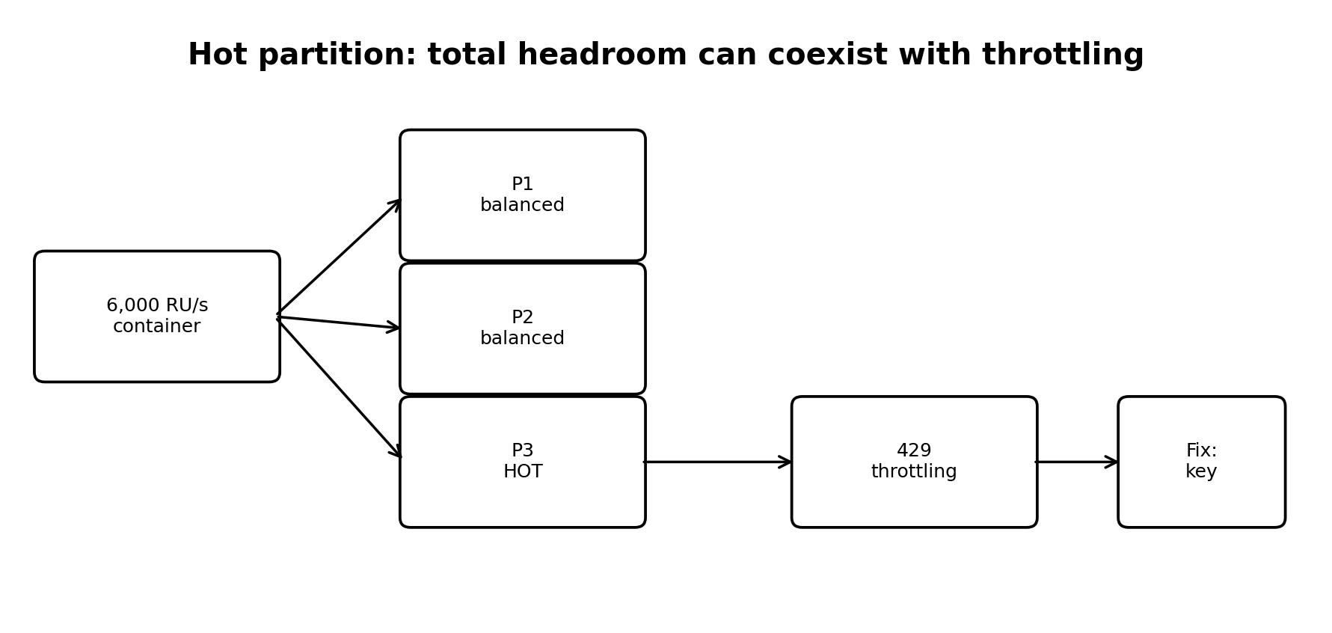
Source scenario: 500 operations/sec × 8 RU = 4,000 RU/s demand, while 6,000 RU/s is provisioned. With status as the key, 74% of the data is concentrated in the largest partition and the source lab shows 2,959 RU/s of demand against a roughly 1,000 RU/s ceiling, resulting in 429 throttling. fileciteturn2file2
Important update The uploaded lab uses ~1,000 RU/s as a simplified physical-partition ceiling. Current Microsoft documentation for Azure Cosmos DB states that an individual physical partition can provide up to 10,000 RU/s. Treat the 1,000 figure as the lab's teaching assumption, not as the current product limit. citeturn0search11
Probing question: The container dashboard says 6,000 RU/s and only 4,000 RU/s is demanded. Why could users still receive 429s?
Answer / expected reasoning: Because throughput can be unevenly consumed. A hot logical/physical partition can be overloaded while other partitions have unused capacity. Diagnose distribution and request concentration before simply increasing total RU/s.
Probing question: What are the first two things you would inspect?
Answer / expected reasoning: Partition-key distribution and per-partition/request distribution. Then inspect RU charge, throttling metrics, query patterns, and whether one tenant/status/customer/etc. dominates traffic.
Lesson that lands 429 does not automatically mean 'buy more RU.' It can be a partition-key problem wearing a capacity costume. fileciteturn2file2

6. Concept 4 — Document shape and hot/cold data
The key design question is: what changes frequently, and what rarely changes?
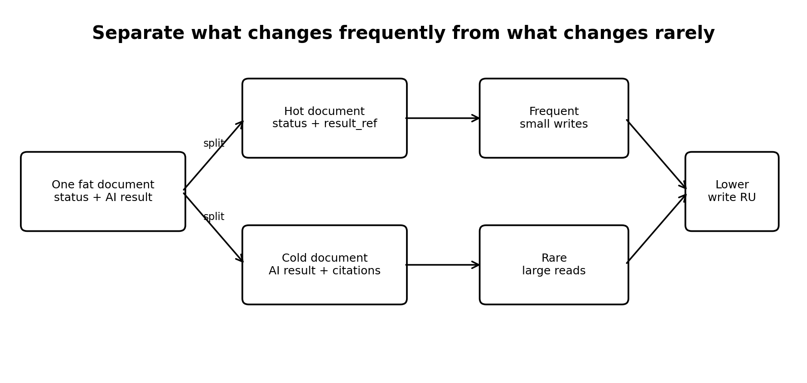
Model | Size in source scenario | Write RU in source scenario | Monthly write RU
One fat document: status + extracted_fields + AI response | 3.0 KB | 15 RU/write | 239.5K
Hot + cold split: small status doc + result_ref | 0.5 KB hot doc | 2.5 RU/write | 40.0K

The source scenario assumes a case changes status four times. In the fat document, each status update rewrites the large AI narrative and citations even though those fields have not changed. The source estimate shows about a sixfold reduction in write RU with the hot/cold split. fileciteturn2file11
Simple analogy Don't rewrite a 100-page book because the bookmark moved from page 20 to page 21. Keep the frequently changing bookmark/state separate from the relatively static book.
Probing question: When is splitting a document worth the extra read?
Answer / expected reasoning: When a large payload changes much less frequently than the operational state. The extra read can be a point read, while the frequent writes remain small. The trade-off should be measured against actual access patterns.
Probing question: Is smaller always better?
Answer / expected reasoning: No. Smaller documents can reduce RU for reads/writes, but over-normalizing can create too many reads and operational complexity. Model around the workload, not a blanket rule.
Lesson that lands Separate what changes from what does not. Document size is a write-cost decision as well as a storage decision.

7. Concept 5 — Secondary access patterns and materialized views
A common NoSQL pattern is intentional duplication: keep a primary representation optimized for one access pattern, then maintain a second projection shaped for another important question.
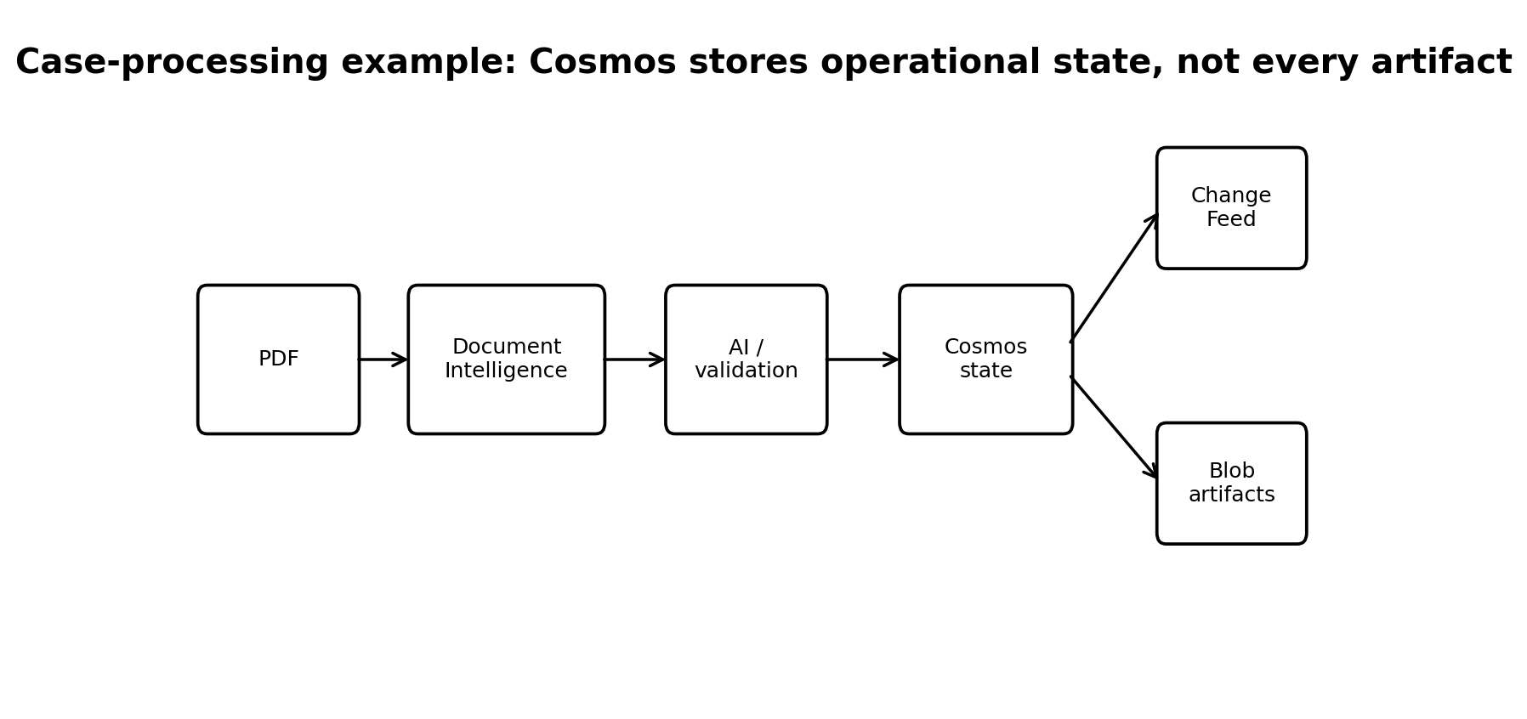
Source design:
- Primary container partitioned by case_id.
- Applicant-oriented materialized view keyed by applicant_id.
- Status-oriented view or a view containing only live cases.
- Change Feed keeps those views current.
Reference: Uploaded deck: 'You do not solve a second access pattern with a second index. You solve it with a second copy of the data, shaped for that question.' fileciteturn2file0
Probing question: Is duplicating data automatically bad?
Answer / expected reasoning: No. In a read-optimized distributed system, duplication can be deliberate. The cost is synchronization, storage, write amplification, and inconsistency handling. The decision is justified when it turns an expensive access pattern into a predictable efficient one.
Probing question: Six months later, the business asks for all cases for one employer across applicants. What do you do?
Answer / expected reasoning: The source scenario presents three options: tolerate a cross-partition query, add another materialized view, or migrate/change the data model. The FDE should quantify traffic and cost before choosing. The decision should be recorded so future teams understand the trade-off. fileciteturn2file17
Lesson that lands Every important access pattern has a cost. A good FDE makes that cost visible and chooses deliberately.

8. Concept 6 — Change Feed: projection versus audit
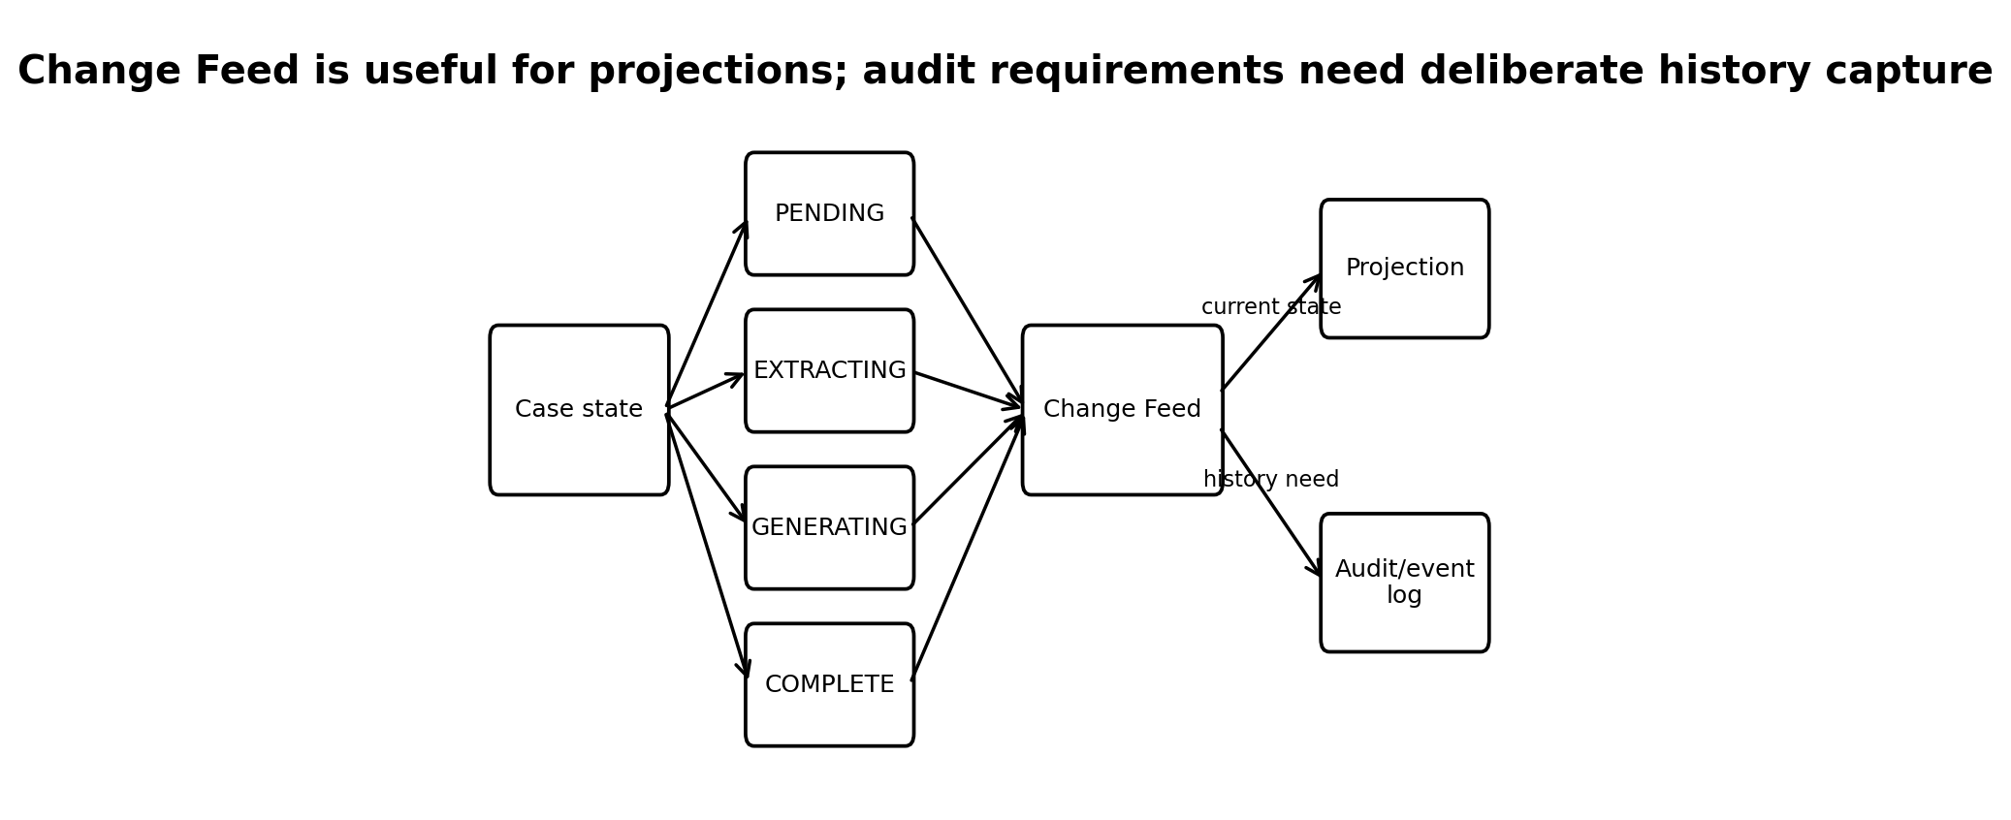
The source deck demonstrates a critical distinction:
Mode | Transitions in scenario | Observed | Lost
latest_version | 200 | 67 | 133 (66%)
all_versions_and_deletes | 200 | 200 | 0

The source scenario explains that a case moving quickly through pending → extracting → generating → complete may be observed only as complete under latest-version consumption. That can be fine for a current-status dashboard but is a hole if the requirement is to prove every transition. fileciteturn2file3
Current Microsoft grounding Microsoft's current documentation confirms that latest-version mode can miss intermediate updates and does not capture deletes; all-versions-and-deletes mode captures every create/update/delete change within the continuous-backup retention window, subject to current feature/account requirements. citeturn0search0turn0search2
Probing question: Can I use Change Feed as my audit log?
Answer / expected reasoning: Not automatically. First define what 'audit' means. If audit requires every transition, who/what made it, when it happened, and evidence that must not disappear, an explicit append-only transition/event record may be the safer design. The source deck makes this distinction explicitly. fileciteturn2file12
Probing question: When is latest-version mode appropriate?
Answer / expected reasoning: For projections, notifications, search/index maintenance, cache updates, and workloads that only need the latest state. Microsoft also notes it is suitable when intermediate changes and deletes do not need to be captured. citeturn0search0
Lesson that lands Current state and historical events are different data requirements.

9. Scenario — hot state write succeeds, cold result write fails
Scenario from the source deck: you split the case into a hot status document and a cold result document. The hot write succeeds, but the cold write fails.
- The status now says COMPLETE.
- The result document is missing or unavailable.
- A handler opens the case and sees a state that implies completion but cannot retrieve the result.
- The FDE must ask whether both writes are in the same logical partition and whether the chosen transaction boundary can cover them.
- If atomicity is not available across the chosen boundaries, the system needs explicit detection/reconciliation/repair logic.
Reference: Uploaded deck scenario on page 16. fileciteturn2file16
Probing question: What is the first design question?
Answer / expected reasoning: Can the two writes be made atomic within the required Cosmos transaction boundary? If not, define the failure state and how the system detects and repairs it.
Probing question: What should the user see?
Answer / expected reasoning: A safe state—not a misleading 'complete' state with a missing result. The API should either expose a consistent status contract or clearly report that processing is incomplete/recovery is in progress.
Lesson that lands Splitting documents can reduce RU, but it creates consistency and failure-mode questions. Good FDE design addresses both.

10. Concept 7 — Serverless, provisioned, and autoscale
Mode | Best mental model | Good fit
Serverless | Pay for consumed RU; no pre-provisioned throughput | POCs, intermittent/spiky workloads, uncertain early traffic
Provisioned | Reserve RU/s for a sustained workload | Predictable production traffic
Autoscale | Provisioned capacity adjusts within configured limits | Variable production traffic where predictable performance matters

The source deck recommends serverless for its POC and using measured RU consumption to size a later provisioned tier. fileciteturn2file4
Current-product grounding Microsoft's current documentation distinguishes provisioned throughput, serverless, and autoscale. Serverless bills for consumed RUs and does not provide predictable throughput/latency guarantees; provisioned throughput is suited to sustained traffic; autoscale is designed for variable traffic within configured limits. citeturn0search5turn0search6turn0search13
Probing question: Why is 'serverless is cheaper' an incomplete answer?
Answer / expected reasoning: Because cost depends on workload shape, sustained versus intermittent traffic, required performance guarantees, regions, and consumption. The correct FDE answer is 'for this measured workload and requirement, serverless/provisioned/autoscale is the better fit.'
Probing question: What evidence should move you from POC to production capacity?
Answer / expected reasoning: Observed RU consumption, peak and average traffic, latency/SLO requirements, throttling, partition distribution, data growth, regional requirements, and cost projections.
Lesson that lands Capacity mode should follow measured workload evidence, not a default preference.

11. Case Study A — AI document-processing platform
Scenario
- A case contains a PDF, extraction results, AI narrative, validation state, and human-review state.
- PDF/OCR/large artifacts are stored outside the operational Cosmos state store.
- Cosmos stores current workflow state and small references to large results.
- Multiple workers can update the same case asynchronously.
- Downstream projections need applicant/status views.

Trainee task
- Choose the partition key and justify it.
- Identify hot and cold fields.
- Decide which data belongs in Cosmos versus Blob Storage.
- Define the Change Feed consumer(s).
- Define the failure mode if status changes but the result write fails.
- Explain how you would prevent competing workers from overwriting each other.
- State what your design would monitor in production.

Expected answer direction
- Use the dominant case lookup as the primary design driver, subject to actual workload evidence.
- Keep frequently changing status/workflow fields small.
- Keep large, relatively immutable artifacts outside the hot operational document.
- Use Change Feed for projections/downstream processing where latest state is sufficient.
- Use an explicit transition/event record if the business requires durable evidence of every state transition.
- Use concurrency controls and idempotent handlers for competing asynchronous updates.
- Monitor RU, throttling, latency, partition skew, projection lag, failed writes, and data-growth trends.

12. Case Study B — Multi-tenant SaaS
Scenario: a SaaS platform has tenants of very different sizes. Tenant A may eventually have tens of millions of records while many other tenants are small.
Question | Weak answer | Better FDE answer
Partition key? | Always tenant_id | Start from query patterns and tenant skew; evaluate whether a hierarchical or other strategy is required.
429s? | Increase RU | Check whether a tenant or other key value is creating a hot partition.
Large tenant growth? | Ignore until production | Model growth and distribution before the tenant becomes a hotspot.

Microsoft documents hierarchical partition keys for scenarios where a hierarchy such as tenantId → userId can help distribute data/workload while preserving useful query patterns. This is an outside-current-doc expansion of the source deck, not a claim that the uploaded lab used hierarchical partitioning.
Reference: Current Microsoft Cosmos DB partitioning guidance: urlPartitioning and horizontal scalinghttps://learn.microsoft.com/en-us/azure/cosmos-db/partitioning

13. Case Study C — Real-world customer discussion: Adobe
Microsoft's current customer-solutions page describes Adobe using Azure Cosmos DB for unified customer profile and identity workloads, including real-time personalization and high-throughput workloads. Use this as a discussion case rather than assuming its internal partition key or schema.
Reference: Microsoft customer-solutions reference: urlAzure Cosmos DB customer solutionshttps://learn.microsoft.com/en-us/azure/cosmos-db/customer-solutions
Probing question: What would you ask before recommending a partition key for a real-time customer-profile system?
Answer / expected reasoning: What are the dominant point lookups? What are the fan-out queries? How many customers, identities, events and profile updates are expected? Is traffic evenly distributed? Are there large enterprise tenants/customers that dominate volume? What are the regional and latency requirements?

14. Probing questions for an FDE
Probing question: What is the most important input to Cosmos DB data-model design?
Answer / expected reasoning: The application's access patterns: what it asks, how often, and at what scale.
Probing question: Why is a partition key a trade-off?
Answer / expected reasoning: Because one key can make some queries efficient while other queries may require broader routing or projections.
Probing question: Why can a query returning 10 records still be expensive?
Answer / expected reasoning: Because the database may have examined far more source data to find those 10.
Probing question: Why can a 429 happen when the container dashboard shows spare RU?
Answer / expected reasoning: Because workload can be concentrated on a hot partition while other partitions are underused.
Probing question: What makes a partition-key candidate attractive?
Answer / expected reasoning: Sufficient cardinality, even workload/data distribution, and alignment with important query patterns.
Probing question: When is duplicating data acceptable?
Answer / expected reasoning: When duplication is intentional, the read pattern benefits materially, and synchronization/inconsistency costs are understood.
Probing question: What is the difference between a projection and an audit log?
Answer / expected reasoning: A projection answers a read question; an audit log preserves a durable account of events/transitions.
Probing question: What does latest-version Change Feed potentially miss?
Answer / expected reasoning: Intermediate updates and deletes in latest-version mode.
Probing question: Why split hot and cold data?
Answer / expected reasoning: To avoid repeatedly rewriting large data that rarely changes.
Probing question: What should be written into an ADR?
Answer / expected reasoning: Chosen key, rejected alternatives, query/cost trade-offs, document shape, Change Feed mode/limitations, capacity decision, and review triggers.

15. Final FDE defence exercise
Trainees to use 10–15 minutes to prepare a five-sentence defence. They should not be allowed to answer with only feature definitions.
Required response format 1) Our dominant access pattern is ___. 2) Therefore our partition key is ___. 3) We rejected ___ because ___. 4) We separated ___ from ___ because ___. 5) We chose ___ capacity because ___.
Then challenge them with one change at a time:
- Traffic doubles.
- One tenant becomes 40% of all traffic.
- A new employer-level query appears.
- The operations team now requires every status transition.
- The AI result becomes 10× larger.
- Two workers begin updating the same case concurrently.
Objective The trainee should revise the design decision, not defend the original design at all costs.

16. One-page quick reference
If you see... | Think... | Ask...
High RU query | How much data is being examined? | Can the query be narrowed to a partition or point read?
429s with spare container RU | Hot partition / skew | Is traffic concentrated on one key value?
Frequent writes to large documents | Hot/cold split | Which fields actually change?
New query pattern | Projection/materialized view | Is this important enough to justify another shaped copy?
Need historical evidence | Audit/event log | Do we need every transition, actor, timestamp, and immutable history?
Uncertain early traffic | Serverless/measurement | What does actual RU consumption look like?
Steady production traffic | Provisioned throughput | What RU/s and SLOs are required?
Variable production traffic | Autoscale | What is the peak/shape and configured limit?

17. Reference links
- Azure Cosmos DB — Request Units: https://learn.microsoft.com/en-in/azure/cosmos-db/request-units
- Azure Cosmos DB — Understand RU consumption: https://learn.microsoft.com/en-us/azure/cosmos-db/understand-request-unit-consumption
- Azure Cosmos DB — Partitioning and horizontal scaling: https://learn.microsoft.com/en-us/azure/cosmos-db/partitioning
- Azure Cosmos DB — Change Feed: https://learn.microsoft.com/en-ca/azure/cosmos-db/change-feed
- Azure Cosmos DB — Change Feed Modes: https://learn.microsoft.com/sr-latn-rs/azure/cosmos-db/change-feed-modes
- Azure Cosmos DB — Change Feed Design Patterns: https://learn.microsoft.com/en-us/azure/cosmos-db/change-feed-design-patterns
- Azure Cosmos DB — Serverless vs provisioned: https://learn.microsoft.com/en-us/azure/cosmos-db/throughput-serverless
- Azure Cosmos DB — Well-Architected guidance: https://learn.microsoft.com/en-us/azure/well-architected/service-guides/cosmos-db
- Azure Cosmos DB — Customer solutions: https://learn.microsoft.com/en-us/azure/cosmos-db/customer-solutions
- Best practices for Azure Cosmos DB: Data modeling Partitioning and RUs - BRK3054 https://www.youtube.com/watch?v=bQBeTeYUrR8

