RETRIES, BACK-OFF & JITTER
FDE Student Learning Guide + Case Studies

1. The crux
A retry is not simply “try again.” It is a resilience decision: Is the failure transient? Is repeating the operation safe? How long should we wait? How many attempts are allowed? What happens when the retry budget is exhausted?
Azure guidance recommends choosing retry count and delay together with timeouts, operation type, service behavior, and end-to-end latency. Aggressive retries can worsen an overloaded dependency. [1]

2. The retry loop
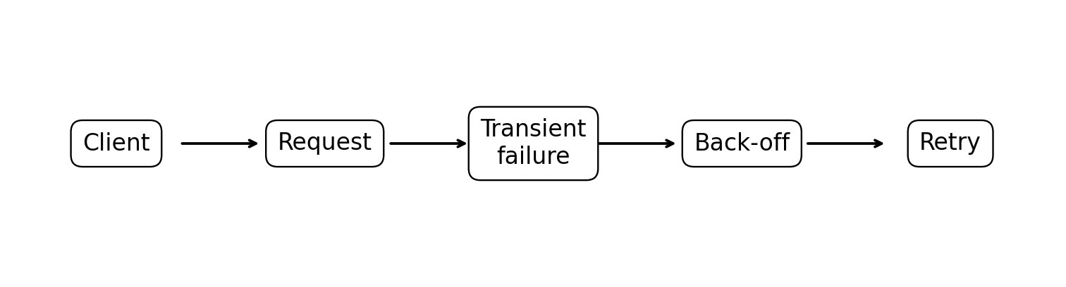
Retry only when the failure has a reasonable chance of succeeding later. Permanent validation or business errors should normally fail fast.
Failure | Transient? | Retry? | Why
Temporary service unavailable (503) | ✅ Usually | ✅ | Service may recover
Gateway timeout (504) | ✅ Often | ✅ | Dependency may respond next time
Rate limit (429) | ✅ Often | ✅ With back-off | Server is asking you to slow down
Network timeout | ✅ Often | ✅ | Network may recover
Invalid JSON | ❌ | ❌ | Same request will fail again
Wrong data type | ❌ | ❌ | Caller must fix request
Unreadable document | ❌ Usually | ❌ | Better input is required
Invalid authentication | ❌ | ❌ | Credentials need fixing

3. Back-off
Back-off is the waiting strategy between attempts. It gives a recovering dependency time to recover instead of immediately adding more load.
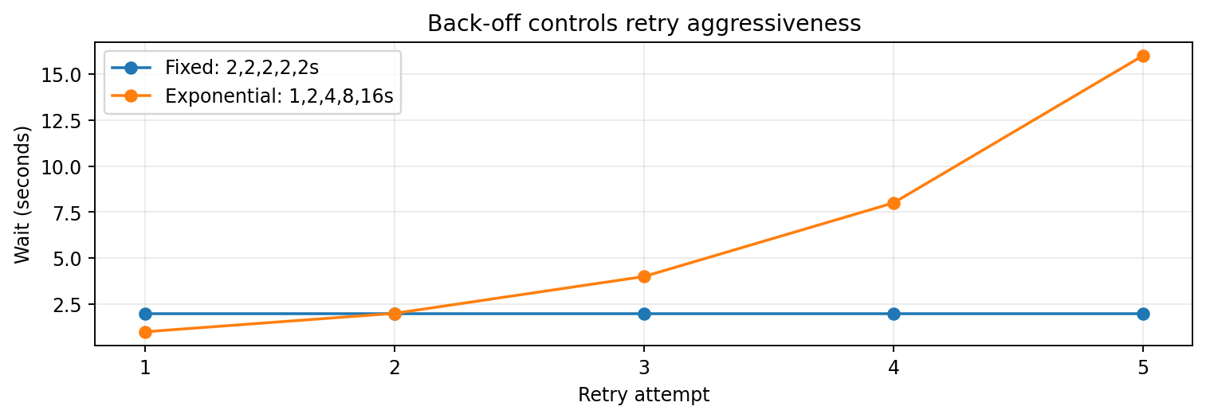
Strategy | Example | Use | Main risk
Immediate | 0s | Very short transient fault | Can amplify failure; limit to one immediate retry
Fixed | 2,2,2s | Simple low-volume use | Clients can synchronize
Incremental | 3,7,11s | Gradually increasing wait | Less adaptive than exponential
Exponential | 1,2,4,8s | Background/transient faults | Latency grows rapidly if uncapped
Exponential + jitter | Randomized exponential delay | Distributed/high concurrency | Needs bounded attempts and delay

4. Exponential back-off example
A common teaching formula is: delay = min(max_delay, base × 2^(attempt−1)).
- Attempt 1 → 1s
- Attempt 2 → 2s
- Attempt 3 → 4s
- Attempt 4 → 8s
- Attempt 5 → 16s
The cap and maximum attempts matter because timeout + retry delays determine the worst-case end-to-end latency. [1]

5. Jitter
Jitter adds randomness to the calculated delay so many clients do not retry at exactly the same moment.
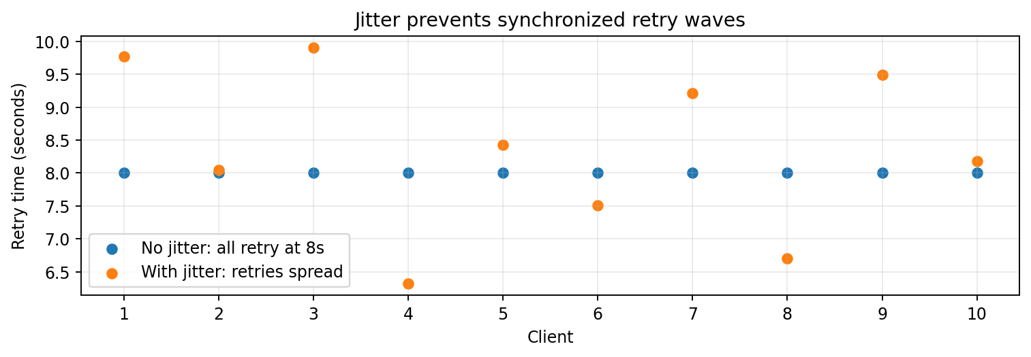
Without jitter, 1,000 workers that all failed at the same time can all wake up together. With jitter, their retries are spread over a window, reducing load spikes. [1][2]

6. Retry storm / thundering herd
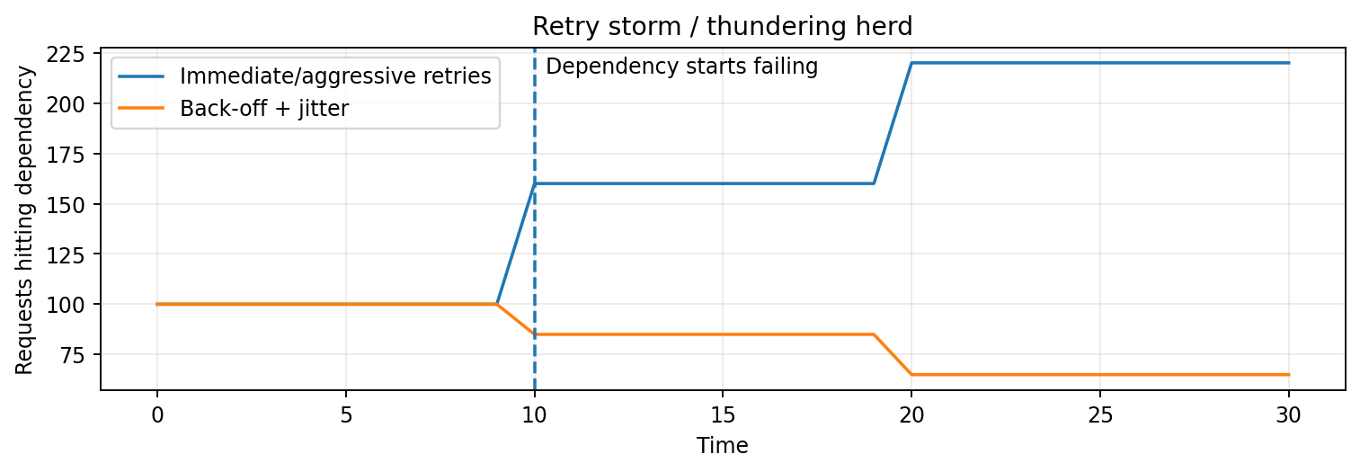
Immediate or unbounded retries can create a feedback loop: service fails → clients retry → load increases → service fails more → clients retry again. Azure documents this as the Retry Storm antipattern. [3]

7. Decide whether to retry
Failure | Typical decision | Retry signal | Reason
400 Bad Request | No | Fail fast | Same request remains invalid
422 Unprocessable Content | Usually no | Fail fast | Input/business condition must change
429 Too Many Requests | Usually yes | Retry-After | Back off because caller is throttled
502 Bad Gateway | Often yes | Back-off + jitter | Upstream may recover
503 Service Unavailable | Often yes | Retry-After if supplied | Temporary unavailability
504 Gateway Timeout | Often yes | Back-off + jitter | Upstream did not respond in time
Authentication failure | No automatic retry | Fix credentials | Repeating same credentials won't help
These are typical decisions, not universal laws. Follow the API contract and service-specific guidance. If Retry-After is supplied, the server's signal should take precedence over a faster client-side schedule. [1][4]

8. Idempotency: the safety check before retrying
For a write operation, : “If the first attempt succeeded but the response was lost, will retrying perform the business action twice?” If yes, the operation needs idempotency protection before automatic retry.
- POST /case-application with Idempotency-Key: CASE-123-01.
- Server accepts the case, but the response is lost.
- Client retries the same key.
- Server recognizes the replay and returns the original acceptance/result instead of creating a second assessment.
Azure's retry guidance explicitly identifies idempotency as a key consideration for retrying operations. [2]

9. Timeout + retry budget
Example: each attempt has a 5-second timeout, with waits of 1s and 2s, across three attempts.
5 + 1 + 5 + 2 + 5 = 18 seconds worst case
If the end-to-end SLO is 10 seconds, this policy cannot meet it. Retry design must include the whole latency budget, not only the retry delay. [1]

10. Case Study A — AI document extraction
A case-processing API calls Document Intelligence. During a short load spike, the dependency returns 503 for some requests.
students:
- Should we retry 503?
- Should the retry be immediate?
- What if Retry-After is returned?
- Why add jitter?
- How many attempts are acceptable?
- What happens after the final attempt?
Expected answer: classify it as potentially transient; honor Retry-After when present; use bounded exponential back-off with jitter; keep a finite retry/latency budget; then route exhausted work to an appropriate failure path rather than retry forever. [1][3]

11. Case Study B — Azure OpenAI throttling
200 workers call a model endpoint and receive HTTP 429.
Correct reasoning:
- 429 is a back-pressure/throttling signal, not a reason to hammer the service.
- Honor Retry-After if supplied.
- Use jitter so the 200 workers do not retry together.
- Limit retries and total duration.
- Do not hide the downstream throttling signal behind a generic 500 if doing so prevents the caller from slowing down.
Azure guidance specifically recommends propagating throttling signals and using Retry-After so clients can back off deliberately. [4]

12. Case Study C — duplicate assessment
POST /case-application times out. The client cannot tell whether the server accepted the request.
Question: “Can I retry?”
Senior FDE answer: “Only if the operation is safely idempotent.” Use an idempotency key or another deduplication mechanism so a retry cannot create a second assessment. [2]

13. Python teaching example
import random
import time
import requests
def call_with_retry(url, max_attempts=4):
for attempt in range(1, max_attempts + 1):
try:
r = requests.get(url, timeout=5)
if r.ok:
return r
if r.status_code not in (429, 502, 503, 504):
r.raise_for_status()
retry_after = r.headers.get("Retry-After")
if retry_after:
delay = float(retry_after)
else:
cap = min(8, 1 * (2 ** (attempt - 1)))
delay = random.uniform(0, cap) # full jitter
if attempt == max_attempts:
break
print(f"attempt={attempt}, retry_in={delay:.2f}s")
time.sleep(delay)
except requests.Timeout:
if attempt == max_attempts:
raise
cap = min(8, 1 * (2 ** (attempt - 1)))
delay = random.uniform(0, cap)
time.sleep(delay)
raise RuntimeError("Retry budget exhausted")
Teaching note: this is illustrative code. Production systems should prefer documented SDK/client retry behavior where appropriate, centralize policy, instrument attempts, and test failure modes. [1]

14. Student exercise
For each scenario, defend: Retry? Delay? Jitter? Maximum attempts? Is it idempotent? What happens after the final failure?
- Document extraction returns 503 for 2% of calls during a short spike.
- An API returns 422 because the document is unreadable.
- Azure OpenAI returns 429 with Retry-After: 15.
- POST /case-application times out after the server may already have accepted it.
- An upstream service returns 500 for every request for 10 minutes.
- 100 workers receive 503 at the same second.

15. Five rules FDEs should remember
1. Retry only when the failure is plausibly transient.
2. Back-off gives the dependency time to recover.
3. Jitter prevents synchronized retry waves.
4. Retries must be bounded by attempts, delay and total latency/SLO.
5. Never assume a retry is safe for a business write—design for idempotency.

16. Grounded references
[1] Microsoft Learn — Transient Fault Handling
https://learn.microsoft.com/en-us/azure/architecture/best-practices/transient-faults
[2] Microsoft Learn — Retry pattern
https://learn.microsoft.com/en-us/azure/architecture/patterns/retry
[3] Microsoft Learn — Retry Storm antipattern
https://learn.microsoft.com/en-us/azure/architecture/antipatterns/retry-storm/
[4] Microsoft Learn — Throttling pattern
https://learn.microsoft.com/en-us/azure/architecture/patterns/throttling
Student emphasis: Do not memorize a formula. Defend a retry policy: what failed, is it transient, can the operation be safely repeated, what does the server tell us, what is the latency budget, and what happens after retries are exhausted?

