Set A

Solution 1)

select t.* from(select train_id from (

select A.total as total1,A.train_id,B.total from

(select count(coachnumber) as total ,train_id from coaches where train_id in

(select trainid from trainschedules where routeid in

(select routeid from routes where (originid =

(select stationid from stations where lower(stationname) like "goa%") and

DestinationId = (select stationid from stations where lower(stationname) like 'mumbai%')) or (originid =

(select stationid from stations where lower(stationname) like "ajmer%") and

DestinationId = (select stationid from stations where lower(stationname) like 'lonavla%')) ))

and NextMaintenanceDate<='2023-11-30'

group by Train_id )A join

(select count(coachnumber) as total,train_id from coaches where train_id in

(select trainid from trainschedules where routeid in

(select routeid from routes where originid =

(select stationid from stations where lower(stationname) like 'goa%') and

DestinationId = (select stationid from stations where lower(stationname) like 'mumbai%')))

group by Train_id )B on A.train_id = B.train_id)C where total/2 <total1) a join train t on a.train_id = t.train_id;

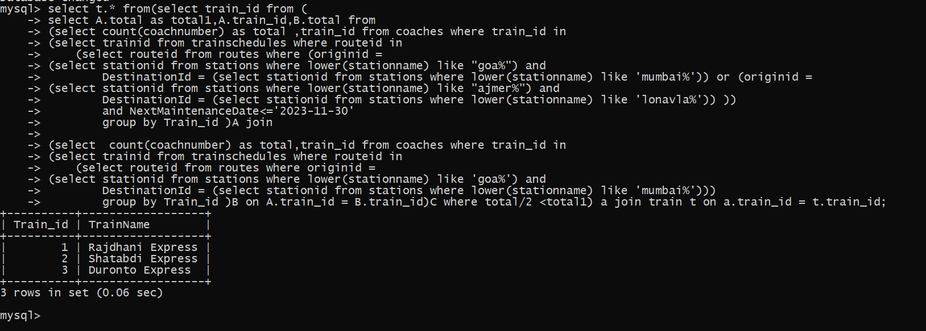

Solution 2)

SELECT

r.RouteID,

r.OriginID,

r.DestinationId,

t.TicketId,

t.TotalTickets,

t.SoldTickets,

t.AvailbleTickets,

COUNT(CASE WHEN b.DiscountType = 'child' THEN 1 END) AS Children,

COUNT(CASE WHEN b.DiscountType = 'None' THEN 1 END) AS Adult,

COUNT(CASE WHEN b.DiscountType = 'Senior Citizen' THEN 1 END) AS SeniorCitizen

FROM

Routes r

JOIN

TrainSchedules ts ON r.RouteID = ts.RouteID

JOIN

Ticket t ON r.RouteID = t.RouteId AND ts.ScheduleID = t.ScheduleID

LEFT JOIN

Bookings b ON r.RouteID = b.RouteID AND ts.ScheduleID = b.ScheduleID

WHERE

MONTH(b.BookingDate) = 10 AND YEAR(b.BookingDate) = YEAR(CURRENT_DATE())

GROUP BY

r.RouteID, r.OriginId, r.DestinationId, t.TicketId, t.TotalTickets, t.SoldTickets, t.AvailbleTickets

ORDER BY

t.SoldTickets DESC;

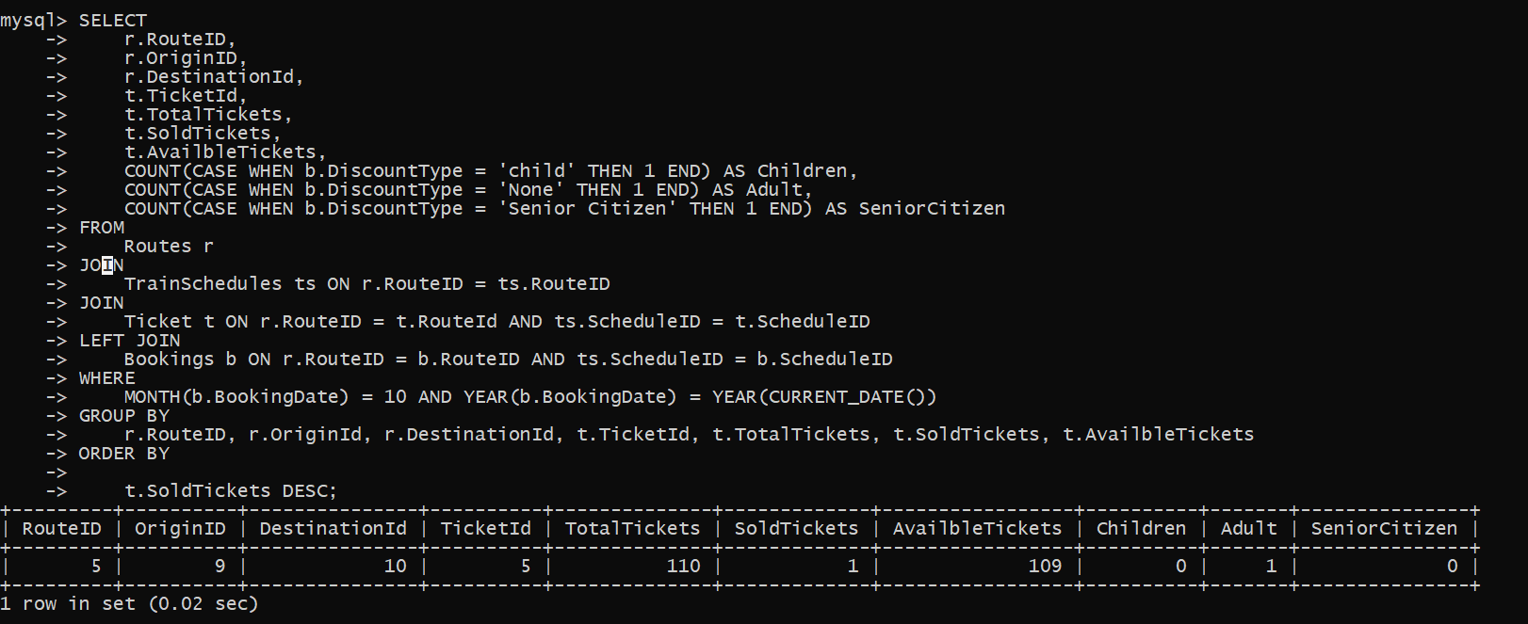

Solution 3)

SELECT

ta.AgentID,

ta.Name AS AgentName,

ta.CommissionPercentage,

COUNT(b.BookingID) AS ConfirmedBookings

FROM

TravelAgents ta

JOIN

Bookings b ON ta.AgentID = b.TravelAgentID

WHERE

MONTH(b.BookingDate) = 09 AND YEAR(b.BookingDate) = YEAR(CURRENT_DATE())

GROUP BY

ta.AgentID, ta.Name, ta.CommissionPercentage

HAVING

COUNT(b.BookingID) >= 10;

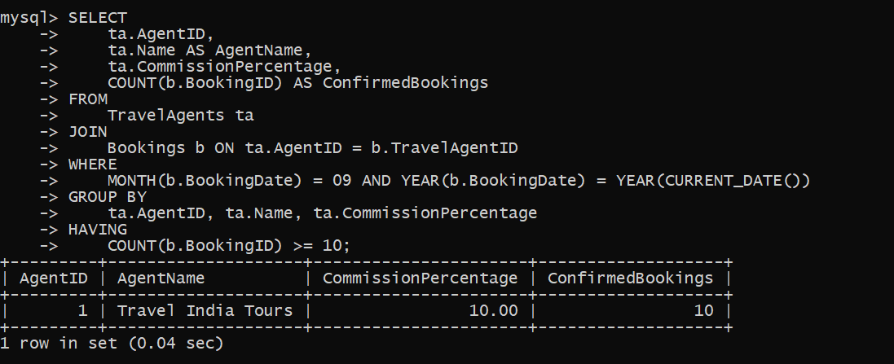

Solution 4)

SELECT

r.RouteID,

r.OriginId,

r.DestinationId,

COUNT(b.DiscountType) AS SeniorCitizenBookings

FROM

Routes r

JOIN

TrainSchedules ts ON r.RouteID = ts.RouteID

LEFT JOIN

Bookings b ON r.RouteID = b.RouteID AND ts.ScheduleID = b.ScheduleID

WHERE

lower( b.DiscountType) = 'senior citizen'

GROUP BY

r.RouteID, r.OriginId, r.DestinationId

ORDER BY

SeniorCitizenBookings DESC

limit 1;

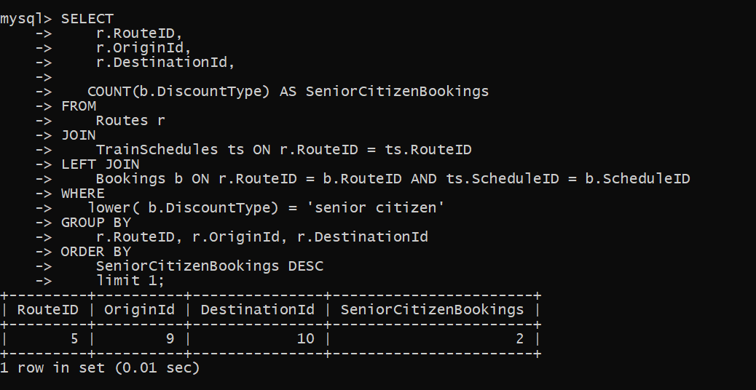

Solution 5)

select a.routeid,a.originid,a.destinationid,a.totalschedules,a.ontimeschedules from (

SELECT

r.RouteID,

r.OriginID,

r.DestinationId,

COUNT(ts.ScheduleID) AS TotalSchedules,

SUM(CASE WHEN ts.ActualArrivalTime = ts.ArrivalTime THEN 1 ELSE 0 END) AS OnTimeSchedules

FROM

Routes r

JOIN

TrainSchedules ts ON r.RouteID = ts.RouteID

GROUP BY

r.RouteID) a where totalschedules= ontimeschedules;

