Set B)

Solution1)

select ts.*,d.* from trainschedules as ts join drivers as d on ts.driverid = d.driverid where ts.date = "2023-10-10”;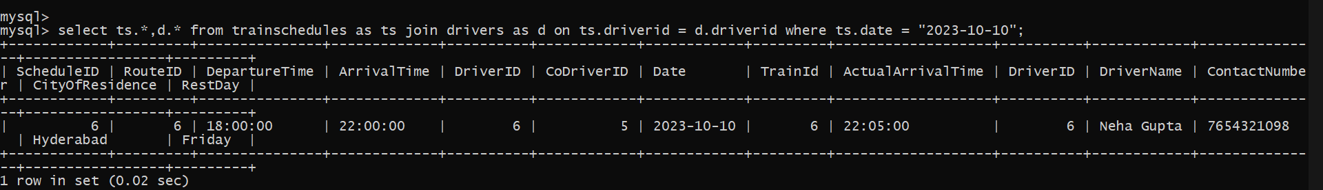

Solution 2)SELECT

c.CoachNumber,

c.Mileage,

c.LastMaintenanceDate,

COUNT(ts.ScheduleID) AS TotalScheduledTrips

FROM

Coaches c

JOIN

TrainSchedules ts ON c.Train_id = ts.TrainId

WHERE

c.Mileage BETWEEN 4000 AND 4999

AND MONTH(ts.Date) = 9 AND YEAR(ts.Date) = YEAR(CURRENT_DATE())

GROUP BY

c.CoachNumber, c.Mileage, c.LastMaintenanceDate;

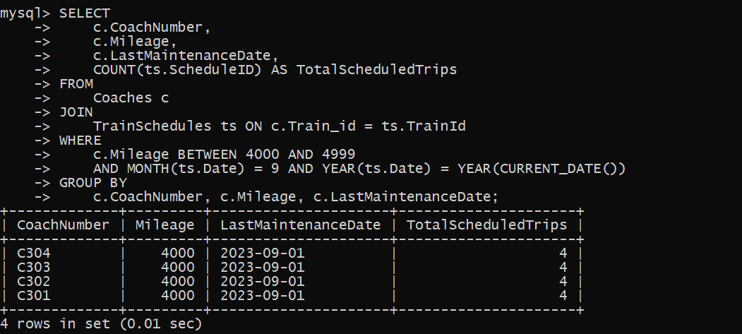

Solution 3)

SELECT

ta.AgentID,

ta.Name AS AgentName,

r.RouteID,

r.Originid,

r.Destinationid,

COUNT(b.BookingID) AS TotalBookings,

COUNT(CASE WHEN b.Iscancelled IS NULL THEN 1 END) AS ConfirmedBookings,

(COUNT(CASE WHEN b.iscancelled IS NULL THEN 1 END) / COUNT(b.BookingID)) * 100 AS PercentageConfirmedBookings

FROM

TravelAgents ta

JOIN

Bookings b ON ta.AgentID = b.TravelAgentID

JOIN

TrainSchedules ts ON b.ScheduleID = ts.ScheduleID

JOIN

Routes r ON ts.RouteID = r.RouteID

WHERE

MONTH(b.BookingDate) = 01 AND YEAR(b.BookingDate) = YEAR(CURRENT_DATE())

GROUP BY

ta.AgentID, ta.Name, r.RouteID, r.Originid, r.Destinationid

ORDER BY

PercentageConfirmedBookings DESC;

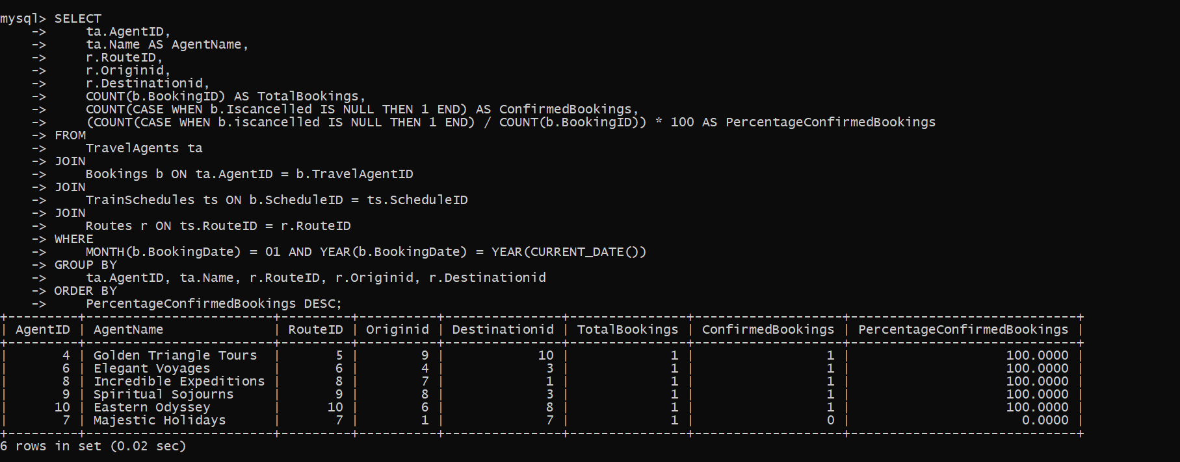

Solution 4)

SELECT

r.RouteID,

r.Originid,

r.Destinationid,

COUNT(b.BookingID) AS TotalBookings,

COUNT(CASE WHEN b.TravelAgentID IS NULL THEN 1 END) AS BookingsNotByAgents,

(COUNT(CASE WHEN b.TravelAgentID IS NULL THEN 1 END) / COUNT(b.BookingID)) * 100 AS PercentageBookingsNotByAgents

FROM

Routes r

JOIN

TrainSchedules ts ON r.RouteID = ts.RouteID

JOIN

Bookings b ON ts.ScheduleID = b.ScheduleID

GROUP BY

r.RouteID, r.Originid, r.Destinationid

HAVING

BookingsNotByAgents > COUNT(b.BookingID) / 2;

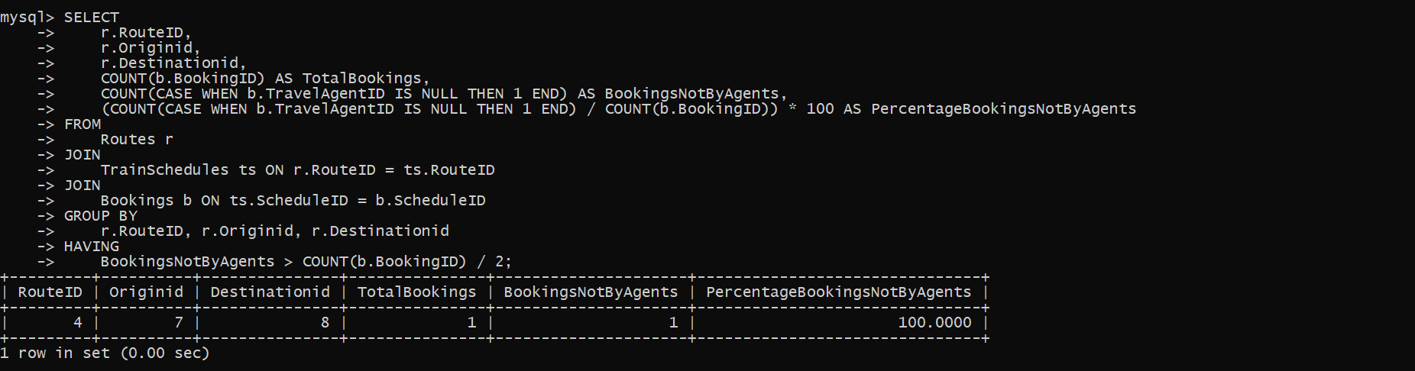

Solution 5)

SELECT

ta.AgentID,

ta.Name AS AgentName,

ta.CommissionPercentage,

((sum(b.ticketprice) *0.1)) AS TotalCommission

FROM

TravelAgents ta

JOIN

Bookings b ON ta.AgentID = b.TravelAgentID

WHERE

MONTH(b.BookingDate) = 09 AND YEAR(b.BookingDate) = YEAR(CURRENT_DATE())

GROUP BY

ta.AgentID, ta.Name, ta.CommissionPercentage

ORDER BY

TotalCommission DESC;

