**Assignment 3B**

**Code :**

# Index: server.js

const express = require("express");

const bodyParser = require("body-parser");

const app = express();

app.use(bodyParser.urlencoded(

{ extended: true }));

app.use(bodyParser.json());

const UserRoute = require("./routes/User");

app.use("/user", UserRoute);

const dbConfig = require("./config/database.con fig.js"); const mongoose = require("mongoose");

mongoose.Promise = global.Promise; mongoose .connect(dbConfig.url, { useNewUrlParser: true,

})

.then(() => {console.log("Database Connected Successfully!!");

})

.catch((err) => { console.log("Could not connect to the database", err);

process.exit(); });

app.get("/", (req, res) => {

res.json({ message: "Hello

Crud Node Express" }); });

app.listen(3000, () => { console.log("Server is

listening on port 3000");

# Routes: User.js

const express = require("express");

const UserController = require("../controllers/User")

const router = express.Router();

router.get("/", UserController.findAll); router.get("/:id", UserController.findOne); router.post("/", UserController.create); router.patch("/:id", UserController.update); router.delete("/:id", UserController.destroy);

module.exports = router;

# Model: User.js

var mongoose = require("mongoose");

var schema = new mongoose.Schema({

email: { type: String, required: true, unique: true },

firstName: { type: String, default: "" },

lastName: { type: String, default: "" },

phone: String,

});

var user = new mongoose.model("User", schema);

module.exports = user;

Output :

Creating user

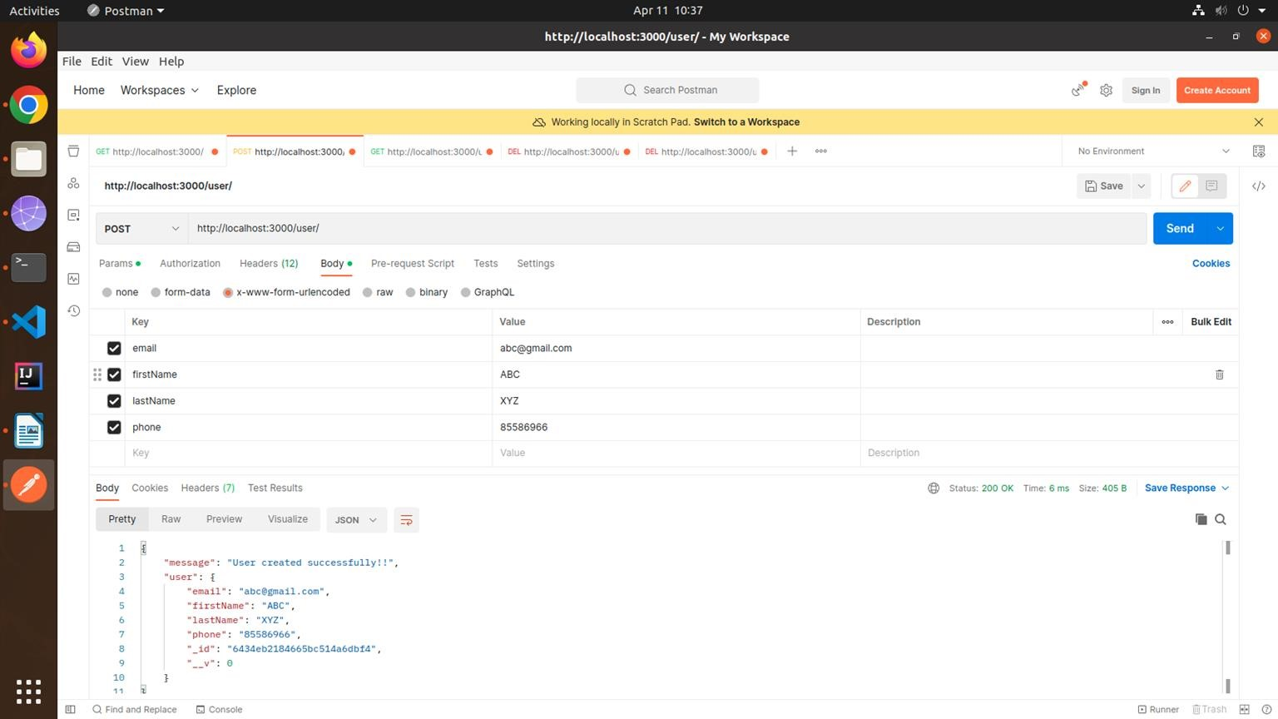

Displaying single user

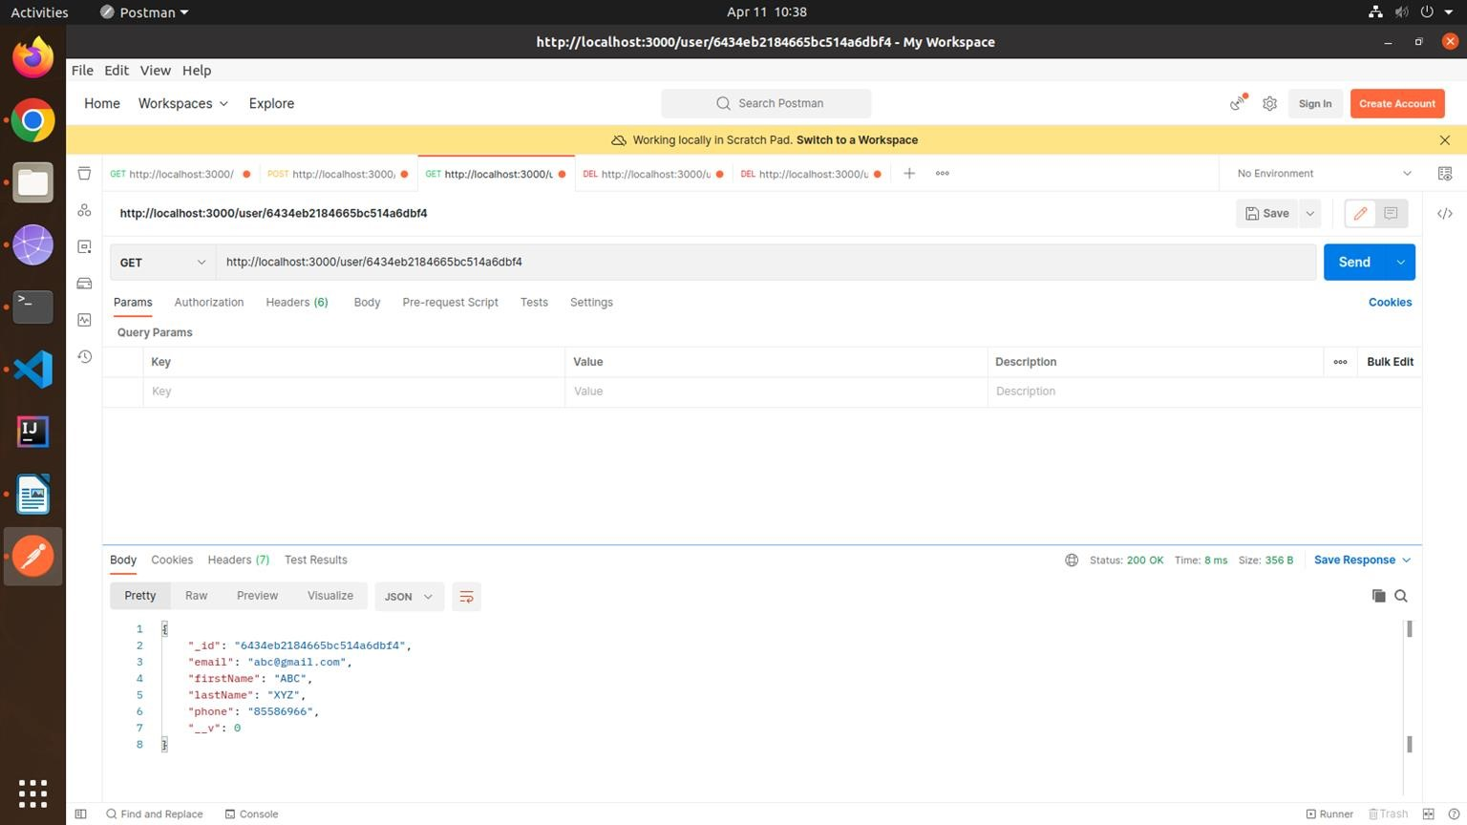

Updating user



Deleting user

