PROBABILITY FOR COMPUTING
UPC :- 2342011203

RAMANUJAN COLLEGE UNIVERSITY OF DELHI

PRACTICAL FILE FOR
DSC – 06 : PROBABILITY FOR COMPUTING

SEMESTER – 2
SESSION – 2025-26

Submitted By:- Submitted To:-

Name: Aditya Kumar Jha College Roll No.: 25570003
University Roll No.: 25020570033

Course: B.Sc (Hons) Computer Science
Dr. Aakash Assistant Professor (Operational Research),
Department of Computer Science,
Ramanujan College, University of Delhi

Acknowledgement

I would like to express my heartfelt gratitude to Dr. Aakash, Assistant Professor (Operational Research), Ramanujan College, University of Delhi, for providing me with the opportunity to work on this practical file for Probability for Computing – 1. His guidance and encouragement have been invaluable throughout the preparation of this file.

I am also thankful to my peers and the faculty members of the Computer Science Department for their continuous support and valuable insights, which have greatly enriched my understanding for the subject.

Finally, I extend my sincere appreciation to my family and friends for their constant motivation and encouragement, which has been a source of strength in completing this work successfully.

Name : Aditya Kumar Jha University Roll No. : 25020570033
Signature :

INDEX

S.  No. | Topic | Page No.
i | Title Page | 1
ii | Acknowledgement | 2
iii | Index | 3-4
1. | Plotting and fitting of Binomial distribution and graphical representation of probabilities. | 5-6
2. | Plotting and fitting of Multinomial distribution and graphical representation of probabilities. | 7
3. | Plotting and fitting of Poisson distribution and graphical representation of probabilities. | 8
4. | Plotting and fitting of Geometric distribution and graphical representation of probabilities. | 9
5. | Plotting and fitting of Uniform distribution and graphical representation of probabilities. | 10
6. | Plotting and fitting of Exponential distribution and graphical representation of probabilities. | 11
7. | Plotting and fitting of Normal distribution and graphical representation of probabilities. | 12-13
8. | Calculation of cumulative distribution functions for Exponential and Normal distribution. | 14
9. | Given data from two distributions, find the distance between the distributions. | 15
10. | Application problems based on the Binomial distribution. | 16-17
11. | Application problems based on the Poisson distribution. | 18
12. | Application problems based on the Normal distribution. | 19

S.  No. | Topic | Page No.
13. | Presentation of bivariate data through scatter-plot diagrams and calculations of covariance. | 20-21
14. | Calculation of Karl Pearson’s correlation coefficients. | 22
15. | To find the correlation coefficient for a bivariate frequency distribution. | 23
16. | Generating Random numbers from discrete (Bernoulli, Binomial, Poisson) distributions. | 24
17. | Generating Random numbers from continuous (Uniform, Normal) distributions. | 25
18. | Find the entropy from the given data set. | 26-27
19. | References | 28

Practical 1: Plotting and Fitting of Binomial Distribution and Graphical Representation of Probabilities
Binomial Distribution:
The Binomial Distribution is a discrete probability model applied to experiments that yield exactly two possible outcomes — commonly termed success and failure — such as flipping a coin or testing a product for defects.

Formula:
P(X = x; n, p) = C(n, x) × p^x × (1 − p)^(n − x)

Where:
- P(X = x; n, p) — the probability of obtaining exactly x successes in n independent trials
- p — the probability of success on any single trial
- n — the total number of trials conducted
- x — the number of successes of interest

Excel Implementation:
BINOM.DIST(number_s, trials, probability_s, cumulative)
- number_s: the desired number of successes
- trials: the total number of independent trials
- probability_s: the probability of success per trial
- cumulative: use FALSE for the exact probability; TRUE for the cumulative probability up to x

Skewness in Binomial Distribution:
- When p = 0.5, the distribution is perfectly symmetric for any value of n.
- When p ≠ 0.5, the distribution exhibits skewness.
- If p < 0.5, the distribution is right-skewed (positively skewed) — probability mass concentrates at lower values with a tail extending rightward.
- If p > 0.5, the distribution is left-skewed (negatively skewed) — probability mass shifts toward higher values with the tail stretching leftward.
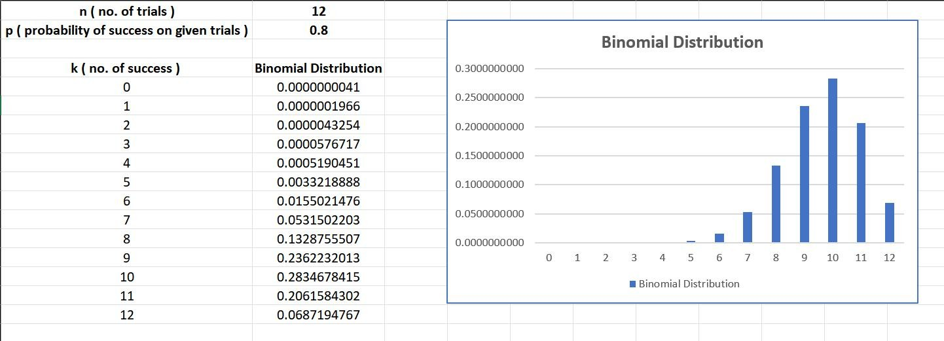

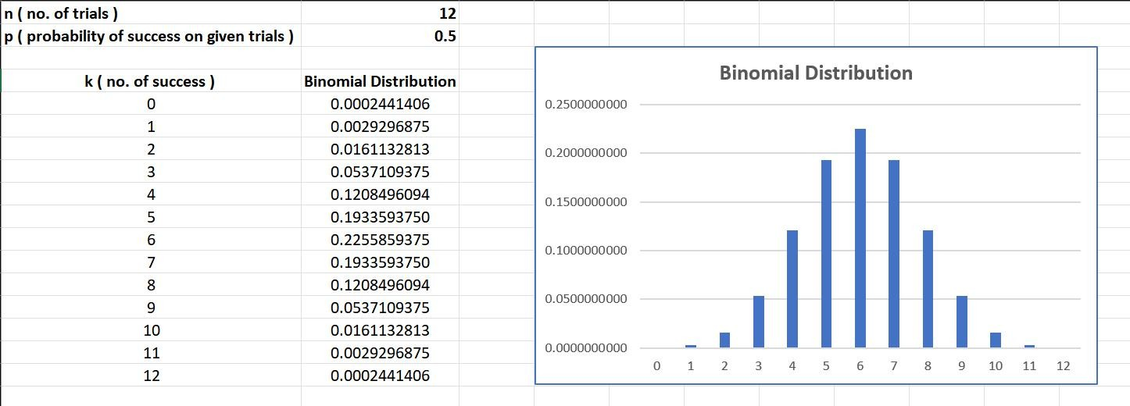
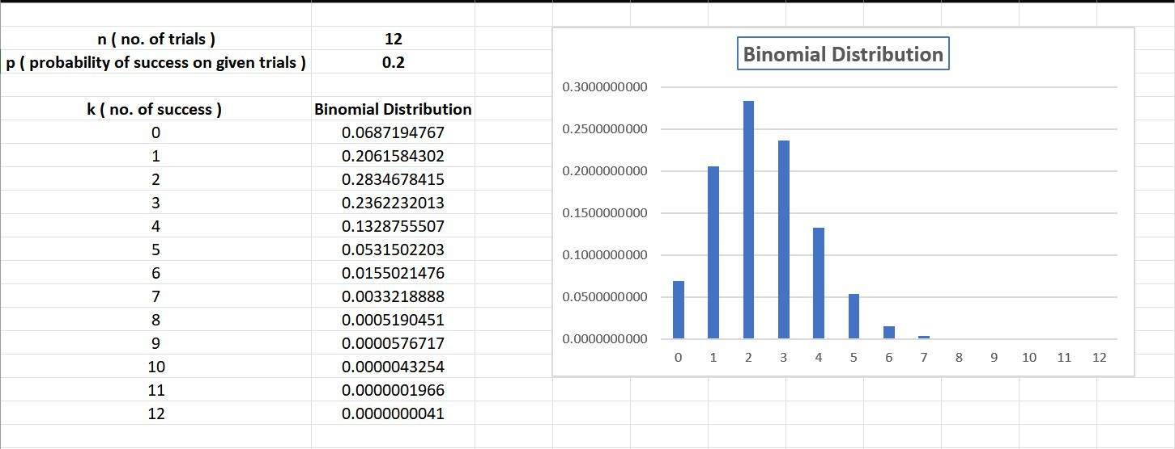

Data Interpretation:
The binomial distribution graph displays a symmetric bell-like shape when p = 0.5, confirming that success and failure are equally probable.
As p moves away from 0.5, the distribution becomes progressively skewed; the plotted bars clearly reflect the theoretical mean (np) and standard deviation (√np(1−p)), validating the model parameters.

Practical 2: Plotting and Fitting of Multinomial Distribution and Graphical Representation of Probabilities

Multinomial Distribution:
The multinomial distribution extends the binomial distribution to situations involving more than two outcome categories. Consider an experiment with exactly k possible outcomes in each trial, where the probability of outcome i is pᵢ (with pᵢ ≥ 0 and Σpᵢ = 1), and n independent trials are performed. If Xᵢ denotes the number of times outcome i is observed, then the vector X = (X₁, X₂, …, Xk) follows a multinomial distribution with parameters n and p = (p₁, p₂, …, pk).

Formula (PMF):
P(X₁=x₁, X₂=x₂, ..., Xk=xk) = [n! / (x₁! × x₂! × ⋯ × xk!)] × p₁^x₁ × p₂^x₂ × ⋯ × pk^xk

Where:
- n = total number of trials
- xᵢ = observed count for outcome i
- pᵢ = probability of outcome i occurring
- Constraints: Σxᵢ = n and Σpᵢ = 1

Note: Each individual Xᵢ follows a binomial distribution with parameters n and pᵢ.
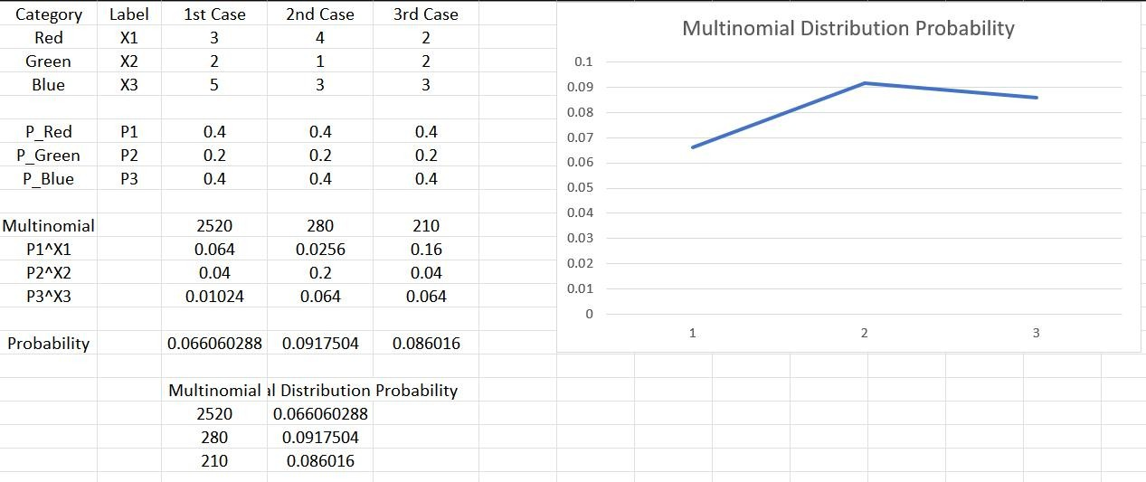

Data Interpretation:
The bar chart for the multinomial distribution illustrates how probability is spread across k outcome categories, with each bar's height directly proportional to its corresponding pᵢ value.
The total of all bar heights equals 1, and categories with higher assigned probabilities visibly dominate the chart, confirming that the plotted data aligns with the theoretical multinomial structure.

Practical 3: Plotting and Fitting of Poisson Distribution and Graphical Representation of Probabilities

Poisson Distribution:
The Poisson distribution is a discrete probability distribution that models the number of times a specific event occurs within a fixed interval of time or space. It depends on a single parameter λ (lambda), which represents the average rate of occurrence per interval.

Formula:
P(X = k) = (e^−λ × λ^k) / k!

Where:
- λ = expected (average) number of occurrences per interval
- k = observed number of occurrences (k = 0, 1, 2, 3, ...)
- e ≈ 2.71828 (Euler's number)
- P(X = k) = probability of exactly k events occurring in the interval

Excel Implementation:
POISSON.DIST(k, λ, cumulative)
Use FALSE as the cumulative argument to obtain the exact probability for a specific k value.
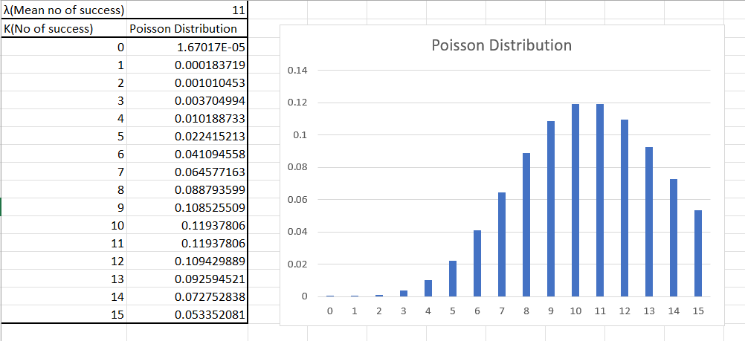

Data Interpretation:
For small values of λ, the Poisson distribution graph is noticeably right-skewed. As λ increases, the distribution becomes progressively more symmetric and approaches a normal-like bell shape.
The peak of the distribution appears near k = λ, demonstrating that the most likely number of events closely tracks the average rate of occurrence.

Practical 4: Plotting and Fitting of Geometric Distribution and Graphical Representation of Probabilities

Geometric Distribution:
The geometric distribution is a discrete probability distribution that models the number of consecutive failures encountered before achieving the first success in a series of independent Bernoulli trials. Each trial has exactly two possible outcomes (success or failure), and the probability of success p remains constant throughout.

Key Assumptions:
- All trials are mutually independent.
- Each trial results in either success or failure — no other outcomes exist.
- The probability of success, p, is fixed and does not vary across trials.

Formula:
P(X = k) = (1 − p)^k × p

Where:
- k = number of failures before the first success (k = 0, 1, 2, ...)
- p = probability of success on each individual trial
- q = 1 − p = probability of failure on each trial

Excel Implementation:
Probability = (1 − p)^k × p
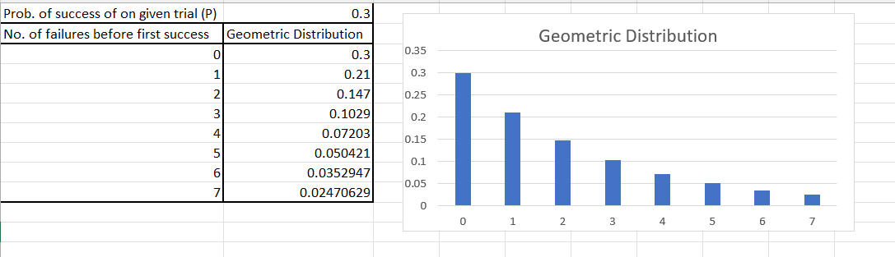
Data Interpretation:
The graph of the geometric distribution shows a steadily decreasing probability as k (number of failures before first success) increases, capturing the diminishing chance of having to wait longer for success.
The rate at which the curve declines is governed by p — a larger p produces a steeper drop, signifying that success is reached sooner on average.

Practical 5: Plotting and Fitting of Uniform Distribution and Graphical Representation of Probabilities

Uniform Distribution:
A uniform distribution assigns equal probability to every value within a specified range, making all outcomes within the interval equally likely. It is also called the rectangular distribution. It is characterized by two parameters: a (minimum value) and b (maximum value), and is denoted as U(a, b).

Probability Density Function (PDF):

f(x) = 1 / (b − a), for a ≤ x ≤ b f(x) = 0, otherwise

Excel Implementation — Required Inputs:
- a: the minimum value of the distribution
- b: the maximum value of the distribution
- x₁: the lower bound of the sub-interval of interest
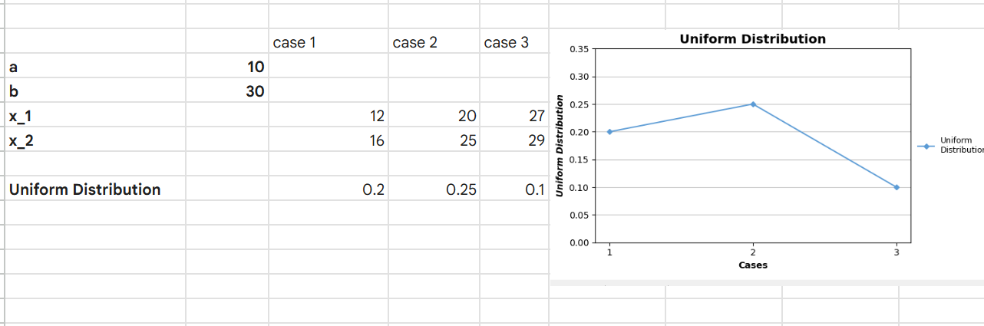
- x₂: the upper bound of the sub-interval of interest Probability of x falling in [x₁, x₂] = (x₂ − x₁) / (b − a)

Data Interpretation:
The uniform distribution is represented visually as a flat, horizontal probability density function between a and b, confirming that every value in the interval carries the same probability.
The histogram generated from sampled values closely matches the expected rectangular shape, and the sample mean converges toward (a + b)/2, consistent with the theoretical expectation.

Practical 6: Plotting and Fitting of Exponential Distribution and Graphical Representation of Probabilities

Exponential Distribution:
The exponential distribution is a continuous probability distribution used to model the time elapsed before a specified event takes place. It applies when the likelihood of an event occurring in any given interval is directly proportional to the length of that interval.

Real-Life Applications:
- Time a shopkeeper waits for the next customer to arrive.
- Duration a battery operates before it runs out of charge.
- Length of time a computer system functions without a failure or breakdown.

Formula:

PDF: f(x; λ) = λ × e^(−λx), for x ≥ 0 CDF: F(x; λ) = 1 − e^(−λx), for x ≥ 0

Where:
- λ = rate parameter (controls the speed of decay)
- x = elapsed time or distance
- e ≈ 2.71828 (Euler's number)
Excel Implementation:
EXPON.DIST(x, lambda, cumulative)
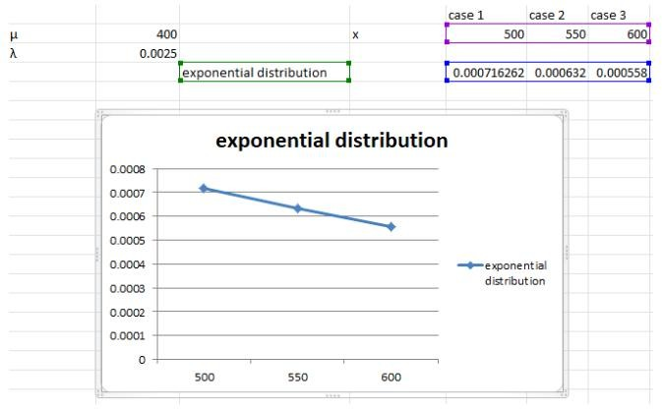
Use FALSE for the PDF value; use TRUE for the cumulative probability.

Data Interpretation:
The exponential distribution graph begins at λ when x = 0 and decreases rapidly, illustrating that events occurring sooner are far more probable than those requiring longer waiting times.

The CDF curve climbs sharply at first and then flattens near 1, showing that the majority of events are concentrated well before the mean waiting time of 1/λ.

Practical 7: Plotting and Fitting of Normal Distribution and Graphical Representation of Probabilities

Normal Distribution:
The Normal Distribution defines the probability density function of a continuous random variable. For a random variable X with mean μ and standard deviation σ, the distribution produces the characteristic symmetric bell-shaped curve.

Formula:
f(x) = (1 / (σ√(2π))) × e^(−(x − μ)² / (2σ²))

Where:
- x = the random variable
- μ (mu) = mean of the distribution
- σ (sigma) = standard deviation of the distribution

Properties of Normal Distribution:
- The mean, median, and mode are all equal for a normally distributed dataset.
- The total area enclosed under the normal curve is exactly 1.
- The curve is perfectly symmetric about its mean.
- Exactly half the values fall to the left of the mean, and half to the right.
- The shape and position of the curve are entirely determined by μ and σ.
- The normal distribution curve is unimodal — it has a single peak.

Excel Implementation:
- Enter your dataset into an Excel spreadsheet.
- Compute the mean: AVERAGE(cell range)
- Compute the standard deviation: STDEV(cell range)
- Choose an x value for evaluation.
- Apply the function: NORM.DIST(x, mean, standard_deviation, FALSE) for PDF; TRUE for CDF.

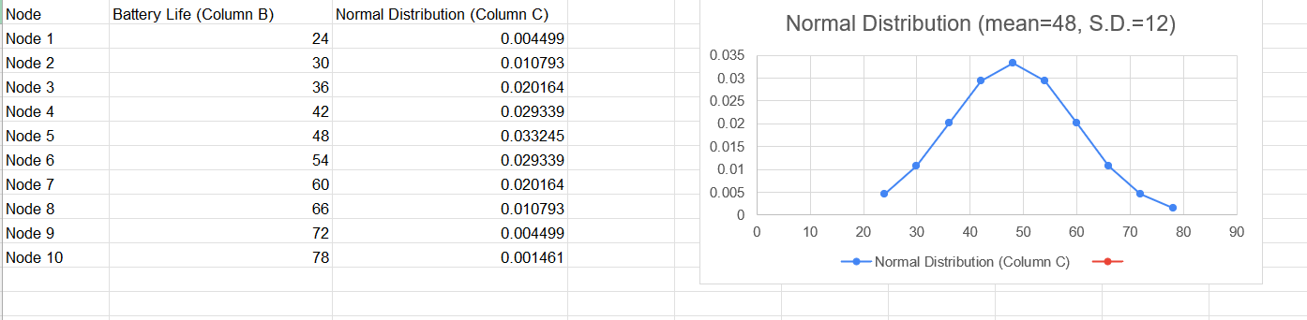

Data Interpretation:

The generated chart illustrates the fundamental characteristics of a Normal Distribution using the Smartwatch battery life data:
- The Peak (The Mean): The absolute highest point of the curve is exactly at 48 Hours. This indicates that a battery life of 48 hours is the most probable outcome for the watches tested.
- Perfect Symmetry: The graph is perfectly balanced at the 48-hour mark. The likelihood of a watch lasting 12 hours less than the mean (36 hours) is identical to the likelihood of it lasting 12 hours more than the mean (60 hours).
- Empirical Rule (68-95-99.7): * Consistent with the empirical rule, approximately 68% of the watches will have a battery life between 36 and 60 hours (within one standard deviation: $48 \pm 12$).
  - About 95% will fall between 24 and 72 hours (within two standard deviations: $48 \pm 24$).
- The Tails: As we move toward the extreme ends—such as a very short battery life of 12 hours or a very long life of 84 hours—the curve approaches zero. These "tails" show that extreme outliers are statistically rare in this population.

Practical 8: Calculation of Cumulative Distribution Functions for Exponential and Normal Distribution

The cumulative distribution function (CDF) gives the probability that a random variable X takes a value less than or equal to a specified x. Below are the CDFs for the Exponential and Normal distributions and their Excel implementations.

Exponential CDF:

Excel: EXPON.DIST(x, lambda, TRUE)

Normal CDF:

F(x; λ) = 1 − e^(−λx), x ≥ 0

F(x; μ, σ) = Φ((x − μ) / σ)

Excel: NORM.DIST(x, mean, standard_deviation, TRUE)
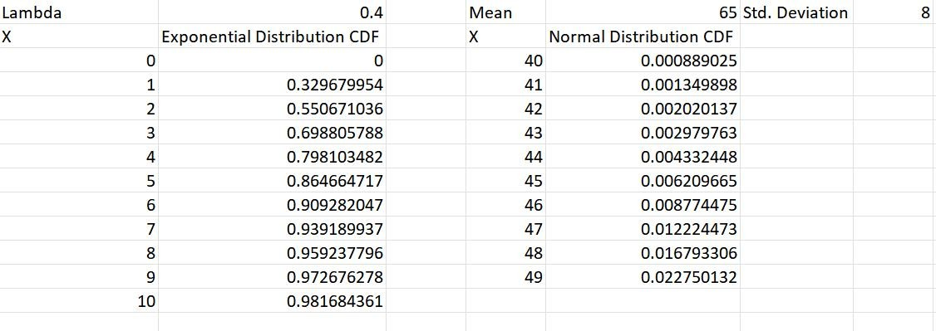

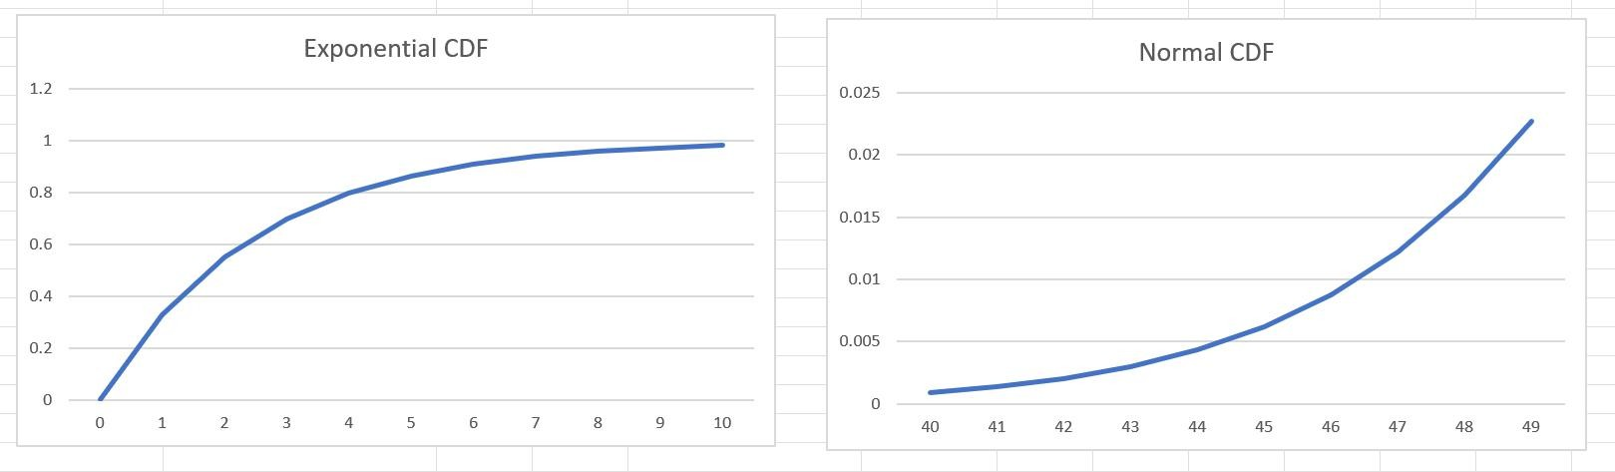
Data Interpretation:
The CDF plot for the exponential distribution rises steeply from zero and levels off as it approaches 1, while the normal distribution CDF traces a smooth S-shaped (sigmoidal) curve centred at the mean.

Both CDFs increase monotonically from 0 to 1, and the point at which each function reaches 0.5 precisely corresponds to the median of the respective distribution.

Practical 9: Given Data from Two Distributions, Find the Distance Between the Distributions

Euclidean Distance:
Euclidean distance measures the straight-line separation between two points in a multi-dimensional space. It is computed as the square root of the sum of squared differences between corresponding elements of two vectors.

Formula:
d(X, Y) = √ Σ(xᵢ − yᵢ)²

Excel Implementation:
= SQRT(SUMXMY2(array_X, array_Y))
Where array_X and array_Y are the two data ranges being compared.
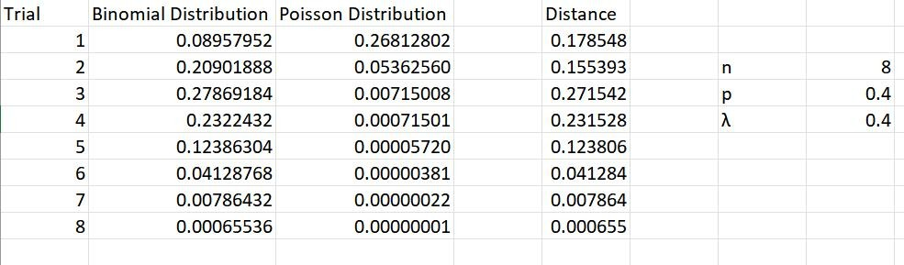

Data Interpretation:
The scatter plot of the two distributions visually highlights the spatial gap between their data clusters, while the Euclidean distance quantifies how far apart they are in feature space.
A smaller Euclidean distance value implies greater resemblance between the two distributions, whereas a larger value indicates clearly distinct and well-separated probability profiles.

Practical 10: Application Problems Based on the Binomial Distribution

Problem:
A cybersecurity firm develops a new machine learning model to filter spam emails. The company claims that the model has an 85% success rate ( $p=0.85$) in correctly identifying spam emails.
An IT auditor randomly selects $n=15$emails that have already been flagged as spam to verify the model's performance. Each email is classified as either “Correctly Identified” (success) or “Misclassified” (failure).
Assuming the model performs as claimed, the number of correctly identified emails $X$follows a Binomial distribution:
$$X∼B(15,0.85)$$
where $X$can take values from 0 to 15.
The auditor aims to evaluate whether the actual identification rate is lower than the stated 85%. Under the null assumption that $p=0.85$, the sample data is used to test whether the observed number of successes provides evidence in favor of $p<0.85$.
In the sample of 15 emails, only 8 are correctly identified. This gives an observed success proportion of:
$$\frac{8}{15}≈0.53$$
which is significantly lower than the claimed rate of 0.85.
This large discrepancy provides strong evidence against the company’s claim. Using the binomial probability formula, the probability:
$$P(X≤8∣n=15,p=0.85)$$
is extremely small. This indicates that observing 8 or fewer correctly identified emails is highly unlikely if the true success rate were actually 85%.
Therefore, the sample results strongly suggest that the model’s actual performance is lower than the claimed level.

Excel Implementation:
In your Probability column (Cell B2), use this syntax:
=BINOM.DIST(k, n, p, cumulative)

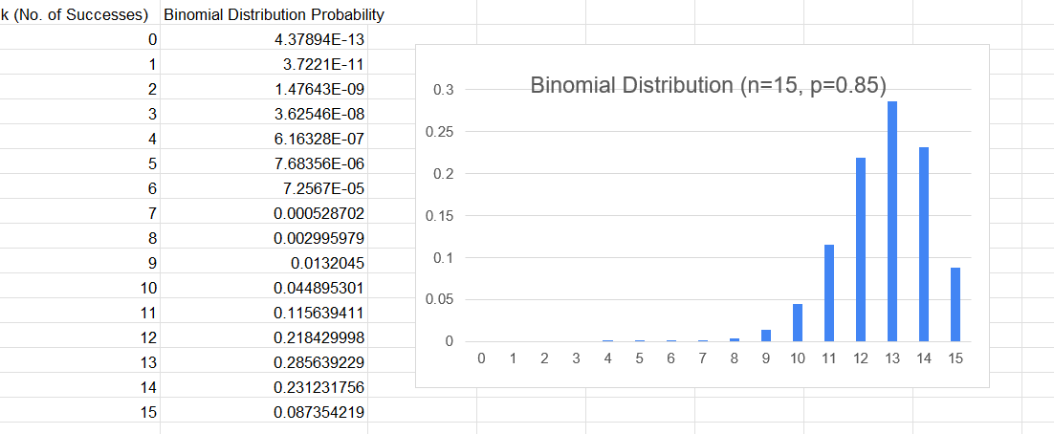

Data Interpretation:
The binomial probability chart for this cybersecurity scenario shows that the probability of correctly identifying 8 or fewer spam emails under the assumption $p=0.85$is negligibly small. This provides strong statistical evidence against the company’s performance claim, suggesting that the true success probability of the model is likely well below the stated 85%.
Since $p>0.5$, the distribution is negatively skewed (left-skewed), with the probability mass concentrated toward higher values.

Practical 11: Application Problems Based on the Poisson Distribution

Problem:
A high-traffic tech blog monitors its server performance to ensure uptime during peak hours. Data from the server logs indicates that the blog receives an average of 6 comments per hour ( $λ=6$) during the evening.
Since comment submissions are independent events occurring at a constant average rate, the number of comments per hour follows a Poisson distribution:
$$X∼\text{Poisson}(6)$$
The IT team aims to determine the probability of receiving exactly 0 to 12 comments in a single hour in order to effectively manage server load and moderation queues.
Additionally, they need to calculate the probability that more than 10 comments arrive during the same period, as this situation may trigger an automated anti-spam filter.
From a system management perspective, the team must recommend a moderation capacity that can handle at least 95% of all possible comment arrival scenarios.

Excel Implementation
To model this scenario dynamically, use the following generalized formula:
=POISSON.DIST(k, λ, cumulative)

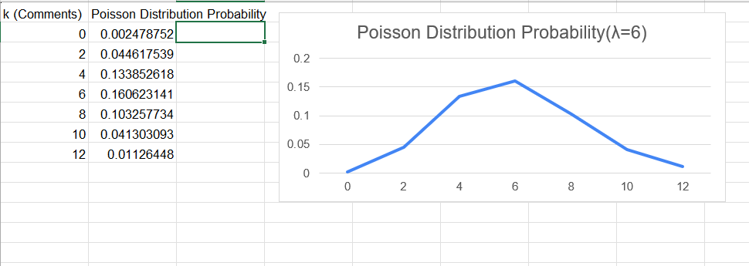

Data Interpretation:
The Poisson probability chart confirms that comment arrivals are most concentrated around $λ=6$, with probabilities decreasing as the count moves further away from the mean. Since $λ$is relatively small, the distribution is slightly right-skewed; however, it gradually approaches a more symmetric, bell-shaped form as the rate increases.
The probability of receiving more than 10 comments per hour is very low (approximately 4%), indicating that a moderation capacity designed to handle 10–11 comments per hour would comfortably cover over 95% of all possible scenarios.
This allows the IT team to optimize server resources efficiently without over-provisioning for infrequent spikes in activity.

Practical 12: Application Problems Based on the Normal Distribution

Problem:
A semiconductor manufacturer produces a specific series of high-performance microprocessors. To ensure quality control and optimize product grading, engineers measure the actual clock speed (in GHz) of 25 randomly selected processors from a single production batch.
Historical data indicates that the processing speeds follow a normal distribution, characterized by a symmetric bell-shaped curve.
For this study, the production line is monitored to determine whether the batch meets the target performance parameters: a mean ( $μ$) of 3.50 GHz and a standard deviation ( $σ$) of 0.15 GHz.
This data is used to calculate the probability of chips falling within specific performance ranges and to identify rare outliers that may require further testing.

Excel Implementation
To model the performance of the microprocessors dynamically, apply the generalized NORM.DIST function to calculate the probability density at each data point:
=NORM.DIST(x, mean, standard_dev, cumulative)
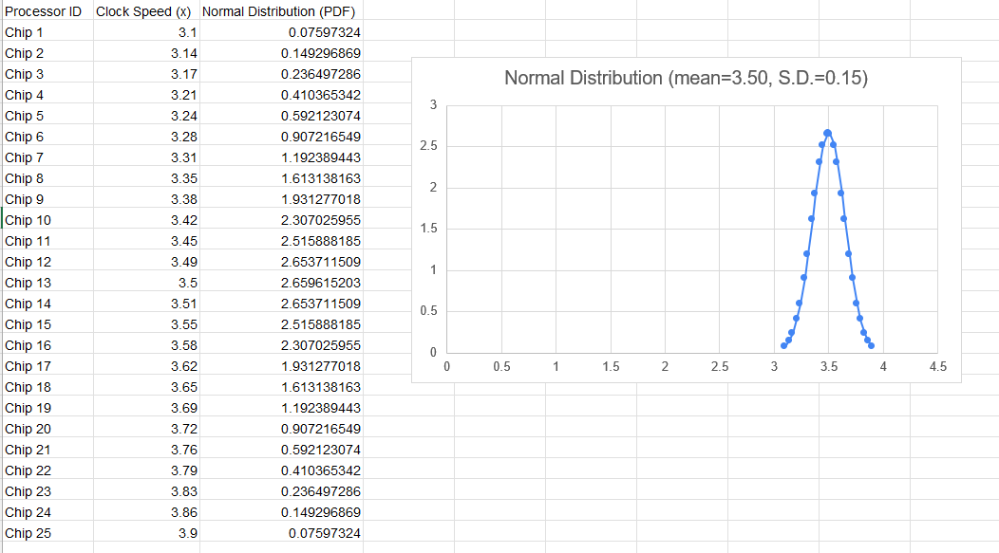
Data Interpretation:

The Peak: The highest probability density occurs exactly at the mean of 3.50 GHz, confirming that this is the most expected performance level.
Symmetry: The distribution is perfectly balanced; a speed of 3.35 GHz has the same probability density as 3.65 GHz.
Empirical Rule: Approximately 68% of the microchips operate within the range of 3.35 to 3.65 GHz.
Tails: The probability decreases significantly as values approach 3.10 GHz or 3.90 GHz, indicating that these are rare outliers.

Practical 13: Presentation of Bivariate Data Through Scatter-Plot Diagrams and Calculation of Covariance

Bivariate Analysis:
Bivariate analysis examines the relationship between two variables simultaneously — one dependent (Y) and one independent (X). The goal is to understand how changes in one variable correspond to changes in the other.

Three Common Approaches:
- Scatter Plots
- Correlation Coefficient
- Simple Linear Regression (SLR)

Bivariate Frequency Distribution:
A bivariate frequency distribution records the joint frequency of two variables simultaneously — for instance, sales revenue and advertising expenditure, or an individual's height and weight.

Significance in Business Research:
- Decision Making — enables data-driven choices
- Market Segmentation — identifies distinct customer groups
- Risk Assessment — quantifies exposure and uncertainty
- Resource Allocation — guides efficient distribution of assets

Covariance — Excel Function:
= COVARIANCE.P(array1, array2)

Key Notes on Covariance and Correlation:
- Text or logical values in the arrays are ignored by the COVARIANCE function.
- Both arrays must contain only numeric data; non-numeric cells are excluded.
- Both arrays must have the same number of data points.
- Datasets must not be empty and should not have a standard deviation of zero.
- Covariance measures the joint variability between two random variables.
- Correlation is a standardised measure indicating the strength and direction of linear association.
- Covariance is in essence an unstandardised measure of correlation.
- Correlation is essentially a scaled version of covariance.
- Covariance ranges from −∞ to +∞; correlation ranges from −1 to +1.
- Covariance indicates the direction of the linear relationship between two variables.
- Correlation captures both the strength and direction of the linear relationship.
- Covariance is sensitive to changes in the measurement scale.

- Correlation is scale-invariant and unaffected by changes in units.

Pearson Correlation Coefficient — Excel Function:
= PEARSON(array1, array2)

Scatter Plot — Excel Steps:
Click the Insert tab on the ribbon → Click Scatter Chart in the Charts group.

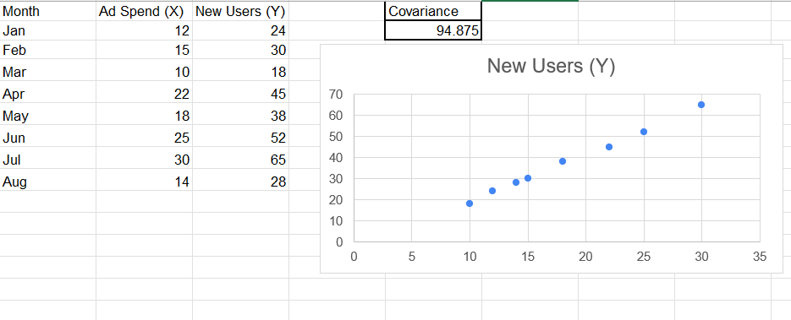

Data Interpretation:

The scatter plot for the e-commerce marketing dataset (Ad Spend vs. New Users) reveals a strong positive linear relationship between the variables. The Covariance value of 94.875 indicates that the two variables move in the same direction; as the marketing expenditure increases, the number of new user acquisitions also increases significantly.
The close alignment of the data points in the scatter diagram suggests high linear dependence. From a business management perspective, this implies that the current ad spend strategy is effective, and increasing the budget is likely to result in further user growth.

Practical 14: Calculation of Karl Pearson's Correlation Coefficients

Karl Pearson's Correlation Coefficient (r):
Karl Pearson’s coefficient of correlation measures the degree and direction of the linear relationship between two continuous variables. It is a dimensionless index ranging from $-1$to $+1$, where $+1$indicates a perfect positive linear relationship and $-1$indicates a perfect negative linear relationship.

Formula:
r = [Σ(xᵢ − x̄)(yᵢ − ȳ)] / [√Σ(xᵢ − x̄)² × √Σ(yᵢ − ȳ)²]

Excel Function:
= CORREL(array1, array2)
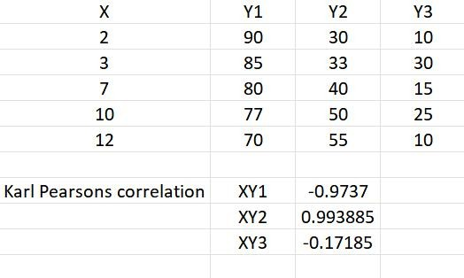

Data Interpretation:
The computed Pearson correlation coefficient quantifies the strength and direction of the linear relationship between the two variables in the dataset.
A coefficient close to +1 or −1 confirms a strong linear association, whereas a value close to 0 suggests that no significant linear relationship exists between the variables.

Practical 15: Finding the Correlation Coefficient for a Bivariate Frequency Distribution

Concept:
When data is presented in a bivariate frequency table (cross-tabulation of two variables), the correlation coefficient is computed using the joint frequency distribution. This method extends the Pearson correlation concept to grouped data, allowing for the analysis of relationships within large populations where individual values are categorized into class intervals

Steps:
- Construct the bivariate frequency table with class intervals for both X and Y.
- Calculate the midpoints for each class of X and Y.
- Compute the means (x̄ and ȳ) and standard deviations (σx and σy).
- Evaluate the covariance using joint frequencies.
- Apply: r = Cov(X, Y) / (σx × σy)
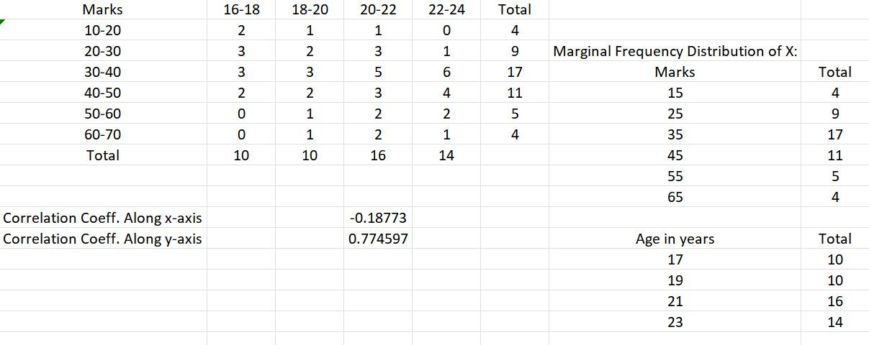

Data Interpretation:
The bivariate frequency distribution table and the corresponding scatter plot reveal the co-variation pattern between the two variables, with clusters appearing at certain combinations of values.
The region of highest frequency corresponds to the modal class, and the overall spread of the scatter diagram is consistent with the computed correlation coefficient.

Practical 16: Generating Random Numbers from Discrete Distributions (Bernoulli, Binomial, Poisson)

Excel Implementation:

Bernoulli Distribution:
= BINOM.INV(1, p, RAND())
This generates 1 (success) with probability p and 0 (failure) with probability 1 − p.

Binomial Distribution:
= BINOM.INV(n, p, RAND())
Generates a random count of successes in n trials, each with probability p.

Poisson Distribution:
Excel does not have a built-in Poisson inverse function. Use the inverse CDF method:
Lookup POISSON.DIST(k, λ, TRUE) to find the k where cumulative probability ≥ RAND()
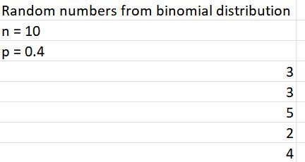

Data Interpretation:
The histograms generated from randomly sampled Bernoulli, binomial, and Poisson values closely resemble their respective theoretical probability mass functions.
As the number of generated values increases, the empirical distributions converge toward the true theoretical shapes, demonstrating the reliability of the Excel-based simulation approach.

Practical 17: Generating Random Numbers from Continuous Distributions (Uniform, Normal)

Excel Implementation:

Uniform Distribution:
= a + (b − a) × RAND()
Generates a uniformly distributed random number between a and b.

Normal Distribution:
= NORMINV(RAND(), μ, σ)
- RAND() generates a uniform random probability between 0 and 1.
- μ (mean) and σ (standard deviation) define the target normal distribution.
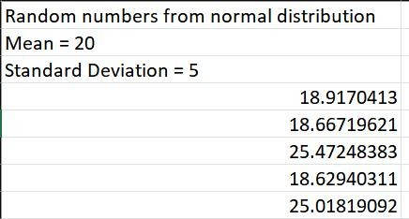

Data Interpretation:
The histograms of randomly generated uniform and normal values closely mirror their respective theoretical distributions.
The normally generated values form a bell-shaped histogram centred at μ, confirming that NORMINV(RAND(), μ, σ) in Excel reliably simulates data from a normal distribution.

Practical 18: Finding the Entropy from a Given Dataset

Entropy:
Entropy measures the average level of information, surprise, or uncertainty associated with the possible outcomes of a random variable. For a discrete random variable X with possible values in alphabet X and probability distribution P: X → [0, 1], the entropy H(X) is defined as:

Formula:
The entropy 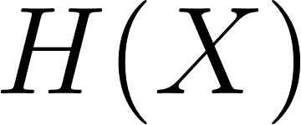 for a discrete random variable is calculated as:
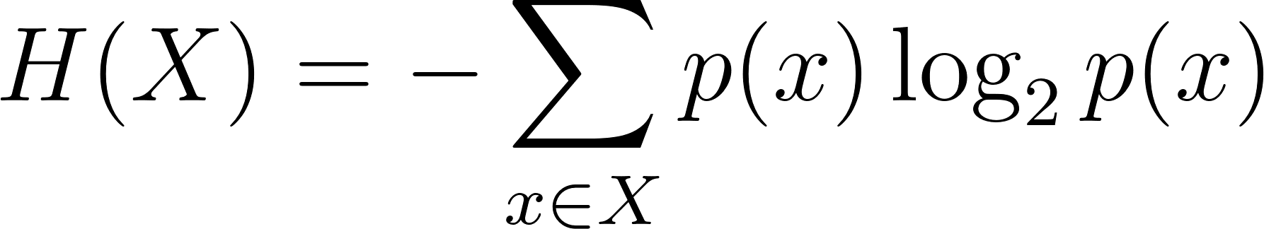

Units of Entropy:
- Base 2 logarithm → entropy measured in bits
- Base e logarithm → entropy measured in nats
- Base 10 logarithm → entropy measured in hartleys

An equivalent interpretation: entropy equals the expected (average) value of the self-information of the random variable.

Excel Implementation:
= − SUMPRODUCT(probabilities, LOG(probabilities, 2))
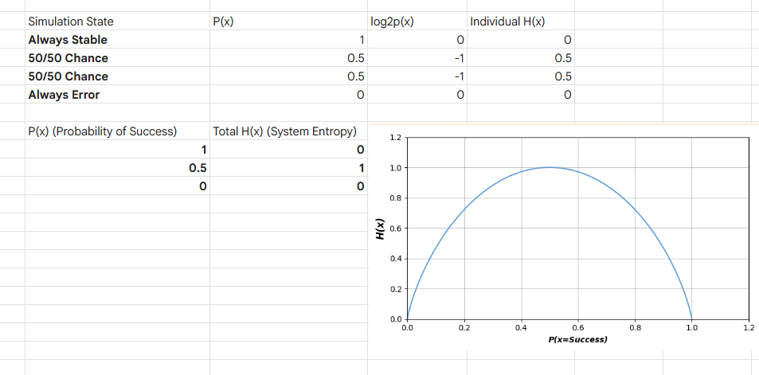
Where 'probabilities' is the range containing the probability values P(xᵢ).
Data Interpretation:
This distinctive parabolic curve is the visual representation of uncertainty.
- The Edges (Total Predictability): When 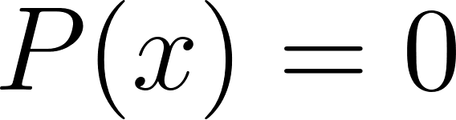 (the glass physics always crash) or when 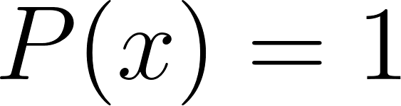 (the glass physics always simulate perfectly), the curve hits the floor at 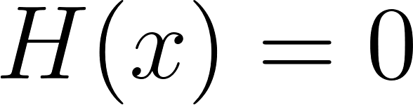. Because you know exactly what is going to happen before you even hit the render button, there is zero uncertainty and zero "information" gained by running the test.
- The Peak (Maximum Chaos): The absolute highest point of the curve is right in the middle at 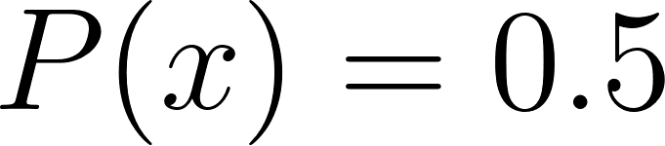, which results in exactly 1 bit of entropy ( 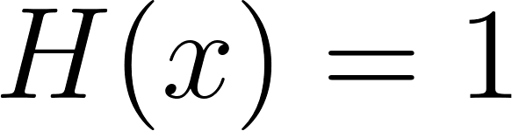 ). This is the point of maximum unpredictability. If the pipeline has a literal 50/50 chance of succeeding or failing, you possess no predictive advantage, meaning the actual outcome of the render provides the maximum possible amount of "surprise."

References
A. Academic & Case Study References
Probability Distribution Theory:
1 Binomial Distribution — Edwards, A. W. F. (1960). The meaning of binomial distribution. Nature.
2 Poisson Distribution — Clarke, R. D. (1946). An application of the Poisson distribution. Journal of the Institute of Actuaries.
3 Normal Distribution — Weisstein, E. W. (2002). Normal distribution. Wolfram MathWorld.
4 Entropy — Shannon, C. E. (1948). A Mathematical Theory of Communication. Bell System Technical Journal.
B. Specific Data Sources (Application-Based Datasets)
5 Cybersecurity & Spam Analysis — Email Spam Classification Dataset. Available at: https://www.kaggle.com/datasets/balaka18/email-spam-classification-dataset-csv
6 Website Traffic Logs — Daily Website Visitors Dataset. Available at: https://www.kaggle.com/datasets/bobnau/daily-website-visitors
7 Hardware Performance (CPU/GPU) — CPU and GPU Product Data. Available at: https://www.kaggle.com/datasets/michaelbryantds/cpu-and-gpu-product-data
8 Marketing & Customer Acquisition — Customer Acquisition Data. Available at: https://www.kaggle.com/datasets/amirmotefaker/customer-acquisition-data
9 Advertising Metrics — Advertising Dataset. Available at: https://www.kaggle.com/datasets/ashydv/advertising-dataset
10 System Simulation & Error Analysis — Climate Model Simulation Crashes Dataset. Available at: https://www.kaggle.com/datasets/analakeshava/climate-model-simulation-crashes-data-set
C. Technical Modeling Guides (Kaggle Notebooks)
11 Statistical Modeling Using Python. Available at: https://www.kaggle.com/code/rtatman/statistical-modeling-using-python
12 Discrete Probability Distributions. Available at: https://www.kaggle.com/code/shivamb/discrete-probability-distributions
13Beginner Python Statistics. Available at: https://www.kaggle.com/code/andyxie/beginner-python-statistics

