**Report**

1. **Task Description**

Develop a React application using Context API for global state management to manage a Todo list. The application allows users to add, update, delete, and toggle the completion status of to dos while persisting data in local storage.

1. **Task Output Screenshot**

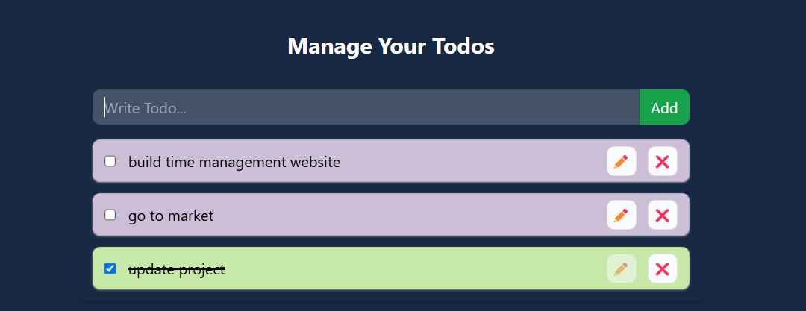

1. **Widget/Algorithm Used In Task**

• **React Context API:**  
Used for global state management, enabling the sharing of the todos state and its associated functions across components.

• **Local Storage:**  
Implemented to persist todos data, ensuring the application's state is maintained even after a page refresh.

• **Dynamic State Updates:**  
Functions such as addTodo, updateTodo, deleteTodo, and toggleComplete update the todos state dynamically using useState.

• **Effect Hook:**  
Utilized useEffect to synchronize the todos state with local storage and initialize it on component mount.

• **Modular Components:**  
Created modular components (TodoForm and TodoItem) for adding and displaying todos, enhancing code reusability and separation of concerns.