**Report**

1. **Task Description**

The task involves implementing a drag-and-drop functionality in a React application to allow users to upload images by dragging and dropping them into a designated area. The application validates the file type and displays the dropped image within the interface.

1. **Task Output Screenshot**

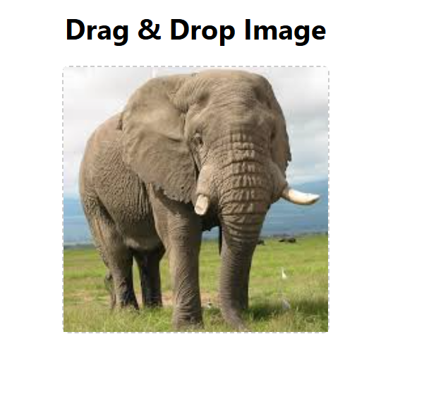

1. **Widget/Algorithm Used In Task**
2. **Drag-and-Drop Events**  
   Utilized native HTML5 drag-and-drop events such as onDragOver and onDrop to enable the dragging and dropping of files within the React component. These events handle user interactions with the drag-and-drop area.
3. **File Validation**  
   Incorporated a file type validation algorithm to ensure only image files (e.g., JPEG, PNG) are accepted. This was achieved by checking the MIME type of the dropped file using file.type.startsWith("image/").
4. **FileReader API**  
   Used the FileReader API to read the dropped image file as a Data URL. This allowed the application to generate and display a preview of the image dynamically without uploading it to a server.
5. **React State Management**  
   Leveraged React's useState hook to manage the state of the dropped image. The state was updated with the image's Data URL, which was then displayed in the UI.
6. **Dynamic Styling**  
   Applied conditional rendering and dynamic styling to enhance the user interface. The drag-and-drop area displayed either a placeholder message or the dropped image, ensuring a responsive and intuitive experience.