**Report**

1. **Task Description**

The task involves building a multi-step form using the MERN (MongoDB, Express.js, React, Node.js) stack. The form captures user data across multiple steps, validates each step, and stores the submitted data in a MongoDB database via an Express API.

1. **Task Output Screenshot**

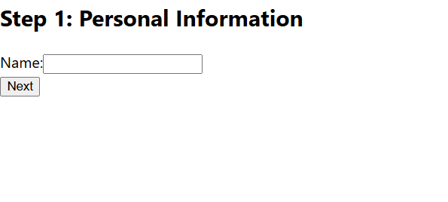

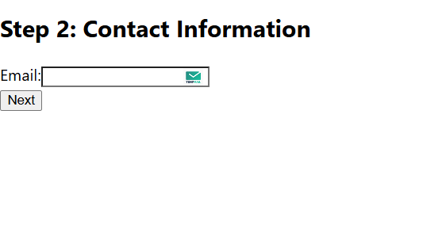

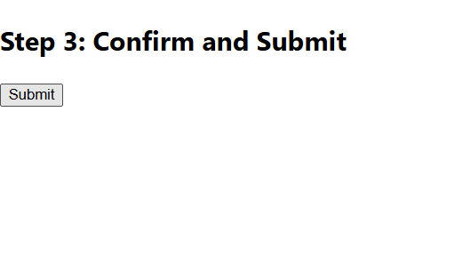

1. **Widget/Algorithm Used In Task**

• **React Context API**  
Used for global state management to share form data between steps, ensuring seamless navigation and data persistence throughout the multi-step form.

• **Form Validation Algorithm**  
Implemented validation logic for each step using custom validation functions and conditional rendering to ensure all required fields are properly filled before proceeding.

• **Axios for API Communication**  
Utilized Axios to send HTTP requests to the Express backend, enabling efficient data transfer and integration with the MongoDB database.

• **Express Routing**  
Designed backend routes to handle form data submission securely, ensuring proper validation and error handling at the server level.

• **MongoDB Schema Design**  
Created a structured schema in MongoDB to store user data effectively, supporting future scalability and data retrieval needs.