Classful Routing Configuration Report

# 1. Introduction

This report explains the concept of classful routing in computer networks. It covers what classful routing is, where it is used, how it functions, and the step-by-step process for configuring it on routers using RIP (Routing Information Protocol) version 1.

# 2. What is Classful Routing?

Classful routing is a routing technique that uses fixed subnet masks based on IP address classes. IP addresses are divided into several classes (Class A, B, and C) where each class has a default subnet mask. In classful routing, routers forward packets based on these predefined address classes without transmitting subnet mask information.

## 3. Address Classes in Classful Routing

Class A: IP addresses from 1.0.0.0 to 126.0.0.0 with a subnet mask of 255.0.0.0.  
Class B: IP addresses from 128.0.0.0 to 191.255.0.0 with a subnet mask of 255.255.0.0.  
Class C: IP addresses from 192.0.0.0 to 223.255.255.0 with a subnet mask of 255.255.255.0.

# 4. Where is Classful Routing Used?

Classful routing is primarily used in older networks and simple configurations where hierarchical IP addressing is sufficient. It is rarely used in modern networks, as it lacks the flexibility and efficiency provided by classless routing protocols. However, it is still valuable for educational purposes and for understanding how routing protocols evolved.

# 5. How Classful Routing Works

Classful routing relies on fixed subnet masks and does not send subnet mask information in routing updates. Routers determine network boundaries based on the IP address class and update their routing tables accordingly. This can lead to inefficiencies in address space utilization.

# 6. Configuration of Classful Routing

The configuration of classful routing can be done using RIP version 1, which supports classful addressing. Below are the steps taken to configure classful routing on two routers:

## Step-by-Step Configuration

* 1. Assign IP addresses to the routers' interfaces according to their respective networks.
* 2. Enable the interfaces using the 'no shutdown' command.
* 3. Enter the global configuration mode using 'configure terminal'.
* 4. Enable RIP routing using 'router rip'.
* 5. Set the RIP version to 1 using 'version 1'.
* 6. Add the networks using 'network <network_address>' commands.
* 7. Exit the configuration mode and save the configuration using 'write memory'.
* 8. Verify the routing table using 'show ip route' and test connectivity using 'ping'.

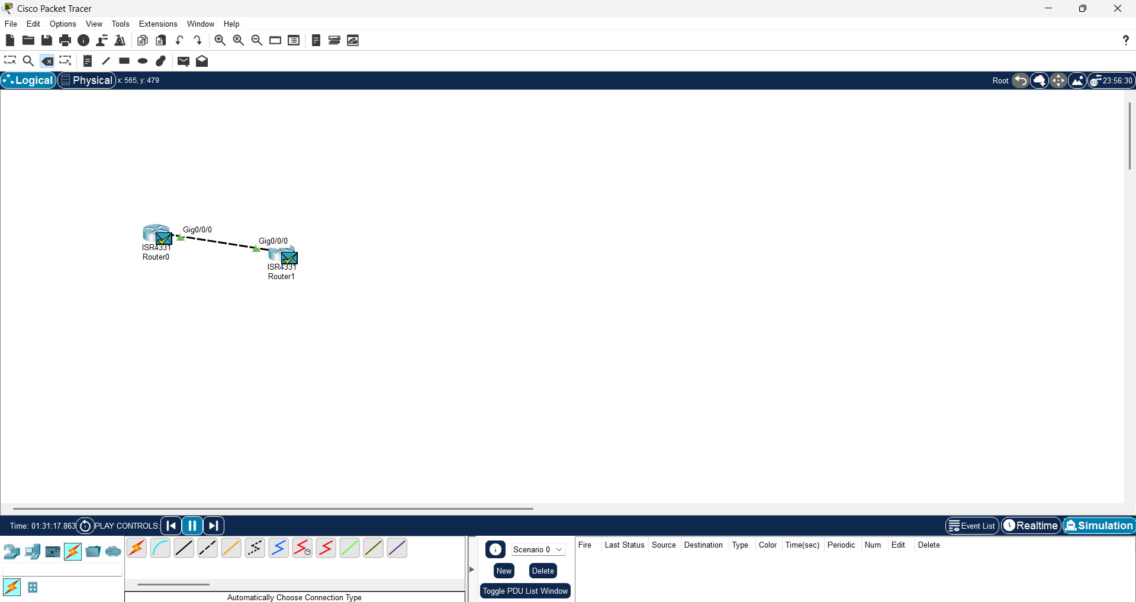

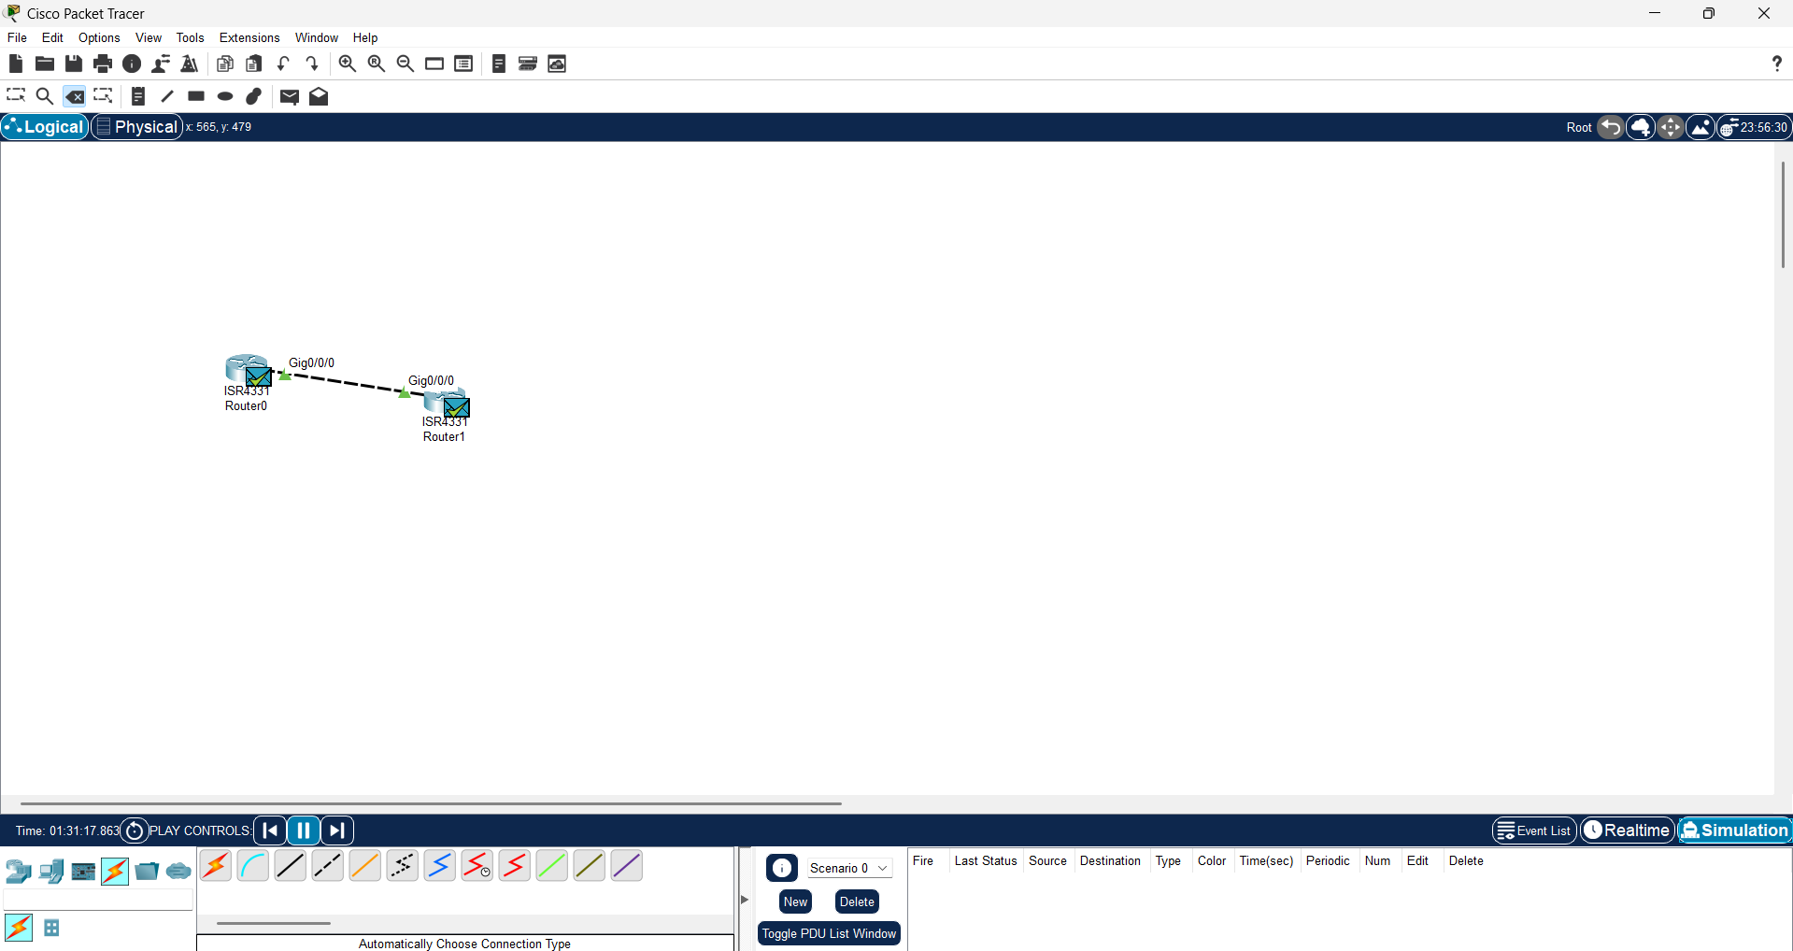

# 7. Verification

After configuring RIP version 1 on both routers, the 'show ip route' command can be used to verify that routes are being learned. The 'ping' command is used to ensure that the routers can reach each other across the configured network segments.

# 8. Conclusion

This report detailed the concept and configuration process of classful routing using RIP version 1. Although classful routing has limitations, understanding its principles provides foundational knowledge for working with more advanced routing protocols.