Classless Routing Configuration Report

# 1. Introduction

This report explains the concept of classless routing in computer networks. It covers what classless routing is, where it is used, how it functions, and the step-by-step process for configuring it on routers using RIP version 2.

# 2. What is Classless Routing?

Classless routing allows routers to send complete routing information including subnet masks with the routing updates. It enables more efficient use of IP address space by allowing variable-length subnet masking (VLSM), which provides flexibility in network design.

# 3. Differences from Classful Routing

- Classless routing includes subnet mask information in routing updates.  
- Supports Variable Length Subnet Masks (VLSM).  
- Allows more efficient IP address allocation.  
- Protocols such as RIP v2, OSPF, and EIGRP use classless routing.

# 4. Where is Classless Routing Used?

Classless routing is used in modern networks that require efficient IP allocation and scalability. It is used in enterprise networks, large-scale networks, and in Internet routing protocols such as BGP.

# 5. How Classless Routing Works

Routers using classless routing send network addresses along with subnet masks in their routing updates. This allows routers to determine the most specific route to a destination using the longest prefix match rule. It also supports overlapping subnets and prevents the inefficiencies of classful routing.

# 6. Configuration of Classless Routing

Classless routing can be configured using RIP version 2, which supports VLSM and includes subnet mask information. The following steps describe the configuration process:

## Step-by-Step Configuration

* 1. Assign IP addresses to router interfaces with appropriate subnet masks.
* 2. Enable the interfaces using the 'no shutdown' command.
* 3. Enter global configuration mode using 'configure terminal'.
* 4. Enable RIP routing using 'router rip'.
* 5. Set RIP version to 2 using 'version 2'.
* 6. Add the relevant networks using 'network <network_address>' commands.
* 7. Disable automatic summarization with 'no auto-summary' to support classless routing and VLSM.
* 8. Exit configuration mode and save the configuration using 'write memory'.
* 9. Verify routing tables using 'show ip route' and test connectivity using 'ping'.

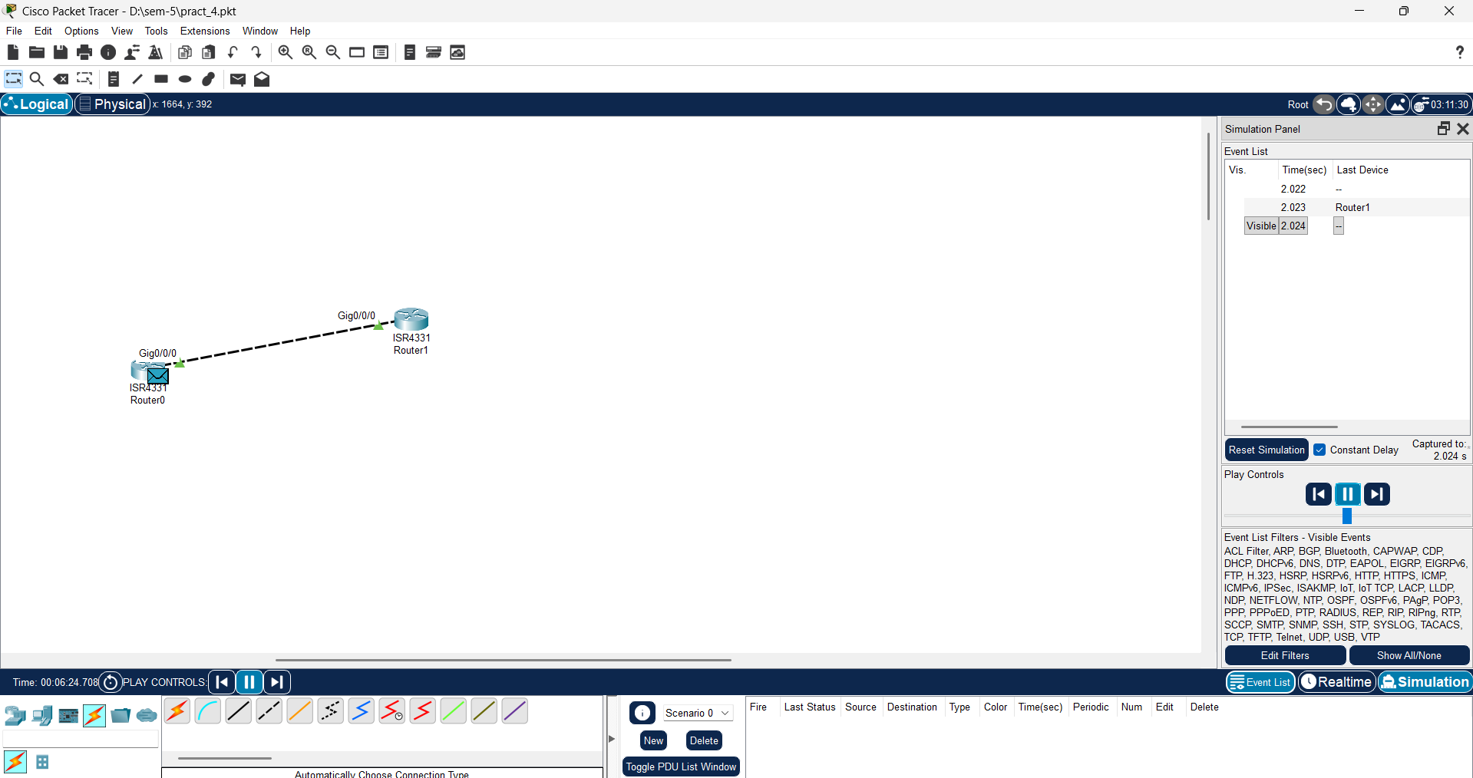



# 7. Verification

After configuring RIP version 2 on both routers, the 'show ip route' command should display learned routes with correct subnet masks. The 'ping' command is used to ensure that routers can communicate across the configured networks.

# 8. Conclusion

This report detailed the concept and configuration process of classless routing using RIP version 2. Classless routing enables efficient IP allocation, flexibility, and modern network scalability. Understanding classless routing is essential for designing and managing modern networks.