Practical Report: Setting up HTTP Server on Linux Mint

This report documents the complete practical steps taken to set up an HTTP server on Linux Mint using Apache2. It includes all commands executed, problems encountered, their resolutions, and the final output. Screenshots have been included at each stage for clarity.

# Step 1: Updating and Upgrading the System

The first step was to update and upgrade the system packages to ensure all dependencies are up to date. The following command was used:

sudo apt update && sudo apt upgrade -y

During this step, an error related to the Linux Mint repository appeared. This indicated that some repositories were outdated or unreachable. However, we continued with the setup using available Ubuntu repositories.

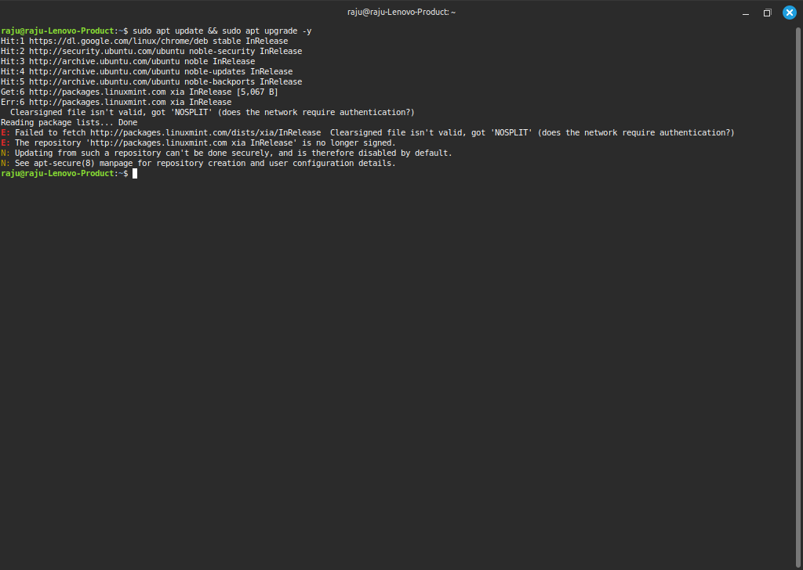

# Step 2: Installing Apache2

Next, we installed the Apache2 HTTP server using the following command:

sudo apt install apache2 -y

This installed Apache2 and its required dependencies. The screenshot below shows the installation process.

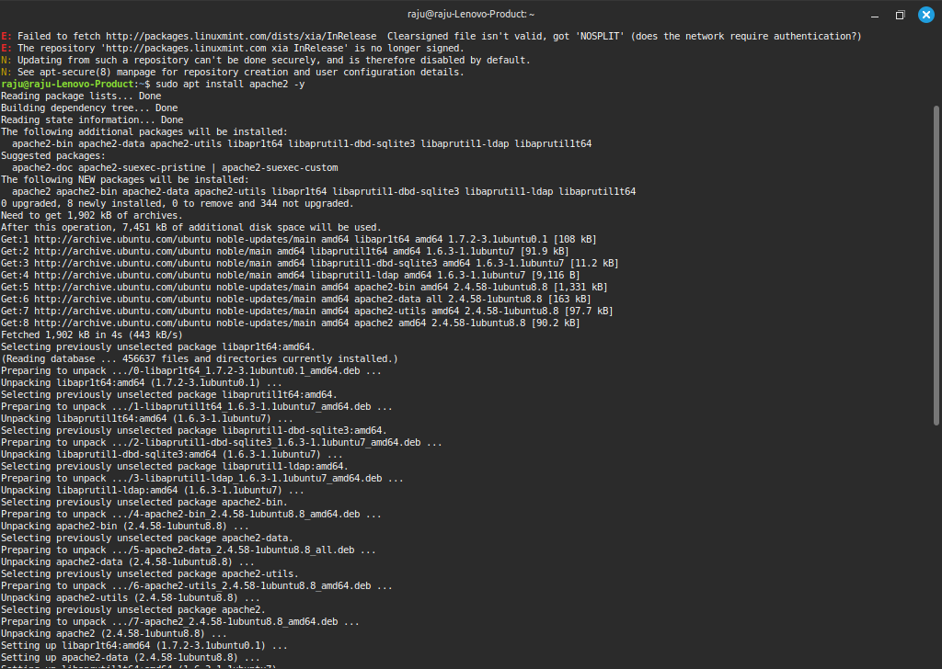

# Step 3: Enabling and Starting Apache2 Service

After installation, we enabled and started the Apache2 service so that it runs automatically at system boot:

sudo systemctl enable apache2  
sudo systemctl start apache2

The screenshot shows the service being enabled and started.

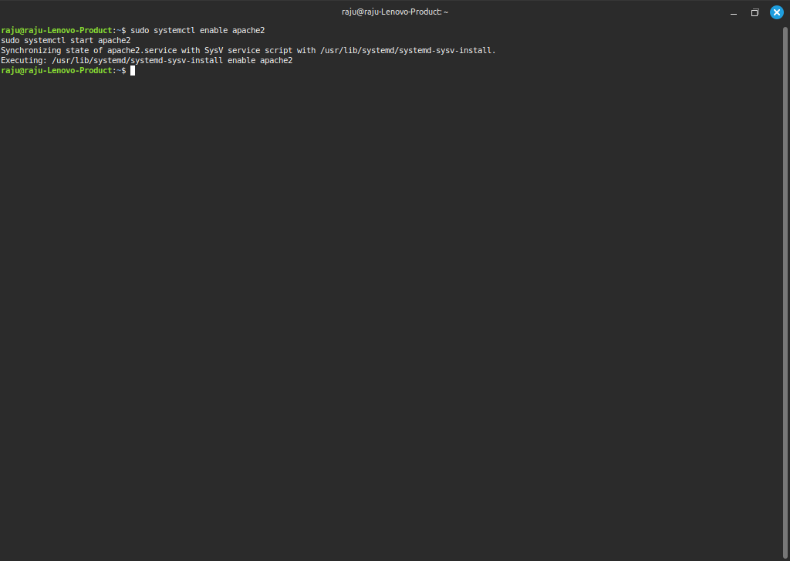

# Step 4: Checking Apache2 Service Status

To confirm Apache2 was running properly, we checked its status with:

sudo systemctl status apache2

The output showed that Apache2 is active and running. This verified that the service started successfully.

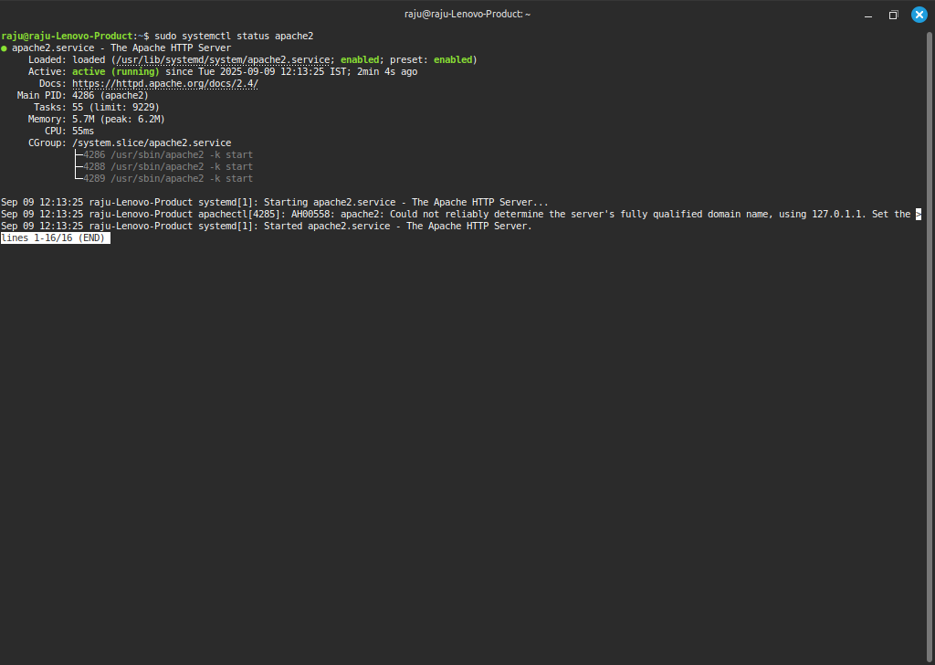

# Step 5: Testing Default Apache Page

By default, Apache serves a test page when you visit http://localhost/. The screenshot below shows the default Ubuntu Apache page confirming that the server was working.

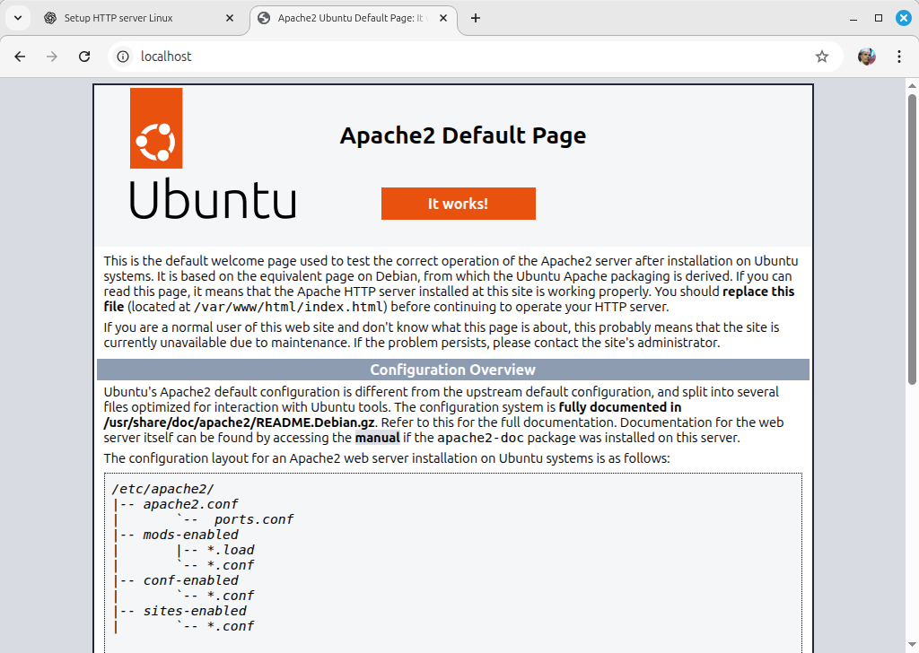

# Step 6: Editing index.html

To customize the server output, we replaced the default index.html with our own HTML page. First, we changed file permissions and opened the file using nano:

sudo chmod 666 /var/www/html/index.html  
sudo nano /var/www/html/index.html

The screenshot below shows editing the file with nano.

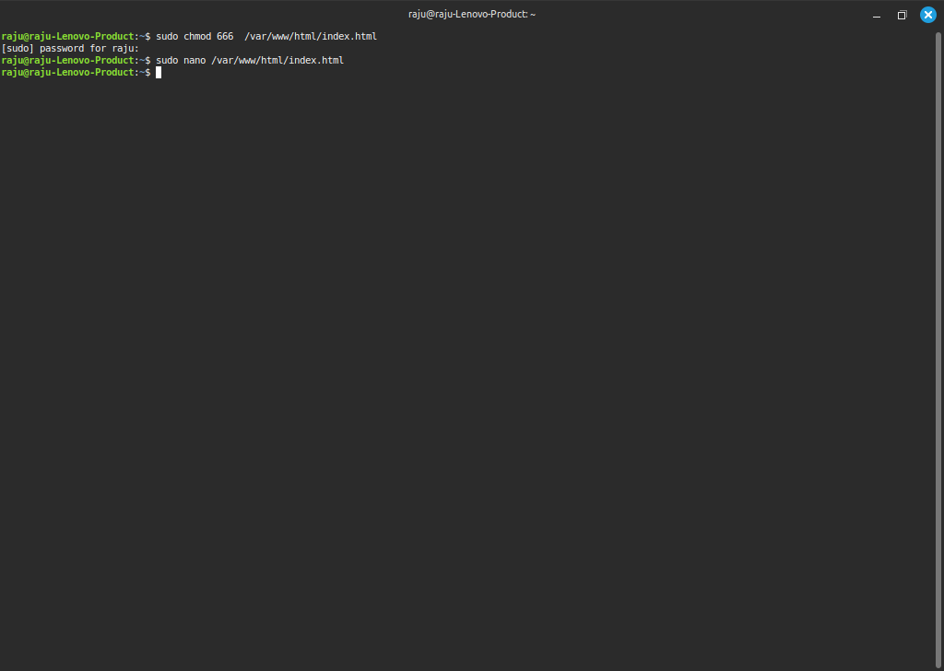

# Step 7: Adding Custom HTML Content

We pasted a custom HTML file that displays a styled message along with the student's name 'Swaraj'. The screenshot below shows the HTML file in nano editor.

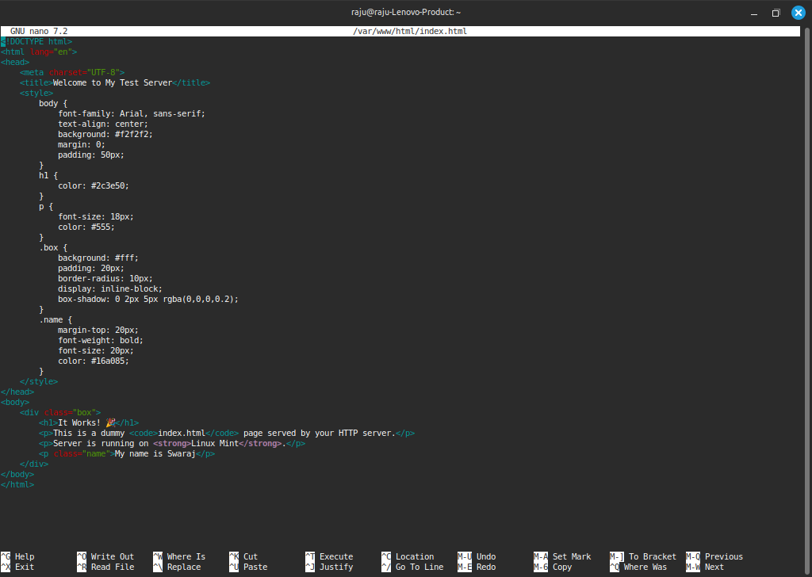

# Step 8: Final Output

Finally, we refreshed http://localhost/ in a browser to verify the changes. The customized web page was displayed successfully with the message and the name 'Swaraj'. This confirmed that the HTTP server was properly set up and serving the new content.

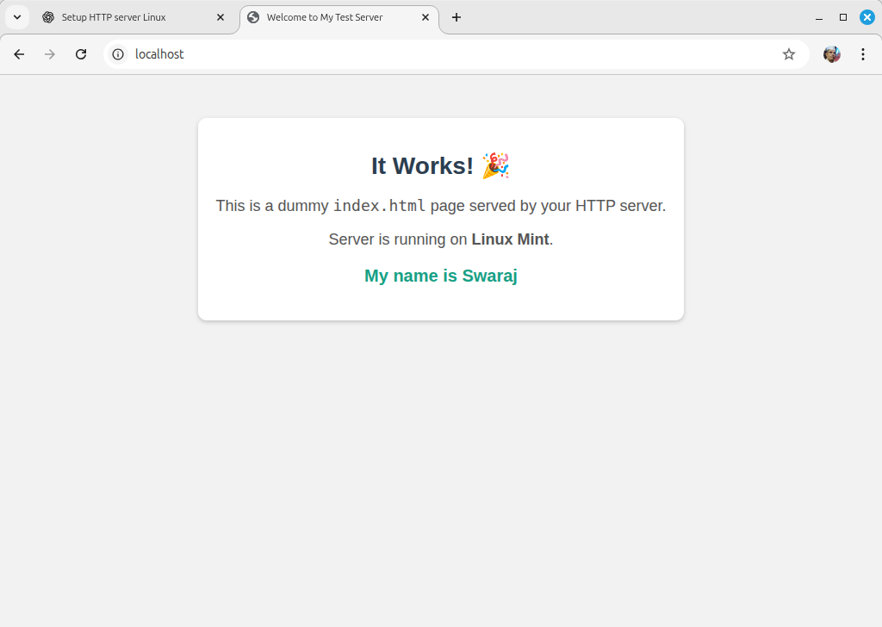

# Conclusion

In this practical, we successfully installed and configured Apache2 on Linux Mint. We verified the service status, tested the default page, and replaced it with a custom HTML page that displayed personalized content. This demonstrates the basic setup and usage of an HTTP server in Linux.